|  |  |  |  |  |  |  |
| --- | --- | --- | --- | --- | --- | --- |
| Urbanovský Jozef | xurban66 | G | A | A | G | A |

Príklad č. 1

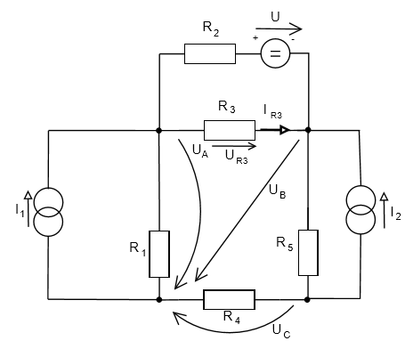Príklad č. 3

U = 120 V

I1 = 0,9 A

I2 = 0,7 A

R1 = 530 Ohm

R2 = 450 Ohm

R3 = 650 Ohm

R4 = 390 Ohm

R5 = 320 Ohm

A: I1 + IR2 – IR1 – IR3 = 0 UR3 + UB – UA = 0 => UR3 = UA - UB

B: IR3 + I2 – IR2 – IR5 = 0 U – UR3 – UR2 = 0 => UR2 = U – UR3

C: I2 + IR4 – IR5 = 0 UR2 = U + UB – UA

UR5 + UC – UB = 0 => UR5 = UB - UC

IR1 = $\frac{UA}{R1}$ IR2 = $\frac{U+UB-UA}{R2}$ IR3 = $\frac{UA-UB}{R3}$ IR4 = $\frac{UC}{R4}$ IR5 = $\frac{UB-UC}{R5}$