**NSV RECORD MANAGEMENT SYSTEM**

**(A WEB-BASED APPLICATION)**

**FOR**

**Nepal Sangeet Vidhyalaya**

**BY**

**Aman Shrestha**

**8888/18**

**7-2-939-60-2018**

Orchid International College

*A Summer Project Report Submitted to*

**Faculty of Management, Tribhuvan University**

In partial fulfillment of the requirements for the degree of

**Bachelor of Information Management**

Kathmandu

July, 2022

# NO OBJECTION CERTIFICATE

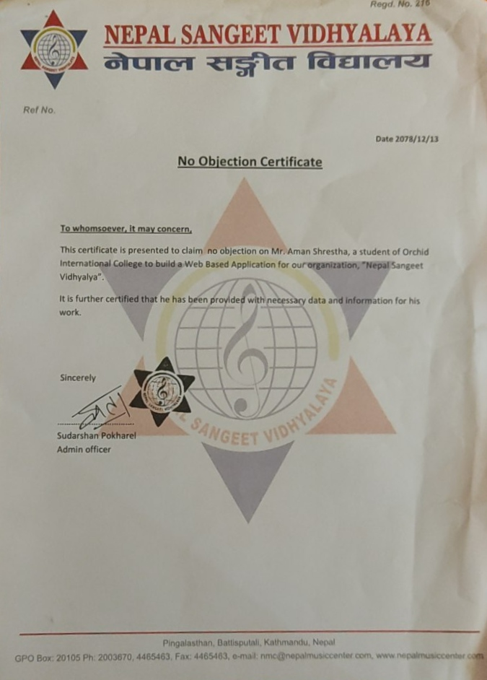

# STUDENT DECLARATION

This is to certify that I have completed the summer project entitled “NSV Management System” under the guidance of “Er. Dhiraj kumar jha” in partial fulfillment of the requirement for the degree of Bachelor of Information Management at faculty of Management, TU.

Name: Aman Shrestha

Roll number: 8888/18

Date:

Signature:

# CERTIFICATE FROM THE SUPERVISOR

This is to certify that the summer project entitled “NSV Management System” is an academic work done by “Aman Shrestha” submitted in the partial fulfillment of the requirement for the degree of Bachelor in Information Management from Faculty of Management, Tribhuvan University under my guidance and supervision. To the best of my knowledge, the information presented by her in the summer project report has not been submitted earlier.

______________________

Signature of the Supervisor

Name: Er.Dhiraj Kumar Jha

Designation: Project Coordinator

Date:

# EXECUTIVE SUMMARY

This report is about making admin website for Nepal Sangeet Vidhyalaya. The main objective of this project is to replace traditional manual system of record keeping with computerized system that help make the manager’s/admin’s operational tasks easier and more manageable than ever. With interactive user interface and functionalities that not only saves his/her time but also provides useful information to track organization activities and progress as well as operate smoothly in day to day scenario.

# ACKNOWLEDGEMENTS

I would like to express my special thanks to NSV for their kind cooperation in providing me insight on their organization and conduct my research. I would also like to extend my gratitude to our Project Coordinator Dhiraj Kumar Jha and Shikha Sharma for providing me the necessary guidance and support in completion of my project.

Table of Contents

NO OBJECTION CERTIFICATE i

STUDENT DECLARATION ii

CERTIFICATE FROM THE SUPERVISOR iii

EXECUTIVE SUMMARY iv

ACKNOWLEDGEMENTS v

LIST OF FIGURES viii

LIST OF TABLES ix

LIST OF ABBREVIATIONS x

CHAPTER I: INTRODUCTION 1

I.1 Background 1

I.2 Introduction to the Organization 1

I.3 Current Situation of the Organization 1

I.4 Problem Statement 1

I.5 Objective of the system 1

I.6 Literature Review 2

I.7 Methodology 3

I.7.1 Data and Information 3

I.7.2 Project Framework 4

I.7.3 Tools used 5

I.7.4 Techniques of Project Report Analysis 5

CHAPTER II: TASKS AND ACTIVITY PERFORMED 7

II.1 Analysis of tasks, activities and problem issues 7

II.1.1 System Analysis 7

II.1.2 Analysis of Task 7

II.1.3 Problem and Issue 7

II.2 Analysis of possible solutions 7

II.2.1 Requirement Analysis 7

II.2.2 Functional Requirement 8

II.2.3 Non Functional Requirement 8

II.2.4 Software Requirements 9

II.2.5 Entity Relationship Diagram 10

II.2.6 Use Case Diagram 11

II.2.7 Class Diagram 14

II.2.8 Activity Diagram 15

II.2.9 Testing 16

II.3 Findings 18

CHAPTER III: DISCUSSIONS AND CONCLUSIONS 19

III.1 Discussions 19

III.2 Conclusions 19

III.3 Future Enhancements 19

REFERENCES 20

# LIST OF FIGURES

Figure 1. 1 Organization Structure of NMC System 4

Figure 1. 2 ERD of NMC System 10

Figure 1. 3 USE CASE Diagram of NMC System 11

Figure 1. 4 Class Diagram of NMC System 14

Figure 1. 5 Activity Diagram of NMC System 15

# LIST OF TABLES

Table 1. 1 Login 12

Table 1. 2 CRUD Operation On Students, Teachers, Courses And Fees 12

Table 1. 3 View Dashboard 12

Table 1. 4 Change Password 13

Table 1. 5 Make Payment 13

Table 1. 6 Test Case For Login 16

Table 1. 7 Test Case For Add, Update Or Delete 17

# LIST OF ABBREVIATIONS

BIM : Bachelor In Information Management

CRUD : Create, Read, Update and Delete

ERD : Entity Relationship Diagram

NMC : Nepal Music Centre

NSV : Nepal Sangeet Vidhyalaya

TU : Tribhuwan University

# INTRODUCTION

## **Background**

This project “NSV Management System” is a web based application which provides the information regarding students, teachers, courses and fees.

## **Introduction to the Organization**

Nepal Sangeet Vidhyalaya (NSV), a music school established in the year 2006 by Music Nepal. It aims to provide formal education in music from the primary level. It is probably the first ever school established with due permission from Ministry of Education, with the given responsibility of developing curriculum for formal music education. This school is managed by Nepal Music Center, a non-profit organization.

## **Current Situation of the Organization**

In the spring of 2016, the ministry of education made an important decision and introduced music in technical stream education and Nepal Sangeet Vidhyalaya was chosen to be the pilot school for this first time ever program in Nepal from the academic year 2073. Expanding into the high school grades with a music curriculum that emphasizes the development of the student as a musician for the 21st century. Nepal Sangeet Vidhayala is the Nepal’s only High school that teaches music as a core subject.

## **Problem Statement**

This organization don’t maintain records on computerized system. So, the goal of this project is to provide them with system that keeps their information in more systematic and organized way where various functionalities can be performed by admin with ease.

## **Objective of the system**

* To assist in management and operational activities that would reduce time, effort and errors.
* To access system from anywhere on computer or laptop that has an internet connection
* To improve quality of work.

## **Literature Review**

﻿Nowadays, more parents are willing to pay school children for learning music as an extra curricular activity through privately-run music school. Managing school efficiently and effectively are important factors that many schools would like to achieve in order to increase student enrollments. However, most music schools still maintain the daily operation manually, in which inefficiency and data inaccuracy may occur due to human error. The interactions between students, tutors and management office are restricted within the school. Hence, a web-based music school management system is proposed and developed to provide a more convenient and efficient management solution to different users. With the help of the flexible scheduling management, the conflicts of the room assignment can be reduced and the individual schedule can be changed efficiently. Simple and convenient workflows are given to reduce the confusion and time for course registration, leave management and so forth. One of the special functions, substitution management is provided for management to choose suitable tutor to substitute tutor on leave. The tutors are allowed to apply substitution of leaved classes such that the time for searching substituted tutor by telephone method can be greatly reduced. This system can also help tutors and students keep track of their own schedule, leave application result, salary or payment record. (Ka Yan Shing, 2008)

Most schools use student information systems (SIS) as a standalone tool and use different applications for other purposes like classroom management, online courses management, and more. However, there are many products that claim to offer all-in-one solutions. But while deciding to implement an SIS solution, you need to be mindful of the tools and applications that you choose. Create and manage your stack of applications in a way that offers you the maximum ROI. Student Record Management Systems Features and Capabilities Now let’s look at some of the features that a student record management system offers: a) **Admission Management** - The admission management module streamlines and automates every aspect of the admission process, including filling up online forms, fee submission, batch allotment, and document submission. b) **Fee Management** - It helps you manage all the fee-related tasks such as accepting fees, keeping fee records, maintaining receipts, taking care of dues and refunds, and more. It also allows you to create the fees cycle of the school. (Sharad Bhardwaj, 2020)

Simply put, school management software is an online platform or tool that is specifically designed for educational institutions. These systems are built to help schools manage their day-to-day processes so that they can run more efficiently. This includes streamlining the management of: Billing and invoicing, Lesson scheduling, Creating timetables, Online registration, Attendance tracking. Therefore, the main purpose of school management software is to automate tedious processes to ensure the smoother running of a teaching business. This gives both administrators and educators better oversight of the music school and more time to focus on delivering high-quality lessons. (teachngo, 2022)

## **Methodology**

### **Data and Information**

The data and information collected for developing this system are mainly from primary source which was on my visit to the organization. For secondary source, I took reference from internet, documentation and books related to programming in management of the institution.

### **Project Framework**

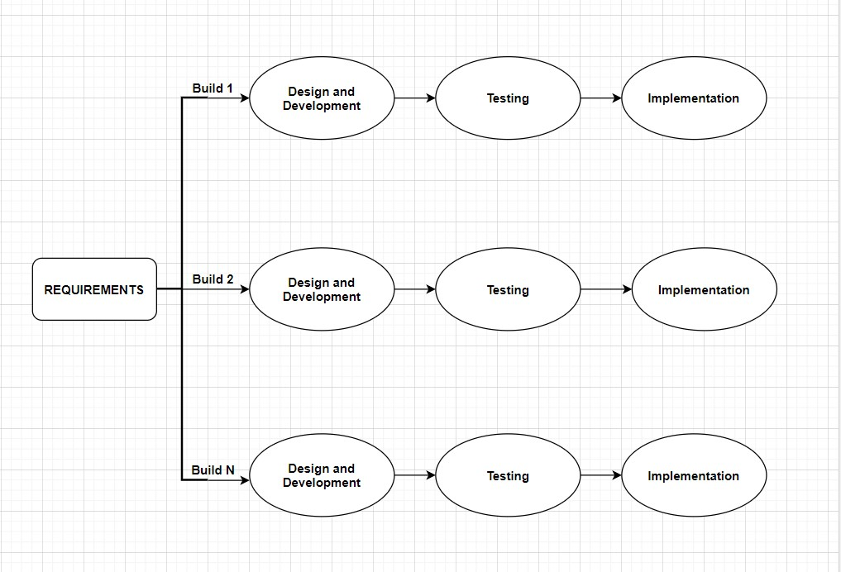

Figure 1. 1 Organization Structure of NMC System

The project framework that I used for this project is Incremental Development .In this model, requirements are divided into several stand-alone software development modules. In this example, each module passes through the requirement, design, development, implementation, and testing phases. That subsequent release of the module adds a feature to the previous release. The process will continue until the whole software is achieved.

### **Tools used**

Python/Django

The core language used for the development of this system is python and django framework. As python along with django works wonder when developing because it takes care of much of the hassle sof web development.

Draw.io

It was used to draw:

* Use Case Diagram
* ER Diagram
* Sequence Diagram
* Class Diagram

HTML/CSS and bootstraps

It is being used to structure the web document and give interactive UI/UX design.

### **Techniques of Project Report Analysis**

#### **Problem Analysis:-**

The problem that this organization is facing is that it has to do a lot of paper works from recording, managing and assessing students or teachers information on a timely basis. For instance, from students enrollment to managing students, teachers and courses records on a timely basis and tasks related with payments everything is manual here. This makes the task of the manager/admin lengthy and unmanageable sometimes. So, I propose this system that assists the manager to monitor and maintain the records related with students, teachers and courses, also handle payments from the students, fetch required records efficiently and lastly be able to see charts for organization performance over a period of time.

#### **Feasibility analysis:-**

Economical

This project is economically feasible because technologies that is being used here are free and estimation of the system will overcome the initial costs incurred by the manager in terms of time, efficacy of record management, etc.

Legal

This technology is going to be developed in accordance with all the legal actions and procedures that would not violate any laws.

Operational

The proposed system will be very user friendly that will assist manager to perform task effectively and efficiently when it comes to managing records and generate reports of students and teachers associated with the organization.

# TASKS AND ACTIVITY PERFORMED

## **Analysis of tasks, activities and problem issues**

### **System Analysis**

The major objective of system analysis are to find major answers for each process. It majorly concerns on answering the question.

The NSV Management System includes the records of all the students, teachers, courses and fees associated with each other. Admin here has the full control on performing CRUD operation on students, teachers, fees and courses.

This system is being developed using python and django framework. The system follows the incremental approach of software development where the features are being updated according to the requirement.

### **Analysis of Task**

The task analysis of this organization was done by visiting the organization and inquiring the manager/supervisor about his day to day tasks and how soon going to be developed system can help him perform his tasks with more efficiency and effectiveness.

### **Problem and Issue**

The problem that I found in this organization was traditional way of manually keeping records which brought lot of hassle to the manager to monitor the overall activities of the organization and on top of that time were consumed by simple tasks such as viewing records.

## **Analysis of possible solutions**

### **Requirement Analysis**

Requirement analysis contains requirements related to the users and the system. These information are collected and analyzed so that the information can be filtered and defined properly. At the end of this activity the requirements are ready to be specified. Requirement analysis consist of following step/process:

* Requirement Discovery
* Requirement Classification and Organization
* Requirement Prioritization and Negotiations
* Requirements Specifications

### **Functional Requirement**

Functional requirement describe what a system should do. Functional requirements of our system are explained below.

* User must have valid username and password to login.
* Administrator can register new courses, teachers and enroll students.
* Students can choose courses.
* Students make payments using paypal for the time being.
* Reports and Charts about course, student, and payment is generated

### **Non Functional Requirement**

#### **Performance Requirement**

Users that will be interacting with this system will be around 100-1000.

#### **Safety Requirement**

If there is extensive damage to a wide portion of the database due to catastrophic failure, such as a disk crash, the recovery method restores a past copy of the database that was backed up to archival storage (typically tape) and reconstructs a more current state by reapplying or redoing the operations of committed transactions from the backed up log, up to the time of failure.

#### **Security Requirement**

Security systems need database storage just like many other applications. However, the special requirements of the security market mean that vendors must choose their database partner carefully.

#### **Software Quality Attributes**

AVAILABILITY: The system should be available when users need it.

CORRECTNESS: The system should follow ACID property.

MAINTAINABILITY: The admin should maintain records.

USABILITY: The systems should satisfy user needs.

### **Software Requirements**

The system requirements specify about the services or features of the system that are required so that the services are delivered properly. The system requirements of the project are software and hardware requirements which includes operating system such as Windows XP or higher, Database such as SQL lite3, MYSQL or Postgres and web browser, Intel Processor of 64-bit at least 5th generation, Ram about 512MB and available storage of around 100mb.

### **Entity Relationship Diagram**

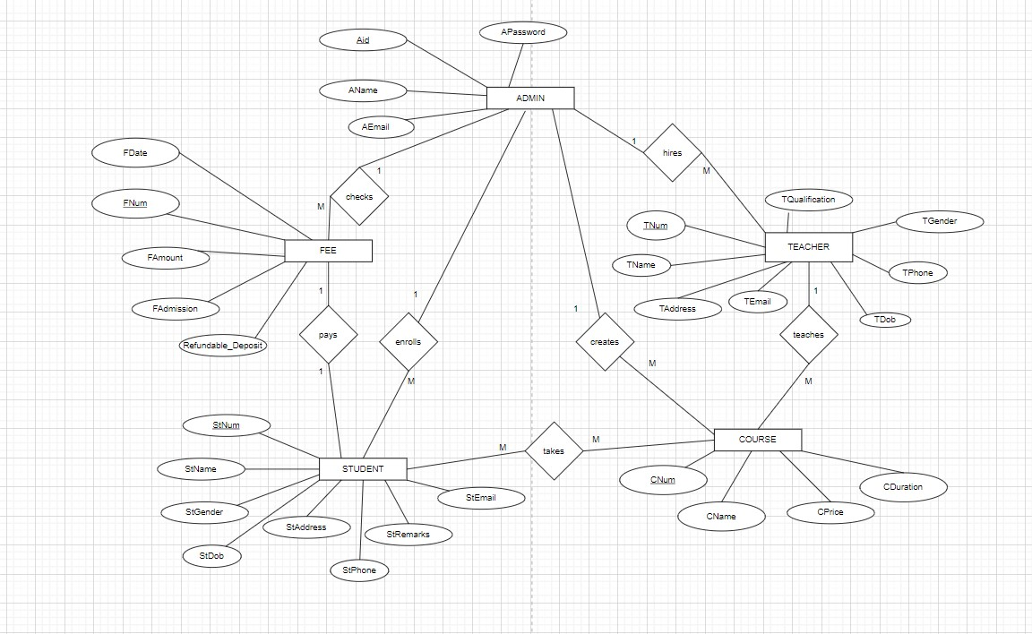

Figure 1. ERD of NSV System

### **Use Case Diagram**

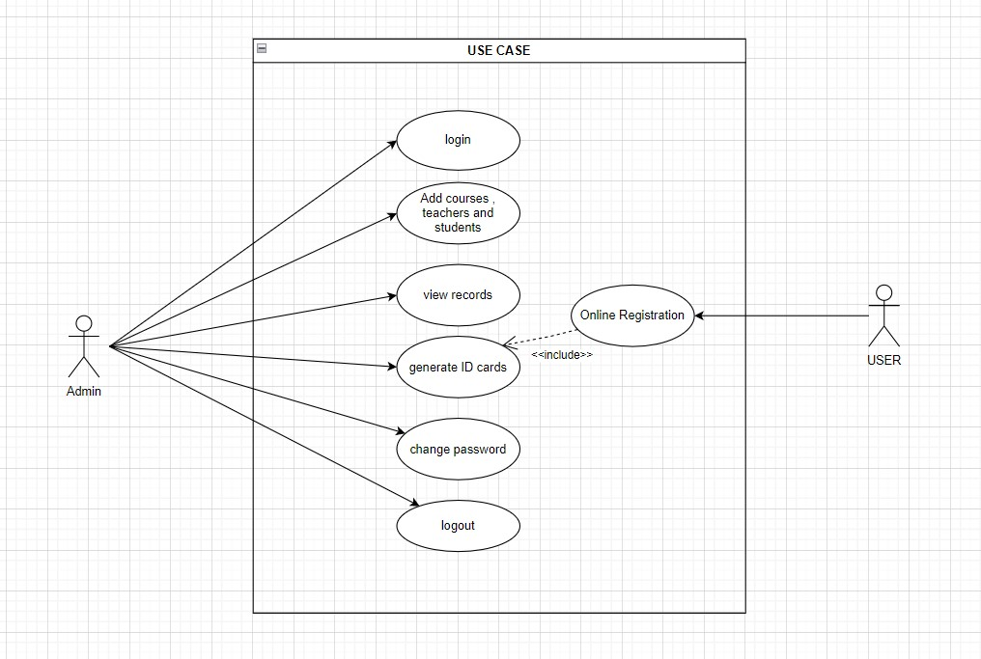

Figure 1. USE CASE Diagram of NSV System

Table 1. Login

|  |  |
| --- | --- |
| Use-Case identifier | UC01-Login |
| Primary Actor | Admin |
| Secondary Actor | None |
| Description | Admin has to login into the system in order to access the system |
| Success Scenario | Login success message should be displayed |
| Failure Scenario | Login failed message should be displayed |

Table 1. CRUD operation on students, teachers, courses and fees

|  |  |
| --- | --- |
| Use-Case identifier | UC02- CRUD operation on students, teachers, courses and fees |
| Primary Actor | Admin |
| Secondary Actor | None |
| Description | Admin has the privilege to perform CRUD functionality on students, teachers, fees and courses. |
| Success Scenario | CRUD operation successfully performed on the database. |
| Failure Scenario | CRUD operation on database failed. |

Table 1. View Dashboard

|  |  |
| --- | --- |
| Use-Case identifier | UC03- View Dashboard |
| Primary Actor | Admin |
| Secondary Actor | None |
| Description | The admin can view the dashboard to monitor the overall activities of the organization. |
| Success Scenario | The dashboard visually provides key performance indicators of the institution. |
| Failure Scenario | The dashboard fails to display reports of the organization’s periodic activities |

Table 1. Change Password

|  |  |
| --- | --- |
| Use-Case identifier | UC04- Change Password |
| Primary Actor | Admin |
| Secondary Actor | None |
| Description | Admin can changes his/her password. |
| Success Scenario | Password is changed |
| Failure Scenario | Password is not changed |

Table 1. Make Payment

|  |  |
| --- | --- |
| Use-Case identifier | UC05- Make Payment |
| Primary Actor | Students |
| Secondary Actor | None |
| Description | Students can make payments. |
| Success Scenario | Payment is successful. |
| Failure Scenario | Payment failed. |

Table 2.6 Print ID card

|  |  |
| --- | --- |
| Use-Case identifier | UC06- Print ID Card |
| Primary Actor | Admin |
| Secondary Actor | None |
| Description | Admin can print ID Card |
| Success Scenario | ID card is printed. |
| Failure Scenario | ID card printing failed. |

### **Class Diagram**

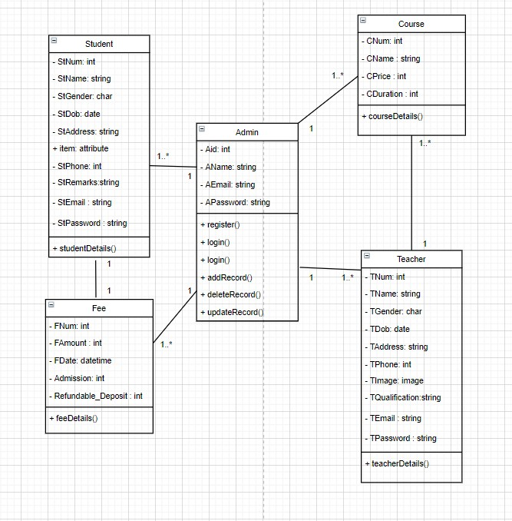

Figure 1. Class Diagram of NMC System

Class diagram describes the attributes and operations of a class and also the constraints imposed on the system. In the above figure, we can observe that there exists relationships between various modules such as student, teachers, fee, etc. And, these modules consist attributes and methods which can be performed on it. The + (public), - (private), # (protected) and ~ (package) symbols before an attribute and operation name in a class denote the visibility of the attribute and operation.

### **Activity Diagram**

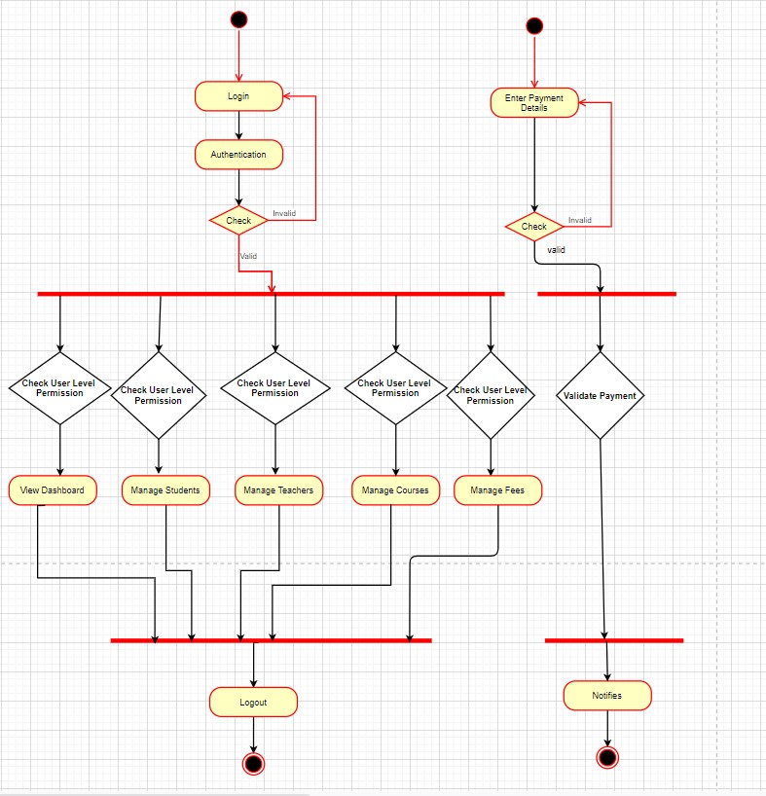

Figure 1. Activity Diagram of NMC System

An activity diagram visually presents a series of actions or flow of control in a system similar to a flowchart or a data flow diagram. In the above figure, it shows how would the system interact with the admin or customer based on the defined privilege.

### **Testing**

Table 1. Test Case for Login

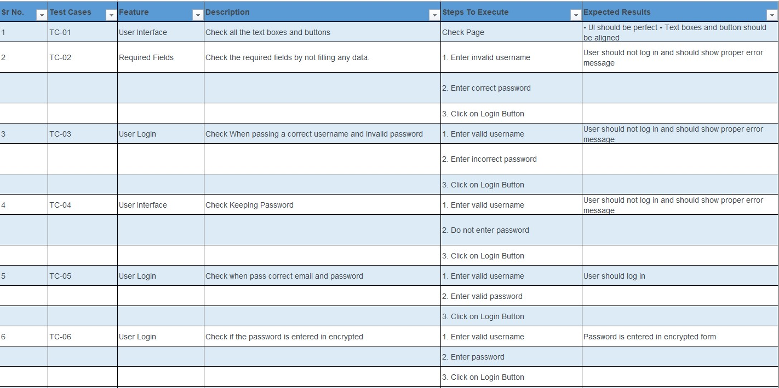

Table 1. Test Case for Add, Update or Delete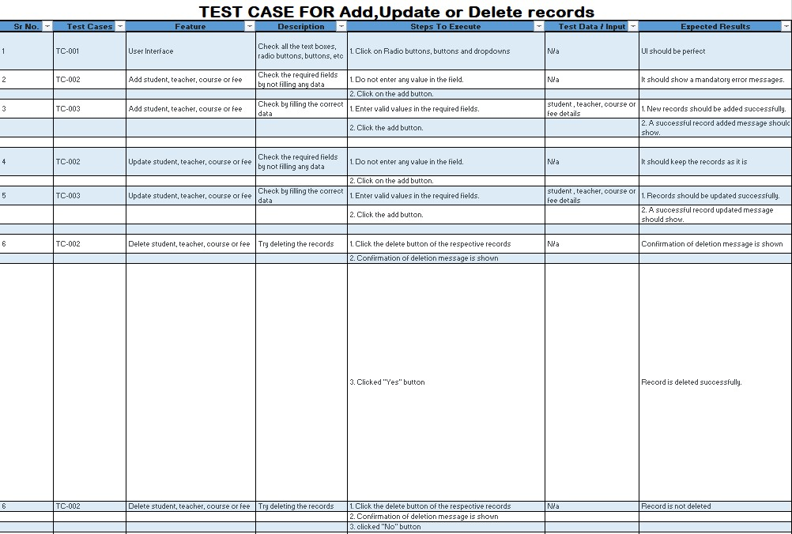

## **Findings**

This project meets the requirement of the organization that was mentioned above. Requirements such as keeping records on computerized system which admin has to login in order to view and he/she can perform various tasks here such as adding records or deleting them, updating them , and so on.

# DISCUSSIONS AND CONCLUSIONS

## **Discussions**

The major concerns when developing this project were what kind of problems to address, which technologies to use, the feasibility of the project, the time limitation and the availability of the required resources for assistance of the project.

## **Conclusions**

With all the learning and knowledge, the proposed project has been successfully completed. NSV Management System is web-based application in which records of organization is kept for present and future use. This system is easy to use and can be accessed by from anywhere at any time with help of pc connected to the internet.

By doing this project, I got to use all my learning over the past semesters and apply it practically. This project helped me to see how a web application is built and what factors to consider when building a project.

## **Future Enhancements**

Project can be updated in near future as and when requirement arises. Since, there are features that could have been added in the system but the objective of the project has to be achieved pertaining to the Time and Money Constraint.

• Dedicated UI for the stakeholders of the institution.

• Mobile applications of the NSV system

## **REFERENCES**

16 Best Student Record Management System for Schools & Institutes. (2022). Retrieved 18 August 2022, from https://www.softwaresuggest.com/blog/best-student-record-management-system/

Music School Scheduling & Management Software | Teachworks. (2022). Retrieved 06 April 2022, from https://teachworks.com/music-school-management-software

Teach 'n Go - Intuitive and Efficient Music School Software. (2022). Retrieved 29 August 2022, from <https://www.teachngo.com/solutions/music-school-software.php>

**Appendices**

