INVOICE

**Invoise номер:** undefined **Ф.И.О клиента:** undefined

**Дата:** 2024-09-19 **Адрес клиента:**  Andijon shaxr A.Fitrat 10 uy

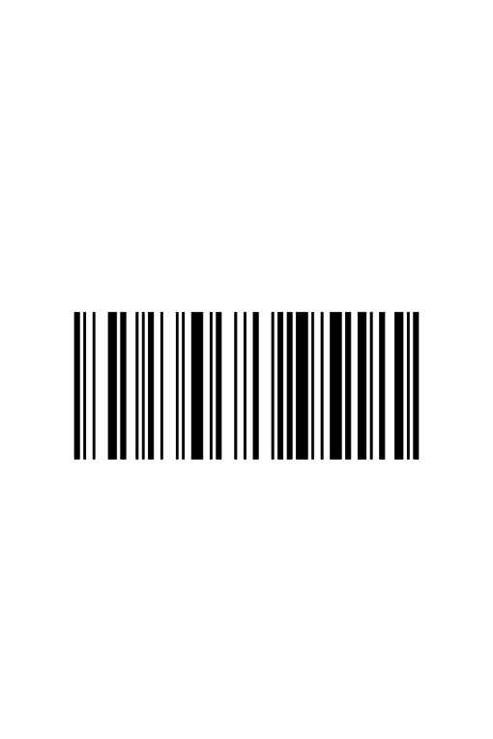**Трек код: Телафон клиента:** +998905269499

**Аккаунт клиента:** axrorbekshermatov2@gmail.com

2025452258965259

|  |  |  |  |  |  |  |  |  |
| --- | --- | --- | --- | --- | --- | --- | --- | --- |
| **#** | **Shop Name** | **Product link** | **Product name** | **Color** | **Quantity** | **Size** | **Product code** | **Sum** |
|  | Uniqlo | https://www.zara.com/uz/ru/%D1%83%D1%82%D0%B5%D0%BF%D0%BB%D0%B5%D0%BD%D0%BD%D1%8B%D0%B8-%D0%B1%D0%BE%D0%BC%D0%B1%D0%B5%D1%80-p03918621.html?v1=378445218&v2=2467336 | undefined | undefined | undefined | undefined | undefined | undefined |

Confirmed by electronic

signature