Assignment 1
Step Counting with a Smartphone Accelerometer
Static threshold versus dynamic threshold
Axel Caire
Student number 2602059
Multidimensional Sensing Techniques
Åbo Akademi University
13 November 2026
GitHub repository

1. Introduction
The goal of this assignment is to count steps with the accelerometer of a smartphone. I write two algorithms in Python and compared . The first one uses a fixe threshold. The second one uses a threshold that change over time and is based on a pedometer design from Analog Devices [1].
This topic is useful because almost every phone and smartwatch now has a step counter. The sensor is simple, but the signal is noisy in real life. It changes with the way the phone is carried, with the walking speed and with the person. The phone is move by hand before and after the walk. A good step counter must deal with all of this.
Section 2 explains how i recorded the data and Section 3 how i read it. Sections 4 and 5 present the two algorithms,and Section 6 compares the results and Section 7 gives some ideas to improve them. Section 8 is the personal reflection.

2. Data acquisition

2.1 Planned method and real method
My plan is to record the walks with MATLAB Mobile, export them as a .mat file and convert them with three MATLAB commands into a CSV file with four columns (index, X, Y, Z). This did not work because i could not log in to MATLAB Mobile. The Microsoft login page crashed every time.
So i used phyphox [3] instead. It is a free app made by RWTH Aachen University, and i used its experiment called “Acceleration with g”. I then converted its CSV file in exact the same format as the MATLAB file (index, X, Y, Z in m/s²). This change do not affect the work. Both apps read the same sensor of the same phone, and the Python code gets a file in the expected format, so the code did not need change.

2.2 My own recordings
I made all recording at 100 Hz with the phone in my pocket.
File | Type of walk | Real steps | Duration
mon_enregistrement_1 | normal walk | 30 | 33 s
mon_enregistrement_2 | fast walk | 52 | 36 s
mon_enregistrement_3 | normal walk | 100 | 66 s
Table 1. My recordings (phone in trouser pocket, 100 Hz)
The data confirm the walks types in Table 1. In recording 2 the median time between two steps is 0.56 s (1.8 steps per second), compared with 0.62 s (1.6 steps per second) in recordings 1 and 3.

2.3 Public dataset
I also use five recording from the chapter “A Pedometer in the Real World” by Dessy Daskalov in the book 500 Lines or Less [2]. They are recorded at 100 Hz. There is a walk of 10 steps, 100 steps and one of 300 steps, a run of 10 steps and a walk of 10 steps with the phone in a bag. I used them to develop and tune the algorithms. In total, i tested the algorithm on 8 files.

3. Reading the data
Each line of the CSV file has four values separated by commas (index, X, Y, Z). The function read_data() reads the file line by line. For each line, it remove spaces with strip(), split the line with split(",") and converts each value for a float and adds it to one of four lists. If a line has fewer than four value, it is skipped, so a broke last line cannot stop the program.
I made two change to the template. i changed the name of the input file, and i changed the value that marks a step on the plot from 50000 to 15. The value 50000 was made for raw sensor units. With a signal in m/s², it made the curve look like a flat line at the bottom of the plot.
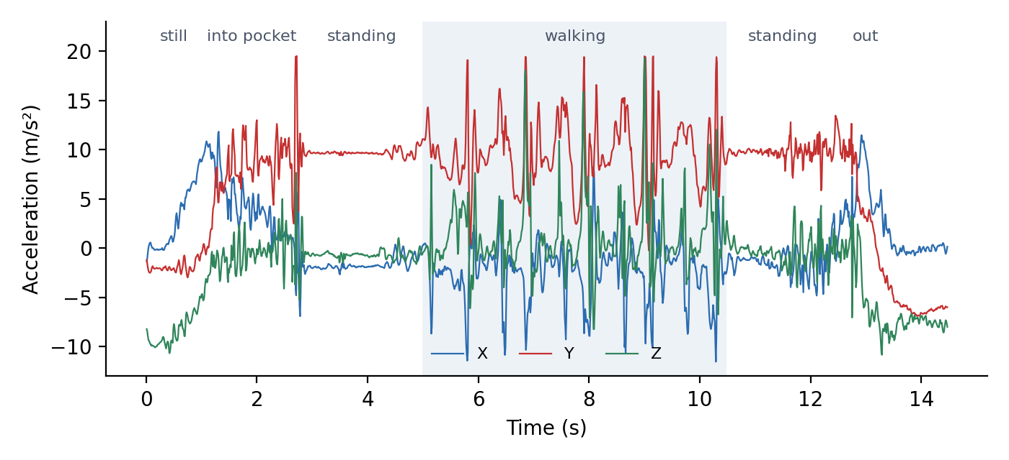
Figure 1. Raw X, Y and Z acceleration of the file walk_10steps
Figure 1 shows the different parts of the recording. At first the phone does not move. Then it goes into the pocket, the person stands, walks, stands again and takes the phone out. The figure also shows that gravity moves from the Z axis to the Y axis when the phone go into the pocket. The orientation of the phone is different in each records, and it can change during a recording. This is why an algorithm that use only one axis would not be reliable.

4. Basic algorithm with a static threshold

4.1 Magnitude of the acceleration
Both algorithms use the magnitude of the acceleration, m = √(x² + y² + z²). The magnitude dont depend of how the phone is turned, so it solve the problem seen in Figure 1. When the phone dont move, the magnitude is about to 9.81 m/s² because the sensor only measures gravity. A step gives a peak of about 15 to 30 m/s².

4.2 First version and hysteresis
My first version count a step each time the magnitude went above 15 m/s². It counted too many steps, 22 for a walk of 10 steps and 377 for a walk of 300 steps. The reason is that the peaks are not smooth. Near the top of one step, the signal can go above and below the threshold several times, and each time is counted as a new step.
To fix this, i used hysteresis with two thresholds. A step is counted when the magnitude goes above 15 m/s², and the next step can only be counted after the magnitude has gone below 7 m/s². This works like the Schmitt trigger in electronics. Daskalov uses the same idea in [2]. She only counts a peak after the signal has crossed zero. Her signal has no gravity and moves around zero, while my magnitude move around 9.81 m/s². So my lower threshold of 7 m/s² has the same role as her zero crossing. I chose both values by looking at the magnitude plots. The upper threshold is between the rest level and the step peaks, and the lower one is below the rest level.
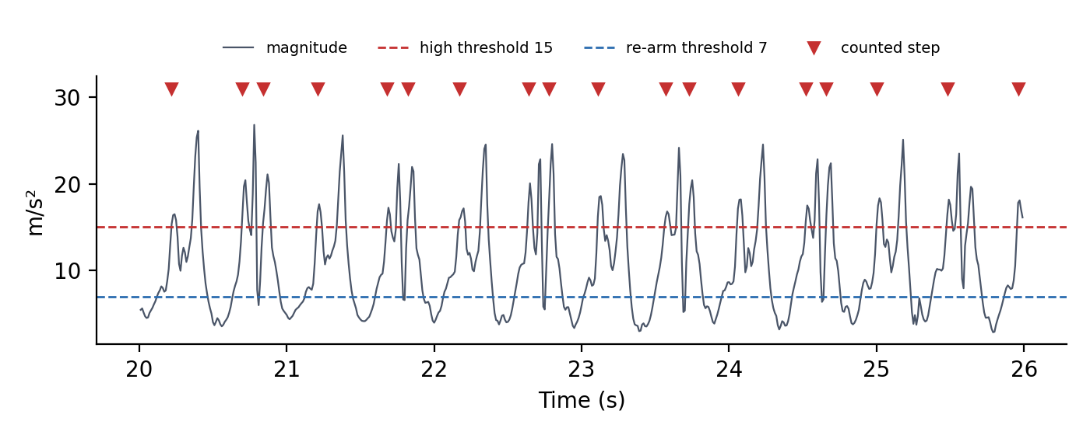
Figure 2. Static threshold with hysteresis on walk_100steps (6 seconds shown)

4.3 Limits
Figure 2 shows that hysteresis is not enough. Sometimes the signal go below 7 m/s² between the two parts of one step, so the same step is count twice. The bigger problem is one threshold cannot work for every file. A threshold of 20 m/s² is almost right for walk_10steps but it give 31 steps for walk_300steps. A threshold that works for strong peak also misse weak peaks completely (see Section 6).

5. Enhanced algorithm with a dynamic threshold
The second algorithms is base on the pedometer design by Neil Zhao for Analog Devices [1]. It has six stages.
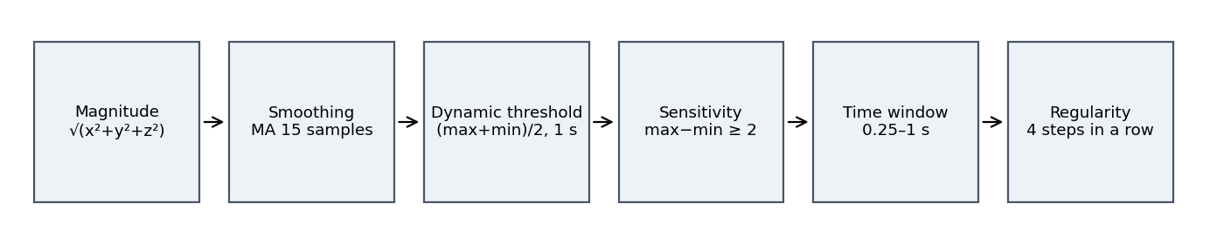
Figure 3. The six stages of the enhanced algorithm
- Magnitude. As in Section 4, so the result don’t depend on the orientation of the phone. Zhao choose the axis with the biggest change instead [1]. The magnitude do the same job but in a simpler way.
- Smoothing. A moving average over 15 samples work as a low-pass filter. Its cut-off frequency is about 3 Hz, so it keeps the step rhythm of about 2 Hz (only 14 % weak) and remove the faster vibrations. Zhao use the same thing of filter with 4 samples at 50 Hz [1].
- Dynamic threshold. Every 100 samples , the threshold become (max + min) / 2 of the last window. A step is found when the smooth signal goes up through this threshold. The window must contain a full stride, which means one step with each foot. The leg with the phone give a big peak and the other leg a small one. With a window of 0.5 s, the threshold kept jumping between the two. Zhao also uses 1 s in [1], since he updates the threshold every 50 samples at 50 Hz.
- Sensitivity. If max minus min is lower than 2 m/s² in the window, the person is probably not walking, so nothing is count. This removes small movements when the person is standing.
- Time window. Two steps must be between 0.25 s and 1 s apart. Peaks that are closer are ignored. After a longer pause, the algorithm starts searching again. Zhao uses a wider window, from 0.2 s to 2 s [1]. My limit of 1 s is stricter and wouldn’t work for a slow walk with less than one step per second.
- Regularity. Steps are only counted after 4 regular steps in a row. This removes the short and irregular movement made when the phone is handle at the start and at the end of a record.
I tuned the parameters by testing. My first settings (a window of 50 sample and a smoothing of 5 samples) gaves 72 steps instead of 52 on my fast walk. I then try several combinations on all eight files and keep the one that gave the best results overall. Figure 4 shows the result on recording 2. The dynamic threshold follows the level of the signal.
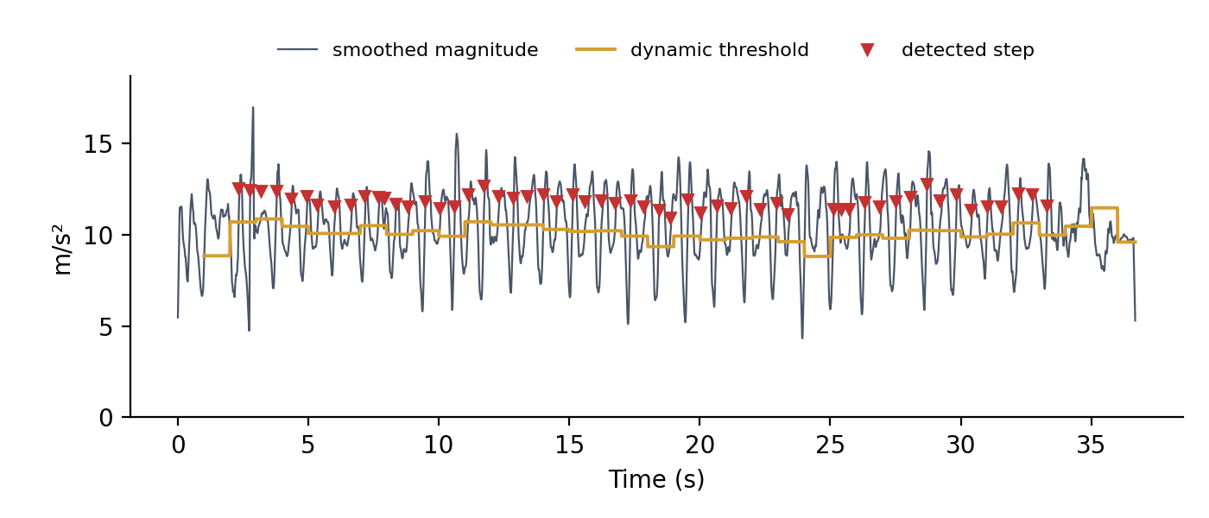
Figure 4. Enhanced algorithm on recording 2 (52 real steps, 56 detected)

6. Results
File | Real | Static | Error | Dynamic | Error
mon_enregistrement_1 | 30 | 15 | −50 % | 28 | −7 %
mon_enregistrement_2 | 52 | 27 | −48 % | 56 | +8 %
mon_enregistrement_3 | 100 | 12 | −88 % | 88 | −12 %
walk_10steps | 10 | 8 | −20 % | 8 | −20 %
walk_100steps | 100 | 138 | +38 % | 100 | 0 %
walk_300steps | 300 | 298 | −1 % | 300 | 0 %
run_10steps | 10 | 17 | +70 % | 8 | −20 %
bagwalk_10steps | 10 | 11 | +10 % | 8 | −20 %
Mean absolute error |  |  | 41 % |  | 11 %
Table 2. Number of steps found by both algorithms
With the dynamic threshold, the mean error go down from 41 % to 11 %. Its error also stay within 20 % on every file, while the static threshold sometimes counts far too few steps and sometimes far too many. On all files together, the dynamic algorithm counts 596 steps for 612 real steps.
The best example is recording 3 (Figure 5). Its step peaks are weak, mostly between 13 and 15 m/s², so they rarely reach the static threshold of 15 m/s². The static algorithm find only 12 steps, and about half of them are in fact peaks cause by putting the phone into the pocket. The dynamic threshold adapts to the level of the signal and finds 88 steps. To be honest, about four of these 88 are also wrong, because they happen while the phone is handled (around 4 to 6 s). So the algorithm really found about 84 steps.
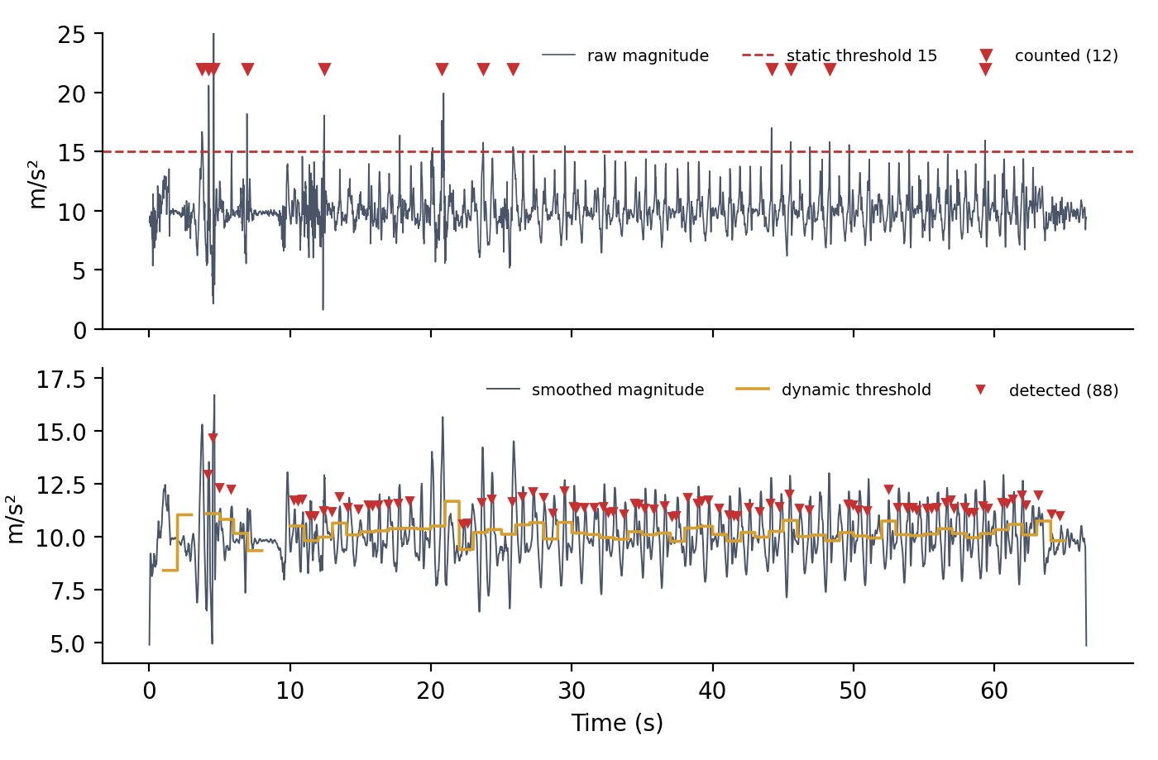
Figure 5. Recording 3. Top, static threshold on the raw magnitude. Bottom, dynamic threshold on the smoothed magnitude.
On the 10-step files, the dynamic algorithm always finds 8 steps. By check the code step by step, I found two reasons. First, a few steps at the start are lost while the algorithm looks for 4 regular steps. Second, some steps at the end of the walk are lost because my code only accepts steps in groups of four. If 1 to 3 steps are waiting when the walk stops, they are never add. In recording 1, for example, the last 3 steps are lost in this way. On a long walk this is only a few steps, but on a 10-step walk it is 20 %.
There is also an important limit. I tune the parameters on the same eight files that i used to test them. This is a kind of overfitting, so on new walks the error would probably be a bit higher than 11 %.

7. Improvements and generalization
- Split the data into a training set and a test set. The parameters would be tune on some recordings and tested on others.
- Fix the regularity stage. As in [1], the algorithm could have two states, “searching regulation” and “found regulation”. After four regular steps, each new valid step would be count at once, so the last step of a walk would not be lost.
- Use a better filter, for example a Butterworth low-pass filter instead of the moving average. Another option is follow [2], find the direction of gravity with a low-pass filter and keep only the frequencies between 1 and 5 Hz.
- Use a wider time window, from 0.2 s to 2 s as in [1], so that very slow walks are also count.
- Adapt the algorithm to the person (height, walking speed), detect the activity (walking or running) and support other phone positions, such as in the hand or in a bag.
- Test the algorithms with more people and more recordings, include stairs for example.

8. Reflection
The main thing i learned is that an algorithm can look simple at first, but in practice it has to be adapt for each situation. This is true for a step counter, and i think it is true for many other problems. Even the algorithm that worked best still made some mistakes. The reason is that a step is never the same. It changes with the walking speed, with the ground, with the way the phone sits in the pocket, or if the phone is in a bag.
What surprised me most is how more complex the problem is than it looks. Counting steps sounds easy, but the real signal is full of noise and movements that are not steps. The static threshold showed this very clearly, because one value that worked well on one file fail completely on another.
The most challenging part was finding parameters that work for all file at the same time. Each change that improved one record could makes another one worse, so i had to test many combinations. In the end, it was really satisfying to see that the dynamic algorithm gave good results on almost all file. It was also nice to find that the choices i made by testing were close to those in the Analog Devices article.

9. References
[1] N. Zhao, “Full-Featured Pedometer Design Realized with 3-Axis Digital Accelerometer,” Analog Dialogue, vol. 44, no. 06, Analog Devices, June 2010.
[2] D. Daskalov, “A Pedometer in the Real World,” in 500 Lines or Less, A. Brown and M. DiBernardo (eds.), The Architecture of Open Source Applications. Chapter and dataset.
[3] S. Staacks, S. Hütz, H. Heinke and C. Stampfer, “Advanced tools for smartphone-based experiments: phyphox,” Physics Education, vol. 53, no. 4, 2018. App available at phyphox.org (RWTH Aachen University).

