GABAY: A HIERARCHICAL MULTI-AGENT RETRIEVAL-AUGMENTED CONVERSATIONAL AI SYSTEM FOR INSTITUTIONAL KNOWLEDGE RETRIEVAL AND DECISION SUPPORT

JAYVEE G. REYES
JAMAICA FEA C. AQUINO
JOHREN MAE B. BISCARRA
RICA U. CASTRONUEVO
KARYLLE P. MONTEMAYOR

DON MARIANO MARCOS MEMORIAL STATE UNIVERSITY
SOUTH LA UNION CAMPUS
COLLEGE OF COMPUTER SCIENCE
AGOO, LA UNION

BACHELOR OF SCIENCE IN COMPUTER SCIENCE

SEPTEMBER 2026

APPROVAL SHEET

This thesis proposal, Gabay: A Hierarchical Multi-Agent Retrieval-Augmented Conversational AI System for Institutional Knowledge Retrieval and Decision Support, prepared and submitted by Jayvee G. Reyes, Jamaica Fea C. Aquino, Johren Mae B. Biscarra, Rica U. Castronuevo, and Karylle P. Montemayor, in partial fulfillment of the requirements for the degree Bachelor of Science in Computer Science, was examined and passed on September 3, 2026, by the Thesis Committee composed of:

MARIA JESECA C. BACULO, PhDCS  Chair | CHARLIE S. MARZAN, PhDCS  Thesis Adviser
emely a. munar, dit  Member | jerome p. songcuan, dit  Member
joe anthony m. milan, PhDCS
Member

Accepted and approved in partial fulfillment of the requirements for the degree, Bachelor of Science in Computer Science.

NEMA ROSE D. RIVERA, DIT
Program Chairperson, BS Computer Science
_______________________
Date Signed

CHARLIE S. MARZAN, PhDCS
Dean, College of Computer Science
_______________________
Date Signed

ACKNOWLEDGEMENTS

The researchers wish to express their heartfelt gratitude to the following people who, without their help, the realization of this thesis would not have been possible:
Dr. Jaime I. Manuel Jr. and Dr. Isidro L. Duran, the University President and SLUC Chancellor, respectively, for their steadfast leadership and commitment to advancing the University’s philosophy, vision, mission, goals, quality policy, and quality objectives;
Dr. Charlie S. Marzan, the Dean of the College of Computer Science and the adviser of the researchers, for his support, fatherly encouragement, wisdom, technical expertise, patience, and enthusiasm which he selflessly shared throughout the process of conceptualizing and developing Gabay;
Dr. Belinda D. Celestial, their Thesis Instructor, for her invaluable supervision, support, and tutelage during the Thesis Writing course;
The Chair and Members of the Thesis Committee, for their valuable time, insightful comments, constructive recommendations, and technical guidance that helped improve the quality, rigor, and overall direction of the study;
The administrators, faculty members, and students of the College of Computer Science, who will serve as the respondents and target users of the study, for their valuable time, participation, feedback, and cooperation in the evaluation of Gabay;
Their parents, siblings, and loved ones, for their unconditional love, moral and financial support, and endless prayers that fueled their determination to finish this endeavor;
And above all, to the Almighty God, for the gift of life, wisdom, strength, and guidance that sustained the researchers throughout the completion of this study.

JR
JFA
JMB
RUC
KPM

DEDICATION

This study is wholeheartedly dedicated to the ALMIGHTY GOD, our ultimate provider of wisdom, strength, and discernment, whose divine grace and guidance sustained us through every challenge and made the realization of this endeavor possible;
To our beloved PARENTS, whose unconditional love, continuous moral guidance, tireless sacrifices, and unwavering financial support served as our pillars of strength throughout this journey. Thank you for meeting our needs during the development of this work and for teaching us that even the most daunting endeavors can be achieved through faith, patience, and perseverance;
To our thesis adviser, DR. CHARLIE S. MARZAN, for his invaluable mentorship, technical expertise, fatherly encouragement, and enduring patience in steering this study toward academic and technical excellence; and
To our FRIENDS and CLASSMATES, for the shared struggles, late-night coding sessions, mutual encouragement, and camaraderie that lightened our burdens and made this journey meaningful and memorable.
This milestone is for all of you.

TABLE OF CONTENTS

Page
Title Page i
Approval Sheet ii
ACKNOWLEDGMENTS iii
Dedication v
LIST OF TABLES viii
LIST OF FIGURES ix
ABSTRACT x
CHAPTER
- Introduction
Situation Analysis 1
Statement of Objectives 10
Time and Place of the Study 11
Definition of Terms 12
- Methodology
Research Design 16
Materials and Procedures 17
Customization of Hierarchical Multi-Agent RAG Architecture 17
Development of Gabay System 24
Technical Performance Evaluation of Gabay 30
Technology Acceptance of Gabay 31
Data Gathered 35
Data Analysis 36
- RESULTS AND DISCUSSION
- summary, conclusions, and recommendations

literature cited 57
APPENDICES
A Extended Technology Acceptance Model 64
B Request for Thesis Adviser 66
C Privacy Policy of Zyberlab Solutions Inc. 67

CURRICULUM VITAE
Jayvee G. Reyes 68
Johren Mae B. Biscarra 70
Karylle P. Montemayor 72
Rica U. Castronuevo. 74
Jamaica Fae C. Aquino 76

LIST OF TABLES

Table  No |  | Page
- Stratified Distribution of Respondent Samples
for Extended TAM Evaluation 34
2 Gabay Technical Performance Evaluation 37
3 Distribution of Benchmark Test Queries Across
Sub-Objectives and Complexity Levels 39
- Statistical Interpretation Scale for Extended TAM Survey 54

LIST OF FIGURES

Figure  No |  | Page
1 Evolution of Traditional to Agentic RAG 2
2 Block Diagram of Procedures in Achieving Study’s Objectives 17
3 Hierarchical Multi-Agent RAG Architecture Framework 19
4 Research and Development Cycle Framework 25
5 Decoupled API-Driven Modular Architecture Framework 26

ABSTRACT

REYES, JAYVEE G., AQUINO, JAMAICA FEA C., BISCARRA, JOHREN MAE B., CASTRONUEVO, RICA U., AND MONTEMAYOR, KARYLLE P. (2026). Gabay: A Hierarchical Multi-Agent Retrieval-Augmented Conversational AI System for Institutional Knowledge Retrieval and Decision Support. Bachelor of Science in Computer Science. Don Mariano Marcos Memorial State University - South La Union Campus, College of Computer Science, Agoo, La Union.

Adviser: Marzan, Charlie S., PhDCS

Large language models and Retrieval-Augmented Generation (RAG) systems have improved information retrieval and conversational assistance; however, existing systems are commonly designed for specific applications and do not provide an integrated approach for retrieving institution-specific knowledge, coordinating multiple academic and administrative domains, and supporting college-level decision-making.
To address this gap, this study proposes Gabay: A Hierarchical Multi-Agent Retrieval-Augmented Conversational AI System for Institutional Knowledge Retrieval and Decision Support for the College of Computer Science of Don Mariano Marcos Memorial State University–South La Union Campus. The study aims to customize the hierarchical multi-agent RAG architecture and develop Gabay to support institutional knowledge retrieval, college management, decision support, and report generation.
A developmental-experimental research design will be employed, combining systematic system development with controlled testing of the proposed architecture. The technical performance of Gabay will be evaluated in terms of retrieval accuracy, response quality, reasoning capability, and report generation accuracy, while its technology acceptance will be determined among administrators, faculty and staff, and students using an extended Technology Acceptance Model (TAM). The study is expected to provide an intelligent and integrated conversational platform that improves access to institutional information and supports efficient, evidence-based academic and administrative decision-making.

Keywords: conversational AI system, hierarchical multi-agent, retrieval-augmented generation

Chapter 1

INTRODUCTION

Situation Analysis
Large language models (LLMs) have become powerful tools for answering questions, writing documents, and carrying on conversations. Despite these strengths, they still have important limitations. They can produce incorrect information, rely on outdated knowledge, and cannot access institution-specific data unless that information is provided during the conversation. Retrieval-Augmented Generation (RAG) addresses these challenges by retrieving relevant documents from an external knowledge base and using them to support the model's responses. As RAG technology has evolved, researchers have moved from simple single-agent designs to more advanced hierarchical multi-agent architectures. This progression provides the foundation for developing a Hierarchical Multi-Agent Retrieval-Augmented Conversational AI System designed for the College of Computer Science at Don Mariano Marcos Memorial State University–South La Union Campus (DMMMSU-SLUC).
Retrieval-Augmented Generation (RAG) has emerged as a significant advancement in conversational artificial intelligence by improving the reliability and factual accuracy of large language models (LLMs). Unlike conventional LLMs that rely solely on knowledge acquired during pre-training, RAG retrieves relevant information from external knowledge sources before generating a response. This retrieval process enables language models to produce answers that are grounded in verified documents, thereby reducing hallucinations and improving access to current and domain-specific information (Sharma, 2025; Asai et al., 2024). Nevertheless, existing RAG systems continue to encounter challenges related to irrelevant document retrieval, scalability, and complex multi-step reasoning, which have driven the continuous evolution of RAG architectures (Oche et al., 2025). As illustrated in Figure 1, this architectural progression spans four distinct paradigms: from static, single-pipeline retrieval to autonomous, hierarchical multi-agent coordination.
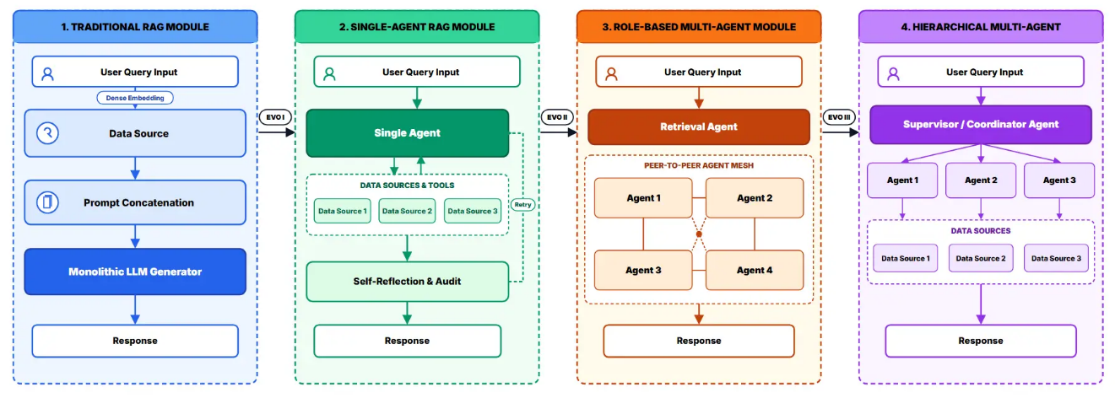
Fig.1. Evolution of Traditional to Agentic RAG
As shown in the first stage of Figure 1, the earliest implementation, commonly referred to as Traditional Retrieval-Augmented Generation, follows a fixed retrieval pipeline. A user's query is embedded into a vector representation, matched against a vector database, and supplemented with retrieved documents before the language model generates a response (Sharma, 2025). This architecture effectively improves factual consistency because responses are supported by external knowledge rather than relying entirely on the model’s internal parameters. However, its rigid workflow limits its ability to revise retrieval strategies or perform additional searches when the initially retrieved documents are insufficient. Consequently, Traditional RAG often struggles with questions that require reasoning across multiple documents or iterative information retrieval, highlighting the need for more adaptive retrieval approaches (Oche et al., 2025).
To overcome these limitations, researchers introduced Agentic Retrieval-Augmented Generation (Agentic RAG), which extends the traditional retrieval pipeline by incorporating autonomous decision-making into the retrieval process. Rather than relying on a single retrieval cycle, Agentic RAG enables intelligent agents to determine when additional retrieval is necessary, evaluate the relevance of retrieved information, and refine the search strategy before generating a final response (Oche et al., 2025). This adaptive capability allows the system to better handle complex and knowledge-intensive tasks that require multiple stages of reasoning.
Several studies have demonstrated the advantages of Agentic RAG. Self-RAG enables the language model to determine whether external retrieval is necessary and evaluate whether the retrieved documents adequately support the generated response, improving factual accuracy and response reliability (Asai et al., 2024). Likewise, Reflective RAG introduces continuous self-evaluation throughout the retrieval and reasoning process, outperforming baseline Agentic RAG systems across multiple knowledge-intensive question-answering benchmarks (Wu et al., 2025). Speculative RAG further improves computational efficiency by employing a smaller language model to guide retrieval before invoking a larger model, reducing inference latency while maintaining high reasoning performance (Wang et al., 2024). Collectively, these developments demonstrate that RAG has evolved from a static retrieval mechanism into a more adaptive and intelligent framework. However, despite these advances, most Agentic RAG implementations still depend on a single language model to perform retrieval, reasoning, and response generation, creating new challenges as applications become increasingly complex.
The limitations of single-model reasoning led to the development of single-agent and eventually multi-agent architectures. In a single-agent architecture, one language model performs all major tasks, including intent recognition, document retrieval, reasoning, and response generation. This centralized design is suitable for straightforward applications because all decisions are handled by a single intelligent agent. However, assigning all responsibilities to one model limits the system's ability to process multiple tasks simultaneously, integrate information from different knowledge sources, and maintain consistent performance when solving complex institutional problems (Buller et al., 2024; Mendoza et al., 2025).
Studies in academic environments demonstrate both the strengths and limitations of single-agent systems. A GPT-4-based academic advising system developed at the United States Military Academy achieved high accuracy in answering institutional policy questions but struggled to reason across multiple handbook sections (Buller et al., 2024). Similarly, a GPT-4o academic advising chatbot implemented at the New York City College of Technology provided clear and policy-consistent responses but remained susceptible to structural hallucinations when integrating information from multiple institutional documents (Mendoza et al., 2025). Aurora, a neuro-symbolic advising system developed at Florida International University, improved response efficiency by combining GPT-4o-mini with a rule-based reasoning engine; however, its dependence on predefined database schemas limited its ability to process unstructured academic scenarios (Quincoso Lugones et al., 2025). These studies collectively suggest that although single-agent architectures perform well in narrowly defined applications, they become less effective as institutional tasks require broader reasoning and coordination.
To improve task specialization, researchers introduced role-based multi-agent architectures, in which several intelligent agents collaborate by performing specialized responsibilities such as retrieval, reasoning, verification, and response generation (Fang et al., 2026; Nguyen et al., 2026). Compared with single-agent systems, this division of labor enables more effective handling of complex queries because each agent focuses on a specific component of the reasoning process. Studies such as Orion, MA-RAG, university admissions counseling systems, and AdvisorX demonstrated improvements in retrieval accuracy, reasoning capability, and response quality through collaborative multi-agent processing (Fang et al., 2026; Jiang et al., 2026; Nguyen et al., 2026; Nguyen-Duc et al., 2026). Despite these improvements, collaboration among multiple agents also introduces coordination challenges. Communication failures, task misalignment, and cascading errors remain common obstacles that reduce system reliability in real-world deployments (Nechepurenko & Shuvalov, 2026; Xie et al., 2026).
To address these coordination issues, researchers proposed hierarchical multi-agent architectures, where a high-level supervisor agent coordinates multiple specialized worker agents responsible for different subtasks (Park & Kwon, 2026; Liu et al., 2026). This layered architecture combines centralized task management with distributed expertise, enabling more efficient task decomposition, coordinated reasoning, and improved decision-making. Recent studies have shown that hierarchical architectures outperform earlier approaches in reasoning capability, coordination efficiency, and retrieval effectiveness (Liu et al., 2026; Park & Kwon, 2026; Torkian & Zhou, 2024). Although routing errors and information loss between hierarchical layers remain existing challenges, these architectures represent the most comprehensive approach currently available for managing complex institutional tasks. Their ability to coordinate specialized agents while maintaining a global view of the overall problem makes them particularly suitable for higher education environments that require integrated academic management, decision support, and learning services.
Despite these advances, higher education institutions continue to face challenges in managing and accessing institutional knowledge efficiently. The College of Computer Science (CCS) at Don Mariano Marcos Memorial State University–South La Union Campus (DMMMSU-SLUC) is no exception. The College manages various academic and administrative functions, including student advising, curriculum management, enrollment, prerequisite verification, research and extension coordination, quality assurance, student services, and institutional reporting. These functions rely on institutional resources such as student handbooks, curriculum guides, university memoranda, course catalogs, accreditation reports, administrative policies, and operational databases. These information resources originate from multiple institutional systems and repositories, requiring users to consult several independent sources before obtaining the information needed for academic or administrative decision-making. Consequently, information retrieval, report preparation, and decision-making often involve manual searches across multiple documents and systems, making these processes both time-consuming and inefficient.
Students frequently seek information regarding enrollment procedures, curriculum requirements, course prerequisites, scholarships, academic policies, and graduation requirements. Likewise, faculty members and administrators regularly verify academic records, interpret university policies, prepare accreditation documents, monitor research and extension accomplishments, generate institutional reports, analyze academic performance, and support institutional planning and decision-making. These activities require information from multiple institutional documents and databases, making the process both time-consuming and labor-intensive.
At present, these tasks are commonly performed through face-to-face consultations, email exchanges, messaging platforms, spreadsheet-based reports, and manual review of institutional documents. Preparing reports, summarizing institutional data, and generating charts, dashboards, and visual presentations for planning and accreditation also require significant manual effort. While these approaches remain functional, they become increasingly inefficient during enrollment periods, accreditation activities, and other peak academic operations, resulting in longer response times, increased administrative workload, and inconsistencies in both information retrieval and institutional reporting.
Another major challenge is the lack of an intelligent conversational system that can retrieve and validate information directly from official university documents. Existing communication methods rely heavily on manual interpretation of institutional documents, making response accuracy and consistency dependent on the knowledge and experience of the personnel providing assistance. Without a retrieval mechanism that grounds responses in verified institutional documents, there is a greater risk of incomplete, outdated, or inconsistent academic guidance. As previous studies emphasize, conversational AI systems without reliable retrieval mechanisms remain vulnerable to hallucinations and factual inaccuracies, particularly in knowledge-intensive environments where institutional information changes over time (Asai et al., 2024; Oche et al., 2025).
These challenges show that the College needs more than a conventional chatbot that answers frequently asked questions. Instead, the College needs an intelligent conversational system that can retrieve and integrate information from official university knowledge sources, reason across multiple institutional documents, generate reports and visual summaries, and support data-driven decision-making for academic and administrative operations. Such a system should also provide accurate, consistent, and context-aware assistance to students, faculty members, administrators, and other stakeholders while improving information accessibility, operational efficiency, and evidence-based institutional planning. Despite recent advances in Retrieval-Augmented Generation and multi-agent conversational AI, it remains unclear whether existing approaches can fully meet these institutional requirements. This unresolved challenge highlights the need for a solution specifically designed to meet the diverse academic and administrative needs of higher education institutions.
The reviewed literature demonstrates that Retrieval-Augmented Generation (RAG) and agent-based conversational AI have significantly improved information retrieval, reasoning, and response generation. Traditional RAG, Agentic RAG, single-agent, role-based multi-agent, and hierarchical multi-agent architectures have each addressed specific limitations of earlier approaches by enhancing factual accuracy, task specialization, and coordination (Asai et al., 2024; Buller et al., 2024; Fang et al., 2026; Liu et al., 2026; Oche et al., 2025; Park & Kwon, 2026). However, these systems are primarily designed for specific applications, such as academic advising, policy assistance, or domain-specific question answering, rather than providing a unified platform for managing the diverse academic and administrative functions of higher education institutions.
For the College of Computer Science at DMMMSU-SLUC, existing approaches do not fully address the need for an integrated conversational AI system that can retrieve and reason across institution-specific knowledge sources while supporting college management, decision support, learning services, institutional reporting, and other academic and administrative operations. Therefore, a hierarchical multi-agent Retrieval-Augmented Generation framework is needed to integrate college management, decision support, learning services, institutional reporting, and document-grounded reasoning within a single intelligent platform tailored to the operational requirements of higher education institutions.
To address the identified research gap, this study proposes Gabay: A Hierarchical Multi-Agent Retrieval-Augmented Conversational AI System for College Management, Decision Support, and Learning Services. The system is named after the Filipino word “gabay”, meaning "guide", reflecting its core purpose to act as an intelligent institutional companion that guides stakeholders by providing timely, accessible, and verified academic and administrative information. The proposed system integrates Retrieval-Augmented Generation with a hierarchical multi-agent architecture to provide accurate, context-aware, and explainable responses using official institutional knowledge sources. Unlike existing conversational AI systems that primarily focus on individual applications, Gabay is designed as a unified platform that supports multiple academic and administrative functions within the College of Computer Science at Don Mariano Marcos Memorial State University–South La Union Campus (DMMMSU-SLUC).
The system is designed to assist students, faculty members, administrators, and other stakeholders by retrieving and integrating information from institutional knowledge sources, generating reports and visual summaries, supporting decision support activities, and assisting academic and administrative operations through coordinated reasoning among specialized intelligent agents. Through its hierarchical coordination of specialized intelligent agents, Gabay aims to improve information accessibility, operational efficiency, institutional reporting, and the consistency of academic and administrative services while reducing the manual effort required in routine institutional processes.
Beyond addressing College of Computer Science's operational needs, Gabay advances conversational artificial intelligence in higher education by showing how Retrieval-Augmented Generation and hierarchical multi-agent architectures can be integrated into a single intelligent platform for college management, decision support, and learning services. The proposed system also supports the University's digital transformation initiatives while contributing to Sustainable Development Goal (SDG) 4: Quality Education, SDG 9: Industry, Innovation and Infrastructure, SDG 10: Reduced Inequalities, and SDG 16: Peace, Justice and Strong Institutions through improved access to institutional knowledge, data-driven decision-making, and transparent academic governance.

Statement of Objectives
The general objective of this study is to design, develop, and evaluate Gabay, a Hierarchical Multi-Agent Retrieval-Augmented Conversational AI System that supports college management and decision support through intelligent retrieval, reasoning, and generation of institution-specific information for the College of Computer Science at Don Mariano Marcos Memorial State University–South La Union Campus (DMMMSU-SLUC).
Specifically, this study aims to:
- Customize the hierarchical multi-agent Retrieval-Augmented Generation architecture for institutional knowledge retrieval and conversational reasoning;
- Develop Gabay to support college management and decision making through institutional knowledge retrieval report generation, and decision support.
- Evaluate and compare the technical performance of GABAY against a baseline single-agent RAG architecture in terms of
3.1 Retrieval accuracy;
3.2 Response quality;
3.3 Reasoning capability; and
3.4 Report generation accuracy
- Determine the technology acceptance of Gabay among administrators, faculty and staff, and students using an extended Technology Acceptance Model (TAM) in terms of:
4.1 Perceived usefulness;
4.2 Perceived ease of use;
4.3 Trust in the AI system; and
4.4 Behavioral intention to use

Time and Place of the Study
The study will be conducted from June 2026 to March 2027 within the premises of the Don Mariano Marcos Memorial State University – South La Union Campus (DMMMSU-SLUC) in Agoo, La Union, specifically in the College of Computer Science (CCS).

Definition of Terms
For a better understanding of this research report, the following terms are operationally defined:
Behavioral intention to use refers to the willingness of students, faculty members, non-teaching staff, and administrators of DMMMSU-SLUC CCS to use Gabay for their academic and administrative tasks.
College Management refers to the academic and administrative activities supported by Gabay, such as student advising, curriculum and prerequisite checking, research and extension monitoring, quality assurance, and preparation of institutional reports.
Conversational AI refers to the natural language feature of Gabay that allows users to ask questions and receive answers based on available institutional documents and data.
Conversational reasoning refers to the process used by Gabay to understand a user's question, identify what information is needed, and use the retrieved information to form an appropriate response.
Decision Support refers to the ability of Gabay to provide useful information, summaries, reports, and data visualizations that can help faculty members and administrators make informed academic and administrative decisions.
Document summarization refers to the ability of Gabay to identify the important information from institutional documents and present it in a shorter and clearer form while keeping the main ideas and essential details.
Gabay refers to the Hierarchical Multi-Agent Retrieval-Augmented Conversational AI System to be developed in this study for the College of Computer Science of DMMMSU-SLUC. It supports institutional knowledge retrieval, college management, and decision-making.
Hierarchical Multi-Agent RAG is Gabay's system architecture, in which a coordinator agent manages specialized agents that perform specific tasks. These agents work together to retrieve information, process user requests, apply relevant rules or policies, and generate responses.
Institutional knowledge retrieval is the process of finding relevant information from official institutional sources, such as student handbooks, curricula, memoranda, policy manuals, and other authorized documents and records.
Institutional Report Generation refers to the ability of Gabay to collect relevant institutional data and automatically organize it into structured summaries, tables, and reports needed for academic and administrative purposes.
Perceived ease of use refers to the degree to which users believe that Gabay is clear, easy to learn, and easy to use.
Perceived usefulness refers to the degree to which users believe that Gabay can help them perform academic and administrative tasks more quickly and efficiently.
Performance of Gabay refers to how well the system performs its intended technical tasks. In this study, it will be evaluated in terms of retrieval accuracy, response quality, reasoning capability, and report generation accuracy.
Reasoning capability refers to how well Gabay performs tasks that require multiple steps, such as applying rules, connecting information from different sources, and arriving at the correct response.
Report generation accuracy refers to the degree to which the information in institutional reports generated by Gabay matches the correct or expected institutional data.
Response quality refers to how well Gabay answers a user's question based on the retrieved information. It considers whether the response is accurate, relevant, complete, clear, and supported by the available institutional information.
Retrieval accuracy refers to Gabay's ability to find correct, relevant information from institutional documents and data sources based on a user's request.
Retrieval-Augmented Generation refers to the process Gabay will use to retrieve relevant information from institutional documents or data sources before the AI generates a response. This helps the system produce answers that are supported by available institutional information.
Technology Acceptance Model refers to the framework that will be used in this study to determine users' acceptance of Gabay based on perceived usefulness, perceived ease of use, trust in the AI system, and behavioral intention to use.
Trust in the AI system refers to the degree to which users believe that Gabay provides reliable and accurate information, follows institutional policies, and handles institutional data appropriately.
Visualization of Operational Data refers to the ability of Gabay to present institutional data using charts, graphs, and other visual formats to help users understand information and support decision-making.

Chapter 2
Methodology

Research Design
This study will employ a developmental-experimental research design, which combines the systematic development of a system with controlled experiments to design, test, and evaluate its technical components. This design is appropriate because it allows the researchers to develop Gabay as a complete system while conducting experiments on its core Hierarchical Multi-Agent Retrieval-Augmented Generation (RAG) architecture.
The developmental phase refers to the systematic process of designing, developing, testing, and refining a system to meet its intended purpose and user requirements (Richey & Klein, 2005). In this study, this phase will cover the requirements analysis, system design, development, integration, testing, and refinement of Gabay for college management and decision support.
The experimental phase involves controlled testing of different conditions or configurations to determine their effects on specific outcomes (Creswell & Creswell, 2018). In this study, a comparative between-architecture experimental design will be employed. The independent variable is the system architecture configuration, comprising: (1) a Baseline Single-Agent RAG system, where a single LLM independently manages query routing, vector lookups, and API tool calling; and (2) the proposed Hierarchical Multi-Agent RAG (GABAY) architecture, incorporating coordinator orchestration, seven domain-specific agents, and traffic-light governance. The dependent variables comprise technical performance metrics across retrieval accuracy, response quality, reasoning capability, and report generation accuracy. Both systems will be evaluated under identical environmental conditions, utilizing the same Qdrant vector collection, Likha ERP API endpoints, and 155 standardized benchmark queries to isolate and measure the architectural performance gains of GABAY over the single-agent baseline.

Materials and Procedures
Figure 2 presents the block diagram of the study’s procedures carried out by the researchers in achieving the objectives posed in this study.
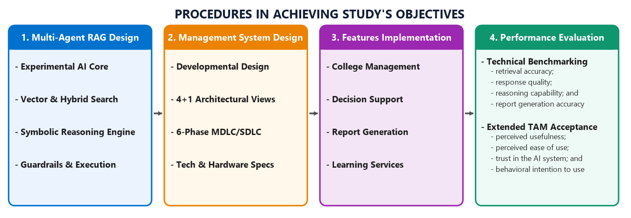
Fig.2. Block Diagram of Procedures in Achieving Study’s Objectives

Customization of Hierarchical Multi-Agent RAG Architecture
In line with Objective No. 1, the customization of the Hierarchical Multi-Agent Retrieval-Augmented Generation (RAG) Architecture serves as the core technical foundation of this study. Rather than engineering an ungrounded framework from the ground up, this study adapts and customizes the hierarchical multi-agent architectural paradigms introduced by Torkian and Zhou (2024) and advanced by Park and Kwon (2026) to address the operational and regulatory requirements of the College of Computer Science at DMMMSU-SLUC. The customized architecture integrates specialized academic domain agents, hybrid Likha ERP tool-calling protocols, and data privacy safeguards to support institutional knowledge retrieval, conversational reasoning, and decision support. As shown in Figure 3, the customized architecture comprises seven major components: Institutional Data Collections, Upstream Ingestion, Qdrant Vector Store, Retrieval Pipeline, Coordinator Swarm, Actuation Assembly, and User Chat Query.
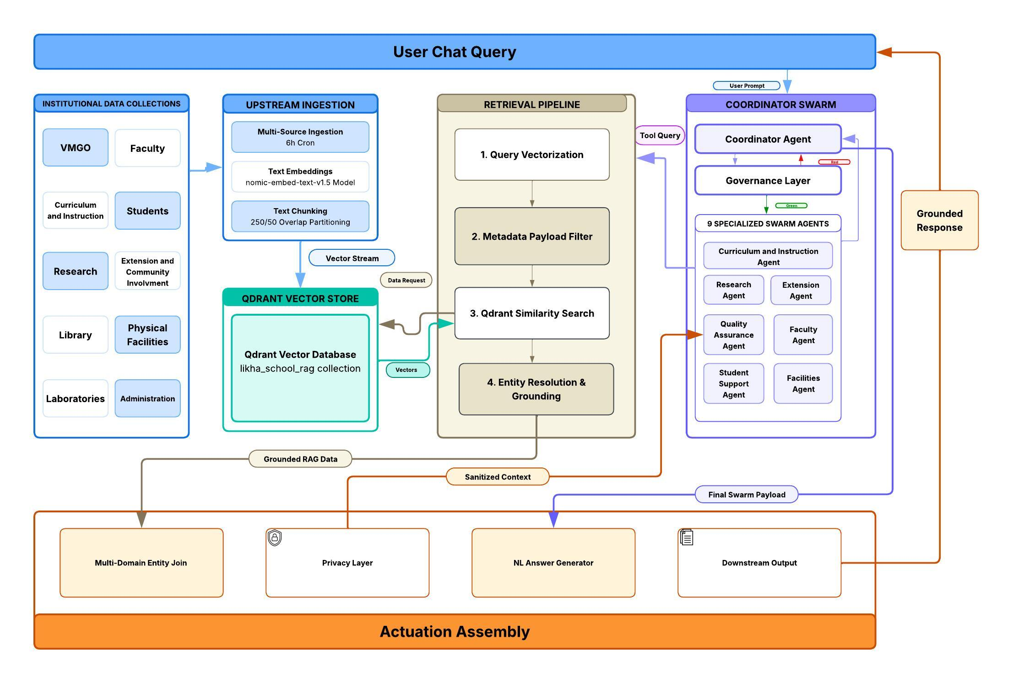

Fig.3. Hierarchical Multi-Agent RAG Architecture Framework
Institutional Data Collections. This serves as the centralized repository of academic, administrative, and operational information that supports organizational processes and decision-making, significantly reducing software development time and enhancing administrative productivity by eliminating redundant database construction and fragmented data silos (Pookduang & Chansanam, 2026; Tiwari et al., 2026).
In this study, institutional data will be sourced from Likha ERP, the College’s enterprise resource planning (ERP) system that serves as the centralized, authoritative repository for academic records, curricula, faculty assignments, and administrative operations. Integrating an established ERP backend substantially accelerates development cycles and improves operational productivity by providing pre-structured relational schemas and ready-to-use data models (Pookduang & Chansanam, 2026). Developed by Zyberlab Solutions Inc., the platform underwent independent Vulnerability Assessment and Penetration Testing (VAPT) against OWASP Top 10 standards and enforces compliance with the Data Privacy Act of 2012 (Republic Act No. 10173) and institutional privacy policies (see Appendix C). To protect transactional database integrity, GABAY interfaces with Likha ERP exclusively via authenticated, read-only Directus and REST API endpoints, enabling secure synchronization of operational records without disrupting day-to-day college workflows (Pookduang & Chansanam, 2026; Tiwari et al., 2026).
Upstream Ingestion. This refers to the process of extracting, transforming, and preparing data before they are stored and used for retrieval and reasoning tasks (Gao et al., 2023; Nussbaum & Nomic AI Team, 2024). In Gabay, institutional data from Likha ERP will be processed through an automated Extract, Transform, and Load (ETL) pipeline. The extracted text is divided into manageable portions using a Recursive Character Text Splitter configured with a 250-character chunk size and a 50-character overlap (250/50). This slight overlap ensures that complete thoughts and sentences are not cut off at chunk boundaries (Asai et al., 2024; Gao et al., 2023). These text chunks are then converted into numerical representations, known as 768-dimensional vector embeddings, using the open-source nomic-embed-text-v1.5 model, enabling the AI to understand the semantic meaning of the text (Nussbaum et al., 2024). Each chunk is also tagged with descriptive labels (metadata) that identify its original document source and college department (such as Research, Extension, QA, etc.). Finally, these vector representations and their metadata tags are sent to the Qdrant Vector Store, which functions as a specialized search database that organizes, stores, and rapidly retrieves matching information when a user asks a question.
Qdrant Vector Store. The Qdrant Vector Store is a vector database designed to store, index, and retrieve vector embeddings together with their metadata (Oche et al., 2025; Wang et al., 2024). Following the Upstream Ingestion process, the generated vector embeddings and their metadata will be stored in the dedicated likha_school_rag collection in Qdrant. Metadata lineage tags and domain attributes (searchFilterJson: metadata.domain) will be attached to each stored vector to identify its source and institutional domain. During query processing, the Qdrant Vector Store will receive requests from the Retrieval Pipeline and return the most relevant vector data based on similarity search and metadata filtering. In this way, Qdrant will serve as the main vector repository that will connect the upstream ingestion process with the retrieval of relevant institutional information.
Retrieval Pipeline. This will be responsible for identifying and retrieving information relevant to a user’s query from the Qdrant Vector Store (Asai et al., 2024; Oche et al., 2025). Following the storage of vector embeddings in Qdrant, Gabay will use Dense (Vector) Retrieval as its core retrieval approach. The retrieval process will consist of four stages. Stage 1 (Query Vectorization) will convert the query into a 768-dimensional vector to enable the AI to understand its semantic meaning. Stage 2 (Metadata Payload Filtering) will apply domain filtering to limit the search to the appropriate institutional domain and reduce unrelated results. Stage 3 (Qdrant Similarity Search) will use cosine similarity to compare the query vector with the stored vectors and retrieve the top eight most relevant results (Asai et al., 2024; Gao et al., 2023). Finally, Stage 4 (Entity Resolution and Grounding) will link the retrieved information to its corresponding verified institutional source. The resulting information will then be forwarded to the appropriate component of the architecture for further processing and response generation.
Coordinator & Swarm. This will represent the hierarchical multi-agent component of the proposed architecture, where a Coordinator Agent will manage and coordinate specialized agents (Nechepurenko & Shuvalov, 2026; Park & Kwon, 2026; Silvestri et al., 2024). In Gabay, the Coordinator Agent, powered by GPT-4o-mini, will receive and analyze user queries to determine their scope and the appropriate domain for processing. The query will then pass through the Governance Layer, which will apply a traffic-light policy control mechanism based on the noise-redefinition approach described by Silvestri et al. (2024). Queries classified as Red due to unclear content or policy violations will be returned to the Coordinator Agent for appropriate handling, while queries classified as Green will be forwarded to the appropriate specialized agent.
The architecture will include seven specialized agents: Curriculum and Instruction agent, Research agent, Extension agent, Quality Assurance agent, Faculty agent, Student Support Agent, and Facilities agent, each operating using GPT-4o-mini. The selected agent will communicate with the Retrieval Pipeline to obtain relevant institutional information needed to process the query. The retrieved information will pass through the appropriate privacy controls before being provided to the agent. The specialized agent will then process the information and return its result to the Coordinator Agent for further processing and response generation.
Actuation Assembly. This refers to the component responsible for integrating retrieved information, protecting sensitive data, and preparing the final response for the user (Nguyen-Duc et al., 2025; Singh et al., 2026). Following Entity Resolution and Grounding, the retrieved RAG data will enter the Multi-Domain Entity Join, where related information from academic, administrative, and other institutional domains will be combined when needed. The combined information will then pass through the Privacy Layer, where sensitive information will be anonymized or protected in accordance with Republic Act No. 10173, otherwise known as the Data Privacy Act of 2012. The resulting sanitized information will then be returned to the appropriate agents for further processing.
After the Coordinator Agent receives and processes the validated results from the specialized agents, the final output will be forwarded to the Natural Language (NL) Answer Generator, which will transform the processed information into a clear and coherent natural language response supported by retrieved institutional information (Aftab et al., 2019; Nguyen-Duc et al., 2025). The generated response will then be sent to the Downstream Output, where it will be formatted and transmitted back to the Gabay platform for presentation to the user.
User Chat Query. The User Chat Query represents the primary interaction point between users and Gabay (Aftab et al., 2019). Administrators, faculty members, non-teaching staff, and students will submit natural language queries through the system's chat interface. The submitted query will pass through the different components of the Hierarchical Multi-Agent RAG architecture for retrieval, reasoning, and response generation. The final response generated by the system will then be presented to the user through the same interface.

Development of Gabay Management System
For Objective No. 2, which focuses on developing the Gabay Management System, this study will adopt the Research and Development (R&D) Cycle Framework, a structured methodology that combines rapid software prototyping with continuous, iterative refinement (Pookduang & Chansanam, 2026). This approach is appropriate for developing Gabay because it supports systematic integration with Likha ERP while allowing researchers to progressively develop and refine its AI reasoning, information retrieval, system functionality, and security mechanisms without disrupting the existing institutional database (Pookduang & Chansanam, 2026).
As illustrated in Figure 4, the development process will consist of six iterative phases: (1) Problem Analysis and Requirements Specification, (2) System Architecture Design, (3) Prototype Development, (4) System Integration and Deployment, (5) Iterative Testing and Refinement, and (6) Multidimensional Evaluation. Although presented sequentially, these phases will follow an iterative process in which findings from testing and evaluation may be used to refine earlier development activities and improve the overall performance and usability of Gabay.
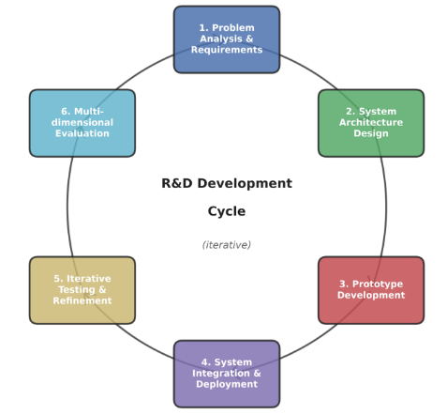
Fig.4. Research and Development Cycle Framework by Pookduang and Chansanam
Problem Analysis & Requirement Specification. This phase will establish the foundation for the development of Gabay by examining existing workflows, identifying operational challenges, and defining the functional and non-functional requirements of the system (Pookduang & Chansanam, 2026).
During this phase, the researchers will conduct interviews and document analysis with relevant DMMMSU-SLUC CCS stakeholders to understand existing academic and administrative processes, information needs, and challenges in accessing institutional information and preparing reports. The findings will be analyzed and translated into system requirements that will guide the development of Gabay. Functional requirements will include capabilities related to intelligent agent routing, retrieval of institutional information, document summarization, generation of reports and visual summaries, decision support, and academic assistance. Non-functional requirements will also be established, particularly for system performance, data privacy and security, usability, reliability, and concurrent user access.
System Architecture Design. This phase will translate the identified system requirements into a structured technical specification that defines the major components of Gabay and their operational interactions (Pookduang & Chansanam, 2026).
Based on these requirements, the researchers will adapt and customize the decoupled API-driven architectural framework established by Pokala (2021) into three interconnected modules tailored for college operations, as illustrated in Figure 5.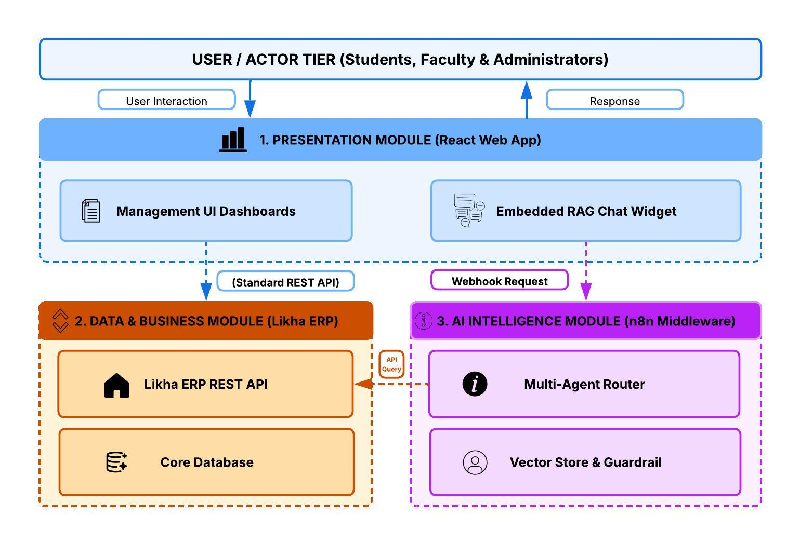
Fig.5. Customized Decoupled API-Driven Modular Architecture Framework
The Presentation Module, developed as a React web application, will provide the management dashboards and embedded RAG chat interface for users. The Data and Business Module, supported by Likha ERP, will provide access to institutional data through its REST API while maintaining the core database. The AI Intelligence Module, implemented through n8n middleware, an extensible, open-source workflow automation and orchestration engine. Utilizing n8n establishes a decoupled, API-driven architecture that isolates the user interface from the underlying model logic, allowing prompts and tool configurations to be updated without altering frontend code (Pokala, 2021). As the central orchestrator, n8n handles incoming chat webhooks, applies traffic-light governance, delegates tasks to the seven specialist agents, and coordinates Likha ERP REST calls with Qdrant vector searches (Nechepurenko & Shuvalov, 2026; Silvestri et al., 2024). This middleware maintains execution state across multi-step workflows, isolating tool errors and preventing cascading coordination failures to ensure secure, reliable inter-module communication (Pokala, 2021; Singh et al., 2026; Tiwari et al., 2026).
Since the Hierarchical Multi-Agent RAG Architecture will be designed under Objective No. 1, this phase will focus on integrating the proposed architecture into the overall Gabay system design. The researchers will develop sequence diagrams to illustrate the flow of user requests and interactions among the system components, and a database design to define the data structures and relationships required by the system. User interface designs and wireframes will also be prepared to establish the layout, navigation, dashboards, chat interface, and other user-facing components of Gabay. These design artifacts will serve as the technical blueprint for the subsequent prototype development and system integration phases.
Prototype Development. This phase will focus on transforming the system architecture and design specifications into functional software components of the Gabay Management System (Pookduang & Chansanam, 2026).
Based on the technical designs established in the previous phase, the researchers will develop the core components of Gabay. This will include creating the responsive web interface using React Vite, implementing the management dashboards and embedded RAG chat interface, configuring n8n workflows for AI processing, and establishing the required API structures for communication with Likha ERP. The Hierarchical Multi-Agent RAG Architecture developed under Objective No. 1 will also be implemented by configuring the coordinator and specialized domain agents, retrieval mechanisms, vector store, and system guardrails within the prototype (Park & Kwon, 2026).
The developed components will undergo unit testing to verify their individual functionality before system-wide integration. Testing will cover key functions such as user interface interactions, API requests and responses, query routing, information retrieval, agent processing, and data formatting. Identified issues will be corrected at the component level to ensure that the individual modules are functional and ready for integration in the succeeding phase.
System Integration and Deployment. This phase will focus on combining the independently developed components of Gabay into a unified and operational system and deploying the integrated application in a secure environment (Aftab et al., 2019).
Following the completion of the prototype, the researchers will integrate the React-based user interface, n8n AI workflows, Hierarchical Multi-Agent RAG Architecture, and Likha ERP backend through authenticated Directus and REST APIs. The integration will enable the different system components to exchange data and process user requests as a complete workflow. The Qdrant vector database will also be connected to the institutional data source, with an automated synchronization mechanism configured to periodically update its knowledge base with the latest authorized institutional documents and records (Tiwari et al., 2026).
Once the components have been successfully integrated, the Gabay will be deployed on a secure hosting infrastructure and configured for access by its intended users (e.g., administrators, faculty and staff, and students). Appropriate authentication, role-based access, and data security mechanisms will be applied to control access to institutional information. The deployed system will then serve as the working version of Gabay for the succeeding iterative testing and refinement phase.
Iterative Testing and Refinement. This phase will focus on systematically testing the integrated Gabay to identify functional issues, retrieval errors, and inconsistencies in AI-generated responses under realistic user scenarios (Baswardono et al., 2021).
Following system integration and deployment, the researchers will conduct scenario-based and multi-step testing using representative queries related to academic, administrative, and student support processes. The tests will examine whether user queries are correctly routed to the appropriate specialized agents, relevant institutional information is accurately retrieved, and responses are properly generated based on the retrieved data. More complex and unusual queries will also be tested to identify potential failures in agent routing, information retrieval, and system processing (Baswardono et al., 2021).
Based on the identified issues and system execution logs, the researchers will iteratively refine the agent prompts, routing rules, retrieval parameters, database lookup configurations, and system guardrails. Errors involving incomplete or unavailable institutional records will also be examined to improve how the system handles insufficient information and prevents unsupported responses. The testing–refinement cycle will be repeated until the identified functional and AI-related issues have been resolved and the system is ready for the succeeding multidimensional evaluation (Nechepurenko & Shuvalov, 2026).
Multidimensional Evaluation. This phase will assess the developed Gabay from both technical performance and user acceptance perspectives (Nguyen-Duc et al., 2025).
For the technical evaluation, the researchers will conduct empirical testing using standardized test questions covering the major functions and domains supported by Gabay. For the user evaluation, the researchers will administer an Extended Technology Acceptance Model (TAM) survey to the respondents. The detailed procedures, measures, instruments, and criteria for the technical and user evaluations will be discussed under Objectives No. 3 and 4, respectively.

Technical Performance Evaluation of Gabay

Following the development of the Gabay Management System, the third objective will evaluate and compare its technical performance against a baseline single-agent RAG architecture across one hundred fifty-five (155) standardized query scenarios (Baswardono et al., 2021; Es et al., 2024). These benchmark queries were formulated by the researchers based on authentic academic and administrative inquiries gathered from stakeholder interviews and university policy documents, and were subsequently validated against official institutional ground truth by domain experts. The evaluation will be conducted using an automated benchmarking suite and empirical evaluation framework, such as the RAGAS Framework and API Runner, with the active participation and oversight of the thesis evaluation panel to ensure the objectivity and reliability of the benchmarking results (Baswardono et al., 2021; Es et al., 2024).

To determine whether the hierarchical multi-agent approach yields measurable technical improvements, all one hundred fifty-five (155) benchmark test queries will be executed concurrently across both the Baseline Single-Agent RAG setup and the GABAY platform following comparative RAG benchmarking methodologies (Chen et al., 2024; Nguyen-Duc et al., 2025; Park & Kwon, 2026). Each query run will log context precision, context recall, tool call hit rate, faithfulness, answer relevancy, execution steps, and report consistency to measure the performance gains achieved by GABAY against the baseline in complex, cross-domain reasoning and multi-step tool orchestration (Es et al., 2024; Nechepurenko & Shuvalov, 2026; Saad-Falcon et al., 2024). Technical performance will be evaluated across four dimensions: Retrieval Accuracy, Response Quality, Reasoning Capability, and Report Generation Accuracy, with specific formulas and evaluation criteria detailed in the Data Analysis section (Baswardono et al., 2021; Tiwari et al., 2026; Xie et al., 2026).

Retrieval Accuracy will assess the comparative ability of both systems to retrieve relevant information from the Qdrant vector store and Likha ERP to support user queries (Asai et al., 2024; Oche et al., 2025). It will determine whether the systems retrieve the appropriate institutional documents and records needed to generate grounded responses (Es et al., 2024).

Response Quality will evaluate the factual accuracy, relevance, and clarity of the responses generated by both configurations based on retrieved institutional information (Es et al., 2024; Xie et al., 2026). Particular attention will be given to whether the generated responses remain grounded in verified Likha ERP records and official institutional documents without hallucination (Nguyen-Duc et al., 2025; Xie et al., 2026).

Moreover, Reasoning Capability will assess the ability to interpret user intent, delegate tasks appropriately, and perform the necessary sequence of actions to respond to complex, multi-step queries (Nechepurenko & Shuvalov, 2026; Park & Kwon, 2026). For GABAY, this will specifically evaluate the Coordinator Agent's routing and orchestration across the Academic, LMS, Research, Extension, QA, and SAS domain agents compared to the monolithic processing of the single-agent baseline (Jiang et al., 2025; Park & Kwon, 2026).

Finally, Report Generation Accuracy will assess the ability to generate structured reports that accurately reflect the corresponding institutional database records (Aftab et al., 2019; Tiwari et al., 2026). The generated tables and summaries from both architectures will be checked for data consistency and adherence to the required institutional report structure (Nguyen-Duc et al., 2025).

Technology Acceptance of Gabay
For Objective No. 4, the technology acceptance of Gabay will be determined using an Extended Technology Acceptance Model (TAM) based on the original model of Davis (1989) and its later extensions (Venkatesh & Davis, 2000; Venkatesh & Bala, 2008). Since Gabay uses conversational AI and automated decision support, Trust in the AI System will be included as an additional construct (Pillai & Sivathanu, 2020; Shin, 2021). A 16-item questionnaire will be used (see Appendix A), with four items each for Perceived Usefulness, Perceived Ease of Use, Trust in the AI System, and Behavioral Intention to Use, rated using a 5-point Likert scale from 1 (Strongly Disagree) to 5 (Strongly Agree).
Perceived Usefulness refers to the degree to which users believe that Gabay improves the efficiency and effectiveness of their academic and administrative tasks. Perceived Ease of Use refers to the degree to which users perceive Gabay as easy to learn, understand, and operate. Trust in the AI System refers to the degree to which users have confidence in Gabay's reliability, accuracy, and appropriate handling of information. Behavioral Intention to Use refers to the users’ willingness and intention to adopt and continue using Gabay for academic and administrative activities (Kasilingam, 2020).
To evaluate the user acceptance of GABAY, respondents will be drawn from all stakeholder groups at DMMMSU-SLUC CCS: administrators, faculty, non-teaching staff, and undergraduate students across all four year levels. The study uses stratified proportional random sampling across each user category. This method is chosen because the college population is diverse and unevenly distributed, ranging from hundreds of students to only two administrators (Creswell & Creswell, 2018; Taherdoost, 2016). Standard random sampling could easily leave out small administrative groups or allow the large student population to dominate the survey results. By selecting participants in direct proportion to their actual group size within the college, this approach ensures that every role is fairly represented and prevents demographic bias.
Based on institutional records, the study encompasses a total population ($N$) of 896, consisting of 862 students, 30 faculty members, two non-teaching staff, and two administrators. Using Slovin’s Formula with a 5% margin of error ($e=0.05$), the required overall sample size ($n$) is computed as follows:
$$n=\frac{N}{1+N{\left(e\right)}^{2}}=\frac{896}{1+896{\left(0.05\right)}^{2}}=\frac{896}{1+896\left(0.0025\right)}=\frac{896}{3.24}$$
$$≈277 respondents$$
The number of respondents sampled from each stratum ($n_{k}$) was allocated proportionally relative to each stratum’s total representation in the overall population, calculated as:
$$n_{k}=\left(\frac{N_{k}}{N}\right)×n$$
Table 1 summarizes the stratified distribution of respondent samples across all user categories.
Table 1. Stratified Distribution of Respondent Samples for Extended TAM Evaluation
Stratum (User Category) | Total Population | Sample Size | Percentage of Sample (%) | Sampling Method
Stratum 1: 1st Year Students | 223 | 69 | 24.9% | Proportional Random
Stratum 2: 2nd Year Students | 234 | 72 | 26.0% | Proportional Random
Stratum 3: 3rd Year Students | 213 | 66 | 23.8% | Proportional Random
Stratum 4: 4th Year Students | 192 | 59 | 21.3% | Proportional Random
Stratum 5: Faculty Members | 30 | 9 | 3.2% | Proportional Random
Stratum 6: Non-Teaching Staff | 2 | 1 | 0.4% | Proportional Random
Stratum 7: Administrators | 2 | 1 | 0.4% | Proportional Random
Total Population / Sample | 896 | 277 | 100.0% | Stratified Sampling

Data Gathered
The following data will be gathered during the development and evaluation of Gabay to support the objectives of the study. All data collected from administrators, faculty and staff, and students, as well as institutional records, will be handled in accordance with Republic Act No. 10173, or the Data Privacy Act of 2012.

Interview
The researchers will conduct semi-structured interviews with administrators, faculty and staff, and students to gather information about existing processes, user needs, challenges, and system requirements. An interview guide will be used to ensure consistency in the data-gathering process.
Document Analysis
Relevant institutional documents, including policy manuals, student handbooks, academic program curricula, and Likha ERP database schemas, will be collected and analyzed to identify information and requirements needed for the development and knowledge base of Gabay.
Benchmark Testing and System Logging
The researchers will conduct benchmark testing and automated system logging to gather technical performance data for Gabay. Data from the 155 standardized test queries will be collected to evaluate retrieval accuracy, response quality, reasoning capability, and report generation accuracy.
Alpha and Beta Testing
During alpha testing, system logs, test results, response times, and identified errors will be gathered to detect and correct technical issues before deployment. During beta testing, data will be gathered from end-users as they interact with the deployed Gabay system in actual academic and administrative tasks.
Survey Questionnaire
A survey questionnaire based on the Extended Technology Acceptance Model (TAM) will be administered to the selected respondents to gather data on Perceived Usefulness, Perceived Ease of Use, Trust in the AI System, and Behavioral Intention to Use.

Data Analysis
To draw meaningful and empirically grounded conclusions from the gathered data, appropriate quantitative analyses, automated evaluation methods, and descriptive statistical treatments will be applied. The data analysis will be organized into two major sections: Technical Performance Analysis, which will evaluate Objective No. 3 in terms of retrieval accuracy, response quality, reasoning capability, and report generation accuracy; and Technology Acceptance Analysis, which will evaluate Objective No. 4 using the Extended Technology Acceptance Model (TAM).

Technical Performance Evaluation of Gabay
The technical performance of Gabay will be evaluated using one hundred fifty-five (155) standardized benchmark test queries designed to assess the system across different types and levels of complexity. The empirical data generated from these queries, including retrieved contexts, execution telemetry logs, multi-agent routing traces, tool execution records, generated responses, and generated reports, will be analyzed using Ragas-based evaluation, LLM-as-a-Judge scoring, and deterministic ground-truth matching, as appropriate to each performance measure. The evaluation will focus on four areas: retrieval accuracy, response quality, reasoning capability, and report generation accuracy.
Capturing these intermediate execution logs prevents a "black-box" evaluation, allowing researchers to pinpoint exactly where a failure occurs, whether in document retrieval, agent routing, API execution, or text generation (Chen et al., 2024; Park & Kwon, 2026). Combining Ragas with deterministic Python scripts balances flexibility with strict precision: Ragas uses an automated AI judge to reliably evaluate the factual grounding and helpfulness of conversational answers without human bias (Es et al., 2024), while Python scripts and direct SQL comparators enforce zero-tolerance validation for API calls, routing accuracy, and database tables (Baswardono et al., 2021; Tiwari et al., 2026). This dual approach ensures complete auditability, proving that performance gains stem directly from Gabay's multi-agent coordination rather than random chance.
To provide an overview of how each technical performance area will be assessed, Table 2 presents the corresponding evaluation metrics and the purpose of each measure.
Table 2. Gabay Technical Performance Evaluation
Performance Area | Evaluation Metrics | Purpose of Evaluation
Retrieval Accuracy | Context Precision; Context Recall; Tool Call Hit Rate | Determines whether Gabay retrieves relevant information and correctly accesses the required data source or API tool.
Response Quality | Faithfulness Score; Answer Relevancy | Determines whether generated responses are supported by the retrieved context and relevant to the user's query.
Reasoning Capability | Agent Routing Accuracy; Multi-Step Pass Rate | Determines whether queries are routed to the appropriate specialized agent and whether required sequential tool operations are successfully executed.
Report Generation Accuracy | Data Consistency Rate; Schema Adherence | Determines whether generated reports contain accurate data and conform to the required structure and format.

Benchmark Query Distribution. The benchmark queries are structured to represent varying levels of task complexity encountered when using Gabay. The 155 queries are classified into four complexity tiers: Easy (Level 1), Moderate (Level 2), Complex (Level 3), and Out-of-Scope (Level 4). This distribution allows the system to be evaluated not only on routine informational retrieval but also on operational tasks requiring multi-step reasoning, cross-domain agent coordination, and tabular report aggregation. Out-of-scope queries provide negative testing to determine whether Gabay can appropriately recognize and refuse requests beyond its intended functional boundaries, verifying traffic-light governance, hallucination suppression, and policy adherence.

Table 3. Distribution of Benchmark Test Queries Across Sub-Objectives and Complexity Levels
Performance Sub-Objective | Easy (Level 1) | Moderate (Level 2) | Complex (Level 3) | Out-of-Scope (Level 4) | Total Queries
Retrieval Accuracy | 12 | 16 | 12 | 10 | 50
Response Quality | 12 | 16 | 12 | 10 | 50
Reasoning Capability | 8 | 12 | 10 | 5 | 35
Report Generation Accuracy | 4 | 6 | 6 | 4 | 20
Total | 36 | 50 | 40 | 29 | 155

The distribution of the 155 benchmark queries follows empirical sizing standards established in recent RAG, multi-agent swarm, and enterprise reporting literature rather than an arbitrary sample size (Chen et al., 2024; Es et al., 2024; Park & Kwon, 2026; Tiwari et al., 2026). Retrieval Accuracy ($n=50$) and Response Quality ($n=50$) are allocated 50 queries each, adhering to the standard 50-item evaluation protocol established by Es et al. (2024) and Chen et al. (2024) to ensure statistical stability across varying document densities in Qdrant. Reasoning Capability ($n=35$) follows the agent swarm evaluation methodology of Park and Kwon (2026), allocating five standardized workflow scenarios across each of the system's seven specialized domain agents. Finally, Report Generation Accuracy ($n=20$) maps directly across the twenty primary operational reporting schemas and relational tables within Likha ERP (Baswardono et al., 2021; Tiwari et al., 2026). Stratified across Easy (Level 1), Moderate (Level 2), Complex (Level 3), and Out-of-Scope (Level 4) tiers, the suite tests routine single-hop retrieval, cross-domain coordination, and tabular aggregation, with the 29 Out-of-Scope queries providing an empirical negative control to verify hallucination suppression, traffic-light governance, and institutional privacy compliance under the Data Privacy Act of 2012 (Republic Act No. 10173) (Chen et al., 2024).
Ground-Truth Formulation and Validation Protocol. To establish an objective, auditable standard against which system executions are measured, a dual-track ground-truth construction protocol will be employed, separating unstructured institutional knowledge from structured transactional records:
To test Context Recall and Faithfulness, reference answers are pulled directly from official university handbooks and academic policies, then split into single factual statements ($S_{\text{ground-truth}}$). To eliminate bias and guarantee accuracy, domain experts, including the BSCS Program Chairperson, the College Secretary, and the thesis evaluation panel, review, resolve any ambiguities, and officially certify each statement as the final benchmark answer key.
To test tool calls, agent routing, and report generation, ground truth is established directly from Likha ERP database records and verified API contracts. API specifications define the exact expected endpoints and parameters for routing and tool execution, while direct SQL queries extract the official records and column types ($C_{\text{expected}}$). These database results serve as an automated answer key to verify the system’s generated tables for cell-by-cell accuracy and proper formatting.
The data obtained from the benchmark testing will then be analyzed using the specific metrics identified in Table 2. Retrieval Accuracy will be analyzed using Context Precision, Context Recall, and Tool Call Hit Rate; Response Quality using Faithfulness and Answer Relevancy; Reasoning Capability using Agent Routing Accuracy and Multi-Step Pass Rate; and Report Generation Accuracy using Data Consistency Rate and Schema Adherence. The computation and interpretation of each metric are presented in the succeeding subsections.
Retrieval Accuracy. The data for Retrieval Accuracy will be analyzed using the three metrics identified in Table 2: Tool Call Hit Rate, Context Precision, and Context Recall. Rather than relying on a single method, this area splits evaluation between an Automated Python Test Harness for deterministic API operations and the Ragas evaluation framework for unstructured text retrieval (Chen et al., 2024; Es et al., 2024; Nechepurenko & Shuvalov, 2026).
The Tool Call Hit Rate quantifies the proportion of benchmark queries that correctly trigger the target Likha ERP Directus/REST API tool with the required parameters (Pookduang & Chansanam, 2026; Tiwari et al., 2026). This metric is evaluated deterministically using the Automated Python Test Harness (API Runner). The test harness automatically inspects outgoing execution logs from the n8n runtime and compares the requested URL, HTTP method, and parameter payload against verified API contracts.
The researchers will compute the Tool Call Hit Rate by dividing the number of benchmark queries that correctly invoke the required API tool with valid parameters by the total number of benchmark queries requiring tool execution:
$$\text{Tool Call Hit Rate}=\left(\frac{T_{\text{correct}}}{T_{\text{total}}}\right)×100\%$$
Where:
$T_{\text{correct}}$ = number of benchmark queries that correctly invoked the target API tool with valid parameters
$T_{\text{total}}$ = total number of benchmark queries requiring tool execution
For the Tool Call Hit Rate, an operational threshold of $≥90\%$ is established as Optimal (Production Ready), reflecting the benchmark standard for reliable API-mediated tool execution in enterprise RAG systems (Pookduang & Chansanam, 2026; Tiwari et al., 2026). Scores between 80% and 89% represent Acceptable performance with minor parameter formatting discrepancies, while scores from 70% to 79% indicate Moderate performance that requires schema refinement (Wang et al., 2024). Scores below 70% are considered Unacceptable, indicating critical failure in invoking backend Directus or REST API endpoints and blocking system release.
In addition, Context Precision measures whether the relevant context chunks retrieved from the Qdrant Vector Store are placed at the very top of the retrieved context window (Es et al., 2024; Pookduang & Chansanam, 2026). Prioritizing the most useful information at the top minimizes attention distraction in the LLM.
The researchers will evaluate Context Precision using the Ragas framework (LLM-as-a-Judge) by checking each retrieved text chunk against its assigned retrieval rank. A relevance value of 1 is assigned if a chunk contains factual evidence answering the query, and 0 if it is irrelevant. The precision at each rank is weighted by its relevance value and summed across the top-$K$ retrieved chunks, divided by the total number of relevant chunks within that set:
$$\text{Context Precision@}K=\frac{\sum_{k=1}^{K}{\left(P@k×v_{k}\right)}}{\text{Total Relevant Chunks in Top-}K}$$
Where:
$K$ = total number of retrieved context chunks evaluated
$P@k$ = precision calculated up to rank $k$
$v_{k}$ = relevance indicator ($1$ if the context chunk at rank $k$ is relevant; $0$ if irrelevant)
A score range of 0.90 to 1.00 is defined as Optimal, indicating that relevant institutional document chunks from Qdrant occupy the highest ranks (Es et al., 2024; Saad-Falcon et al., 2024). Scores between 0.80 and 0.89 denote Acceptable ranking quality with slight contextual noise, whereas scores from 0.70 to 0.79 reflect Moderate performance needing optimization (Chen et al., 2024). Scores falling below 0.70 represent Poor retrieval precision, requiring adjustments to the text splitter chunk size or stricter metadata domain filters (Oche et al., 2025).
Finally, Context Recall evaluates whether the Qdrant Vector Store and Likha ERP connectors successfully retrieve all necessary reference statements required to answer a benchmark query completely (Es et al., 2024; Oche et al., 2025). Context Recall is evaluated using the Ragas framework (LLM-as-a-Judge) by matching retrieved passages against human-curated ground-truth statements.
The researchers will compute Context Recall by determining the number of ground-truth reference statements identified within the retrieved context and dividing it by the total number of reference statements defined in the ground truth:
$$\text{Context Recall}=\frac{|S_{\text{retrieved}}∩S_{\text{ground-truth}}|}{|S_{\text{ground-truth}}|}$$
Where:
$|S_{\text{retrieved}}∩S_{\text{ground-truth}}|$ = count of ground-truth reference statements successfully
found in the retrieved context
$|S_{\text{ground-truth}}|$ = total number of reference statements required to answer the benchmark query completely
A score of 0.90 to 1.00 is designated as Optimal, verifying that the retrieval pipeline captures all facts necessary to answer complex institutional inquiries (Es et al., 2024; Oche et al., 2025). Scores between 0.80 and 0.89 are classified as Acceptable, where most essential information is captured with minor omissions (Chen et al., 2024). Scores ranging from 0.70 to 0.79 indicate Moderate recall requiring top-$K$ expansion, while scores below 0.70 represent Unacceptable information loss that directly compromises the completeness of generated responses.
Response Quality. Response Quality determines how effectively Gabay generates answers that are directly grounded in retrieved institutional data and relevant to the user's intent. Both primary metrics under this dimension, Faithfulness and Answer Relevancy, are analyzed using the Ragas evaluation framework (LLM-as-a-Judge) (Es et al., 2024; Xie et al., 2026).
Faithfulness measures the extent to which the factual claims in Gabay's generated response are supported by the retrieved context, verifying that the system does not hallucinate information absent from official records (Chen et al., 2024; Nguyen-Duc et al., 2025; Xie et al., 2026). Using Ragas, an LLM evaluator breaks down the generated answer into discrete, atomic factual statements and cross-checks each against the retrieved context from Qdrant or Likha ERP.
The researchers will compute the Faithfulness Score by dividing the number of context-supported claims by the total number of factual claims made in the generated response:
$$\text{Faithfulness}=\frac{|V|}{|T|}$$
Where:
$|V|$ = number of factual claims in the generated response that are supported by the retrieved context
$|T|$ = total number of factual claims identified in the generated response
A strict threshold of 0.90 to 1.00 is established as Optimal, confirming that generated statements are derived strictly from retrieved institutional evidence without hallucination (Chen et al., 2024; Es et al., 2024; Nguyen-Duc et al., 2025). Scores from 0.80 to 0.89 represent an Acceptable tier with minor stylistic variations that do not alter factual meaning (Xie et al., 2026). Scores between 0.70 and 0.79 denote Moderate reliability requiring prompt guardrail adjustments, whereas scores below 0.70 are deemed Unacceptable, triggering an immediate deployment block due to high hallucination risk in official college policies.
Furthermore, Answer Relevancy measures how well Gabay's generated response directly addresses the user's query without including unnecessary or unrelated narrative filler (Es et al., 2024).
The researchers will compute Answer Relevancy using the Ragas framework by prompting an LLM to generate three candidate questions based solely on Gabay's final answer. An embedding model then calculates the semantic cosine similarity between the embedding vector of the original user query and the embedding vectors of each generated candidate question, averaging the similarity scores to produce the final score:
$$\text{Answer Relevancy}=\frac{1}{n}\sum_{i=1}^{n}{\cos\left(E_{q},E_{a_{i}}\right)}$$
Where:
- $n$ = number of candidate questions generated from Gabay's response ($n=3$)
- $E_{q}$ = semantic embedding vector of the original user query
- $E_{a_{i}}$ = semantic embedding vector of the $i$-th candidate question generated from the response
An Answer Relevancy score of 0.90 to 1.00 indicates Optimal performance, demonstrating that the response directly fulfills user intent with minimal extraneous prose (Es et al., 2024; Saad-Falcon et al., 2024). Scores between 0.80 and 0.89 represent Acceptable response alignment suitable for general academic assistance (Nguyen-Duc et al., 2025). Scores from 0.70 to 0.79 indicate Moderate relevancy with noticeable verbosity or topic drift, while scores below 0.70 represent Poor generation quality requiring prompt template revision.
Reasoning Capability. Reasoning Capability determines how effectively Gabay interprets user requests, routes them to the appropriate specialized agent, and coordinates multi-step tool execution when a query spans multiple institutional domains. Both metrics under this dimension are evaluated programmatically through the Automated Python Test Harness (Telemetry Logger and Execution Tracer) to ensure deterministic, objective verification (Nechepurenko & Shuvalov, 2026; Park & Kwon, 2026; Silvestri et al., 2024).
Agent Routing Accuracy measures how reliably the Coordinator Agent directs a user query to the appropriate specialized agent based on the required domain (Curriculum, Research, Extension, Quality Assurance, Student Support, or LMS). The Automated Python Test Harness (Telemetry Logger) captures the Coordinator Agent's routing dispatch event from n8n execution traces and compares the selected agent tag against the human-verified ground truth.
The researchers will compute Agent Routing Accuracy by dividing the number of queries successfully delegated to the correct specialist agent by the total number of test queries evaluated:
$$\text{Agent Routing Accuracy}=\left(\frac{R_{\text{correct}}}{R_{\text{total}}}\right)×100\%$$
Where:
$R_{\text{correct}}$ = number of benchmark queries correctly routed to the expected specialized agent
$R_{\text{total}}$ = total number of benchmark queries evaluated for agent routing
A performance level of $≥90\%$ is defined as Optimal, ensuring that the Coordinator Agent classifies user intent and delegates tasks without misrouting (Nechepurenko & Shuvalov, 2026; Park & Kwon, 2026). Scores of 80% to 89% reflect Acceptable routing reliability, whereas scores from 70% to 79% indicate Moderate performance with boundary confusion between overlapping domains (Xie et al., 2026). Scores below 70% are classified as Unacceptable, as routing failures cause cascading communication breakdowns across the agent swarm.
Moreover, The Multi-Step Tool Execution Pass Rate measures how effectively Gabay completes queries requiring sequential, dependent tool executions across one or more specialized agents without dropping parameters or entering execution loops (Jiang et al., 2025; Pookduang & Chansanam, 2026). This metric is evaluated by the Automated Python Test Harness (Execution Tracer), which tracks the execution graph of tool calls during each test run. The tracer validates step sequence, state completeness, parameter continuity, and execution boundaries.
The researchers will compute the Multi-Step Pass Rate by dividing the count of multi-step test queries where all sequential tool dependencies executed deterministically to completion by the total number of multi-step benchmark scenarios:
$$\text{Multi-Step Pass Rate}=\left(\frac{M_{\text{completed}}}{M_{\text{total}}}\right)×100\%$$
Where:
$M_{\text{completed}}$ = number of multi-step benchmark queries in which all required tool execution steps completed successfully
$M_{\text{total}}$ = total number of multi-step benchmark queries evaluated
A threshold of $≥90\%$ is established as Optimal, confirming that complex queries requiring chained tool calls execute smoothly across domain boundaries (Jiang et al., 2025; Pookduang & Chansanam, 2026). Pass rates between 80% and 89% represent Acceptable multi-step orchestration (Mialon et al., 2023). Scores from 70% to 79% represent Moderate performance requiring workflow timeout and retry adjustments, while pass rates below 70% are Unacceptable, indicating broken execution flows that block deployment.
Report Generation Accuracy. Report Generation Accuracy determines how effectively Gabay generates accurate, properly formatted tabular reports from institutional data. Because tabular outputs demand absolute precision, this dimension is verified using deterministic programmatic scripts (SQL comparators and Pydantic schema validation) rather than generative LLM judges (Aftab et al., 2019; Tiwari et al., 2026).
The Data Consistency Rate measures the numerical and textual accuracy of values in Gabay-generated tabular reports by comparing them with direct ground-truth database query results (Nguyen-Duc et al., 2025; Pookduang & Chansanam, 2026). A Deterministic Python Evaluation Script (SQL Comparator) executes the ground-truth SQL query directly against Likha ERP to retrieve the target benchmark table. The script then parses Gabay's generated table, standardizes formatting, aligns primary keys, and performs cell-by-cell assertions across all text, date, and numeric fields (Pookduang & Chansanam, 2026).
The researchers will calculate the Data Consistency Rate by dividing the total count of perfectly matched cells by the total number of expected cells in the ground-truth table:
$$\text{Data Consistency Rate}=\left(\frac{C_{\text{matched}}}{C_{\text{expected}}}\right)×100\%$$
Where:
$C_{\text{matched}}$ = number of cells in the generated report that match the corresponding ground-truth cells
$C_{\text{expected}}$ = total number of expected cells in the ground-truth table
An evaluative threshold of $≥95\%$ is set as Optimal, verifying that cells in Gabay-generated reports match direct database queries cell-for-cell (Pookduang & Chansanam, 2026; Tiwari et al., 2026). Consistency scores from 85% to 94% represent an Acceptable standard for administrative summaries (Wang et al., 2024). Scores between 75% and 84% reflect Moderate consistency requiring query aggregation adjustments, while scores below 75% denote Unacceptable discrepancies requiring backend SQL tool schema corrections.
In addition, Schema and Formatting Adherence measures how effectively Gabay-generated tabular reports comply with predefined structural requirements, including column headers, data formats, and sort order (Aftab et al., 2019; Tiwari et al., 2026). This metric is evaluated using an Automated Pydantic Schema Validation Harness adapted from enterprise software testing methodologies. The harness ingests the generated table structure and validates it against strict schemas specifying required column names, non-null constraints, data typings, and sorting rules (Aftab et al., 2019; Baswardono et al., 2021, Tiwari et al., 2026).
The researchers will compute Schema Adherence by dividing the number of generated tabular reports that completely satisfy all predefined schema rules by the total number of generated reports evaluated:
$$\text{Schema Adherence}=\left(\frac{S_{\text{compliant}}}{S_{\text{total}}}\right)×100\%$$
Where:
$S_{\text{compliant}}$ = number of generated tabular reports that comply with all predefined schema and formatting requirements
$S_{\text{total}}$ = total number of generated tabular reports evaluated
A rate of $≥90\%$ is defined as Optimal, validating that generated reports fully comply with expected column structures, header conventions, data types, and sorting sequences (Aftab et al., 2019; Tiwari et al., 2026). Adherence rates between 80% and 89% represent an Acceptable level with minor layout variations that do not corrupt the table schema (Nguyen-Duc et al., 2025). Rates from 70% to 79% indicate Moderate adherence requiring schema validation updates, while rates below 70% represent Unacceptable formatting failures that prevent frontend UI dashboard rendering.
Relative Performance Improvement. To assess whether the architectural transition from a monolithic single-agent pipeline to a hierarchical multi-agent framework yields measurable empirical gains, the relative percentage change across all technical evaluation metrics will be computed following standard comparative RAG benchmarking methodologies (Chen et al., 2024; Nguyen-Duc et al., 2025; Saad-Falcon et al., 2024). The Relative Performance Improvement ($Δ\%$) isolates the architectural configuration as the treatment variable, quantifying the performance delta achieved by GABAY over the single-agent control baseline under identical data and model parameters (Park & Kwon, 2026):
$$\text{RPI}=\left(\frac{S_{\text{Gabay}}-S_{\text{Baseline}}}{S_{\text{Baseline}}}\right)×100\%$$
Where:
$RPI$ = Relative Performance Improvement percentage achieved by the hierarchical multi-agent architecture.
$S_{\text{Gabay}}$ = Empirical score achieved by GABAY on a designated evaluation metric.
$S_{\text{Baseline}}$ = Empirical score achieved by the Single-Agent RAG baseline under the identical test query and metric.
A positive value ($RPI>0$) signifies a performance gain attributable to coordinator decomposition, domain specialization, and traffic-light governance, whereas a negative value indicates performance regression or coordination overhead (Chen et al., 2024; Park & Kwon, 2026). This relative gain formulation allows cross-metric comparison across bounded scalar rates (such as Context Precision, Faithfulness, and Multi-Step Pass Rate), validating whether the hierarchical design delivers statistically meaningful enhancements across varying query complexity tiers (Nguyen-Duc et al., 2025; Saad-Falcon et al., 2024).

Technology Acceptance of Gabay
Quantitative survey responses gathered from the $n=277$ stratified campus evaluators (Students across four-year levels, Faculty Members, and Administrators) will be analyzed using descriptive statistics, specifically the Weighted Mean ($\underline{x}$) and Standard Deviation ($SD$) (Atmowardoyo, 2018; Davis, 1989; Sahin & Mete, 2021; Venkatesh & Bala, 2008).
The Weighted Mean will be calculated for each of the sixteen (16) questionnaire items as well as the composite mean for each of the four constructs: perceived usefulness, perceived ease of use, trust in the AI system, and behavioral intention to use
The researchers will compute the Weighted Mean by multiplying the frequency count of responses ($f$) for each Likert scale option by its assigned weight ($x$, ranging from 1 to 5), calculating the summation of these products across all response levels $(\sum{\left(f⋅x\right)}$), and dividing the resulting total by the total number of respondents ($n$) within that stratum or overall sample:
$$\overline{x}=\frac{\sum{\left(f⋅x\right)}}{n}$$
Where:
$\underline{x}$ = Computed Weighted Mean score
$f$ = Frequency of responses for a specific Likert rating scale
$x$ = Assigned numerical weight of the Likert rating ($1$ to $5$)
$n$ = Total number of respondent evaluators within the stratum or overall sample
Standard Deviation ($SD$). The Standard Deviation will be computed alongside each mean score to measure the dispersion and consensus of evaluator ratings around the calculated mean.
The researchers will determine the Standard Deviation by subtracting the computed sample mean ($\underline{x}$) from each individual respondent's score ($x_{i}$), squaring each deviation value, summing these squared differences across all respondents ($\sum{{\left(x_{i}-\overline{x}\right)}^{2}}$), dividing the total sum by the sample size minus one ($n-1$) to obtain the sample variance, and calculating the principal square root of the result:
$$SD=\sqrt{\frac{\sum_{i=1}^{n}{{\left(x_{i}-\overline{x}\right)}^{2}}}{n-1}}$$
Where:
$x_{i}$ = Individual respondent rating
$\underline{x}$ = Computed sample mean score
$n$ = Total number of respondents in the sample/stratum
Statistical Interpretation Scale. To provide qualitative meaning to the calculated weighted mean scores, an established 5-point Likert continuum scale will be utilized (Davis, 1989; Sahin & Mete, 2021; Venkatesh & Bala, 2008), as presented in Table 4.

Table 4. Statistical Interpretation Scale for Extended TAM Survey
Mean Range | Likert Weight | Verbal Interpretation | Level of Technology Acceptance
4.21 – 5.00 | 5 | Strongly Agree | Highest Acceptance
3.41 – 4.20 | 4 | Agree | High Acceptance
2.61 – 3.40 | 3 | Neutral | Moderate Acceptance
1.81 – 2.60 | 2 | Disagree | Low Acceptance
1.00 – 1.80 | 1 | Strongly Disagree | Lowest Acceptance

As shown in Table 4, the statistical interpretation continuum was established using standard psychometric class-interval calculations to derive five equal, mutually exclusive score ranges with an interval width of 0.80 (Davis, 1989; Sahin & Mete, 2021; Venkatesh & Bala, 2008). Mean scores ranging from 3.41 to 5.00 indicate High to Highest Acceptance, reflecting that stakeholders perceive Gabay as highly useful, easy to operate, trustworthy, and ready for institutional adoption. Conversely, scores falling at or below 3.40 represent moderate acceptance or operational resistance that necessitates further system refinement. This standardized continuum will serve as the evaluative benchmark for interpreting the composite construct scores and comparing perceptual variations across Students, Faculty Members, and Administrators.

Ethical Considerations
The researchers sought ethical clearance from the Don Mariano Marcos Memorial State University–Research Ethics Committee (DMMMSU-REC) to ensure that all procedures complied with institutional and national ethical standards. In adherence to ethical principles, all administrators, faculty members, non-teaching staff, and students participating in the study received an informed consent form prior to participating in interviews, system testing, or the Extended Technology Acceptance Model (TAM) survey.
The consent form ensured that individuals fully understood the nature, purpose, and procedures of the research. It clearly outlined the voluntary nature of participation, the strict confidentiality of their feedback, and their right to withdraw from the study at any point without academic penalty or administrative prejudice. All survey responses were treated anonymously and reported only in aggregate form to protect participant privacy.
In addition, because Gabay interfaces with institutional records, data handling conformed strictly to Republic Act No. 10173 (Data Privacy Act of 2012). Personally identifiable information (PII) retrieved from Likha ERP was anonymized through the system’s privacy controls, and only authenticated, read-only API endpoints were utilized to prevent any alteration of live campus databases. The system was also restricted to an advisory decision-support role, ensuring that all final institutional decisions remain with authorized human administrators.
This ethical framework, encompassing formal ethical clearance, informed consent, and institutional data privacy, underscores the researchers' dedication to conducting a responsible and ethical study, safeguarding the rights, privacy, and well-being of all participants and the institution.
Chapter 3
RESULTS AND DISCUSSION

Chapter 4
SUMMARY, CONCLUSION, AND RECOMMENDATION

LITERATURE CITED

Aftab, S., Nawaz, Z., Anwer, F., Ahmad, M., Iqbal, A., Jan, A. A., & Bashir, M. S. (2019). Using FDD for small project: An empirical case study. International Journal of Advanced Computer Science and Applications, 10(3), 151–158.
Asai, A., Sewon, M., Izacard, G., Mandyam, G., Slobodkin, S., Yu, S., … & Yih, W. T. (2024). Reliable RAG: Self-RAG and reflection mechanisms in conversational AI systems. Proceedings of the Association for Computational Linguistics (ACL), 45–62.
Atmowardoyo, H. (2018). Research methods in TEFL studies: Descriptive research, case study, error analysis, and R & D. Journal of Language Teaching and Research, 9(1), 197–204.
Baswardono, W., Septiana, Y., Arifin, D. M., & Fatimah, D. D. S. (2021). Design of emergency response assessment system using Feature-Driven Development approach. IOP Conference Series: Materials Science and Engineering, 1098(3), 032064.
Buller, W., Karkevandian, A., & Henderson, K. (2024). Evaluating large language models for academic advising and policy interpretation in higher education: A case study at the United States Military Academy. Proceedings of the ASEE Annual Conference & Exposition, 1–15.
Chen, L., Wu, J., Zhang, X., & Wang, Y. (2024). Benchmarking large language models in retrieval-augmented generation. Proceedings of the AAAI Conference on Artificial Intelligence, 38(16), 17750–17758.
Creswell, J. W., & Creswell, J. D. (2018). Research design: Qualitative, quantitative, and mixed methods approaches (5th ed.). SAGE Publications, 147–179.
Davis, F. D. (1989). Perceived usefulness, perceived ease of use, and user acceptance of information technology. MIS Quarterly, 13(3), 319–340.
Es, S., James, J., Espinosa-Anke, L., & Schockaert, S. (2024). RAGAS: Automated evaluation of retrieval-augmented generation. Proceedings of the 18th Conference of the European Chapter of the Association for Computational Linguistics (EACL), 1500–1510.
Fang, Y., Zhang, C., Lin, X., & Wang, K. (2026). Orion: A role-based multi-agent framework for complex reasoning and collaborative information retrieval. Proceedings of the AAAI Conference on Artificial Intelligence, 40(12), 14210–14219.
Gao, Y., Xiong, Y., Gao, X., Jia, K., Pan, J., Bi, Y., Dai, Y., Sun, J., & Wang, H. (2023). Retrieval-augmented generation for large language models: A survey. arXiv preprint arXiv:2312.10997.
Jiang, H., Zhang, L., Liu, Y., & Chen, X. (2026). AdvisorX/AdvisingWise: Role-based multi-agent retrieval-augmented generation for university advising. Journal of Artificial Intelligence in Education, 35(1), 88–110.
Kasilingam, D. L. (2020). Understanding the attitude and intention to use smartphone chatbots for shopping. Technology in Society, 62, 101280.
Liu, X., Wang, Y., Zhang, Z., & Chen, J. (2026). Hierarchical multi-agent reasoning and task allocation in complex distributed environments. IEEE Transactions on Systems, Man, and Cybernetics: Systems, 56(2), 489–502.

Mendoza, R., Chen, Y., & Morales, G. (2025). Design and evaluation of a GPT-4o conversational advising agent for urban undergraduate institutions. Computers & Education: Artificial Intelligence, 7, 100189.
Mialon, G., Fourrier, C., Swift, C., Wolf, T., LeCun, Y., & Scialom, T. (2023). GAIA: A benchmark for general AI assistants. arXiv preprint arXiv:2311.12983, 1–28.
Nechepurenko, A., & Shuvalov, V. (2026). Coordination defect analysis and governance protocols in production multi-agent swarms. IEEE Transactions on Software Engineering, 52(4), 410–428.
Nguyen, H. T., Tran, M. D., & Pham, V. Q. (2026). MA-RAG: Collaborative multi-agent retrieval-augmented generation for university counseling and advising services. Computers & Education: Artificial Intelligence, 9, 100245.
Nguyen-Duc, A., Le, T., & Vo, H. (2026). UTT Admissions MARAUS: Multi-agent RAG with FAISS and cross-encoder reranking for higher education. Computers & Education: Artificial Intelligence, 8, 100215.
Nussbaum, Z., & Nomic AI Team. (2024). Nomic Embed: Training an open, vision-language and dense text embedding model. arXiv preprint arXiv:2402.01613.
Oche, E., Kumar, R., & Patel, S. (2025). Retrieval-augmented generation for domain-specific knowledge base question answering systems. International Journal of Computer Vision and AI, 17(2), 201–218.
Park, J., & Kwon, Y. (2026). Multi-Framework: Dual adapter hierarchical multi-agent orchestration for task efficiency. ACM Transactions on Computer Systems, 44(2), 1–24.
Pillai, R., & Sivathanu, B. (2020). Adoption of AI-based chatbots for hospitality and tourism. International Journal of Contemporary Hospitality Management, 32(10), 3199–3226.
Pokala, P. (2021). Process view and run-time dynamics in software architecture. Technical Architecture Journal, 9(3), 45–56.
Pookduang, P., & Chansanam, W. (2026). Bridging ERP complexity through retrieval-augmented generation: Design and evaluation of an intelligent question-answering system for SMEs. Computers, 15(7), 427.
Quincoso Lugones, D., Martinez, J., & Clarke, P. (2025). Aurora: A neuro-symbolic academic advising framework combining small language models with relation al rule engines. IEEE Transactions on Learning Technologies, 18(2), 245–259.
Richey, R. C., & Klein, J. D. (2005). Developmental research methods: Tools for producing instructional design and technology knowledge. Educational Technology Research and Development, 53(2), 23–36
Saad-Falcon, J., Khattab, O., Potts, C., & Zaharia, M. (2024). ARES: An automated evaluation framework for retrieval-augmented generation systems. Proceedings of the 2024 Conference of the North American Chapter of the Association for Computational Linguistics: Human Language Technologies (NAACL-HLT), 338–354.
Sahin, S., & Mete, J. (2021). A brief study on descriptive research: Its nature and application in social science. International Journal of Research and Analysis in Humanities, 1(1), 11.
Sharma, A. (2025). Retrieval-Augmented Generation architectures: Survey, taxonomies, and technical challenges in enterprise knowledge management. Journal of Systems Architecture, 149, 103112.
Silvestri, M., Rossi, A., & Bianchi, L. (2024). Noise-redefinition and traffic-light governance protocols in multi-agent conversational frameworks. Journal of Artificial Intelligence Research, 81, 312–335.
Singh, R., Patel, K., & Verma, N. (2026). Actuation assembly and privacy enforcement layers in multi-agent enterprise RAG systems. IEEE Transactions on Information Forensics and Security, 21, 1145–1158.
Shin, D. (2021). The effects of explainability and causability on perception, trust, and acceptance: How do users understand algorithmic systems? Computers in Human Behavior, 116, 106620.
Taherdoost, H. (2016). Sampling methods in research methodology; How to choose a sampling technique for research. International Journal of Academic Research in Management, 5(2), 18–27.
Tiwari, R., Sharma, P., & Gupta, A. (2026). Campus Nova ERP: Real-time dynamic database integration for academic RAG portals. Journal of Systems Architecture, 148, 103050.
Torkian, P., & Zhou, L. (2024). Hierarchical multi-agent architectures for collaborative problem solving and complex task decomposition. Expert Systems with Applications, 238, 122150.
Venkatesh, V., & Bala, H. (2008). Technology Acceptance Model 3 and a research agenda on interventions. Decision Sciences, 39(2), 273–315.
Venkatesh, V., & Davis, F. D. (2000). A theoretical extension of the Technology Acceptance Model: Four longitudinal field studies. Management Science, 46(2), 186–204.
Wang, Z., Araki, J., Jiang, Z., Parvez, M. R., & Neubig, G. (2024). Speculative RAG: Enhancing retrieval augmented generation through drafting and verifying. Proceedings of the 2024 Conference on Empirical Methods in Natural Language Processing (EMNLP), 12450–12465.
Wu, C., Zhang, H., Ding, L., & Liu, M. (2025). Reflective RAG: Enhancing retrieval-augmented generation via continuous self-reflection and multi-hop reasoning. Proceedings of the AAAI Conference on Artificial Intelligence, 39(14), 15620–15629.
Xie, Y., Zhang, M., & Wang, H. (2026). Genealogy governance: Counteracting error cascades in multi-agent factual reasoning swarms. Artificial Intelligence, 328, 104080.

APPENDICES

APPENDIX A
Extended Technology Acceptance Model Survey Questionnaire
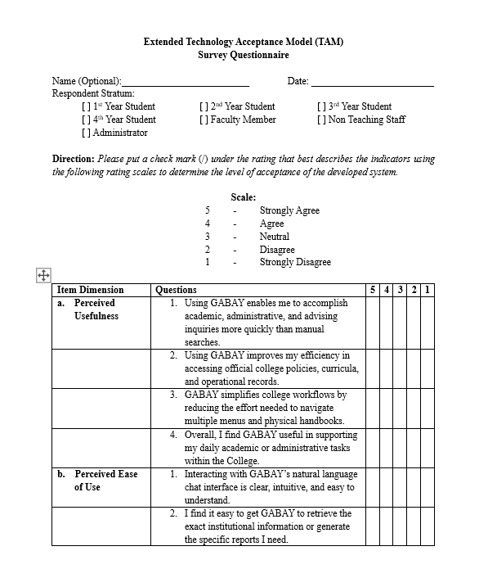
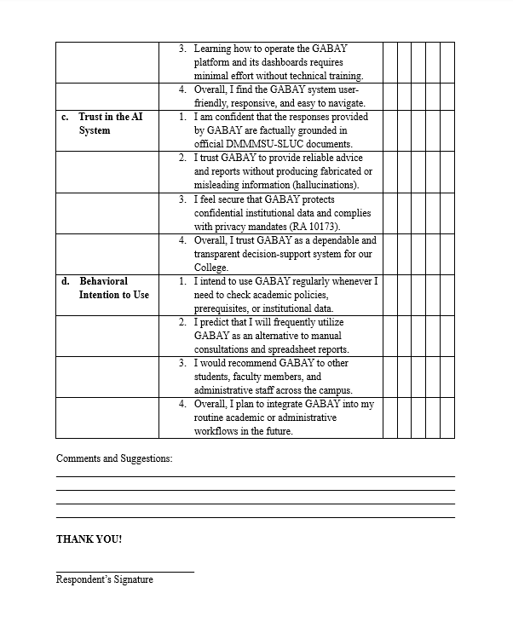
APPENDIX B
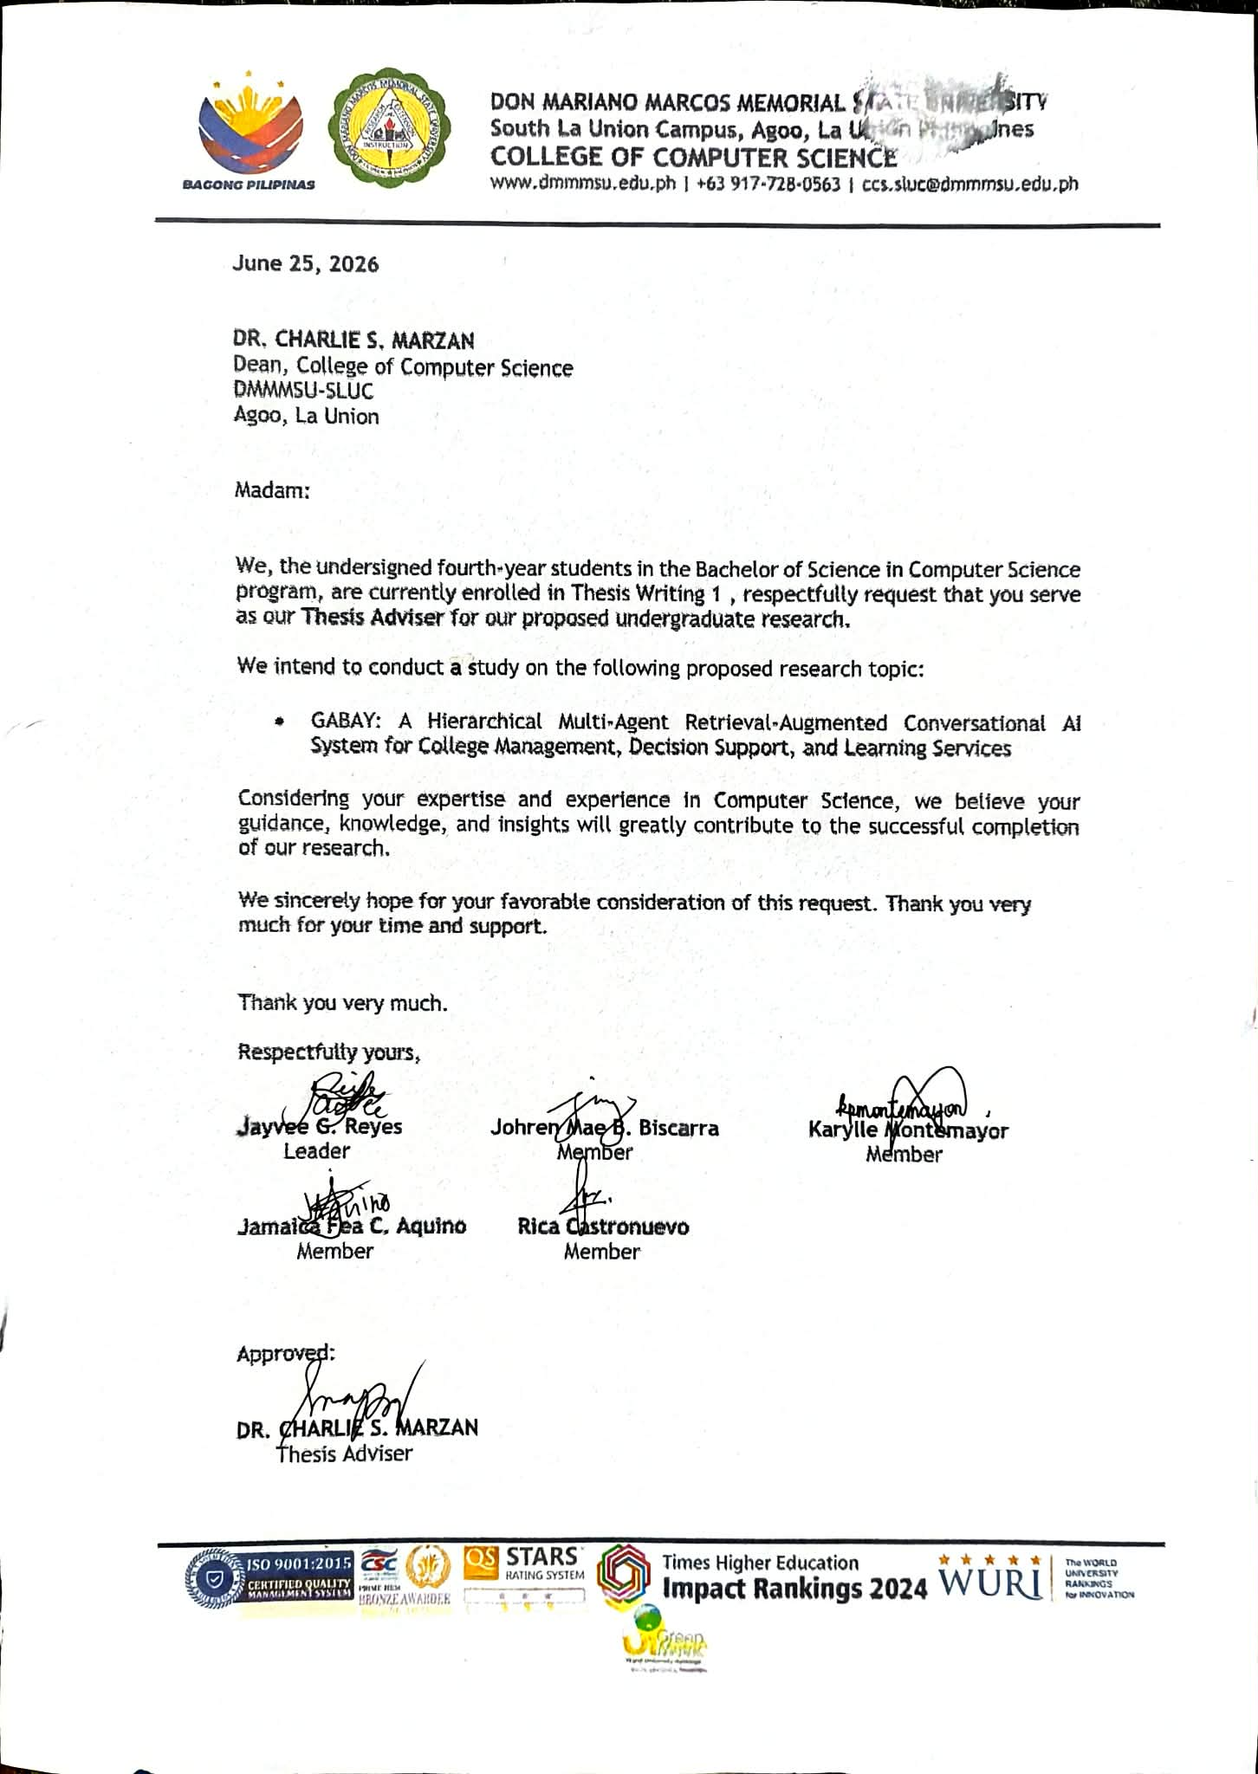
Request for Thesis Adviser
APPENDIX C
Privacy Policy of Zyberlab Solutions Inc.


CURRICULUM VITAE

REYES, JAYVEE G.
Patac, Santo Tomas La Union
2505 Philippines
Contact No: 09075251244
Email: jreyes23110823@student.dmmmsu.edu.ph

Educational Background

2023 – present Bachelor of Science in Computer Science
Don Mariano Marcos Memorial State University
Consolacion, Agoo, La Union

2017 – 2023 Sto. Tomas National High School
Santo Tomas, La Union

2012 – 2017 Patac Elementary school
Patac, Santo Tomas, La Union

2011 – 2012 Tagumpay Elementary school
Montalban, Rodriguez, Rizal

Awards and Honors Received

June 2026 Certificate of Completion of On-the-Job-Training
Zyberlab Solutions Inc.
Nibaliw East, San Fabian, Pangasinan

2016 – 2023 Consistent Honor Student
Santo Tomas, La Union

2023 – 2024 Dean’s Lister
Don Mariano Marcos Memorial State University
Consolacion, Agoo, La Union

Work Experiences

2024 – present Web Developer
Freelancing

2026 – present Junior Developer
Zyberlab IT Solutions
San Fabian, Pangasinan

Seminars and Trainings Attended

May – June 2026 Zyberlab IT Solutions On-the-Job-Training
DMMMSU SLUC BSCS OJT Facilitator
San Fabian, Pangasinan

Special Skills and Talents
- Expert in programming languages (C#, PHP, JavaScript, SQL, HTML5, CSS3), backend (ASP.NET Core, Entity Framework, Web API), frontend (jQuery, Tailwind, Bootstrap, AJAX), databases (SQL Server, MySQL), and tools (Git, Excel data processing).
- Strong in communication, leadership, problem-solving, technical writing, and working under pressure.
Certified true and correct.

JAYVEE G. REYES
Signature over Printed Name



BISCARRA, JOHREN MAE B.
Dangdangla, Bangued, Abra
2800 Philippines
Contact No: 09975569322
Email: jmbiscarra23100603@student.dmmmsu.edu.ph

Educational Background

2023 – present Bachelor of Science in Computer Science
Don Mariano Marcos Memorial State University
Consolacion, Agoo, La Union

2022 – 2023 Abra High School
Zone 1, Bangued, Abra

2016 – 2021 Abra High School
Zone 1, Bangued, Abra

2010 – 2016 Dangdangla Elementary school
Dangdangla, Bangued, Abra

Awards and Honors Received

June 2026 Certificate of Completion of On-the-Job-Training
Deparment of Environment and Natural Resources
DENR Compound, Gibraltar Rd, Baguio City

Work Experiences

May – June 2026 Administrative Assistant
Department of Environment and Natural Resources – Office of the Regional Executive Director

Seminars and Trainings Attended

May – June 2026 Department of Environment and Natural Resources
On-the- Job-Training
DMMMSU SLUC BSCS OJT Facilitator
DENR Compound, Gibraltar Rd, Baguio City

Special Skills and Talents

- Proficient in Microsoft Word, with the ability to create, format, and edit professional documents, reports, and correspondence efficiently. Skilled in Microsoft Excel, including data entry, basic formulas, spreadsheet organisation, and creating clear, well-structured tables
- Strong technical aptitude and computer literacy, including the confident operation of various software applications and operating systems.

Certified true and correct.

JOHREN MAE B. BISCARRA
Signature over Printed Name



MONTEMAYOR, KARYLLE P.
Bail, Santo Tomas, La Union
2505 Philippines
Contact No: 09940540488
Email: kmontemayor23103343@student.dmmmsu.edu.ph

Educational Background

2023 – present Bachelor of Science in Computer Science
Don Mariano Marcos Memorial State University
Consolacion, Agoo, La Union

2017 – 2023 Bail National High School Bail, Santo Tomas, La Union

2011 – 2017 Bail Elementary School Bail, Santo Tomas, La Union

Awards and Honors Received

June 2026 Certificate of Completion of On-the-Job-Training
Municipality of Agoo La Union
Agoo, La Union
Work Experiences

May – June 2026 Data Entry Clerk
Municipality of Agoo La Union – Business Permits
and Licensing Office

Seminars and Trainings Attended

May – June 2026 Municipality of Agoo On-the-Job-Training
DMMMSU SLUC BSCS OJT Facilitator
Agoo, La Union

Special Skills and Talents
- Strong organizational and time-management abilities, with a proven capacity to prioritize tasks and meet deadlines in busy environments.
- Effective multitasking ability, comfortably handling several responsibilities at once while maintaining quality and focus.

Certified true and correct.

KARYLLE P. MONTEMAYOR
Signature over Printed Name



CASTRONUEVO, RICA U.
Inmalog Norte, San Fabian, Pangasinan
2433 Philippines
Contact No: 09934569301
Email: rcastronuevo23101453@student.dmmmsu.edu.ph

Educational Background

2023 – present Bachelor of Science in Computer Science
Don Mariano Marcos Memorial State University
Consolacion, Agoo, La Union

2017 – 2023 San Fabian Integrated School SPED Center
Inmalog Sur, San Fabian, Pangasinan

2011 – 2017 Inmalog Nortes Elementary School
Inmalog Norte, San Fabian, Pangasinan

Awards and Honors Received

June 2026 Certificate of Completion of On-the-Job-Training
Academia De Sta. Cecilia Foundation Inc.
San Fabian, Pangasinan
Work Experiences

2020 Front Desk Associate
PTA Beach Resort
San Fabian, Pangasinan

May – June 2026 Administrative Assistant
Academia De Sta. Cecilia Foundation Inc. –
Registrar’s Office
Seminars and Trainings Attended

May – June 2026 Academia De Sta. Cecilia Foundation Inc.
On-the-Job- Training
DMMMSU SLUC BSCS OJT Facilitator
San Fabian, Pangasinan

Special Skills and Talents
- Competent in managing digital files and folders across multiple platforms, ensuring documents are accurately stored and easily retrievable
- Ability to operate standard office systems and software efficiently while handling multiple tasks.
Certified true and correct.

RICA U. CASTRONUEVO
Signature over Printed Name



AQUINO, JAMAICA FEA C.
Malabago, Santo Tomas La Union
2505 Philippines
Contact No: 09128590485
Email: jfaquino23102663@student.dmmmsu.edu.ph

Educational Background

2023 – present Bachelor of Science in Computer Science
Don Mariano Marcos Memorial State University
Consolacion, Agoo, La Union

2017 – 2023 St. Mary of the Sea Academy
Poblacion, Santo Tomas, La Union
2011 – 2017 Sto. Tomas Central School Poblacion, Santo Tomas, La Union

Awards and Honors Received

June 2026 Certificate of Completion of On-the-Job-Training
Municipality of Santo Tomas, La Union
Sto. Tomas, La Union

Work Experience

May – June 2026 Data Entry Clerk
Municipality of Agoo La Union - Treasury Office
Seminars and Trainings Attended

May – June 2026 Sto. Tomas LGU On-the-Job-Training
DMMMSU SLUC BSCS OJT Facilitator
Santo Tomas, La Union

Special Skills and Talents

- Strong interpersonal skills, building positive working relationships with people
- Organised and able to manage time well when handling multiple responsibilities

Certified true and correct.

JAMAICA FEA C. AQUINO
Signature over Printed Name

