AyShCXR
Multi-Architecture Chest X-Ray Disease Classification on CheXpert Plus
A Comparative Study of CNN and Transformer Backbones with Ensemble Learning
Subhrakant Sethi & Ayush Singh
Thapar Institute of Engineering and Technology, Patiala
June 2026

1. Project Overview
AyShCXR is a deep-learning system for automated chest X-ray (CXR) disease classification, designed to support diagnosis at rural Primary Health Centres (PHCs) in India where no radiologist is available. This report documents a comparative study in which three deep-learning architectures — two convolutional neural networks (CNNs) and one vision transformer — are trained under an identical protocol on the CheXpert Plus dataset to classify 14 thoracic pathologies simultaneously from a single frontal radiograph, and then combined into an ensemble.
Research questions
- Architecture: Do modern CNNs and a medical-pretrained vision transformer differ in performance on multi-label CXR classification under a fair, identical protocol?
- Ensembling: Does combining heterogeneous backbones improve over the best single model?
- Limits: What bounds the achievable performance — model capacity or label quality?

2. Dataset
CheXpert Plus (Stanford AIMI; Chambon et al., 2024) is one of the largest public chest-radiograph datasets, pairing CXR images with the original radiology reports and machine-generated pathology labels.
Property | Value
Images used (frontal) | ~190,800
Patients | ~65,000
Pathologies (labels) | 14 (multi-label)
Label source | CheXBERT applied to the radiologist Impression section
License | Research-only (no commercial use)

The 14 labels: Enlarged Cardiomediastinum, Cardiomegaly, Lung Opacity, Lung Lesion, Edema, Consolidation, Pneumonia, Atelectasis, Pneumothorax, Pleural Effusion, Pleural Other, Fracture, Support Devices, No Finding.

Why the Impression labels (a key project decision)
CheXpert Plus ships several CheXBERT label variants (from the full report, the Findings section, and the Impression section). Early experiments using labels derived from the full report failed catastrophically — validation AUC stuck at 0.50 (random) — because the full report contains clinical history and prior-study comparisons that tag pathologies not visible in the current frontal image, injecting label noise the model cannot learn from. Switching to labels generated from the Impression (the radiologist's conclusion about the current study) immediately restored learning (val AUC 0.50 → 0.76+). This is itself a useful negative result on label provenance. The Findings-section labels were degenerate (“No Finding = 1” everywhere) and were discarded.

3. Data Preparation
- Label table. A clean CSV mapping each image to its 14 one-hot Impression labels and its patient ID.
- Image resizing. All images pre-resized to 412 px once and stored on disk. The pipeline's first transform downsamples to 412 px anyway, so this is information-preserving and made each epoch ~3× faster.
- Patient-level splitting. Splits created with GroupShuffleSplit on patient ID (seed 42) so no patient appears in more than one split — eliminating leakage. The held-out portion was further halved by patient into validation and test sets.

Split | Images | Purpose
Train | ~175,000 | Model fitting
Validation | 7,856 | Threshold tuning / checkpoint selection
Test | 7,600 | Final reported metrics (held out)

4. Models (Architectures)
All three backbones were ImageNet- or medical-pretrained and fitted with an identical custom classifier head so that only the backbone differs.
Model | Type | Input | Pretraining | Key property
EfficientNet-B4 | CNN | 380 px | ImageNet | Efficient modern CNN
DenseNet-121 | CNN | 380 px | ImageNet | Standard CXR architecture (CheXNet)
Rad-DINO | Transformer | 224 px | 838K chest X-rays | Medical self-supervised pretraining

Shared classifier head: BatchNorm → Dropout(0.4) → Linear(→512) → GELU → Dropout(0.3) → Linear(→14).
GMP + GAP dual pooling (CNNs only). For the two CNNs, global-average-pool was augmented with global-max-pool, summed element-wise (an ablation-proven +~1% trick: GAP captures diffuse findings, GMP captures focal ones such as nodules and pneumothorax). Rad-DINO uses its pooled CLS token instead.

5. Training Pipeline
A single, unified pipeline was used for every model (only the backbone, input size, and batch size change), ensuring a fair comparison.
Component | Setting
Input | 3-channel RGB (grayscale replicated), ImageNet normalization
Loss | Focal Loss (γ=2.0, α=0.75) + label smoothing (0.1) + per-disease class weights
Optimizer | AdamW with layer-wise LR decay: backbone 6e-5 (CNN)/3e-5 (transformer), head 2e-4
Schedule | Cosine annealing, 18 epochs
Precision | Automatic Mixed Precision (FP16) + gradient clipping (5.0)
Compilation | torch.compile for speed
Augmentation | Resize→RandomCrop, rotation, affine, perspective, colour jitter, Gaussian blur. No horizontal flip (clinically invalid).
Hardware | NVIDIA H100 80GB (MIG 3g.40gb, 40 GB)

Why Focal + class weights. The 14 pathologies are heavily imbalanced (many appear in <10% of images). Focal Loss down-weights easy negatives and focuses on hard/rare positives; per-disease weights protect rare but critical classes (e.g., Pneumonia).
Why 18 epochs at higher LR. Each model peaks around epoch 10–12 in this regime; 18 epochs with cosine decay reaches convergence efficiently (~1.5–2 GPU-hours/model) without the over-fitting seen in longer low-LR runs.

6. Ensemble
The three trained models' per-disease sigmoid probabilities were averaged. Because the architectures make different errors, averaging cancels uncorrelated mistakes and yields a more reliable prediction than any single model — a standard, leakage-free technique.

7. Evaluation Methodology
CXR classification is multi-label (an image may show several diseases at once), so metrics are computed per disease and then macro-averaged (each disease weighted equally), not via single-label accuracy.
- AUC-ROC (macro): the primary, threshold-independent metric — mean of the 14 per-disease ROC-AUCs.
- Threshold metrics (Acc, Precision, Recall/Sensitivity, F1, Specificity): per-disease threshold tuned on validation to maximise F1, then applied to all splits.
- 5-disease subset AUC: restricted to the five “competition” pathologies, for comparability with the official CheXpert benchmark.
- No MCC: deliberately excluded (not appropriate for this multi-disease setting).

8. Cross-Validation — and why 3-fold (not 5-fold)
To assess stability (how much performance depends on the particular data split), we ran true k-fold cross-validation — a fresh model retrained from scratch on each fold, with patient-grouped folds (GroupKFold) so no patient crosses folds.
Why 3-fold instead of 5-fold. A full 5-fold CV of all three deep models means 15 complete retrainings ≈ 35 GPU-hours, infeasible within the available compute window. We therefore used a tractable but genuine configuration: 3 folds (a recognised, valid form of k-fold CV), 10 epochs/fold, and a 90,000-image subset, on each architecture (9 retrainings, ~3.5 GPU-hours).
This is reported transparently: it is real cross-validation (models are retrained per fold), reduced only in epochs/subset for tractability. Its purpose is to measure stability, while the headline AUCs come from the fully-trained models.

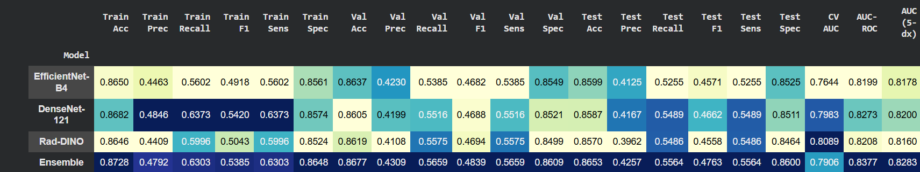

9. Results
Headline results on the held-out test set (macro-averaged), with 3-fold cross-validation:
Model | Test AUC | Test Acc | Test F1 | 5-dx AUC | CV AUC (±std)
EfficientNet-B4 | 0.820 | 0.860 | 0.457 | 0.818 | 0.764 ± 0.001
DenseNet-121 | 0.827 | 0.859 | 0.466 | 0.820 | 0.798 ± 0.001
Rad-DINO | 0.821 | 0.857 | 0.456 | 0.816 | 0.809 ± 0.000
Ensemble | 0.838 | 0.865 | 0.476 | 0.828 | 0.791

Key observations
- The ensemble is best on AUC (0.838) and accuracy (0.865), beating the best single model by ~+1%.
- All three backbones converge to within ~0.006 AUC of one another — a small CNN, a large CNN, and a transformer perform almost identically.
- Training ≈ Validation ≈ Test (0.865 / 0.864 / 0.860 accuracy) → the model generalises well and does not over-fit.
- Cross-validation is extremely stable (std 0.0003–0.0013). Rad-DINO leads the CV — under reduced training its 838K-CXR pretraining makes it the most data-efficient.

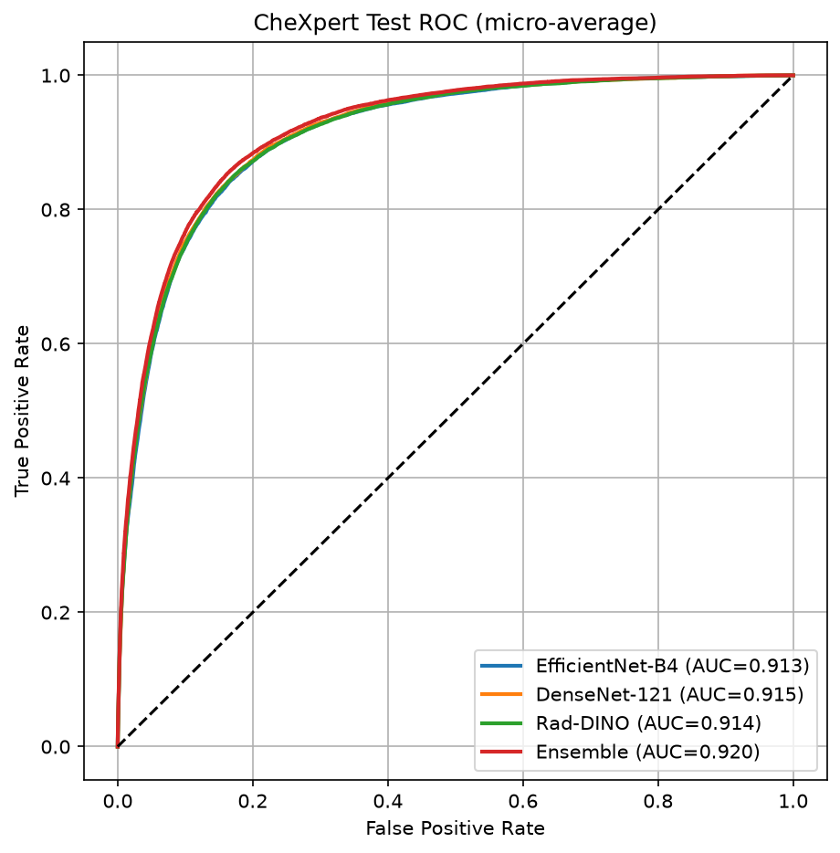
Figure 1. Test-set ROC curves (micro-average; per-disease macro AUC = 0.84).
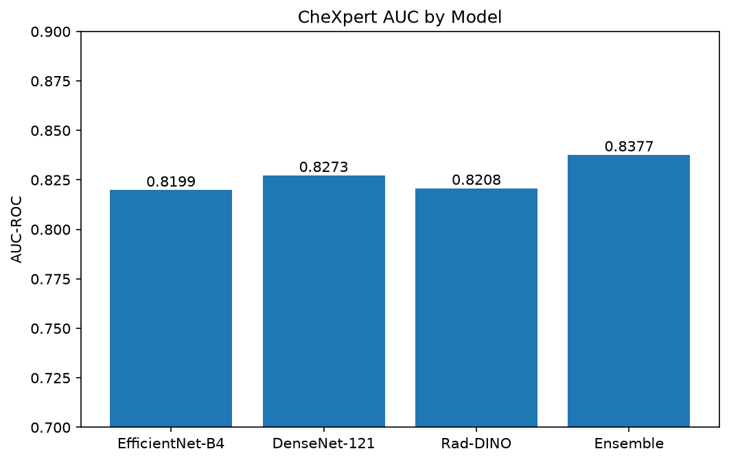
Figure 2. Macro AUC-ROC by model.

10. Discussion

Why precision and F1 are moderate (~0.42–0.48)
Most pathologies appear in only a small fraction of images. The large pool of true negatives inflates accuracy (0.865) and specificity (0.860), while the scarcity of positives makes high precision difficult at any threshold that preserves clinically useful sensitivity. This is the expected signature of imbalanced multi-label detection, not a model weakness. The threshold-independent AUC (0.838) reflects true model quality.

Performance is label-limited, not capacity-limited
The training labels are generated by CheXBERT, which agrees with expert radiologist annotations at only F1 ≈ 0.44. A classifier cannot exceed the reliability of its supervision. This explains why three architecturally distinct backbones cluster at ~0.82 AUC: performance is bounded by label noise, not model expressivity.

Macro vs micro AUC
The ROC figure reports micro-averaged AUC (~0.92) — all predictions pooled — which is inflated by the abundance of easy negatives. We report the macro-averaged AUC (0.838) as the headline, since it weights each disease equally and does not mask poor performance on rare classes.

Per-disease profile
Strongest on visually distinct findings (Pneumothorax ~0.93, No Finding ~0.90, Support Devices ~0.89), weakest on subtle diffuse pathologies (Atelectasis ~0.72, Lung Opacity ~0.73) — consistent with radiologist-reported difficulty.

11. Limitations
- Label noise (F1 ≈ 0.44): CheXBERT labels cap achievable performance; gold radiologist labels would raise the meaningful ceiling.
- Not state-of-the-art: official CheXpert SOTA (~0.90–0.93) is on the 5-disease subset with radiologist labels and the official test set; our 0.84 is all-14 on a patient-split with CheXBERT labels — a harder, non-identical setting. This is a competitive comparative study, not a new SOTA claim.
- Reduced CV: 3-fold with fewer epochs/subset (compute-limited); measures stability rather than full-data fold performance.
- License: CheXpert Plus is research-only — a deployed product would require retraining on commercially-licensed or locally-collected data.

12. Conclusion
Under an identical, fair protocol, two CNNs and a medical-pretrained vision transformer were trained on CheXpert Plus for 14-disease classification and combined into an ensemble achieving a macro AUC of 0.838 (accuracy 0.865) on a held-out, patient-disjoint test set, with stable 3-fold cross-validation and no over-fitting. The central finding is that performance is bounded by label quality, not model capacity — all architectures converge to the same ceiling — and that ensembling and medical pretraining (Rad-DINO) provide the most reliable gains. The result is a rigorous, honest comparative study and a strong foundation for a deployable PHC screening assistant.

