|  |
| --- |
| The Smurfs Game |
|  |
| Team Members:   * Aya Abouzeid 2 * Aya Fouad 3 * Salma Yehia 35 * Nada Ayman 79 |
|  |



***Alexandria University***

***Faculty of Engineering***

***Computer and Systems Engineering Dept.***

1. Introduction:
2. Project Description:

It is two-player game (one uses keyboard, and the other uses the mouse) in which each character carry two stacks of plates, and there are a set of colored different dynamically loaded shapes that end up falling down and players try to catch the falling shapes.

The main aim of the project is to implement an advanced user friendly GUI, and use at minimum eleven different design patterns to avoid any problems commonly occurring in software design on a large scale.

The project is designed in **Java**, GUI implemented using **JavaFX**, saving the game to load later in JSON files using **GSON**, besides complete logging file using **Log4**j.

1. Report Overview:
2. Software Design:

Illustrates the design and how the code is organized between different packages and classes, also explains the role of each class and how it interacts with the rest of them.

1. Class Diagrams:

A type of static structure diagrams that describes the structure of a system by showing the system's classes, their attributes, operations (or methods), and the relationships among objects.

1. Sequence Diagrams:

An [interaction diagram](https://en.wikipedia.org/wiki/Interaction_diagram) that shows how objects operate with one another and in what order. It is a construct of a [message sequence chart](https://en.wikipedia.org/wiki/Message_sequence_chart). It shows object interactions arranged in time sequence.

1. Design Patterns:

Illustrates thoroughly the design patterns used, why they are most suitable where they are used and how they helped overcome design possible problems.

1. GUI Snapshots:

Shows the GUI of the game with different snapshots

1. User Guide:

Shows the user how to use the project / game and the way to win.

1. Software Design:

The project is divided into many packages

* Button
* Controller
* Factories
* Iterator
* Layouts
* **Logs**

Contains the class responsible for writing the logs to the logging.log file.

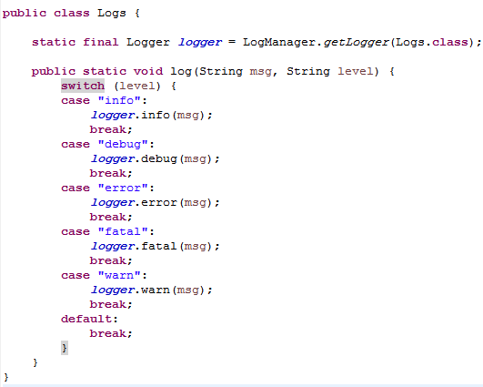

* Observer
* Player
* Save
* Shape
* Snapshot
* states

1. Class Diagrams:
2. Sequence Diagram:
3. Design patterns:

Singleton:

Singleton design Pattern is used in our project when a restriction was to be made on a class to limit it’s instantiation to only one object and provide global access to that instance, this is typically done by declaring the class’s constructors to be private and providing a private static instance and a method that returns nothing but that one and only instance.

Singleton pattern was chosen to be applied on Factory and State Design Patterns, as well as The Game Controller.

**A. Singleton applied on Factory Design Pattern:**

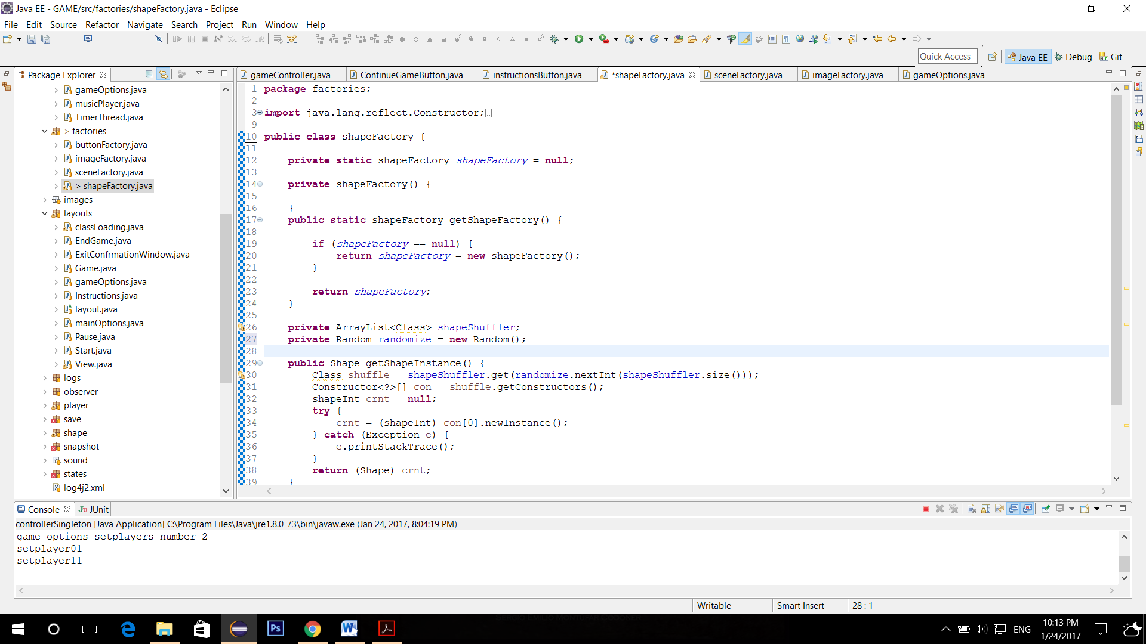

**B. Singleton applied on State Design Pattern:**

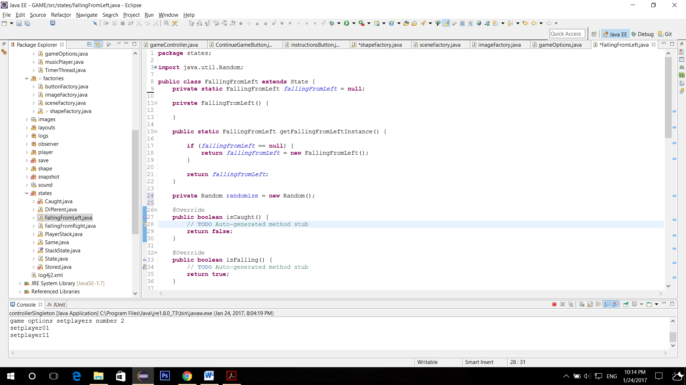

**C. Singleton applied on The Game Controller :**

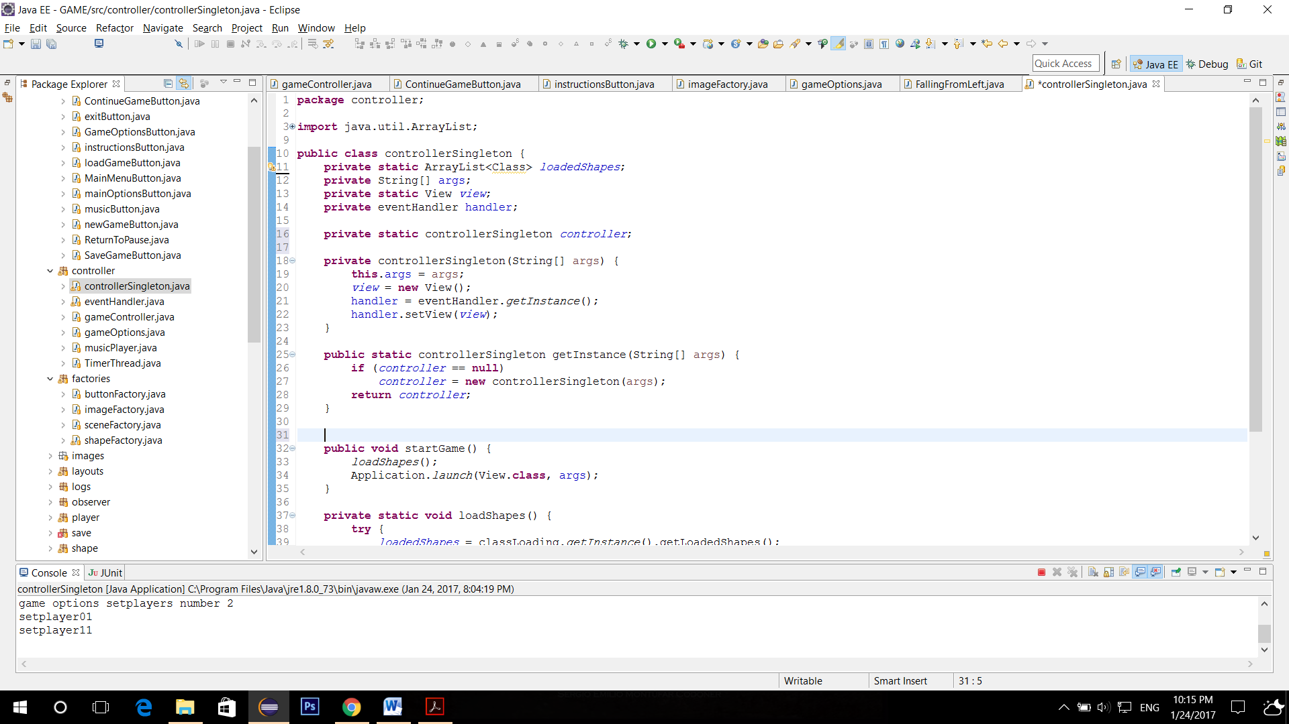

Factory:

Factory Design Pattern is used in our project to create objects on demand without specifying the required class to create this object, where the factory handles this operation and returns the exact required object.

This was applied by four different factories in our design which are Button Factory, Scene Factory, Image Factory, and Shape Factory.

**A. Factory applied on Buttons :**

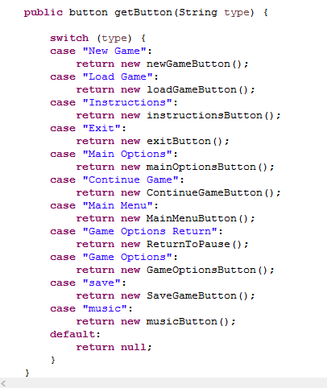

**B. Factory applied on Scenes :**

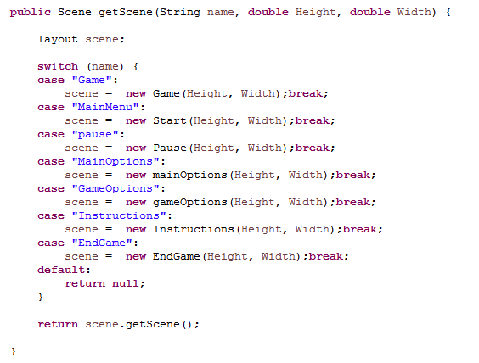

**C. Factory applied on Image Views:**

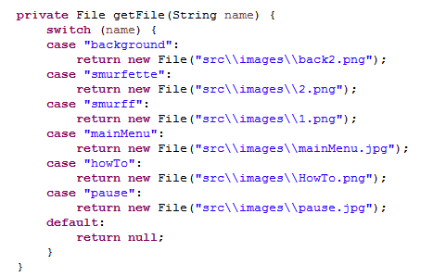

**D. Factory applied on Shapes :**

The shuffler here does all the work for randomizing returned shapes.

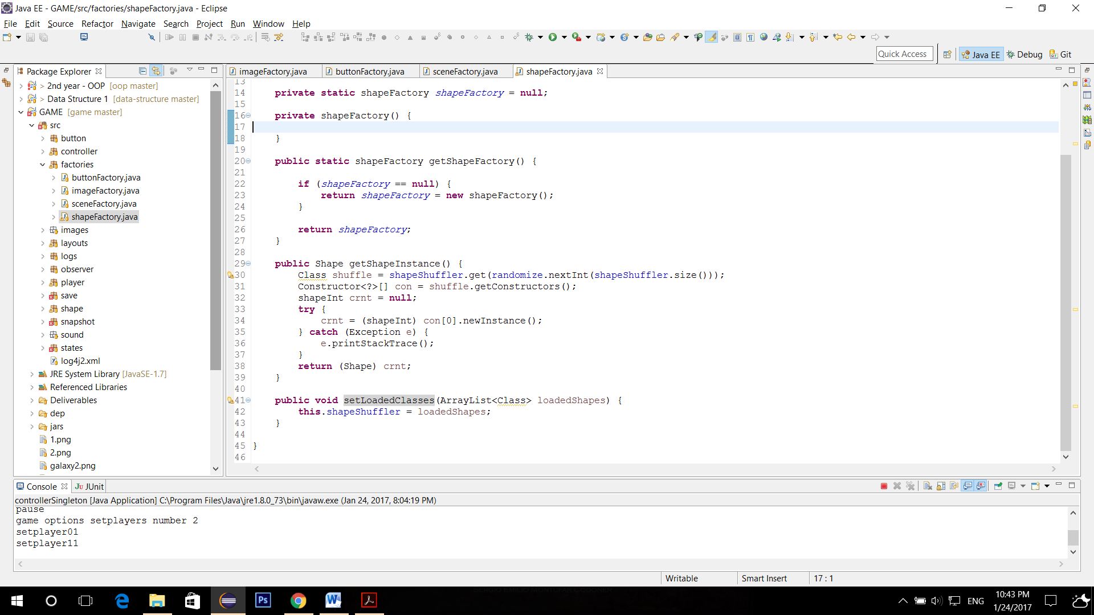

Iterator:

Dynamic Linkage:

Dynamic linkage (Dynamic class loading) is used to load all the shapes at the beginning of the game at run time – loads all the jar files is the jars folder after checking that it implements the required interface (shapeInt) by default there are two shapes to load [plate - ellipse] but the user can later add as much shapes as he wants by providing new jars.

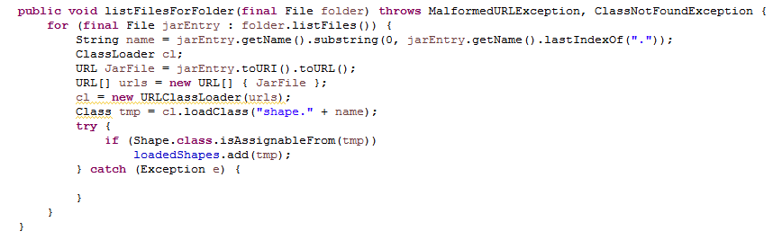

Snapshot:

State:

Strategy:

Observer:

MVC:

Object Pool:

CHOSEN ONE ???

1. GUI Snapshots:
2. User Guide:

REQUIRED بالصلاة على النبي

**Describe your design thoroughly.**

**Class diagram of your design**. == UML ?????????????????

**Sequence diagram showing the typical scenarios of the game.**

**Section for each pattern (the required and any other patterns you used) and how you used it in your design, and a class diagram explaining this.**

**Snapshots of your GUI.**

**User guide explains how to play the game.**

**Any design decisions that you have made should be listed clearly.**

**A significant part of the grade will go to the report, so make sure you make it clean and readable**.