**Name: Aya Allah Ali Abbas track: system admin / ITI Alex**

**P5: Create your bridge network, two containers from ubuntu image with different names and try to ping each other using NAME.**

**Part1**

**Create two containers and the network bridge**

**Make sure to attach the containers to my network bridge while creating them**

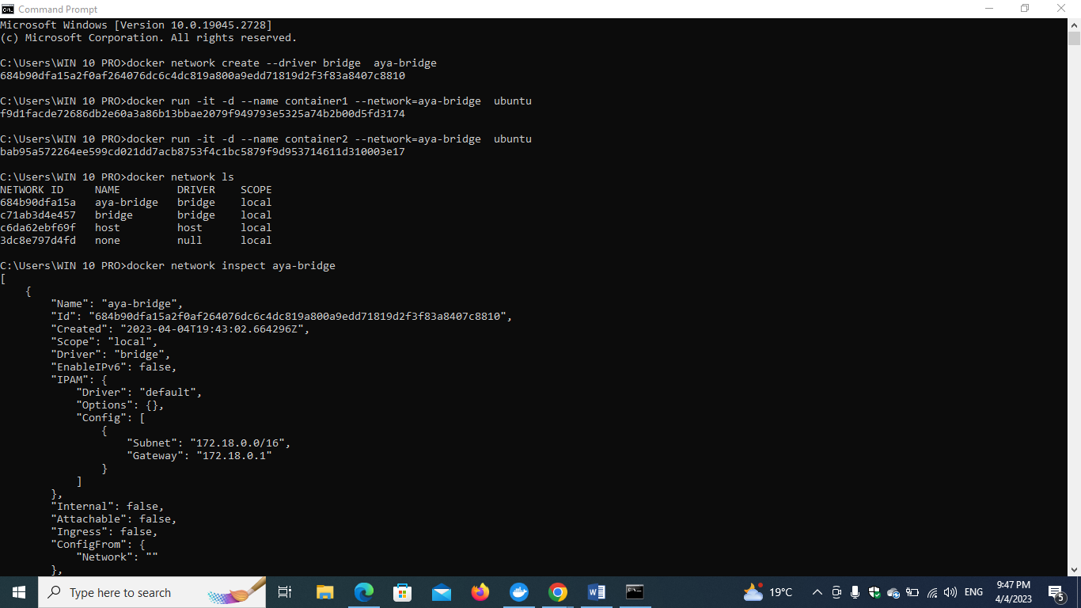

**Check that the containers are attached to aya-bridge network using the following command which helps to show the metadata**

**docker network inspect aya-bridge**

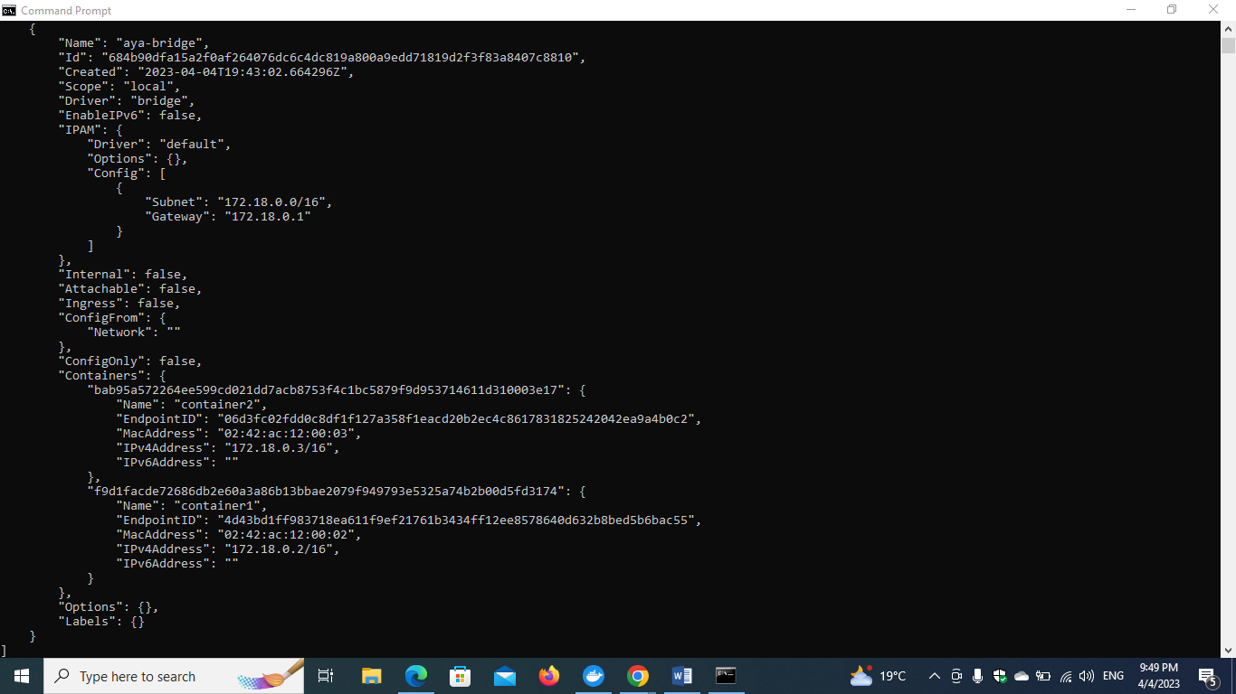

**Ping from container1 to container2 using name**

**The Ping command wasn’t found so I needed to install the package providing the ping command**

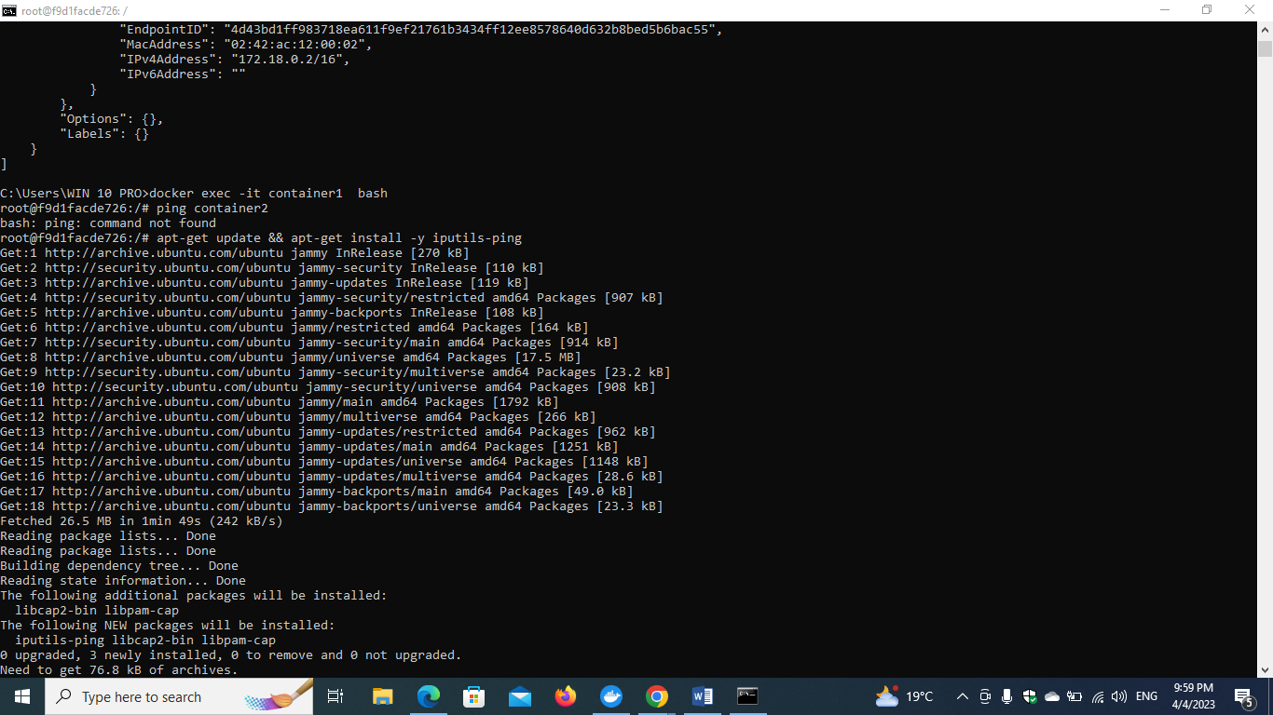

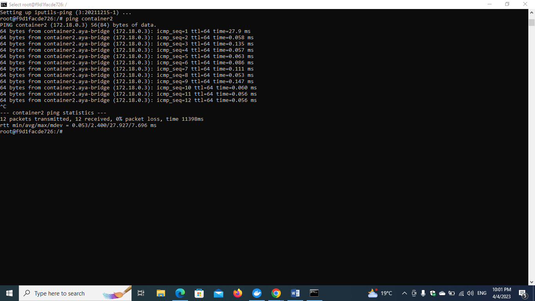

**The ping was successful**

**Now, Lets ping via versa from container2 to container1**

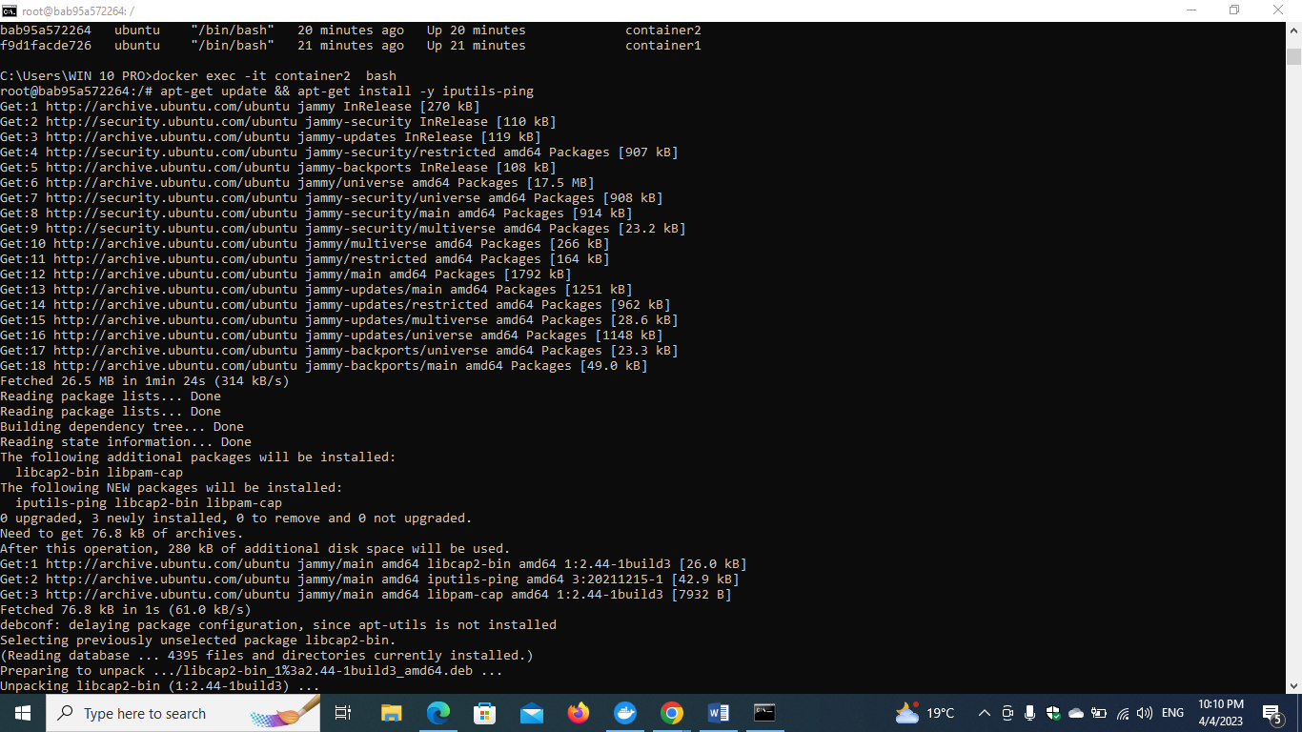

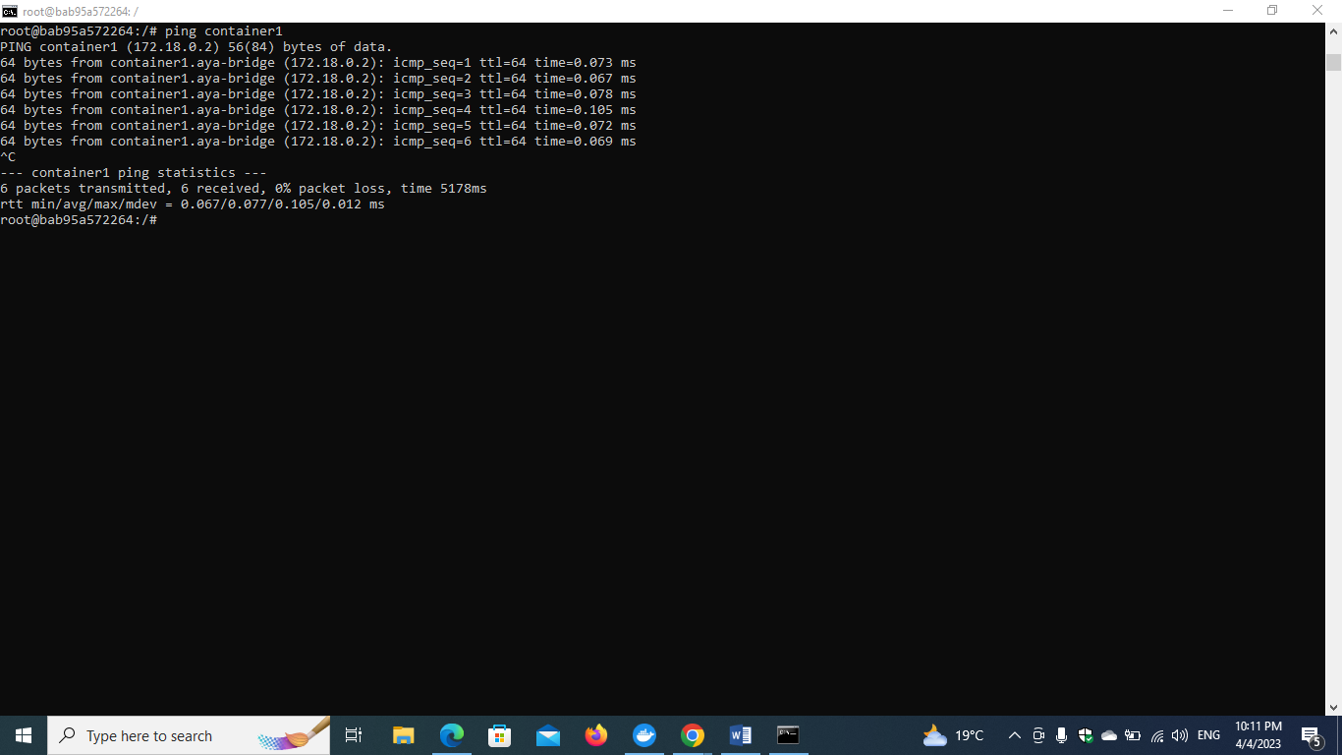

**The ping was also successful**

**Deleting containers and network to begin part2**

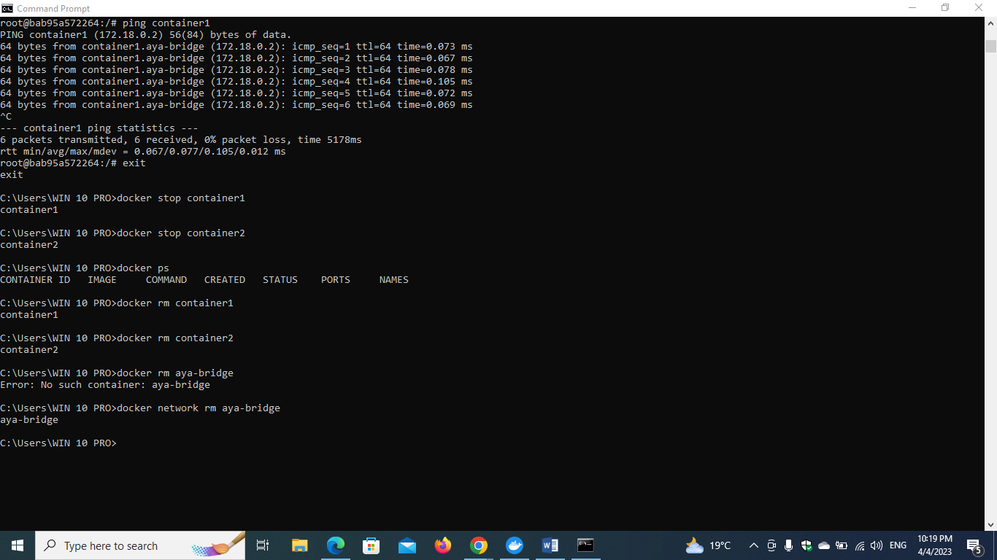

**Part 2**

**Create docker compose and run it**

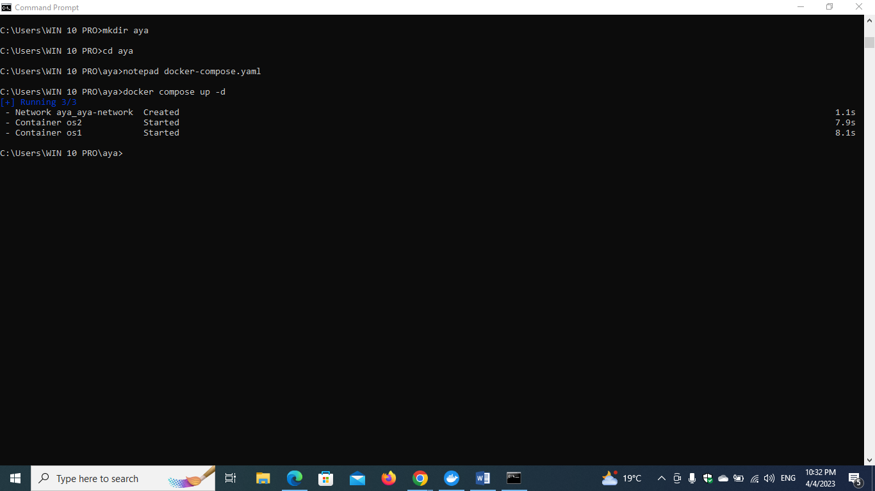

**Note that**

**tty: true to make sure the ubuntu works in the background 😊**

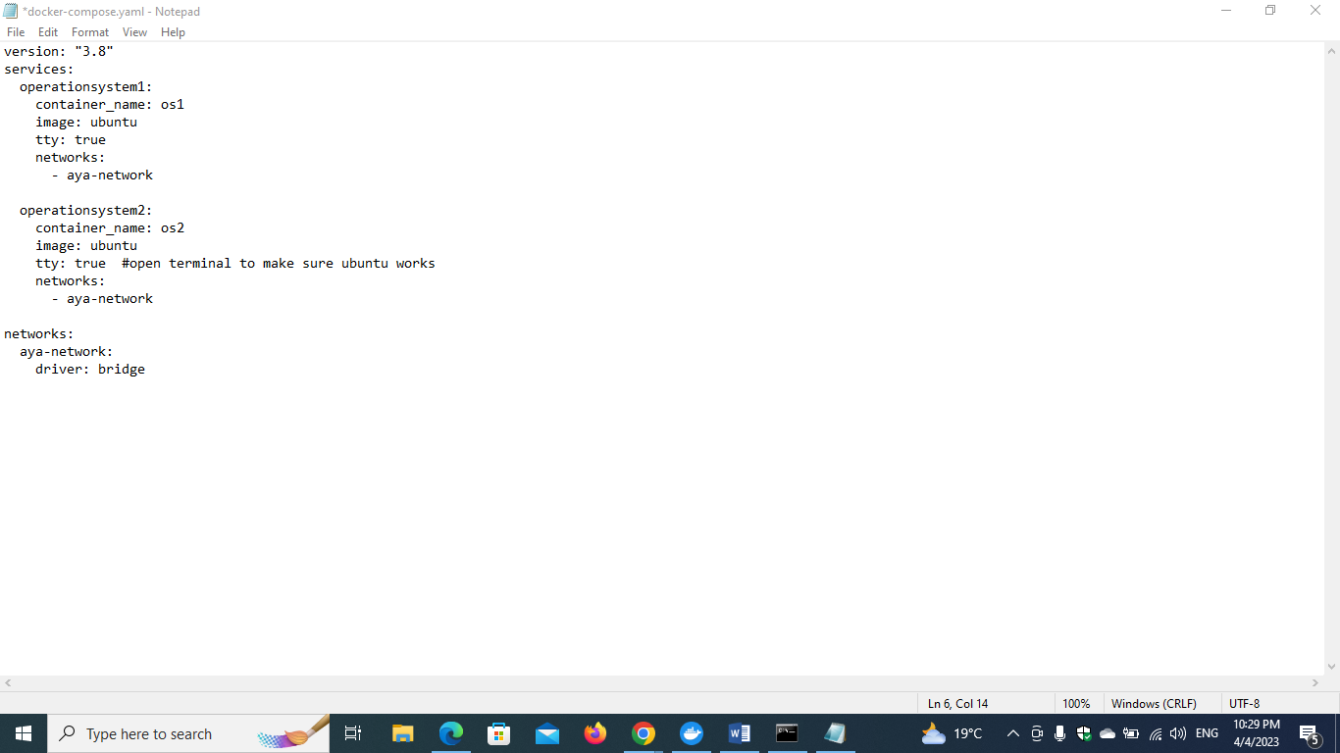

**Then try the ping using name same as part 1 😊**

**Ping from os1 to os2**

**Download the ping package first**

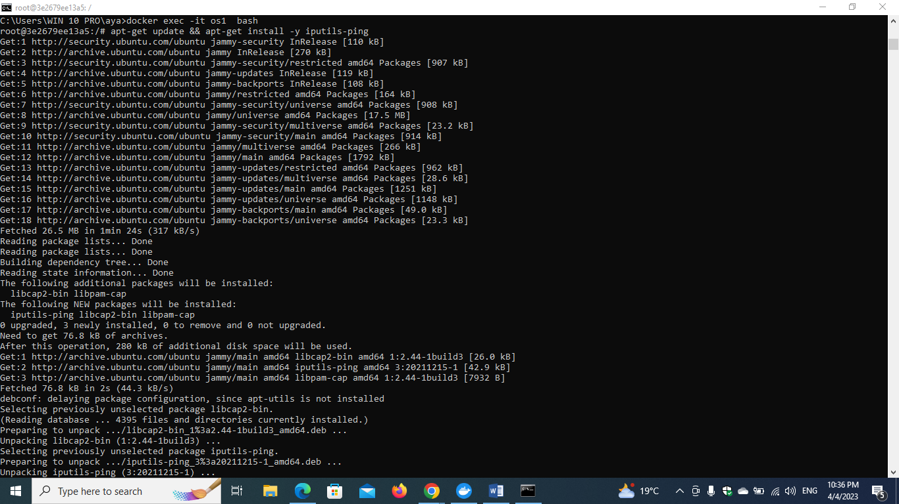

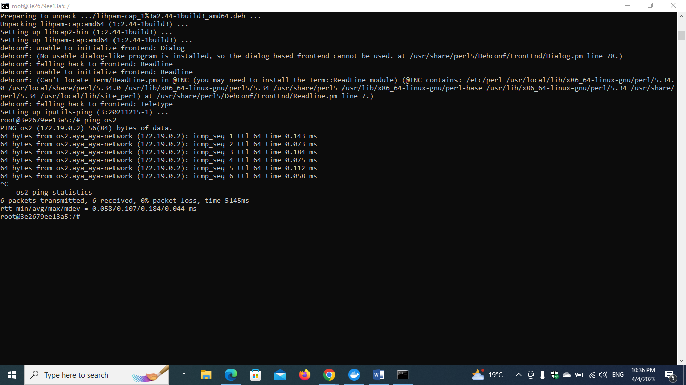

**The ping was successful**

**Now let try to do the same thing and ping using name from os2 to os1 😊**

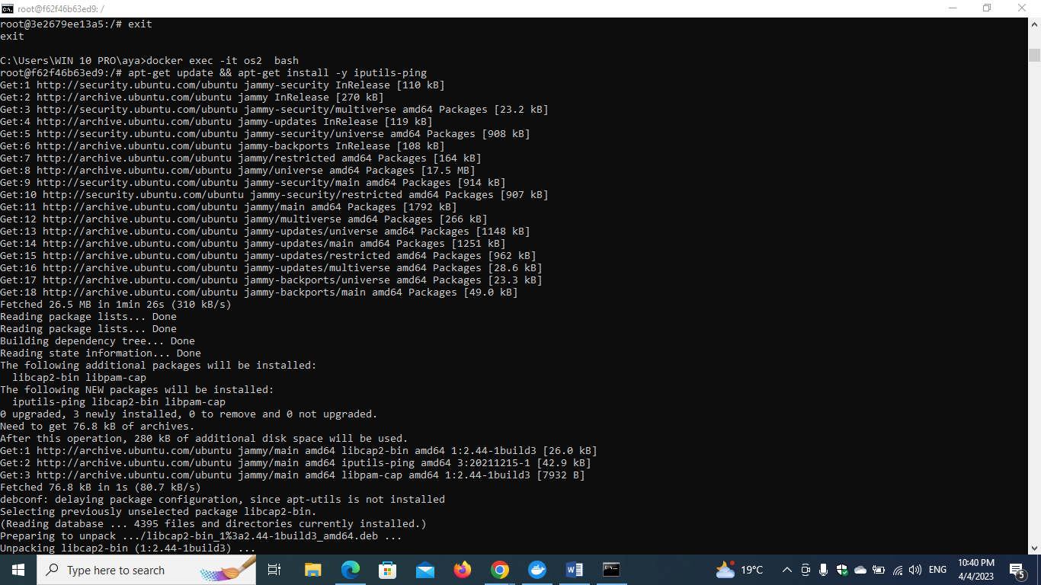

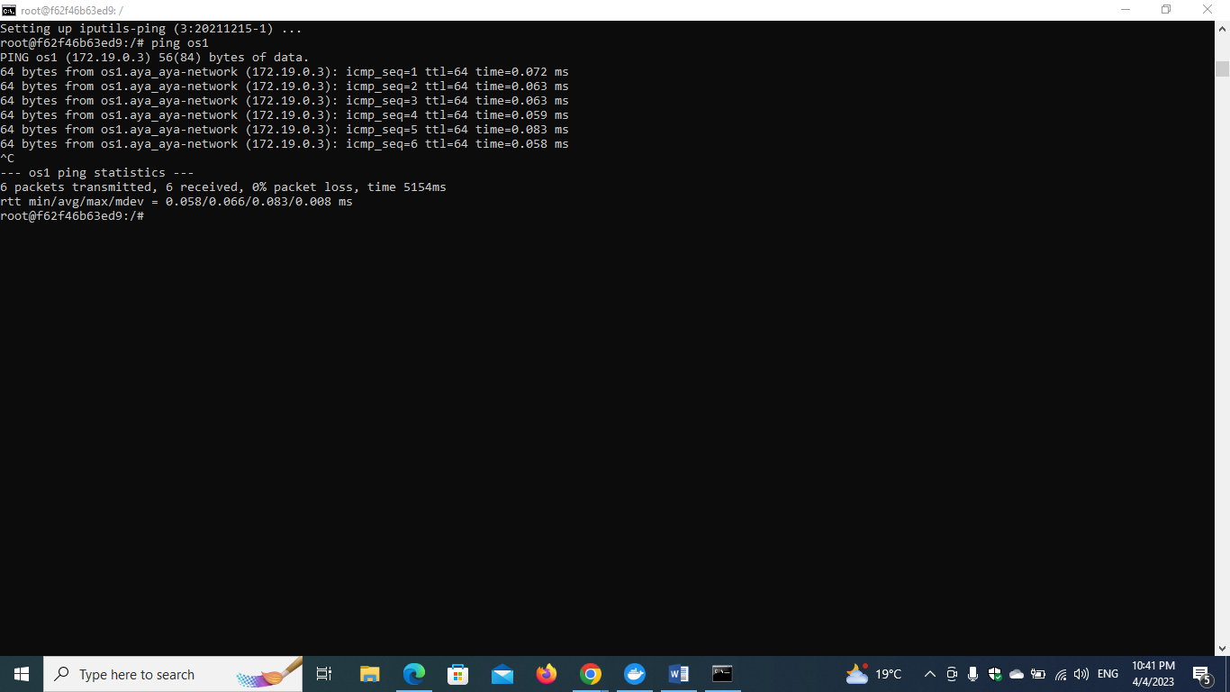

**The ping also worked**

**Comment: this proves that user defined bridge can resolve DNS (the name I gave to the container)**