**Lab3**

**Name: AyaAllah Ali Abbas Ahmed Track: System Admin**

**1) USER management:**

**=======================**

**- create PERMANENT tablespace with name ITI with two data files with intial size 50 MB each, 250 MB maxsize and increment of 10 MB**

**CREATE TABLESPACE ITI_NEW DATAFILE '/u01/oracle_base/oradata/SYS/sys1.dbf' SIZE 50M AUTOEXTEND ON NEXT 10M MAXSIZE 250M, '/u01/oracle_base/oradata/SYS/sys2.dbf' SIZE 50M AUTOEXTEND ON NEXT 10M MAXSIZE 250M;**

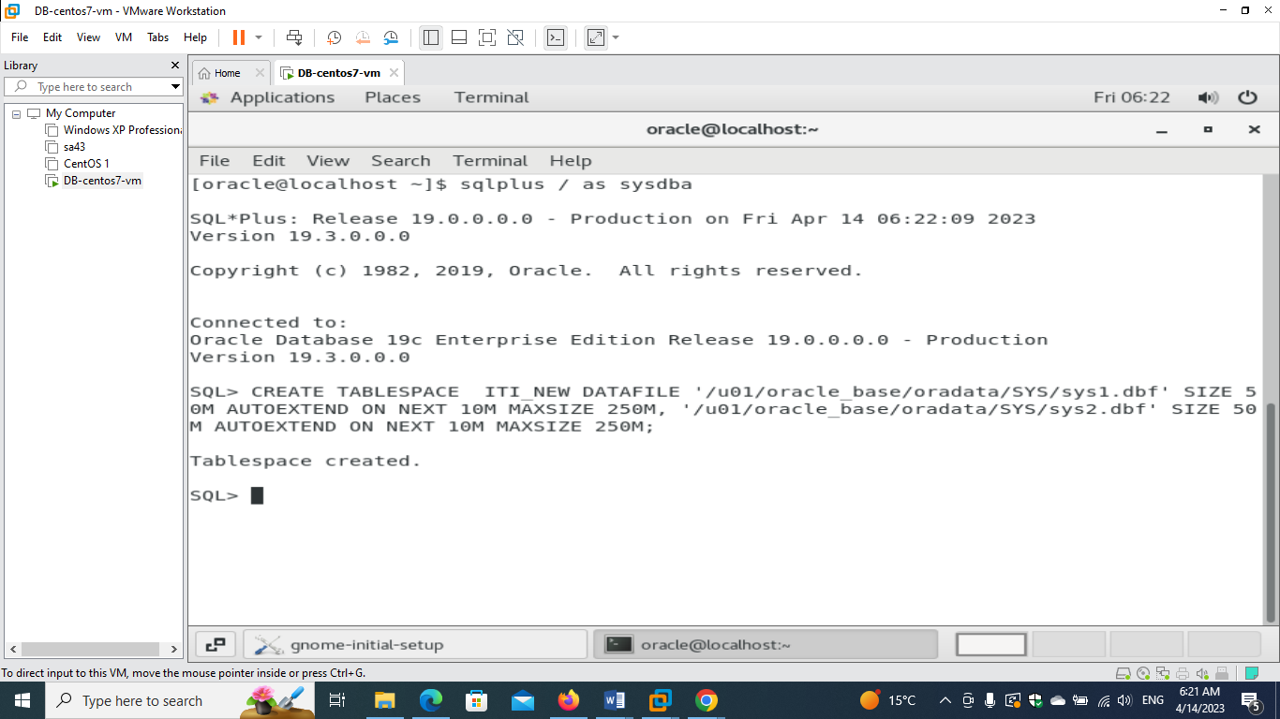

**- create new user <your_name> and make ITI tablespace is the default tablespace with unlimited quota on it.**

**create user aya1 identified by 123 default tablespace ITI_NEW QUOTA UNLIMITED ON ITI_NEW;**

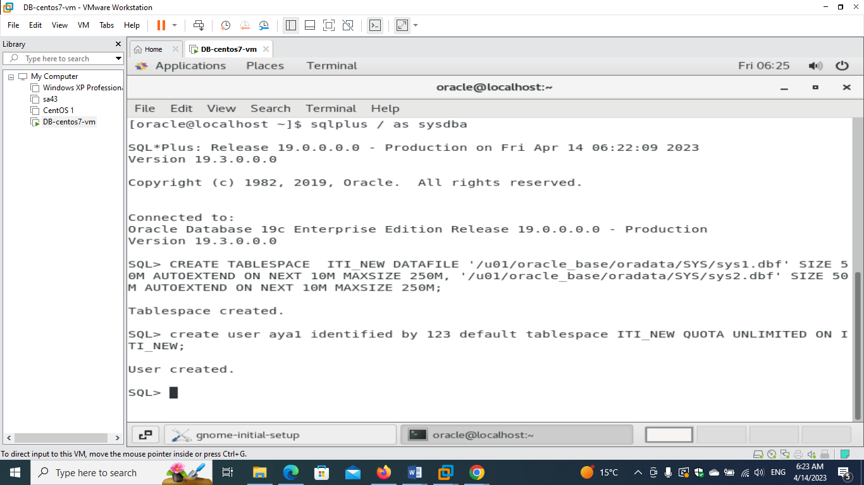

**- try to connect with the new created user.**

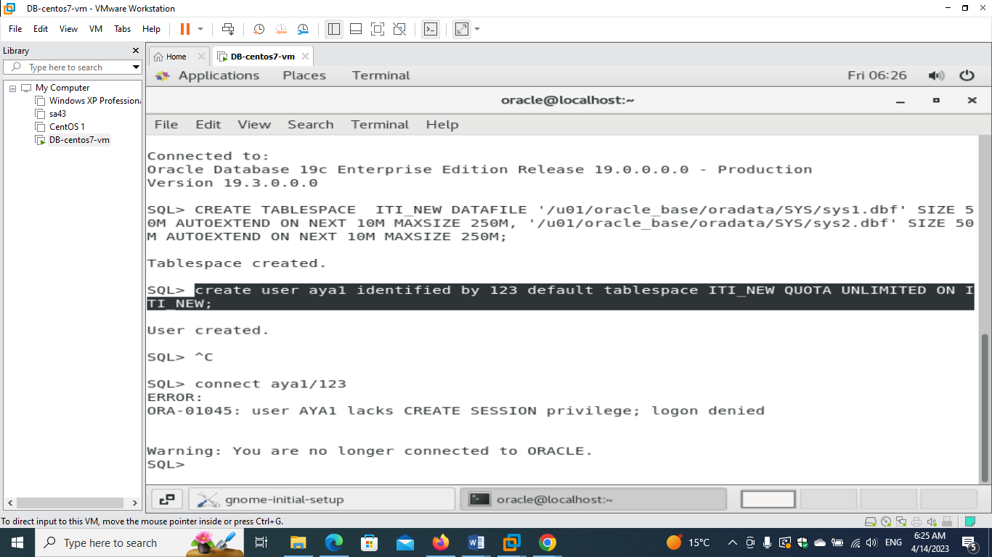

**- give the new user connect, resource and create view privilges.**

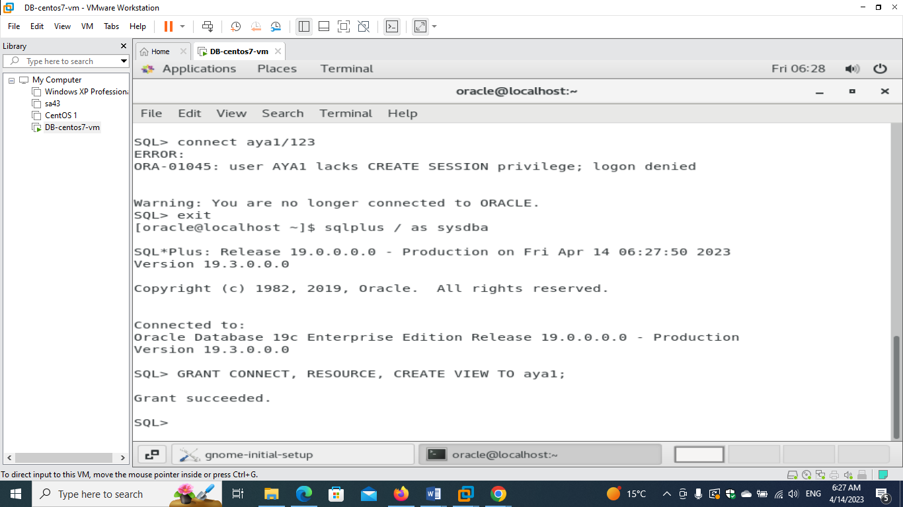

**- try to connect with the new created user.**

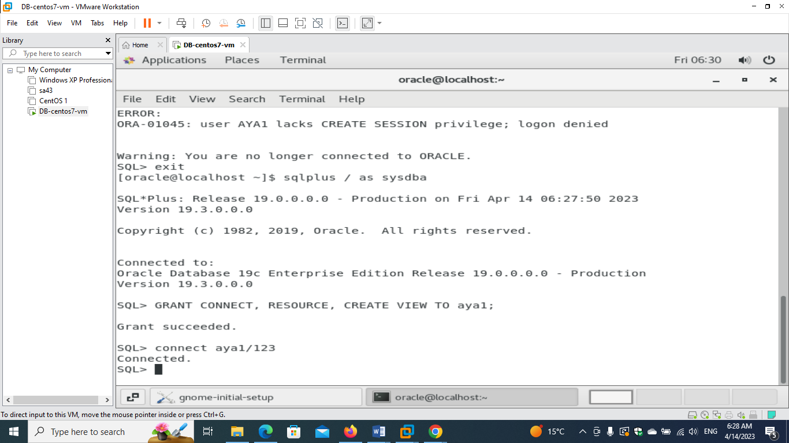

**- list all users exist in the system.**

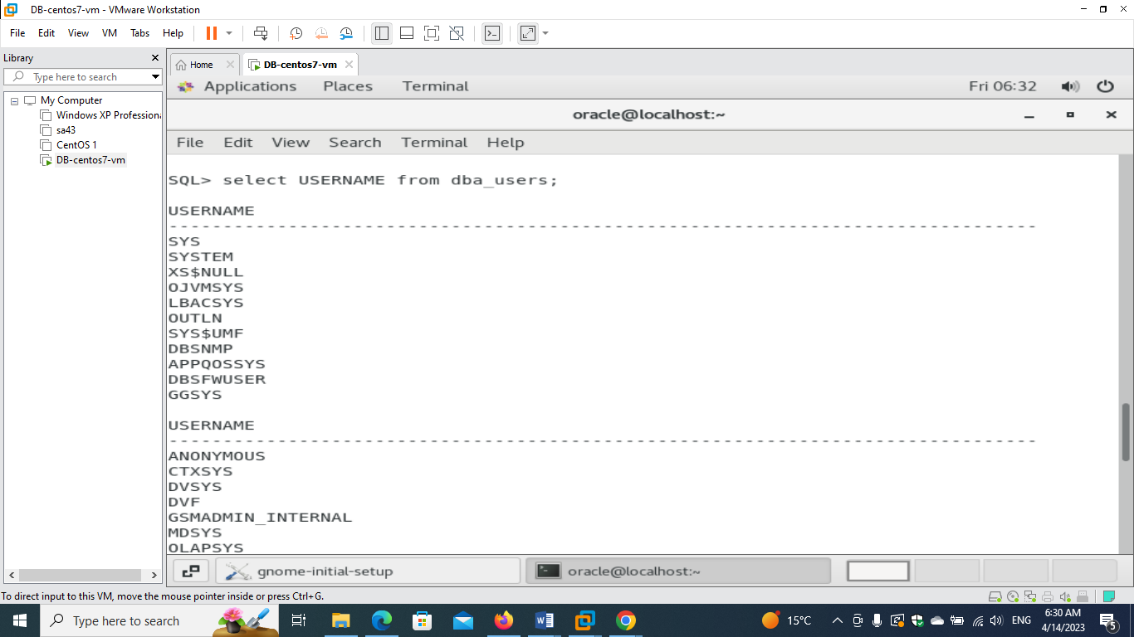

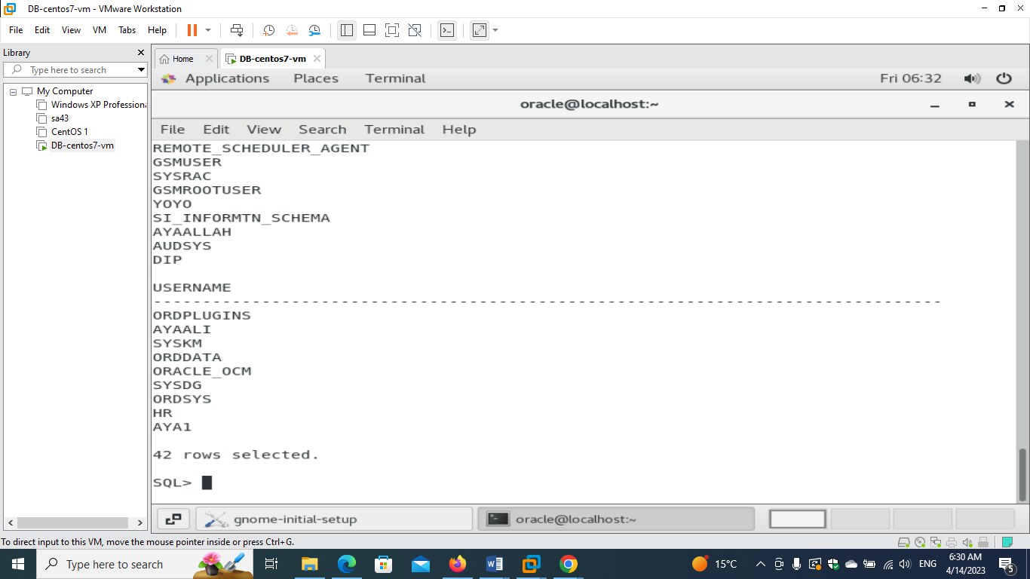

**- show the usernames, their passwords, their tablespace, their roles and their acccount status using the views "dba_users" and "DBA_ROLE_PRIVS"**

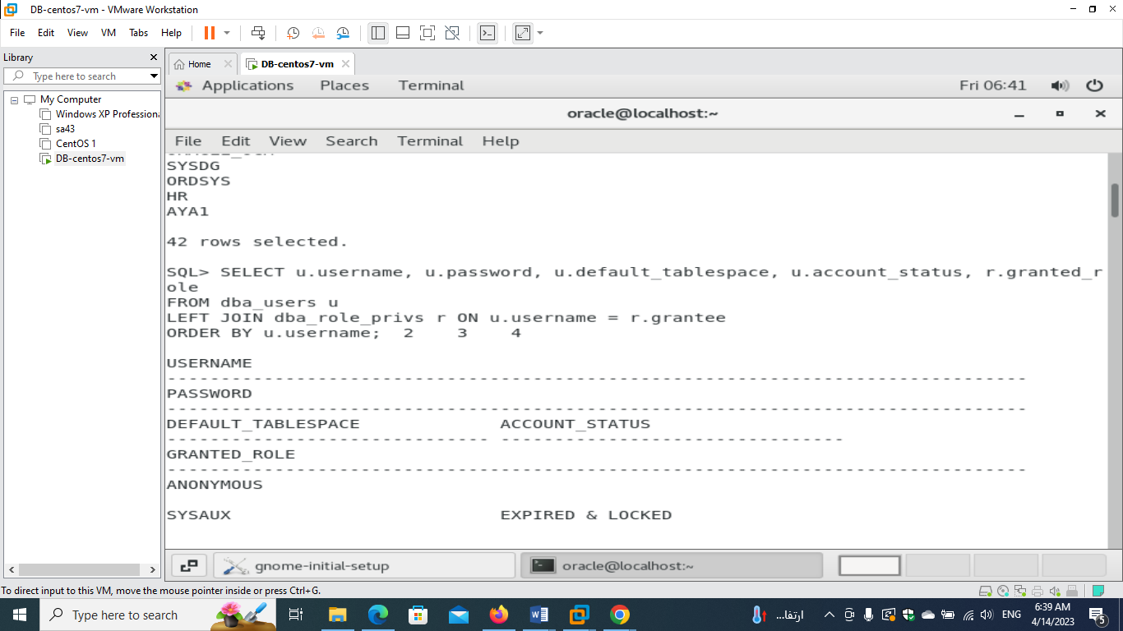

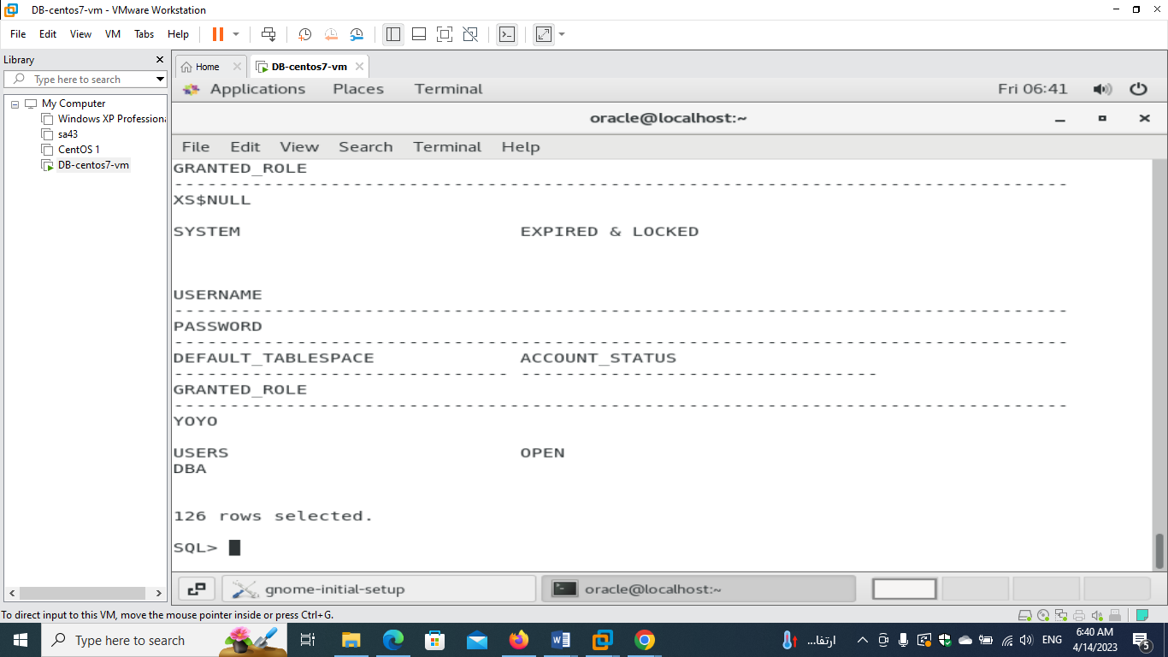

**- create new role <your_name>_role by sys user , and grant select any table to this role.**

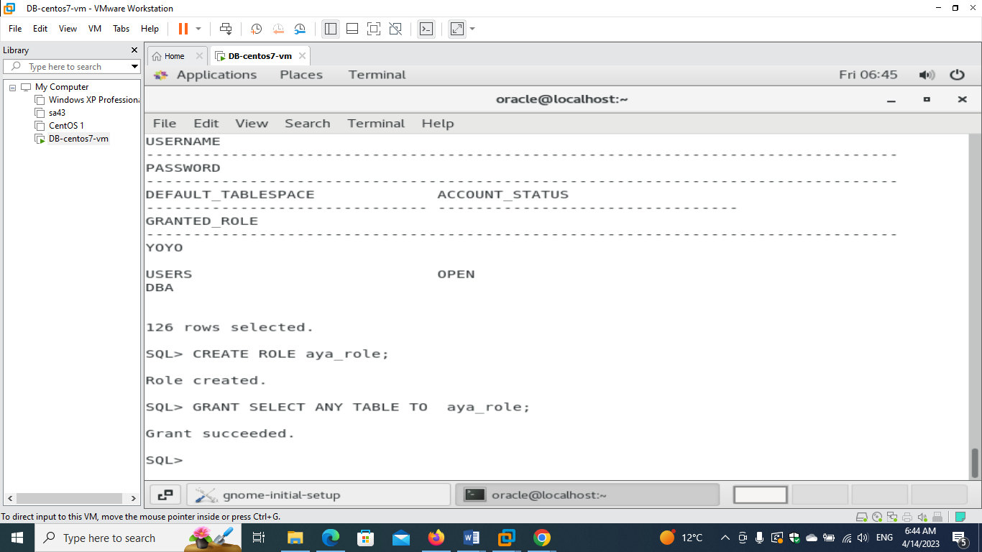

**- assign this role to the new user**

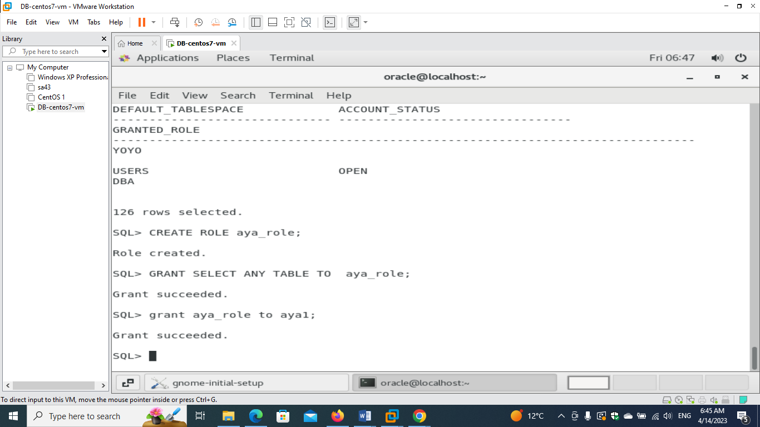

**- create new profile <your_name>_prof and make max number of failed login attempts=2.**

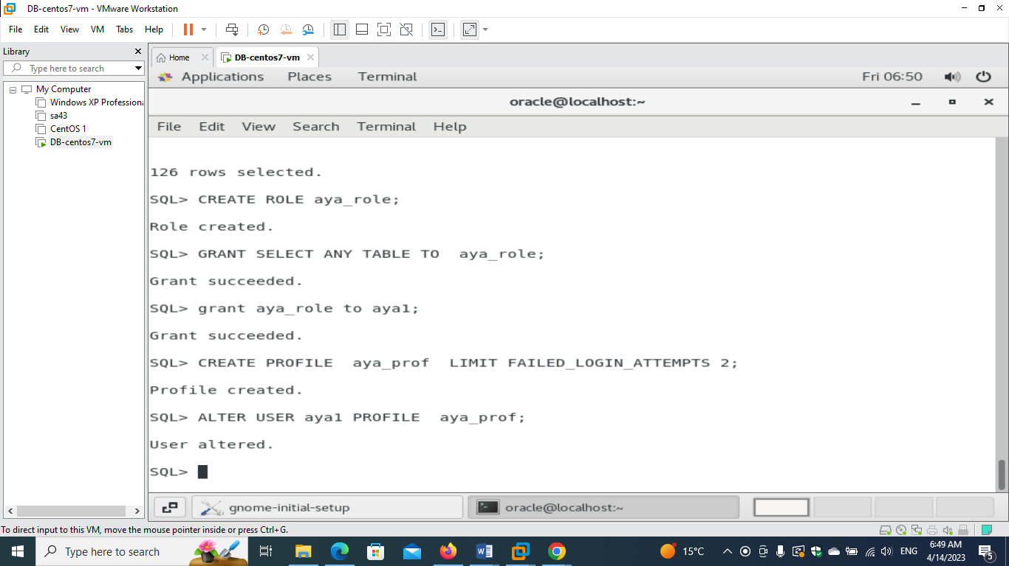

**- assign the profile to the new user**



**- enter wrong password three times , check if user is locked. then unlock it**

