**Name :Aya Allah Ali Abbas track : system admin**

**BY Sabreen Salama**

**C2 General**

**AWS LAB1:**

1. **Create aws account and set billing alarm**
2. 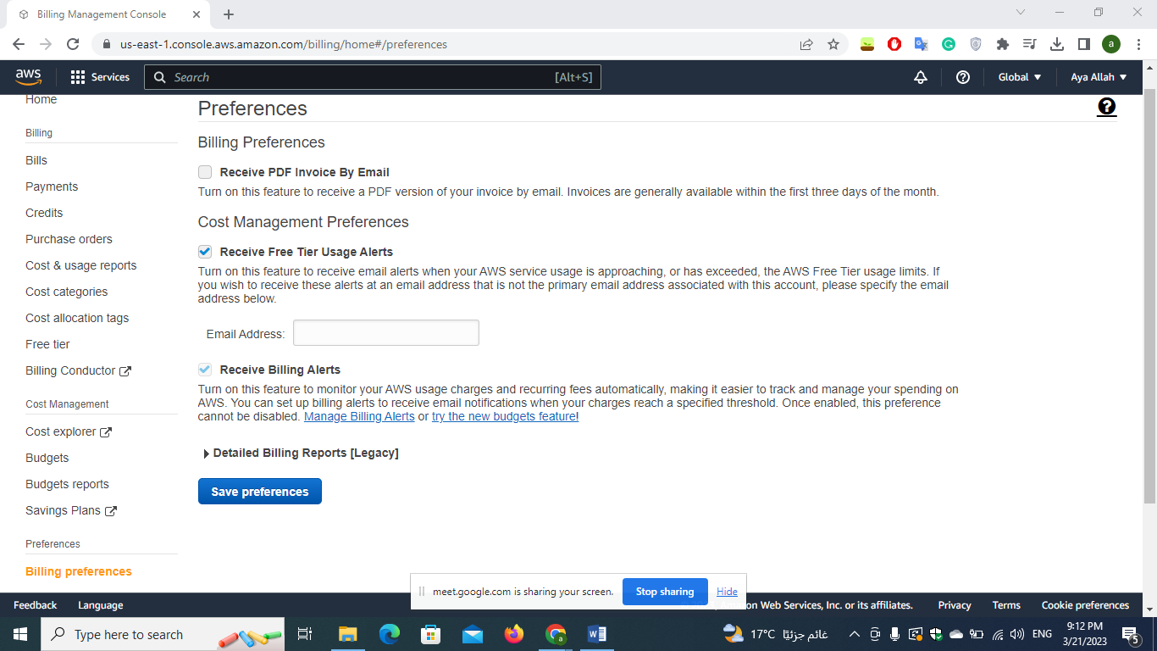

**2-**

**• create 2 groups one admin and one for development**

**• in the admin group it has admin permission , and in the development only access to s3**

***First Aya_Admin Group***

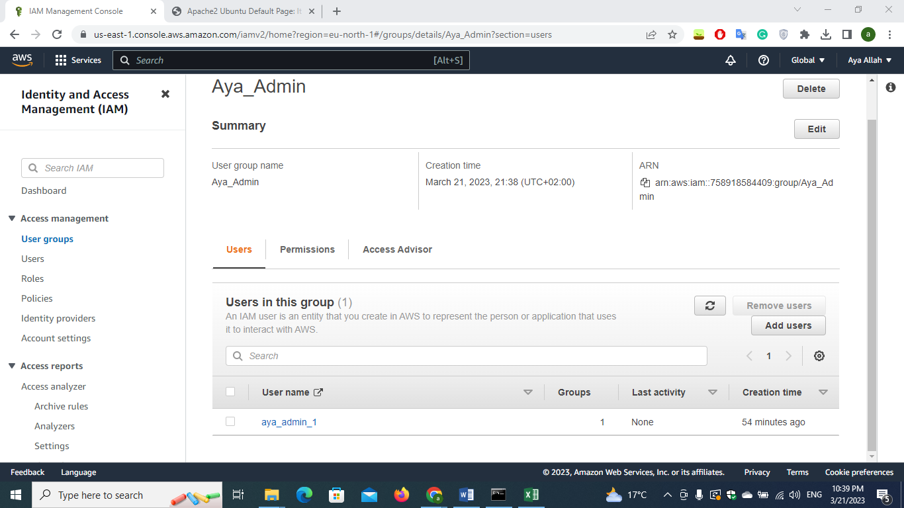

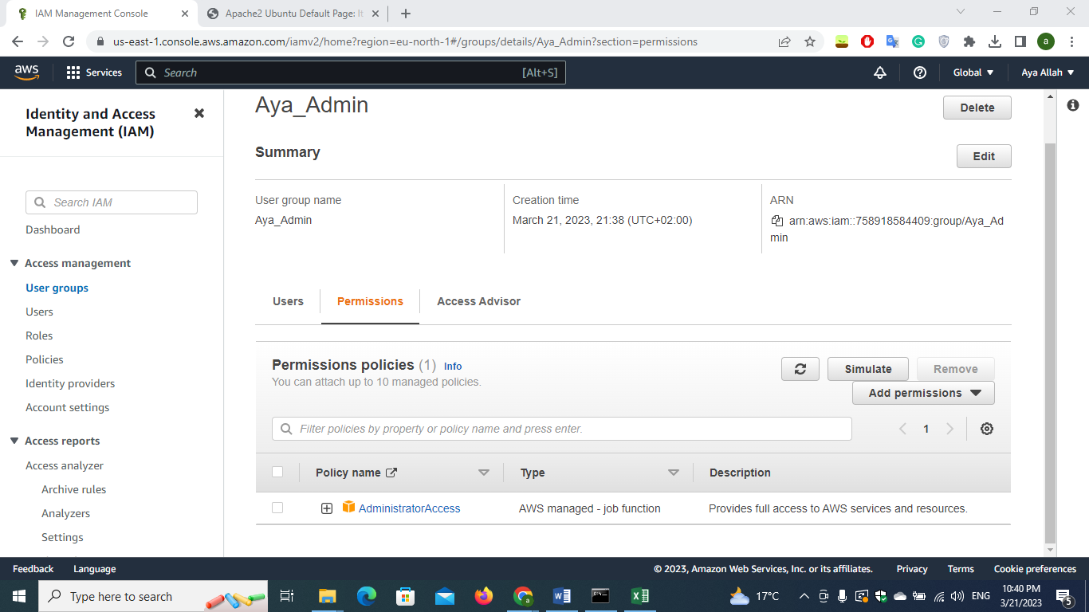

**Sec Aya_Development Group**

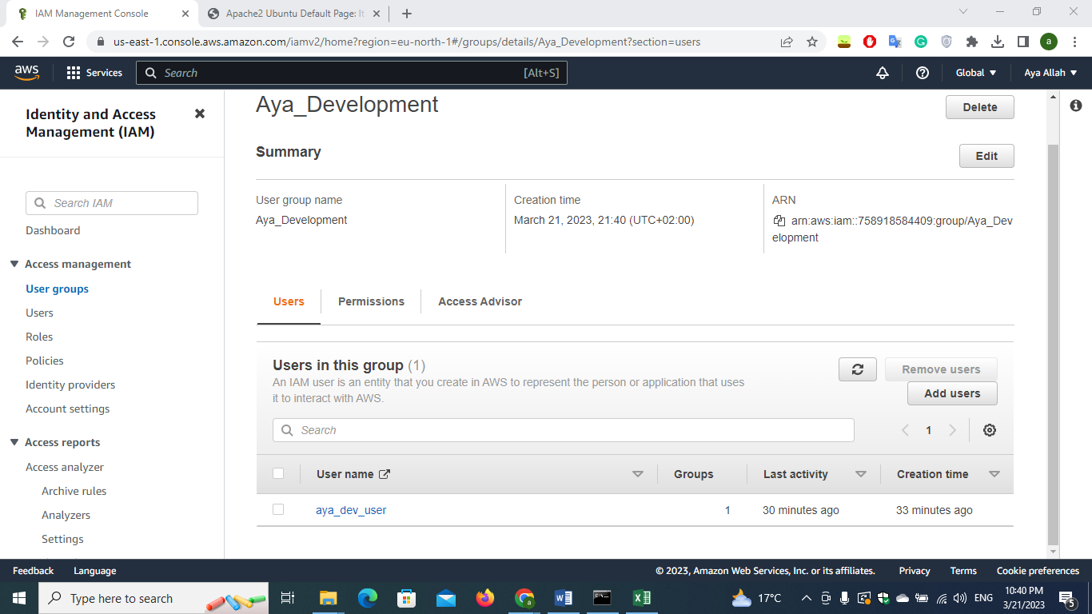

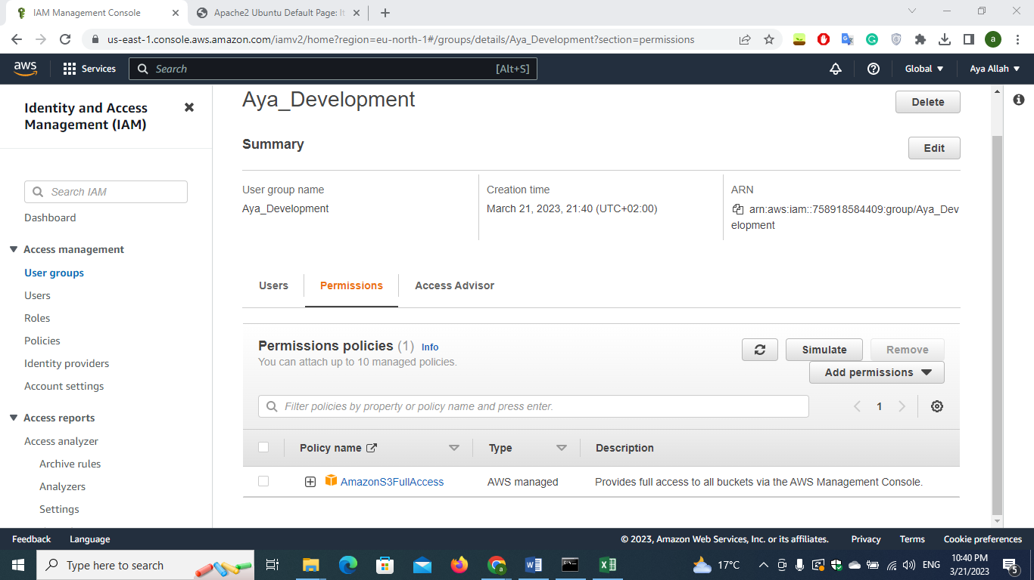

**• create admin-1 user console access and mfa enabled in admin group**

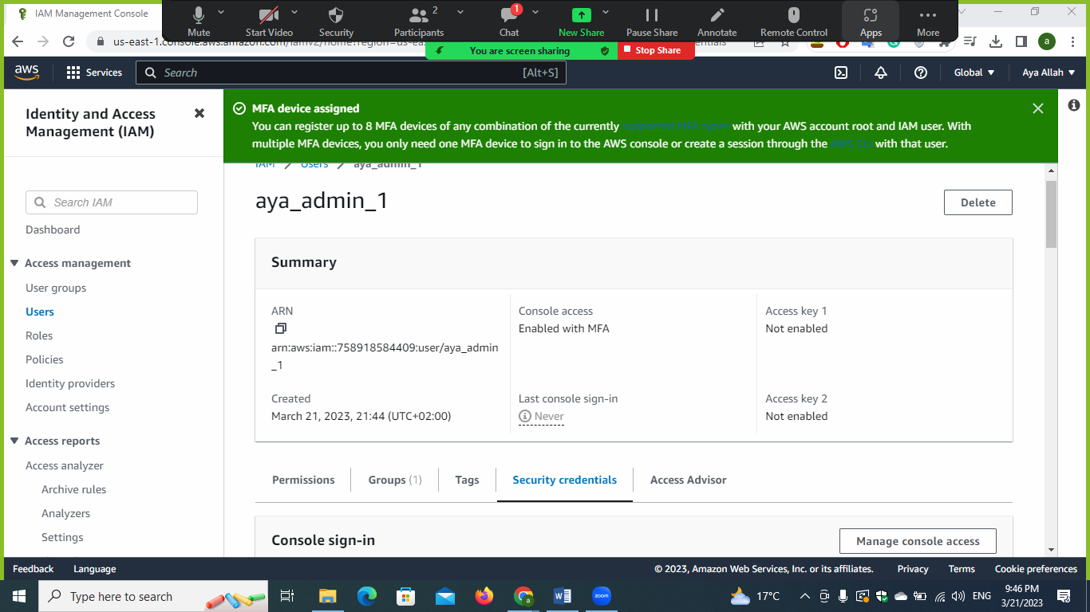

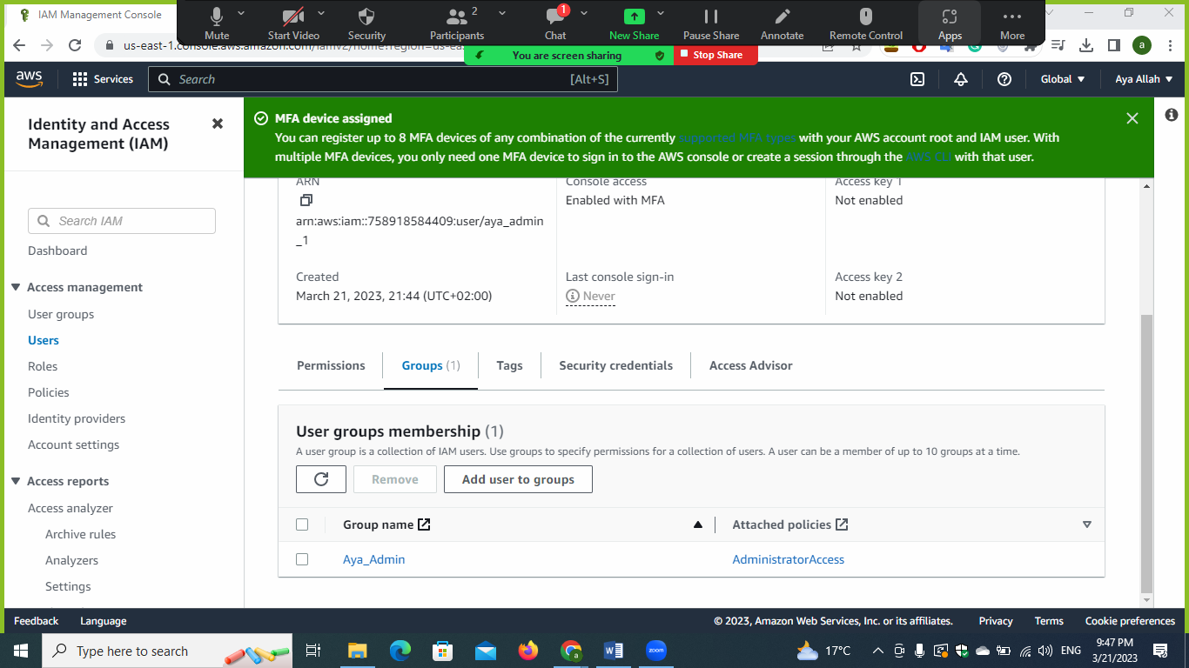

**• and admin2-prog with cli access only and list all users and groups using commands not console**

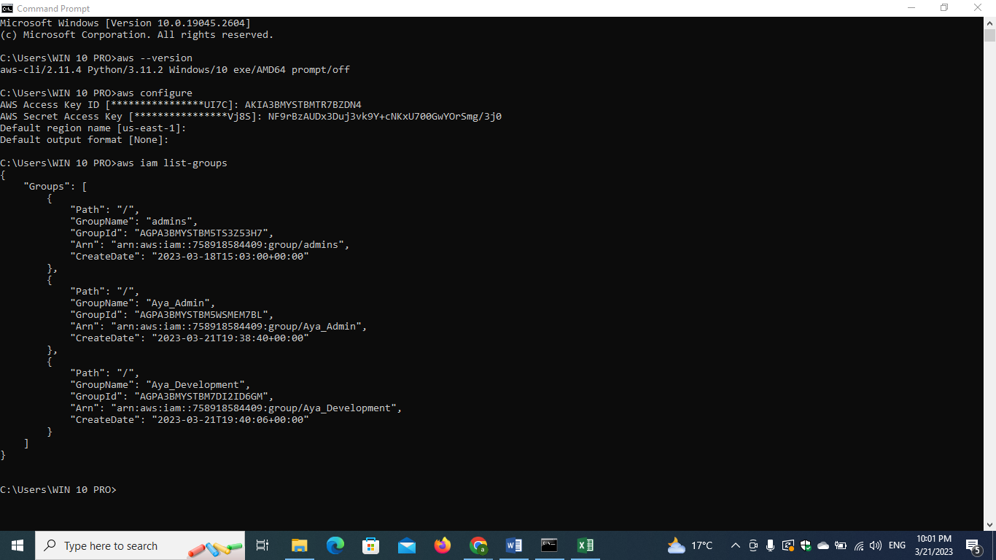

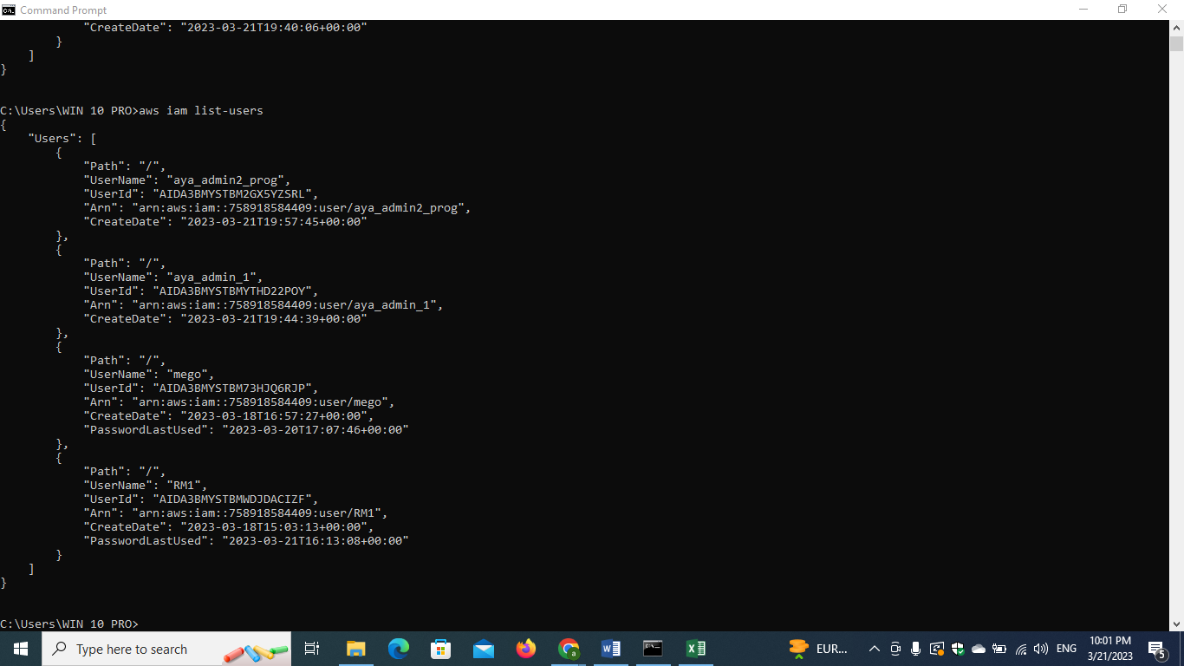

**• in the development group create user with name dev-user with programmatic and console access then try to access aws using it (take a screenshot from accessing ec2**

**and s3 console)**

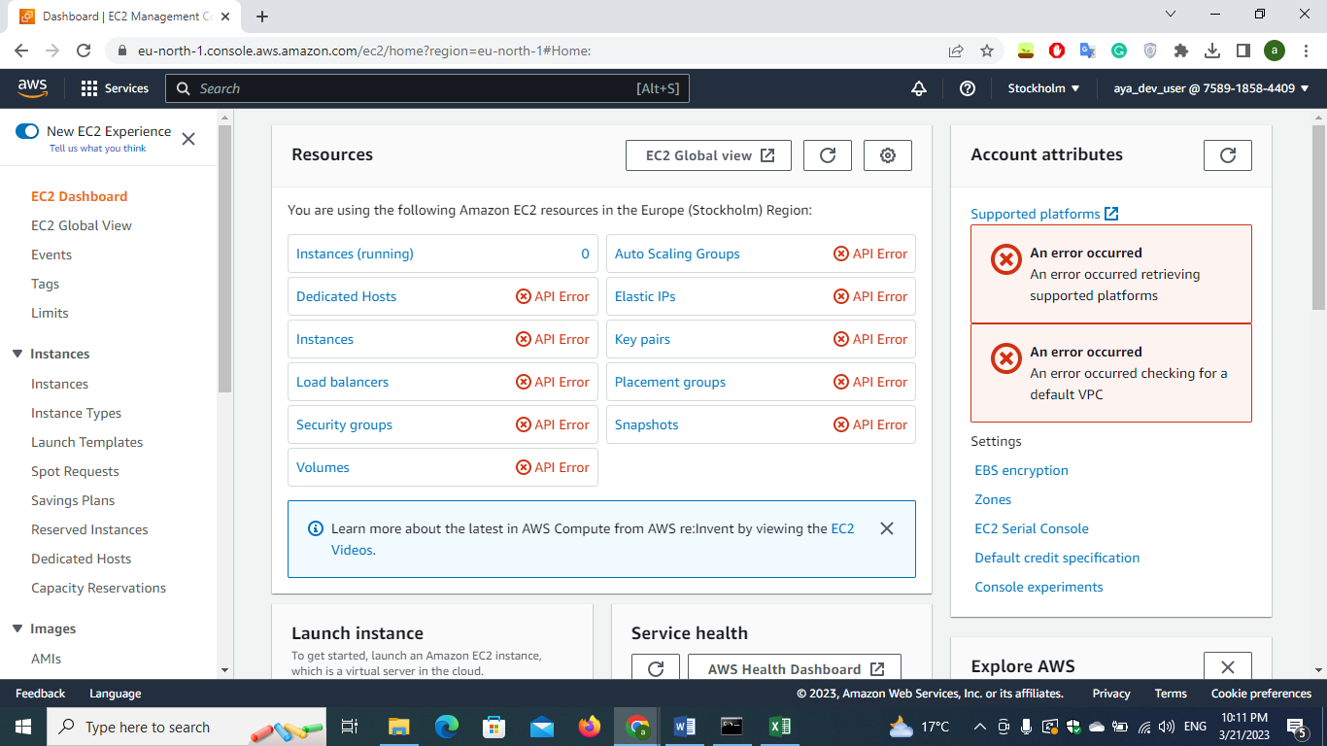

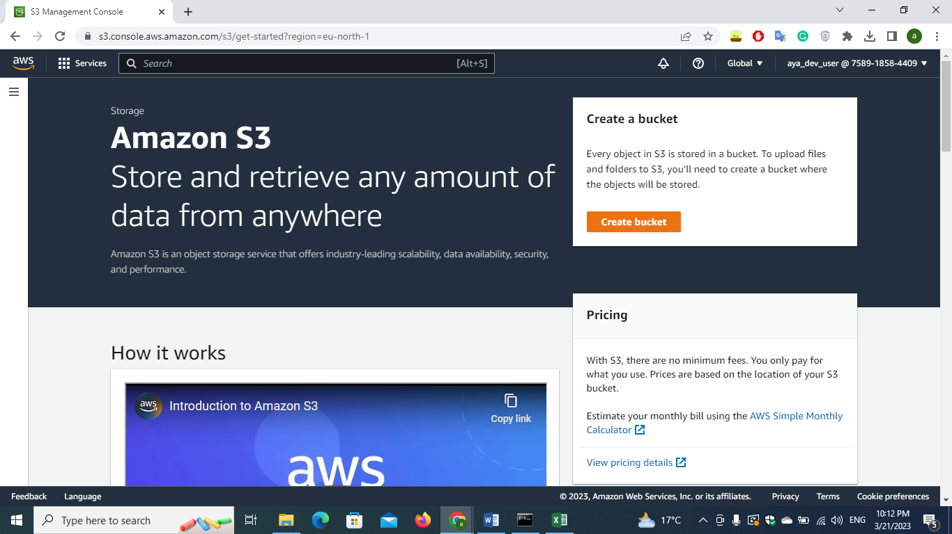

**• Also access cli using dev-user and try to get all users and groups using it**

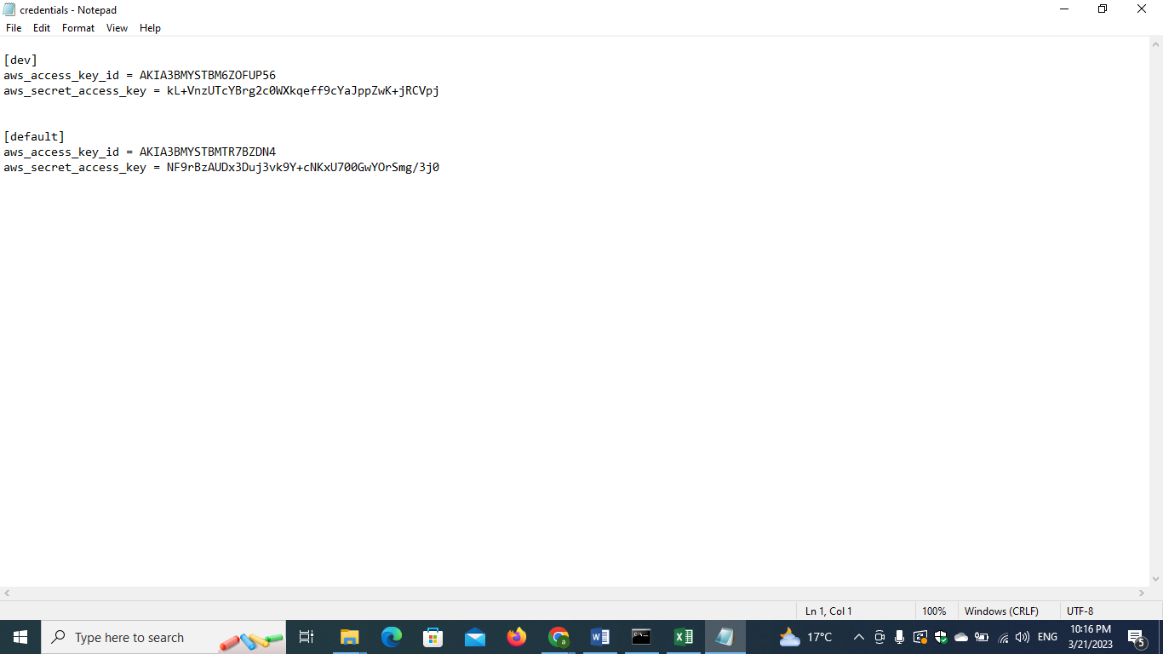

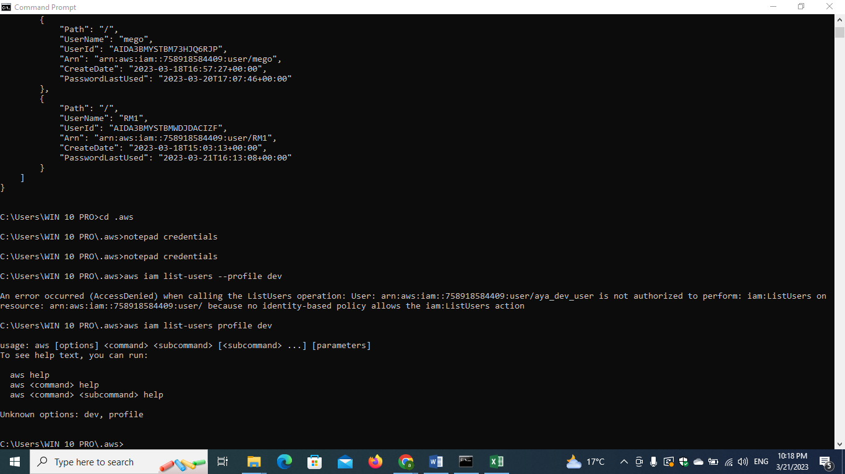

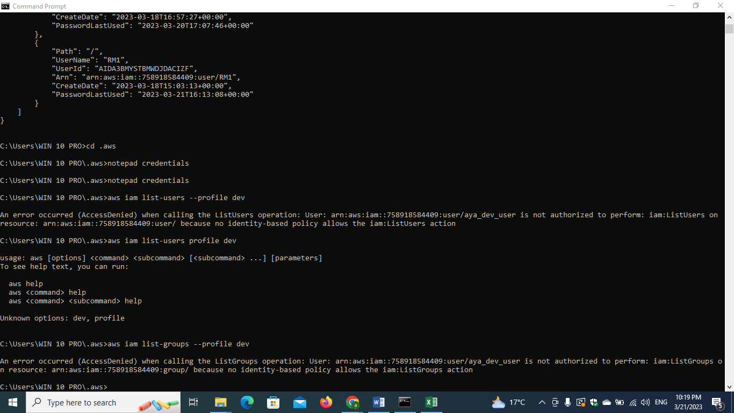

1. **Create ec2 and install apache2 on it.**

**Writing command on cmd through aws cli**

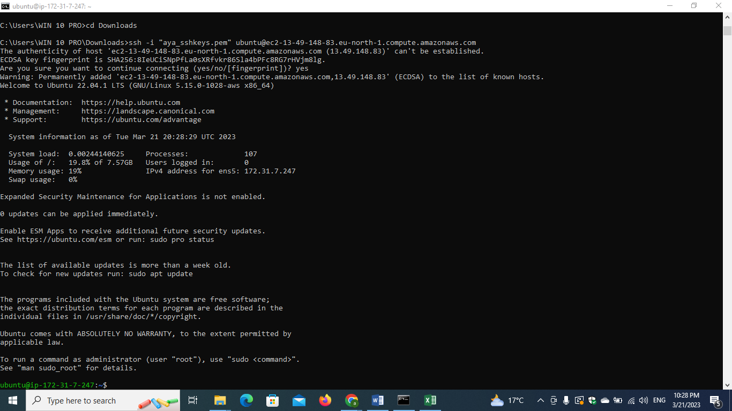

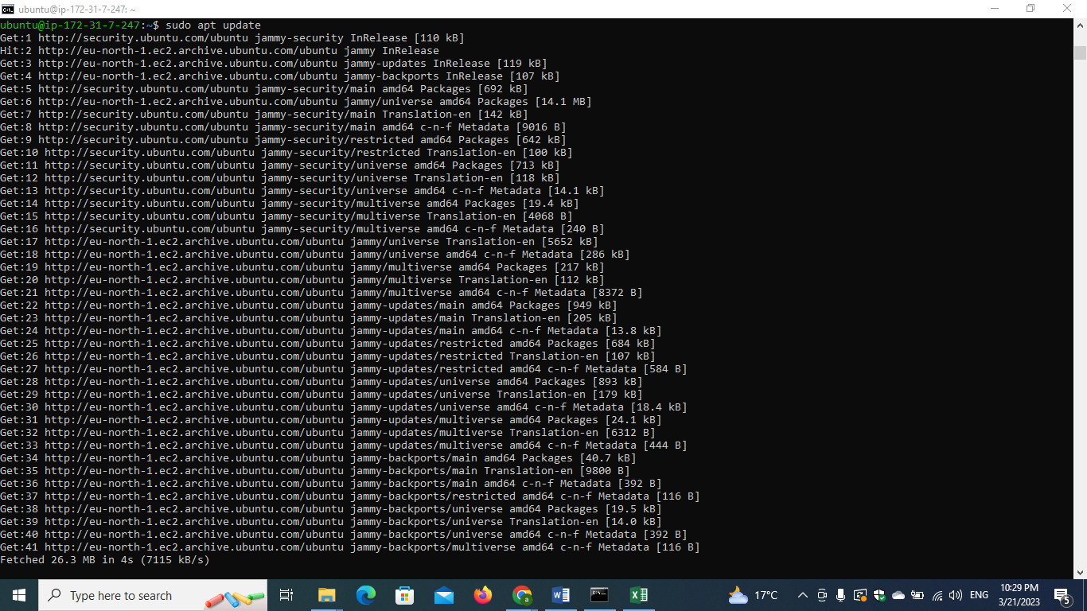

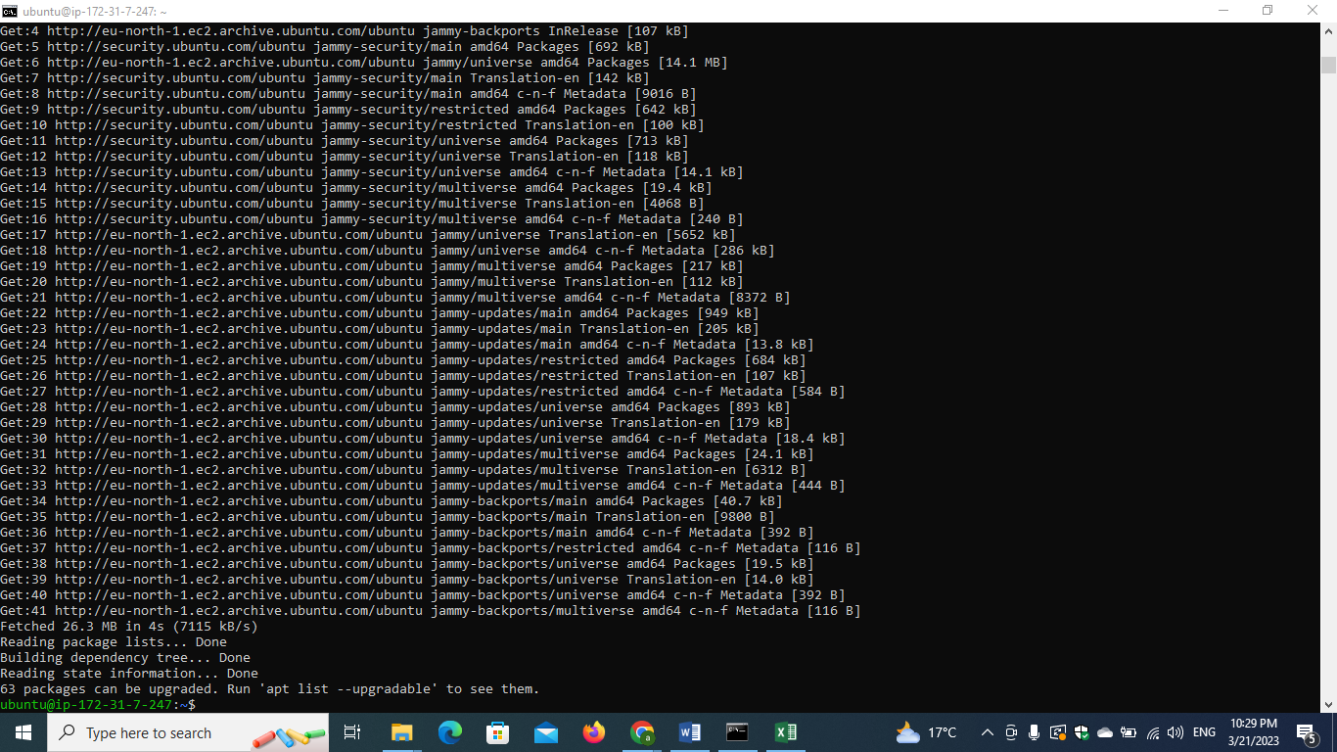

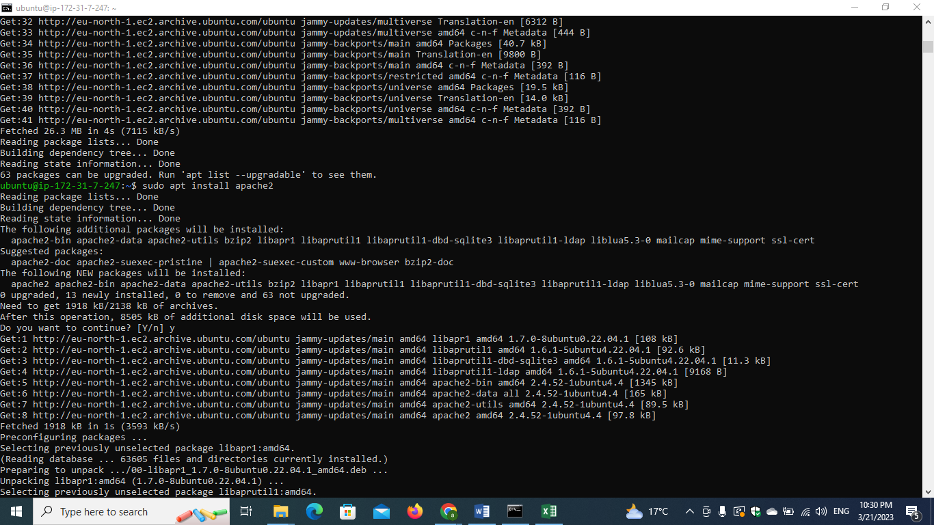

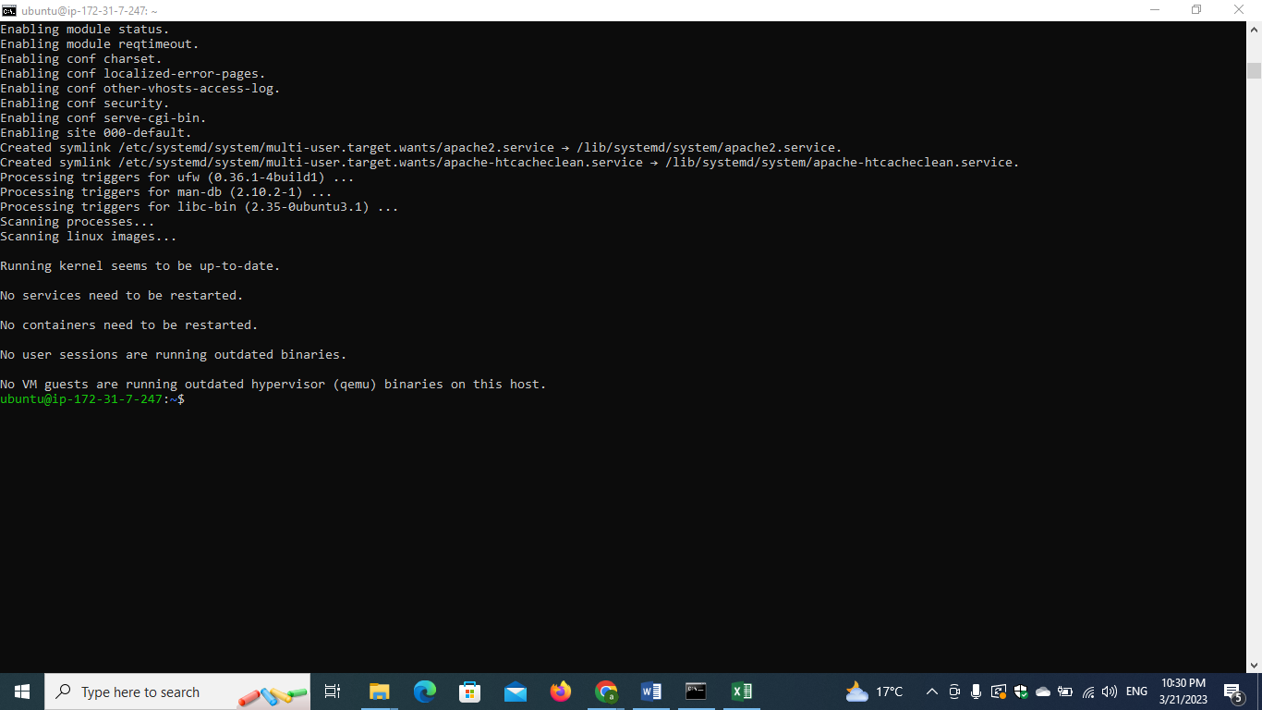

**The apache2 was installed but wasn’t accessible through the internet so I needed to use security group to open port 80 make it allowed so that the ec2 could accept traffic from that port**

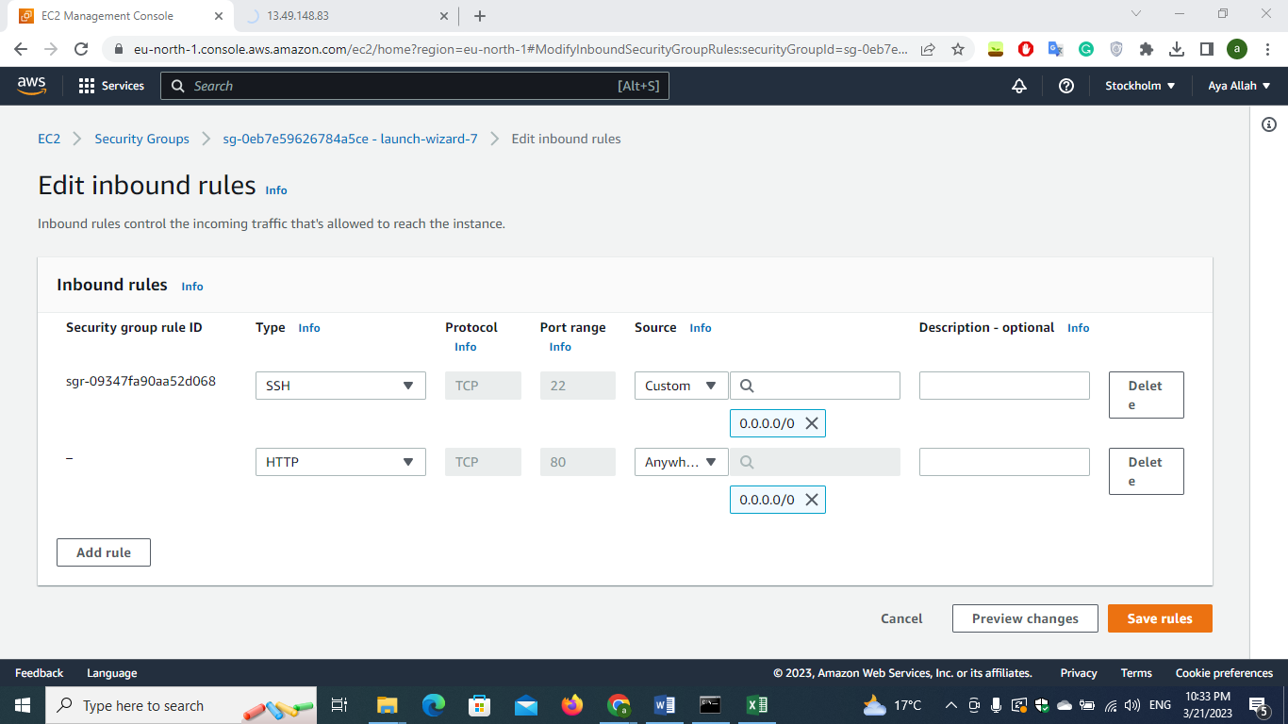

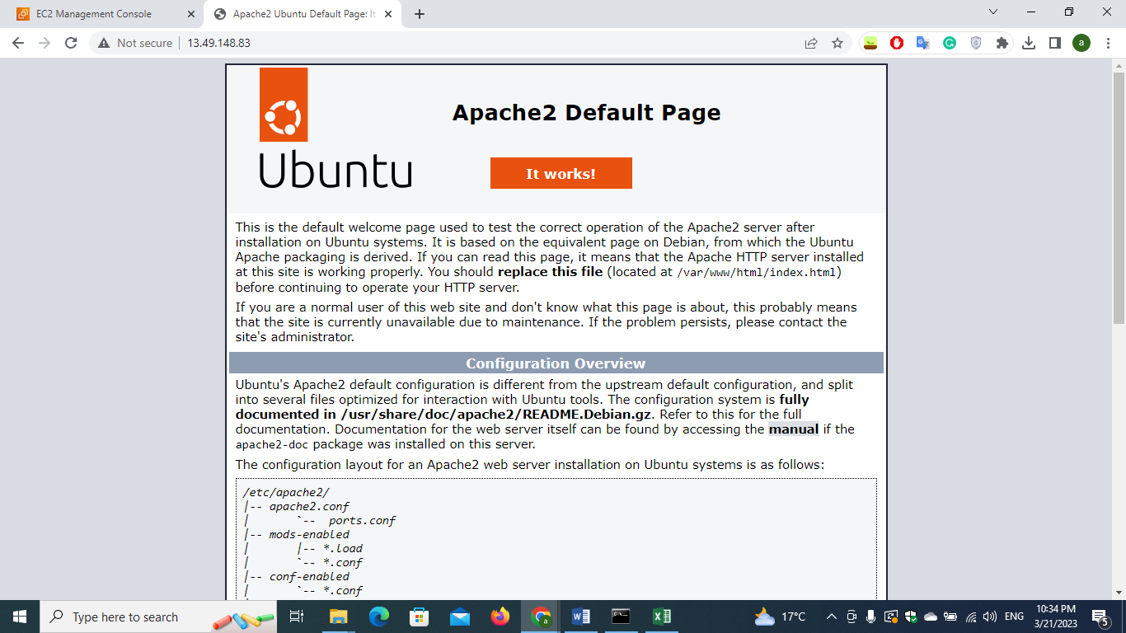

**Required:**

1. **Screenshot from each group with users and permissions attached to it**
2. **Screenshot from using dev-user to access ec2 and s3 from console**
3. **Screenshot from listing users and groups using admin2-prog**
4. **Screenshot from listing users and groups using dev-users**
5. **screenshot From accessing the machine public ip from the browser**