Name : Aya Allah Ali track: system admin

**Lab2**

1. **Create vpc**

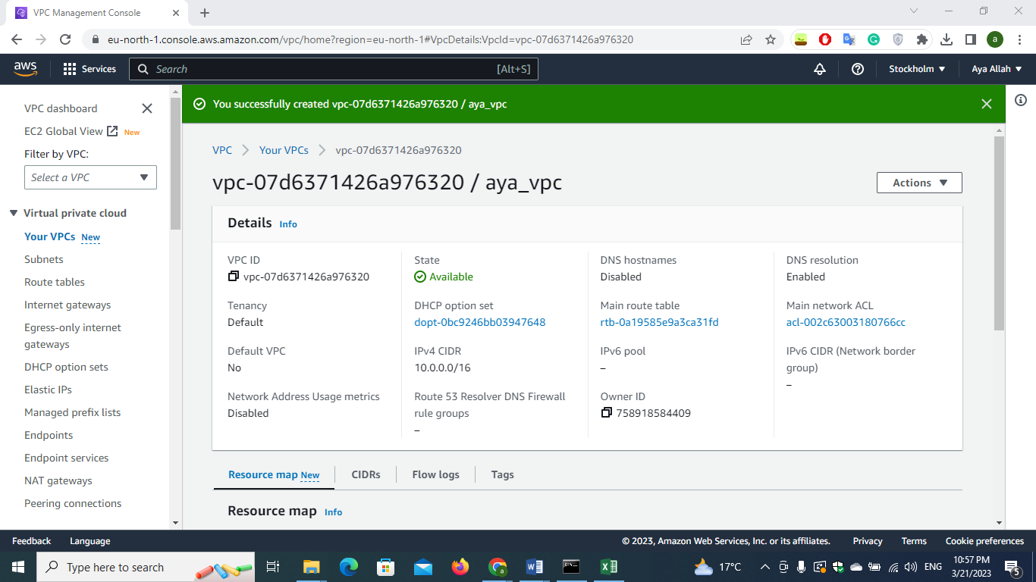

**2)create subnets**

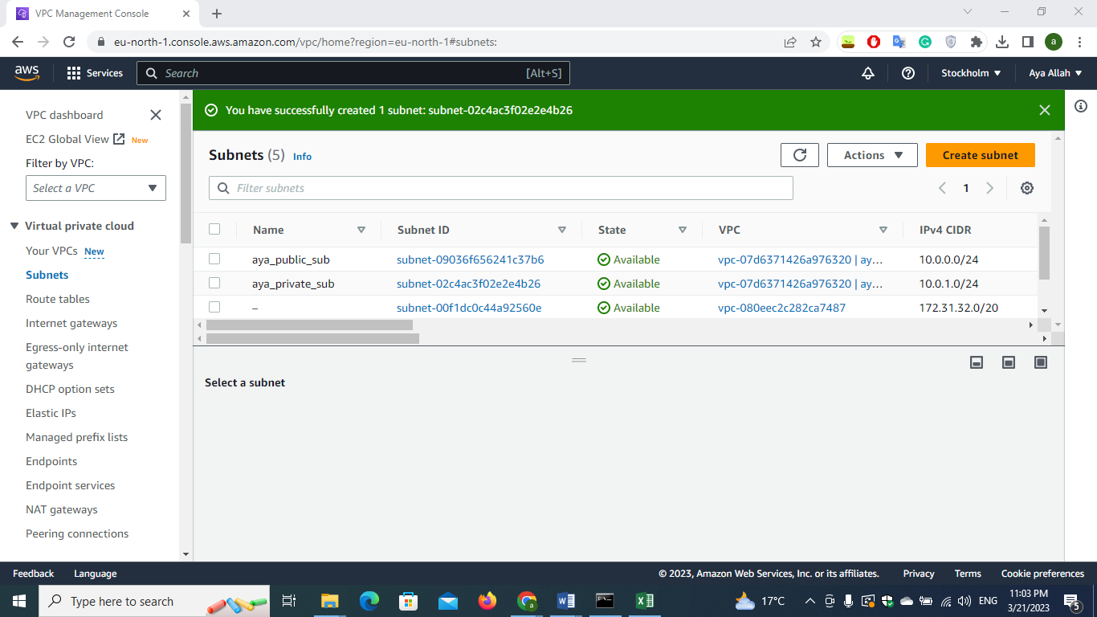

**3)create internet gateway and attach it to the vpc**

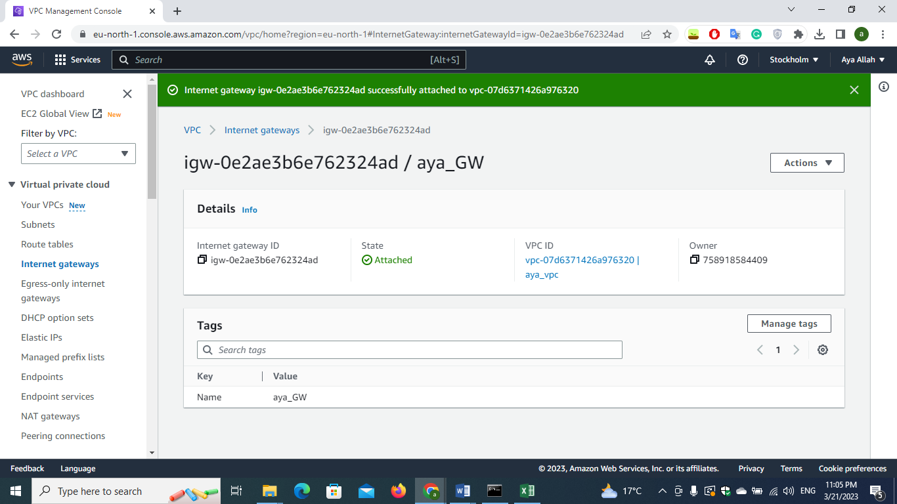

1. **Create route table for the public subnet and**

**make sure that there is access to the internet (0.0.0.0/0 🡪 internet gateway)**

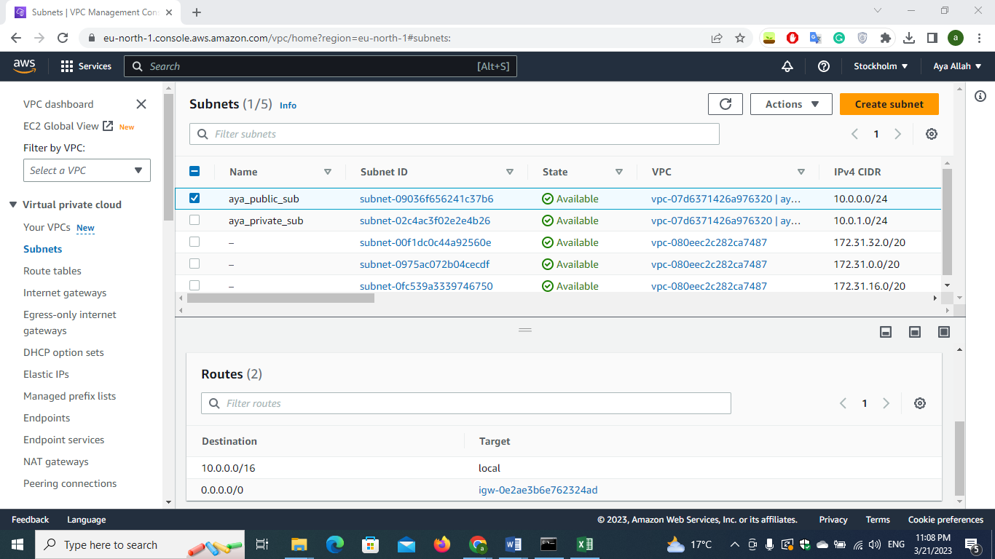

1. **Create route table for private subnet**

**First create the NAT GATEWAY in the public subnet and create private subnet table putting the NAT gateway to 0.0.0.0/0**

**And then attach the routing table to the private subnet**

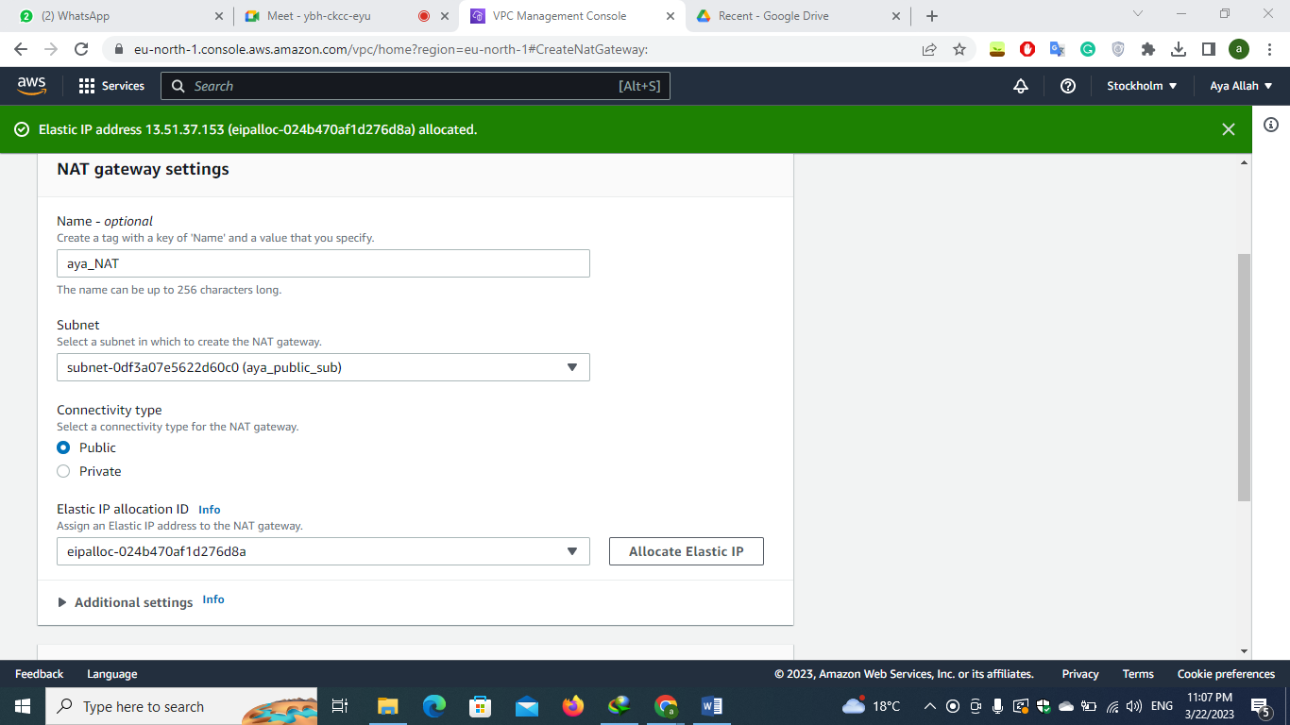

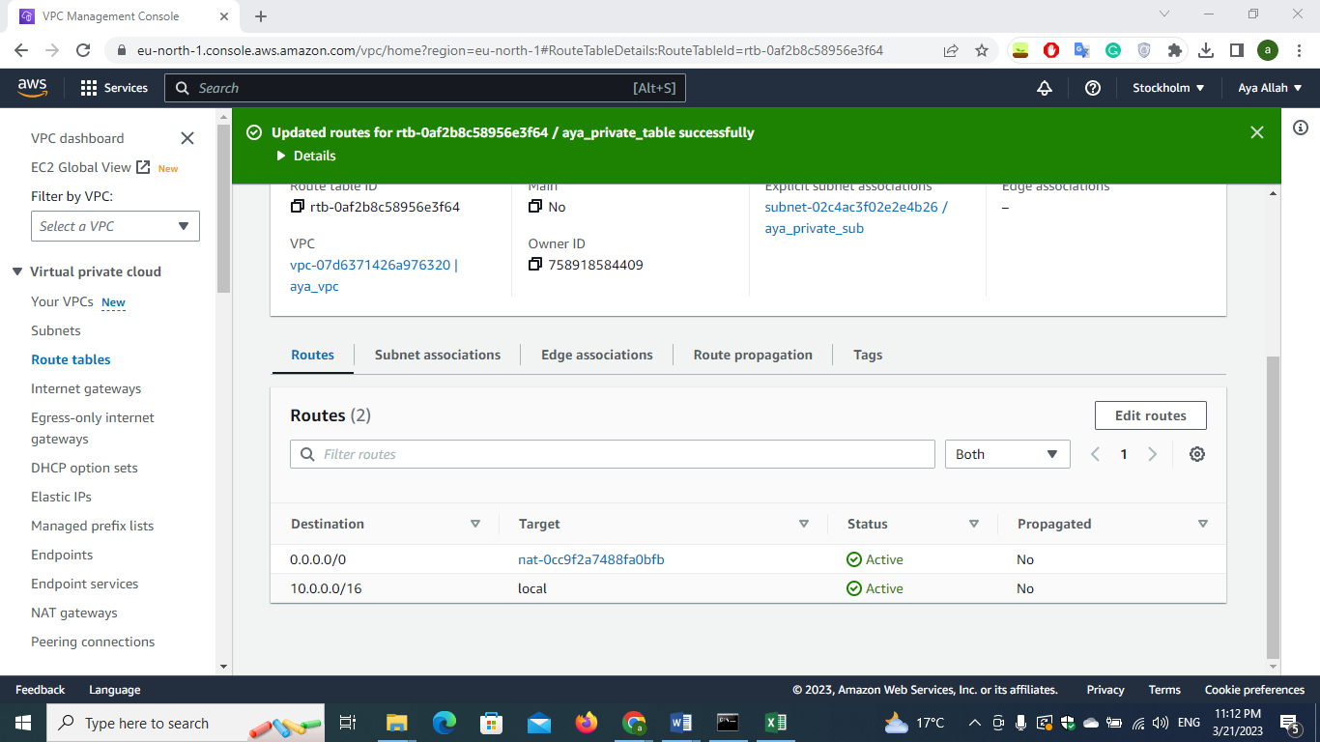

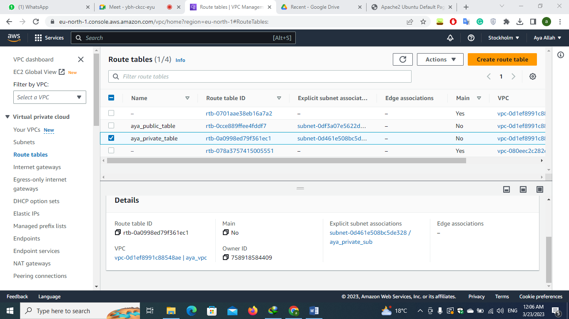

1. **Create instance using EC2 service**

**Instance in public subnet**

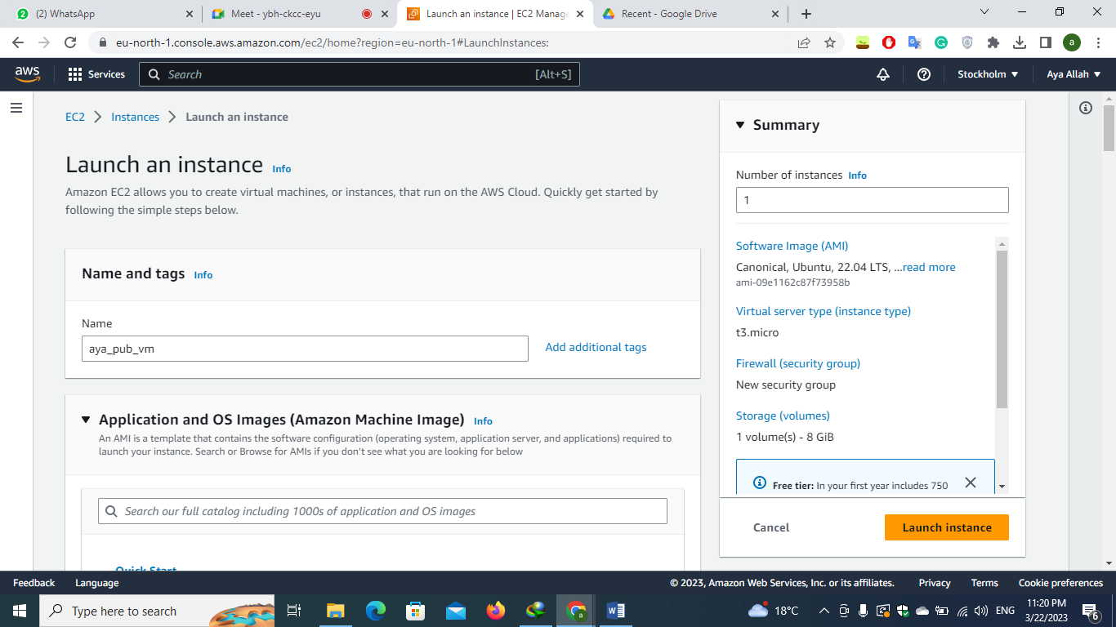

**edit the network setting so that the instance is in the vpc and in the public subnet**

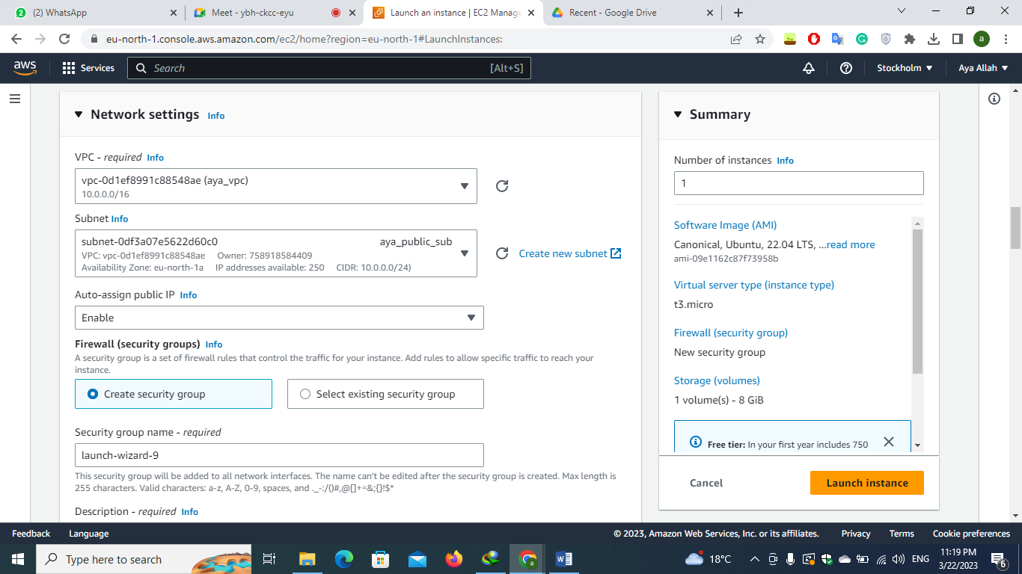

**add security group to allow http**

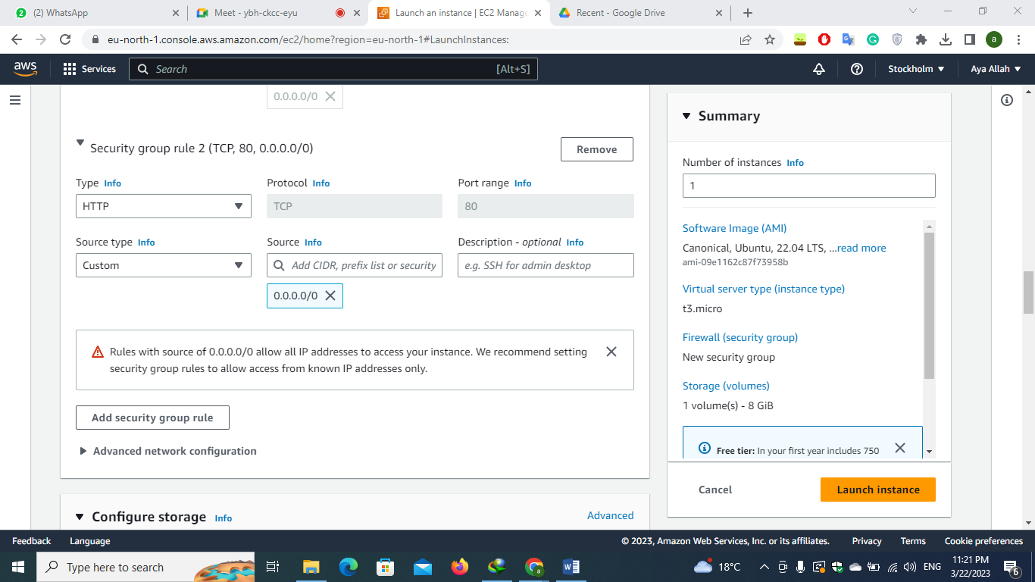

**Writing bash script to install apache2**

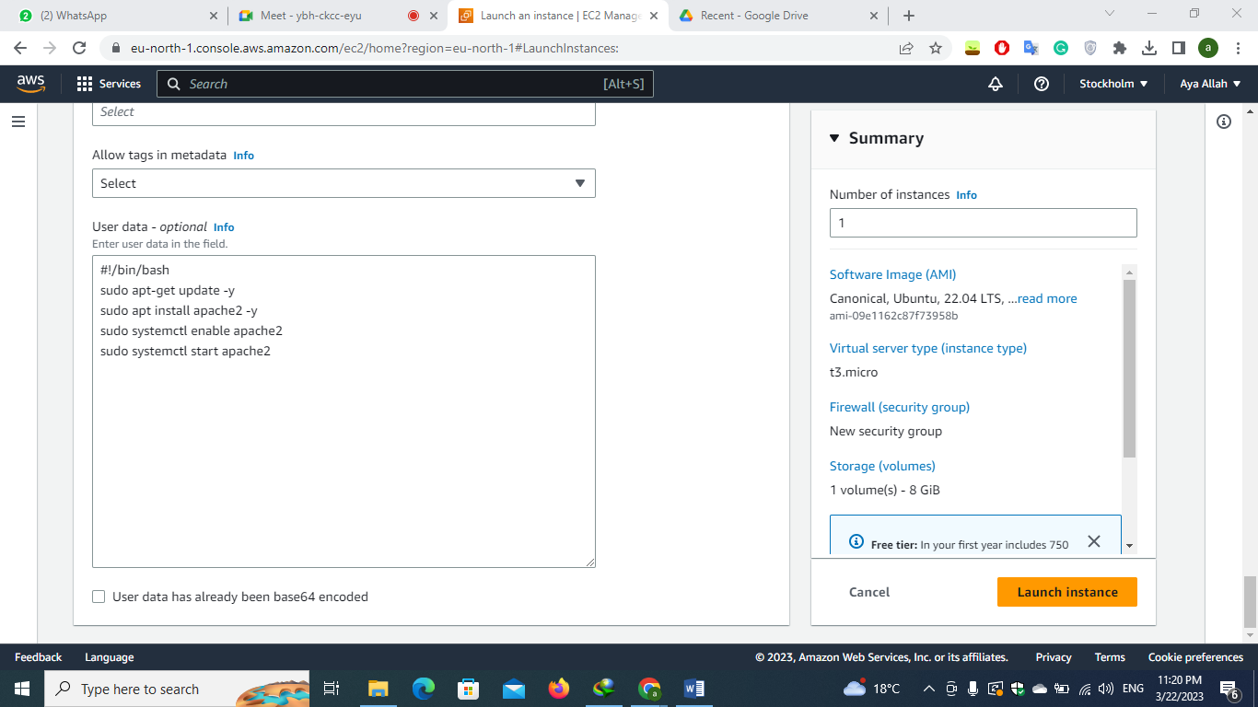

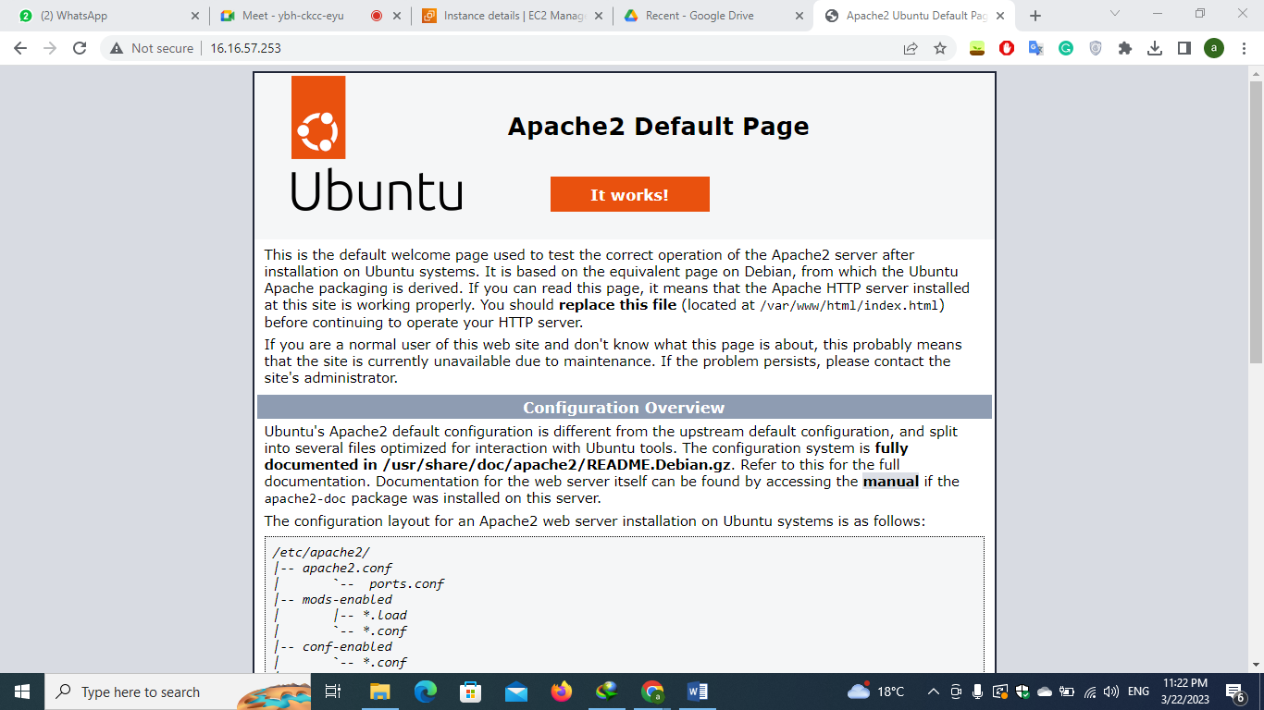

**Instance in private subnet**

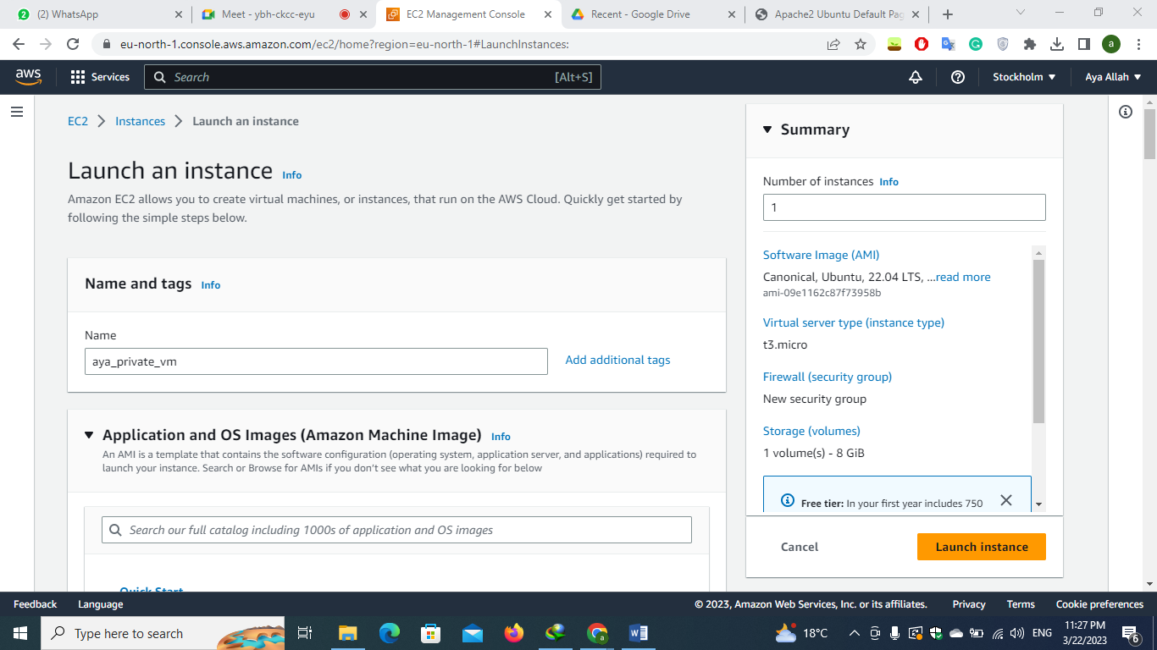

**edit the network setting so that the instance is in the vpc and in the private subnet**

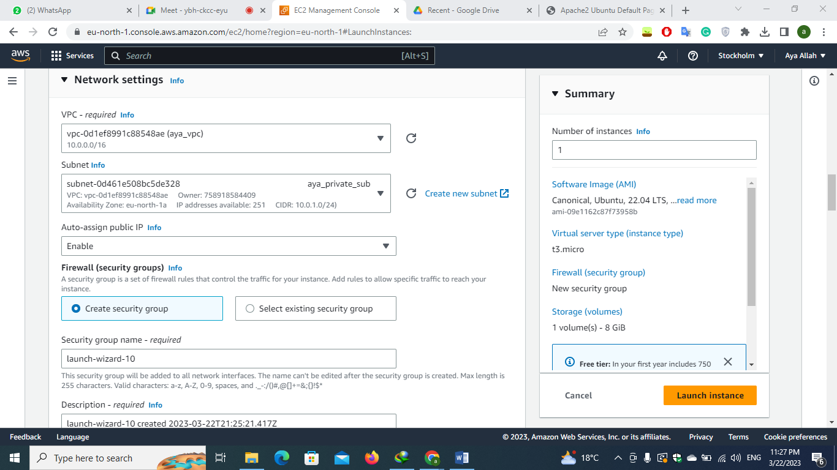

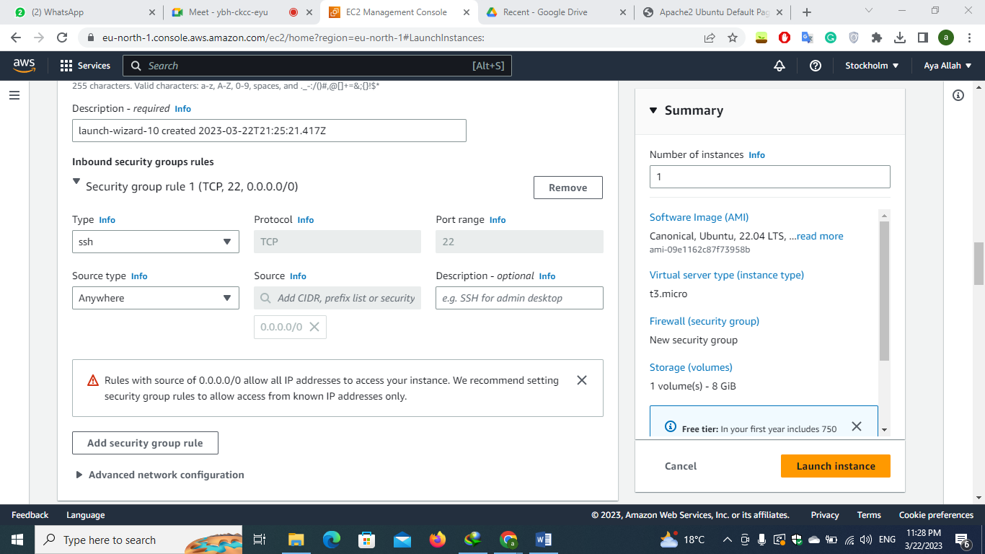

**Writing bash script to install apache2**

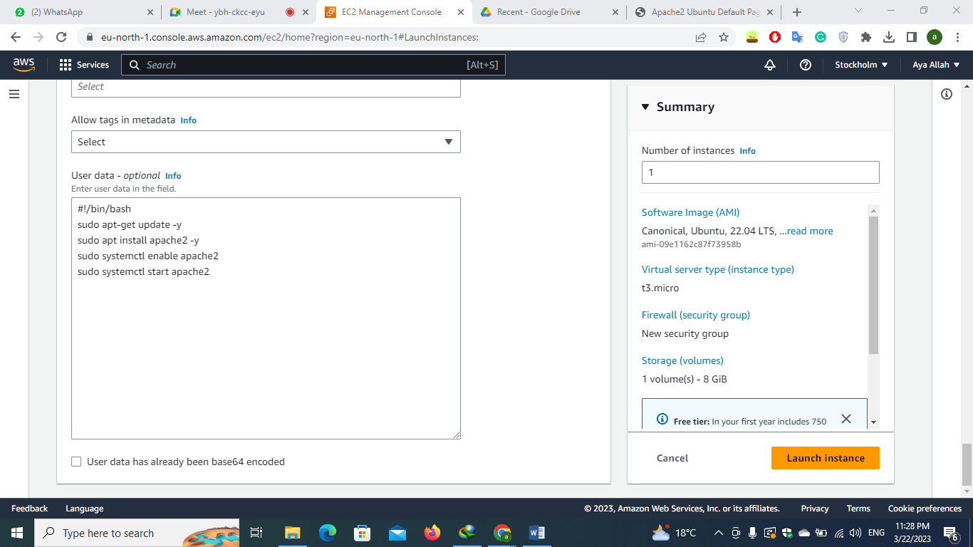

**The instance ip is 10.0.1.31 which is within the range of the private subnet /// after that check the logs**

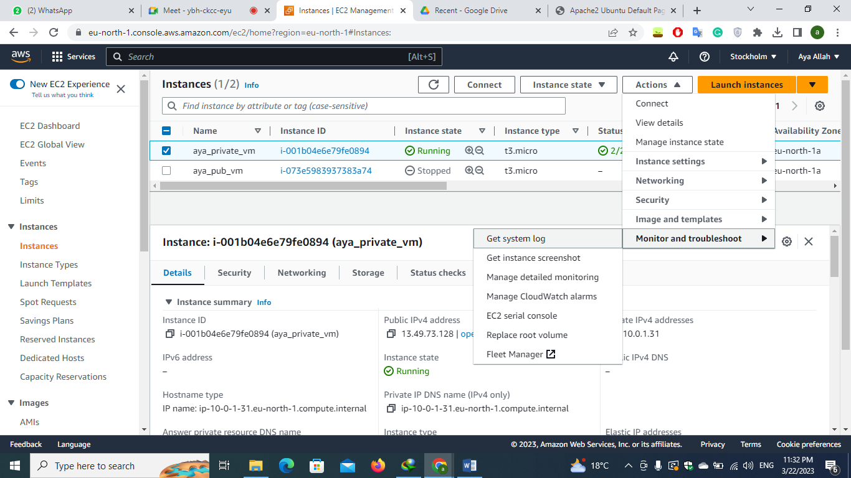 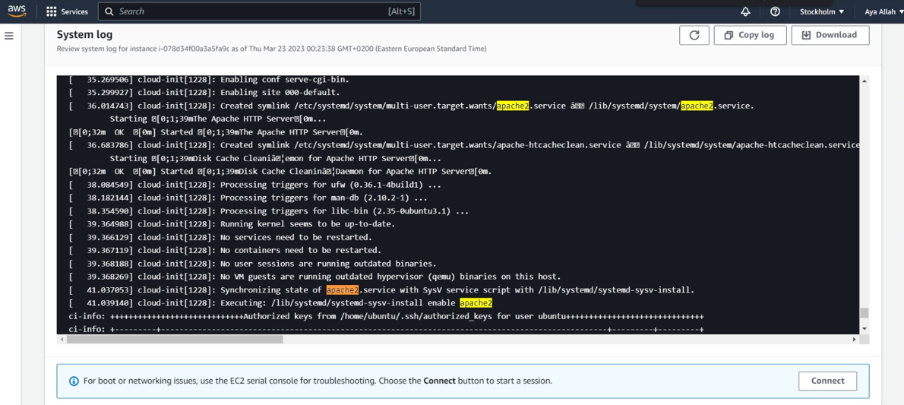

**After I terminated the instance I wanted to prove that the instance in the private subnet is not reachable as It can connect to the internet but you can’t reach through the internet so first I redo the entire lab once again :D I made sure the instance private ip is within the private subnet range**

**And also add security group to the instance allowing the http to test the reachability**

**I tried to reach the instance through the internet and I couldn’t**

**And I tried to reach it through connecting the instance (which is the same concept as SSH) and also couldn’t which proves that the instance is in private subnet 😊**

