Page de Garde

Development of a Web-Based CMMS Application

Acknowledgments

I wish, at the end of this work, to express my sincere respect and gratitude to the management of my institute:
Higher Institute of Technological Studies Sousse who offered me the opportunity to undertake this internship and enrich my theoretical knowledge in web development through practical experience, and to discover the professional environment.

Table of Contents

List of Figures

List of tables

General Introduction

As part of the training for future IT professionals, the Higher Institute of Technological Studies of Sousse (ISET) offers us the opportunity to undertake an end-of-study internship starting from february 6, 2024.
This report is the result of our internship carried out at the company "ketha ", aiming to synthesize our theoretical knowledge, refine our perceptions of our university curriculum, and draw upon our experience, while preparing us, under the best conditions, for professional life.
During this internship, our task was to ……………………………………………
To better define the work and explain the different steps taken, we have written this report, which will account for all the phases carried out for the implementation of our project.
The present report is structured around four chapters. We begin with the general context of our internship. In this chapter, we start with the presentation of the host organization, then we present the project to be carried out.
The second chapter, entitled " ……….", is dedicated to………………….
The third chapter, entitled "…………..", presents the various components of the MERN stack.
And we will conclude our report with the fourth chapter, which provides a description of the implementation stage of our project through the various graphical interfaces designed for the application.

Chapter 1:
General presentation

1.Introduction :
We present in this chapter a preliminary study of the project. First, we let's present the internship environment. We then describe the problem, as well as the main objectives of the project.

2. Presentation of the host organization:

1.1.Problematic and objectives :
The maintenance management process in many organizations is often plagued by inefficiencies, such as manual record-keeping, lack of real-time data access, and disjointed communication channels. This leads to increased downtime, higher operational costs, and underperformance of critical assets.
objectives :
1-Development of a Web-Based CMMS Application
2- Asset visibility
3- Workflow visibility
4- Real-Time Data Accessibility
5- Work Order Management Enhancement
6- asset Management Optimization
7- Preventive maintenance
8- Consistency and knowledge transfer
9-track available employees
10- Scalability and Integration
11-reduce maintenance cost
OR
*Structuring Corrective Maintenance Management
*Structuring Preventive Maintenance Management
*Structuring Spare Parts Management
*Building Documentation

CHAPITRE 2 :
Theoretical Study

1.Introduction :
In the industrial environment, there is a large and complex inventory of machinery and equipment, each requiring meticulous maintenance for optimal functionality. High security requirements, coupled with the imperative of reducing operating costs while ensuring equipment availability, underscore the critical role of maintenance services. These services are tasked with intervening only when faults arise, minimizing repair time and costs, and delivering clear diagnoses despite the intricate nature of the equipment.
This introduction sets the stage for our exploration of maintenance management practices and Computerized Maintenance Management Systems (CMMS). Through a theoretical study, we delve into key concepts, methodologies, and frameworks essential for understanding effective maintenance management. By examining established theories and industry standards, we establish a solid foundation for comprehending the guiding principles that underpin efficient maintenance management.

2.1 Generalities on Maintenance
2.1.1 Definition of Maintenance
Maintenance encompasses a range of activities aimed at preserving or restoring the functionality of a system or product. This includes tasks such as testing, measurements, replacements, adjustments, repairs, inspections, testing, servicing, and more, all intended to maintain material or equipment in a serviceable condition or to restore it to such a condition. Ultimately, maintenance ensures that a system or product can perform its required functions reliably over time.

2.1.2 Objectives and Strategic Challenges of Maintenance

Maintenance services play an indispensable and crucial role within industrial organizations, ensuring the smooth operation of production lines and equipment. The primary objectives of reliable and efficient maintenance are:
. To reduce the cost and non-quality issues of equipment that lead to production stoppages or malfunctions in production tools.
. To enhance productivity by implementing industrial maintenance management tools and methods that yield better performance.
. To ensure the availability of company equipment at the most suitable and optimal cost.
. To promote the quality of equipment and production tools in the industrial environment.
. To address all constraints related to quality, safety, and the environment.
. To control breakdowns caused by failures.
2.1.3 Different Types of Maintenance
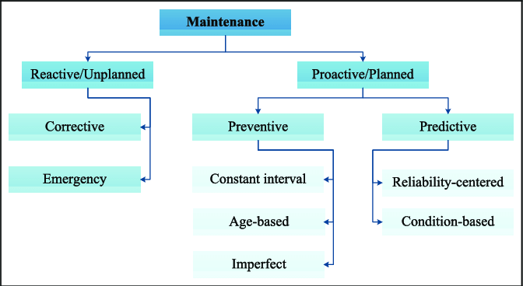
Several types of maintenance are commonly recognized:
Figure : The types of industrial maintenance

- Unplanned maintenance :

. Corrective maintenance : sometimes referred to as breakdown maintenance or reactive maintenance, is a type of maintenance in which machinery or equipment is fixed after it has broken down or malfunctioned. Corrective maintenance fixes problems as they occur and gets equipment back in working order, in contrast to preventive or predictive maintenance strategies, which try to stop failures before they happen.

- Planned maintenance :

. Preventive Maintenance: based on the idea of planned maintenance procedures. carried out on a scheduled basis to extend asset life and prevent equipment breakdown. The goal of preventive maintenance is to take care of possible problems before they become expensive malfunctions.

.Predictive Maintenance: is a proactive strategy that aims to foresee equipment failures and schedule maintenance ahead of time, utilizing data-driven methods such as condition monitoring, predictive analytics, and machine learning algorithms. Unlike preventive maintenance, which relies on scheduled interventions, predictive maintenance leverages IoT devices and sensors to predict potential failures, allowing maintenance frequency to be minimized to avoid costly reactive strategies. This approach increases asset availability, reduces unscheduled downtime, and eliminates breakdowns before they occur.
2.1.4 Maintenance Levels

Maintenance level |  | Operations | Operator | Means
1 |  | simple interventions  ( not require the dismantling or opening of the equipment) | operator himself or by a non-specialized operator. | few spare parts or consumables.  + the available instructions, e.g. manual or visual instructions.
2 |  | less complex interventions  ( procedures are simple to follow ) | qualified technician | Standard tools and Spare parts located nearby
3 |  | interventions considered as complex | specialized technicians | using the tools indicated in the machine’s maintenance instructions
4 |  | complex and of great importance | technician or a team of specialized technicians with a specific qualification, and supervised by a specialized manager. | General and Specialized Tools
5 |  | complex actions performed | equipment manufacturer or by a company approved by him | Important Means Close to Those of Manufacturers

Table : Maintenance Levels

2.1.5 Maintenance Tools

In the maintenance service, the quality and competence of its personnel, as well as the reliability of the equipment subject to interventions, play a crucial role in the effectiveness of the service. Among the maintenance tools, we mention:

- Maintenance Personnel

The maintenance team consists of:

- Maintenance and Methods Managers: They are responsible for planning, managing, and coordinating various complex actions and activities within maintenance.
- Maintenance Technicians and Operators: These are execution and intervention specialists, distributed across several roles such as Managers, Preparers, Methods Specialists, and Implementation Personnel.

- Equipment

Each equipment or component involved in production must have two records:

- Technical Sheet: This contains the equipment's identity card and specifications.
- Historical Sheet: This records the history of interventions performed on the equipment.

2.1.6 Performance Indicators

Among the performance indicators, we mention the most commonly used and well-known ones that we have already integrated into our solution:

- MTTR: Mean Time To Repair is a powerful indicator that represents the average time required to repair a faulty component or device and restore it to working condition. The lower the MTTR, the more efficient the maintenance system.

MTTR = Downtime / Number of Failures

- MTBF: Mean Time Between Failures. MTBF is an excellent indicator for determining the reliability of equipment. It can be crucial in deciding whether to replace equipment if it is deemed too short, leading to repeated shutdowns and significant productivity losses.

MTBF = Total Operating Time / Number of Failures
- Availability: Availability is an indicator that describes the ability of equipment to be in a state to perform a required function under given conditions. High availability requires excellent reliability as well as good maintainability.
Availability = MTBF / (MTBF + MTTR)

2.2 Generalities on Computerized Maintenance Management System (CMMS)
Definition
A computerized maintenance management system or CMMS is software that centralizes maintenance information and facilitates the processes of maintenance operations. It helps optimize the utilization and availability of physical equipment like vehicles, machinery, communications, plant infrastructures and other assets. Also referred to as CMMIS ( computerized maintenance management information system) OR as Enterprise Asset Management (EAM) , CMMS systems are found in manufacturing, oil and gas production, power generation, construction, transportation and other industries where physical infrastructure is critical.
The core of a CMMS is its database. It has a data model that organizes information about the assets a maintenance organization is charged with maintaining, as well as the equipment, materials and other resources to do so.[1]
Objectives
The primary objectives of CMMS include improving equipment reliability, reducing downtime, extending asset lifespan, and minimizing maintenance costs. By facilitating proactive maintenance strategies, CMMS enhances operational efficiency and asset performance.

2.2.2 Why Integrate a CMMS Solution?

Asset visibility: Centralized information in the CMMS database enables maintenance managers and teams to almost instantly call up when an asset was purchased, when maintenance was performed, frequency of breakdowns, parts used, efficiency ratings and more.
Workflow visibility: Dashboards and visualizations can be tuned to technician and other roles to assess status and progress virtually in real time. Maintenance teams can rapidly discover where an asset is, what it needs, who should work on it and when.
Automation: Automating manual tasks such as ordering parts, replenishing MRO (maintenance, repair, and operation )inventory, scheduling shifts, compiling information for audits and other administrative duties helps save time, reduce errors, improve productivity and focus teams on maintenance not administrative tasks.
Streamlined processes: Work orders can be viewed and tracked by all parties involved. Details can be shared to coordinate work in the field with operational centers. Material and resource distribution and utilization can be prioritized and optimized.
Managing field workforces: Managing internal and external field workforces can be complex and costly. CMMS and EAM capabilities can unify and cost-effectively deploy internal teams and external partnerships. The latest EAM solutions offer advances in connectivity, mobility, augmented reality and blockchain to transform operations in the field.
2.2.3 Modules and Features of a CMMS
The most suitable functionalities of a CMMS include:
- Equipment Management Module: Hierarchical structure of equipment and technical documents.
- Maintenance Intervention Management Module: Work Orders, diagnostics, tracking intervention reports, corrective action management.
- Planning and Preventive Maintenance Module: Planning, management, and scheduling of preventive maintenance plans.
- Spare Parts Inventory Management Module: Managing stock and spare parts inventory.
- Maintenance Cost Management: Labor costs, spare parts, maintenance costs.
- Dashboards and Statistics: Tracking key performance indicators (KPIs), notification system, and historical data.
3. Study of Existing Solutions
The theoretical study provided a foundational understanding of Computerized Maintenance Management Systems (CMMS) and their role in optimizing maintenance operations. We now examine the current CMMS solutions on the market, each of which has special features and functions to meet the varied needs of businesses in a range of industries. By investigating these options, we hope to assess how well they adhere to CMMS guidelines and find viable contenders to meet our project's needs.

3.1 IBM Maximo
IBM Maximo is a leading CMMS solution that provides comprehensive asset management and maintenance capabilities for organizations seeking to enhance operational efficiency and asset reliability. With its robust features, including work order management, preventive maintenance scheduling, inventory control, and analytics, IBM Maximo offers a holistic approach to maintenance management. By leveraging IBM Maximo, organizations can centralize maintenance data, optimize resource utilization, and minimize downtime, thereby aligning with the core objectives of CMMS implementation.

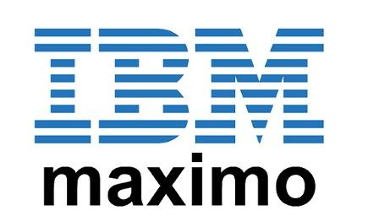

3.2 ERP Odoo Maintenance
ERP Odoo Maintenance module is part of the broader Odoo Enterprise Resource Planning (ERP) suite, offering integrated maintenance management functionalities alongside other business processes such as accounting, inventory, and sales. Odoo Maintenance module facilitates the planning, execution, and tracking of maintenance activities, enabling organizations to streamline maintenance operations within a unified platform. With its modular design and customizable features, ERP Odoo Maintenance caters to the diverse needs of businesses seeking an integrated solution for maintenance management, aligning with the principles of CMMS integration and data centralization.
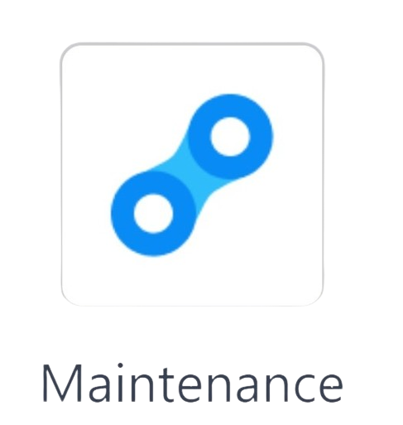

3.3 Hippo CMMS
Hippo CMMS is a cloud-based maintenance management solution designed to simplify maintenance processes and improve asset performance. With its intuitive interface and user-friendly features, Hippo CMMS empowers organizations to manage work orders, preventive maintenance tasks, asset records, and inventory effectively. By providing real-time insights into maintenance activities and asset health, Hippo CMMS enables proactive decision-making and resource optimization. The scalability and flexibility of Hippo CMMS make it suitable for organizations of all sizes, aligning with the scalability aspect of CMMS solutions.
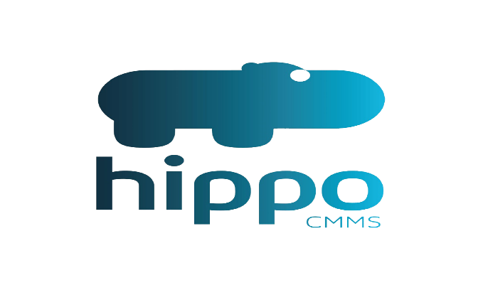

3.4 Comparative table:

Functionality | IBM Maximo | ERP Odoo Maintenance | Hippo CMMS
Work order management | ✔️ | ✔️ | ✔️
Preventive maintenance scheduling | ✔️ | ✔️ | ✔️
Inventory control | ✔️ | ✔️ | ✔️
Asset management | ✔️ | ✔️ | ✔️
Reporting and analytics | ✔️ | ✔️ | ✔️
Financial management | ✔️ | ✔️ | ❌
Project management | ✔️ | ✔️ | ❌
CRM integration | ✔️ | ✔️ | ❌
Manufacturing module |  | ✔️ | ❌
Maintenance cost tracking | ✔️ | ❌ | ✔️
IoT integration | ✔️ | ❌ | ❌
AI-powered predictive maintenance | ✔️ | ❌ | ❌
Mobile augmented reality | ✔️ | ❌ | ❌

Table : Comparative table

Conclusion
In this chapter, we have provided an overview of maintenance, its types and levels, and the tools for improving this service. Additionally, we have briefly discussed the Computerized Maintenance Management System (CMMS): its definition, benefits, and functionalities. It represents an excellent tool for enhancing maintenance management, increasing productivity, reducing costs, and avoiding quality incidents. In the next chapter, we will present …………………………………………………….

Chapter 4: Implementation

1 . Introduction
In this chapter we will present the software environment of our application then the implementation of the use cases of our actors as well as the real user interfaces then we ends with a conclusion.
2. working environment
in this part, we present a presentation of the work environment used to carry out our project.
2.1. material environment
The development of the application is carried out by means of a laptop which has the following characteristics:
CHARACTERISTICS | MACHINE
Brand | ASUS
Processor | I5-10300H
Hard disk | 512 Go
GPU | Nvidia GeForce GTX 1650
RAM | 16 Go
Operating system | Windows 10

Table 2 : Basic material

2.2. Software Environment
2.2.1. Visual Studio Code


Figure 4 :Logo Visual Studio Code

Visual Studio Code, also commonly referred to as Vs code, is a source-code editor made by Microsoft with the Electron Framework, for Windows, Linux and macOS.
Visual Studio Code is a source-code editor that can be used with a variety of programming languages, including C, C#, C++, Fortran, Go, Java, JavaScript, Node.js, Python, Rust. [3]
2. MERN Stack
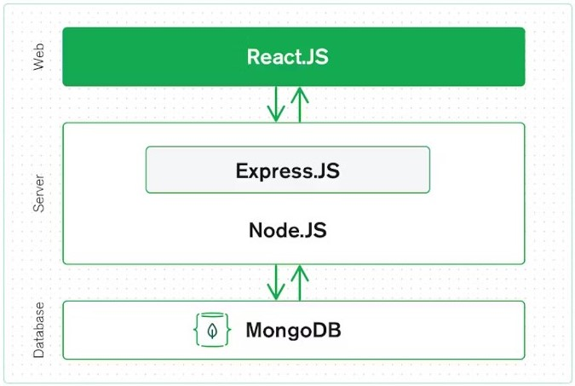
MERN Stack is a combination of the latest technologies used for creating premium web applications. These applications are developed using multiple frameworks, databases, libraries, and more. [7]
MERN stands for MongoDB, Express, React, Node, after the four key technologies that make up the stack.
MongoDB — document database
Express(.js) — Node.js web framework
React(.js) — a client-side JavaScript framework
Figure : 3-level architecture

Node(.js) — the premier JavaScript web server
2.1 PostgreSQL
PostgreSQL also known as Postgres, is a free and open-source relational database management system (RDBMS) emphasizing extensibility and SQL compliance. PostgreSQL features transactions with atomicity, consistency, isolation, durability (ACID) properties, automatically updatable views, materialized views, triggers, foreign keys, and stored procedures. It is supported on all major operating systems, including Linux, FreeBSD, OpenBSD, macOS, and Windows, and handles a range of workloads from single machines to data warehouses or web services with many concurrent users. [8]


Figure :PostgreSQL

2.2 Node
Node.js is a cross-platform, open-source JavaScript runtime environment that can run on Windows, Linux, Unix, macOS, and more. Node.js runs on the V8 JavaScript engine, and executes JavaScript code outside a web browser.
Node.js lets developers use JavaScript to write command line tools and for server-side scripting. The ability to run JavaScript code on the server is often used to generate dynamic web page content before the page is sent to the user's web browser. Consequently, Node.js represents a "JavaScript everywhere" paradigm, unifying web-application development around a single programming language, as opposed to using different languages for the server- versus client-side programming.

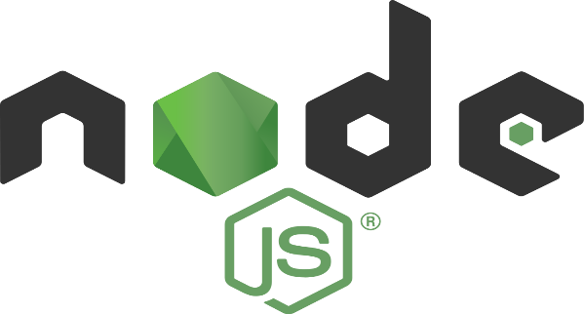
Node.js has an event-driven architecture capable of asynchronous I/O. These design choices aim to optimize throughput and scalability in web applications with many input/output operations, as well as for real-time Web applications (e.g., real-time communication programs and browser games). [9]

Figure : Nodejs logo

2.3 Express

Express.js est un framework pour construire des applications web basées sur Node.js3. C'est de fait le framework standard pour le développement de serveur en Node.js4. L'auteur original, TJ Holowaychuck, le décrit comme un serveur inspiré de Sinatra5 dans le sens qu'il est relativement minimaliste tout en permettant d'étendre ses fonctionnalités via des plugins. [10]

Figure : Express logo

2.4 React
React (also known as React.js or ReactJS) is a free and open-source front-end JavaScript library for building user interfaces based on components. It is maintained by Meta (formerly Facebook) and a community of individual developers and companies.
React can be used to develop single-page, mobile, or server-rendered applications with frameworks like Next.js. Because React is only concerned with the user interface and rendering components to the DOM, React applications often rely on libraries for routing and other client-side functionality. A key advantage of React is that it only rerenders those parts of the page that have changed, avoiding unnecessary rerendering of unchanged DOM elements.[11]
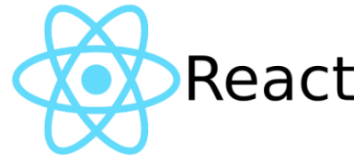

3.Redux
Figure : ReactJS logo

Redux:
Redux is a state management tool that makes it easier to pass data between components. Redux provides a store which makes the state inside components easier to maintain. Along with stores, react-redux introduces actions and reducers which work simultaneously with stores to make the state more predictable [12]

Redux ToolKit(RTK):
Redux Toolkit is used for writing redux code but in a more concise way. Redux Toolkit (RTK) solves problems that most of the developer’s face who used redux in a react application. RTK abstracts the basic redux code and provides us boilerplates that enable us to write redux code in less lines of code

Issues with basic Redux:
- Configuring a Redux store is too complicated
- Have to add a lot of packages to build a large-scale application
- Redux requires too much boilerplate code which makes it cumbersome to write efficient and clean code.

Reasons for preferring RTK(Redux ToolKit):
- Redux ToolKit solves various issues by providing a hook-based implementation of Redux
- RTK gives the ability to write mutable state updates in the reducers.
- It also eliminates the use of extra coding by providing boilerplates.

- RTK also has the feature of RTK query which eliminates the use of Thunks and makes the query processing faster
- It also provides automatic support for Redux Dev-tools Extension and for immer.js library which is a great tool to deal with immutable objects.
- You can also use the various predefined functions of Redux Toolkit which not only speeds up the process but also saves time.

Dependencies Included with RTK(Redux ToolKit):
- immer
- redux
- redux-thunk
- reselect

6. creation of models
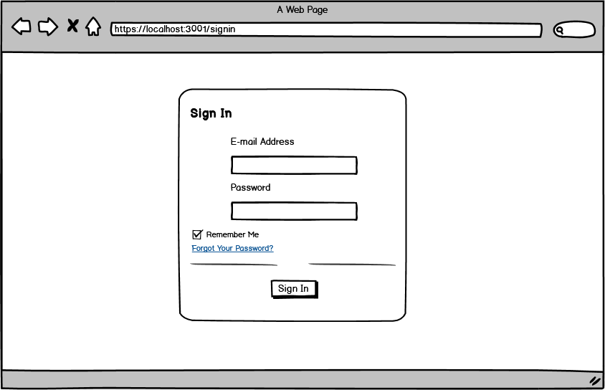

References

[1] https://www.ibm.com/topics/what-is-a-cmms (10/02/2024)
- https://www.ibm.com/fr-fr/products/maximo ( where u can find problématique and objectives(11/02/2024))
- [3] https://fr.wikipedia.org/wiki/Visual_Studio_Code (11/02/2024)
- [4] https://www.ibm.com/fr-fr/products/maximo (12/02/2024)
- [5] https://website.maintenanceconnection.com (12/02/2024)
- [6] https://hippocmms.iofficecorp.com/solutions/cmms-software (12/02/2024)
- [7] https://www.mongodb.com/mern-stack (12/02/2024)
- [8] https://en.wikipedia.org/wiki/PostgreSQL (12/02/2024)
- [9] https://en.wikipedia.org/wiki/Node.js (13/02/2024)
- [10] https://fr.wikipedia.org/wiki/Express.js (13/02/2024)
- [11] https://en.wikipedia.org/wiki/React (13/02/2024)
- [12] https://www.geeksforgeeks.org/why-redux-toolkit-is-preferred-over-redux/ (13/02/2024)

