

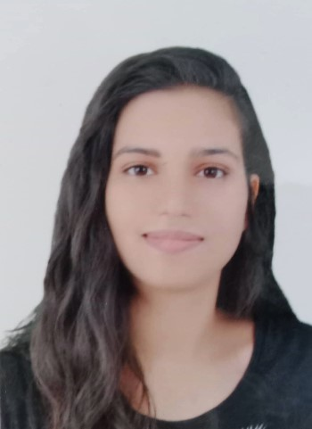

Name : Aya derouiche
Address : Tunisia/Sousse
Date of birth : 01/07/2002

EDUCATION

ISET Sousse :  Bachelor Degree in multimedia and web development | September 2023
Ahmed Noureddine Secondary School :  Baccalaureate in Computer Science | September 2016 → June 2021

SKILLS

DEVELOPMENT | MODELIZATION | VIDEO GAMES DEVELOPMENT
HTML/CSS/JS | 3DS MAX | UNREAL ENGINE
PHP/MySQL | SKETCHUP | UNITY3D
SYMFONY/ANGULAR | BLENDER | C/C#
JAVA/J2E | PHOTOSHOP
LARAVEL
ANDROID
CMS
ReactJs

LANGUAGES

ARABIC | Fluent
ENGLISH | Very good
FRENCH | Good

INTERESTS

- Football |  | - Cooking
- Music |  | - painting
- Video games

