Member 4 D1 Report: River Online Learning & ADWIN Drift Detection
CSAI415 Climate Evidence GraphRAG Agent | Scope: Online Learning Only
Method. A River text-classification pipeline was implemented using Bag-of-Words features and Multinomial Naive Bayes. Each incoming climate query is predicted first, then the true label is learned using River’s online learn_one() update.
Classes. The classifier predicts six climate topics: mitigation, adaptation, climate_science, policy_governance, technology_innovation, and uae_cop28.
Stream and drift. A stream of 600 labelled climate queries was simulated. Concept drift was injected at query 350 by changing the relationship between query wording and topic labels.
Evaluation. Prequential evaluation was used: predict -> check correctness -> update ADWIN -> learn the correct label. ADWIN monitored the error stream, where correct = 0 and wrong = 1.

Metric | Result
Queries / drift point | 600 / 350
First ADWIN alert | 377 (27-query delay)
Pre-drift accuracy | 89.97%
Drift-window accuracy | 2.22%
Post-drift accuracy | 95.65%
Final cumulative / rolling | 78.33% / 100%

Prequential Accuracy Plot
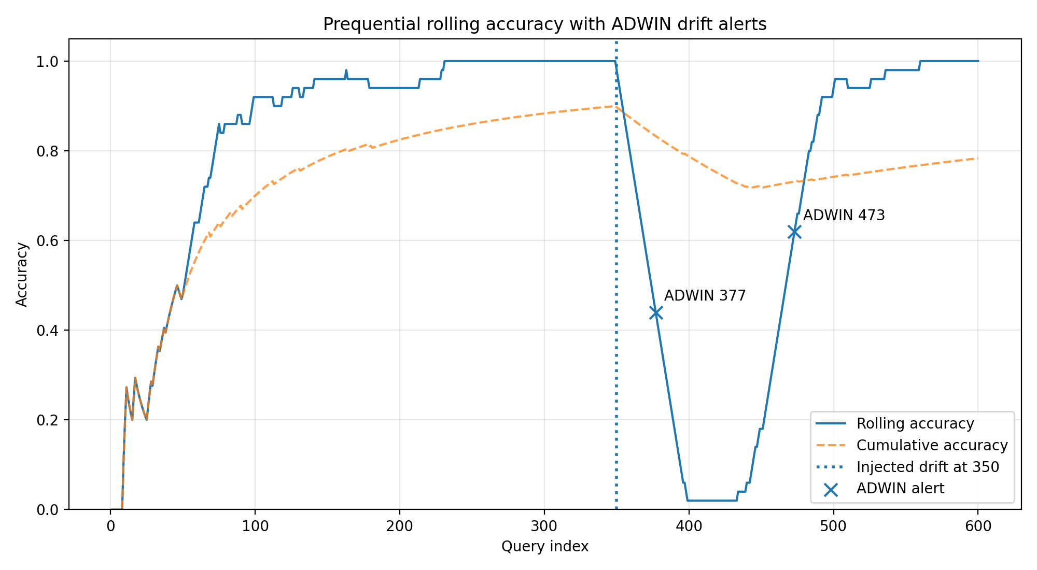
Figure 1. Rolling accuracy falls after drift at query 350, ADWIN alerts at 377 and 473, then accuracy recovers.

Conclusion. The results show a clear online-learning pattern: accuracy rises before drift, drops during the injected drift, ADWIN detects the change at query 377, and the model recovers strongly after adapting to the new stream.
Project contribution. In the final GraphRAG system, this module can route queries by climate topic and later help adapt BM25/dense retrieval weights using feedback.

