Climate Evidence GraphRAG Agent
Updated Project Plan with Climate-Specific Knowledge Graph and Architecture Graph

Project focus: A trusted AI assistant that answers climate policy, sustainability, and climate-AI research questions using evidence from PDFs, a climate-specific knowledge graph, hybrid retrieval, online learning, AutoML, PEFT/QLoRA tuning, evaluation, and safety checks.

Field | Updated Plan
Course | CSAI-415 — Special Topics in Artificial Intelligence
Project Weight | 60% of module grade
Team Size | 5 students approved by instructor
Domain | Climate policy, climate science, sustainability, and climate-AI research
Core system | Climate Evidence GraphRAG Agent
Key update | Knowledge graph is now climate-specific, not only a generic PDF/paper graph
Members | Reem, Salma, Rana, Aaya, Alia

1. Corrected Project Idea
This project builds a Climate Evidence GraphRAG Agent that answers natural language questions over a curated climate corpus. The PDFs are used as evidence sources, but the system is not only a PDF reader. It builds a climate evidence knowledge graph that connects countries, policies, climate risks, sectors, technologies, targets, indicators, findings, organizations, and source documents.
- The user asks a climate question, such as: Which UAE climate policies address renewable energy targets?
- The system extracts climate entities from the question, such as UAE, policy, renewable energy, or target.
- The graph identifies related climate concepts and evidence documents.
- Hybrid retrieval finds supporting chunks from the PDFs.
- The answer generator produces a citation-grounded response with document names and page ranges.
- Safety checks prevent unsupported climate statistics, fake policy commitments, and hallucinated citations.

2. System Architecture Graph
The updated architecture below shows that the project is a full climate evidence system. MongoDB stores metadata and provenance, Qdrant supports dense semantic search, and Neo4j stores the climate evidence knowledge graph. The agent blends BM25, dense retrieval, and graph expansion before generating citation-safe answers.
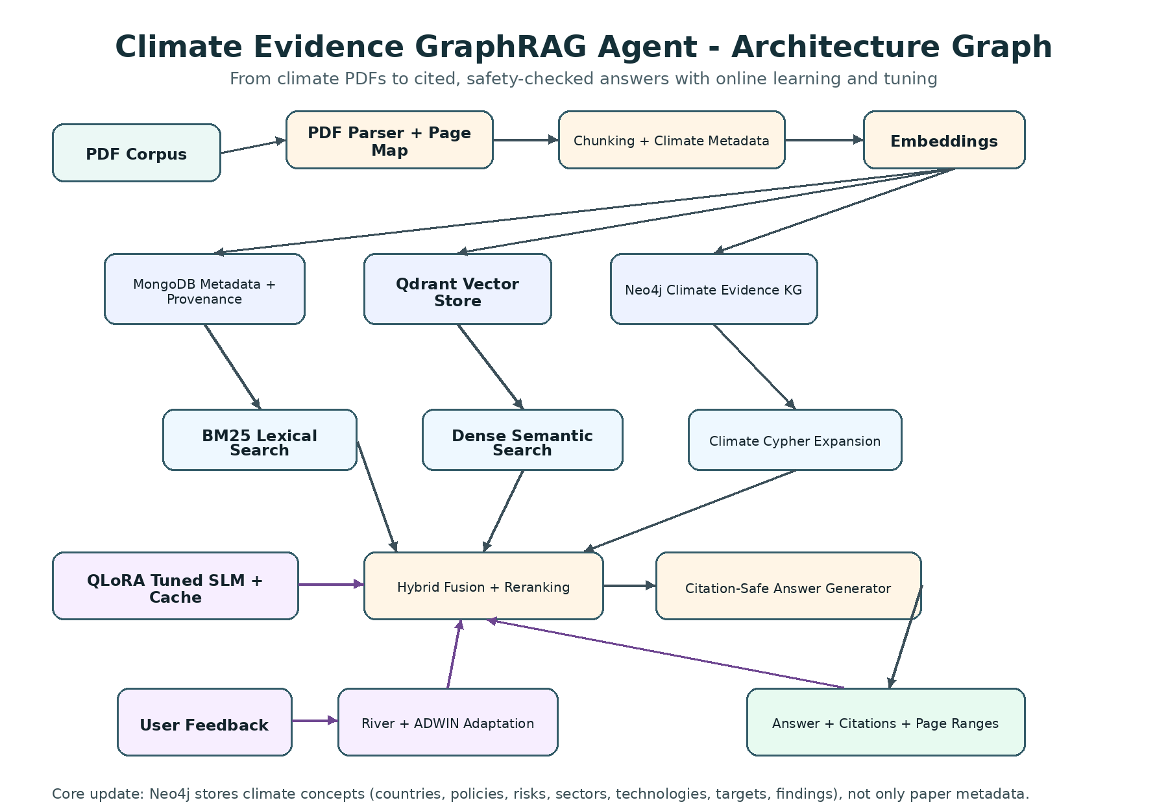

3. Climate Evidence Knowledge Graph
The previous graph was too close to a normal paper/PDF graph. The corrected graph below is climate-specific. Documents remain important because they provide evidence, but the graph now represents climate knowledge such as policies, risks, sectors, targets, indicators, findings, and technologies.
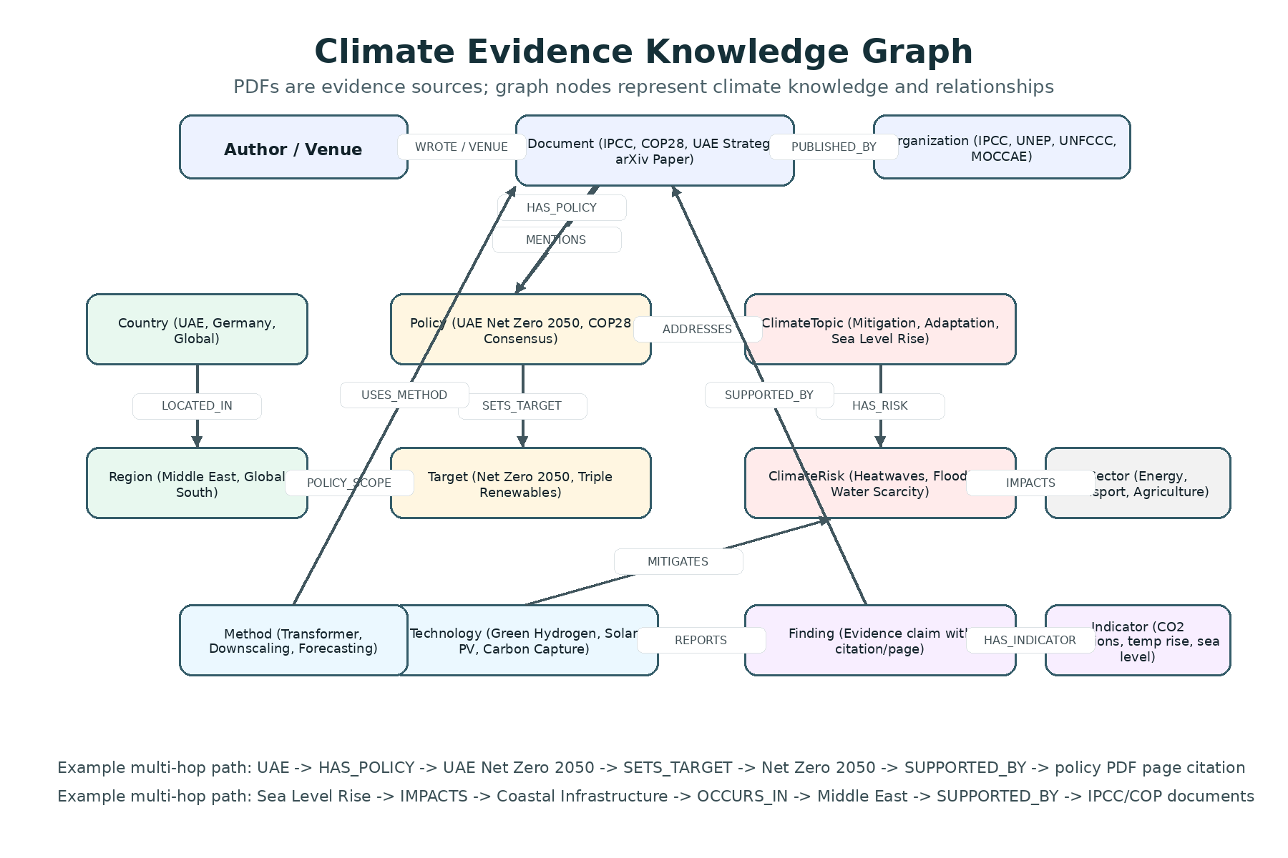

4. Updated Dataset Metadata Schema
The metadata CSV must include climate-specific fields so Reem, Rana, Salma, and Alia can use the same fields across ingestion, filtering, graph building, retrieval, safety, and evaluation.
Column | Purpose | Example
document_id | Unique ID for every PDF | uae_net_zero_2050
title | Full source title | UAE Net Zero by 2050 Strategic Initiative
authors | Authors if academic paper | Smith et al.
organization | Publisher or institution | IPCC / UNEP / UNFCCC / MOCCAE
venue | Journal, report series, or conference | IPCC AR6 / arXiv / COP28
year | Publication year | 2023
document_type | Report, policy, paper, strategy, agreement | Policy
pdf_path | Local path to PDF | data/pdfs/uae_net_zero_2050.pdf
topics | Climate topics | Mitigation; Energy transition
countries | Countries mentioned | UAE
regions | Regions mentioned | Middle East
sectors | Affected or emitting sectors | Energy; Transport
climate_risks | Risks discussed | Heatwaves; Water scarcity
technologies | Solutions or AI technologies | Solar PV; Green Hydrogen; Transformer
policies | Policy names | UAE Net Zero 2050
targets | Measurable goals | Net Zero emissions by 2050
indicators | Measured climate values | CO2 emissions; temperature rise

5. Updated Knowledge Graph Schema
Node | Role in climate project | Example
Document | Evidence source PDF | IPCC AR6 WG1, COP28 UAE Consensus
Organization | Publisher or institution | IPCC, UNEP, UNFCCC, UAE MOCCAE
Country | Country mentioned in climate documents | UAE, Germany, France
Region | Geographic area | Middle East, Gulf Region
ClimateTopic | Broad climate topic | Mitigation, Adaptation, Sea Level Rise
ClimateRisk | Specific climate risk | Heatwaves, Flooding, Water Scarcity
ClimateImpact | Consequence of climate change | Health risk, Crop loss, Coastal damage
Sector | Affected/emitting sector | Energy, Transport, Agriculture
Policy | Named climate policy or agreement | UAE Net Zero 2050, COP28 Consensus
Target | Measurable commitment or goal | Triple renewable energy, Net Zero 2050
Technology | Climate solution or AI method | Green Hydrogen, Solar PV, Carbon Capture
Indicator | Climate measurement | CO2 emissions, temperature rise, sea level
Finding | Evidence claim extracted from document | Warming increases climate extremes
Method | Scientific or AI method | Transformer, downscaling, forecasting
Author | Academic/report author | Author name
Venue | Publication series or journal | arXiv, IPCC Report, Nature Climate Change

6. Climate Graph Relationships
(:Document)-[:PUBLISHED_BY]->(:Organization)
(:Document)-[:DISCUSSES]->(:ClimateTopic)
(:Document)-[:REPORTS_FINDING]->(:Finding)
(:Finding)-[:SUPPORTED_BY]->(:Document)
(:Finding)-[:HAS_INDICATOR]->(:Indicator)
(:Finding)-[:AFFECTS]->(:Sector)
(:ClimateRisk)-[:IMPACTS]->(:Sector)
(:ClimateRisk)-[:OCCURS_IN]->(:Region)
(:Country)-[:LOCATED_IN]->(:Region)
(:Country)-[:HAS_POLICY]->(:Policy)
(:Policy)-[:SETS_TARGET]->(:Target)
(:Policy)-[:ADDRESSES]->(:ClimateTopic)
(:Technology)-[:MITIGATES]->(:ClimateRisk)
(:Technology)-[:USED_IN]->(:Sector)
(:Document)-[:MENTIONS_COUNTRY]->(:Country)
(:Document)-[:MENTIONS_TECHNOLOGY]->(:Technology)
(:Document)-[:USES_METHOD]->(:Method)
(:Author)-[:WROTE]->(:Document)
(:Document)-[:PUBLISHED_IN]->(:Venue)

7. Updated GraphRAG Flow
- Step 1: User asks a climate question.
- Step 2: Extract climate entities such as country, region, policy, risk, sector, target, technology, indicator, and topic.
- Step 3: Run climate-specific Cypher queries against Neo4j.
- Step 4: Return related documents, findings, policies, targets, risks, or sectors.
- Step 5: Filter Qdrant and MongoDB search using graph results and metadata fields.
- Step 6: Blend graph-guided chunks with global BM25+dense retrieval results.
- Step 7: Generate an answer using only retrieved evidence.
- Step 8: Verify every citation using source pinning and page-range checking.

8. Climate-Specific Demo Questions
- Which UAE climate policies address renewable energy targets?
- Which climate risks affect agriculture in the Middle East?
- Which documents discuss green hydrogen as a mitigation technology?
- What climate impacts are linked to sea level rise?
- Which AI methods are used in climate forecasting papers?
- Which organizations published evidence about emissions reduction?
- What targets are connected to the COP28 UAE Consensus?
- What documents support claims about water scarcity risks?

9. Member Responsibilities and Submitted Files
Under each member, the files they submit for each deliverable are highlighted. Each member writes the report section for the part they implemented. Alia may compile the final report, but she does not write the other members’ sections.

Member 1 — Reem
Role: Data, Ingestion, Gold Q/A, and Page Citation Verification
Deliverable | Responsibility | Highlighted files to submit
D1 | Prepare climate metadata and gold Q/A set | data/metadata/papers_metadata_template.csv  data/gold/gold_qa_set_template.json  reports/member1_d1_data_section.md
D2 | Build PDF parsing, chunking, MongoDB storage | src/ingest/pdf_loader.py  src/ingest/chunker.py  src/ingest/mongo_store.py  src/ingest/run_ingest.py  reports/member1_d2_ingestion_section.md
D3 | Verify page citations and data quality | src/ingest/page_verifier.py  reports/member1_d3_data_quality_section.md
D4 | Final dataset check and tuning data support | data/tuning/finetune_qa_template.jsonl  reports/member1_d4_dataset_section.md

Member 2 — Salma
Role: Retrieval, Hybrid Search, AutoML, and Retrieval Evaluation
Deliverable | Responsibility | Highlighted files to submit
D1 | Implement Optuna AutoML for hybrid retrieval | src/retrieval/automl_tuner.py  configs/run_card_d1.yaml  reports/member2_d1_automl_section.md
D2 | Build BM25, dense, hybrid retrieval and /search support | src/retrieval/bm25_retriever.py  src/retrieval/dense_retriever.py  src/retrieval/hybrid_retriever.py  src/retrieval/fusion.py  reports/member2_d2_retrieval_section.md
D3 | Run vector-only, BM25-only, hybrid, graph-guided ablations | src/evaluation/retrieval_metrics.py  reports/tables/d3_retrieval_ablation.csv  reports/member2_d3_retrieval_ablation_section.md
D4 | Evaluate retrieval latency with tuned model/cache | src/evaluation/latency.py  reports/tables/d4_retrieval_latency.csv  reports/member2_d4_retrieval_perf_section.md

Member 3 — Rana
Role: Climate Evidence Knowledge Graph and GraphRAG
Deliverable | Responsibility | Highlighted files to submit
D1 | Draft climate graph schema and explain GraphRAG plan | src/graph/graph_schema.md  reports/member3_d1_graph_plan_section.md
D2 | Build climate-specific Neo4j graph and Cypher queries | src/graph/neo4j_builder.py  src/graph/cypher_queries.py  docs/climate_evidence_kg_graph.png  reports/member3_d2_graph_section.md
D3 | Implement full climate GraphRAG executor | src/rag/graphrag_executor.py  src/rag/prompt_builder.py  src/rag/citation_builder.py  reports/member3_d3_graphrag_section.md
D4 | Optimize graph queries and explain final graph behavior | src/rag/graphrag_executor.py  src/graph/cypher_queries.py  reports/member3_d4_graph_final_section.md

Member 4 — Aaya
Role: Online Learning, ADWIN Drift, Feedback Adaptation, and QLoRA
Deliverable | Responsibility | Highlighted files to submit
D1 | Implement River classifier, ADWIN, prequential plot | src/learning/river_topic_classifier.py  src/learning/drift_detector.py  reports/figures/prequential_accuracy_plot.png  reports/member4_d1_online_learning_section.md
D2 | Connect topic learner to climate retrieval routing | src/learning/feedback_adapter.py  reports/member4_d2_adaptation_section.md
D3 | Analyze feedback adaptation and drift behavior | src/learning/feedback_adapter.py  reports/member4_d3_adaptation_section.md
D4 | Prepare fine-tuning data and run PEFT/QLoRA | src/tuning/prepare_finetune_data.py  src/tuning/finetune_qlora.py  src/tuning/inference_tuned.py  reports/tuning_card.md  reports/member4_d4_tuning_section.md

Member 5 — Alia
Role: API, UI, Safety, Evaluation, README, and Report Compilation
Deliverable | Responsibility | Highlighted files to submit
D1 | Format metrics and compile D1 report only | src/evaluation/retrieval_metrics.py  reports/member5_d1_eval_section.md  reports/D1_report.pdf
D2 | Build FastAPI ingestion/search endpoints and dataflow diagram | src/api/main.py  docs/architecture_graph.png  reports/member5_d2_api_eval_section.md  reports/D2_report.pdf
D3 | Implement safety, citation verification, RAG evaluation | src/safety/source_pinning.py  src/safety/citation_verifier.py  src/evaluation/rag_metrics.py  src/evaluation/ablation.py  reports/member5_d3_safety_eval_section.md  reports/D3_report.pdf
D4 | Build final UI/API demo, tests, README, final compilation | src/ui/streamlit_app.py  tests/test_api.py  tests/test_search.py  README.md  demo_script.md  reports/member5_d4_demo_eval_section.md  reports/final_report.pdf

10. Deliverable Summary
Deliverable | Focus | Main shared outputs
D1 — Week 5 | AutoML + River online learning | notebooks/D1_automl_online_learning.ipynb  configs/run_card_d1.yaml  reports/D1_report.pdf
D2 — Week 7 | Ingestion + retrieval + climate graph + API | docker-compose.yml  src/ingest/  src/retrieval/  src/graph/  src/api/main.py  reports/D2_report.pdf
D3 — Week 9 | Climate GraphRAG + evaluation + safety | src/rag/graphrag_executor.py  src/safety/  src/evaluation/ablation.py  reports/D3_report.pdf
D4 — Week 10/11 | QLoRA + final demo + report | src/tuning/  reports/tuning_card.md  README.md  tests/  reports/final_report.pdf

11. Notes for Improvements
- Use a smaller core corpus first: 100–120 PDFs, then extend if all pipelines work.
- Create climate metadata carefully because it drives graph creation, retrieval filters, safety, and evaluation.
- Do not make GraphRAG only return documents. It must return climate relationships and supporting evidence.
- Keep source pinning strict: if the retrieved context does not support a claim, the system must refuse or say evidence is insufficient.
- Use realistic climate failure cases: fake COP commitments, unsupported emissions statistics, wrong country, wrong sector, or missing page citation.
- Each member must keep separate AI chat logs for their actual deliverable work.

