Climate Evidence GraphRAG Agent
A Trusted Climate Evidence Assistant using Hybrid Retrieval, GraphRAG, Online Learning, and QLoRA
CSAI415 Special Topics in Artificial Intelligence
Group Project Plan and Member Deliverable Ownership

Project weight | 60% of module grade
Team size | 5 students
Domain | Climate science, sustainability policy, climate risk, and climate-AI research
Core technology | Hybrid Retrieval, Climate Evidence KG, GraphRAG, River, Optuna, PEFT/QLoRA, FastAPI
Corpus target | 100-120 open-access PDFs; extend to 130-150 only if the core system is stable
Design principle | The graph represents climate knowledge; PDFs are evidence sources, not the whole system
Team Members
Member | Name | Main Role
Member 1 | Reem | Data, Ingestion, Climate Metadata, Gold Q/A, Page Citations
Member 2 | Salma | Retrieval, Hybrid Search, AutoML, Retrieval Metrics
Member 3 | Rana | Climate Evidence Knowledge Graph and GraphRAG
Member 4 | Aaya | River, ADWIN, Feedback Learning, PEFT/QLoRA
Member 5 | Alia | API, UI, Safety, Evaluation, Final Compilation

Contents
- 1. Project Idea and Problem Statement
- 2. Project Scope and Corpus
- 3. System Architecture
- 4. Climate Evidence Knowledge Graph Design
- 5. Updated Climate Metadata and Gold Q/A Strategy
- 6. Research Questions and Evaluation Strategy
- 7. Deliverables Overview
- 8. Team Role Summary
- 9. Member 1 - Reem: Data and Ingestion Lead
- 10. Member 2 - Salma: Retrieval and AutoML Lead
- 11. Member 3 - Rana: Climate Knowledge Graph and GraphRAG Lead
- 12. Member 4 - Aaya: Online Learning and Fine-Tuning Lead
- 13. Member 5 - Alia: API, UI, Safety, and Evaluation Lead
- 14. Report Writing Ownership
- 15. AI Chat Log Requirement
- 16. Final Repository Structure
- 17. Timeline and Submission Checklist
- 18. References

1. Project Idea and Problem Statement
Project idea. The Climate Evidence GraphRAG Agent is a trusted AI assistant that answers climate science, climate policy, sustainability, and climate-AI research questions using a curated collection of open-access PDFs as evidence. The updated project is not only a PDF reader. The PDF corpus provides evidence, while the Neo4j Climate Evidence Knowledge Graph represents climate concepts such as countries, policies, risks, sectors, technologies, targets, indicators, and findings.
Problem statement. Climate information is spread across long technical documents such as IPCC reports, UNEP reports, COP28 documents, UAE climate strategies, and academic climate-AI papers. A user may need to connect a country to a policy, a policy to a target, a technology to a climate risk, and a finding to a page-cited document. General chatbots can hallucinate climate statistics or fake policy commitments. This project solves that by generating answers only from retrieved and citation-verified evidence.
Final objective. Build a complete climate evidence AI agent using hybrid retrieval, a climate-specific knowledge graph, GraphRAG, online learning, AutoML, PEFT/QLoRA tuning, safety checks, evaluation metrics, FastAPI, and a minimal UI.

2. Project Scope and Corpus
The corpus remains focused and achievable. The system should start with 100-120 PDFs and expand only after ingestion, retrieval, graph building, and evaluation are stable.
Source type | Target count | Purpose
IPCC summary and special reports | 10-15 | Scientific climate evidence, impacts, indicators, and risks
UNEP emissions gap reports | 5-8 | Emissions, mitigation, sectors, indicators, and policy evidence
COP28 / UNFCCC documents | 10-15 | International commitments, climate targets, policies, and UAE/Dubai relevance
UAE climate strategy documents | 5-8 | Local policies such as UAE Net Zero 2050 and national climate plans
arXiv climate-AI papers | 60-80 | AI methods, climate forecasting, downscaling, optimization, and climate modelling
Optional open-access papers | 10-20 | Extra research depth if time allows

3. System Architecture
The architecture keeps the clean first-document design but updates the system to show climate-specific reasoning. The flow below separates ingestion, storage, retrieval, graph reasoning, generation, and feedback learning.
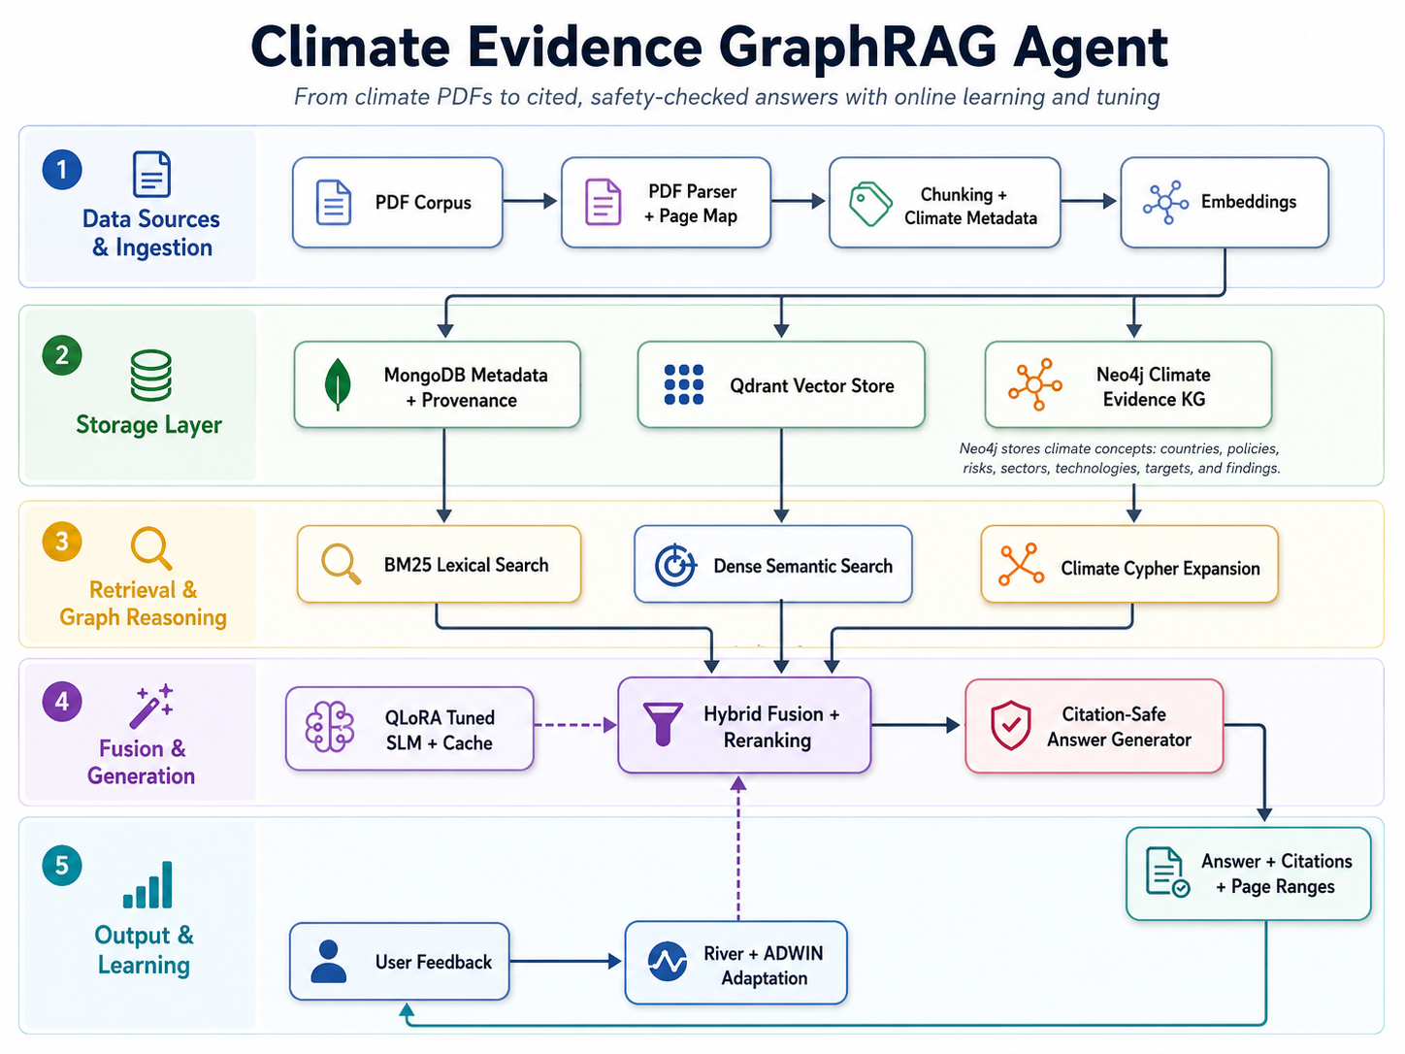
Figure 1. Climate Evidence GraphRAG Agent architecture graph.
- PDF Corpus -> PDF Parser + Page Map -> Chunking + Climate Metadata -> Embeddings.
- MongoDB stores document metadata, chunks, provenance, page maps, run cards, feedback, and evaluation results.
- Qdrant stores dense vectors for semantic search over climate evidence chunks.
- Neo4j stores the Climate Evidence Knowledge Graph: countries, regions, policies, targets, climate topics, risks, sectors, technologies, methods, findings, indicators, organizations, authors, and documents.
- BM25 lexical search, dense semantic search, and climate Cypher expansion feed Hybrid Fusion + Reranking.
- The Citation-Safe Answer Generator produces answers with document titles and page ranges only when the retrieved evidence supports the answer.
- User feedback updates the River + ADWIN adaptation component, which can influence retrieval routing and fusion weights.

4. Climate Evidence Knowledge Graph Design
Core update. The previous graph was too close to a generic PDF/paper graph. The corrected version is a Climate Evidence Knowledge Graph. PDFs remain evidence sources, but the graph nodes represent real climate knowledge and relationships.
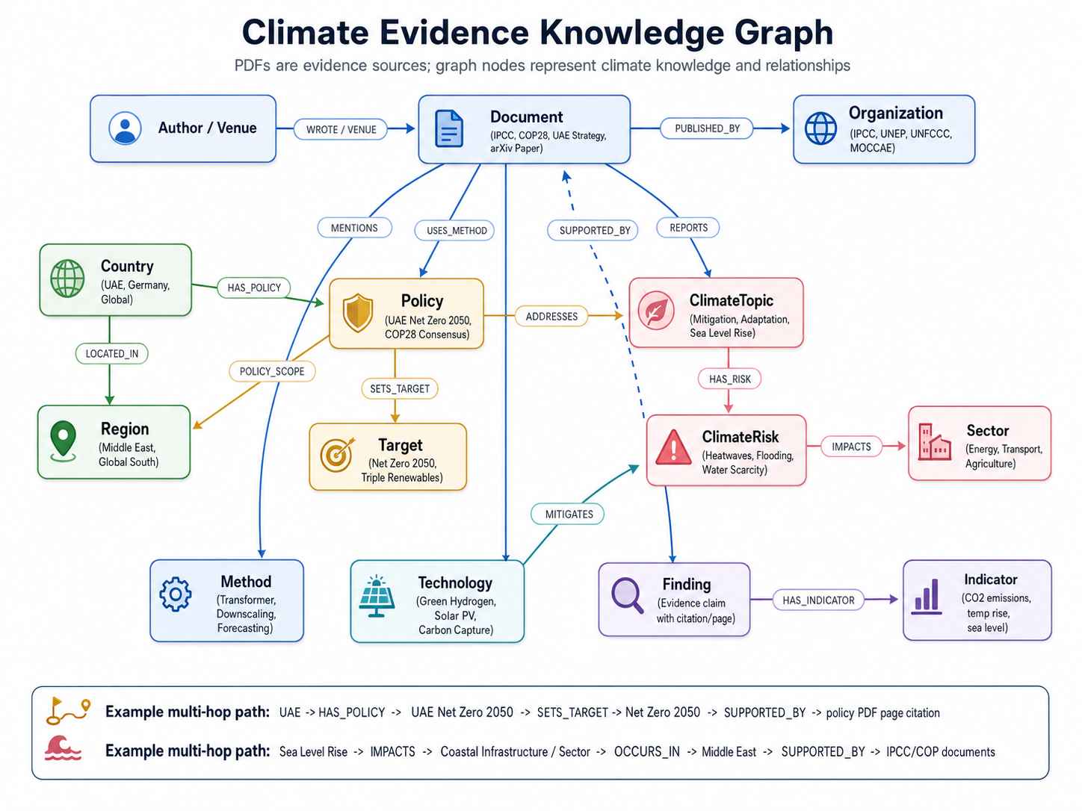
Figure 2. Climate Evidence Knowledge Graph showing climate concepts and evidence links.
Node type | Properties | Example
Document | id, title, year, source_type, pdf_path, page_map | IPCC AR6, COP28 UAE Consensus, UAE Net Zero 2050, arXiv paper
Organization | name, type | IPCC, UNEP, UNFCCC, UAE MOCCAE
Country | name, iso_code | UAE, Germany, Global
Region | name | Middle East, Global South, Coastal regions
Policy | name, year, scope | UAE Net Zero 2050, COP28 Consensus
Target | name, metric, year | Net Zero 2050, Triple Renewables
ClimateTopic | name, category | Mitigation, Adaptation, Sea Level Rise
ClimateRisk | name | Heatwaves, Flooding, Water Scarcity
Sector | name | Energy, Transport, Agriculture, Buildings
Technology | name | Green Hydrogen, Solar PV, Carbon Capture
Method | name, family | Transformer, Downscaling, Forecasting
Finding | claim_text, source_page | Evidence claim with citation/page
Indicator | name, unit | CO2 emissions, temperature rise, sea level
Author / Venue | name, affiliation/type | Research authors, arXiv, IPCC report series
Main climate-specific relationships:
- (:Document)-[:PUBLISHED_BY]->(:Organization)
- (:Document)-[:DISCUSSES]->(:ClimateTopic)
- (:Document)-[:REPORTS]->(:Finding)
- (:Finding)-[:SUPPORTED_BY]->(:Document)
- (:Finding)-[:HAS_INDICATOR]->(:Indicator)
- (:Country)-[:LOCATED_IN]->(:Region)
- (:Country)-[:HAS_POLICY]->(:Policy)
- (:Policy)-[:SETS_TARGET]->(:Target)
- (:Policy)-[:ADDRESSES]->(:ClimateTopic)
- (:ClimateTopic)-[:HAS_RISK]->(:ClimateRisk)
- (:ClimateRisk)-[:IMPACTS]->(:Sector)
- (:Technology)-[:MITIGATES]->(:ClimateRisk)
- (:Technology)-[:USED_IN]->(:Sector)
- (:Document)-[:MENTIONS]->(:Policy), (:Document)-[:MENTIONS]->(:Technology)
- (:Document)-[:USES_METHOD]->(:Method)
- (:Author)-[:WROTE]->(:Document), (:Document)-[:PUBLISHED_IN]->(:Venue)

5. Updated Climate Metadata and Gold Q/A Strategy
Metadata update. The metadata template must include climate-specific fields so retrieval, graph construction, filtering, and evaluation all support the climate domain.
Field | Purpose
document_id | Unique ID for every PDF
title, authors, organization, venue, year, pdf_path | Core document and provenance metadata
document_type | Report, policy document, scientific paper, COP document, strategy
topics | Mitigation, adaptation, climate science, climate technology, policy
countries, regions | UAE, Germany, Global, Middle East, Global South
sectors | Energy, transport, agriculture, buildings, water, health
climate_risks | Heatwaves, sea level rise, flooding, drought, water scarcity
technologies | Solar PV, green hydrogen, carbon capture, forecasting model
policies, targets | UAE Net Zero 2050, COP28 Consensus, Triple Renewables
indicators | CO2 emissions, temperature rise, sea level, renewable capacity
Gold Q/A update. The gold Q/A set should include not only document lookup questions, but climate reasoning questions that require country-policy-target, technology-risk, risk-sector, and finding-indicator connections.

6. Research Questions and Evaluation Strategy
Research question | Question | Evaluation evidence
RQ1 | Does hybrid retrieval improve Recall@5 and NDCG@5 compared with BM25-only and dense-only retrieval? | Recall@5, NDCG@5, MRR, p95 latency
RQ2 | Does climate graph-guided retrieval improve answer faithfulness compared with vector-only RAG? | Faithfulness, answer relevance, climate GraphRAG ablation
RQ3 | Does PEFT/QLoRA tuning improve answer quality or maintain quality with lower latency/token usage? | Zero-shot vs tuned comparison, latency, tokens per answer
RQ4 | Can source pinning reduce unsupported climate claims and fake policy/statistic citations? | Hallucinated citation rate, before/after safety evidence

7. Deliverables Overview
Deliverable | Focus | Main expected outputs
D1 - Week 5 | Streaming Learner and AutoML Note | Optuna tuning, River online learner, ADWIN drift, prequential plot, run card, 2-page report
D2 - Week 7 | Retrieval Stack and Climate Graph Build | Ingestion, MongoDB, Qdrant, climate Neo4j graph, hybrid /search, climate Cypher queries, Docker Compose, FastAPI
D3 - Week 9 | Climate GraphRAG Executor, Evaluation, and Safety | Climate entity extraction, graph expansion, answer citations, faithfulness/relevance, ablation, source pinning
D4 - Week 10/11 | SLM Tuning and Final Demo | PEFT/QLoRA, tuning card, tuned-vs-zero-shot, final UI/API demo, README, tests, final report

8. Team Role Summary
Member | Name | Main responsibility | Difficulty
Member 1 | Reem | Data, Ingestion, Climate Metadata, Gold Q/A, Page Citations | Medium
Member 2 | Salma | Retrieval, Hybrid Search, AutoML, Retrieval Metrics | Hard
Member 3 | Rana | Climate Evidence KG and GraphRAG | Hardest
Member 4 | Aaya | River, ADWIN, Feedback Learning, PEFT/QLoRA | Very hard
Member 5 | Alia | API, UI, Safety, Evaluation, Final Compilation | Medium-hard

9. Member 1 - Reem: Data and Ingestion Lead
Main responsibility. Reem owns the PDF corpus, climate metadata, page map, chunking, MongoDB ingestion, gold Q/A evidence set, and citation page verification. Her update is to make the dataset climate-aware, not just document-aware.
Report ownership. Reem writes the dataset, ingestion, climate metadata, gold Q/A creation, PDF parsing limitations, and page-citation verification sections.
Highlighted files below are the files this member should submit or own for each deliverable.
Deliverable | What this member does | Files to submit / own | Report section written by this member
D1 - Week 5 | Prepare initial corpus metadata.  Build first gold Q/A set with climate reasoning questions.  Check each answer has a source document and page reference. | data/metadata/papers_metadata.csv  data/metadata/papers_metadata_template.csv  data/gold/gold_qa_set.json  reports/member1_d1_data_section.md | Corpus selection.  Climate metadata fields.  Gold Q/A creation method.
D2 - Week 7 | Implement PDF parsing and page map extraction.  Chunk text with overlap.  Store paper and chunk metadata in MongoDB.  Add climate metadata fields for graph and filters. | src/ingest/pdf_loader.py  src/ingest/chunker.py  src/ingest/metadata_loader.py  src/ingest/mongo_store.py  src/ingest/qdrant_store.py  src/ingest/run_ingest.py  reports/member1_d2_ingestion_section.md | PDF ingestion pipeline.  Chunking strategy.  MongoDB schema and provenance.  Climate metadata quality.
D3 - Week 9 | Verify page ranges used in answer citations.  Review retrieved chunks for citation reliability.  Document data issues affecting GraphRAG faithfulness. | src/ingest/page_verifier.py  reports/tables/page_citation_check.csv  reports/member1_d3_data_quality_section.md | Page citation verification.  Examples of correct/incorrect citations.  Data quality effect on faithfulness.
D4 - Week 10/11 | Finalize corpus summary.  Support fine-tuning data from verified chunks.  Confirm source types and licenses for final report. | data/tuning/finetune_qa.jsonl  reports/tables/final_corpus_summary.csv  reports/member1_d4_dataset_section.md | Final corpus description.  Dataset licensing.  Fine-tuning data support.

10. Member 2 - Salma: Retrieval and AutoML Lead
Main responsibility. Salma owns BM25, Qdrant dense search, hybrid fusion, Optuna tuning, retrieval metrics, latency measurement, and retrieval ablation. Her update is to support climate metadata filters such as country, sector, risk, policy, and technology.
Report ownership. Salma writes the retrieval, AutoML, search-space, fusion strategy, metrics, latency, and ablation sections.
Highlighted files below are the files this member should submit or own for each deliverable.
Deliverable | What this member does | Files to submit / own | Report section written by this member
D1 - Week 5 | Implement Optuna AutoML for hybrid retrieval.  Tune BM25 weight, dense weight, top_k, normalization, chunk settings, and metadata filters if available.  Save winning run card. | src/retrieval/automl_tuner.py  src/retrieval/hybrid_retriever.py  configs/run_card_d1.yaml  reports/tables/d1_retrieval_metrics.csv  reports/member2_d1_automl_section.md | AutoML search space.  Objective function.  Baseline vs tuned retrieval.  Latency findings.
D2 - Week 7 | Build BM25 lexical retrieval.  Build dense retrieval wrapper over Qdrant.  Build hybrid retrieval with climate filters.  Support /search endpoint. | src/retrieval/bm25_retriever.py  src/retrieval/dense_retriever.py  src/retrieval/hybrid_retriever.py  src/retrieval/fusion.py  src/retrieval/metadata_filters.py  reports/member2_d2_retrieval_section.md | BM25 and dense retrieval.  Hybrid fusion logic.  Climate metadata filtering.  Recall@5 and p95 latency.
D3 - Week 9 | Run retrieval ablation: BM25-only, dense-only, hybrid, graph-guided hybrid.  Compare Recall@5, NDCG@5, and latency. | src/evaluation/retrieval_metrics.py  reports/tables/d3_retrieval_ablation.csv  reports/member2_d3_retrieval_ablation_section.md | Retrieval ablation results.  Latency trade-offs.  How graph expansion affects retrieval.
D4 - Week 10/11 | Measure final retrieval latency with tuned model/cache.  Prepare final retrieval performance table. | src/evaluation/retrieval_metrics.py  src/evaluation/latency.py  reports/tables/d4_retrieval_latency.csv  reports/member2_d4_retrieval_perf_section.md | Final retrieval performance.  Caching/latency effect.  Remaining retrieval limitations.

11. Member 3 - Rana: Climate Knowledge Graph and GraphRAG Lead
Main responsibility. Rana owns the Climate Evidence Knowledge Graph, climate Cypher queries, climate entity extraction, graph-guided expansion, and the GraphRAG executor. This is the most important update because the graph must show climate reasoning, not only PDF metadata.
Report ownership. Rana writes the climate graph schema, graph-building method, Cypher queries, graph expansion logic, GraphRAG pipeline, and graph-guided ablation sections.
Highlighted files below are the files this member should submit or own for each deliverable.
Deliverable | What this member does | Files to submit / own | Report section written by this member
D1 - Week 5 | Draft the Climate Evidence KG schema.  Define climate node/relationship types.  Prepare example Cypher plan for D2/D3. | src/graph/graph_schema.md  docs/climate_knowledge_graph_design.md  reports/member3_d1_graph_plan_section.md | Climate graph schema plan.  Why graph is climate-specific.  How graph supports GraphRAG.
D2 - Week 7 | Build Neo4j nodes and relationships for climate concepts.  Write 5-8 meaningful climate Cypher queries.  Create/update graph schema diagram. | src/graph/neo4j_builder.py  src/graph/cypher_queries.py  src/graph/graph_schema.md  docs/diagrams/climate_evidence_knowledge_graph.png  reports/member3_d2_graph_section.md | Climate Evidence KG model.  Node and relationship definitions.  Cypher query examples with results.
D3 - Week 9 | Implement climate GraphRAG executor.  Extract climate entities from queries.  Use graph paths to find evidence documents/chunks.  Blend graph-guided results with hybrid retrieval. | src/rag/graphrag_executor.py  src/rag/climate_entity_extractor.py  src/graph/cypher_queries.py  reports/tables/d3_graph_guided_results.csv  reports/member3_d3_graphrag_section.md | GraphRAG 4-step pipeline.  Climate Cypher expansion.  Graph-guided evidence examples.  Failure cases.
D4 - Week 10/11 | Optimize graph queries.  Prepare final graph examples for demo.  Explain final graph behavior in report/presentation. | src/rag/graphrag_executor.py  src/graph/cypher_queries.py  reports/member3_d4_graph_final_section.md | Final graph optimization.  Demo graph examples.  Graph limitations/future work.

12. Member 4 - Aaya: Online Learning and Fine-Tuning Lead
Main responsibility. Aaya owns River online learning, ADWIN drift detection, user feedback adaptation, fine-tuning dataset preparation, PEFT/QLoRA training, inference, and tuned-vs-zero-shot comparison. Her update is to use climate-specific topics such as mitigation, adaptation, climate science, policy, technology, and UAE/COP28.
Report ownership. Aaya writes the online learning, ADWIN drift, feedback adaptation, QLoRA training, tuning card, and tuned-model comparison sections.
Highlighted files below are the files this member should submit or own for each deliverable.
Deliverable | What this member does | Files to submit / own | Report section written by this member
D1 - Week 5 | Implement River query-topic classifier.  Use climate-specific topic labels.  Inject drift around policy/COP28 query increase.  Produce prequential accuracy plot. | src/learning/river_topic_classifier.py  src/learning/drift_detector.py  reports/figures/prequential_accuracy_plot.png  reports/member4_d1_online_learning_section.md | River model choice.  Climate topic labels.  ADWIN drift detection.  Prequential plot interpretation.
D2 - Week 7 | Connect topic classifier to retrieval routing.  Prepare feedback schema for adaptation.  Support /feedback endpoint logic. | src/learning/feedback_adapter.py  src/learning/topic_router.py  reports/member4_d2_adaptation_section.md | How query topics support retrieval.  Feedback data structure.  Adaptation plan.
D3 - Week 9 | Analyze feedback adaptation effect.  Connect user feedback to learner updates.  Report improvement after drift or feedback. | src/learning/feedback_adapter.py  src/learning/adaptation_eval.py  reports/tables/d3_adaptation_results.csv  reports/member4_d3_adaptation_section.md | Feedback learning behavior.  Drift/adaptation results.  Online learner limitations.
D4 - Week 10/11 | Prepare fine-tuning dataset.  Run PEFT/QLoRA fine-tuning.  Create tuning card.  Compare zero-shot vs tuned model. | src/tuning/prepare_finetune_data.py  src/tuning/finetune_qlora.py  src/tuning/inference_tuned.py  data/tuning/finetune_qa.jsonl  reports/tuning_card.md  reports/tables/zero_shot_vs_tuned_eval.csv  reports/member4_d4_tuning_section.md | Fine-tuning dataset.  QLoRA configuration.  Tuning card.  Zero-shot vs tuned evaluation.

13. Member 5 - Alia: API, UI, Safety, and Evaluation Lead
Main responsibility. Alia owns FastAPI, Streamlit UI, source pinning, citation verification, evaluation scripts, smoke tests, README, demo script, and final document compilation. Her update is to make safety climate-specific by preventing unsupported climate claims, fake statistics, and fake policy commitments.
Report ownership. Alia writes only her API, UI, safety, and evaluation sections. She compiles the final report from the individual sections written by Reem, Salma, Rana, Aaya, and herself.
Highlighted files below are the files this member should submit or own for each deliverable.
Deliverable | What this member does | Files to submit / own | Report section written by this member
D1 - Week 5 | Format D1 metrics and figures.  Compile the D1 report from all members' sections.  Check the 2-page limit. | src/evaluation/d1_report_tables.py  reports/D1_report.pdf  reports/member5_d1_eval_section.md | D1 evaluation summary.  Report formatting only; technical sections remain written by owners.
D2 - Week 7 | Build /ingest and /search FastAPI endpoints.  Create Streamlit UI shell.  Prepare Docker/API checks.  Compile D2 report from member sections. | src/api/main.py  src/ui/streamlit_app.py  tests/test_api.py  reports/figures/d2_dataflow_diagram.png  reports/member5_d2_api_eval_section.md  reports/D2_report.pdf | FastAPI endpoints.  UI shell.  Engineering/integration checks.  Report compilation notes.
D3 - Week 9 | Implement climate source pinning.  Verify every citation appears in retrieved chunks.  Run faithfulness/relevance evaluation.  Prepare before/after safety evidence. | src/safety/source_pinning.py  src/safety/citation_verifier.py  src/safety/injection_detector.py  src/evaluation/rag_metrics.py  src/evaluation/ablation.py  reports/tables/d3_ablation_results.csv  reports/tables/d3_safety_results.csv  reports/member5_d3_safety_eval_section.md  reports/D3_report.pdf | Climate safety mitigation.  Citation verification.  RAG evaluation results.  Before/after safety evidence.
D4 - Week 10/11 | Finalize API and Streamlit demo.  Run smoke tests.  Prepare README and demo script.  Compile final report from all members' sections. | src/api/main.py  src/ui/streamlit_app.py  tests/test_api.py  tests/test_search.py  tests/test_graphrag.py  README.md  .env.example  demo_script.md  reports/member5_d4_demo_eval_section.md  reports/final_report.pdf | Final API/UI demo.  Safety and evaluation summary.  README and test evidence.  Final report compilation only.

14. Report Writing Ownership
Important rule. No single student writes the whole report. Each member writes the section related to the component they built. Alia only combines, formats, and checks consistency after every member submits their own section.
Final report section | Owner
Introduction and problem motivation | All members contribute; final wording reviewed together
Dataset, climate metadata, and ingestion | Reem
Retrieval and AutoML | Salma
Climate Evidence KG and GraphRAG | Rana
Online learning and QLoRA tuning | Aaya
API, UI, safety, and evaluation | Alia
Failure cases and limitations | Each member writes failures from their own component
Ethics and licensing | Reem + Alia
Final conclusion | All members contribute
Formatting and compilation | Alia only formats/combines

15. AI Chat Log Requirement
Each member must keep a separate AI chat log for each deliverable that matches their actual technical work. The logs should show questions, debugging, verification, failed attempts, and improvements. Identical logs across members should be avoided.
Member | AI chat logs to submit
Reem | D1 data/gold Q/A log; D2 ingestion log; D3 citation verification log; D4 dataset/licensing log
Salma | D1 AutoML log; D2 retrieval log; D3 ablation log; D4 latency/caching log
Rana | D1 graph schema log; D2 Neo4j/Cypher log; D3 GraphRAG log; D4 graph optimization log
Aaya | D1 River/ADWIN log; D2 feedback routing log; D3 adaptation log; D4 QLoRA tuning log
Alia | D1 evaluation/report formatting log; D2 API/UI log; D3 safety/evaluation log; D4 demo/final report log

16. Final Repository Structure
climate-evidence-graphrag-agent/
data/
pdfs/
metadata/papers_metadata.csv
gold/gold_qa_set.json
tuning/finetune_qa.jsonl
docs/
diagrams/climate_evidence_architecture.png
diagrams/climate_evidence_knowledge_graph.png
src/
ingest/
retrieval/
graph/
rag/
learning/
tuning/
safety/
evaluation/
api/
ui/
reports/
D1_report.pdf
D2_report.pdf
D3_report.pdf
final_report.pdf
configs/
config.yaml
run_card_d1.yaml
.env.example
tests/
docker-compose.yml
requirements.txt
README.md
demo_script.md

17. Timeline and Submission Checklist
Time | Main checklist
Week 1 | Collect PDFs, build metadata, create first 15 gold Q/A questions, set up local databases
Week 2 | Finish PDF loader/chunker, BM25/dense prototypes, River prototype, Neo4j climate graph prototype
Week 3 | Run Optuna, finish 30 gold Q/A, prepare ADWIN plot, draft D1 sections
Week 5 | Submit D1: notebook/script, run card, plot, metrics, 2-page report, individual AI logs
Week 7 | Submit D2: ingestion, MongoDB/Qdrant/Neo4j climate graph, /search endpoint, climate Cypher queries, diagram, metrics
Week 9 | Submit D3: climate GraphRAG executor, ablation, faithfulness/relevance, safety evidence
Week 10/11 | Submit D4: QLoRA tuning, tuning card, final demo, README, tests, final report

18. References
- CSAI415 Course Project Brief: PDF-Papers AI Agent: Hybrid Retrieval + GraphRAG with Online Learning and AutoML.
- CSAI415 Climate Intelligence Agent Guide: Climate & Sustainability Intelligence Agent, Hybrid Retrieval, GraphRAG, Online Learning, QLoRA Fine-Tuning.

