Homework 2. SQL-II

Due date: September 25, 11:59 pm
Submission Guidelines:
- Dataset: You must use the provided IMDB.sqlite dataset to answer all questions.
- Code and Output: Copy your code and attach screenshots of your outputs under each question.
- Submission Format: Each student is required to push one Word or PDF file to the designated GitHub repository created specifically for this week’s assignment.
- Repository Name: Use the format HW2-LastName, where LastName is your last name.
- Code Quality: Ensure your code is well-commented and organized for easy understanding.

Date-Based Queries

1. Find the First and Last Movie Released Each Year
Retrieve the first and last movie released in each year. Display the year, first movie title, and last movie title.
Code:
WITH RankedMovies AS (
SELECT
strftime('%Y', release_date) AS release_year,
title,
release_date,
ROW_NUMBER() OVER (PARTITION BY strftime('%Y', release_date) ORDER BY release_date ASC, title ASC) AS rank_first,
ROW_NUMBER() OVER (PARTITION BY strftime('%Y', release_date) ORDER BY release_date DESC, title DESC) AS rank_last
FROM Movies
WHERE release_date IS NOT NULL AND release_date != ''
)
SELECT
release_year AS year,
MAX(CASE WHEN rank_first = 1 THEN title END) AS first_movie_title,
MAX(CASE WHEN rank_last = 1 THEN title END) AS last_movie_title
FROM RankedMovies
GROUP BY release_year
ORDER BY year ASC;

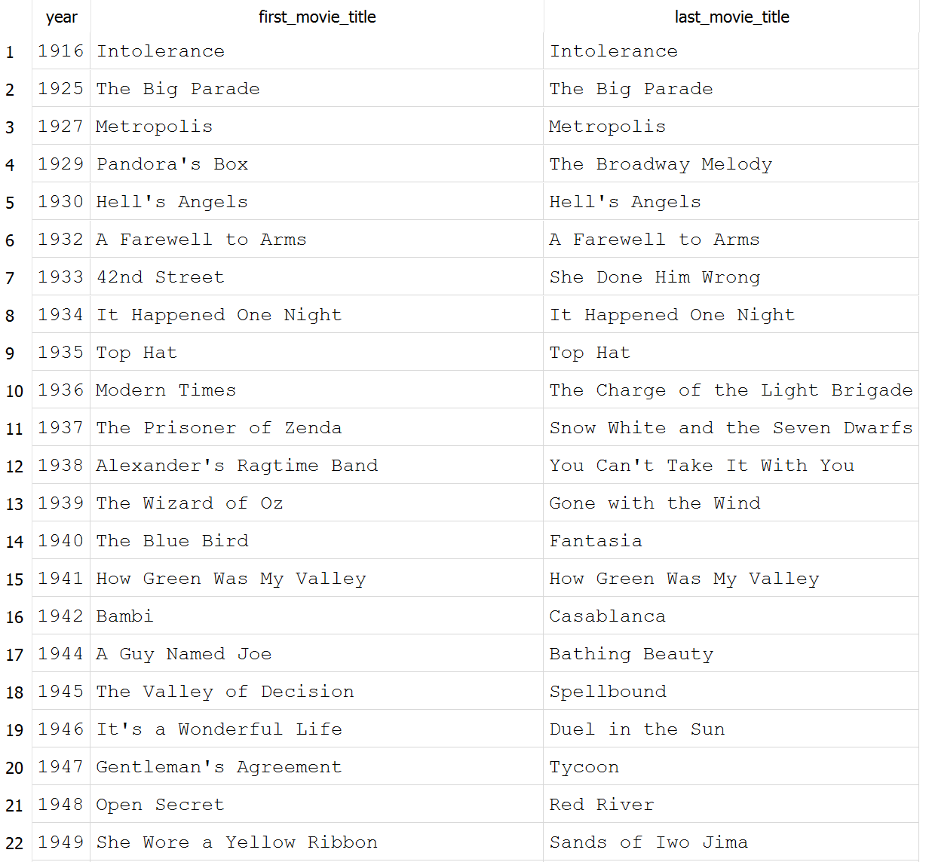
Results:

2. Total Revenue Generated Each Year
Calculate the total revenue generated by movies released in each year. Display the year and total revenue, ordered by revenue in descending order.

Code:
SELECT
strftime('%Y', release_date) AS year,
SUM(revenue) AS total_revenue
FROM movies
WHERE release_date IS NOT NULL AND release_date != ''
GROUP BY year
ORDER BY total_revenue DESC;
Results:

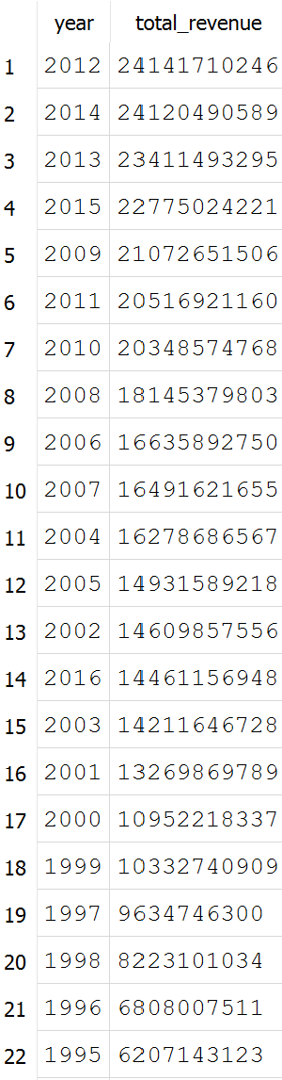

3. Movies Released in the First Half of the Year

Find all movies that were released between January and June. Display the movie title, release date, and director name.
Code:
SELECT
m.title AS movie_title,
m.release_date,
d.name AS director_name
FROM movies m
JOIN directors d ON m.director_id = d.id
WHERE strftime('%m', m.release_date) BETWEEN '01' AND '06'
ORDER BY m.release_date ASC;
Results:
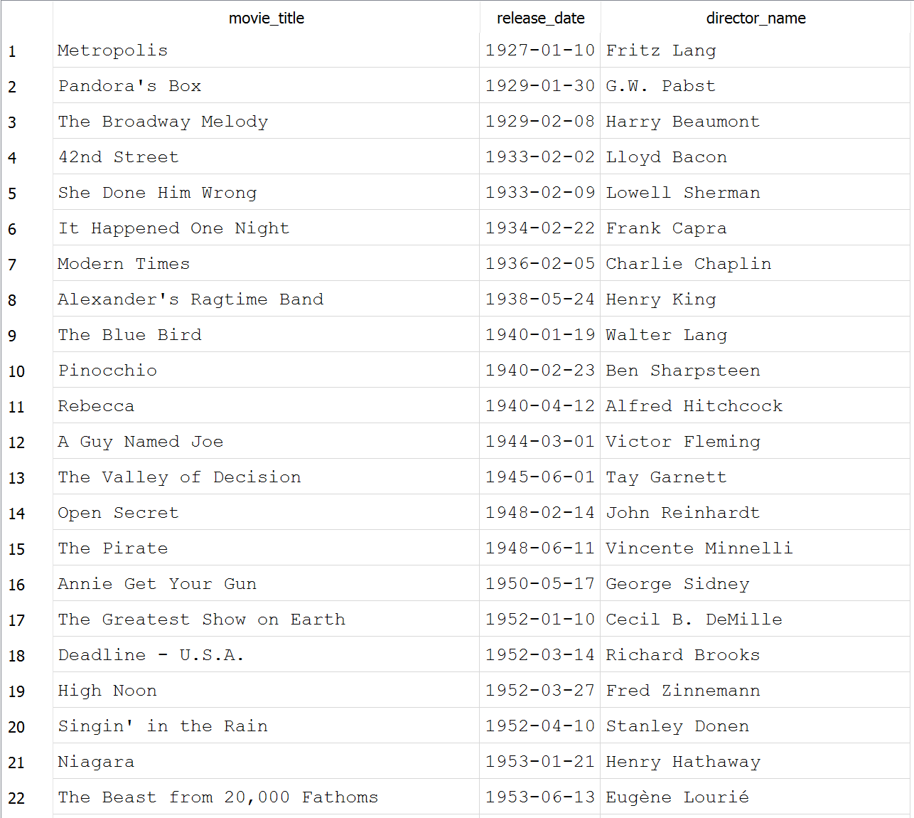

4. Number of Movies Released on Weekends
Count the total number of movies released on a weekend (Saturday or Sunday). Use SQLite's strftime('%w') to determine the day of the week (0 = Sunday, 6 = Saturday).
Code:
SELECT
COUNT(*) AS weekend_movie_count
FROM movies
WHERE strftime('%w', release_date) IN ('0', '6');

Results:
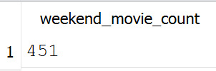

CASE Statement Queries

5. Categorize Directors Based on Total Revenue
Classify directors based on the total revenue of their movies:
- High Revenue if total revenue > $1 billion
- Moderate Revenue if total revenue is between $500 million and $1 billion
- Low Revenue if total revenue < $500 million
Code:
SELECT
d.name AS director_name,
SUM(m.revenue) AS total_revenue,
CASE
WHEN SUM(m.revenue) > 1000000000 THEN 'High Revenue'
WHEN SUM(m.revenue) BETWEEN 500000000 AND 1000000000 THEN 'Moderate Revenue'
ELSE 'Low Revenue'
END AS revenue_category
FROM directors d
JOIN movies m ON d.id = m.director_id
GROUP BY d.id, d.name
ORDER BY total_revenue DESC;

Results:
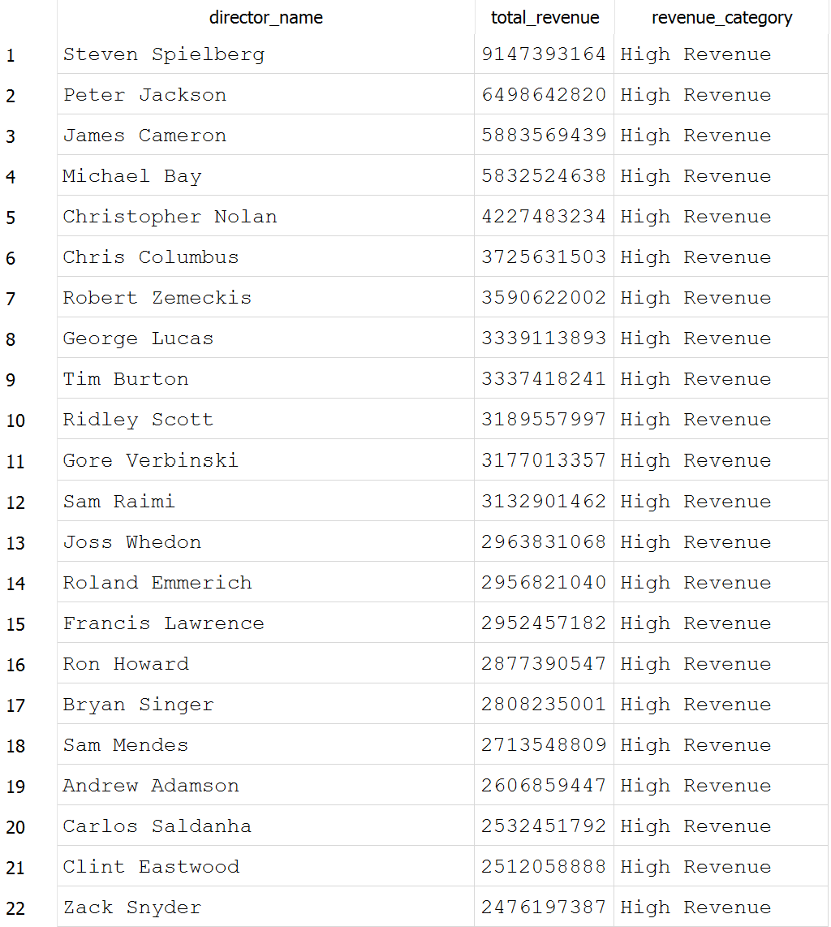

6. Movies Based on Popularity and Revenue
Classify movies into the following categories based on popularity and revenue:
- Blockbuster if popularity > 100 and revenue > $500 million
- Hit if popularity > 50 and revenue between $100 million and $500 million
- Average for all other movies
Code:
SELECT
title,
popularity,
revenue,
CASE
WHEN popularity > 100 AND revenue > 500000000 THEN 'Blockbuster'
WHEN popularity > 50 AND revenue BETWEEN 100000000 AND 500000000 THEN 'Hit'
ELSE 'Average'
END AS movie_category
FROM movies
ORDER BY popularity DESC;

Results:

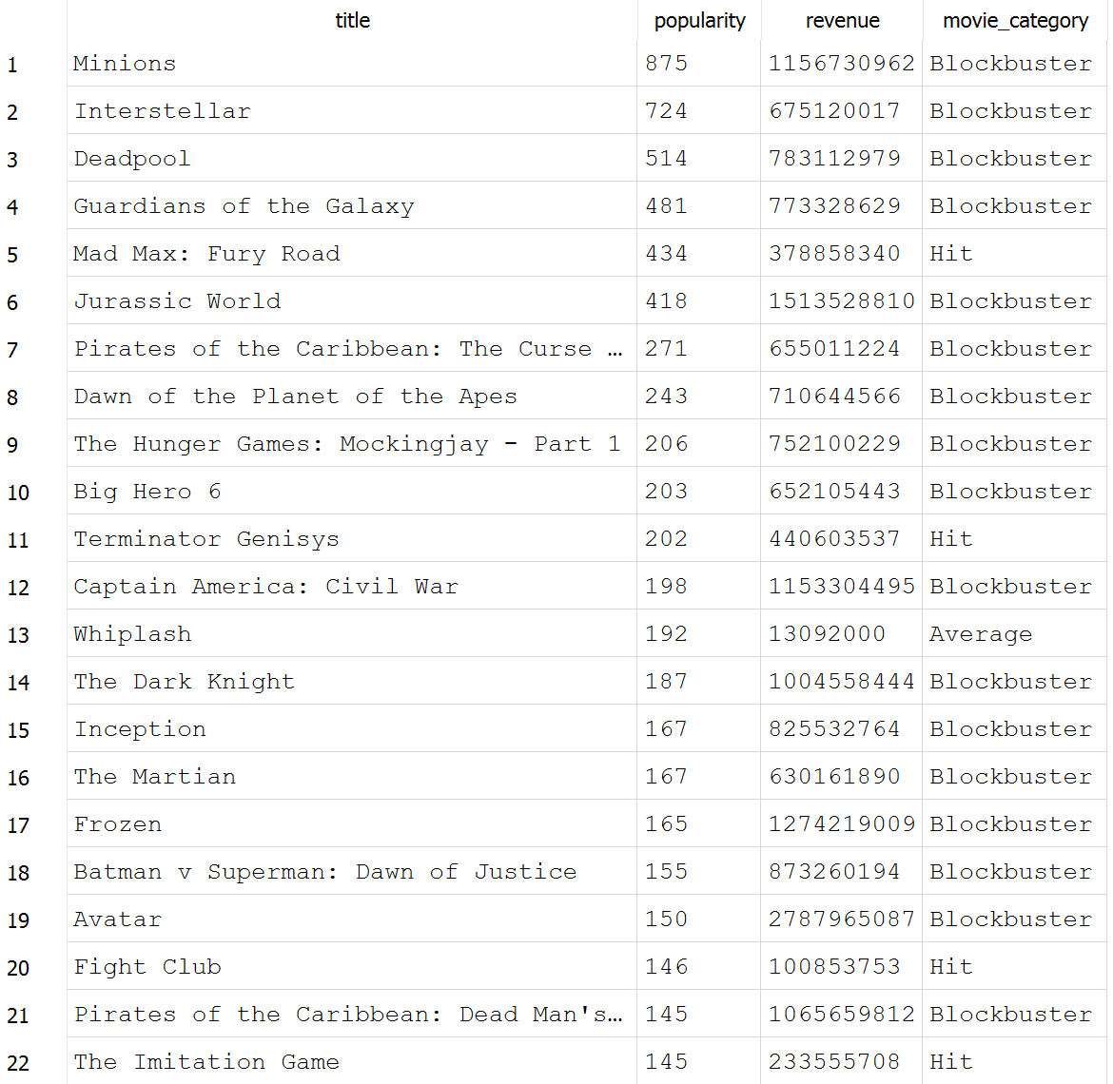

7. Directors with Critically Acclaimed and Poorly Rated Movies
List directors and count how many of their movies fall into these categories:
- Critically Acclaimed if vote_average >= 8
- Poorly Rated if vote_average < 5
Code:
SELECT
d.name AS director_name,
COUNT(CASE WHEN m.vote_average >= 8 THEN 1 END) AS critically_acclaimed_count,
COUNT(CASE WHEN m.vote_average < 5 THEN 1 END) AS poorly_rated_count
FROM directors d
JOIN movies m ON d.id = m.director_id
GROUP BY d.id, d.name
HAVING critically_acclaimed_count > 0 OR poorly_rated_count > 0
ORDER BY critically_acclaimed_count DESC, poorly_rated_count DESC;


Results:

