main_function('strings4.wav',1,'IIR',1,1,1,2,2,2,3,3,3);
main_function('strings4.wav',1,'FIR Window',1,1,1,2,2,2,3,3,3);
main_function('strings4.wav',2,'FIR Window',1,1,1,2,2,2,3,3,3);
main_function('strings4.wav',0.5,'FIR Window',1,1,1,2,2,2,3,3,3);
main_function('strings4.wav',1,'FIR Window',12,0,0,0,0,0,0,0,0);
function composite_signal = main_function(file_name,choose_rate,filter_type,gain_1,gain_2,gain_3,gain_4,gain_5,gain_6,gain_7,gain_8,gain_9)
% Read wav File
%file_name = 'strings4.wav';
[x,Fs]=audioread(file_name);
% Choose rate value
switch choose_rate
case 1
rate = Fs;
case 2
rate = (Fs)*2;
case 0.5
rate = (Fs)/2;
otherwise
end
% play Sound
sound(x, rate);
% plot Frequency Domain for original signal
figure;
Nfft = length(x);
f=linspace(0, Fs, Nfft);
G=abs(fft(x, Nfft));
plot(f(1:Nfft/2), G(1:Nfft/2));
% Plot Time Domain for original signal
figure;
t = linspace(0,length(x)/Fs,length(x));
plot(t,x);
switch filter_type
case 'IIR'
band_1 = IIR_ButterWorth(Fs,0,170);
band_2 = IIR_ButterWorth(Fs,170,310);
band_3 = IIR_ButterWorth(Fs,310,600);
band_4 = IIR_ButterWorth(Fs,600,1000);
band_5 = IIR_ButterWorth(Fs,1000,3000);
band_6 = IIR_ButterWorth(Fs,3000,6000);
band_7 = IIR_ButterWorth(Fs,6000,12000);
band_8 = IIR_ButterWorth(Fs,12000,14000);
band_9 = IIR_ButterWorth(Fs,14000,16000);
case 'FIR Window'
band_1 = FIR_Window(Fs,0,170);
band_2 = FIR_Window(Fs,170,310);
band_3 = FIR_Window(Fs,310,600);
band_4 = FIR_Window(Fs,600,1000);
band_5 = FIR_Window(Fs,1000,3000);
band_6 = FIR_Window(Fs,3000,6000);
band_7 = FIR_Window(Fs,6000,12000);
band_8 = FIR_Window(Fs,12000,14000);
band_9 = FIR_Window(Fs,14000,16000);
otherwise
end
% filter using digital filters generating 9 signal of 9 bands
signal_1=filter(band_1, x);
signal_2=filter(band_2, x);
signal_3=filter(band_3, x);
signal_4=filter(band_4, x);
signal_5=filter(band_5, x);
signal_6=filter(band_6, x);
signal_7=filter(band_7, x);
signal_8=filter(band_8, x);
signal_9=filter(band_9, x);
% Amplify the output signals using the user-defined gain
% Changing from db to magnitude
signal_1=signal_1*(10^(gain_1/20));
signal_2=signal_2*(10^(gain_2/20));
signal_3=signal_3*(10^(gain_3/20));
signal_4=signal_4*(10^(gain_4/20));
signal_5=signal_5*(10^(gain_5/20));
signal_6=signal_6*(10^(gain_6/20));
signal_7=signal_7*(10^(gain_7/20));
signal_8=signal_8*(10^(gain_8/20));
signal_9=signal_9*(10^(gain_9/20));
% Add the amplified-output signals in time domain to form composite signal.
composite_signal = signal_1 + signal_2 + signal_3 + signal_4 + signal_5 + signal_6 + signal_7 + signal_8 + signal_9;
% time domain for composite signal
figure;
t = linspace(0,length(composite_signal)/Fs,length(composite_signal));
plot(t,composite_signal);
% frequency domain for composite signal
figure;
Nfft = length(composite_signal);
f=linspace(0, Fs, Nfft);
G=abs(fft(composite_signal, Nfft));
plot(f(1:Nfft/2), G(1:Nfft/2));
% play composite signal
sound(composite_signal, rate);
% save composite signal
audiowrite('file.wav',composite_signal,Fs);
end
Warning: Data clipped when writing file.
Warning: Data clipped when writing file.
Warning: Data clipped when writing file.
Warning: Data clipped when writing file.

IIR Filter sample run:
main_function('strings4.wav',1,'IIR',1,1,1,2,2,2,3,3,3);
Frequency domain for Original signal
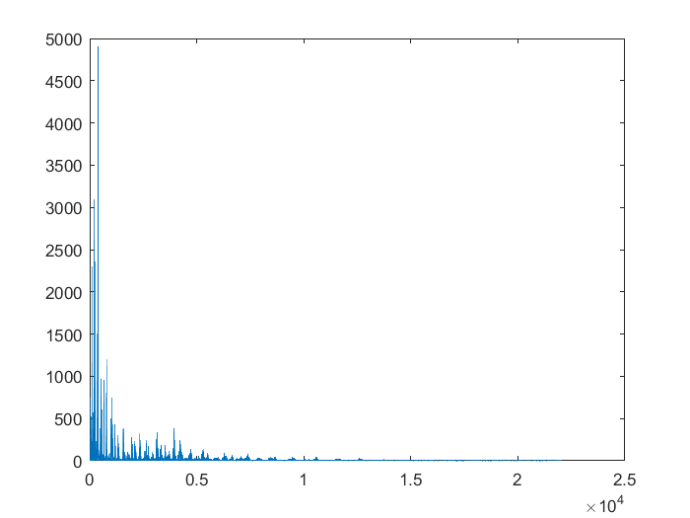

Time domain for Original signal
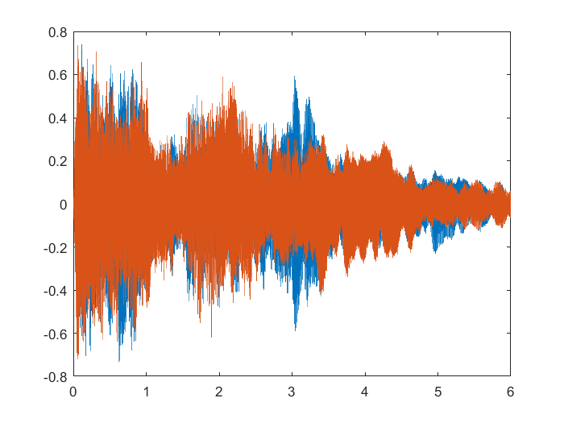

Time domain for Composite signal

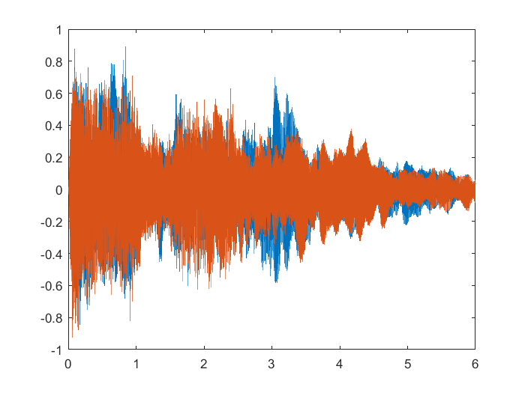

Frequency domain for Composite signal

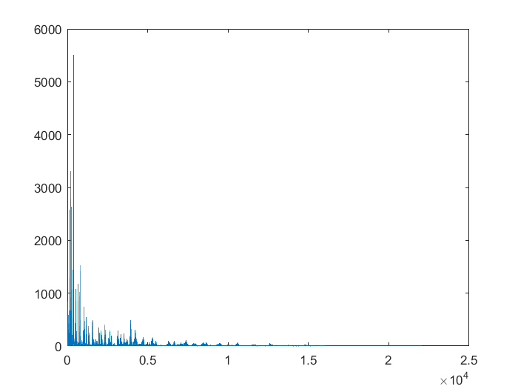

FIR Filter sample run:
main_function('strings4.wav',1,'FIR Window',1,1,1,2,2,2,3,3,3);

Frequency domain for Original signal

Time domain for Composite signal

Time domain for Composite signal

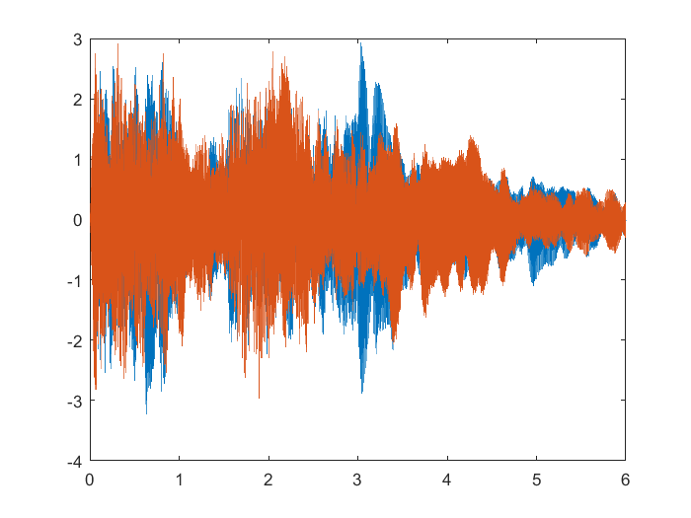

Frequency domain for Composite signal

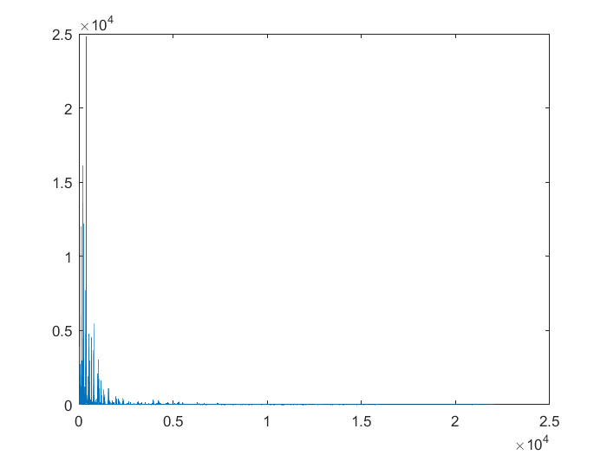

Double rate FIR sample run
main_function('strings4.wav',2,'FIR Window',1,1,1,2,2,2,3,3,3);
Frequency domain for Original signal

Time domain for Original signal

Time domain for Composite signal

Frequency domain for composite signal

Half rate FIR example
main_function('strings4.wav',0.5,'FIR Window',1,1,1,2,2,2,3,3,3);

Frequency domain for Original signal

Time domain for Original signal

Time domain for Composite signal

Frequency domain for Composite signal

Base Sample Run
main_function('strings4.wav',1,'FIR Window',12,0,0,0,0,0,0,0,0);
Frequency domain for Original signal

Time domain for Original signal

Time domain for Composite signal

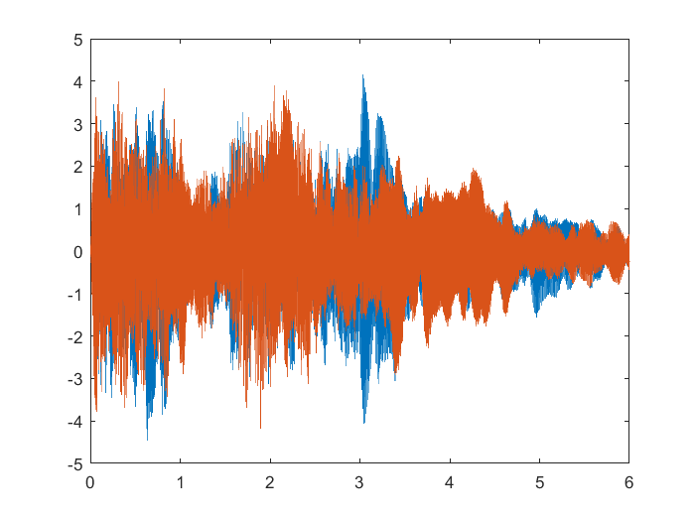

Frequency domain for Composite signal

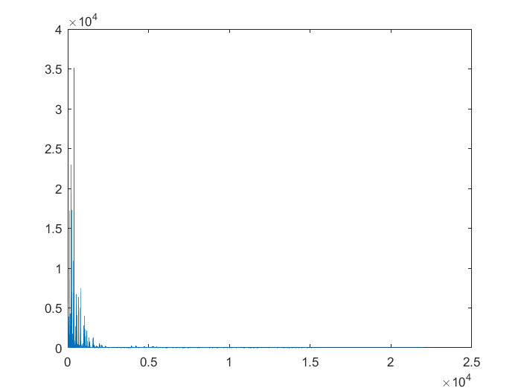
Filter Specification for band 1 IIR
Impulse response
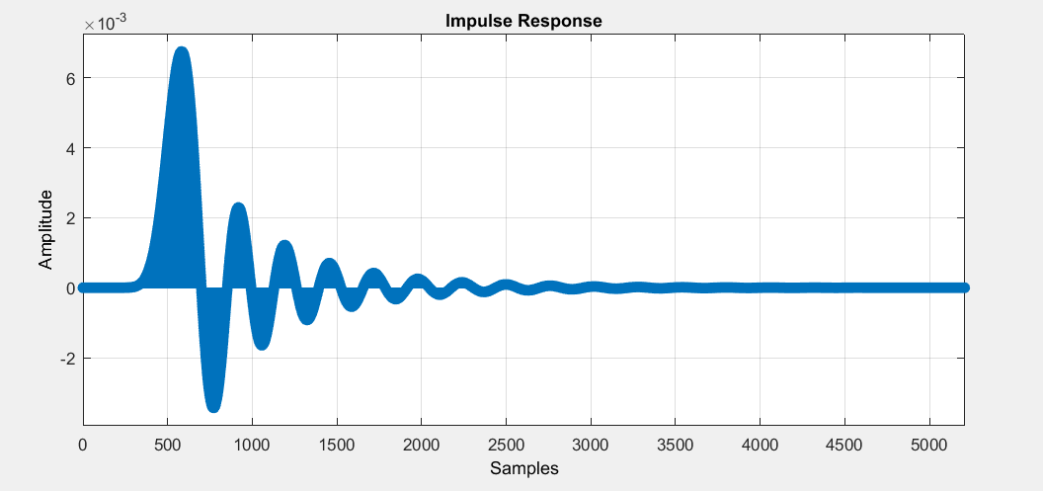

Frequency Response (Gain)
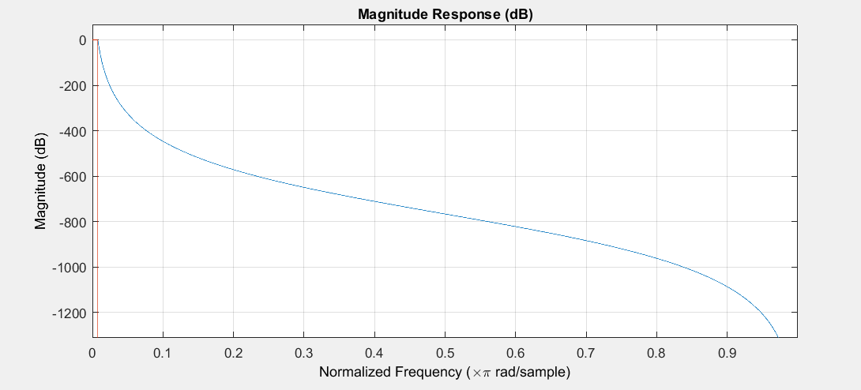
Frequency Response (phase)
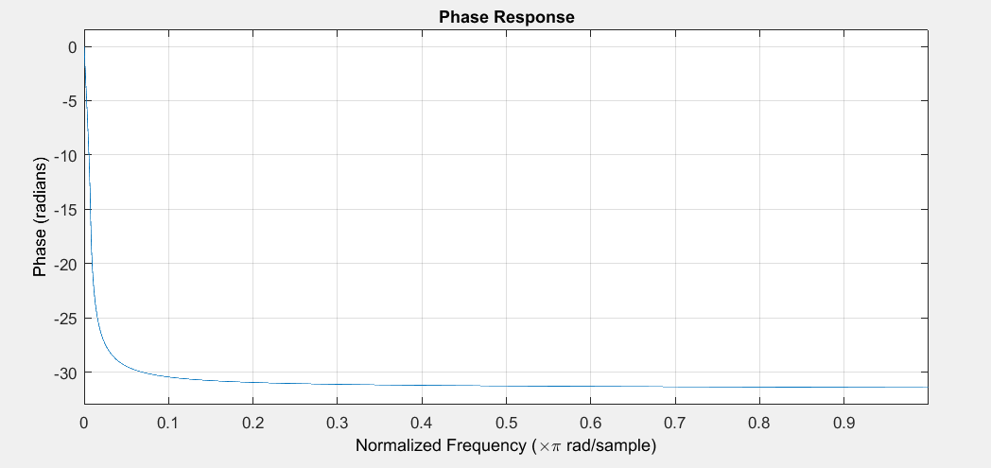

Group delay
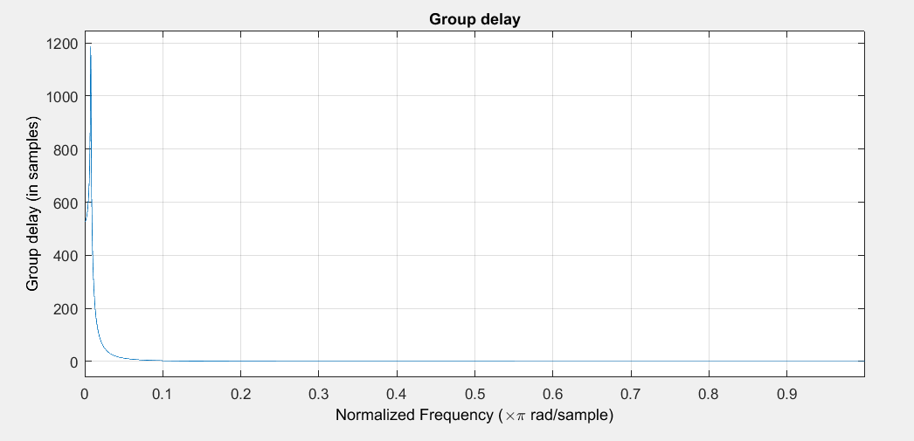

poles and zeros
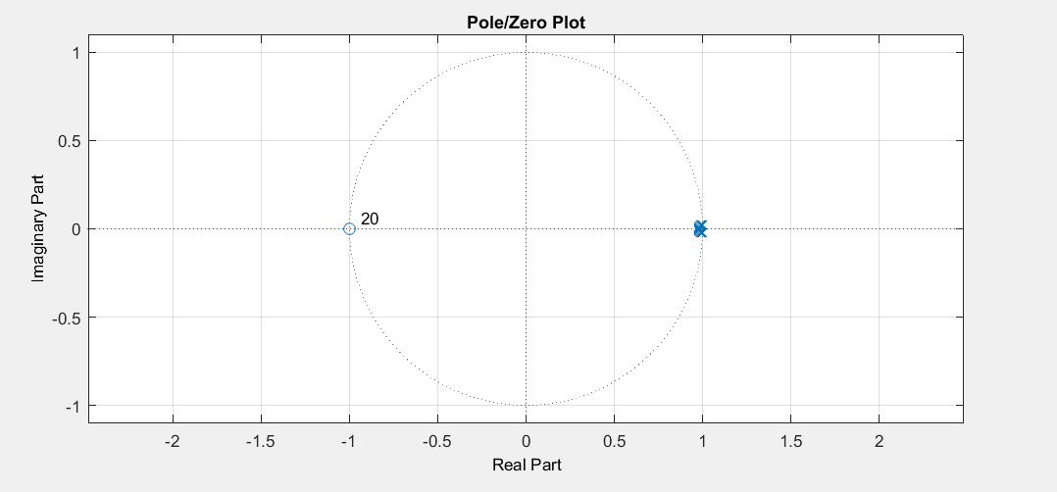

Filter Specification for band 1 FIR
Impulse response
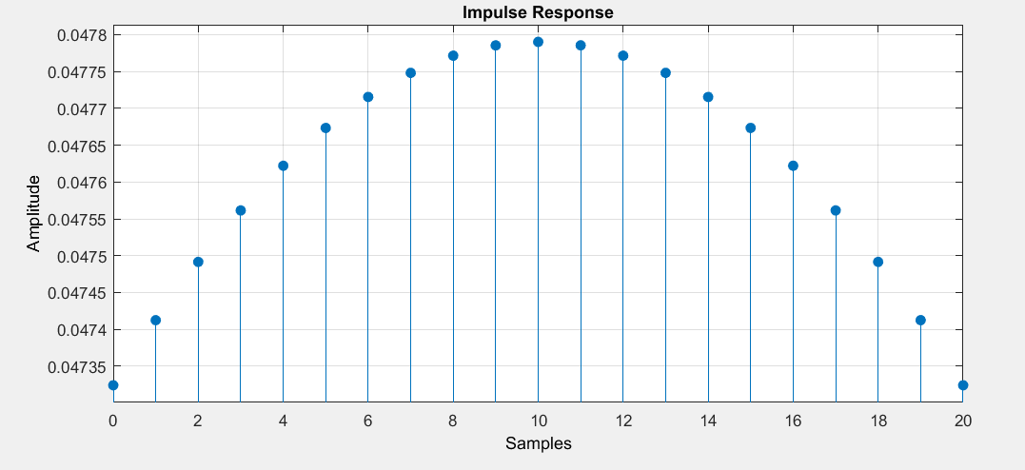
Frequency response (gain)
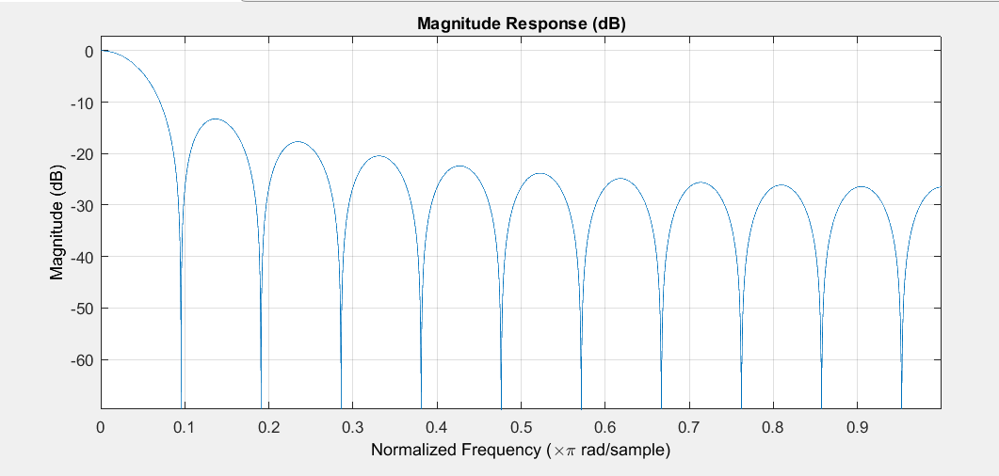
Frequency response (phase)
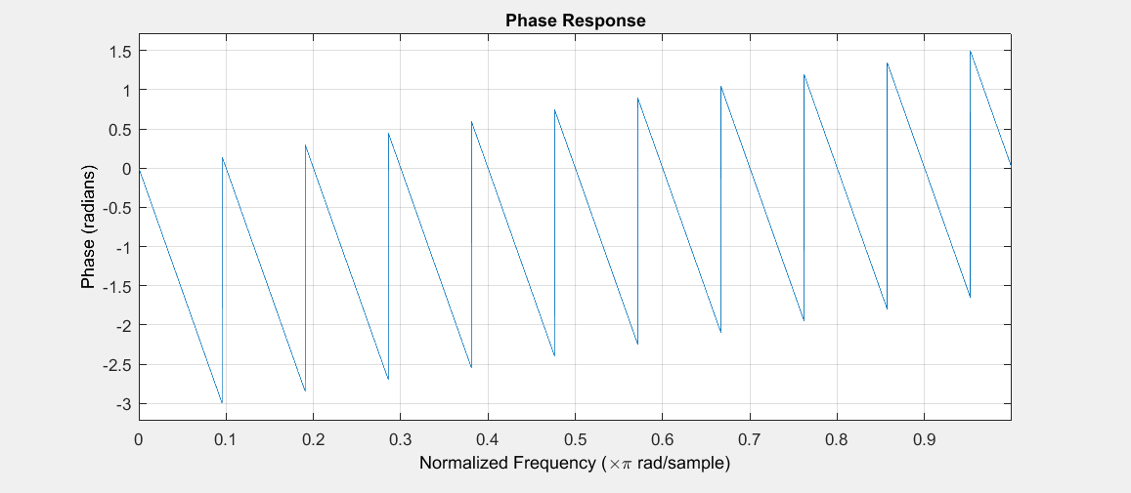
Group delay
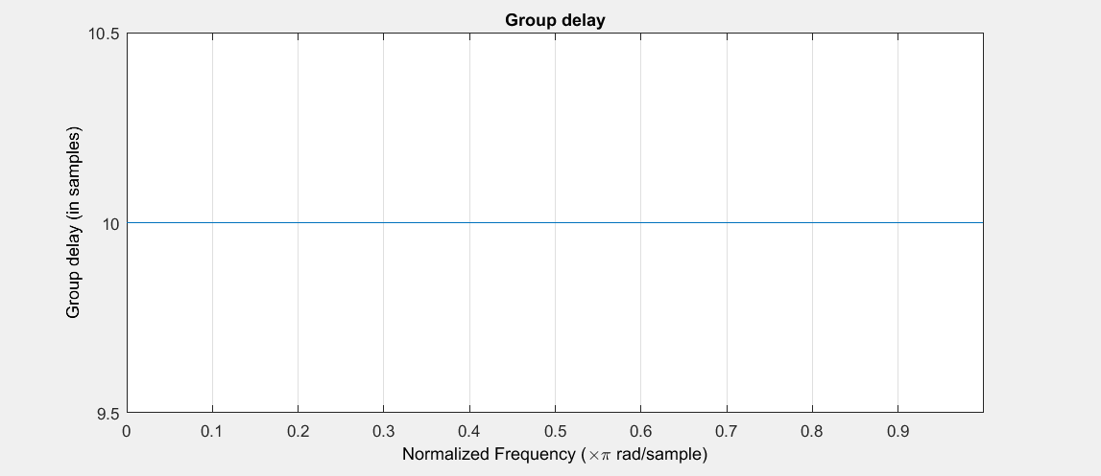
Plots and zeros
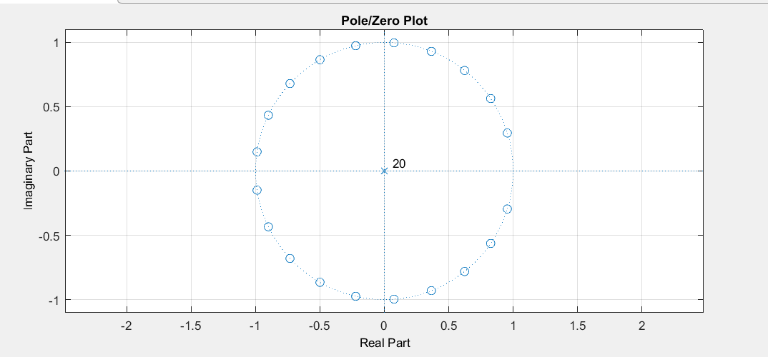
Error :-

1 π
_ ∫ |Hd(ω) − H(ω)| dω, average absolute error
2π −π

maxω |Hd(ω) − H(ω)|, maximum error (p = ∞)

maxω |W(Hd(ω) − H(ω))|, maximum weighted error (p = ∞)

the maximum weighted error between the desired response and the actual frequency
response of an FIR filter. We want to find the FIR filter that minimizes this error.
Filter Specifications for IIR
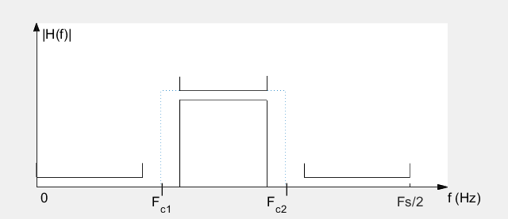
Filter Specifications for FIR
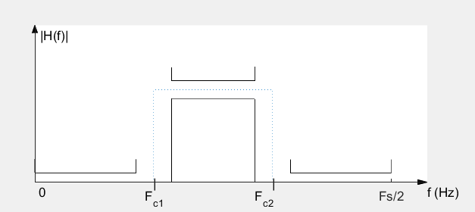
Fc1,Fc2 : range of frequency of band pass
Order : as order increase, performance of filter increase we choose a suitable order of 10
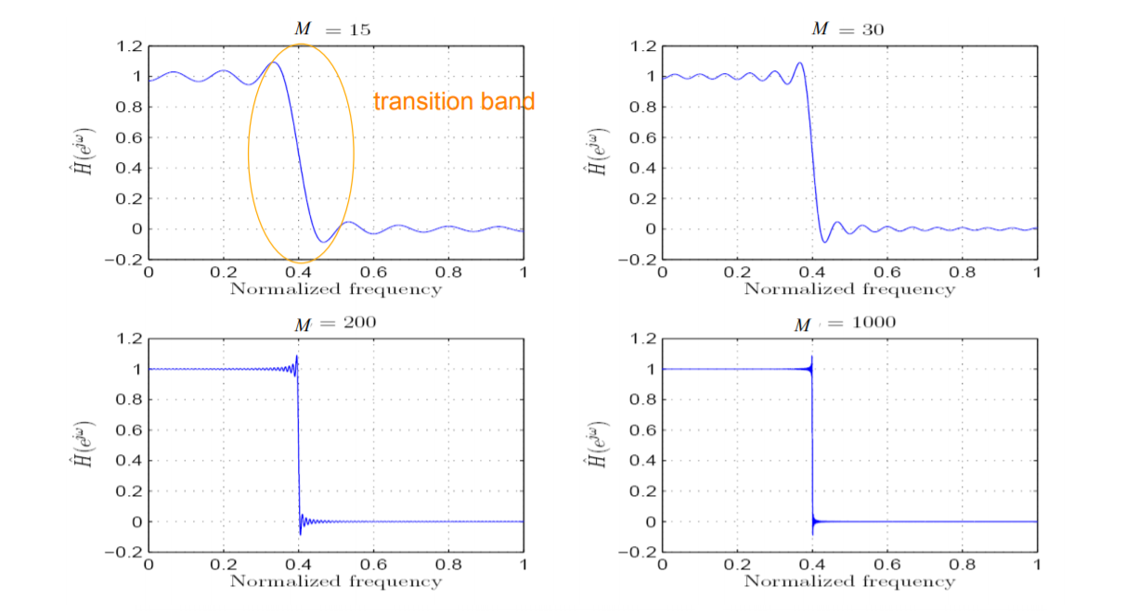
As number of samples increase the transition band gets narrower which is the delay so performance of filter is better as error decrease
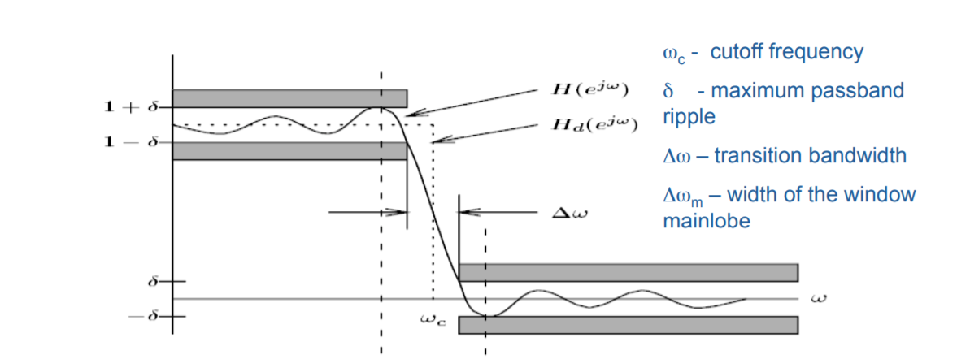
Low pass Window filter
equal transition bandwidth on both sides of the ideal cutoff frequency
peak approximation error in the passband is equal to that in the stopband
peak approximation error is determined by the window shape independent of the filter order
References :
https://drive.google.com/file/d/11KhjiktC3-GpGtRSdeGu3jFT8wkFr7BX/view?usp=drivesdk

Published with MATLAB® R2017a

