1. We wanted to check the countries that are dominating the domain according to the number of movies
2. We conclude thanks to a pivot table filtered from highest to lowest level that USA, UK, France and Canada are the dominating ones.

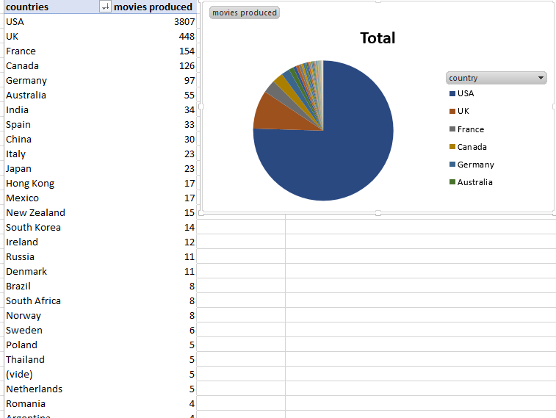

1. As the most relevant ones are USA, UK, France and Canada we wanted to check for them if success is related to the number of movies produced or not. Can small number of movies lead to be the first?
2. To do that we used the imdb_score for those 4 countries and we selected the years where they had the best imdb scores
3. We can see that the ranking didn’t change and conclude that producing more movies gives you better chances to be the first one in the domain

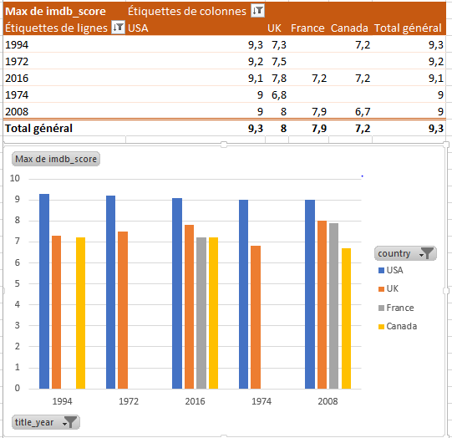

We have discovered that during the years 1994 1972 2016 2008 1974 imdb score for those four countries is the highest and mainly for USA we want to know now if it has a relationship with the budget inverted in movies. And check that maybe not all the high quality movies need a lot of money

We conclude that in fact, USA inverted much more money than the other countries which lead to the best imdb score and the ranking is still the same , which make us think that everything is related , more movies and more budget means more success.

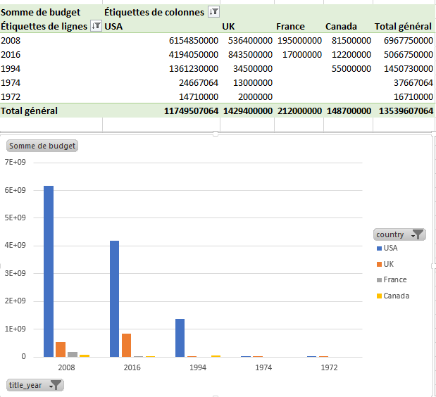

But how much money should’ve those countries inverted to beat USA? Let’s use the solver

