Article
Periodic Boundary Conditions in Generalized Beam Theory for the Buckling of Omega-Stringer-Stiffened Composite Panels
Aya Medhat Elsayed ¹, Navid Kharghani ^{1,*} and Christian Mittelstedt ¹
Academic Editor: Firstname Lastname
Received: date
Revised: date
Accepted: date
Published: date
Citation: To be added by editorial staff during production.
Copyright: © 2026 by the authors. Submitted for possible open access publication under the terms and conditions of the Creative Commons Attribution (CC BY) license (https://creativecommons.org/licenses/by/4.0/).
¹ Institute for Lightweight Engineering and Structural Mechanics (LSM), Department of Mechanical Engineering, Technical University of Darmstadt, Otto-Berndt-Straße 2, 64287 Darmstadt, Germany
* Correspondence: navid.kharghani@lsm.tu-darmstadt.de
A.M.E.: ayaallah.elsayed@stud.tu-darmstadt.de; C.M.: christian.mittelstedt@lsm.tu-darmstadt.de
Abstract
Stringer-stiffened composite panels are commonly analyzed as one representative cell with periodic boundary conditions. Generalized Beam Theory (GBT) represents the buckling of thin-walled members through cross-section deformation modes, but periodic side edges have not been incorporated into its cross-section analysis. This paper embeds the periodic condition into every family of GBT modes: the conventional modes are restricted to their periodic subspaces, the warping follows from the cell treated as a closed contour, and the shear and Mindlin modes are merged across the side edges. Each mode, and hence every truncated basis, then satisfies it exactly, without penalty terms or Lagrange multipliers. A shear-deformable GBT–Ritz member analysis then follows, with laminated Reissner–Mindlin walls, the true stringer offset, a computed pre-buckling state and B-spline amplitudes, reducing to classical GBT for uncoupled walls. Verified against periodic Abaqus shell models for 30 cells, the critical loads agree on average to within 0.57% (simply supported) and 0.64% (clamped), with mode shapes matching to a modal assurance criterion above 0.999. Short cells buckle locally; longer cells in a long-wave mode driven by the transverse compression that the constant width induces, or globally. Permitting lateral expansion raises the critical loads by factors of 2.0–2.9, so the restraint implicit in periodic analyses matters for long panels.
Keywords: generalized beam theory(GBT); Ritz method; periodic boundary conditions; stiffened panels; omega stringer; laminated composites; buckling

1. Introduction
Stringer-stiffened panels are the standard construction of aircraft fuselage and wing covers, and buckling is often their governing design criterion [1,2]. The omega (hat) stringer offers high bending and torsional stiffness and a wide bonding area [3,4]. Away from its longitudinal edges, a cover with many identical stringers is represented by one repeating cell with periodic boundary conditions [5–7]. The principle goes back to waves in periodic structures [8] and is used in exact strip programs (VIPASA, VICONOPT) [9,10] and finite strip methods [11,12].
Closed-form models of stiffened composite panels have been developed for blade stringers [5,6] and omega stringers [3,13], including local and column buckling [4,7], shear and combined loading [14,15] and postbuckling [16], and most recently local buckling and postbuckling of omega-stringer panels including the stringer feet [17–19]; see also [20]. These models reduce the panel to a repeating unit with periodic [5–7] or symmetry conditions [18], the latter admitting only modes symmetric about the symmetry lines. They are efficient but idealize the skin–stringer interaction by elastic restraints, separate local and global buckling, assume a uniform pre-buckling stress and include membrane–bending coupling through a reduced bending stiffness [21], as does the physics-informed neural network of the authors [22]. Shell finite element models avoid these idealizations but are expensive and give the mode only as a nodal field.
GBT, originated by Schardt [23,24] and developed further by Davies and Leach [25], describes a thin-walled member by cross-section modes with amplitude functions along the axis, which makes it transparent for coupled instabilities [26–29]. Silvestre and Camotim formulated GBT for orthotropic and laminated members [30,31] including shear deformation [32,33]. The cross-section analysis was extended to branched sections [34], reformulated [35,36] with shear modes [37] and implemented in GBTUL 2.0 [38]; closed sections were treated for tubes [39,40], and GBT was applied to fiber-reinforced polymer (FRP) columns [41], stiffened composite panels [42] and stiffened sections [43]. The Ritz method complements GBT in the member analysis [44–46]: Kharghani and Mittelstedt combined both into a GBT–Ritz approach for global, local and distortional buckling of shear-deformable composite beams [47], composite box girders [48] and beams with unsymmetric lay-ups [49,50].
GBT has been developed for members with free longitudinal edges or closed contours, whereas the skin of a panel cell ends at two side edges whose displacements must be equal. This condition has not been formulated in GBT, and it cannot simply be imposed on a truncated set of classical modes: these are computed for an open contour with independent side edges, so that few of their combinations are periodic. Moreover, the omega stringer forms closed cells with the skin, which excludes Vlasov’s warping, it is offset from the skin, and the pre-buckling state is not uniform.
The present study closes this gap. Its novelty is the formulation of the periodic condition within the cross-section analysis of GBT, such that every mode, and therefore every truncated basis, satisfies it exactly, together with a shear-deformable GBT–Ritz analysis [50] of omega-stringer-stiffened panels with symmetric and unsymmetric laminates, verified against Abaqus shell models. The mode decomposition reveals, besides the transition from local to global buckling of long cells, a long-wave mode caused by the constant width that the periodic condition imposes. Since every mode is periodic by construction, the formulation is also suited as the physics model of physics-informed neural networks for such panels, extending the authors’ earlier network [22] (Section 4).

2. Theory and formulations
GBT analyses a thin-walled member in two stages [24,30,36]: the cross-section analysis (Sections 2.1 and 2.2) yields the deformation modes and their stiffness constants (modal tensors); the member analysis (Section 2.3) yields the amplitude functions of the modes along the length and the critical load.. Classical GBT is extended, and recovered as a special case (Section 2.3.4), by periodic modes, the main contribution (Section 2.2), closed contours without Vlasov’s assumptions, Reissner–Mindlin laminated walls and a computed pre-buckling state.

2.1. Cross-section analysis

2.1.1. Periodic cell and displacement field
The cell of the infinitely wide panel (Figure 1b) contains two stringers at the pitch $b_{s}$; it has the width $W=2b_{s}$ and the length $L=βb_{s}$, with the aspect ratio $β$ (Figure 1a). Two stringers are needed because a cell of one pitch contains only modes that repeat in every bay, not those that alternate from bay to bay (Section 2.2.5). $X$ runs across the panel, $Y$ normal to the skin and $x$ along the stringers; the skin occupies $-W≤X≤0$, with the side edges $s_{L}$ ($X=-W$) and $s_{R}$ ($X=0$) in the flat middle of a skin bay. Every wall has local axes $\left(x,s,z\right)$ ($s$ along its mid-line, $z$ normal) with mid-surface displacements $u$, $v$, $w$ [32]. The walls are divided into segments of at most $b_{s}/25$ [24,36]; for $b_{s}=150$ mm the cell has $N=92$ nodes, 19 walls and 93 segments (Figure 1c).
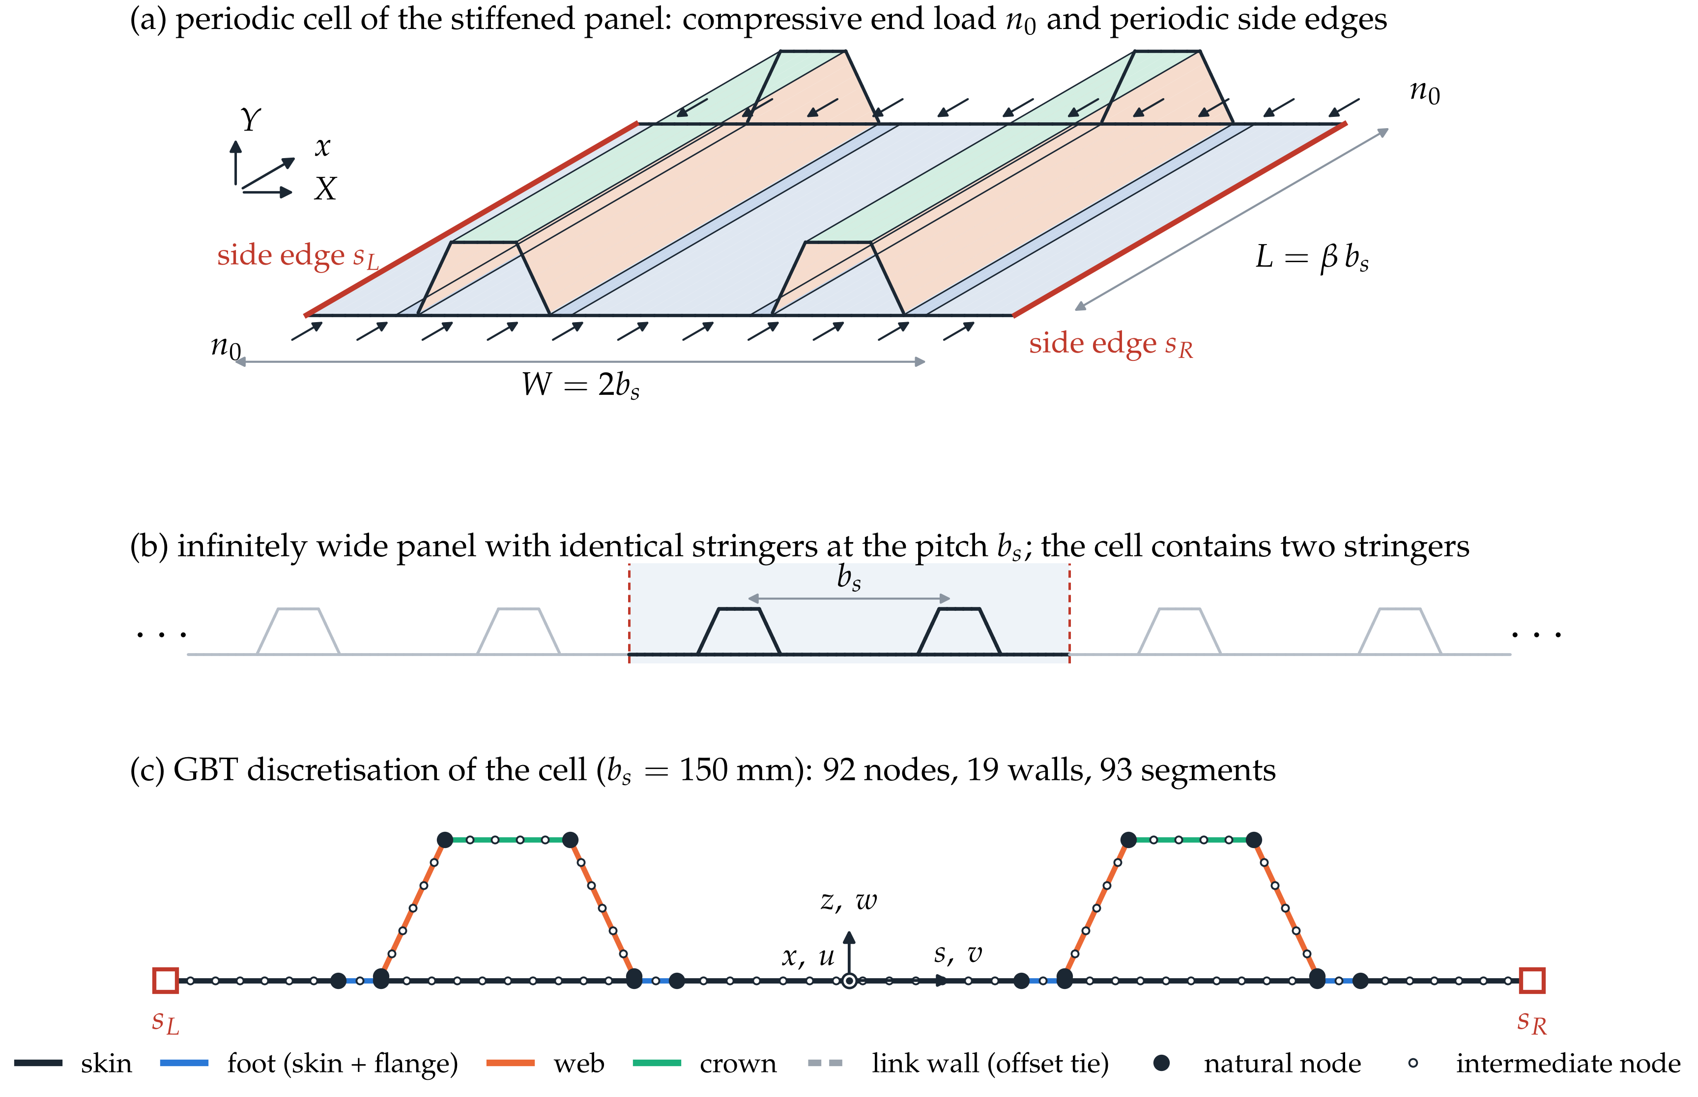
Figure 1. Periodic cell of the omega-stringer-stiffened panel. (a) Cell of width $W=2b_{s}$ and length $L=βb_{s}$ with the end load $n_{0}$ and the side edges $s_{L}$, $s_{R}$ linked by the periodic condition. (b) Infinitely wide panel and the cell (shaded). (c) GBT discretisation for $b_{s}=150$ mm with nodes, wall types and local axes $\left(x,s,z\right)$.
In GBT, every displacement is a sum of mode profiles (functions of $s$) times amplitude functions (functions of $x$) [32],
$$u\left(x,s\right)=u_{k}\left(s\right) ϕ_{k,x}\left(x\right)+u_{j}\left(s\right) φ_{j}\left(x\right), v\left(x,s\right)=v_{k}\left(s\right) ϕ_{k}\left(x\right), w\left(x,s\right)=w_{k}\left(s\right) ϕ_{k}\left(x\right),$$ | (1)
with summation over repeated indices. The conventional modes $k$ deform the cross-section in its plane ($v_{k}$, $w_{k}$), with a warping $u_{k}$ tied to $ϕ_{k,x}$ as in beam theory; the shear modes $j$ add an independent warping $u_{j}$, i.e. mid-surface shear, and include the axial extension $u_{j}=1$. The rotations of the Reissner–Mindlin wall normals are described by transverse shear (Mindlin) modes $r$,
$$ψ_{x}\left(x,s\right)=ξ_{r}\left(s\right) χ_{r}\left(x\right), ψ_{s}\left(x,s\right)=ζ_{r}\left(s\right) χ_{r}\left(x\right),$$ | (2)
with the profiles $ξ_{r}$, $ζ_{r}$ and amplitudes $χ_{r}$; in variations, $i$ and $h$ replace $k$ and $j$.

2.1.2. Strains and constitutive relations
Inserting Eqs. (1) and (2) into the Reissner–Mindlin strains, i.e. membrane strains plus $z$ times the curvatures $κ_{xx}=-w_{,xx}+ψ_{x,x}$, $κ_{ss}=-w_{,ss}+ψ_{s,s}$, $κ_{xs}=-2w_{,xs}+ψ_{x,s}+ψ_{s,x}$, and the transverse shear strains $γ_{xz}=ψ_{x}$, $γ_{sz}=ψ_{s}$, gives
$$\begin{matrix}ε_{xx}=\left(u_{k}-z w_{k}\right)ϕ_{k,xx}+u_{j} φ_{j,x}+z ξ_{r} χ_{r,x}, ε_{ss}=\left(v_{k,s}-z w_{k,ss}\right)ϕ_{k}+z ζ_{r,s} χ_{r}, \\ γ_{xs}=\left(γ_{k}-2z w_{k,s}\right)ϕ_{k,x}+u_{j,s} φ_{j}+z\left(ξ_{r,s} χ_{r}+ζ_{r} χ_{r,x}\right), γ_{xz}=ξ_{r} χ_{r}, γ_{sz}=ζ_{r} χ_{r},\end{matrix}$$ | (3)
with the membrane shear strain profile $γ_{k}=u_{k,s}+v_{k}$. In [32] the conventional modes satisfy Vlasov’s assumptions $γ_{k}=0$ (no membrane shear) and $v_{k,s}=0$ (no transverse extension) and the walls are Kirchhoff plates ($ξ_{r}=ζ_{r}=0$); here, transverse extension modes are included and $γ_{k}=0$ cannot hold in closed contours (Section 2.2.3). The geometric stiffness requires the quadratic membrane strains
$$ε_{xx}^{NL}=1/2\left(u_{,x}^{2}+v_{,x}^{2}+w_{,x}^{2}\right), ε_{ss}^{NL}=1/2\left(u_{,s}^{2}+v_{,s}^{2}+w_{,s}^{2}\right), γ_{xs}^{NL}=u_{,x}u_{,s}+v_{,x}v_{,s}+w_{,x}w_{,s},$$ | (4)
of which classical GBT retains $1/2\left(v_{,x}^{2}+w_{,x}^{2}\right)$ [31,32]. The membrane forces $N$, moments $M$ and transverse shear forces $Q$ follow from first-order shear deformation laminate theory (FSDT) with a shear correction factor of 5/6 [51–53],
$$\left[\begin{matrix}N \\ M \\ Q\end{matrix}\right]=\left[\begin{matrix}A & B & 0 \\ B & D & 0 \\ 0 & 0 & A_{z}\end{matrix}\right]\left[\begin{matrix}ε^{M} \\ κ \\ γ_{z}\end{matrix}\right],$$ | (5)
with the membrane, coupling, bending and transverse shear stiffnesses $A$, $B$, $D$, $A_{z}$. All couplings are retained [32,50], and $N_{ss}$ is not set to zero as in beam theories, since the cell restrains the transverse expansion of the skin (Section 3.2).
Two walls need special treatment. A stringer foot (skin plus bonded flange) is one wall whose stiffness is referred to the skin mid-plane, so that it joins the neighboring skin at the same height. With the stiffnesses $\tilde{A}$, $\tilde{B}$, $\tilde{D}$ of the combined stack about its own mid-plane, at $z_{f}=t_{f}/2$ from the skin mid-plane towards the flange, the standard shift of the reference plane ($z=z'+z_{f}$ in the stiffness integrals) gives
$$A_{f}=\tilde{A}, B_{f}=\tilde{B}+z_{f} \tilde{A}, D_{f}=\tilde{D}+2z_{f} \tilde{B}+z_{f}^{2} \tilde{A}.$$ | (6)
The second wall reproduces the offset $c=\left(t_{s}+t_{f}\right)/2$ between the stringer and skin mid-surfaces (thicknesses $t_{s}$, $t_{f}$), bridged by a tie in the shell model. Every web root is a node at $Y=c$, joined to the skin node below by a link wall that must transfer displacements and rotation rigidly without adding material; its stiffnesses are multiples of the skin stiffnesses $A_{0}$, $D_{0}$, $A_{z0}$,
$$\begin{matrix}A_{11}^{L}={10}^{-3}A_{0,11}, A_{22}^{L}=k_{L}A_{0,22}, A_{66}^{L}=k_{L}A_{0,66}, \\ D_{11}^{L}={10}^{-3}D_{0,11}, D_{22}^{L}=k_{L}D_{0,22}, D_{66}^{L}={10}^{-3}D_{0,66}, A_{z}^{L}=k_{L}A_{z0},\end{matrix}$$ | (7)
with all other entries zero. The factor $k_{L}={10}^{3}$ makes the link rigid in the cross-section plane; the factor ${10}^{-3}$ removes its axial, longitudinal bending and twisting stiffness, which a row of rigid links does not have. Both are numerical choices: changing $k_{L}$ from ${10}^{2}$ to ${10}^{4}$ or the small factor from ${10}^{-2}$ to 0 changes the critical load by less than 0.01 % (Section 3.7).

2.1.3. Nodal description and mode families
As in modern GBT [36,37], the modes are built from nodal quantities: on every segment $p$ (width $b_{p}$, unit tangent $t_{p}$, end nodes $q$, $q'$, local coordinate $η∈\left[0,1\right]$), $u$ and $v$ vary linearly, and $w$ is the cubic Hermite interpolation of the nodal normal displacements $w_{q}$ and rotations $θ_{q}=w_{,s}$,
$$\begin{matrix}w\left(η\right)=H_{1}\left(η\right) w_{q}+b_{p}H_{2}\left(η\right) θ_{q}+H_{3}\left(η\right) w_{q'}+b_{p}H_{4}\left(η\right) θ_{q'}, \\ H_{1}=1-3η^{2}+2η^{3}, H_{2}=η-2η^{2}+η^{3}, H_{3}=3η^{2}-2η^{3}, H_{4}=-η^{2}+η^{3}.\end{matrix}$$ | (8)
This is equivalent to Schardt’s nodal moments [24], but makes the periodic conditions linear in the nodal quantities. The in-plane deformation is described by the nodal displacements $U$ (a vector of the $2N$ components $U_{X}$, $U_{Y}$ of all nodes) and the nodal rotations $Θ$ ($N$ components), and the segment elongations by the matrix $E_{l}$, ${\left(E_{l}U\right)}_{p}=t_{p}⋅\left(U_{q'}-U_{q}\right)$. The modes are generated in the usual GBT families:
- G (global): rigid-body translations and rotation;
- D (distortional): nodal displacements without segment elongation ($E_{l}U=0$), orthogonal to G and L, which move the wall junctions;
- L (local): a unit normal displacement of a non-junction node or a unit nodal rotation, i.e. wall bending between junctions;
- T (transverse extension): the columns of $E_{l}^{T}$, which stretch the segments;
- S (shear): the nodal hat functions of the warping, one replaced by the axial mode $u_{j}=1$;
- M (Mindlin): nodal vectors $Ω_{q}$ with $ξ_{r}=t⋅Ω_{q}$, and nodal values of $ζ_{r}$, interpolated linearly.
G, D and L span the null space (kernel) $kerE_{l}=\{U: E_{l}U=0\}$ of fields that elongate no segment, and T spans the range of $E_{l}^{T}$ (the space spanned by its columns); by the standard decomposition $R^{2N}=kerE_{l}⊕rangeE_{l}^{T}$ of linear algebra, the families thus cover every in-plane deformation, with the rotations in family L. The warping $u_{k}$ of the G and D modes is not free: classical GBT chooses it such that the membrane shear strain $γ_{k}$ vanishes [24,54]. In a closed contour this is impossible, so $u_{k}$ minimises the membrane shear strain energy,
minu Πwu=p​A66,p bpuq'-uqbp+vp​η=122 subject to caxTu=0, | (9)
where $u$ collects the nodal warping values, the bracket is $γ_{k}$ at the segment mid-point, ${\hat{A}}_{66}=A_{66}-A_{26}^{2}/A_{22}$ is the shear stiffness for zero transverse force, and the constraint, with cax,q=p∋q​12A11,pbp and ${\hat{A}}_{11}=A_{11}-A_{12}^{2}/A_{22}$, removes the axial resultant (axial extension is the separate mode $u_{j}=1$). For an open contour the minimum is zero and Vlasov’s warping is recovered; in a closed contour the remaining $γ_{k}$ is kept in Eq. (3).

2.2. Periodic boundary conditions in the cross-section analysis

2.2.1. Continuous condition and its modal form
As one period of the infinite panel, the cell has side edges that are the same line of the panel, so all displacements and rotations must be equal on them,
$$U_{α}\left(X=-W, x\right)-U_{α}\left(X=0, x\right)=0, α=1,…,6, 0≤x≤L,$$ | (10)
where $U_{1}$–$U_{3}$ are the translations in $X$, $Y$, $x$ and $U_{4}$–$U_{6}$ the rotations about $X$, $Y$, $x$ of a shell node; shell models impose Eq. (10) with one equation per pair of side nodes and degree of freedom [5–7]. Table 1 gives the corresponding conditions on the GBT modes.
Table 1. Degrees of freedom of a skin side node and the corresponding modal conditions.
Shell DOF | Meaning at a skin side node | Modal condition
$$U_{1}$$ | in-plane displacement $U_{X}$ | $U_{X,s_{L}}=U_{X,s_{R}}$ for every conventional mode, Eq. (12)
$$U_{2}$$ | deflection $U_{Y}$ | $U_{Y,s_{L}}=U_{Y,s_{R}}$ for every conventional mode, Eq. (12)
$$U_{3}$$ | axial displacement $u$ | $u_{k}\left(s_{L}\right)=u_{k}\left(s_{R}\right)$, Eq. (13); $u_{j}\left(s_{L}\right)=u_{j}\left(s_{R}\right)$, Eq. (14)
$$U_{4}$$ | rotation $-w_{,x}+ψ_{x}$ | follows from $U_{2}$ for $w_{,x}$; $ξ_{r}\left(s_{L}\right)=ξ_{r}\left(s_{R}\right)$, Eq. (14)
$$U_{6}$$ | rotation $θ+ψ_{s}$ | $θ_{s_{L}}=θ_{s_{R}}$, Eq. (12); $ζ_{r}\left(s_{L}\right)=ζ_{r}\left(s_{R}\right)$, Eq. (14)
$$U_{5}$$ | drilling rotation | not a degree of freedom of the plate theory
Inserting Eqs. (1) and (2) into Eq. (10) gives, e.g. for $U_{3}$,
$$\left[u_{k}\left(s_{L}\right)-u_{k}\left(s_{R}\right)\right]ϕ_{k,x}\left(x\right)+\left[u_{j}\left(s_{L}\right)-u_{j}\left(s_{R}\right)\right]φ_{j}\left(x\right)=0 ∀ x∈\left[0,L\right].$$ | (11)
Proposition 1. Equation (10) holds for arbitrary amplitude functions if, and only if, every mode satisfies it individually: $U_{k}$, $θ_{k}$ and $u_{k}$ of all conventional modes, $u_{j}$ of all shear modes and $ξ_{r}$, $ζ_{r}$ of all Mindlin modes take equal values at $s_{L}$ and $s_{R}$.
Proof. If every bracket vanishes, Eq. (11) and its analogues hold for any amplitudes. Conversely, if all amplitude functions but one are set to zero, the bracket of the remaining mode must vanish. $▫$
The periodic condition can therefore be built into the cross-section analysis by modes that are periodic one by one (Sections 2.2.2–2.2.4); every combination of them, in particular every Ritz trial function, is then periodic, without penalty terms or Lagrange multipliers.

2.2.2. Conventional modes: constrained family subspaces
For the conventional modes, the conditions on $U_{1}$, $U_{2}$ and the nodal rotation part of $U_{6}$ are three linear equations,
$$R\left[\begin{matrix}U \\ Θ\end{matrix}\right]=0, R=\left[\begin{matrix}e_{X,s_{L}}^{T}-e_{X,s_{R}}^{T} \\ e_{Y,s_{L}}^{T}-e_{Y,s_{R}}^{T} \\ e_{θ,s_{L}}^{T}-e_{θ,s_{R}}^{T}\end{matrix}\right]∈R^{3×3N}, rankR=3,$$ | (12)
where the unit vectors $e$ pick the $U_{X}$, $U_{Y}$ or $θ$ entry of a side node and the three rows are independent ($rankR=3$). The periodic deformations form the null space $kerR$ of dimension $3N-3$. To keep the GBT meaning of the modes, they are built family by family. With $V_{g}$ the nodal fields of family $g∈\{G,D,L,T\}$ of the non-periodic cell: (1) columns with $Rv=0$ are kept; (2) the other columns $V'_{g}$ are replaced by the largest periodic subspace $V'_{g}Z_{g}$, with $Z_{g}$ a basis of $ker\left(RV'_{g}\right)$, i.e. of all $z$ with $RV'_{g}z=0$; (3) periodic deformations not reached by steps 1–2, $\left(I-P\right)kerR$ with $P$ the orthogonal projector onto their span, are added to T if they elongate a segment and to D otherwise; (4) every mode is scaled to a unit maximum. The columns of the modal matrix $V$ then span exactly $kerR$: no admissible deformation is lost and none is spurious ($n_{C}=3N-3$). Family G keeps only the two translations, since a rigid rotation $ω$ about $x$ would lift one side edge and lower the other ($U_{Y,s_{L}}-U_{Y,s_{R}}=-Wω$). Equal lateral translations and rotations of the side nodes enter family D in step 3.

2.2.3. Warping: the periodic cell as a closed contour
The condition $u_{k}\left(s_{L}\right)=u_{k}\left(s_{R}\right)$ joins the side edges, so that for the warping the cell is a contour closed through its side edges, like the closed sections of GBT [24,40]. With the segment difference matrix $Δ$, ${\left(Δu\right)}_{p}=u_{q'}-u_{q}$, the weights $A_{w}=diag\left({\hat{A}}_{66,p}/b_{p}\right)$ and the vector $f$ of $b_{p}v_{p}\left(η=1/2\right)$, the objective of Eq. (9) is ${\left(Δu+f\right)}^{T}A_{w}\left(Δu+f\right)$; with the constraints $C_{u}u=0$, $C_{u}=\left[c_{ax}^{T}; e_{s_{L}}^{T}-e_{s_{R}}^{T}\right]$, its minimum is the solution of the standard Karush–Kuhn–Tucker system
$$\left[\begin{matrix}Δ^{T}A_{w}Δ & C_{u}^{T} \\ C_{u} & 0\end{matrix}\right]\left[\begin{matrix}u \\ τ\end{matrix}\right]=\left[\begin{matrix}-Δ^{T}A_{w}f \\ 0\end{matrix}\right],$$ | (13)
with the Lagrange multipliers $τ$. The solution is unique, since the axial constraint excludes uniform warping, the only warping without shear energy. For a mode with non-zero circulation $∮v ds$, the remaining $γ_{k}$ is the shear flow of a closed section, carried by $A_{66}γ_{k}γ_{i}$ in the modal tensors.

2.2.4. Shear and Mindlin modes: merging of the side-edge functions
The shear and Mindlin modes are defined node by node (hat function ${\hat{u}}_{q}$, vectors $Ω_{q}$ and function $ζ_{q}$ of node $q$). A combination with the coefficients $y_{q}$ is periodic if, and only if, $y_{s_{L}}=y_{s_{R}}$, so the periodic basis replaces the separate functions of the two side nodes by their sums,
$$\overline{u}={\hat{u}}_{s_{L}}+{\hat{u}}_{s_{R}}, \overline{Ω}=Ω_{s_{L}}+Ω_{s_{R}}, \overline{ζ}=ζ_{s_{L}}+ζ_{s_{R}},$$ | (14)
while the functions of all other nodes are kept. This basis spans exactly the periodic subspace ($Ω_{s_{L}}$ and $Ω_{s_{R}}$ can be paired because both side nodes lie in the straight skin). This gives $n_{S}=N-1$ shear modes, including the axial mode, and nM=q​mq-msL+N-1 Mindlin modes, with $m_{q}$ independent vectors $Ω_{q}$ at node $q$ ($m_{q}=2$ at a kink, $m_{q}=1$ between collinear segments); see Table 2.
Table 2. Number of deformation modes per family of the periodic cell (independent of the lay-up).
$b_{s}$ [mm] | $$N$$ | G | D | L | T | S (incl. axial) | M | total
150 | 92 | 2 | 13 | 166 | 92 | 91 | 194 | 558
285.5 | 78 | 2 | 13 | 138 | 78 | 77 | 166 | 474

2.2.5. Properties and hierarchical ordering
The periodic basis is exact (every truncation satisfies Eq. (10)), complete (the full basis is equivalent to imposing Eq. (10) node by node), interpretable through the GBT families and consistent with Bloch–Floquet theory [8]: a cell of width $2b_{s}$ contains the Bloch waves $u\left(X+b_{s},x\right)=e^{ik_{B}b_{s}}u\left(X,x\right)$ with the Bloch wavenumbers $k_{B}b_{s}=0$ and $π$, i.e. modes that repeat in every bay and modes that alternate. To order them from global to local, the conventional modes are recombined by $\hat{B} y=Λ\left(k_{r}^{2}{\hat{D}}^{I}+k_{r}^{4}\hat{C}\right) y$ (matrices of the modal tensors, Eq. (25); reference wavenumber $k_{r}$); a small ratio $Λ$ of transverse to longitudinal stiffness indicates a global mode, and the recombined modes remain periodic. In Figure 2, modes 1 and 2 are rigid translations; the others combine skin-bay bending with stringer translation, rotation and distortion and, unlike modes of open members, belong to no single family.

Figure 2. First eight hierarchical conventional modes of the periodic cell ($b_{s}=150$ mm, Cross-ply lay-up, ordered at $k_{r}=π/b_{s}$). Line: in-plane deformation (grey: undeformed); colour: normalised warping $u_{k}\left(s\right)$. The side nodes $s_{L}$ and $s_{R}$ (squares) move identically in every mode.

2.3. Member analysis

2.3.1. Strain energy and modal tensors
To obtain the equations for the amplitude functions, the strain energy is expressed in terms of the modes. Its variation is shown in Eq. (15):
δU=L​b​t​σTδε dz ds dx=L​b​NTδεM+MTδκ+QTδγzds dx, | (15)
The integration over the length $L$, contour $b$ and thickness $t$ becomes, with Eqs. (3) and (5) and integration over $s$, in the form of Silvestre and Camotim [32],
δU=L​(Cikϕk,xxδϕi,xx+HikIϕk,xδϕi,xx+HkiIϕk,xxδϕi,x+DikIϕk,xδϕi,x+DikIIϕkδϕi,xx+DkiIIϕk,xxδϕi+FikIϕk,xδϕi+FkiIϕkδϕi,x+Bikϕkδϕi+Chjφj,xδφh,x+HhjIφjδφh,x+HjhIφj,xδφh+DhjIφjδφh+Cijφj,xδϕi,xx+HijIφjδϕi,xx+HjiIIφj,xδϕi,x+DjiIφjδϕi,x+DjiIIφj,xδϕi+FijIIφjδϕi+Chkϕk,xxδφh,x+HkhIIϕk,xxδφh+HhkIϕk,xδφh,x+DhkIϕk,xδφh+DhkIIϕkδφh,x+FkhIIϕkδφh)dx+δUM, | (16)
where the first two lines contain the conventional modes, the third the shear modes, the others their coupling, and $δU_{M}$ the Mindlin terms. The tensors of the last two lines follow from those of the preceding two by exchanging conventional and shear modes ($C_{ij}→C_{hk}$, $H_{ij}^{I}→H_{kh}^{II}$, $H_{ji}^{II}→H_{hk}^{I}$, $D_{ji}^{I}→D_{hk}^{I}$, $D_{ji}^{II}→D_{hk}^{II}$, $F_{ij}^{II}→F_{kh}^{II}$, as in Eq. (12) of [32]). $C$ pairs axial, $B$ transverse, $D^{I}$ shear, $D^{II}$ axial–transverse, $F$ transverse–shear and $H$ axial–shear strains. For the conventional modes,
Cik=b​A11 ukui-B11wkui+wiuk+D11 wkwids, | (17)
Bik=b​A22 vk,svi,s-B22vk,swi,ss+wk,ssvi,s+D22 wk,sswi,ssds, | (18)
DikI=b​A66 γkγi-2B66γkwi,s+wk,sγi+4D66 wk,swi,sds, | (19)
DikII=b​A12 vk,sui-B12vk,swi+wk,ssui+D12 wk,sswids, | (20)
FikI=b​A26 γkvi,s-B26γkwi,ss+2wk,svi,s+2D26 wk,swi,ssds, | (21)
HikI=b​A16 γkui-B16γkwi+2wk,sui+2D16 wk,swids; | (22)
for the shear modes,
Chj=b​A11 ujuh ds, DhjI=b​A66 uj,suh,s ds, HhjI=b​A16 uj,suh ds; | (23)
and for the coupling between conventional and shear modes,
Cij=b​A11ui-B11wiuj ds, HijI=b​A16ui-B16wiuj,s ds,HjiII=b​A16γi-2B16wi,suj ds, DjiI=b​A66γi-2B66wi,suj,s ds,DjiII=b​A12vi,s-B12wi,ssuj ds, FijII=b​A26vi,s-B26wi,ssuj,s ds. | (24)
For modes satisfying Vlasov’s assumptions, Eqs. (17)–(24) reduce to Eqs. (10)–(12) of [32]; the terms with $γ_{k}$ and $v_{k,s}$ are the additions for closed contours and transverse extension. In the block-matrix notation of the GBT–Ritz approach [50], the conventional tensors form the matrices $\hat{B}=\left[B_{ik}\right]$, $\hat{C}=\left[C_{ik}\right]$, etc. (the hat distinguishes them from the laminate stiffnesses $A$, $B$, $D$ of Eq. (5)) and the block matrix
Ξ=BFIDIITFITDIHITDIIHIC, δU=L​δΦTΞ Φ dx, Φ=ϕϕ,xϕ,xx, | (25)
where $ϕ$ collects the amplitudes $ϕ_{k}$ (the blocks ${\hat{D}}_{2}$ and ${\hat{H}}_{1}$ of [50] are ${\left({\hat{D}}^{II}\right)}^{T}$ and ${\left({\hat{H}}^{I}\right)}^{T}$ here). For all modes, including $δU_{M}$, writing the strains of Eq. (5) as $\left[ε^{M};κ;γ_{z}\right]=\sum_{d=0}^{2}{E^{\left(d\right)}}\left(s\right) Φ^{\left(d\right)}\left(x\right)$, where $Φ^{\left(d\right)}$ collects the $d$-th derivatives of all amplitude functions ($Φ=\left[Φ^{\left(0\right)};Φ^{\left(1\right)};Φ^{\left(2\right)}\right]$) and $E^{\left(d\right)}$ contains the corresponding strain profiles of Eq. (3), turns Eq. (15) into
δU=L​d,e=02δΦdT Ξde Φe dx, Ξde=b​EdT Clam Ee ds, | (26)
with $C_{lam}$ the laminate stiffness matrix of Eq. (5). For a Mindlin mode $r$, Eq. (3) gives the non-zero entries $ζ_{r,s}$ ($κ_{ss}$), $ξ_{r,s}$ ($κ_{xs}$), $ξ_{r}$ ($γ_{xz}$), $ζ_{r}$ ($γ_{sz}$) of $E^{\left(0\right)}$ and $ξ_{r}$ ($κ_{xx}$), $ζ_{r}$ ($κ_{xs}$) of $E^{\left(1\right)}$; for the conventional and shear modes, Eq. (26) reproduces Eqs. (17)–(24).

2.3.2. Geometric tensors, loads and pre-buckling state
Buckling occurs when the work of the pre-buckling membrane forces $S_{xx}$, $S_{ss}$, $S_{xs}$ (per unit length, tension positive) on the non-linear strains of Eq. (4) balances the strain energy of the mode. This second-order work
V=L​b​Sxx εxxNL+Sss εssNL+Sxs γxsNLds dx, | (27)
defines the geometric tensors; with Eq. (1), for the conventional modes,
δV=L​(XikU ϕk,xxδϕi,xx+XikVW ϕk,xδϕi,x+XikS ϕkδϕi+XikP ϕk,xδϕi+XkiP ϕkδϕi,x+XikR ϕk,xxδϕi,x+XkiR ϕk,xδϕi,xx)dx+…,XikU=b​Sxx uiuk ds, XikVW=b​Sxxvivk+wiwk+Sss ui,suk,sds,XikS=b​Sssvi,svk,s+wi,swk,sds, XikP=b​Sxsvi,svk+wi,swkds,XikR=b​Sxs ui,suk ds, | (28)
where the dots stand for the shear-mode terms. In the general form analogous to Eq. (26), with the displacement gradients of all modes ∂u,v,wT/∂x=d​JxdΦd and ∂u,v,wT/∂s=d​JsdΦd,
Xde=b​Sxx JxdTJxe+Sss JsdTJse+SxsJxdTJse+JsdTJxeds, | (29)
which contains Eq. (28) and, with $∂u/∂x=u_{j}φ_{j,x}$ and $∂u/∂s=u_{j,s}φ_{j}$, the shear-mode terms; the Mindlin modes do not move the mid-surface and do not contribute. For a uniform $S_{xx}$ and $S_{ss}=S_{xs}=0$, only $X_{ik}^{U}$ and $X_{ik}^{VW}$ remain, the geometric matrices of the GBT–Ritz approach [47,50]; $X_{ik}^{VW}$ corresponds to $X_{pik}W_{p}^{o}$ of [31,32] (there, $p$ is a mode index).
The compressive end load $n_{0}\left(s\right)$, acting at the distance $e_{0}\left(s\right)$ from the wall reference surface, enters through generalised end forces, as $q_{i}^{I}$ in [32]; with the axial displacement $u_{0}=u-e_{0}w_{,x}$ at the load,
δΠext=-qkI δϕk,x+qhI δφhx=0+qkI δϕk,x+qhI δφhx=L,qkI=b​n0uk-e0wkds, qhI=b​n0 uh ds. | (30)
Instead of assuming stresses through modal resultants $W_{p}^{o}$ [32], the pre-buckling state is computed, since the load enters through the eccentric foot, is shared by shear lag and produces transverse forces (Section 3.2). It is the linear static solution of the same GBT–Ritz model under the end load, $δU+δΠ_{ext}=0$, which gives the membrane strains $ε^{M,0}$, the curvatures $κ^{0}$ and the forces
$${\left[S_{xx}, S_{ss}, S_{xs}\right]}^{T}=A ε^{M,0}+B κ^{0},$$ | (31)
which vary along $s$ and $x$.

2.3.3. Equilibrium equations and boundary conditions
At the critical load, $δU+λ δV=0$ for all variations, with the load factor $λ$ scaling the pre-buckling forces. Integration by parts in $x$ gives one GBT equilibrium equation per conventional and per shear mode (the Mindlin equations follow likewise),
$$\begin{matrix}K_{ik} ϕ_{k}+K_{ij} φ_{j}+λ\left(G_{ik} ϕ_{k}+G_{ij} φ_{j}\right)=0, \\ K_{hk} ϕ_{k}+K_{hj} φ_{j}+λ\left(G_{hk} ϕ_{k}+G_{hj} φ_{j}\right)=0,\end{matrix}$$ | (32)
with the stiffness operators
$$\begin{matrix}K_{ik}=C_{ik}\frac{d^{4}}{dx^{4}}+H_{ik}\frac{d^{3}}{dx^{3}}-D_{ik}\frac{d^{2}}{dx^{2}}+F_{ik}\frac{d}{dx}+B_{ik}, \\ K_{ij}=C_{ij}\frac{d^{3}}{dx^{3}}+\left(H_{ij}^{I}-H_{ji}^{II}\right)\frac{d^{2}}{dx^{2}}-\left(D_{ji}^{I}-D_{ji}^{II}\right)\frac{d}{dx}+F_{ij}^{II}, \\ K_{hk}=C_{hk}\frac{d^{3}}{dx^{3}}+\left(H_{hk}^{I}-H_{kh}^{II}\right)\frac{d^{2}}{dx^{2}}-\left(D_{hk}^{I}-D_{hk}^{II}\right)\frac{d}{dx}-F_{kh}^{II}, \\ K_{hj}=C_{hj}\frac{d^{2}}{dx^{2}}+H_{hj}\frac{d}{dx}-D_{hj}^{I},\end{matrix}$$ | (33)
where the shear-mode equation is multiplied by $-1$, as $K_{hj}$ in [32], and
$$H_{ik}=H_{ik}^{I}-H_{ki}^{I}, D_{ik}=D_{ik}^{I}-D_{ik}^{II}-D_{ki}^{II}, F_{ik}=F_{ik}^{I}-F_{ki}^{I}, H_{hj}=H_{hj}^{I}-H_{jh}^{I}.$$ | (34)
The geometric operators $G$ follow from Eq. (28); for a uniform $S_{xx}$, $G_{ik}=X_{ik}^{U} d^{4}/dx^{4}-X_{ik}^{VW} d^{2}/dx^{2}$, in general with $x$-dependent coefficients. The boundary terms give the end conditions
$${\left[\left(W_{i}^{σ}+q_{i}^{I}\right)δϕ_{i,x}+W_{i}^{τ} δϕ_{i}+\left(W_{h}^{σ}+q_{h}^{I}\right)δφ_{h}\right]}_{x=0}^{x=L}=0,$$ | (35)
with the generalised normal stress resultants
$$\begin{matrix}W_{i}^{σ}=C_{ik}ϕ_{k,xx}+H_{ik}^{I}ϕ_{k,x}+D_{ik}^{II}ϕ_{k}+C_{ij}φ_{j,x}+H_{ij}^{I}φ_{j}, \\ W_{h}^{σ}=C_{hj}φ_{j,x}+H_{hj}^{I}φ_{j}+C_{hk}ϕ_{k,xx}+H_{hk}^{I}ϕ_{k,x}+D_{hk}^{II}ϕ_{k},\end{matrix}$$ | (36)
and the generalised shear stress resultant $W_{i}^{τ}=-W_{i,x}^{σ}+W_{i}^{xs}$, $W_{i}^{xs}=H_{ki}^{I}ϕ_{k,xx}+D_{ik}^{I}ϕ_{k,x}+F_{ki}^{I}ϕ_{k}+H_{ji}^{II}φ_{j,x}+D_{ji}^{I}φ_{j}$. Since the coefficients vary with $x$ and the end conditions couple all modes, these equations are solved by the Ritz method, directly from the energy.

2.3.4. Ritz solution, end conditions and classical limit
As in [47,50], every amplitude function is a sum of basis functions with unknown coefficients,
$$ϕ_{k}\left(x\right)=\sum_{l=1}^{n_{b}}{Ψ_{l}}\left(x\right) a_{kl}, φ_{j}\left(x\right)=\sum_{l=1}^{n_{b}}{Ψ_{l}}\left(x\right) a_{jl}, χ_{r}\left(x\right)=\sum_{l=1}^{n_{b}}{Ψ_{l}}\left(x\right) a_{rl},$$ | (37)
i.e. $Φ=Ψa$, with $Ψ$ the matrix of the basis functions $Ψ_{l}$ and their derivatives and $a$ all coefficients. Instead of trigonometric series [47,50], the $n_{b}$ functions $Ψ_{l}$ are cubic B-splines on an open uniform knot vector with spans $h_{x}=b_{s}/20$: they are local, so that they resolve the end zones, and their end values are the end coefficients ($ϕ\left(0\right)=a_{1}$; $ϕ_{,x}\left(0\right)=0⇔a_{2}=a_{1}$), so that end conditions are imposed exactly. Cubic B-splines are established in spline finite strips [12] and isogeometric analysis [55]; unlike the Hermite elements of GBT-based finite elements [38], they are twice continuously differentiable.
As in the shell models (Section 3), simply supported (SS) loaded edges have $U_{Y}=0$ at every end node, i.e. k​UY,qkϕk=0 at $x=0,L$, imposed by reducing $a$ to the null space of these conditions; unlike the classical $ϕ_{k}=sin\left(mπx/L\right)$, this leaves $U_{X}$, warping and rotations free. Clamped (CC) edges have $ϕ_{k}=ϕ_{k,x}=0$ and $χ_{r}=0$ at both ends and $φ_{j}\left(0\right)=0$, so that $x=L$ can warp under the load. Inserting $Φ=Ψa$ into Eqs. (26) and (29) turns $δU+λ δV=0$ into
$$\left(K+λ G\right)a=0, K=\int_{0}^{L}{Ψ^{T}}Ξ Ψ dx, G=\int_{0}^{L}{Ψ^{T}}X\left(x\right) Ψ dx,$$ | (38)
with $Ξ=\left[Ξ^{\left(de\right)}\right]$ and $X=\left[X^{\left(de\right)}\right]$ (four Gauss points per span). With pre-buckling forces for $n_{0}=1$ N/mm, the smallest positive $λ$ is $N_{cr}$ in N/mm. Since $G$ is indefinite, the largest $μ=1/λ$ of $-Ga=μKa$ is computed by the implicitly restarted Lanczos method [56]. For $b_{s}=150$ mm and $L=225$ mm (33 B-splines), the SS model has 18,230 unknowns.
Classical GBT is a special case, used for verification (Section 3.1): for uncoupled walls ($A_{16}=A_{26}=0$, $B=0$, $D_{16}=D_{26}=0$), a uniform $S_{xx}$ and conventional modes only, $H_{ik}=F_{ik}=0$ and Eq. (32) becomes
$$C_{ik} ϕ_{k,xxxx}-D_{ik} ϕ_{k,xx}+B_{ik} ϕ_{k}+λ\left(X_{ik}^{U} ϕ_{k,xxxx}-X_{ik}^{VW} ϕ_{k,xx}\right)=0,$$ | (39)
which, without $X_{ik}^{U}$, is the classical second-order GBT equation [24,31]; with $ϕ_{k}={\hat{ϕ}}_{k}sin\left(k_{m}x\right)$, $k_{m}=mπ/L$, for $m$ half-waves,
$$\left[B_{ik}+k_{m}^{2} D_{ik}+k_{m}^{4} C_{ik}+λ\left(k_{m}^{2} X_{ik}^{VW}+k_{m}^{4} X_{ik}^{U}\right)\right]{\hat{ϕ}}_{k}=0,$$ | (40)
whose smallest eigenvalue over $m$ is the signature curve. The periodic condition does not change this structure; it restricts the admissible modes.

2.4. Mode decomposition
As in [50], the buckling mode is decomposed into the contributions of the families $g∈\{G,D,L,T,S,M\}$: with $a_{g}$ the vector $a$ with all coefficients outside family $g$ set to zero, the strain energy $U=1/2a^{T}Ka$ is divided into
Ug=12 agTK a, ρg=UgU, g​ρg=1. | (41)
The participation $ρ_{g}$ includes half of the coupling energy between $g$ and every other family, so that the participations add up exactly to one; the normalised self-energies $1/2a_{g}^{T}Ka_{g}$ of [50] omit the coupling energy. This matters for the strongly coupled D and L modes: for the Unsym cell ($b_{s}=150$ mm, $β=1.5$, SS) the normalised self-energies assign 41 % to D and 58 % to L, Eq. (41) 1 % and 97 %. Since $Ka=-λGa$ and the Mindlin modes do not enter $G$, $ρ_{M}=0$; their influence is assessed by omitting them (Section 3.6). The partition also applies to individual hierarchical modes.

3. Results and discussion
After a verification (Section 3.1) and the pre-buckling state (Section 3.2), critical loads and modes are compared with Abaqus shell models (Sections 3.3–3.5), followed by truncated bases (Section 3.6) and accuracy, cost and limitations (Section 3.7). Tables 3 and 4 give the geometry, materials and lay-ups: an isotropic reference, an uncoupled cross-ply laminate, two angle-ply laminates with bending–twisting coupling and an unsymmetric laminate with membrane–bending coupling. The pitches $b_{s}=150$ mm and $285.5$ mm with $0.5≤β≤3$ are considered first; longer cells follow in Section 3.5.
Table 3. Geometry of the cross-section (Figure 1) and material properties (CFRP: carbon fibre-reinforced polymer).
Parameter | Value
stringer pitch $b_{s}$ | 150 mm, 285.5 mm
web root half-width $b_{3}$, web height $h_{w}$, web inclination | 27.75 mm, 30 mm, 25° from the vertical
crown half-width $b_{t}=b_{3}-h_{w}tan{25}^{∘}$ | 13.76 mm
foot width $b_{1}=0.1 \left(b_{s}-2b_{3}\right)$ | 9.45 mm, 23.00 mm
skin and stringer thickness $t_{s}$, $t_{f}$ | 1.0 mm, 0.875 mm (8 and 7 plies of 0.125 mm)
stringer offset $c=\left(t_{s}+t_{f}\right)/2$ | 0.9375 mm
CFRP ply | $E_{1}=150$ GPa, $E_{2}=9$ GPa, $G_{12}=G_{13}=G_{23}=5.3$ GPa, $ν_{12}=0.33$
isotropic material | $E=200$ GPa, $ν=0.3$
Table 4. Lay-ups of skin and stringer (angles in degrees from the $x$-axis).
Name | Skin | Stringer | Coupling
Isotropic | – | – | none
Cross-ply | [0/90/0/90]$​_{s}$ | [0/90/0/90/0/90/0] | none
Sym1 | [45/−45/−45/45]$​_{s}$ | [45/−45/45/−45/45/−45/45] | $D_{16},D_{26}$ (stringer also $A_{16},A_{26}$)
Sym2 | [60/−30/−30/60]$​_{s}$ | [60/−30/60/−30/60/−30/60] | $$A_{16},A_{26},D_{16},D_{26}$$
Unsym | [0/30/60/90]$​_{2}$ | [0/30/60/90/0/30/60] | $A$, $B$, $D$ fully populated
In both models, a line load of 1 N/mm compresses both loaded edges of skin, webs and crowns, and 2 N/mm a foot (two edges: skin and flange) at the height of their resultant, so that $λ$ is directly $N_{cr}$ in N/mm. The shell models are those of [17,22] (geometry, S4R/S3 elements with a seed of 3.7 mm, stringer tied to the skin by *TIE with the true offset $c$), extended here by periodic constraint equations; they are linear buckling analyses in Abaqus/Standard 2024. Eq. (10) links every skin node of the edge $X=-W$ to the node of $X=0$ at the same $x$ by one constraint equation per degree of freedom, except for degrees of freedom already prescribed at the end corners. Simply supported (SS) loaded edges have $U_{2}=0$ on every end node, with $U_{1}=U_{3}=0$ at one corner; clamped (CC) loaded edges have all six degrees of freedom fixed at $x=0$ and all except $U_{3}$ at $x=L$, where the load is applied. GBT imposes the same conditions (Section 2.3.4). The GBT–Ritz analysis was implemented in Python 3.13 (NumPy 2.5, SciPy 1.18). The deviation of GBT from Abaqus is $e=\left(N_{cr}^{GBT}-N_{cr}^{Abaqus}\right)/N_{cr}^{Abaqus}$, and modes are compared by the modal assurance criterion $MAC={\left(w_{GBT}^{T}w_{Abq}\right)}^{2}/\left[\left(w_{GBT}^{T}w_{GBT}\right)\left(w_{Abq}^{T}w_{Abq}\right)\right]$ of the skin deflections at all skin nodes of the shell model ($w_{Abq}$) and of GBT interpolated to them ($w_{GBT}$); MAC = 1 means identical shapes.

3.1. Verification
Three checks confirm the implementation. Every mode is periodic to round-off: for the cross-ply cell with $b_{s}=150$ mm, the largest side-node differences of the conventional modes are $7.9×{10}^{-15}$ (in-plane displacements), $1.1×{10}^{-16}$ (rotation) and $2.3×{10}^{-11}$ (warping), and zero for the shear and Mindlin modes. The explicit tensors of Eqs. (17)–(24) agree with the numerical cross-section integration of Eq. (26) to $2×{10}^{-15}$, and, in the classical limit (Section 2.3.4), the Ritz solution reproduces the signature-curve minimum of Eq. (40) for the cross-ply cell (33.747 N/mm, three half-waves for $L=225$ mm and six for $L=450$ mm) to 0.001 %.

3.2. Pre-buckling state
Figure 3 shows the computed membrane forces for $b_{s}=150$ mm and $β=1.5$. Away from the loaded edges the axial force is $1.00$–$1.16 n_{0}$ in the skin and $1.6$–$2.0 n_{0}$ in the feet (Figure 3a,c), and the transverse force (Figure 3b) is nearly uniform: $0.32 n_{0}$ for the isotropic, $0.03$–$0.04 n_{0}$ for the Cross-ply and Unsym, and $0.86$–$0.89 n_{0}$ for the angle-ply cells. It results from the restrained Poisson expansion: the compressed skin tends to expand laterally, but the periodic condition, like the shell model’s constraint equations, keeps the cell width constant, so that $S_{ss}≈\left(A_{12}/A_{11}\right) S_{xx}$; for the isotropic, Cross-ply and Sym1 skins the ratio agrees within 2 %, and the angle-ply values are large because of their large $A_{12}$. This compression enters $G$ through Eq. (28) and becomes decisive for long cells (Section 3.5). Clamping raises the axial force at $x=0$, up to $1.43 n_{0}$ in the skin bay of the Sym1 cell (Figure 3c,d).
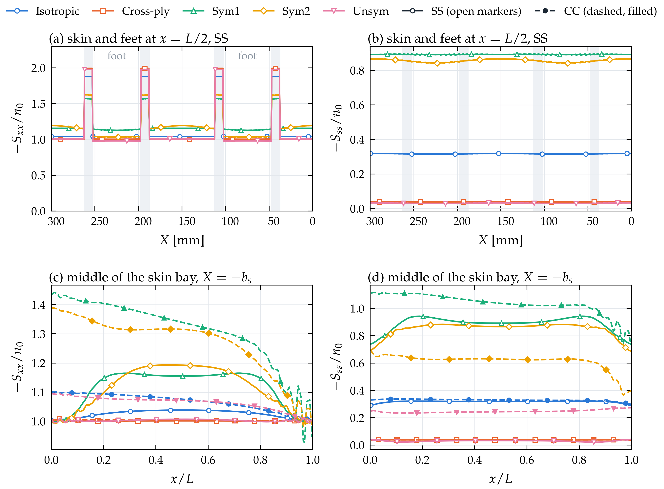
Figure 3. Pre-buckling membrane forces per unit load $n_{0}$ (compression positive), $b_{s}=150$ mm, $β=1.5$: (a) axial and (b) transverse force at mid-length, SS (shaded: feet); (c) axial and (d) transverse force along the middle of the skin bay; solid/open: SS, dashed/filled: CC.

3.3. Critical loads of short cells
Figure 4 and Table 5 give the critical loads of the 60 cases, and Figure 5 the deviations from Abaqus. With SS loaded edges, GBT agrees with Abaqus within 0.57 % on average and 1.25 % at most, with the same accuracy for uncoupled and coupled laminates (mean 0.49–0.73 % for every lay-up). With CC loaded edges the deviations are 0.64 % on average and 1.52 % at most. The SS curves of the isotropic, cross-ply and unsymmetric cells vary little with $β$, with the garland maxima of plates where the number of half-waves changes (e.g. $β=0.75$, cross-ply, $b_{s}=150$ mm); the angle-ply curves decrease monotonically, because skewed buckles cannot adapt to straight loaded edges. Clamping raises the critical loads of short cells, by 59 % for the isotropic cell with $b_{s}=150$ mm and $β=0.5$, and all CC curves decrease monotonically. For 9 of the 30 cells, mainly with $β=3$ or angle-ply lay-ups, the CC load is nevertheless below the SS load, in GBT and Abaqus alike (e.g. Figure 6), probably because the clamped ends also fix the in-plane displacements of the loaded edges and thereby raise the axial force near them (Section 3.2).

Figure 4. Critical load $N_{cr}$ (logarithmic scale) as a function of the aspect ratio: (a, b) simply supported and (c, d) clamped loaded edges; (a, c) $b_{s}=150$ mm and (b, d) $b_{s}=285.5$ mm. Lines: GBT; open markers: Abaqus.
Table 5. Critical loads $N_{cr}$ [N/mm] of the periodic cells: Abaqus, GBT and the deviation $e=\left(N_{cr}^{GBT}-N_{cr}^{Abaqus}\right)/N_{cr}^{Abaqus}$.
Lay-up | $b_{s}$ [mm] | $$β$$ | SS: Abaqus | SS: GBT | SS: $e$ [%] | CC: Abaqus | CC: GBT | CC: $e$ [%]
Isotropic | 150 | 0.75 | 127.650 | 126.284 | −1.07 | 146.600 | 145.225 | −0.94
 | 150 | 1.5 | 123.880 | 122.674 | −0.97 | 126.100 | 124.801 | −1.03
 | 150 | 3 | 122.740 | 121.412 | −1.08 | 119.420 | 118.133 | −1.08
 | 285.5 | 0.75 | 23.979 | 23.954 | −0.10 | 30.678 | 30.646 | −0.11
 | 285.5 | 1.5 | 23.720 | 23.707 | −0.05 | 24.713 | 24.675 | −0.15
 | 285.5 | 3 | 22.873 | 22.852 | −0.09 | 22.913 | 22.870 | −0.19
Cross-ply | 150 | 0.75 | 34.848 | 34.530 | −0.91 | 49.330 | 48.878 | −0.92
 | 150 | 1.5 | 31.464 | 31.243 | −0.70 | 36.806 | 36.503 | −0.82
 | 150 | 3 | 31.061 | 30.810 | −0.81 | 32.275 | 32.027 | −0.77
 | 285.5 | 0.75 | 6.607 | 6.595 | −0.18 | 11.250 | 11.228 | −0.19
 | 285.5 | 1.5 | 6.609 | 6.597 | −0.19 | 7.749 | 7.737 | −0.16
 | 285.5 | 3 | 6.304 | 6.296 | −0.13 | 6.709 | 6.699 | −0.16
Sym1 | 150 | 0.75 | 22.880 | 22.675 | −0.90 | 24.199 | 24.047 | −0.63
 | 150 | 1.5 | 17.475 | 17.315 | −0.92 | 15.825 | 15.606 | −1.38
 | 150 | 3 | 15.202 | 15.078 | −0.82 | 13.077 | 12.882 | −1.49
 | 285.5 | 0.75 | 4.760 | 4.762 | +0.03 | 5.572 | 5.564 | −0.15
 | 285.5 | 1.5 | 4.011 | 4.004 | −0.18 | 3.849 | 3.813 | −0.94
 | 285.5 | 3 | 3.832 | 3.819 | −0.33 | 3.501 | 3.472 | −0.84
Sym2 | 150 | 0.75 | 24.291 | 24.024 | −1.10 | 30.485 | 30.252 | −0.76
 | 150 | 1.5 | 21.386 | 21.118 | −1.25 | 23.877 | 23.563 | −1.31
 | 150 | 3 | 20.415 | 20.174 | −1.18 | 21.954 | 21.619 | −1.52
 | 285.5 | 0.75 | 5.033 | 5.026 | −0.14 | 6.679 | 6.683 | +0.06
 | 285.5 | 1.5 | 4.758 | 4.744 | −0.29 | 5.021 | 5.005 | −0.32
 | 285.5 | 3 | 4.620 | 4.602 | −0.39 | 4.557 | 4.530 | −0.59
Unsym | 150 | 0.75 | 33.489 | 33.277 | −0.63 | 36.370 | 36.129 | −0.66
 | 150 | 1.5 | 32.561 | 32.260 | −0.92 | 30.238 | 30.030 | −0.69
 | 150 | 3 | 31.825 | 31.616 | −0.66 | 28.027 | 27.821 | −0.73
 | 285.5 | 0.75 | 6.775 | 6.806 | +0.46 | 7.707 | 7.718 | +0.14
 | 285.5 | 1.5 | 5.880 | 5.897 | +0.28 | 6.002 | 6.013 | +0.19
 | 285.5 | 3 | 5.864 | 5.876 | +0.21 | 5.446 | 5.455 | +0.17
The deviations depend mainly on the pitch: for $b_{s}=285.5$ mm the SS mean deviation is 0.21 % (maximum 0.46 %), for $b_{s}=150$ mm 0.93 % (maximum 1.25 %), with all 15 GBT results below Abaqus. This offset is not a truncation error (the complete basis is used), not a discretisation error of GBT (finer segments lower the GBT result further, Table 6) and not caused by flexible link walls (stiffer links leave it unchanged, Section 3.7). It is most likely due to the different modelling of the stringer–skin junction (one combined foot laminate with link walls in GBT, two shells tied by *TIE in Abaqus), which governs a larger part of the buckle in the short skin bays of the narrow pitch; closed-form models of the same panels also deviate most from shell models for $b_{s}=150$ mm [18].

Figure 5. Deviation of the GBT critical loads from Abaqus: (a) simply supported and (b) clamped loaded edges. Filled: $b_{s}=150$ mm, open: $b_{s}=285.5$ mm; $β=0.75$, 1.5, 3 from left to right; shaded: $±1$ %.

3.4. Buckling modes and mode decomposition
All short cells buckle locally. For the Unsym cell with $b_{s}=150$ mm and $β=1.5$ (Figure 6), with MAC = 0.9998 (SS) and 0.9999 (CC) between GBT and Abaqus, the skin bays buckle in three skewed half-waves (SS) or two hardly skewed ones (CC), and the stringers move only slightly. Over all short cells, Eq. (41) assigns 96–101 % to the local family, up to 3.5 % to the global family (cross-ply cell with $b_{s}=285.5$ mm) and −1.6 % to 1.1 % to the distortional family; T and S contribute less than 0.1 % (Figure 7a–c). Values slightly outside 0–100 % stem from coupling energies, which can be negative.
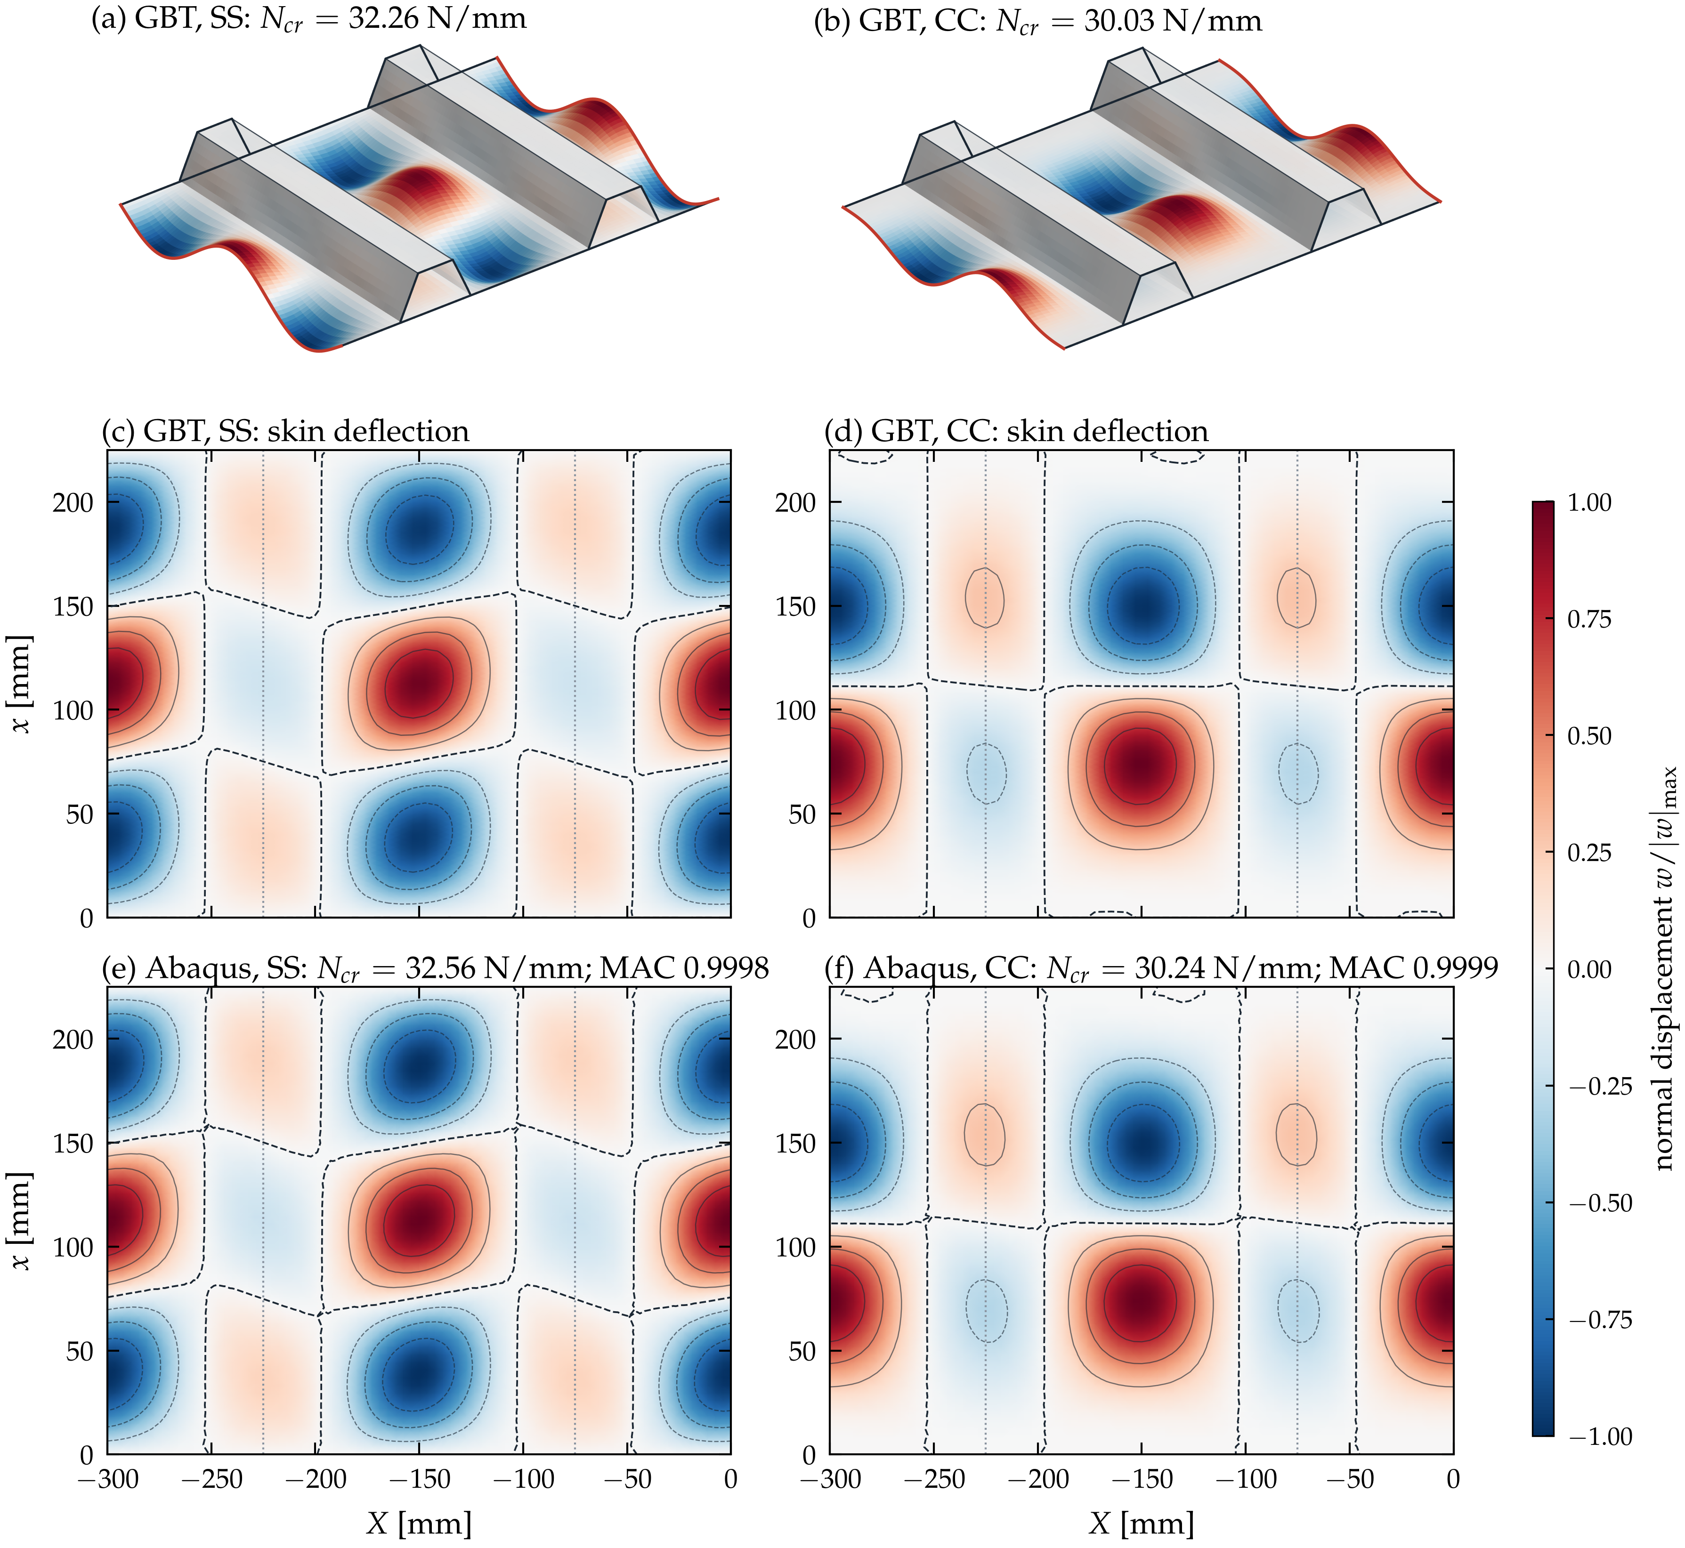
Figure 6. Critical mode of the Unsym cell, $b_{s}=150$ mm, $β=1.5$: (a, b) deformed cell from GBT (colour: displacement normal to the walls); skin deflection $w/{\left|w\right|}_{max}$ from (c, d) GBT and (e, f) Abaqus (contours at $±0.25$, $±0.5$, $±0.75$; dashed: $w=0$); left: SS, right: CC.
The hierarchical modes (Section 2.2.5) give a finer decomposition, in the manner of classical GBT (Figure 7d–f). For the Unsym cell with SS edges, computed with the complete basis in hierarchical form ($N_{cr}$ = 32.26 N/mm, relative difference from the nodal basis $1.3×{10}^{-10}$), the four modes 12, 18, 8 and 20 carry 96.5 % of the strain energy and the first 20 modes 97.9 %.

Figure 7. Mode decomposition. (a)–(c) Family participation $ρ_{g}$ versus $β$: (a) Cross-ply, $b_{s}=285.5$ mm, SS; (b) Unsym, $b_{s}=150$ mm, SS; (c) the same, CC. (d) Participation $ρ_{k}$ of the first 60 hierarchical conventional modes in the critical mode of the Unsym cell, $b_{s}=150$ mm, $β=1.5$, SS; (e) amplitude functions and (f) in-plane shapes of the four dominant modes.

3.5. Long cells: change of the buckling mode
Figure 8 extends the SS cells with $b_{s}=150$ mm to $β=16$ ($L=2400$ mm), and Figure 9 shows typical modes. The change of the mode depends on $A_{12}/A_{11}$ of the skin, which sets $S_{ss}$ (Section 3.2).
The Cross-ply and Unsym cells (small $S_{ss}$) buckle locally up to $β=10$ (30.61 and 31.44 N/mm) and globally from $β=12$, with 99.9 % global participation (Figure 9c); the load then decreases as for an Euler column, for the Unsym cell from 22.41 N/mm at $β=12$ to 12.71 N/mm at $β=16$ (ratio 1.76 against ${\left(16/12\right)}^{2}=1.78$), and local buckling becomes the second eigenvalue (31.43 N/mm).
The isotropic and angle-ply cells switch from $β≈6$ to a mode with a much lower, decreasing critical load, e.g. for Sym1 14.69, 5.20 and 4.40 N/mm at $β=4$, 8 and 16. The skin forms one full wave across the cell and one half-wave along it, adjacent stringers deflecting oppositely (Figure 9a; about 85 % local, 15 % distortional). This mode has the period $2b_{s}$ ($k_{B}b_{s}=π$, Section 2.2.5) and would be missed by a cell of one pitch. It is driven by $S_{ss}$: without $S_{ss}$ in $G$ (dashed lines in Figure 8a), the critical load of the isotropic cell with $β=8$ rises from 75.09 to 148.72 N/mm with a local mode (Figure 9b), and the Sym1 cell buckles globally at 17.73 instead of 5.20 N/mm. As for a plate under transverse compression, the load decreases with the length until the global mode, which is hardly affected by $S_{ss}$ (72.28 against 72.33 N/mm at $β=12$), takes over at $β=14$ for the isotropic cell.
Abaqus confirms both mechanisms: with constant width it gives 75.32 and 5.22 N/mm for the long-wave modes (isotropic, Sym1, $β=8$) and 22.37 and 22.29 N/mm for the global modes (Unsym, $β=12$; Cross-ply, $β=14$), within 0.46 % of GBT and with MAC $≥$ 0.9999 (Figures 8a and 9). The long-wave mode is thus caused by the constant cell width, which periodic shell models impose as well. If the shell model lets the cell expand laterally (common jump of $U_{1}$ and $U_{3}$ between the side edges), the isotropic cell with $β=8$ buckles locally at 152.44 N/mm and the Sym1 cell globally at 15.40 N/mm, i.e. 2.0 and 2.9 times higher than with constant width. Omitting $S_{ss}$ in GBT reproduces the local case within 2.4 % but overestimates the global load of the Sym1 cell by 15 %, probably because the free model also releases the in-plane shear (common jump of $U_{3}$); free expansion in GBT requires additional generalised coordinates for these jumps and is left for future work. Constant width, as in periodic shell models, is thus conservative for panels that can expand laterally, whereas omitting $S_{ss}$, as models that prescribe only the axial load implicitly do, is not conservative in general (Sym1 cell: +15 %).

Figure 8. Long cells, SS, $b_{s}=150$ mm: (a) critical load versus aspect ratio (logarithmic scales); solid: complete pre-buckling state, dashed: $S_{ss}$ omitted from $G$; stars: Abaqus, constant width; crosses: Abaqus, free lateral expansion; (b)–(f) participation of the local, distortional and global families.
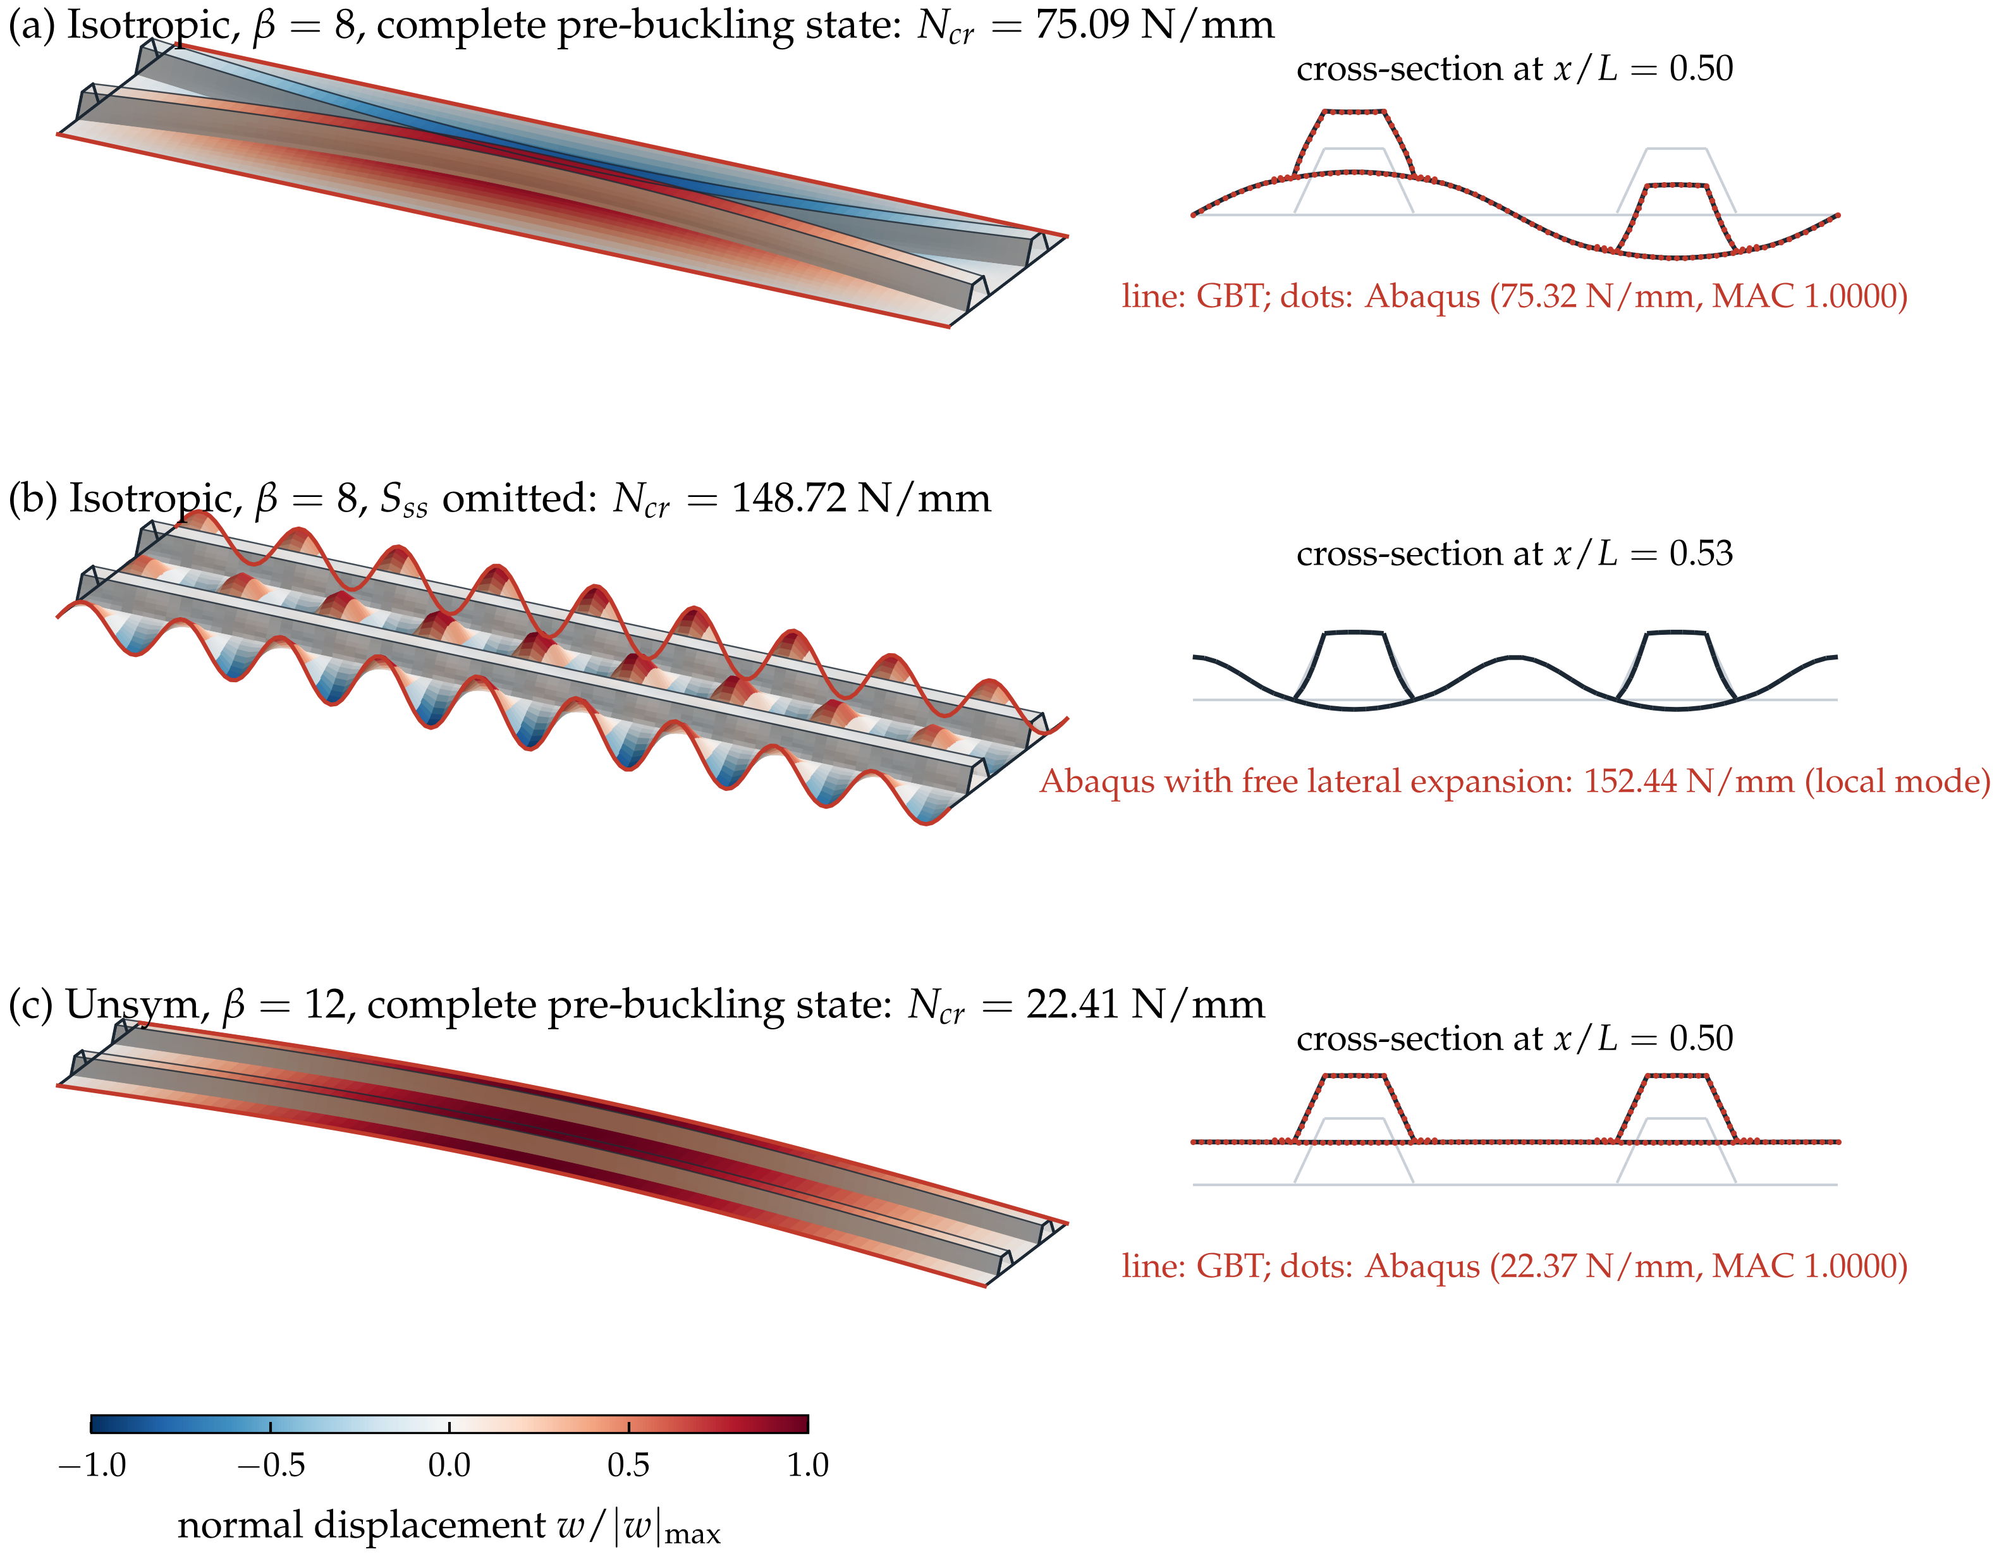
Figure 9. Critical modes of long cells (SS, $b_{s}=150$ mm): deformed cell and cross-section at the largest displacement (line: GBT; dots: Abaqus, in (a) and (c)). (a) Isotropic, $β=8$: long-wave mode; (b) the same with $S_{ss}$ omitted: local mode; (c) Unsym, $β=12$: global mode.

3.6. Hierarchical mode bases
Whether a few modes suffice, as often in GBT, was examined by keeping the first $n_{C}$ hierarchical conventional modes ($k_{r}=π/b_{s}$) together with all shear and Mindlin modes, with the pre-buckling state of the complete basis (Figure 10). The convergence is stepwise; the four modes from $n_{C}=17$ to 20 reduce the deviation by a factor of 6 to 29. A deviation below 1 % requires 20 to 40 modes for the isotropic, cross-ply and angle-ply cells, but 80 to 100 of the 273 modes for the unsymmetric cell. Omitting the Mindlin modes raises the critical load by 0.36 % to 2.01 %. A classical small basis (20 conventional modes, their warping at $k_{r}$, no Mindlin modes; 41 modes) gives +1.45 % for the isotropic cell with $b_{s}=285.5$ mm and $β=0.75$, but +10.36 % for the Unsym cell with SS edges.

Figure 10. Deviation of the critical load from the complete basis versus the number $n_{C}$ of hierarchical conventional modes, $β=1.5$.

3.7. Accuracy, efficiency and limitations
The default discretisation (segments of at most $b_{s}/25$, spans $b_{s}/20$) was checked by refining each parameter in turn (Table 6). All changes are within 0.50 %, except for the Sym1 cell with CC edges, $b_{s}=285.5$ mm and $β=1.5$, for which halving the spans repeatedly raises the critical load by +0.26, +0.47 and +0.62 %, lowering its deviation from Abaqus from −0.94 to −0.32 %. The critical load depends neither on the link-wall factor (122.667, 122.674 and 122.671 N/mm for $k_{L}={10}^{2}$, ${10}^{3}$, ${10}^{4}$; isotropic cell, SS, $β=1.5$) nor on the soft factor of Eq. (7) (122.684 to 122.673 N/mm for ${10}^{-2}$ to 0), whereas a stiff twisting term $D_{66}^{L}=k_{L}D_{0,66}$ would lock the web roots (+22.8 %).
Table 6. $N_{cr}$ [N/mm] with the default and refined discretisations (change in brackets).
Case | Default | Spans $h_{x}/2$ | Segments $b_{s}/40$
Isotropic, SS, $b_{s}=150$, $β=1.5$ | 122.6740 | 122.5921 (−0.07 %) | 122.4080 (−0.22 %)
Sym2, SS, $b_{s}=150$, $β=3$ | 20.1744 | 20.1776 (+0.02 %) | 20.1476 (−0.13 %)
Unsym, CC, $b_{s}=150$, $β=1.5$ | 30.0295 | 30.0275 (−0.01 %) | 29.8795 (−0.50 %)
Sym1, CC, $b_{s}=285.5$, $β=3$ | 3.4715 | 3.4780 (+0.19 %) | 3.4698 (−0.05 %)
Sym1, CC, $b_{s}=285.5$, $β=1.5$ | 3.8130 | 3.8230 (+0.26 %) | 3.8100 (−0.08 %)
A complete GBT analysis with 474–558 modes takes 4.6 s on average for the ten cells with $b_{s}=150$ mm and $β=1.5$, of which the cross-section analysis, reused for all lengths, takes less than 1 s. For the four long cells of Table 7, GBT has about 32 % of the degrees of freedom of the shell model and needs 24–51 % of its time (different two-core machines); since the global and distortional modes couple with all others, the GBT matrices are less sparse, and the main benefit is the modal description.
Table 7. Model size and computing time of the long cells (SS, $b_{s}=150$ mm; Abaqus: 8 eigenvalues, time of the solver step, Intel i5-13420H; GBT: 2 eigenvalues and mode decomposition, Intel Xeon 2.1 GHz; 2 cores each).
Cell | Abaqus DOFs | Abaqus time [s] | GBT unknowns | GBT time [s]
Isotropic, $β=8$ | 282,750 | 167 | 90,770 | 61
Sym1, $β=8$ | 282,750 | 146 | 90,770 | 35
Unsym, $β=12$ | 423,690 | 492 | 135,410 | 132
Cross-ply, $β=14$ | 495,030 | 208 | 157,730 | 106
The plate assumptions (Reissner–Mindlin walls, link walls for the tie, linear buckling about a first-order state) are the likely origin of the −1 % offset for $b_{s}=150$ mm, and the formulation represents panels whose lateral expansion is restrained (Section 3.5).

4. Conclusions
Periodic boundary conditions were built into the cross-section analysis of shear-deformable GBT: conventional modes by restricting each mode family to its periodic subspace, the warping by a constrained least-squares problem on the cell as a closed contour, and shear and Mindlin modes by merging the side-node functions. Every mode, and hence every truncated basis, is exactly periodic, and the formulation reduces to classical GBT (confirmed to 0.001 %).
For 30 omega-stringer cells with simply supported loaded edges, the GBT–Ritz critical loads agree with Abaqus shell models within 0.57 % on average and 1.25 % at most, and with clamped loaded edges within 0.64 % and 1.52 %, for all lay-ups; the mode shapes of the six cells compared agree to MAC > 0.999. Cells up to three stringer pitches long buckle locally. From about six pitches, isotropic and angle-ply cells buckle in a long-wave mode driven by the transverse compression that the constant cell width induces, and from twelve pitches cross-ply and unsymmetric cells buckle globally; with free lateral expansion, Abaqus gives 2.0–2.9 times higher critical loads for the two cells examined. Since periodic shell models impose the same constant width, this must be considered for panels whose lateral expansion is not restrained.
In future work, the formulation will serve as the physics model of the authors’ next study on physics-informed neural networks (PINNs). The hybrid PINN of [22] predicts the local buckling load of omega-stringer-stiffened panels from a plate energy with a reduced bending stiffness, an approximation that is not generally valid for laminates with membrane–bending coupling [21], together with Abaqus results selected by active learning. Using the present GBT–Ritz formulation and its code instead removes this approximation, since the full matrices $A$, $B$ and $D$ are retained, and replaces the expensive shell analyses by solutions that take seconds per design; with periodic GBT modes as the output of the network, every prediction also satisfies the periodic condition exactly.

Author Contributions: Conceptualization, A.M.E. and N.K.; methodology, A.M.E. and N.K.; software, A.M.E.; validation, A.M.E.; formal analysis, A.M.E.; investigation, A.M.E.; writing—original draft preparation, A.M.E.; writing—review and editing, N.K. and C.M.; supervision, N.K. and C.M.; project administration, C.M.; funding acquisition, C.M. All authors have read and agreed to the published version of the manuscript.
Funding: This research received no external funding.
Data Availability Statement: The data presented in this study are available on request from the corresponding author.
Acknowledgments: During the preparation of this study, the authors used Claude Opus 5.5 (Anthropic) for literature research and refinement of the manuscript text. The authors have reviewed and edited the output and take full responsibility for the content of this publication.
Conflicts of Interest: The authors declare no conflicts of interest.

References
- Zhang, G.; Hu, Y.; Yan, B.; Tong, M.; Wang, F. Buckling and post-buckling analysis of composite stiffened panels: A ten-year review (2014–2023). Thin-Walled Structures 2024, 205, 112525. https://doi.org/10.1016/j.tws.2024.112525
- Mittelstedt, C. Mechanics of Composite Structures; Springer: Berlin, Heidelberg, Germany, 2025. https://doi.org/10.1007/978-3-662-70788-3
- Mittelstedt, C.; Beerhorst, M. Closed-form buckling analysis of compressively loaded composite plates braced by omega-stringers. Composite Structures 2009, 88, 424–435. https://doi.org/10.1016/j.compstruct.2008.05.021
- Schilling, J.C.; Mittelstedt, C. Local buckling analysis of omega-stringer-stiffened composite panels using a new closed-form analytical approximate solution. Thin-Walled Structures 2020, 147, 106534. https://doi.org/10.1016/j.tws.2019.106534
- Mittelstedt, C. Closed-form analysis of the buckling loads of uniaxially loaded blade-stringer-stiffened composite plates considering periodic boundary conditions. Thin-Walled Structures 2007, 45, 371–382. https://doi.org/10.1016/j.tws.2007.04.005
- Mittelstedt, C. Explicit local buckling analysis of stiffened composite plates accounting for periodic boundary conditions and stiffener–plate interaction. Composite Structures 2009, 91, 249–265. https://doi.org/10.1016/j.compstruct.2009.04.021
- Schilling, J.C.; Mittelstedt, C. A simple closed-form analytical model for the column buckling of omega-stringer-stiffened panels with periodic boundary conditions. Results in Engineering 2020, 6, 100120. https://doi.org/10.1016/j.rineng.2020.100120
- Mead, D.J. Wave propagation in continuous periodic structures: Research contributions from Southampton, 1964–1995. Journal of Sound and Vibration 1996, 190, 495–524. https://doi.org/10.1006/jsvi.1996.0076
- Wittrick, W.H.; Williams, F.W. Buckling and vibration of anisotropic or isotropic plate assemblies under combined loadings. International Journal of Mechanical Sciences 1974, 16, 209–239. https://doi.org/10.1016/0020-7403(74)90069-1
- Kennedy, D.; Williams, F.W.; Anderson, M.S. Buckling and vibration analysis of laminated panels using VICONOPT. Journal of Aerospace Engineering 1994, 7, 245–262. https://doi.org/10.1061/(ASCE)0893-1321(1994)7:3(245)
- Cheung, Y.K. Finite Strip Method in Structural Analysis; Pergamon Press: Oxford, UK, 1976.
- Lau, S.C.W.; Hancock, G.J. Buckling of thin flat-walled structures by a spline finite strip method. Thin-Walled Structures 1986, 4, 269–294. https://doi.org/10.1016/0263-8231(86)90034-0
- Mittelstedt, C.; Schröder, K.-U. Local postbuckling of hat-stringer-stiffened composite laminated plates under transverse compression. Composite Structures 2010, 92, 2830–2844. https://doi.org/10.1016/j.compstruct.2010.04.009
- Schilling, J.C.; Mittelstedt, C. Shear-buckling of omega-stringer-stiffened panels. International Journal of Mechanical Sciences 2021, 207, 106646. https://doi.org/10.1016/j.ijmecsci.2021.106646
- Schilling, J.C.; Atamann, D.; Voges, J.; Mittelstedt, C. Local buckling of omega-stringer-stiffened composite panels under compression–shear interaction. Thin-Walled Structures 2022, 180, 109838. https://doi.org/10.1016/j.tws.2022.109838
- Schilling, J.C.; Mittelstedt, C. Local postbuckling of omega-stringer-stiffened composite panels. Thin-Walled Structures 2022, 181, 110027. https://doi.org/10.1016/j.tws.2022.110027
- El Yaakoubi-Mesbah, C.; Mittelstedt, C. Closed-form analytical solution for local buckling of omega-stringer-stiffened composite panels under compression. Composite Structures 2025, 353, 118716. https://doi.org/10.1016/j.compstruct.2024.118716
- El Yaakoubi-Mesbah, C.; Mittelstedt, C. Computational model for local buckling of compressively loaded omega-stringer-stiffened panels. In Proceedings of the 16th World Congress on Computational Mechanics and 4th Pan American Congress on Computational Mechanics (WCCM-PANACM 2024), Vancouver, Canada, 2024. https://doi.org/10.23967/wccm.2024.059
- El Yaakoubi-Mesbah, C.; Mittelstedt, C. Closed-form analytical solution for the postbuckling analysis of omega-stringer-stiffened panels considering stringer feet effects. Composite Structures 2026, 385, 120209. https://doi.org/10.1016/j.compstruct.2026.120209
- Mittelstedt, C. Buckling of Stiffened Laminates. In Mechanics of Composite Structures; Springer: Berlin, Heidelberg, Germany, 2025; pp. 605–696. https://doi.org/10.1007/978-3-662-70788-3_17
- Ewing, M.S.; Hinger, R.J.; Leissa, A.W. On the validity of the reduced bending stiffness method for laminated composite plate analysis. Composite Structures 1988, 9, 301–317. https://doi.org/10.1016/0263-8223(88)90050-5
- Elsayed, A.M.; Kharghani, N.; El Yaakoubi-Mesbah, C.; Mittelstedt, C. A hybrid physics-informed neural network framework for local buckling prediction of stiffened composite panels with epistemic uncertainty quantification. Composite Structures 2026, 399, 120959. https://doi.org/10.1016/j.compstruct.2026.120959
- Schardt, R. Verallgemeinerte Technische Biegetheorie: Lineare Probleme; Springer: Berlin, Heidelberg, Germany, 1989.
- Schardt, R. Generalized beam theory—An adequate method for coupled stability problems. Thin-Walled Structures 1994, 19, 161–180. https://doi.org/10.1016/0263-8231(94)90027-2
- Davies, J.M.; Leach, P. First-order generalised beam theory. Journal of Constructional Steel Research 1994, 31, 187–220. https://doi.org/10.1016/0143-974X(94)90010-8
- Camotim, D.; Basaglia, C.; Silvestre, N. GBT buckling analysis of thin-walled steel frames: A state-of-the-art report. Thin-Walled Structures 2010, 48, 726–743. https://doi.org/10.1016/j.tws.2009.12.003
- Mittelstedt, C. Buckling and post-buckling of thin-walled composite laminated beams—A review of engineering analysis methods. Applied Mechanics Reviews 2020, 72, 020802. https://doi.org/10.1115/1.4045680
- Mittelstedt, C. Generalized beam theory for the analysis of thin-walled structures—A state-of-the-art survey. Thin-Walled Structures 2024, 200, 111849. https://doi.org/10.1016/j.tws.2024.111849
- Mittelstedt, C. Generalized Beam Theory. In Mechanics of Composite Structures; Springer: Berlin, Heidelberg, Germany, 2025; pp. 1013–1036. https://doi.org/10.1007/978-3-662-70788-3_26
- Silvestre, N.; Camotim, D. First-order generalised beam theory for arbitrary orthotropic materials. Thin-Walled Structures 2002, 40, 755–789. https://doi.org/10.1016/S0263-8231(02)00025-3
- Silvestre, N.; Camotim, D. Second-order generalised beam theory for arbitrary orthotropic materials. Thin-Walled Structures 2002, 40, 791–820. https://doi.org/10.1016/S0263-8231(02)00026-5
- Silvestre, N.; Camotim, D. Shear deformable generalized beam theory for the analysis of thin-walled composite members. Journal of Engineering Mechanics 2013, 139, 1010–1024. https://doi.org/10.1061/(ASCE)EM.1943-7889.0000506
- Silvestre, N.; Camotim, D. Generalized beam theory to analyze the vibration of open-section thin-walled composite members. Journal of Engineering Mechanics 2013, 139, 992–1009. https://doi.org/10.1061/(ASCE)EM.1943-7889.0000507
- Dinis, P.B.; Camotim, D.; Silvestre, N. GBT formulation to analyse the buckling behaviour of thin-walled members with arbitrarily ‘branched’ open cross-sections. Thin-Walled Structures 2006, 44, 20–38. https://doi.org/10.1016/j.tws.2005.09.005
- Gonçalves, R.; Ritto-Corrêa, M.; Camotim, D. A new approach to the calculation of cross-section deformation modes in the framework of generalized beam theory. Computational Mechanics 2010, 46, 759–781. https://doi.org/10.1007/s00466-010-0512-2
- Bebiano, R.; Gonçalves, R.; Camotim, D. A cross-section analysis procedure to rationalise and automate the performance of GBT-based structural analyses. Thin-Walled Structures 2015, 92, 29–47. https://doi.org/10.1016/j.tws.2015.02.017
- Gonçalves, R.; Bebiano, R.; Camotim, D. On the shear deformation modes in the framework of generalized beam theory. Thin-Walled Structures 2014, 84, 325–334. https://doi.org/10.1016/j.tws.2014.07.012
- Bebiano, R.; Camotim, D.; Gonçalves, R. GBTul 2.0—A second-generation code for the GBT-based buckling and vibration analysis of thin-walled members. Thin-Walled Structures 2018, 124, 235–257. https://doi.org/10.1016/j.tws.2017.12.002
- Silvestre, N. Generalised beam theory to analyse the buckling behaviour of circular cylindrical shells and tubes. Thin-Walled Structures 2007, 45, 185–198. https://doi.org/10.1016/j.tws.2007.02.001
- Gonçalves, R.; Camotim, D. Elastic buckling of uniformly compressed thin-walled regular polygonal tubes. Thin-Walled Structures 2013, 71, 35–45. https://doi.org/10.1016/j.tws.2013.04.016
- Silva, N.M.F.; Silvestre, N.; Camotim, D. GBT formulation to analyse the buckling behaviour of FRP composite open-section thin-walled columns. Composite Structures 2010, 93, 79–92. https://doi.org/10.1016/j.compstruct.2010.06.013
- Silva, N.M.F.; Camotim, D.; Silvestre, N.; Degenhardt, R. On the use of generalized beam theory to assess the buckling and postbuckling behavior of laminated CFRP cylindrical stiffened panels. International Journal of Structural Stability and Dynamics 2010, 10, 737–760. https://doi.org/10.1142/S0219455410003713
- Taig, G.; Ranzi, G. Generalised beam theory (GBT) for stiffened sections. International Journal of Steel Structures 2014, 14, 381–397. https://doi.org/10.1007/s13296-014-2017-x
- Mittelstedt, C. The Ritz Method for Buckling Analysis of Shear-Deformable Laminates. In Mechanics of Composite Structures; Springer: Berlin, Heidelberg, Germany, 2025; pp. 511–563. https://doi.org/10.1007/978-3-662-70788-3_15
- Vescovini, R.; Dozio, L.; D’Ottavio, M.; Polit, O. On the application of the Ritz method to free vibration and buckling analysis of highly anisotropic plates. Composite Structures 2018, 192, 460–474. https://doi.org/10.1016/j.compstruct.2018.03.017
- Kuehn, T.; Pasternak, H.; Mittelstedt, C. Local buckling of shear-deformable laminated composite beams with arbitrary cross-sections using discrete plate analysis. Composite Structures 2014, 113, 236–248. https://doi.org/10.1016/j.compstruct.2014.03.022
- Kharghani, N.; Mittelstedt, C. Global–local–distortional buckling of shear-deformable composite beams with open cross-sections using a novel GBT–Ritz approach. Journal of Composites Science 2025, 9, 608. https://doi.org/10.3390/jcs9110608
- Kharghani, N.; Mittelstedt, C. Buckling analysis of composite box girders using generalized beam theory (GBT) and Ritz method. In Engineering Materials, Structures, Systems and Methods for a More Sustainable Future; CRC Press: London, UK, 2025; pp. 224–229. https://doi.org/10.1201/9781003677895-37
- Kharghani, N.; Mittelstedt, C. Generalized beam theory and Ritz method for buckling analysis of thin-walled composite beams with unsymmetric layups. ce/papers 2026, 9, 791–796. https://doi.org/10.1002/cepa.70366
- Kharghani, N.; Mittelstedt, C. Efficient buckling analysis of thin-walled composite beams with symmetric and unsymmetric layups using a GBT–Ritz approach. Journal of Composites Science 2026, 10, 307. https://doi.org/10.3390/jcs10060307
- Mindlin, R.D. Influence of rotatory inertia and shear on flexural motions of isotropic, elastic plates. Journal of Applied Mechanics 1951, 18, 31–38. https://doi.org/10.1115/1.4010217
- Whitney, J.M.; Pagano, N.J. Shear deformation in heterogeneous anisotropic plates. Journal of Applied Mechanics 1970, 37, 1031–1036. https://doi.org/10.1115/1.3408654
- Reddy, J.N. Mechanics of Laminated Composite Plates and Shells: Theory and Analysis, 2nd ed.; CRC Press: Boca Raton, FL, USA, 2004.
- Vlasov, V.Z. Tonkostennye Uprugie Sterzhni (Thin-Walled Elastic Beams), 2nd ed.; Fizmatgiz: Moscow, USSR, 1959. (In Russian)
- Hughes, T.J.R.; Cottrell, J.A.; Bazilevs, Y. Isogeometric analysis: CAD, finite elements, NURBS, exact geometry and mesh refinement. Computer Methods in Applied Mechanics and Engineering 2005, 194, 4135–4195. https://doi.org/10.1016/j.cma.2004.10.008
- Lehoucq, R.B.; Sorensen, D.C.; Yang, C. ARPACK Users’ Guide: Solution of Large-Scale Eigenvalue Problems with Implicitly Restarted Arnoldi Methods; SIAM: Philadelphia, PA, USA, 1998.
Disclaimer/Publisher’s Note: The statements, opinions and data contained in all publications are solely those of the individual author(s) and contributor(s) and not of MDPI and/or the editor(s). MDPI and/or the editor(s) disclaim responsibility for any injury to people or property resulting from any ideas, methods, instructions or products referred to in the content.

