Project Plan

Project Name: Foodies

Project Manager: Aya Hamdy

Synopsis: Initial plan

Version: <version number, such as Draft V0.1, Final V1.0, etc>

Issue Date: 04-28-2019

Prepared by: Maryam Mohamed

Authorized by:

It is often desirable to have the client authorize the Project Plan. This document will include expectations of what the client is required to do in order to help make the project a success.
Amendment History

Version Issue Date Changes
Version 1.0 04-28-2018 Initial version.
Table of Contents
1 Introduction 1
1.1 Document Purpose 1
1.2 Associated Documents 1
1.3 Project Plan Maintenance 1
2 Project Scope 2
2.1 Outline of Client’s Objectives 2
2.1.1 Objectives 2
2.1.2 Success Criteria 2
2.1.3 Risks 2
2.2 Outline of <Organization> Objectives 2
2.2.1 Objectives 2
2.2.2 Success Criteria 2
2.2.3 Risks 2
2.3 Definitive scope statement 2
3 Deliverables 3
3.1 To client 3
3.2 From client 3
4 Project Approach 4
4.1 Project Lifecycle Processes 4
4.2 Project Management Processes 4
4.3 Project Support Processes 4
4.4 Organization 4
4.4.1 Project Team 4
5 Communications Plan 5
6 Work Plan 6
6.1 Work Breakdown Structure 6
6.2 Resources 6
7 Milestones 7
8 Risks, Constraints, Assumptions 8
8.1 Risks 8
8.2 Constraints 8
8.3 Assumptions 8

Introduction

Document Purpose
This document describes the initial planning for the project “Foodies”, it will outlines the basic work flows, breakdown structures and the communications plan.

Associated Documents
Describe associated planning documents. For example, details of the projects processes and standards may be captured in an associated Quality Plan, details of acceptance by the client may be in an Acceptance Test Plan, etc. Refer to documents by name, version number, & issues date. Some documents may not be written at the time of producing this plan, they are still referenced here as related documents. Any documents in this section, together with this Project Plan document, form the complete planning set of documents for the project.

Project Plan Maintenance
The project plan is subject to change and can be updated only with the approval of both the customer and the project manager.

Minor updates will be recorded in status reports, major changes will require a reissue and full re-approval of the Project Plan document itself.

Project Scope

Outline of Client’s Objectives

Objectives
- To have a food ordering web application that users can navigate (still needs time bounds)
- The system should have admin and user panels with different features.

Success Criteria

Risks
Brief statement of the major risks of the client’s project. If your project is helping them mitigate against their risk then explain this.

Outline of <Organization> Objectives

Objectives
Explain what your organization’s objectives are, and what you are responsible for, mapped into the larger picture of the client’s overall project / program as described above. Be careful not to take on responsibilities that really belong to the client. For instance, you may be providing the client with a capability to do something, but the client’s objective is to make use of that capability to achieve some stated business objective. Your project is then to provide that capability, not to achieve the client’s business objective. To give an example, the client may want to reduce hold time in a call center by 50% over 6 months, and your project may be to provide the capability to enable them to do that, which only gives them their benefit PROVIDED that they then use your capability appropriately.

Success Criteria
State how the success of your project will be measured. This may be different from the client’s measurements, for instance this may be a fixed cost project for an external client and you have certain profitability objectives.

Risks
Very brief statement of the major risks of your project and how they are being minimized. This is expanded on later in this document, so just give an overview of the key risks here.

Definitive scope statement
What is the definitive statement of what your project is responsible for? This is normally be reference to some other document, such as a contractual Statement of Work, a Requirements Document, a gap analysis on an existing system, etc.

Deliverables

To client
External Deliverables:

- Project wireframes
- Website mockup demonstrations
- Final prototype

Internal Deliverables:

- Project plan
- Test plan

From client
- Audits
- Document reviews

Project Approach

Project Lifecycle Processes

The project shall follow the Agile Development which is an iterative approach where the project will be completed in small iterations (1-week iteration)
Requirements will be broken into smaller pieces (user stories), each user story should have the following:

- User story description
- Estimate (size and effort)
- Acceptance criteria
- Priority in terms of importance

This is done collaboratively with the team members (Scrum master, Product owner, Development team).
User stories are then selected for each iteration and broken down into specific tasks with assigned roles, tasks are tracked using visual aids and burn-up charts.

Project Management Processes
This is a description of those processes used to manage and control the project. It is critical that this section at a minimum describes the formal process to control project changes. It could also include such things as the risk management process, and how performance information is captured and reported (which may be expanded on in the Communications Plan section later in this document).

Project Support Processes
This is a description of those processes that typically happen throughout the project lifecycle and support the various other activities. Often includes such processes as configuration management, release control, how the support infrastructure will be used, etc.

Organization

Project Team
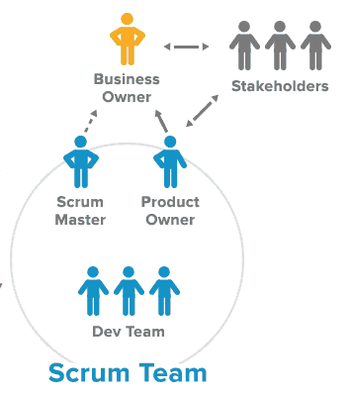

Communications Plan
The following table describes who needs what information, when they will need it, and how they will get it.

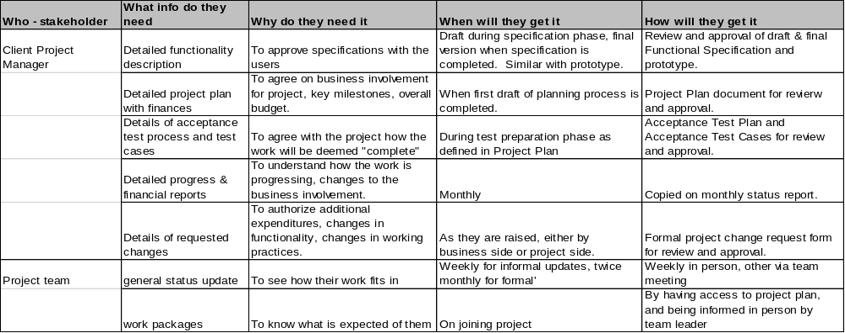

Work Plan
In this section we identify the tasks to undertake the project, and how resources are mapped to these tasks, together with other non-people resources that are needed.

Work Breakdown Structure
This may be done by listing the tasks directly here, or may be accomplished by a high level summary of tasks with the details captured in an Appendix using a tool such as Microsoft Project. The purpose of this section is to break down the work to the lowest level at which it is to be delegated, to help define what level the work needs to be monitored and controlled at. When the Project Plan is first produced some tasks towards the latter stages of the project may only be in outline here, and scheduled for being detailed at a later date.

Resources
Show how the project team is used to undertake the identified tasks. This may be in the form of a Gantt chart from a project scheduling tool such as Microsoft Project, ABT Workbench, etc.

Include non-people resources, such as equipment, other materials, travel expenses, etc. Map these onto a timeline. For some types of projects this may be a significant listing, and require breaking this section down into sub-sections.

Milestones
Identify the key project milestones, and any project phasing. These milestones are typically events that demonstrate significant project progress, events that have a major impact to the client, and payment milestones. You do not want to have so many milestones identified here that it makes it difficult for project tracking to show the big picture of the project’s progress.

Sometimes this list can seem to be a duplicate of the “deliverables” list in the earlier section. You want to try and make this milestones list only the key events / deliverables. You may chose not to put dates against the deliverables in the earlier section if in fact all the deliverables are also project milestones identified here. Just use your common sense as to what seems most appropriate.

You may want to list milestones on the client’s side as a separate list, in much the same way that client deliverables were separately identified.

A typical type of milestone table that can be used if this is the manner in which you want to show this information is as follows:

Milestone number | Title | Forecast date
1* | <milestone description> | 21-Sep-99
2 | <milestone description> | 22-Oct-99
… | … | …
N | <milestone description> | 15-Jan-00
Note: * against milestone indicates a payment milestone.

Risks, Constraints, Assumptions

Risks

Constraints

Assumptions
List any assumptions you have made in the construction of this plan.

