Cairo University  
Faculty of Computers and Artificial Intelligent

**CS251**

**Software Engineering I**

Project Name

Software Design

Team Names

Month & Year

Contents

Instructions [To be removed] 3

Team 3

Document Purpose and Audience 3

System Models 3

I. Class diagrams 3

Important Algorithm 4

II. Sequence diagrams 5

Class - Sequence Usage Table 6

Ownership Report 6

Policy Regarding Plagiarism: 7

# Team

|  |  |  |  |
| --- | --- | --- | --- |
| **ID** | **Name** | **Email** | **Mobile** |
| 20200088 | Alaa Ayman Hashem | alaasalman211@gmail.com | 01003837227 |
| 20200552 | Moaaz Mohsen Attia | moaazmohsen72@gmail.com | 01125741365 |
| 20201041 | Aya Hasanen said | ayaayad162002@gmail.com | 01091487695 |
| 20200379 | Farah Mohamed Mohamed | farahemam70@gmail.com | 01030805323 |

# Document Purpose and Audience

This document is an explanation for an application that provide a new and easy way for users to park their vehicles in a garage by providing some functions that take the vehicle information(number , width and length) and find suitable place(slot)for the car to be parked in.

Presented to the project manager and customers.

# 

# System Models

## I. Class diagrams

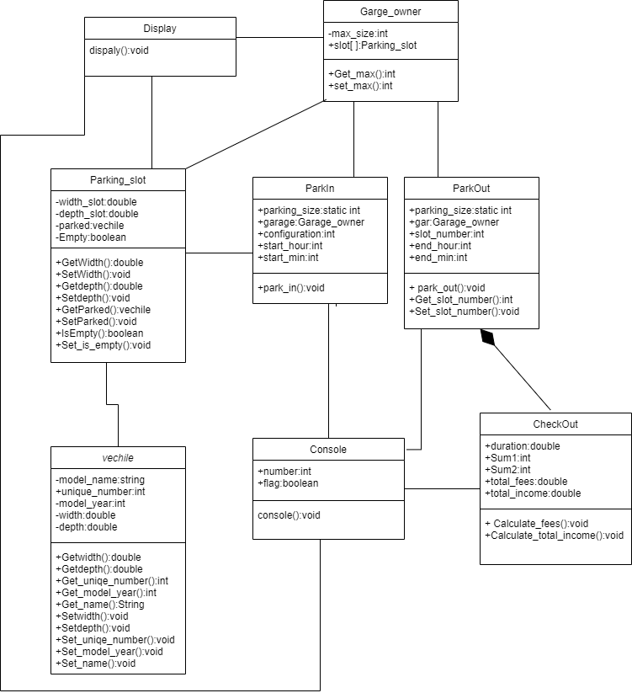

| **Class ID** | **Class Name** | **Description & Responsibility** |
| --- | --- | --- |
| 1 | vehicle | Takes vehicle’s information |
| 2 | Garage owner | Takes dimensions of available slots |
| 3 | CheckOut | Calculate total fees and total income |
| 4 | Parking _slot | Check if there is an empty slots and park car in them |
| 5 | Park in | Find the best slot to the driver according to the chosen configuration |
| 6 | Park out | Remove the car from the slot |
| 7 | display | Displaying available slots |
| 8 | console | Display options to choose what to do |

# Questions:

1. **Does your class diagram respect or violate SOLID principles? justify your answer.**

Yes as we applied the single responsibility principle in our classes

1. **Does your class diagram contain any design pattern(s)?**

No, it does not contain any design pattern

## 

## II. Sequence diagrams

1. Park-in

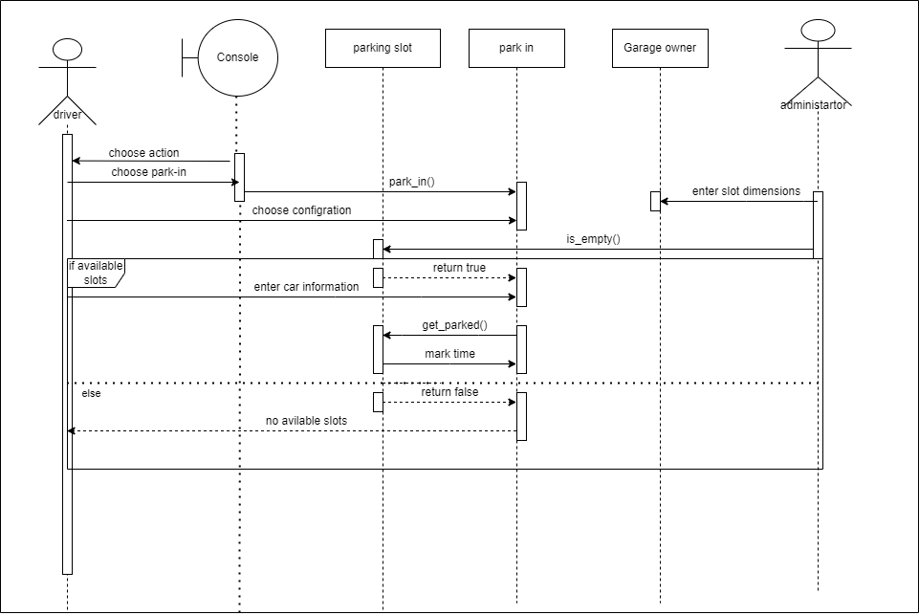

2-park-out

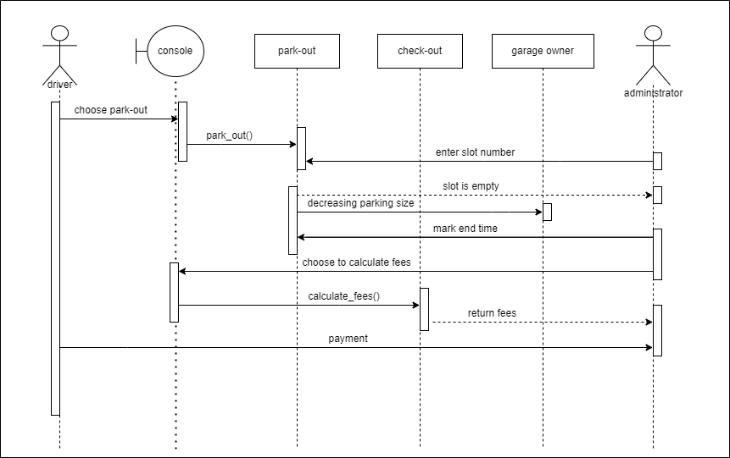

3-caculate total income

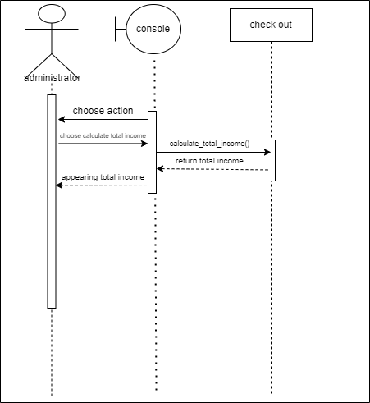

4-display available slots

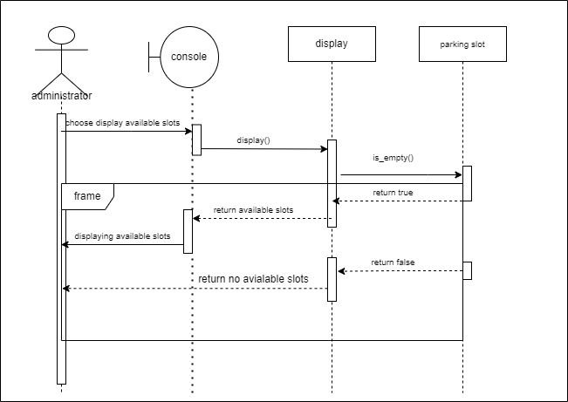

### Class - Sequence Usage Table

| **Class Name** | **Sequence Diagrams** | **Overall used methods** |
| --- | --- | --- |
| Garage owner | 1,2 | Number of slots in the garage |
| Parking slot | 1 , 4 | Check number of free slots |
| CheckOut | 2,3 | Calculate fees and total income |
| display | 4 | Display available free slots |
| Park-in | 1 | Find a suitable slot for the car to be parked in |
| Park-out | 2 | Remove the car from the slot |
| console | 1,2,3,4 | Displaying options for user to choose between them |

# Ownership Report

|  |  |
| --- | --- |
| **Item** | **Owners** |
| Class diagram | All team members |
| Sequence diagrams | All team members |