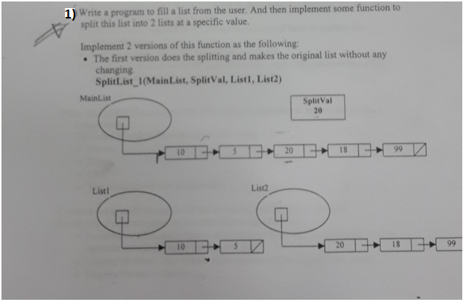

#include <iostream>

using namespace std;

class CNode

{

public:

int info;

CNode* pNext;

};

class CList

{

public:

CNode* pHead;

CNode* pTail;

CList()

{

pHead = NULL;

pTail = NULL;

}

void Attach(CNode* pnn)

{

if (pHead == NULL)

{

pHead = pnn;

pTail = pnn;

}

else

{

pTail->pNext = pnn;

pTail = pnn;

}

}

~CList()

{

CNode* pTrav = pHead;

while (pHead != NULL)

{

pHead = pTrav->pNext;

pTrav->pNext = NULL;

delete pTrav;

pTrav = pHead;

}

}

};

void SplitList_1(CList MainL, int val, CList L1, CList L2)

{

CNode* pTrav = MainL.pHead;

CNode* pB = MainL.pHead;

int ct = 0;

while (pTrav->info != val) //get node of target value(trav) & prev node(pB)

{

ct++; //how many nodes to copy in L1

pB = pTrav;

pTrav = pTrav->pNext;

}

cout << "L1\n";

CNode* pTrav2 = MainL.pHead; //to traverse and copy info

for (int i = 0; i < ct; i++)

{

CNode* pnn = new CNode;

if (L1.pHead == NULL)

{

L1.pHead = pnn;

L1.pTail = pnn;

pnn->info = pTrav2->info;

cout << pnn->info << " ";

}

else

{

L1.pTail->pNext = pnn;

L1.pTail = pnn;

pnn->info = pTrav2->info;

cout << pnn->info << " ";

}

if (i == ct)

{

pnn->pNext = NULL;

}

pTrav2 = pTrav2->pNext;

}

ct = 0;

while (pB->pNext != NULL) //how many nodes to copy in L2

{

ct++;

pB = pB->pNext;

}

cout << "L2\n";

for (int i = 0; i <= ct; i++)

{

CNode* pnn = new CNode;

if (L2.pHead == NULL)

{

L2.pHead = pnn;

L2.pTail = pnn;

pnn->info = pTrav->info;

cout << pnn->info << " ";

}

else

{

L2.pTail->pNext = pnn;

L2.pTail = pnn;

pnn->info = pTrav->info;

cout << pnn->info << " ";

}

if (i == ct)

{

pnn->pNext = NULL;

}

pTrav = pTrav->pNext;

}

}

void main()

{

CList MainL;

CList L1;

CList L2;

int val;

CNode* pnn;

int N;

cin >> N;

for (int i = 0; i < N; i++)

{

pnn = new CNode;

cout << "enter info\n";

cin >> pnn->info;

pnn->pNext = NULL;

MainL.Attach(pnn);

}

cout << "enter val \n";

cin >> val;

SplitList_1(MainL, val, L1, L2);

}

void SplitList_2(CList& MainL, int val, CList& L1, CList& L2)

{

CNode* pTrav = MainL.pHead;

CNode* pB = MainL.pHead;

while (pTrav->info != val) //get node of target value(trav) & prev node(pB)

{

pB = pTrav;

pTrav = pTrav->pNext;

}

L1.pHead = MainL.pHead;

pB->pNext = NULL;

L1.pTail = pB;

L2.pHead = pTrav;

L2.pTail = MainL.pTail;

//empty the main list

MainL.pHead = NULL;

MainL.pTail = NULL;

//output

CNode* pOut = L1.pHead;

cout << "L1\n";

while (pOut != NULL)

{

cout << pOut->info << " ";

pOut = pOut->pNext;

}

cout << "\n";

pOut = L2.pHead;

cout << "L2\n";

while (pOut != NULL)

{

cout << pOut->info << " ";

pOut = pOut->pNext;

}

}

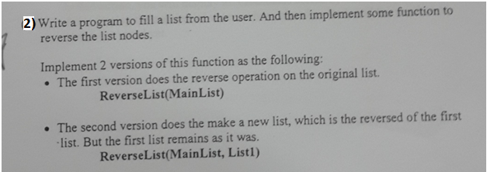

**VERSION ONE**

#include <iostream>

using namespace std;

class CNode

{

public:

int info;

CNode* pNext;

};

class CList

{

public:

CNode* pHead;

CNode* pTail;

CList()

{

pHead = NULL;

pTail = NULL;

}

void Attach(CNode* pnn)

{

if (pHead == NULL)

{

pHead = pnn;

pTail = pnn;

}

else

{

pTail->pNext = pnn;

pTail = pnn;

}

}

~CList()

{

CNode* pTrav = pHead;

while (pHead != NULL)

{

pHead = pTrav->pNext;

pTrav->pNext = NULL;

delete pTrav;

pTrav = pHead;

}

}

};

void ReverseList(CList MainL)

{

CNode* pB = MainL.pHead; //current node to change arrow of

CNode* pTrav = MainL.pHead; //node after (next)

CNode* pArrow = NULL; //node to redirect the arrows(next) of nodes

CNode* pLast = MainL.pTail; //to store the pTail for reverse at the end

while (pB != NULL) //NULL is reaching after end of list

{

pTrav = pTrav->pNext; //travserse

pB->pNext = pArrow;

pArrow = pB; //redirects arrow to prev node

pB = pTrav;

}

MainL.pTail = MainL.pHead;

MainL.pHead = pLast;

//output

pTrav = MainL.pHead;

while (pTrav != NULL)

{

cout << pTrav->info << " ";

pTrav = pTrav->pNext;

}

}

void main()

{

CList MainL;

CNode* pnn;

cout << "Enter N \n";

int N;

cin >> N;

for (int i = 0; i < N; i++)

{

pnn = new CNode;

cout << "enter info\n";

cin >> pnn->info;

pnn->pNext = NULL;

MainL.Attach(pnn);

}

ReverseList(MainL);

}

**VERSION TWO**

void ReverseList(CList MainL, CList L)

{

CNode* pTrav = MainL.pHead;

CNode* pB = L.pTail;

while (pTrav != NULL)

{

CNode* pnn = new CNode;

if (L.pHead == NULL)

{

pnn->info = pTrav->info;

L.pHead = pnn;

L.pTail = pnn;

pB = L.pTail; //to keep track of the node that each new node will point to

}

else

{

pnn->info = pTrav->info;

L.pHead = pnn;

pnn->pNext = pB;

pB = pnn;

}

pTrav = pTrav->pNext;

}

//output

pTrav = L.pHead;

while (pTrav != NULL)

{

cout << pTrav->info << " ";

pTrav = pTrav->pNext;

}

}

#include <iostream>

using namespace std;

class CNode

{

public:

int info;

CNode* pNext;

};

class CList

{

public:

CNode* pHead;

CNode* pTail;

CList()

{

pHead = NULL;

pTail = NULL;

}

void Attach(CNode* pnn)

{

if (pHead == NULL)

{

pHead = pnn;

pTail = pnn;

}

else

{

pTail->pNext = pnn;

pTail = pnn;

}

}

~CList()

{

CNode* pTrav = pHead;

while (pHead != NULL)

{

pHead = pTrav->pNext;

pTrav->pNext = NULL;

delete pTrav;

pTrav = pHead;

}

}

};

void main()

{

CList L1;

CNode* pnn;

int N, num, ct=0;

cout << "Enter N \n";

cin >> N;

for (int i = 0; i < N; i++)

{

pnn = new CNode;

cout << "enter info\n";

cin >> pnn->info;

pnn->pNext = NULL;

L1.Attach(pnn);

}

cout << "enter num\n";

cin >> num;

CNode* pTrav = L1.pHead; //to point at target node

CNode* pB = L1.pHead; //to point at node before target

while (pTrav != NULL)

{

if (ct == num)

{

pB->pNext = NULL; //to make it last node

L1.pTail->pNext = L1.pHead; //to make last point to start node

L1.pHead = pTrav; //head points at target

L1.pTail = pB; //tail points at node before target

break;

}

ct++;

pB = pTrav;

pTrav = pTrav->pNext;

}

//output

pTrav = L1.pHead;

while (pTrav != NULL)

{

cout << pTrav->info << " ";

pTrav = pTrav->pNext;

}

}

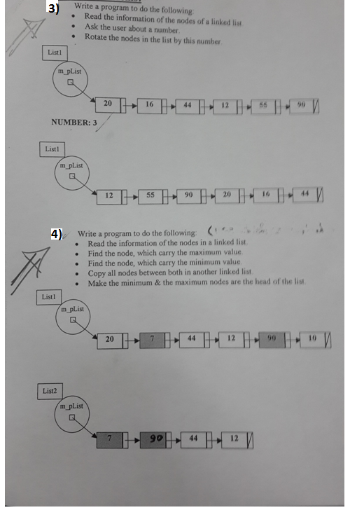

#include <iostream>

using namespace std;

class CNode

{

public:

int info;

CNode* pNext;

};

class CList

{

public:

CNode* pHead;

CNode* pTail;

CList()

{

pHead = NULL;

pTail = NULL;

}

void Attach(CNode* pnn)

{

if (pHead == NULL)

{

pHead = pnn;

pTail = pnn;

}

else

{

pTail->pNext = pnn;

pTail = pnn;

}

}

~CList()

{

CNode* pTrav = pHead;

while (pHead != NULL)

{

pHead = pTrav->pNext;

pTrav->pNext = NULL;

delete pTrav;

pTrav = pHead;

}

}

};

void main()

{

CList L1;

CList L2;

CNode* pnn;

cout << "Enter N \n";

int N;

cin >> N;

for (int i = 0; i < N; i++)

{

pnn = new CNode;

cout << "enter info\n";

cin >> pnn->info;

pnn->pNext = NULL;

L1.Attach(pnn);

}

CNode* pTrav = L1.pHead;

CNode* pMin = L1.pHead;

CNode* pMax = L1.pHead;

int min = 9999, max = -9999, i=0,imin=0, imax=0;

while (pTrav != NULL)

{

if (pTrav->info < min)

{

min = pTrav->info;

pMin = pTrav;

imin = i;

}

if (pTrav->info > max)

{

max = pTrav->info;

pMax = pTrav;

imax = i;

}

pTrav = pTrav->pNext;

i++;

}

for (int i = 0; i < 2; i++) //add min and max into new list

{

CNode* pnn = new CNode;

if (L2.pHead == NULL)

{

pnn->info = min;

L2.pHead = pnn;

L2.pTail = pnn;

}

else

{

pnn->info = max;

L2.pTail->pNext = pnn;

L2.pTail = pnn;

}

}

if (imin < imax)

{

pTrav = pMin->pNext;

while (pTrav != NULL && pTrav != pMax)

{

CNode* pnn = new CNode;

pnn->info = pTrav->info;

L2.pTail->pNext = pnn;

L2.pTail = pnn;

pTrav = pTrav->pNext;

}

}

else

{

pTrav = pMax->pNext;

while (pTrav != NULL && pTrav != pMin)

{

CNode* pnn = new CNode;

pnn->info = pTrav->info;

L2.pTail->pNext = pnn;

L2.pTail = pnn;

pTrav = pTrav->pNext;

}

}

//output

pTrav = L2.pHead;

while (pTrav != NULL)

{

cout << pTrav->info << " ";

pTrav = pTrav->pNext;

}

}