**Dereqment of Computer Engineering**



**Cairo University**

**Faculty of Engineering**

**Control Engineering**

**Project**

**Submitted to**

Dr. Meena Elia Samouil Girgis

Eng. Youssef Hassan Mohamed

**Submitted by**

|  |  |  |
| --- | --- | --- |
| **Name** | **Sec** | **BN** |
| **Aya Ahmed Musad Husein** | **1** | **15** |
| **Salma Ragab Hassan** | **1** | **31** |

**Req 1 :**

**Dynamic Equations:**

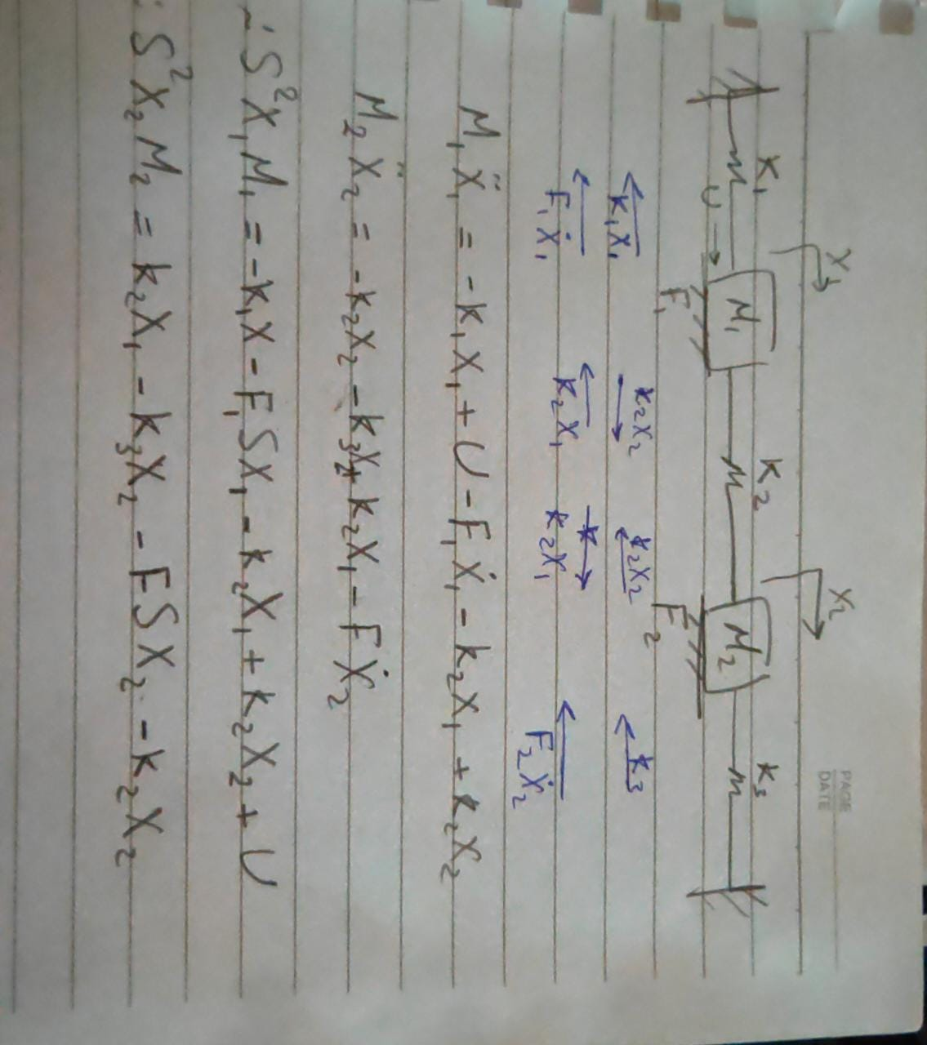

**BlockDiagram:**

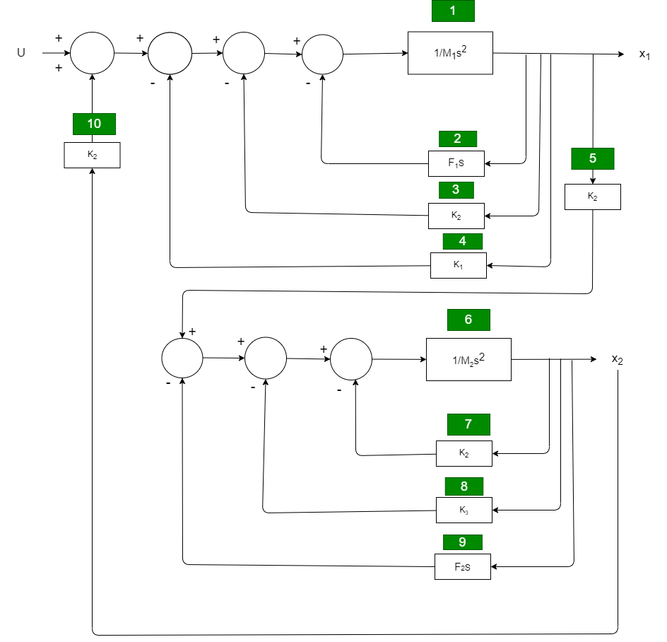

**Req 2:**

**TF:**

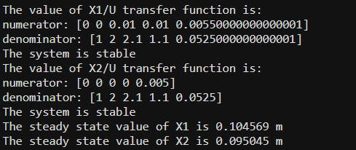



# **Req 3 :**

Both Systems are stable

# **Req 4 :**

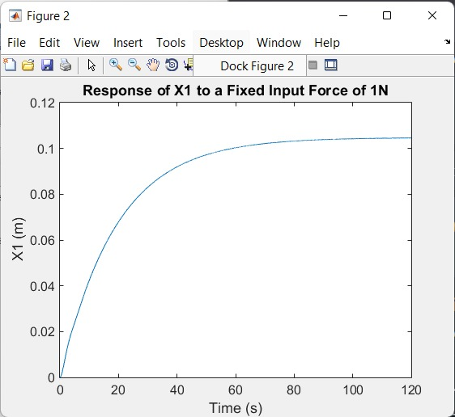

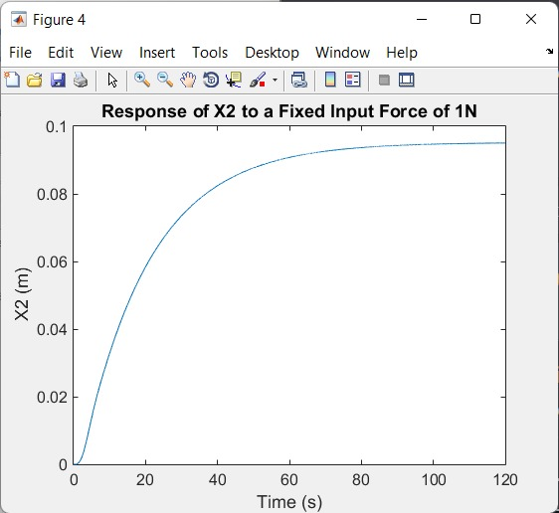

**SteadyStateValues:**



**Req 5:**

We used unity feedback to compare the actual output to the desired input displacement .

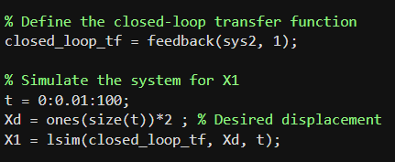

**Req 6:**

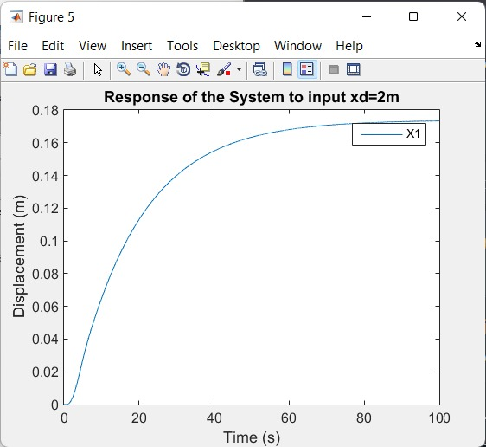

# **Req7:**

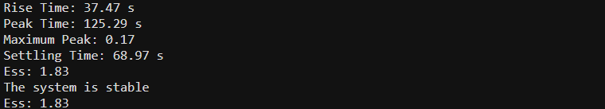

# **Req 8:**

As kp increase ess,rise time(time to reach yss for first time),settling time and peak time(time to reach shooting time for first time )decrease while max peak increase until Kp reaches a critical value , the system becomes unstable and unpredictable .

Kp=1

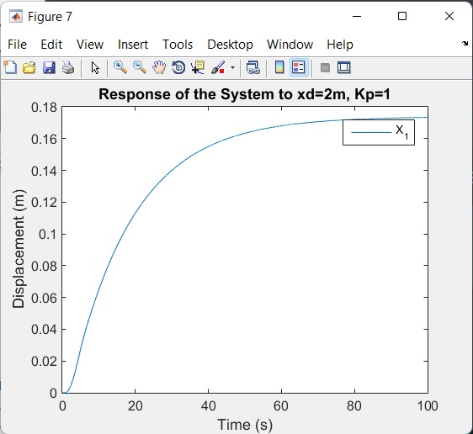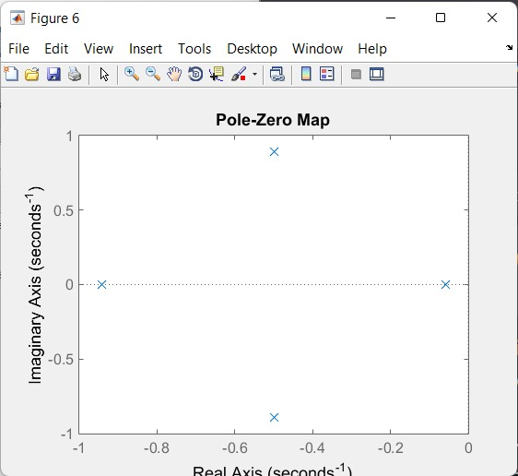

Transient Response:

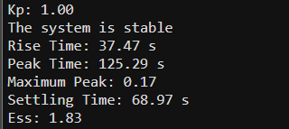

Kp=10

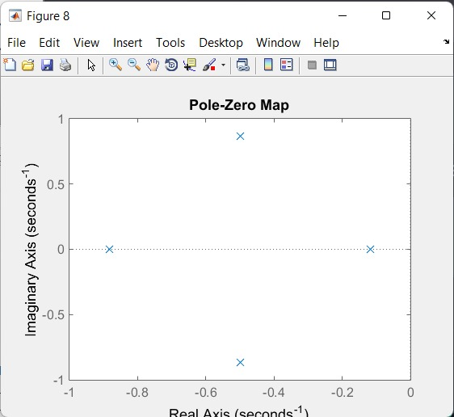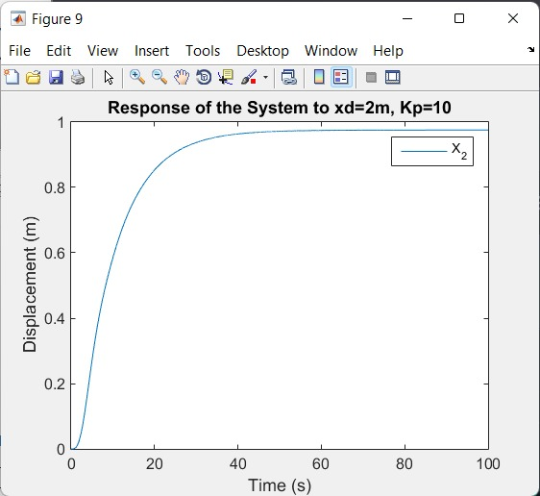

Transient Response:

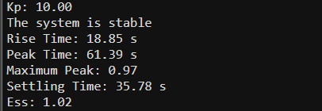

Kp=100

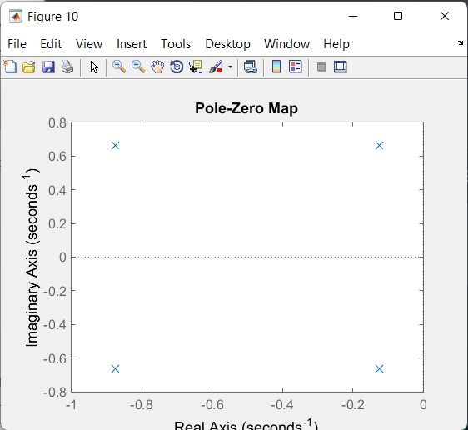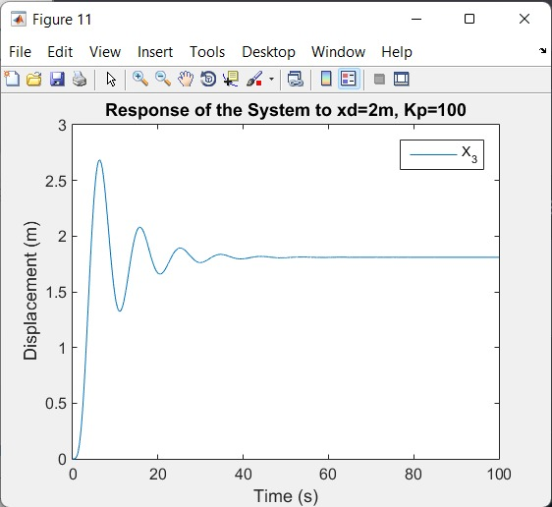

Transient Response:

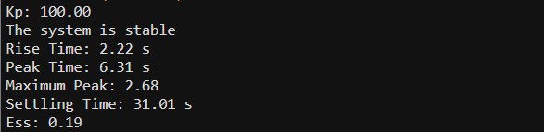

Kp=1000

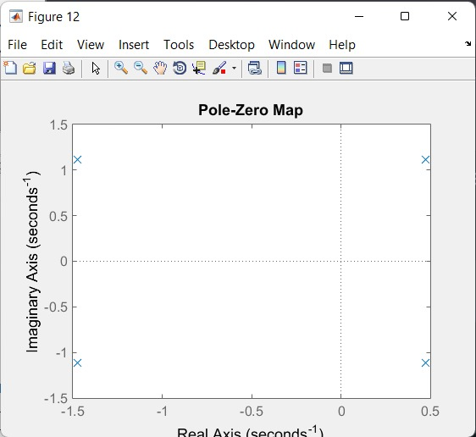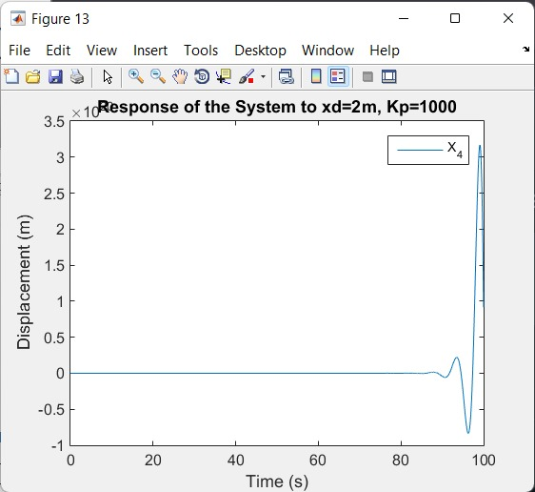

Transient Response:

# 

# **Req 9:**

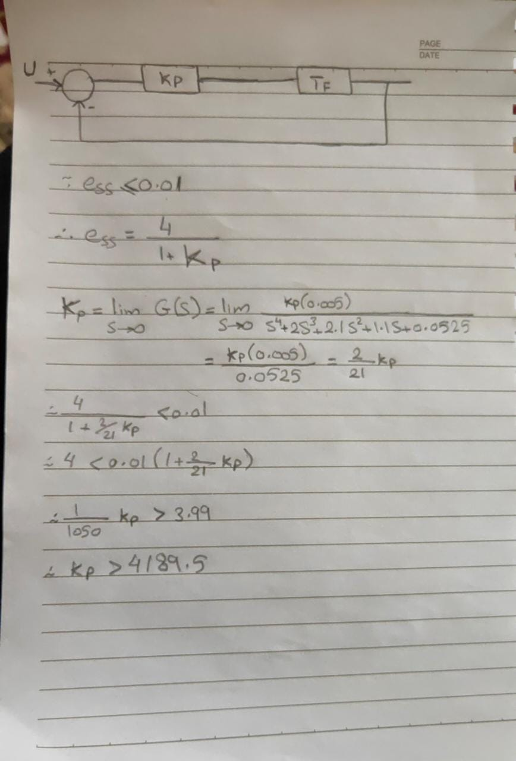

From the analysis we can see that we need Kp to be greater than 4189.6 to satisfy the requirement , but as we can see in the output this makes the system unstable .

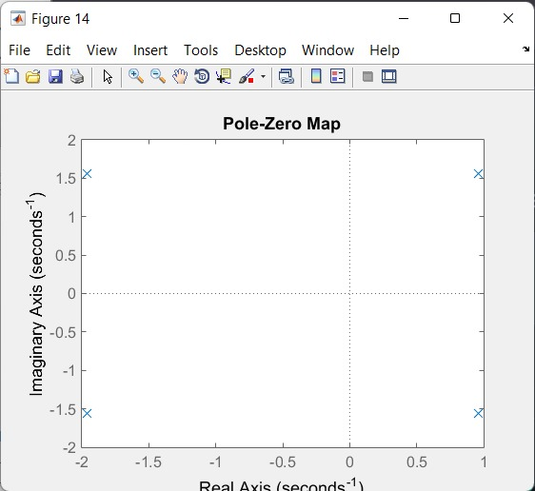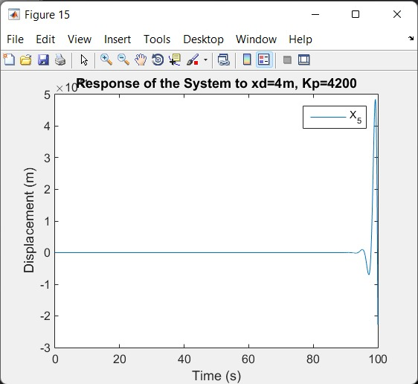

The System is unstable

# **Req 10:**

In order to enhance the performance of the system, we have decided to implement a PI controller (proportional-integral) mechanism. Through extensive experimentation, we have tested various parameter values to ensure system stability. After thorough analysis, we have determined that setting the integral gain (KI) to 3.8 and the proportional gain (KP) to 110 successfully fulfill this requirement.

