**Trip Visor**

Project 10 - Masterpiece

Documented by:

Aya Meizer

March-2022

**Table of contents**

Abstract................................................................2

Chapter 1: Project Introduction............................3  
1.1 Current situation and opportunity..................3

1.2 Competition Analysis.......................................4

1.3 Problem statement.........................................4

1.4 Problem solution ….........................................4

Abstract

While trips and flights Advertisers are becoming more and more wide, it’s really important to know how genuine the website/app/AD really is.  
  
Most websites/apps provide a not really accurate information of the trips, for example; as you proceed with their steps you realize that the price is getting higher and higher, which obviously is baiting.  
  
Having such a project to work on really is a challenge, because I wanted to combine between being a genuine, trust worthy website and giving the users one the best trip-booking sites.  
  
Considering the fact that I & my relatives faced the problem of not having the accurate information of the trip wanted, or just facing problems with mismatching the quality advised versus what we see in real life, I thought that I might be the one to solve such problem, not just for me and my family, but for everyone interested in such service!

**Chapter 1: Project Introduction**

**1.1 Current situation and opportunity**

Having a trust worthy website that gives you the information of any trip/ flight fully loud and clear is kind of hard nowadays, most of their reputation comes from the huge marketing for them.   
Solving this problem was by giving out all the information, giving the users all of the trips and flights available by us, all the information needed by them, nothing hidden!

**1.2 Competition Analysis**

For example, Booking.com is one of the well-known travel marketplaces, they got a mobile application and a website.  
  
**1.3 Problem statement**

1. Lack of local trip/flights reservations services.

2. Biased reputation and most of the ratings are misleading.

**1.4 Problem solution**  
  
An online website that is dedicated for (mostly local) trips and flights, also having everything loud and clear; no hidden or extra fees no matter how!  
  
Mainly the website is going to be focused on the local flights and trips, due to the lack of such services.  
  
  
**1.5 Project objectives**

1. Support the local flights and trips, by combining them all in one place.

2. Provide a fully description of the trips.

**1.6 Project technology and tools**

1. HTML, CSS, React JS (Front end).

2. PHP Laravel (Backend).

**Chapter 2: System Requirements and** **Analysis**  
**2.1 System scope the system scope is listed by the functionalities below:**   
  
1. User account registration.   
2. User account login.   
3. Trips and flights with details.  
4. Product search.   
5. Product filter.   
6. Product review and rating.

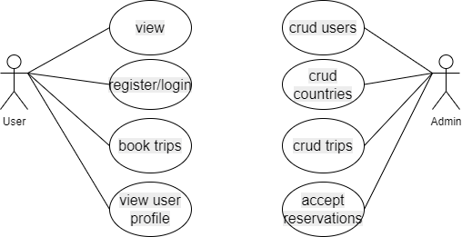  
**2.2 System Requirements**  
  
 **2.2.1 List of functional requirements**  
 A.1. The user shall log in by entering correct email and password.  
 A.2. The system shall show an error message if any of the login data is incorrect.  
 A.3. The user shall create an account by entering a valid email and password.  
 A.4. The system shall show an error message if any of the sign-up data does not match the input validation.  
 A.5. The user shall search for trips and flights by entering the text in the search box.

A.6. The system shall return all matching records as search results.  
A.7. 1.The user shall filter trips by clicking the dropdown menu and selecting the filter type by category.  
A.7. 2. The user shall filter trips by moving the slider and selecting the price range for the trip.  
A.8. The user shall view product details by clicking “View trip” on the trip’s card.  
A.9. The user shall add the product to the basket by clicking “Add to basket” on the trip’s card.  
A.10. The user shall log out of his/her account by clicking “Logout” on the navigation bar.

**B. Admin**  
B.1. The admin shall log in by entering correct email and password.  
B.2. The system shall show an error message if any of the login data is incorrect.   
B.3. The admin shall add, edit and delete product categories with providing necessary data.   
B.4. The admin shall add, edit and delete products with providing necessary data.   
B.5. The admin shall add, edit and delete system admins with providing necessary data.   
B.6. The admin shall add, edit and delete system users with providing necessary data.   
B.7. The admin shall log out of his/her account by clicking “Logout” on the navigation bar.  
  
**2.2.2 List of non-functional requirements**   
A. Availability The system shall be available 24/7   
B. Reliability The system shall be real-time.   
C. Maintainability The system is designed to be maintained in the shortest time possible.   
D. Security The system is developed using best practices in term of security.   
E. Scalability The system is built to take as much users and products as possible.

**Chapter 4:**

**4.1 System wireframe**

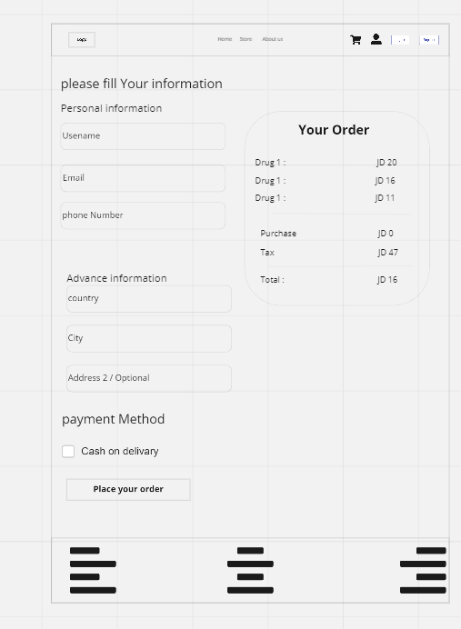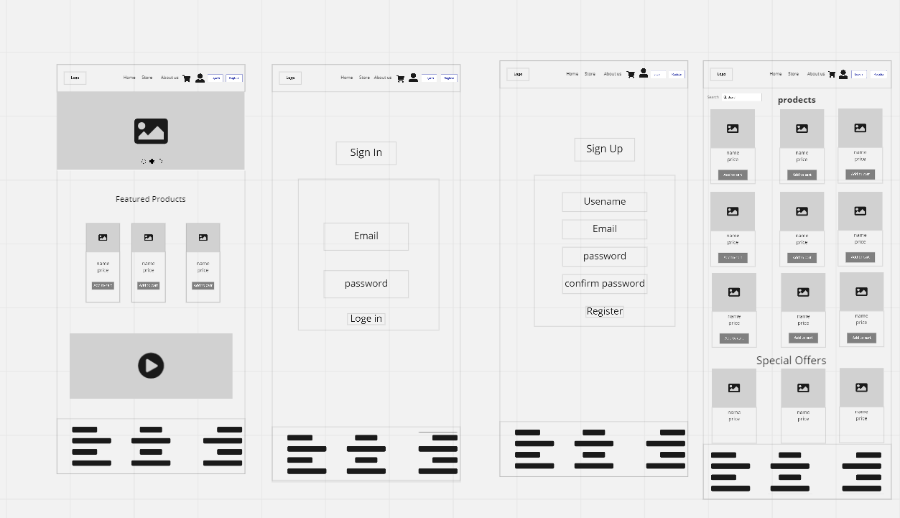

**4.2**

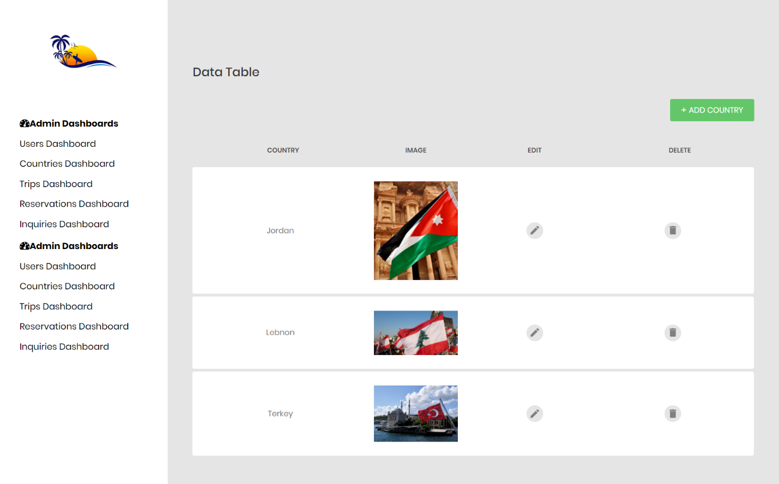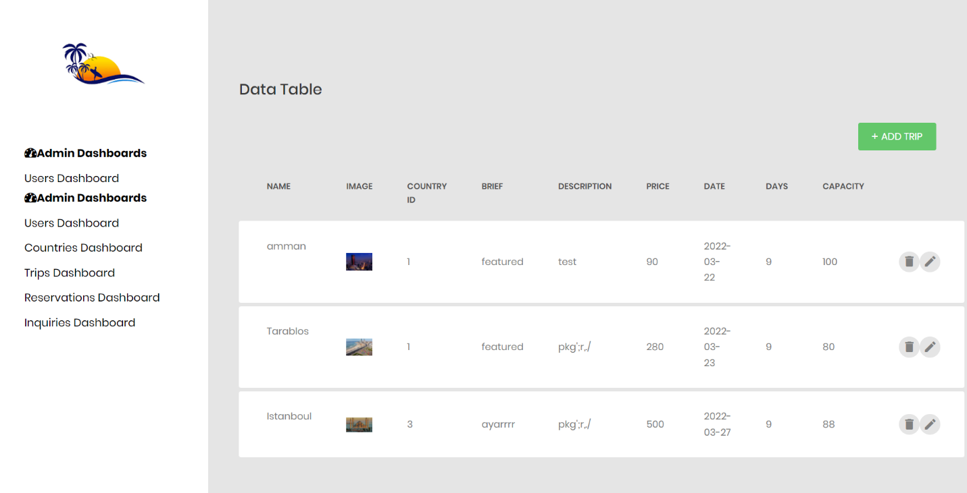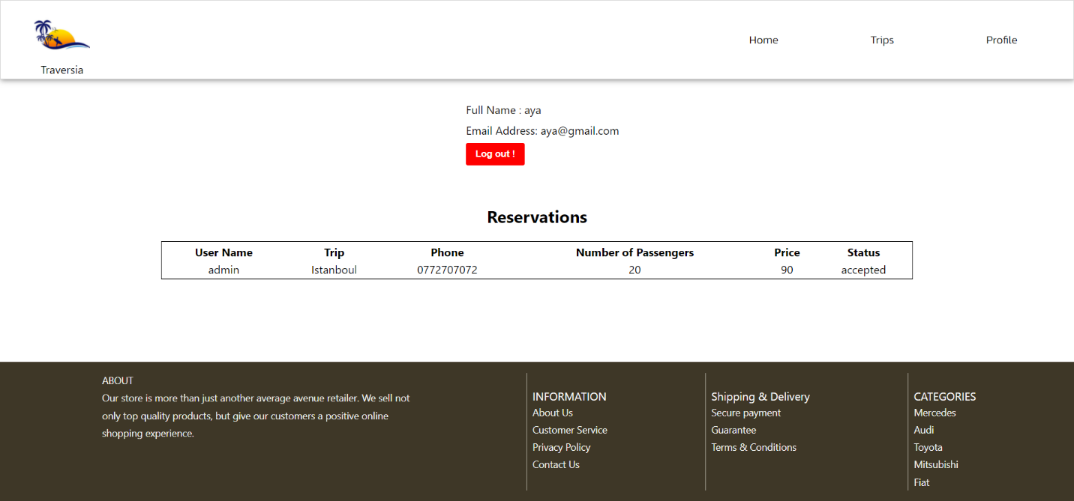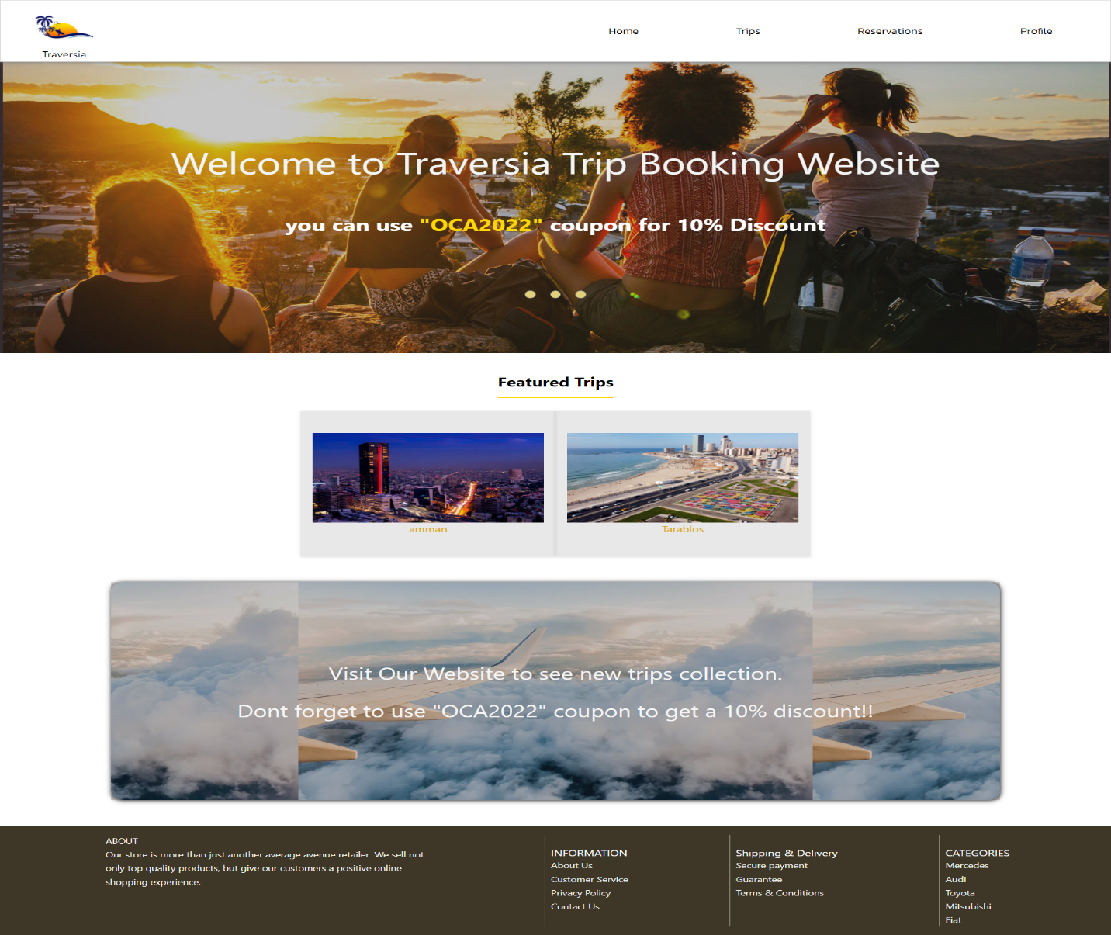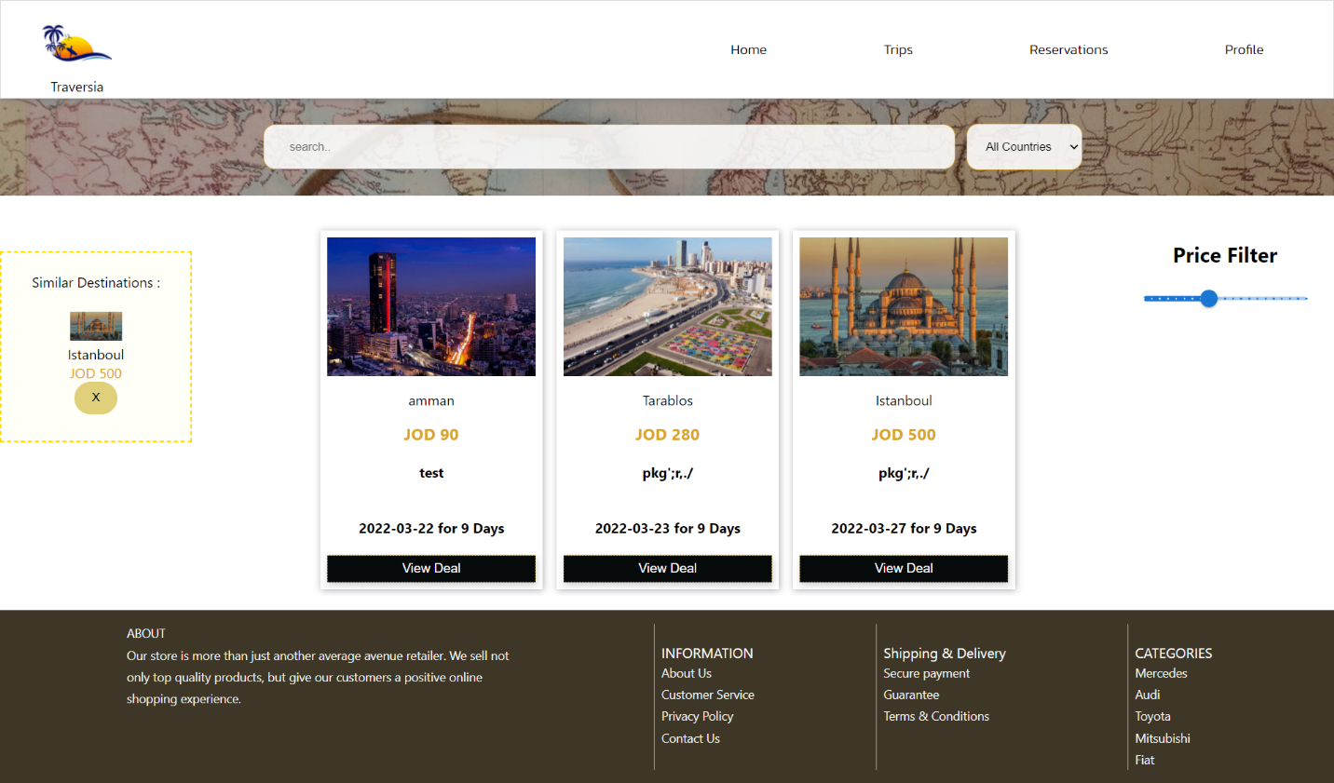

**Chapter 5:**   
**System Security 5.1**   
Data validation All inputted data throughout the system gets validated and an alert is shown in case if it’s invalid, here is the validation rules:   
A. email: must be a correct email format.   
B. password: must be between 8 and 32 alphanumeric characters.   
C. admin dashboard input: not empty.   
 5.2 Data authentication   
In this system password authentication is implemented for the login functionality. Also, there is authentication in recognizing a user's identity. The credentials provided are compared to those in the database.   
**5.3 Best practices**  
A. 404 page: it appears when trying to navigate to a non existing page.   
B. Neat URLs: short and descriptive naming conventions.   
C. SEO: tailored to the best possible within the project technology and scope.   
D. Functionalities access: functionalities related to users are only accessed from within accounts and not publicly for guests. E. Reusability: all common parts of pages are reused components.   
F. Responsiveness: All system screens and content are responsive on all devices and display sizes.   
G. Neat code: added code comments, used proper naming conventions and indentations to make the code readable and easy to navigate.

**Chapter 6: Conclusion & Future Work**   
**6.1 Conclusion**  
 As the world is an evolving place with an ever-ending need and produce of products, as this system shall keep being updated and upgraded to keep up with it.   
To wrap up my experience in creating and developing the MVP of the system, I have implemented most of what I self-learned in Coding Academy by Orange covering the following competencies in transpose level:  
1. Create mock-ups for an application.  
2. Create static and adaptive web user interfaces.   
3. Develop a dynamic web user interface.   
4. Create a user interface with a content management or e-commerce solution.   
5. Create a database.   
6. Develop data access components.   
7. Develop the back end of a web or mobile web application.   
8. Create and implement components in a content management or e commerce application.  
  
 It was a journey full of ups and downs, but thriving in general.  
 Here are some of the lessons learned on both levels personally and professionally:   
1. Planning is essential for project enrollment and success.   
2. Working on a personal project while newly joining a company is overwhelming yet disciplining.

3. Team work is appreciated and makes all the difference yet independency is powerful.   
4. Full-stack development is essential to understand the full view of a web developer, personally working on this project I discovered that I am more into frontend development than backend development.  
5. Self-learning is not that easy but opens great potential when mastered.  
  
**6.2 Future work**   
Believing in continuous development and the urge to keep the value of this system increasing, below is a list of the enhancements and features to be added to the website:  
  
1. Expand trips directories to worldwide.   
2. Add region/country classification.   
3. Implement live chat for users to interact directly about trips.