**Configuration management**

For

**Learning Hub Web Application**

Prepared By: Aya Mohamed

VERSION HISTORY

|  |  |  |  |  |
| --- | --- | --- | --- | --- |
| **Version Number** | **Implemented by** | **Description of Change** | **Revision Date** | **Reviewed By** |
| 1.0 | Aya Mohamed | - document formatting needed minor modifications  -CCB role process has been added  -naming convention has been added | 3/5/2019 | Wafaa ezz elarab |

1. Introduction :

A [systems engineering](https://en.wikipedia.org/wiki/Systems_engineering) process for establishing and maintaining consistency of a product's performance, functional, and physical attributes with its requirements, design, and operational information throughout its life.

1. Objective:

* CM streamlines the delivery of software and applications by automating the build out of systems quickly and efficiently
* It ensures an audit trail of changes done to the system.

1. Used CM tool:

* git
* Remote repository: github

1. Configuration items:

* Project Plan
* Risk sheet
* Issues sheet
* Cm plan
* SRS
* Source code
* Test cases

Using NAMING CONVENTION

(Lhub_(abbreviation of CI)

*Refer to CIList sheet

1. Configuration folder structure:

* Master branch: Contains the latest baseline of the project
* Development branch: contains source code , database diagram
* Testing branch: contains test cases, test plan

1. Roles:

* Configuration controller: Implement a controlled change process.  This is typically achieved by setting up a change control board whose primary function is to approve or reject change requests that are set against any baseline.

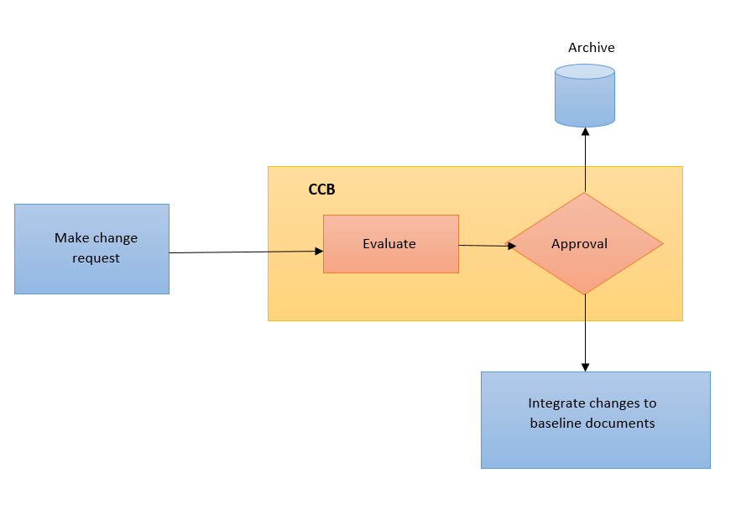

* Testers: access “testing branch” to follow test plan, implement and execute test cases.
* Developers: access “development branch” to implement and execute the main functions of the project.
* project manager: review and accept any merge or pull request from different branches to master branch