**Learning web hub application**

**Project Plan**

Client: Mohammad Gamal

Project Name: Learning web hub application

Version: 1.0

Issue Date: 4-5-2019

Prepared by: Testing Team- Development Team

Authorized by: Farah Alaa , Nada Sayed

|  |  |  |  |  |  |
| --- | --- | --- | --- | --- | --- |
| **Version #** | **Implemented**  **By** | **Revision**  **Date** | **Reviewed By** | **Approval**  **Date** | **Reason** |
| 1.0 | Farah Alaa  Nada Sayed | 1-May-2019  3- May-2019 | Aya Mohamed Ragab | 2-May-2019  3- May-2019 | Updated Risk Assessment ,  Issue Management Sheet  Update associated documents section |
| 1.1 | Nada Sayed | 10/5/2019 | Farah Alaa | 10/5/2019 | Edit in purpose and update the project time line and the risk sheet |
|  |  |  |  |  |  |
|  |  |  |  |  |  |

TABLE OF CONTENTS

**1.** **INTRODUCTION** 2

1.1 Purpose of Plan 2

1.2 Association Documents 2

1.3 Project Plan Maintenance 2

**2. GOALS AND OBJECTIVES** 2

2.1 Project Goals and Objectives 2

**3. SCOPE** 3

3.1 Scope 3

3.2 Milestones 3

3.3 Risk Assessment 4

3.4 WBS 5

5

**4. CONSTRAINTS 6**

4.1 Project Constraints 6

**5. PROJECT MANAGEMENT APPROACH 6**

5.1 Project Timeline 7

5.2 Project Roles and Responsibilities 7

5.3 Issue Management 8

5.4 Configuration Management 8

5.4.1 Introduction 8

5.4.2 Objective 8

5.4.3 Used CM Tool 8

**6. COMMUNICATION PLAN 9**

6.1 Communications Methodology 9

6.2 Communications Outreach 9

**7. APPROVALS 10**

Sign-off Sheet 10

**1 INTRODUCTION**

**1.1 Purpose of Plan**

Learning Hub is web application that allows people to learn for personal accomplishment or to earn a professional degree by exploring and receiving knowledge in different categories, users also can share their knowledge, and they can publish articles, upload videos and record voice, without physically attending a traditional university or academic setting. learning Hub is versatile enough to accommodate all learning styles.

**1.2 Associated Documents**

This document associated with Software Requirement Specification document (SRS), Software Design Document (SDD), Requirement Traceability Matrix (RTM), software interactive Questionnaire (SIQ), risk sheet, project schedule, issues sheet and configuration management (CM) document.

**1.3 Project Plan Maintenance**

Any change requests will be updated by the Management Team, it should be approved by both the Testing team and the Development team, it should be tracked at the RTM document and updated at the project plan, project schedule documents.

**2 OBJECTIVES**

**2.1 Project Objectives**

E-Learning “Learn Hub “represents an innovative shift in the field of learning, providing rapid access to specific knowledge and information. It offers online instruction that can be delivered anytime and anywhere through a wide range of electronic learning solutions such as video and audio streaming, and reading articles. Learn Hub enables individuals to transcend distance and other individual’s gaps by providing a cohesive virtual learning environment. Individuals must educated and trained to stay competitive and Learn Hub can provide such just-in-time knowledge in a cost-effective way.

**3 SCOPE**

**3.1 Scope Definition**

|  |  |
| --- | --- |
| **Scope** | **Out Of Scope** |
| User will be able to Login and Register  in websites | Specific categories for the articles |
| Web application based on Chrome & Firefox browser on windows operating system | The article be written online or the user upload it as a file |
| The application supports English language only | Maximum size for the text article |
| Audio format must be mp3 format to be uploaded and the videos format must be mp4 only | Maximum size for the audio file |
| The application has only one admin who accepts or rejects the article | Maximum size for the video file |
| Users can rate other users’ articles , user can publish article, upload video and record voice | The article file format |
|  | Number of the users |

**3.2 Milestones**

The table below lists the milestones for this project, along with their estimated completion timeframe.

|  |  |  |
| --- | --- | --- |
| **Milestone** | **Description** | **Delivery Date** |
| First Milestone | 1-project plan Document  2- SRs Document  3-SIQ Sheet  4-CM tool  5- Project Schedule  6-Risk sheet  7-Issues sheet  8-RTM  9-SRS PR sheet | 4/5/2019 |
| Second Milestone | 1- Design document  2- Design PR sheet | 11-5-2019 |

**3.3 Risk Assessment**

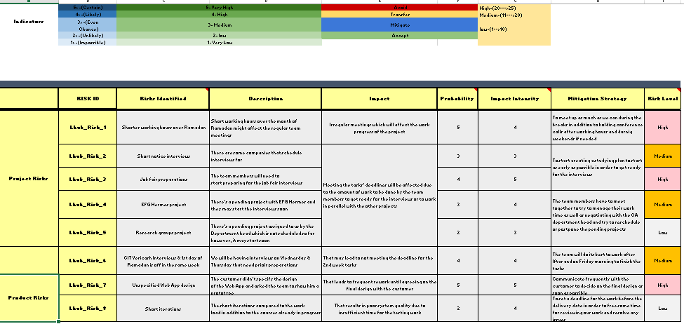

**3.4 WBS**

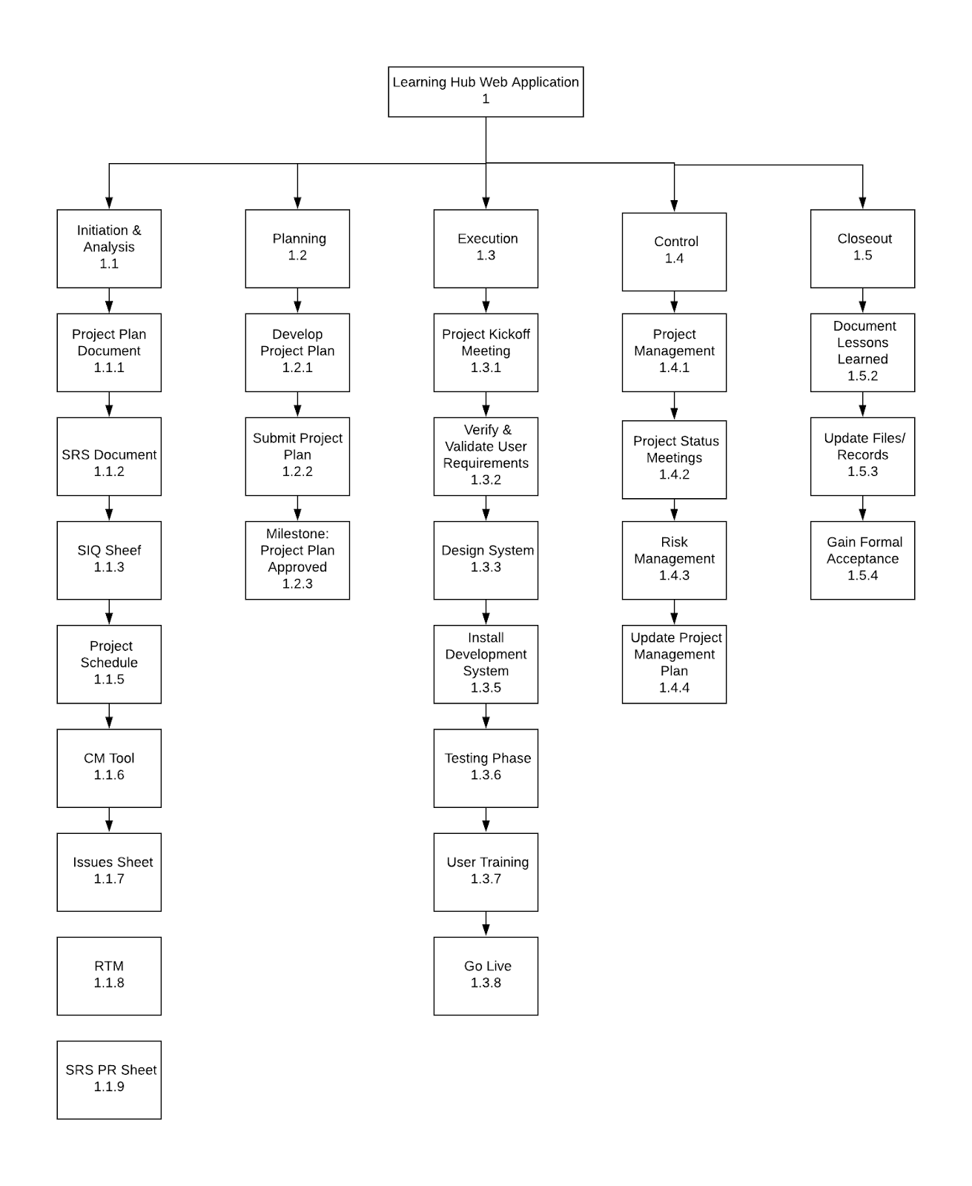

**4 CONSTRAINTS**

**4.1 Project Constraints**

* The project must work on chrome or Firefox only
* Staff must complete the project within normal working hours
* There’s limited time for each iteration
* Unique user ID

**5 PROJECT MANAGEMENT APPROACH**

**5.1 Project Timeline**

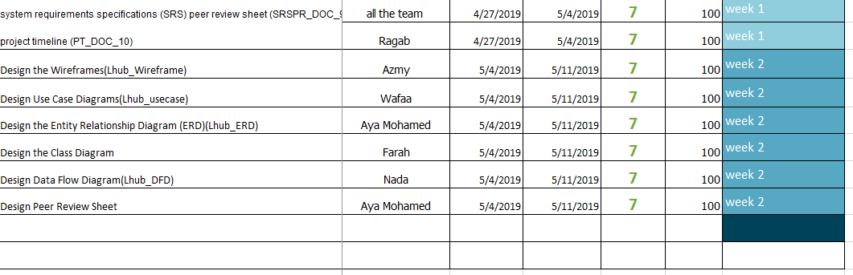

**5.2 Project Roles and Responsibilities**

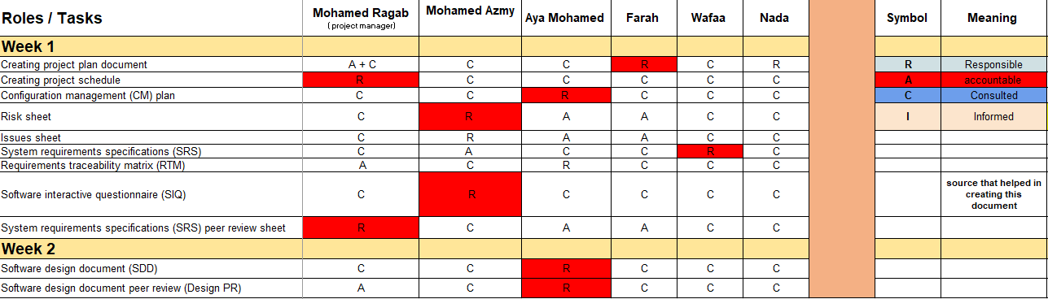

**5.3 Issue Management**

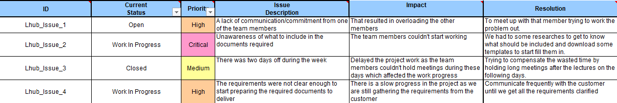

**5.4 Configuration management Tool**

**5.4.1 Introduction:**

A [systems engineering](https://en.wikipedia.org/wiki/Systems_engineering) process for establishing and maintaining consistency of a product's performance, functional, and physical attributes with its requirements, design, and operational information throughout its life.

**5.4.2 Objective:**

* Focuses on establishing and maintaining consistency of a product's performance, and its functional and physical attributes with its requirements, design, and operational information throughout its life.
* CM streamlines the delivery of software and applications by automating the build out of systems quickly and efficiently
* It ensures an audit trail of changes done to the system.

**5.4.3 Used CM tool:**

* Git
* Remote repository: GitHub

**6 Communication Plan**

Disseminating knowledge about the project is essential to the project’s success. Project participants desire knowledge of what the status of the project is and how they are affected. Furthermore, they are anxious to participate. The more that people are educated about the progress of the project and how it will help them in the future, the more they are likely to participate and benefit.

This plan provides a framework for informing, involving, and obtaining buy-in from all participants throughout the duration of the project.

**Audience** This communication plan is for the following audiences:

1. Project Manager
2. Developers
3. Testers

**6.1 Communications Methodology** The communications methodology utilizes three directions for effective communication:

### **Top-Down** It is absolutely crucial that all participants in this project sense the executive support and guidance for this effort. The executive leadership of the organization needs to speak with a unified, enthusiastic voice about the project and what it holds for everyone involved. This will be 'hands-on' change management, if it is to be successful.

### Not only will the executives need to speak directly to all levels of the organization, they will also need to listen directly to all levels of the organization, as well.

The transition from the project management practices of today to the practices envisioned for tomorrow will be driven by a sure and convinced leadership focused on a vision and guided by clearly defined, strategic, measurable goals.

### **Middle-Out** Full support at all levels, where the changes will have to be implemented, is important to sustainable improvement. At this level (as with all levels), there must be an effort to find and communicate the specific benefits of the changes. People need a personal stake in the success of the project management practices.

**6.2 Communications Outreach** The following is a list of communication events that are established for this project:

### **Weekly Status Reports** the Project Manager shall provide monthly written status reports to the Steering Committee. The reports shall include the following information tracked against the Project Plan:

1. Summary of tasks completed in previous week
2. Summary of tasks scheduled for completion in the next week
3. Summary of issue status and resolutions

### **Weekly Steering Committee Meeting** These status meetings are held at least once per week and are coordinated by the Project Manager. Every member of the Steering Committee participates in the meeting. The Project Manager sends the status report to each member of the team prior to the meeting time so everyone can review it in advance.

### **Bi-Weekly Project Team Status Meeting** These status meetings are held every other week. Every member of the Project Team will be invited to participate in the meeting. Project Manager sends the status report to each member of the team prior to the meeting so everyone can review it in advance.

**7 APPROVALS**

**Sign-off Sheet**

*I have read the above Project Plan and will abide by its terms and conditions and pledge my full commitment and support for the Project Plan.*

Project Manager:

Steering Committee:

Date: ______________________________________________________________