Learning web hub application

System design document

Client: Mohammad Gamal
Project Name: Learning web hub application
Version: 1.0
Issue Date: 11-5-2019
Prepared by: Testing Team- Development Team

TABLE OF CONTENTS

- INTRODUCTION

1.1 Purpose
1.2 Goal and objectives
1.3 Reference Material
1.4 Definitions and Acronyms

- SYSTEM OVERVIEW

- SYSTEM ARCHITECTURE

3.1 Architectural Design
3.2 Decomposition Description

- DATA DESIGN

4.1 Data Description

- HUMAN INTERFACE DESIGN

5.1 Overview of User Interface
  - Screen Images

- Structural Design
6.1 Class Diagram

- Dynamic Model

- REQUIREMENTS MATRIX

- INTRODUCTION

  - Purpose
This software design document describes the architecture and system design of Learning-hub web application
As it provides an outline of all parts of the software and how they will work.

  - Goal and objectives
The main goal of the project, is to allow users to share their knowledge easily and enable them to publish articles, upload videos and record voices. Also, to enable them explore and receive knowledge in different categories and allow them to rate other articles, they will get notifications from the website and rate other users’ articles

1.4 Reference Material

http://www.zeynepaltan.info/SDD-Template.pdf
https://youtu.be/AYHE2m651dY
https://youtu.be/lTkL1oIMiaU
1.5 Definitions and Acronyms

Provide definitions of all terms, acronyms, and abbreviations that might exist to properly interpret the SDD. These definitions should be items used in the SDD that are most likely not known to the audience.

Acronym | Definition
DFD | Data flow diagram
ERD | Entity relationship diagram
HLD | High level design

- SYSTEM OVERVIEW

Learning hub is web application that acts as an online free hosting tons, so users can explore and receive knowledge in different categories, users also can share their knowledge, and they can publish article, upload video and record voice

- SYSTEM ARCHITECTURE

3.1 Architectural Design

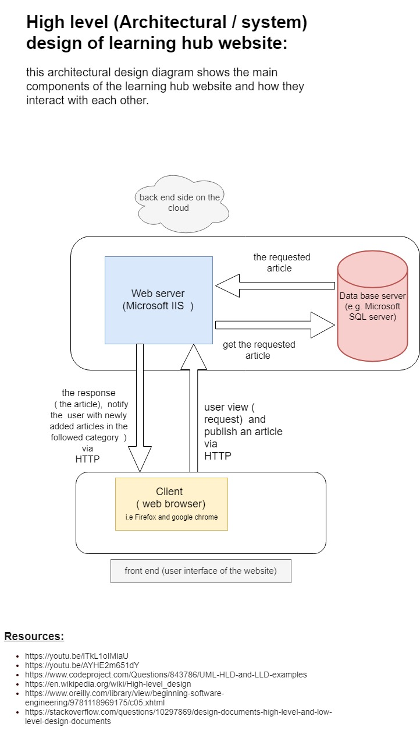
3.2 Decomposition Description

3.2.1 Data Flow Diagram
- Learning hub Data Flow Diagram is often used as preliminary step to create an overview of the project without going into great detail, which can later be elaborated. It normally consist of overall application dataflow and processes of the Learning hub process. It contains all of the user flow and their entities such as the flow of Admin, User, Register, Log in and out.

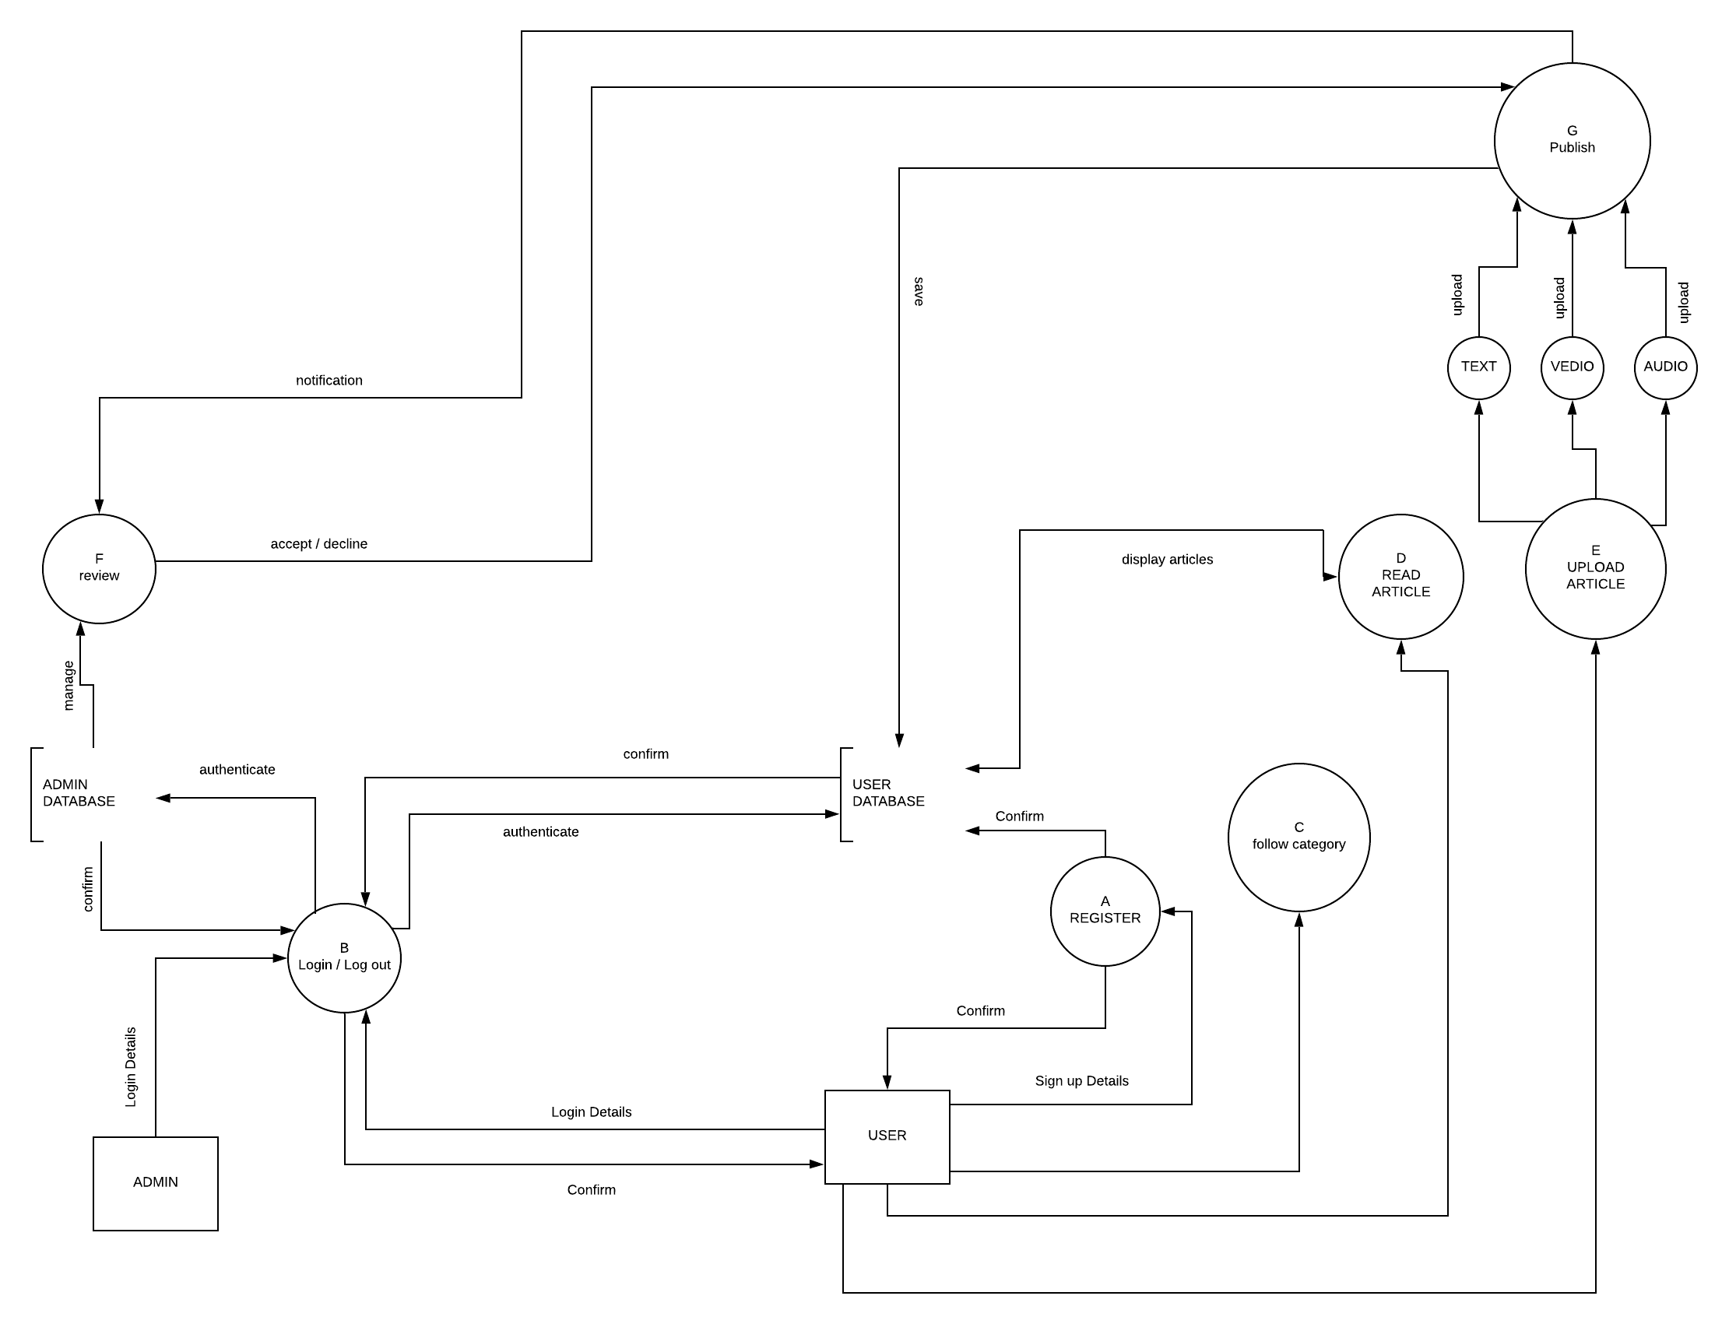
- 3.2.1.1 Admin
DFD shows the main entities of the Admin, it gives a view that Admin can “Sign in / Log out “of the system according the “Admin Data Base “confirmation. Also Admin can “Review “the uploaded articles so he can accept or reject.

- 3.2.1.2 User
DFD shows the main entities of the User, it gives a view that user can “Register “if he/she has no account then “Sign in / Log out “of the system according the “User Data Base “confirmation. User can “Follow Category “to choose the type of articles for reading or streaming. Also user can “ Upload “ and “ publish “ articles in the format of text , audio and video , but it must be accepted by the Admin .
- DATA DESIGN

4.1 Data Description

The system consists of 4 major entities (tables)
    - User table
- It holds the main information about any user like (id, email, username, and password)
- And the primary key of this table is the user id attribute.
- It also stores the role of each user, which could be (admin or a normal user)

    - Category table
- As each user can follow any category, so this table stores information about any category like (category id and category name)
- And the primary key of this table is the category id attribute.

4.1.3 Article table
- As each category consists of multiple articles, so this table stores information about any article like (article id, text, video and audio)
- And the primary key of this table is the article id attribute.
- Any article can contain text, or video or audio.
4.1.4 Admin table
- As an admin can review one or more articles, so this table stores information about admin like (username ,email ,password)
- It is a weak table , as it does not have a primary key

As there’s a many-to-many relation between User table and Category table:

4.1.5 Category User table
- It is a third intersect table (Category User table)
- Which stores the user id and the category id that the user will follow.
- And the primary key of this table is a composition of the user id and the category id
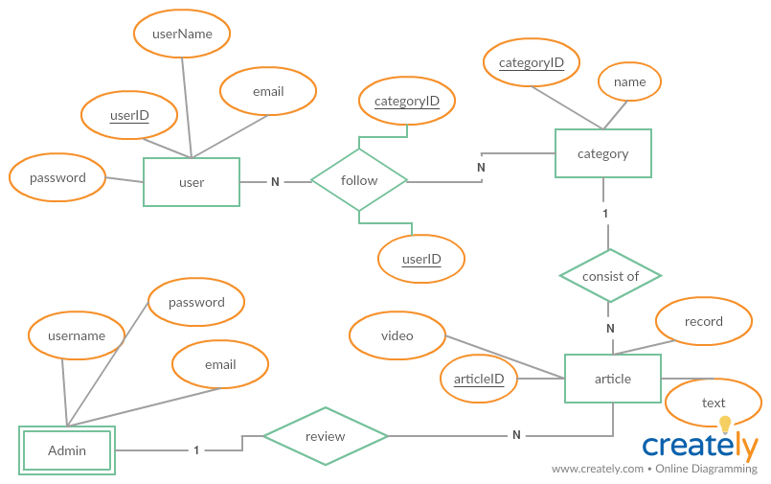
- HUMAN INTERFACE DESIGN

5.1 Overview of User Interface
Learning hub interface is user friendly. The user is able to navigate through different categories through the navigation bar that is shown at the top of the window page. There are some icons beside the navigation bar in which the user can access his/her profile, upload a new article, check notifications if any and use the search bar to search for any word included in an article’s title or body. The homepage includes the recently added articles by users and they are displayed by their titles so the user can quickly select the preferred article. The administrator has his own page where he can check the pending article publishing requests and take the necessary action with them. The user also is able to open his profile to check his article uploading history as well as their status and ratings.

  - Screen Images

    - Login page

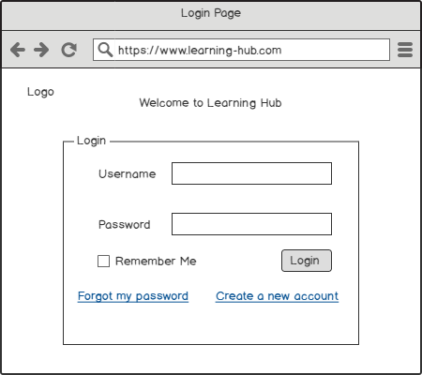
Purpose: This is the landing page where the user gets when he/she accesses the Web App URL. It contains Username and Password fields in addition to two links “Forgot my password” and “Create a new account”

Navigation & User Interaction: To login, the user is required to enter valid username and password if he/she is already registered on the website. In case the user forgot the password, there is a link “Forgot my password” to reset it. To register a new account the user should click on “Create a new account”

    - Registration page

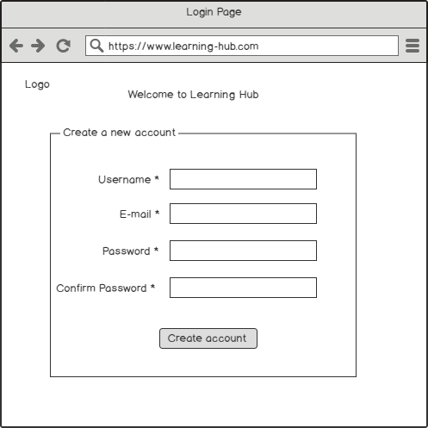

Purpose: The “Create a new account” page aims to register a user to the system. There are some text fields shown in this page, which are mandatory and should be filled in.

Navigation & User Interaction: To register a new account, the user should enter a unique username, e-mail, and password two times. There are some constraints for the password as it should be complex and consist of 8 - 12 characters including at least two capital letters, two symbols and a number

    - Home page

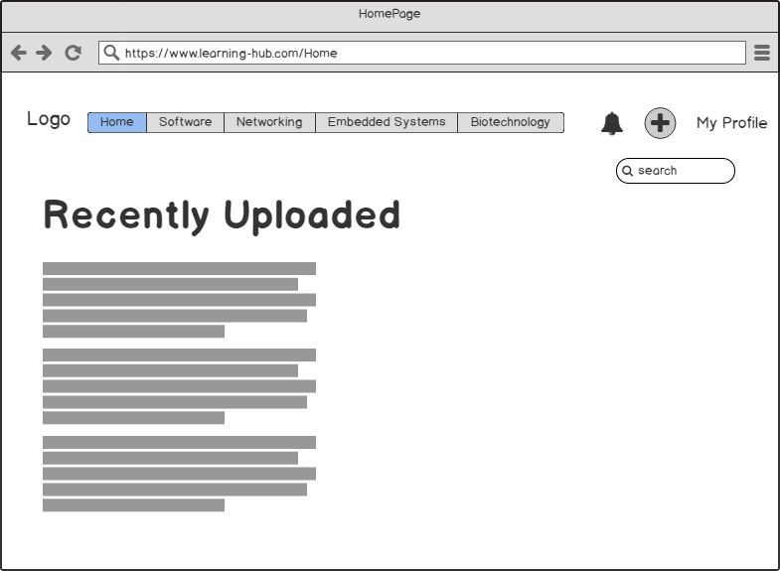

Purpose: The home page is the first page displayed to the user after logging into the system. He/She can see the navigation bar containing the different categories, search bar, “My profile” link, upload an article and notification icon. The page also includes the recently uploaded articles.

Navigation & User Interaction: The user has to select an article to open it or select any category from the navigation bar to explore the website. In addition to the different icons for notifications, view profile and upload a new article to share it with other users.
    - Category page

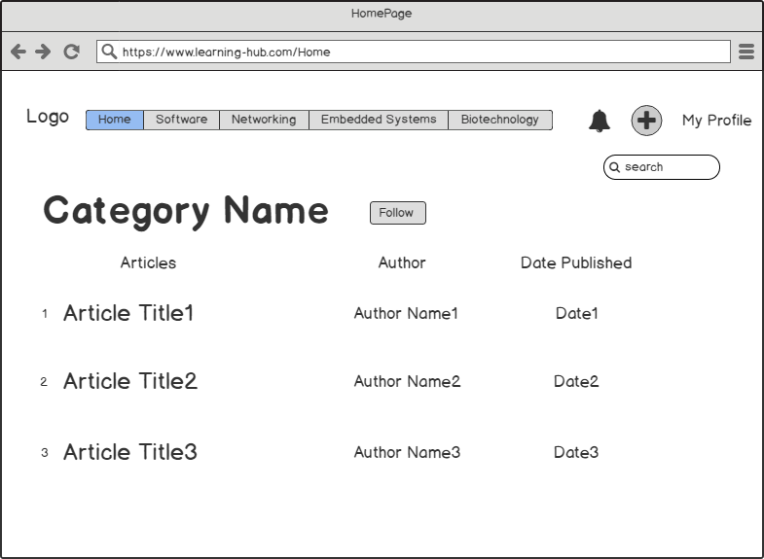

Purpose: The category page shows the articles exist in that category. The articles are displayed with their Title, Author name, Date published. There is also a “Follow” button so that the user could follow that specific category to get the new articles uploaded to it.

Navigation & User Interaction: To follow that specific category, the user should click on the button “Follow” and it will turn into “Unfollow” which means that the user is already following it. The user also can select one of the articles listed in the page to view and read it.

    - Article page

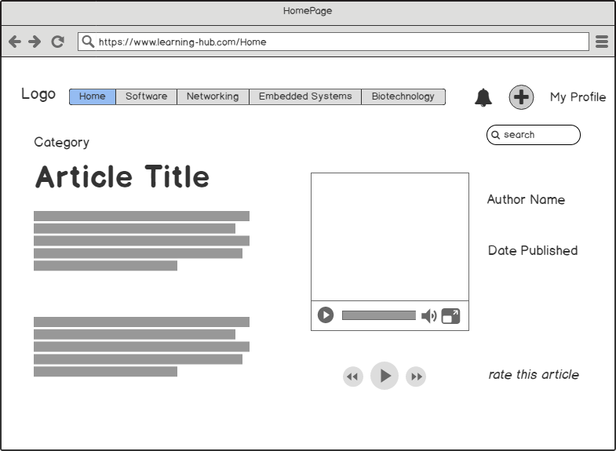

Purpose: The article page aims to display the article selected by the user. It includes the article title and category in addition to any attachments like video or audio files uploaded by the author as well as his name and the date his article is published.

Navigation & User Interaction: The user can read the article and play the attached files (audio or video). He is also able to interact by giving a rate to that article.

    - Admin page

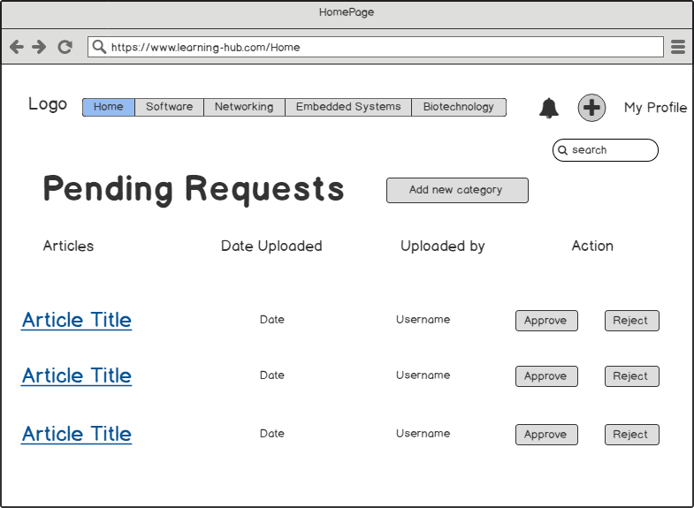
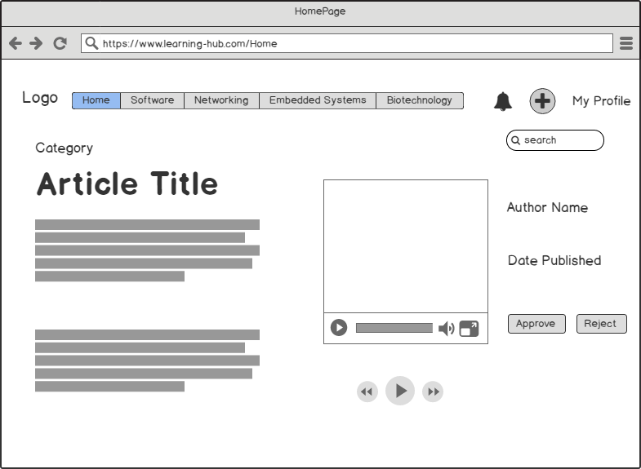

Purpose: These are the pages where the administrator can receive the requests from users want to upload articles. The admin can see the request by article title, date uploaded, who is the user uploaded it and action buttons to approve or reject the article after reviewing it.

Navigation & User Interaction: The admin has to confirm or reject the article by just clicking on the button after reviewing it.

    - User profile

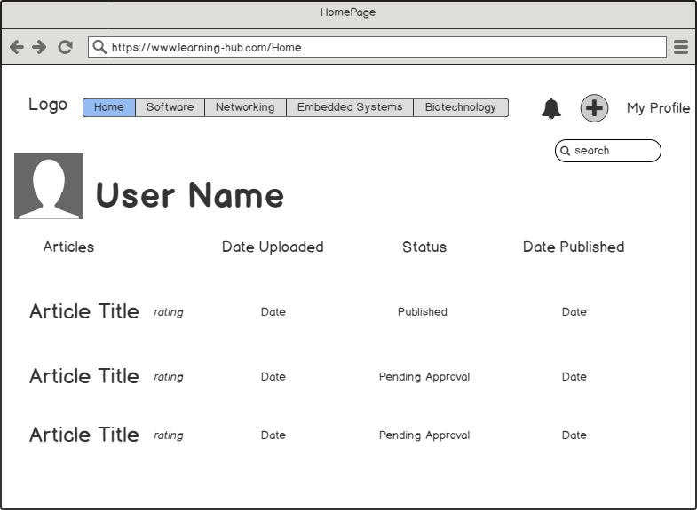

Purpose: The user’s profile is to display the username, picture and a list of the uploaded articles by that user with their details like date, status and publish date or NA if still pending approval.

Navigation & User Interaction: The user can change the profile picture or check the uploaded articles and their statuses.

    - Search results

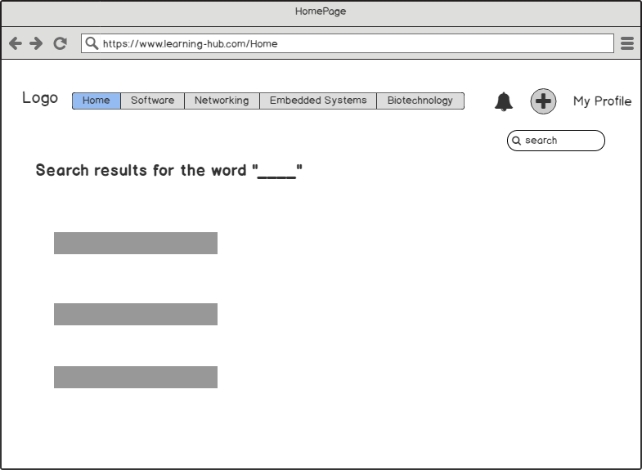

Purpose: In this page, the user can see the search results listed. He/she can search for an article by just typing its title or any word included in the body of the desired article.

Navigation & User Interaction: The user can choose an article from the results listed to open it and view its content.

    - Uploading an article

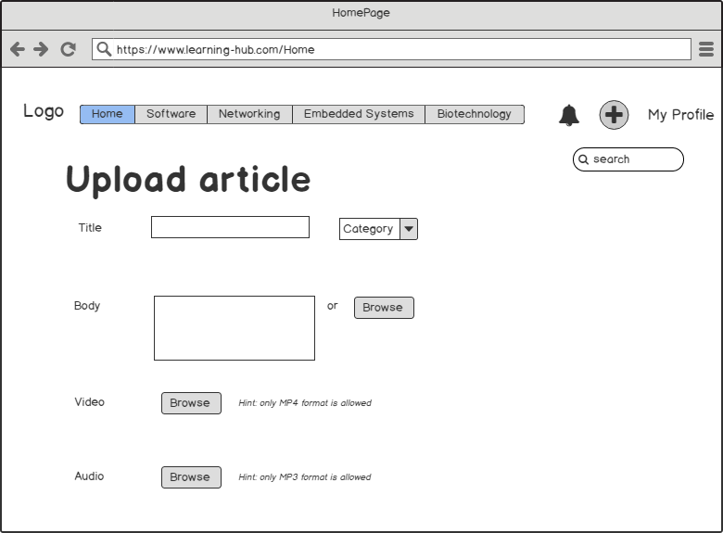

Purpose: This page is to help the user upload a new article to the system by filling in some fields like Title, category, body and attach a video or audio

Navigation & User Interaction: To upload an article the user has to enter the article title and choose a category from the drop down list. The user also is required to enter the text body of the article or browse for a ready file saved locally. There is also an option to upload a video or audio file to support the article if the user wants.

- Structural Diagram
6.1 class Diagram

6.1.1 Class: person
- Purpose: It is the Base class that user and Admin inherit form it.

6.1.1.1 Attribute Descriptions
- Attribute: Frist Name
Type: String
Description: Store the Frist Name in Frist Name variable

- Attribute: Last Name
Type: String
Description: Store the Last Name in Last Name variable

- Attribute: Email
Type: String
Description: Store the Email in Email variable

- Attribute: Password
Type: String
Description: Store the Password in Password variable

6.1.1.2 Method Descriptions

6.1.1.2.1 Method: Get Name
Return Type: string
Parameters: it doesn’t take parameter
Function Description: the function return the first name and last name of the user or the admin who is sign in

6.1.1.2.2 Method: Set Name
Return Type: void
Parameters: (first name, last name)
Function Description: the function set the values of the first name and set the value of the last name of the user or the admin who is sign in

6.1.1.2.3 Method: Get Email
Return Type: string
Parameters: it doesn’t take parameter
Function Description: the function return the Email of the user or the admin who is sign in

6.1.1.2.4 Method: Set Email
Return Type: void
Parameters: (Email)
Function Description: the function set the values of the Email of the user or the admin who is sign in

6.1.1.2.5 Method: Get Password
Return Type: string
Parameters: it doesn’t take parameter
Function Description: the function return the password of the user or the admin who is sign in

6.1.2.6 Method: Set Password
Return Type: void
Parameters: (password)
Function Description: the function set the values of the password the user or the admin who is sign in

6.1.2 Class: User
1. Purpose: this class describe the Actions of the user in the web site like search, publish article, rate article, follow category

6.1.2.1 Attribute Descriptions
1. Attribute: User ID
Type: String
Description: Store the User ID in User ID variable

6.1.2.2 Method Descriptions
6.1.2.2.1 Method: Get User ID
Return Type: string
Parameters: it doesn’t take parameter
Function Description: the function return the UserID a of the user who is sign in

6.1.2.2.2 Method: Set User ID
Return Type: void
Parameters: (User ID)
Function Description: the function set the values of the User ID of the user who is sign in

6.1.2.2.3 Method: Publish article
Return Type: void
Parameters: (Article ID)
Function Description: this function enable the user to upload his article on the web application

6.1.2.2.4. Method: Rate article
Return Type: void
Parameters: (Article ID)
Function Description: this Function enable user to rate other user article by searching with the article ID

6.1.2.2.5 Method: Remove article
Return Type: void
Parameters: (Article ID)
Function Description: this function enable user to remove an article by getting the article ID of the article

6.1.2.2.6. Method: Follow Category
Return Type: void
Parameters: (Category Name)
Function Description: this function enable user to follow a category that the user published his article on

6.1.2.2.7. Method: search article
Return Type: void
Parameters: (Word)
Function Description: this function enable the user to search for specific article with word or article name

6.1.3 Class: Admin
1. Purpose: this class describe the Actions of the Admin in the web site like Accept Article, display category

6.1.3.1 Attribute Descriptions

There is no Attribute

6.1.3.2 Method Descriptions
6.1.3.2.1. Method: Review Article
Return Type: string
Parameters: (Article ID)
Function Description: This Function is specify for the admin to accept or reject the article, if accept article it return true, else return false

6.1.3.2.2. Method: Display Users
Return Type: void
Parameters: it doesn’t take parameter
Function Description: this function display the user who published article to the admin

6.1.3.2.3. Method: Display Category
Return Type: void
Parameters: it doesn’t take parameter
Function Description: this function display the categories to the admin, enable admin to navigate between categories

6.1.4 Class: Category
1. Purpose: this class get the category name and the Id of the web application

6.1.4.1 Attribute Descriptions
1. Attribute: Category ID
Type: String
Description: Store the Category ID in Category ID variable

2. Attribute: Category Name
Type: String
Description: Store the Category Name in Category Name variable

6.1.4.2 Method Descriptions

6.1.4.2.1 Method: Get Category ID
Return Type: string
Parameters: it doesn’t take parameter
Function Description: the function return the Category ID

6.1.4.2.2. Method: Set Category ID
Return Type: void
Parameters: (Category ID)
Function Description: the function set the values of the Category ID

6.1.4.2.3. Method: Get Category Name
Return Type: string
Parameters: it doesn’t take parameter
Function Description: the function return the Category Name

6.1.4.2.4. Method: Set Category Name
Return Type: void
Parameters: (Category Name)
Function Description: the function set the values of the Category Name

6.1.5 Class: Article
1. Purpose: this class get the article name and id and check on the content of the article, check on the format of the video and the record

6.1.5.1 Attribute Descriptions
1. Attribute: Article ID
Type: String
Description: Store the Article ID in Article ID variable

2. Attribute: Article Name
Type: String
Description: Store the Article Name in Article Name variable

6.1.5.2 Method Descriptions
6.1.5.2 .1. Method: Get Article ID
Return Type: string
Parameters: it doesn’t take parameter
Function Description: the function return the Category ID

6.1.5.2.2. Method: Set Article ID
Return Type: void
Parameters: (Category ID)
Function Description: the function set the values of the Category ID

6.1.5.2.3. Method: Get Article Name
Return Type: string
Parameters: it doesn’t take parameter
Function Description: the function return the Article Name

6.1.5.2.4. Method: Set Article Name
Return Type: void
Parameters: (Article Name)
Function Description: the function set the values of the Article Name

6.1.5.2.5 .Method: check on video format
Return Type: Boolean
Parameters: (Article ID)
Function Description: this function return true if the format of the video is mp4 else return false

6.1.5.2.6. Method: Check on upload Record
Return Type: Boolean
Parameters: (Article ID)
Function Description: this function return true if the upload forma of the record is mp3 else return false

6.1.6 Class: Generate Setting
1. Purpose: this class change the language of the application m and display notification to user when a new article is added to the category that user follow it his article and notify admin when user upload article

6.1.6.1 Attribute Descriptions
1. Attribute: language
Type: String
Description: Store the selected language in language variable

6.1.6.2 Method Descriptions
6.1.6.2.1. Method: Change Language
Return Type: void
Parameters: (language)
Function Description: this function change the language of the website according to what language user selected it

6.1.6.2.2. Method: Get Notification
Return Type: void
Parameters: (User ID, Article ID)
Function Description: this function show notification to user when a new article is added to the category which user follow it, and show notification to admin when user upload article or add category

6.1.7 Class: Login
1. Purpose: this class enable user or admin to login to the application

6.1.7.1 Attribute Descriptions
There is no attribute

6.1.7.2 Method Descriptions
6.1.7.2.1. Method: login
Return Type: void
Parameters: (Email and Password)
Function Description: this function make user or admin to login in to the application

6.1.7.2.2. Method: Get Registration link
Return Type: string
Parameters: it doesn’t take a parameter
Function Description: the login page should include registration link which redirect user to the edit password and confirm password

6.1.7.2.3. Method: Get forget password link
Return Type: void
Parameters: it doesn’t take a parameter
Function Description: the login page should include forget password link which redirect user to the registration page if you don’t have create account yet

6.1.7.2. 4. Method: validate password and email
Return Type: Boolean
Parameters: (Email, Password)
Function Description: this function check on the validate the password constrains to be from 8 - 12 characters including at least two capital letters, a number and at least two special characters and email should support all the domain , else return false

6.1.8 Class: Registration
1. Purpose: this class enable user or admin to create account on the application if they didn’t sign in yet

6.1.8.1 Attribute Descriptions
1. Attribute: confirm password
Type: String
Description: Store the confirm password in confirm password variable
2. Attribute: country
Type: String
Description: Store the selected country in country variable

6.1.8.2 Method Descriptions
6.1.8.2.1. Method: Create Account
Return Type: void
Parameters: (Email, Password, First Name, Last Name, confirm password)
Function Description: this function make user to login to the application by entering his data and store it in the data base

6.1.8.2.2. Method: Check format User ID
Return Type: Boolean
Parameters: User ID
Function Description: this function check on the format of the user id it must be to be alphanumeric, has special characters, case sensitive, else return false

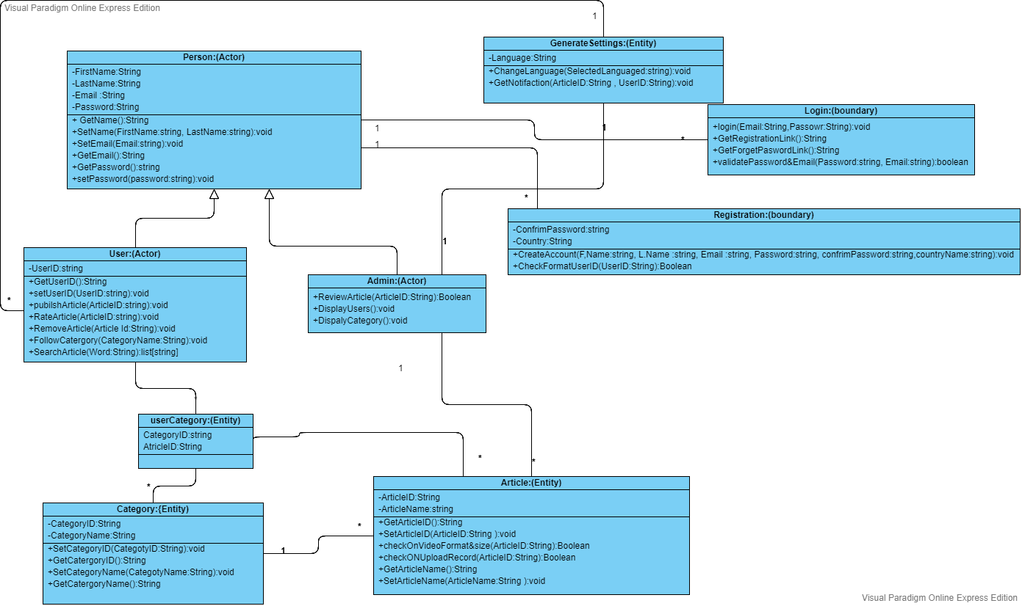

- Dynamic Module

7.1 Use Case Diagram
  - Use Case notations
Use cases define interactions between external actors and the system to attain particular goals. A use case diagram contains four main components
  - Actors
Actors are usually individuals involved with the system defined according to their roles. The actor can be a human or other external system.
  - Use Case
A use case describes how actors uses a system to accomplish a particular goal. Use cases are typically initiated by a user to fulfill goals describing the activities and variants involved in attaining the goal.
  - Relationship
The relationships between and among the actors and the use cases.
  - System boundary
The system boundary defines the system of interest in relation to the world around it.

    - Use Case description

      - User has the ability to make an account through Registration Form (Use Case)
Actor: User
Relationship: association
System Boundary: Registration Module
      - User has the ability to Login to his account after Registration(Use Case)
Actor: User
Relationship: Includes, from registration use case
System Boundary: Login Module
      - User has the ability to Add Articles through home Page (Use Case)
Actor: User
Relationship: association
System Boundary: Home Page Module
      - User has the ability to Upload videos through home Page (Use Case)
Actor: User
Relationship: association
System Boundary: Home Page Module
      - User has the ability to Upload Records through home Page (Use Case)
Actor: User
Relationship: association
System Boundary: Home Page Module
      - User has the ability to Navigate Between Categories (Use Case)
Actor: User
Relationship: association
System Boundary: Integration Module
      - User has the ability to follow specific Category (Use Case)
Actor: User
Relationship: association
System Boundary: Category Module
      - User has the ability to rate Categories (Use Case)
Actor: User
Relationship: Includes, from follow specific category use case
System Boundary: Category Module

      - User has the ability to search for articles (Use Case)
Actor: User
Relationship: association
System Boundary: Category Module
      - Admin has the ability to make an account through Registration Form (Use Case)
Actor: Admin
Relationship: association
System Boundary: Registration Module
      - Admin has the ability to Login to his account after Registration (Use Case)
Actor: Admin
Relationship: Includes, from registration use case
System Boundary: Login Module
      - Admin has the ability to review articles (Use Case)
Actor: Admin
Relationship: association
System Boundary: Review Module
      - Admin has the ability to accept articles through review module (Use Case)
Actor: Admin
Relationship: Extends, from review articles use case
System Boundary: Review Module

      - Admin has the ability to reject articles (Use Case)
Actor: Admin
Relationship: Extends, from review articles use case
System Boundary: Review Module

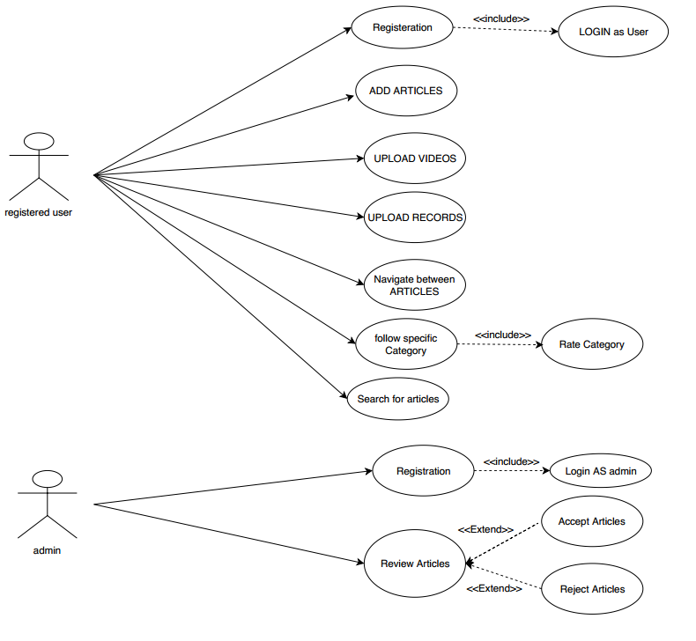

- REQUIREMENTS MATRIX
Refer to Lhub_RTM document.

