**Learn**: Delegate – Expressions – Extensions Methods - .net builder – Identity – Iconfiguration -

1. Choosing Architecture
   1. Core: contains Business entities
   2. API: responsible for receiving HTTP requests and sending response
   3. 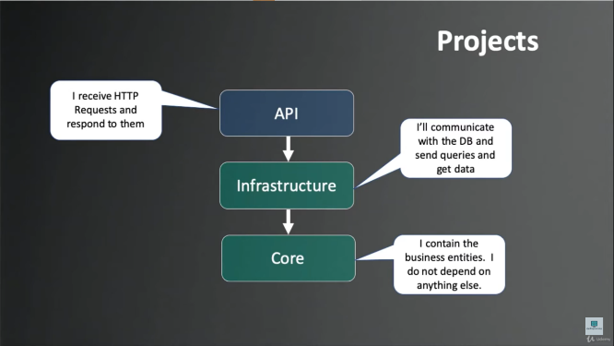**Infrastructure**: communication with DB, sending Queries.

Configure Https

* dotnet dev-certs https -t

What is the benefit of Repository Pattern?

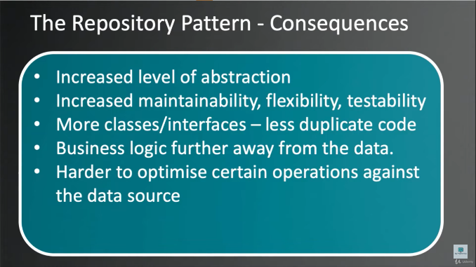Repository Pattern will be between my DbContext and my controller

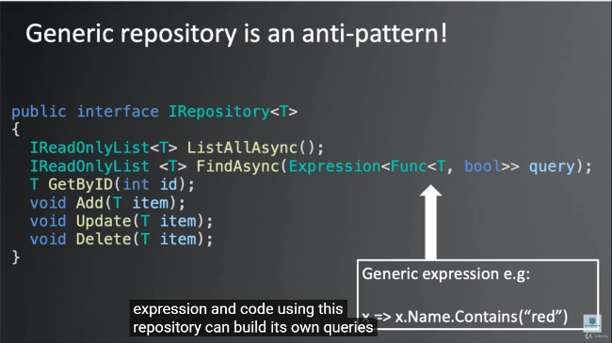

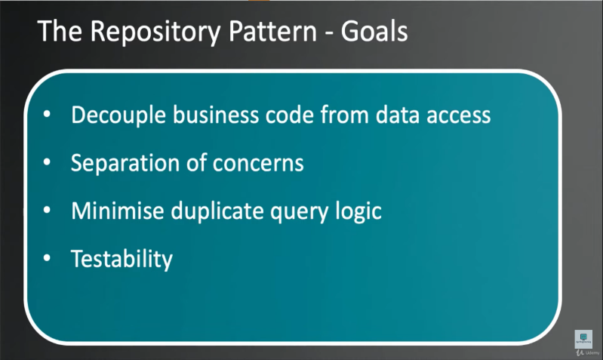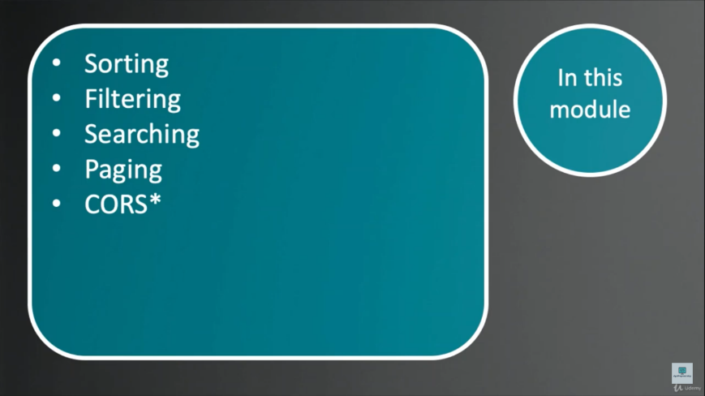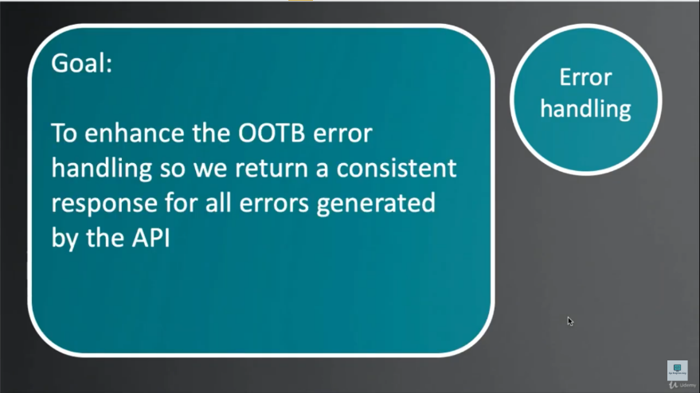

Used Techniques:

1. N-Tier Arch
2. Repository Pattern And unit of Work
3. Structured Logging using Serilog and Seq
4. Seeding Data
5. eager Loading
6. Specification Pattern
7. Error Handling
8. Deferred Executions
9. Redis For storing the client Basket
10. API Validation
11. Handling Customer Orders
12. **Reset Password**
13. **External Login with Google – Done**
    1. **integrating Google OAuth with MS Identity**
14. **Refresh Token**
15. **Localization**
16. **Email Confirmation for signing up – Done**
    1. **Security using hashing the token and store it in the DB**
    2. **+ using CSRFtoken**
17. **Google Adds -- Optional**