How to Download Aya’s Monk from GitHub

1. Go to <https://github.com/AyaProfiles/Aya-Monk>
2. Click the lua file

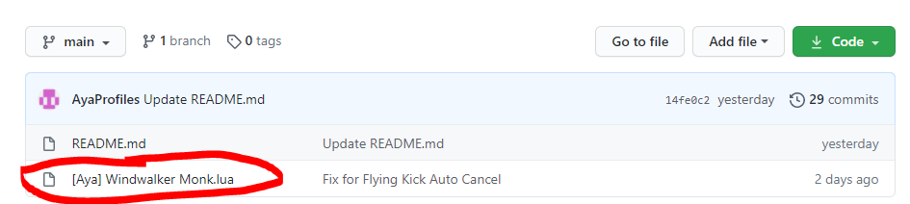

3. Click Raw to get an easy download file

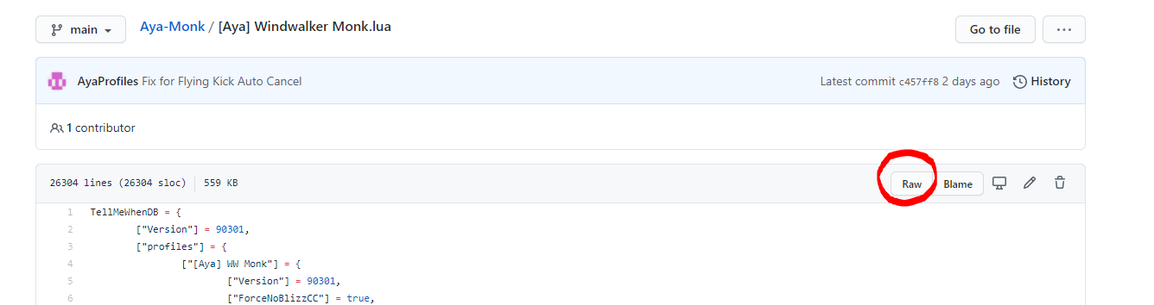

4. A page will open with a lot of code. Push CTRL + S to save the file and save it somewhere you will remember. Make sure the file name says .lua at the end



5. Go to GGL and click Profile Install

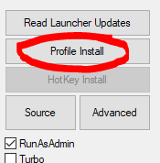

6. Select “Import (from file)”

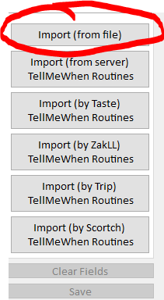

7. Click all the boxes and hit save

