*Abstract*

The project report consists of 2 phases. In the first phase, the problem assigned to us has been

mentioned. Second phase provides the solution for the same problem along with an insight into

the development process involved.

Introduction part gives the information regarding Bookshop Automation System. It also

gives brief introduction about the project under the topic **PROBLEM DEFINITION** .It

gives a short introduction about Bookshop and its operations.

The next part is the **REQUIRMENT ANALYSIS** which is mainly concerned with study

of various requirements such as user, System, Hardware/Software & Performance. It also

includes feasibility study of system.

The next part is on **SYSTEM DESIGN**, which include interface design, detailed design.

It also includes function flow, Gantt chart, and ER diagram & database design.

Last part is regarding **CONCLUSION** about above mention problem.

**Table of Content**

1. Introduction 5

2. Problem Definition 6

3. System Objective 7

4. Related work comparison 8

5. Time plan 10

5.1. Activity network 13

5.2. Gantt diagram 14

6. System Analysis 15

6.1. User Requirement 15

6.2. All functional & nonfunctional requirements 19

7. System Design 22

7.1. ER diagram 22

7.2. Schema 23

7.3. Database diagram 24

8. System Implementation 27

9. References 54

**Introduction:**

Bookstore gives you an online shopping cart and point-of-sale system for your school's bookstore. Online shoppers can browse and purchase items via the shopping interface or via Buy Now links for individual items embedded on other sites. In-person sales can be handled using Point of Sale, which works with USB barcode scanners and credit card readers. Students who want to pay later can charge their Bookstore orders to their accounts. On the back end, you can manage inventory, process online orders, and run sales reports. Additionally, all Bookstore transactions are automatically fed into your General Ledger.

**Problem Definition:**

Almost every activity in the world today is controlled by computer driven software programs.

According to the above fact, managing and maintaining a book shop could also be controlled by

efficient software. This project focuses attention on designing efficient and reliable software

which controls the transactions of a bookshop.

When the bookshop issues an item to a customer, all the stages of the transaction procedure will

be facilitated by the system & it will be more accurate.

**System Objectives:**

The main objective of “Online Book Store” is to provide an essence

of online book store via a simple and yet powerful medium.

The project has been designed to simulate the working of an actual

online book store.

**Related work comparison:**

|  |  |  |
| --- | --- | --- |
| **Application Name** | **Points of strengths** | **Points of weaknesses** |
| **My Library** | 1. Online stores are cheap. 2. Online shopping is very convenient. 3. Online stores are not limited by space. 4. Online bookstores simplify access. 5. Online stores allow both authors and consumers the opportunity to view feedback from previous customers. | 1. As with most online transactions, you need a lot of trust to use online bookstores. 2. When you buy books online, you don’t receive any personalized service. 3. By choosing to buy books online, you are also choosing to accept the risks of fraud. 4. Though the actual books purchased from an online store may be cheaper. 5. Returns are very problematic when you buy books online. |
| **Amazon** | 1. Strong background and deep pockets. 2. Customer centric. 3. Cost leadership. 4. Efficient delivery network. 5. Global strategy. | 1. Shrinking margins. 2. Tax avoidance issue. 3. High debt. 4. Product flops. |

|  |  |  |
| --- | --- | --- |
| **Online Bookstore** | 1. Online transactions through the e-Commerce . 2. To the book seller is that he is not limited by geography location and time as compared to a physical store. 3. The seller gets orders any time and supply the electronic material needed at any time. 4. Any customer who is connected to the internet is able to place an order for any academic or non academic material. 5. They are able to buy cheaper and effective books. | 1. The buyer is not able to share the books with those he ones not unless he or she has provided them with password to personal account. 2. With online books, it is difficult to trust that deliveries will be made. 3. Delivery 4. Costs and returns. 5. Cost of using the internet. 6. Buying more: because everything is at the click of a mouse, it's very easy to buy and spend more then you intended to. |

**Time Plan:**

|  |  |  |
| --- | --- | --- |
| **Task Name** | **Duration (weeks)** | **Parallel&dependence** |
| 1. Interview with system actors. | 1 week |  |
| 1. Determine system requirement. | 1 week | Depends on T1. |
| 3. Collect system requirement. | 1 week | Depends on T1,T2  Parallel with T2. |
| 4. Design initial plan. | 1 week | Depends on T3 |
| 5. Time plan. | 1 week | Depends on T4. |
| 6. Estimate coast. | 1 week | Parallel with T5. |
| 7. Design a proposal system contract. | 1 week | Depends on T4  Parallel with T5, T6. |
| 8. Analyiz system requirement. | 1 week | Depends on T7. |
| 9. Designing “UML”diagram. | 1 week | Depends on T8  Parallel with T7. |
| 10. Design database. | 1 week | Depends on T8  Parallel with T9. |
| 11. Implement system. | 2 weeks | Depends on T8  Parallel with T9, T10. |
| 12. Maintain final system. | 1 week | Depends on T11. |
| 13. Testing the deliverable system. | 1 week | Depends on T11  Parallel with T12. |

Tasks with its milestones:

|  |  |  |
| --- | --- | --- |
| **Task Name** | **Duration (days)** | **Dependencies** |
| 1. Interview with system actors. | 5 days |  |
| 1. Determine system requirement. | 5 days | T1(M1) |
| 3. Collect system requirement. | 5 days | T1,T2 (M2) |
| 4. Design initial plan. | 5 days | T3 (M3) |
| 5. Time plan. | 5 days | T4.(M4) |
| 6. Estimate coast. | 5 days | T5 (M5) |
| 7. Design a proposal system contract. | 5 days | T4 (M4) |
| 8. Analyze system requirement. | 5 days | T7 (M6) |
| 9. Designing “UML”diagram. | 5 days | T8 (M7) |
| 10. Design database. | 5 days | T8 (M8) |
| 11. Implement system. | 10 days | T10 (M9) |
| 12. Maintain final system. | 5 days | T11 (M10) |
| 13. Testing the deliverable system. | 5 days | T11 (M10) |

Activity Network:

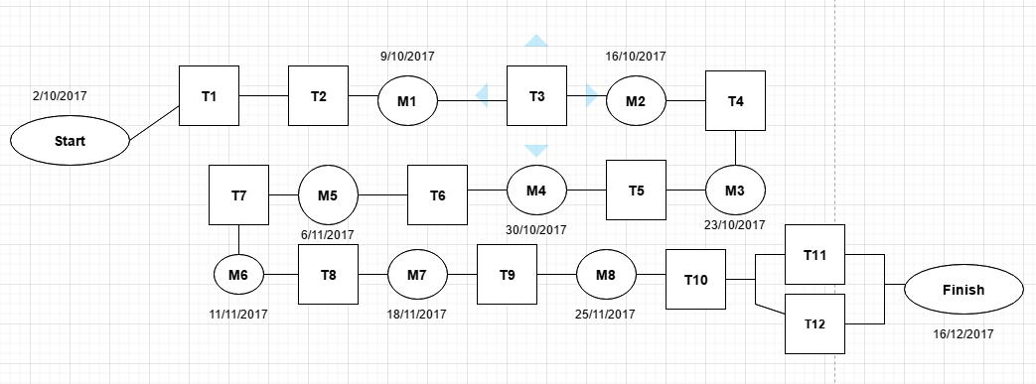

Gantt chart:

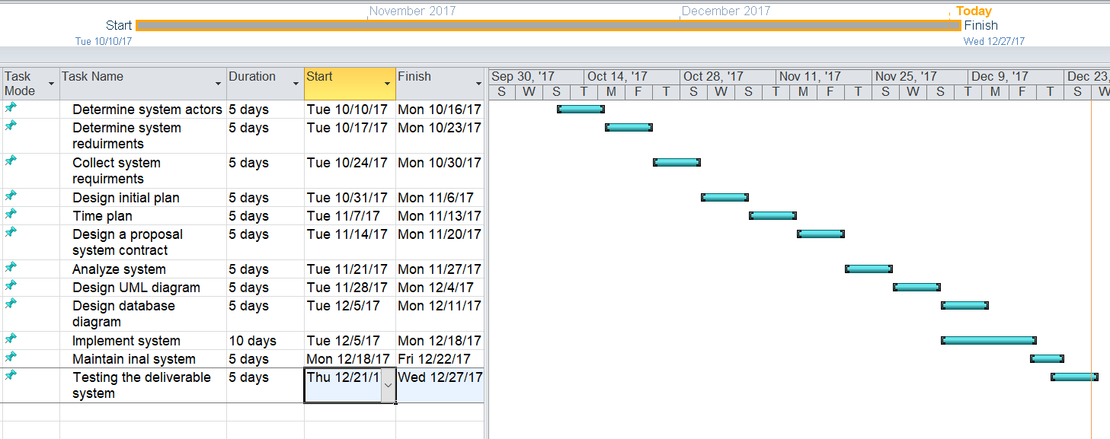

**System Analysis:**

1-Registration

User System Requirement

The Online Book Store shall allow user registration.

System Requirement

* 1. User enters his data (username, password, email).
  2. Check username and password are valid.
  3. User presses the button register.
  4. Check user email is correct.
  5. Admins add the data to database.

2-Log in

User System Requirements

The Online Book Store shall allow the process of log in.

System Requirement

2.1- User enters username and password.

2.2- User presses the button log in.

2.3- Check that username and password are valid.

3-Searching

User System Requirement

The Online Book Store shall allow searching by author name and book name.

System Requirement

3.1- Ask user if he wants to search by author name or book name.

3.2- If user choose searching by author name.

3.3- User writes author name.

3.4- Check that author name is valid.

3.5- The application will display all books related to this author.

3.6- If user choose searching by book name.

3.7- User writes book name.

3.8- Check that book name is valid.

3.9- The application will display all the information about that book.

4-Buying

User System Requirement

The Online Book Store shall allow buying books.

System Requirement

4.1- User presses the button of buying.

4.2- User chooses if he wants hard copy or soft copy.

4.3- User chooses the way of payment.

4.4- The application will display the deliverable time.

Functional Requirement

1. The user registers his data.
2. The user can log in easily.
3. The user can search about any book easily.
4. The user can buy any book easily.

Non-Functional Requirement

1.1-User enters his data (username, password, email).

1.2-Check username and password are valid.

1.3-User presses the button register.

1.4-Check user email is correct.

1.5-Admins add the data to database.

2.1-User enters username and password.

2.2- User presses the button log in.

2.3- Check that username and password are valid.

3.1- Ask user if he wants to search by author name or book name.

3.2- If user choose searching by author name.

3.3- User writes author name.

3.4- Check that author name is valid.

3.5- The application will display all books related to this author.

3.6- If user choose searching by book name.

3.7- User writes book name.

3.8- Check that book name is valid.

3.9- The application will display all the information about that book.

4.1-User presses the button of buying.

4.2- User chooses if he wants hard copy or soft copy.

4.3- User chooses the way of payment.

4.4- The application will display the deliverable time.

**System Design:**

The online book store “Entity Relation Diagram”

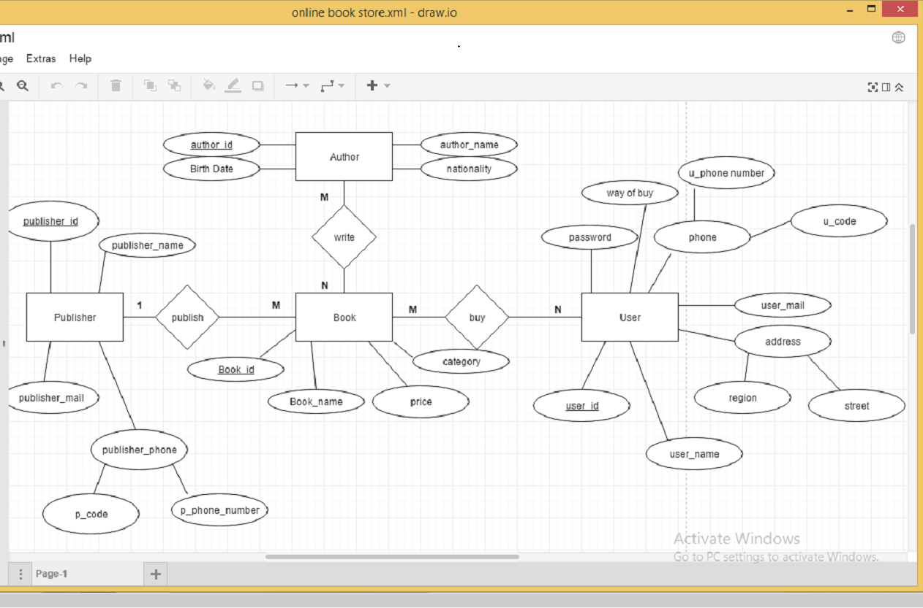

Schema:

User

|  |  |  |  |  |  |  |  |  |
| --- | --- | --- | --- | --- | --- | --- | --- | --- |
| User_id | User_name | Region | User_mail | U_phone number | U_code | Way of buy | street | password |

Author

|  |  |  |  |
| --- | --- | --- | --- |
| Author_id | Author_name | Birth date | nationality |

Book

|  |  |  |  |  |
| --- | --- | --- | --- | --- |
| Book_id | Book_name | price | category | Publisher_id |

Publisher

|  |  |  |  |  |
| --- | --- | --- | --- | --- |
| Publisher_id | Publisher_name | Publisher_mail | P_code | P_phone number |

Buy

|  |  |
| --- | --- |
| User_id | Book_id |

Write

|  |  |
| --- | --- |
| Book_id | Author_id |

Data base diagram:

The online bookstore‘s database diagram represent the relationship

between its tables.

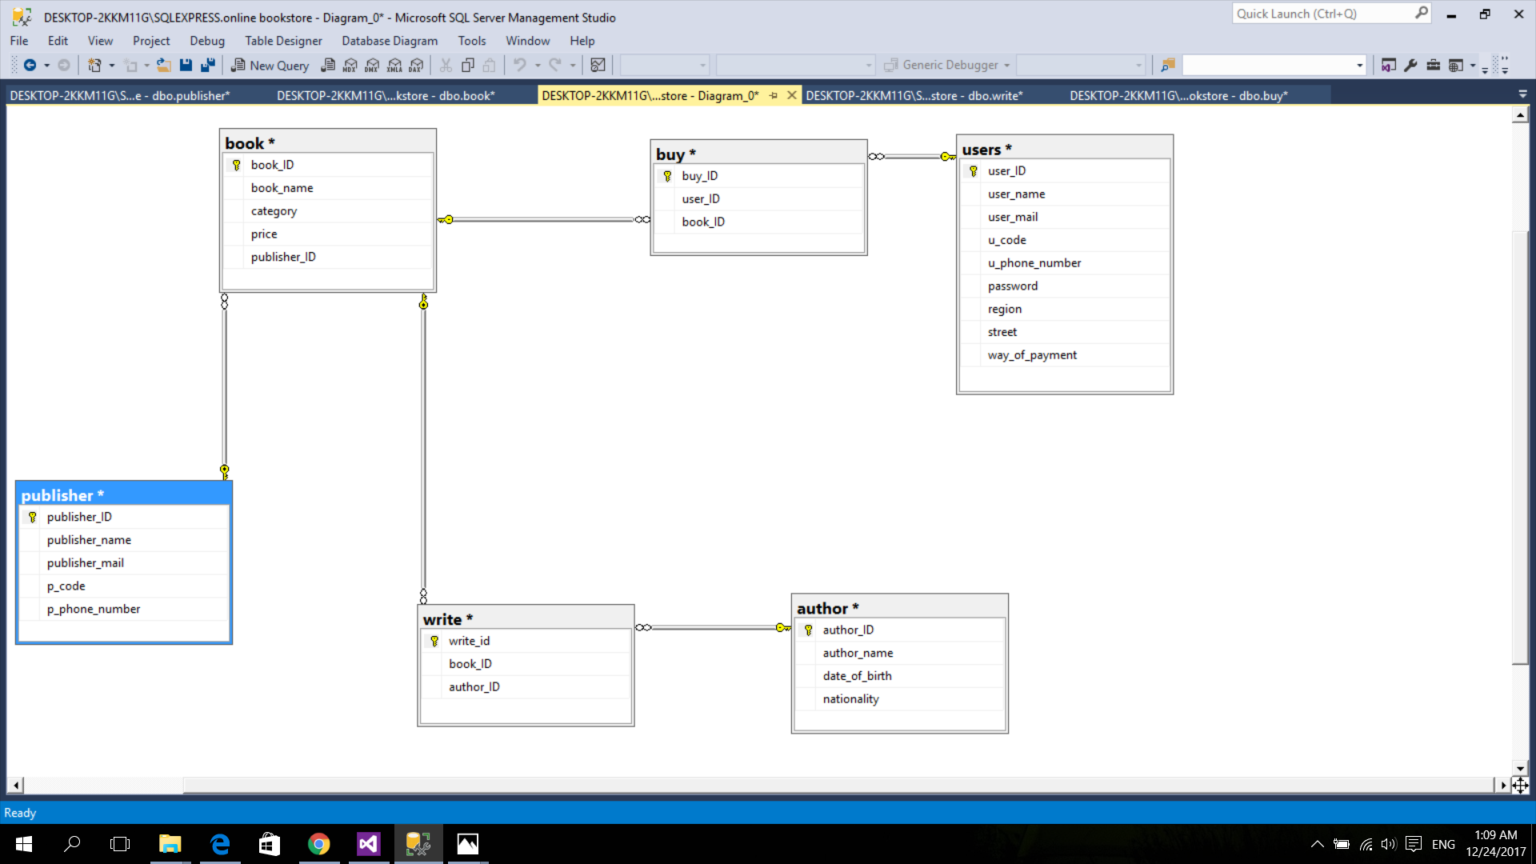

Tables Design:

User table

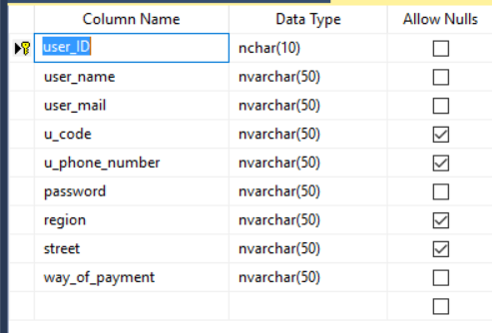

Book table

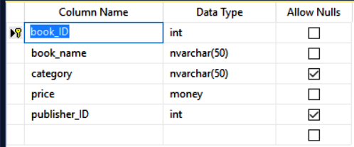

Author table

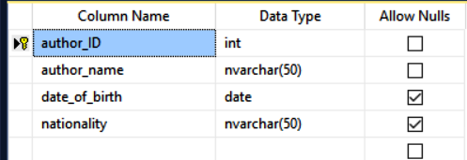

Publisher table

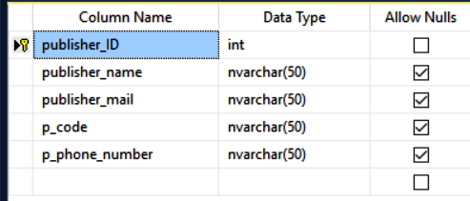

Buy table

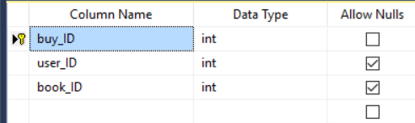

Write table

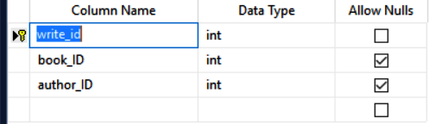

Application user interface:

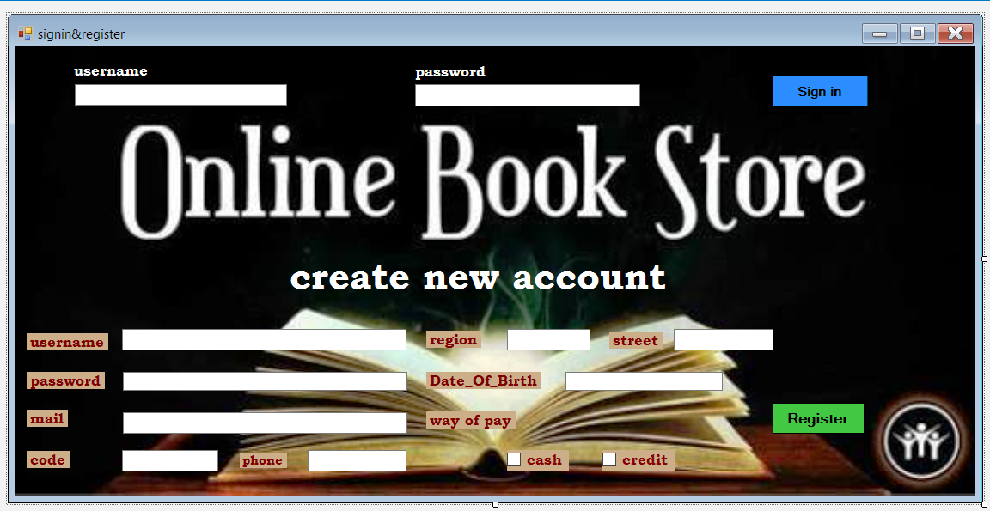

System Implementation:

Form 1 consists of 2 buttons,

First button is Register button



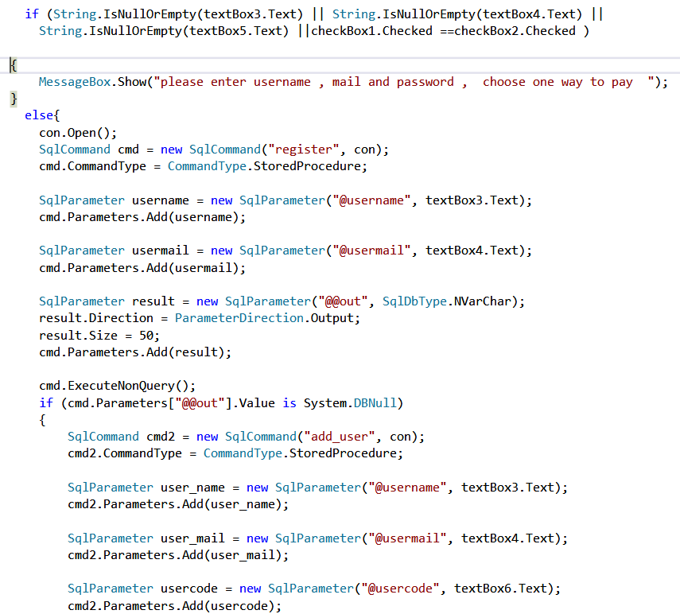

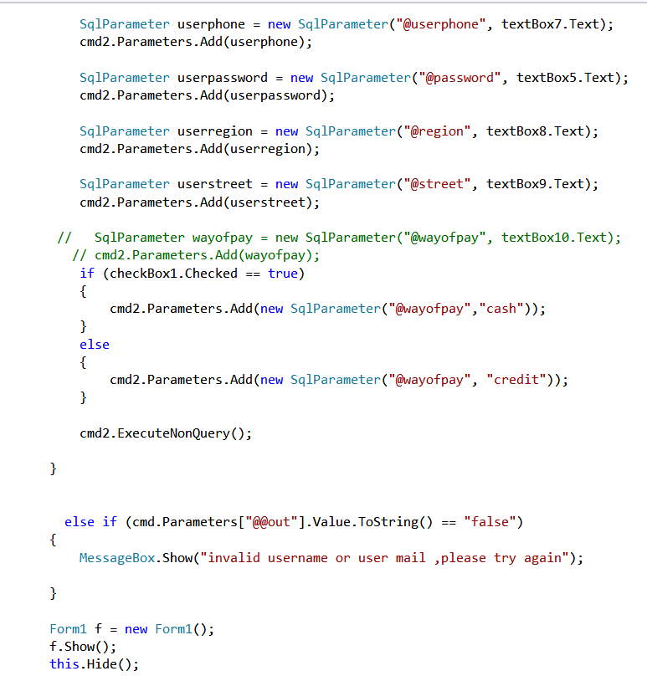

Second button sign in

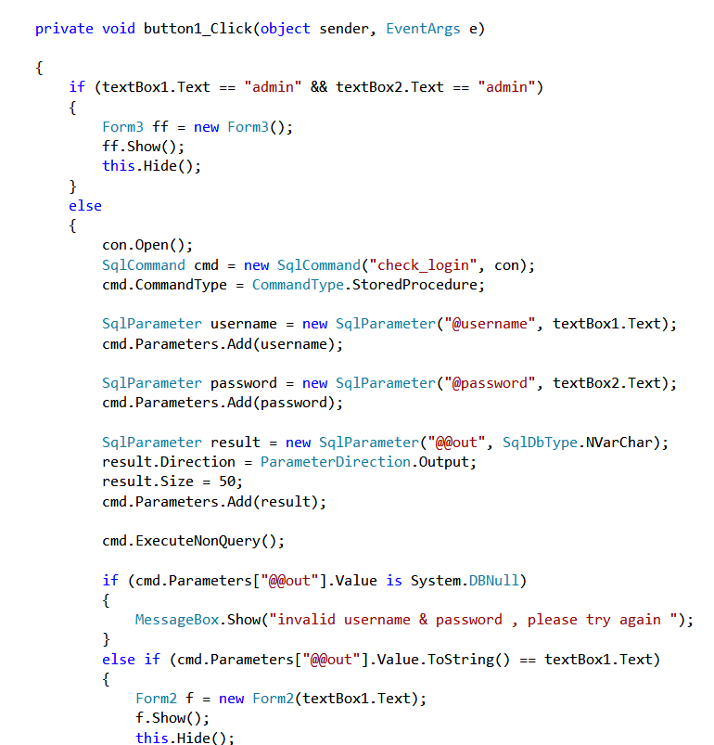

Form 2 consists of 4 buttons

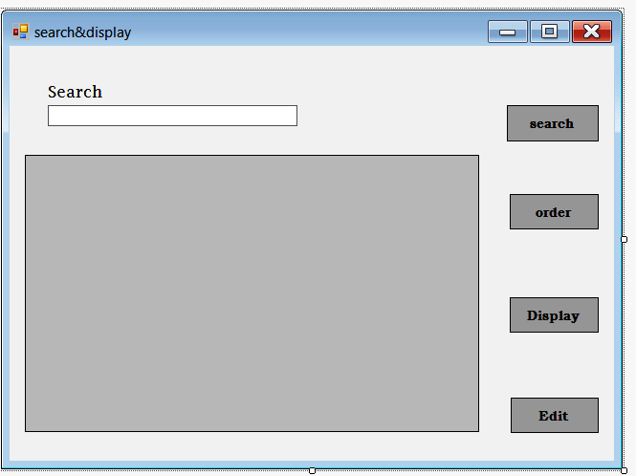

Search button

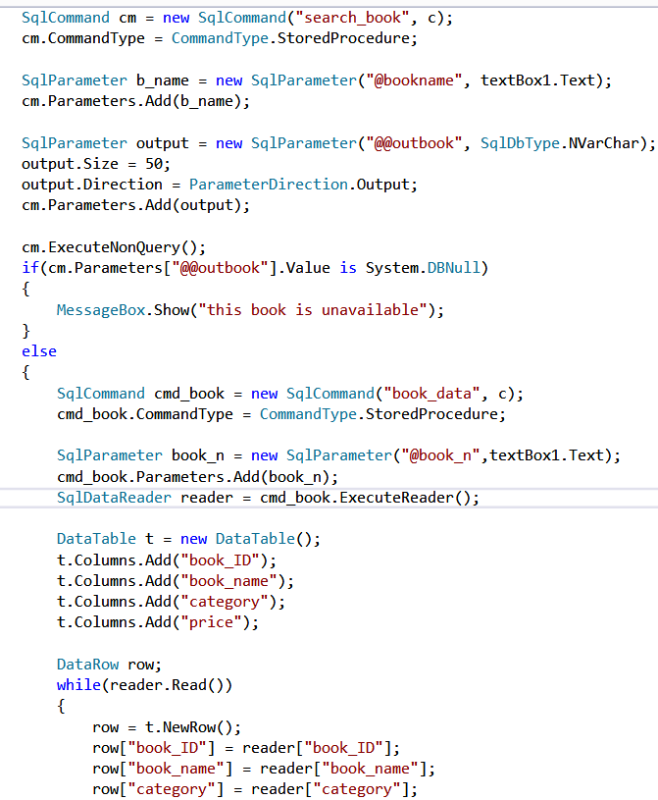

Order button

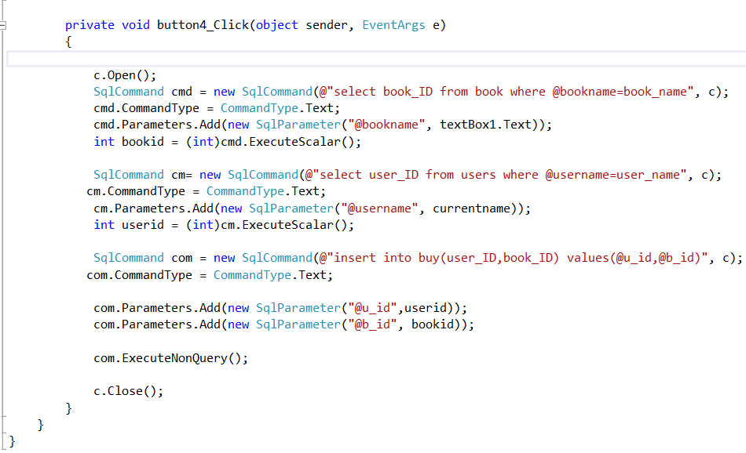

Display button

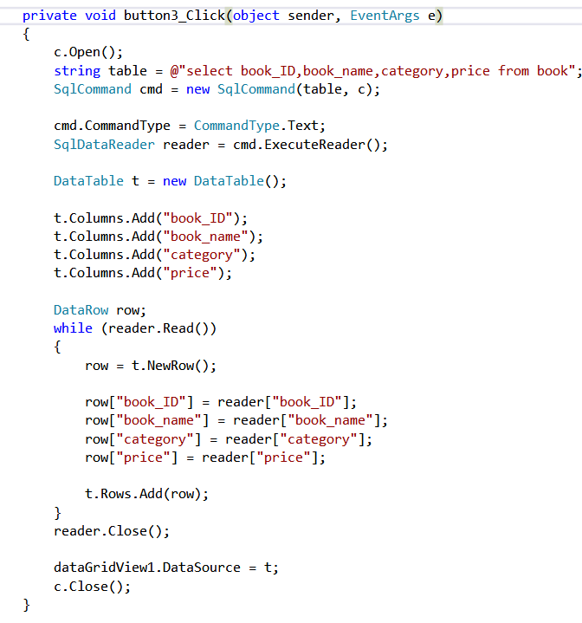

Edit button

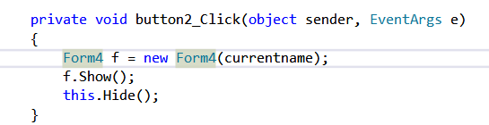

Form3 consists of 3 buttons

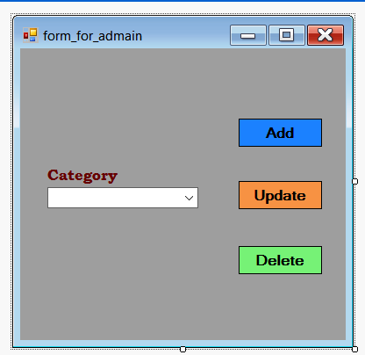

Add button

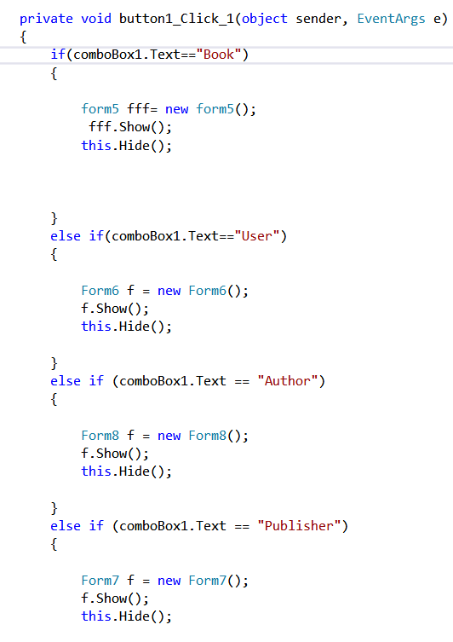

Update button

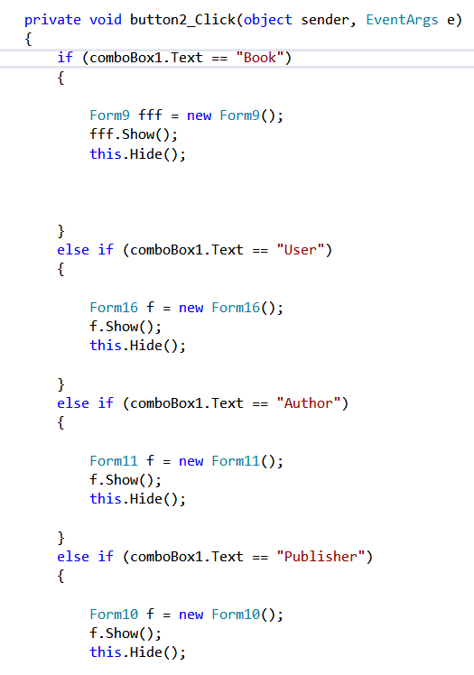

Delete button

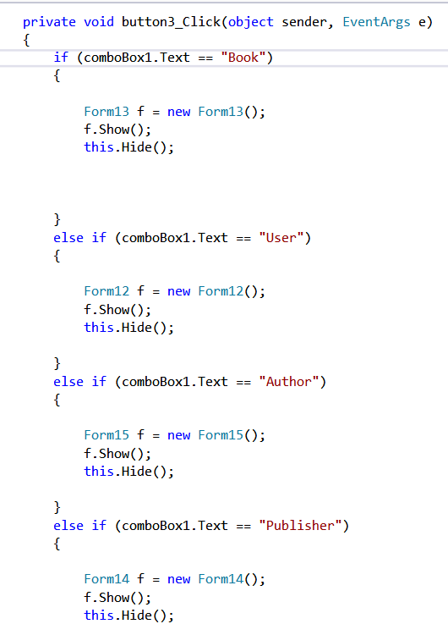

Form 4 edit for user

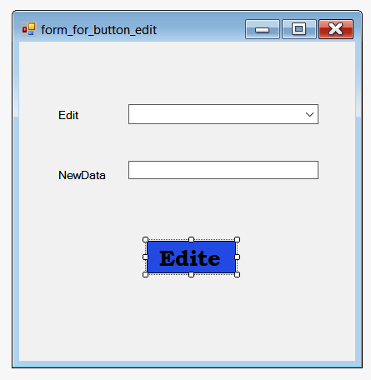

Edite button

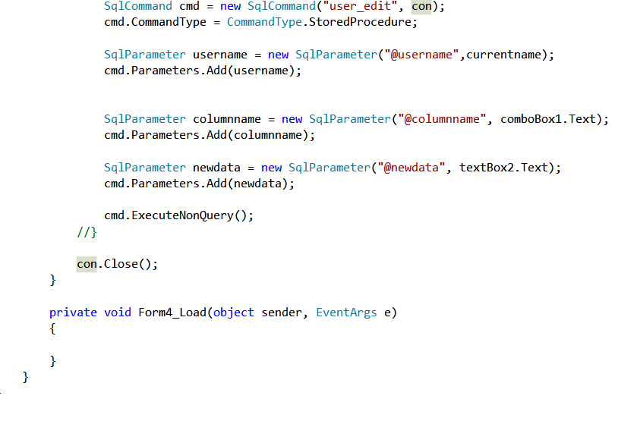

Form 5 add for book

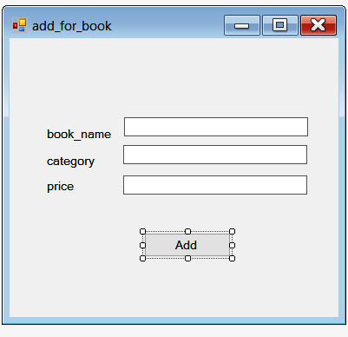

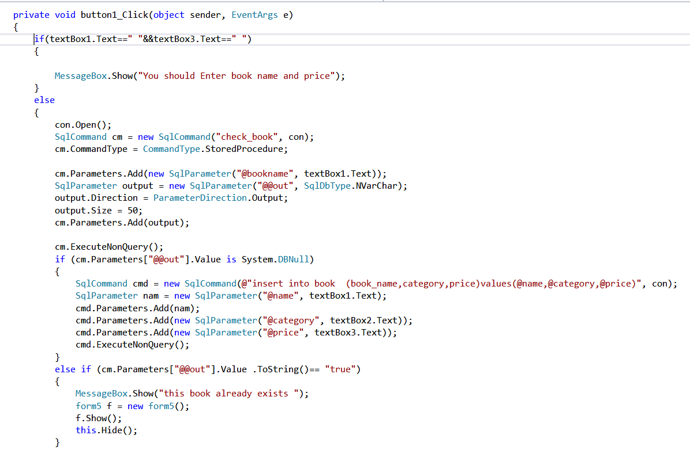

Form 6 add for user

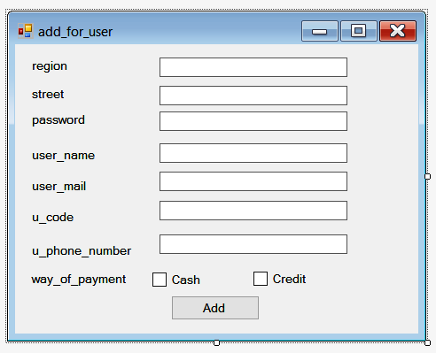

Add button

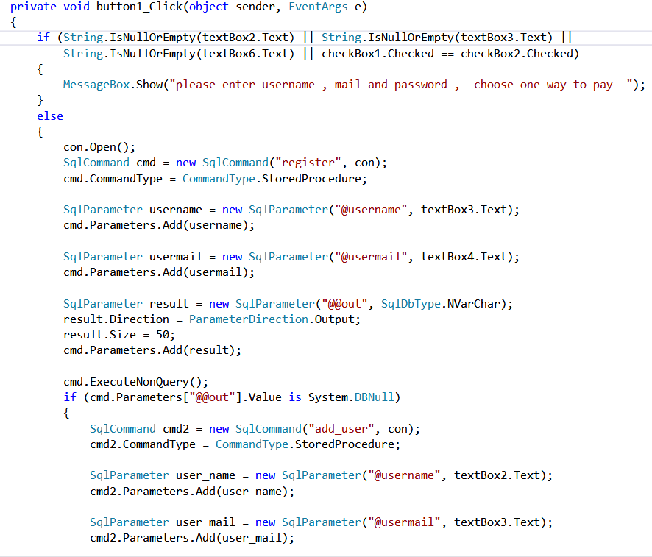

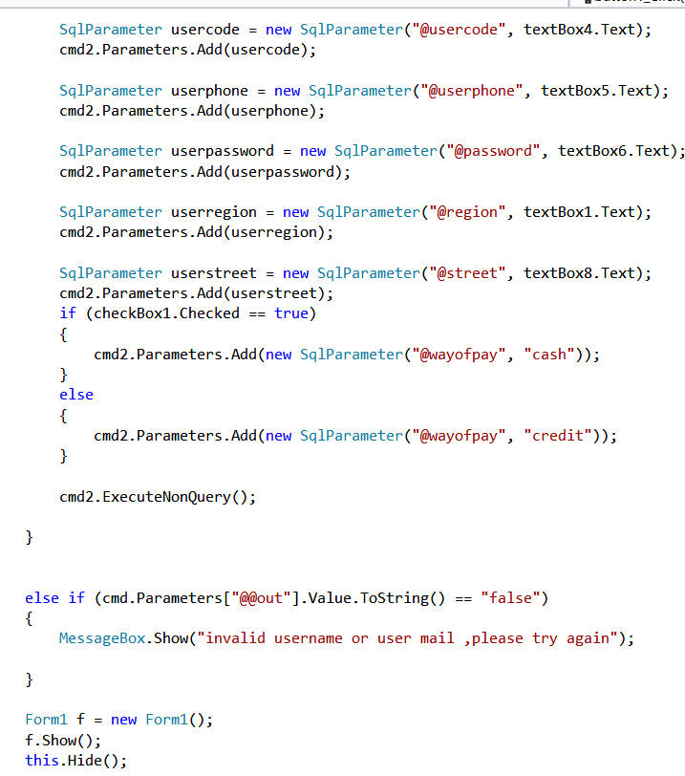

Form 7 add for publisher

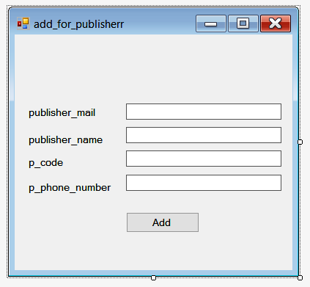

Add button

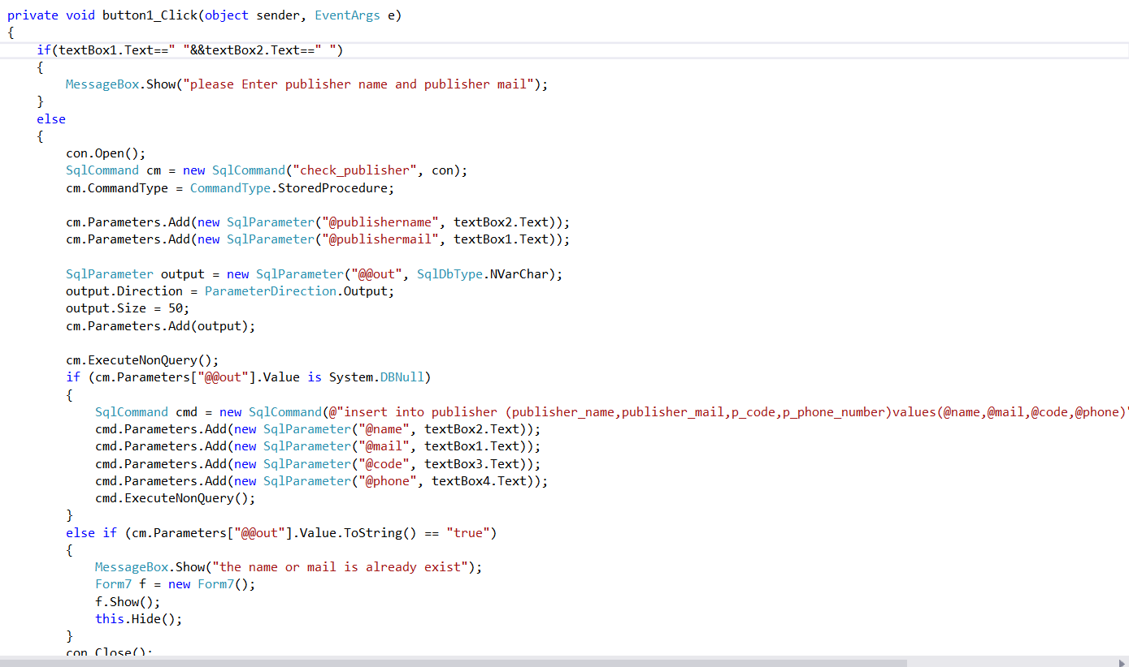

Form 8 add for author

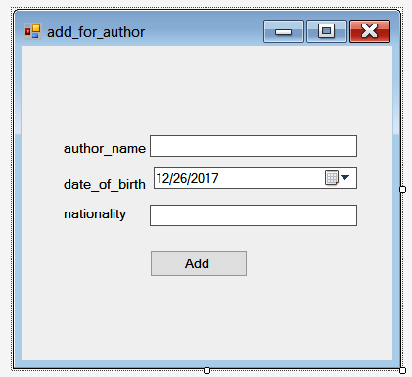

Add button

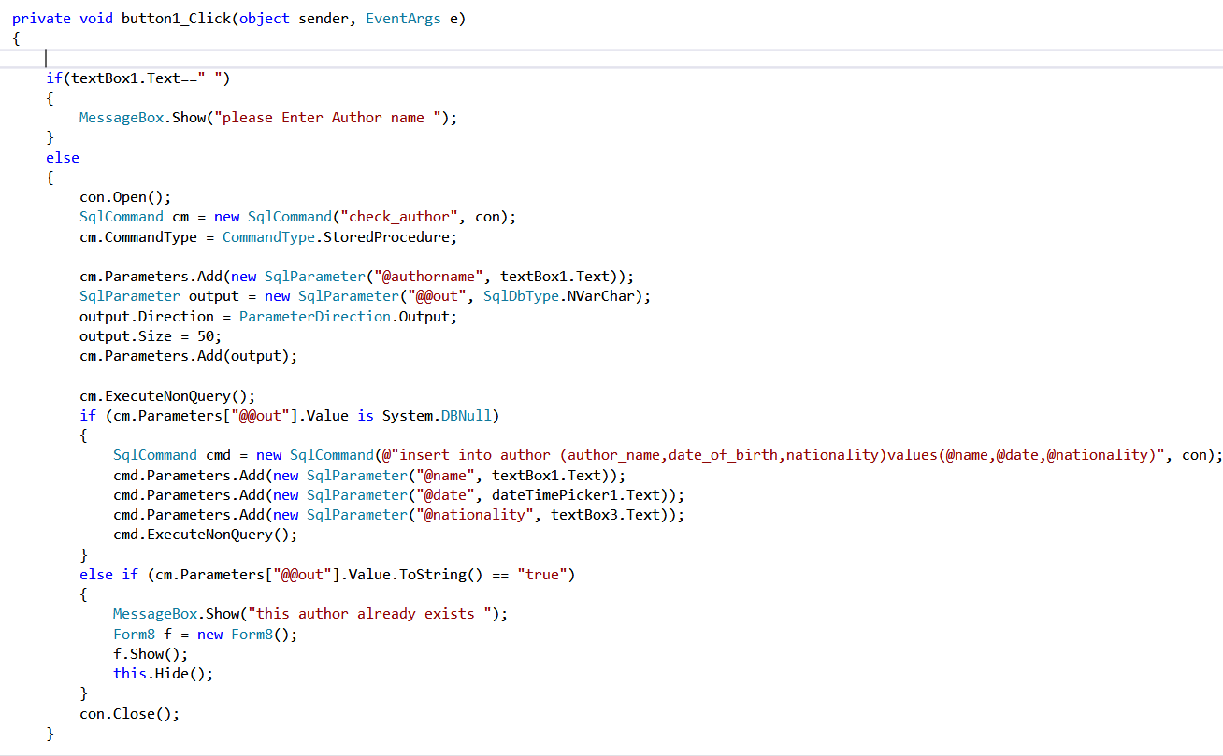

Form 9 update for book

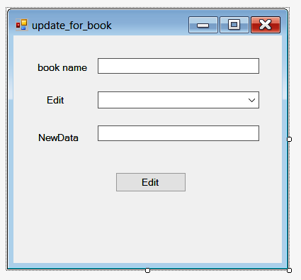

Edit button

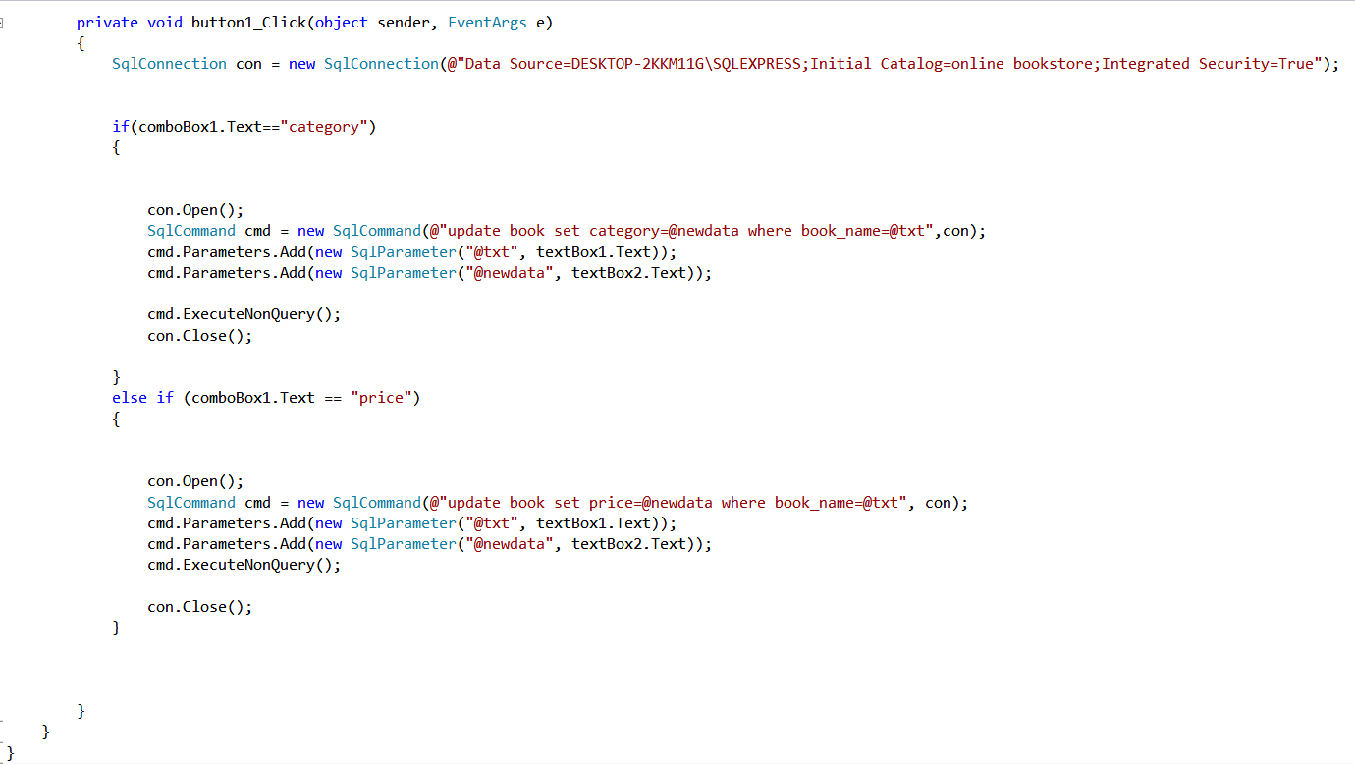

Form 10 update for publisher

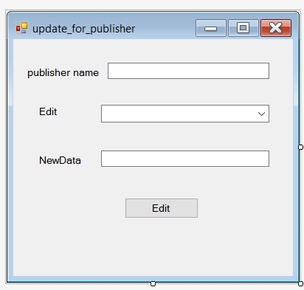

Edit button

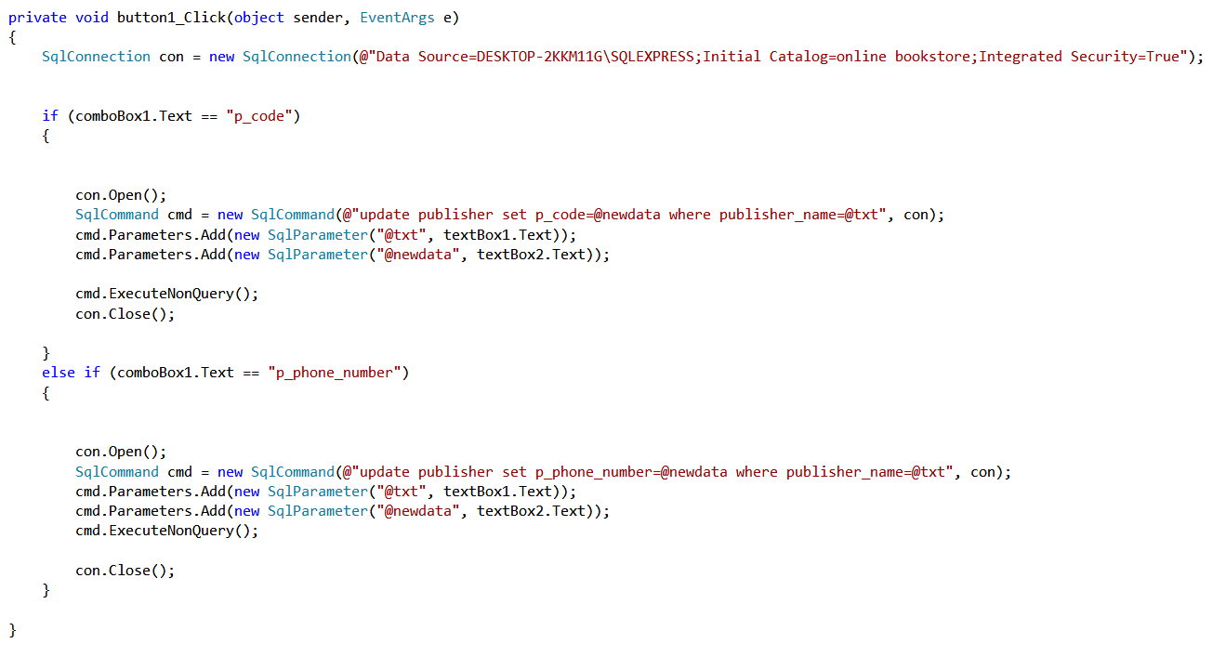

Form 11 update for author

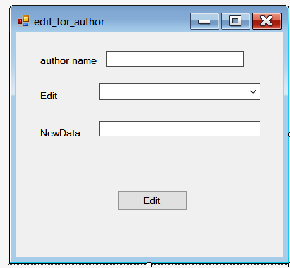

Edit button

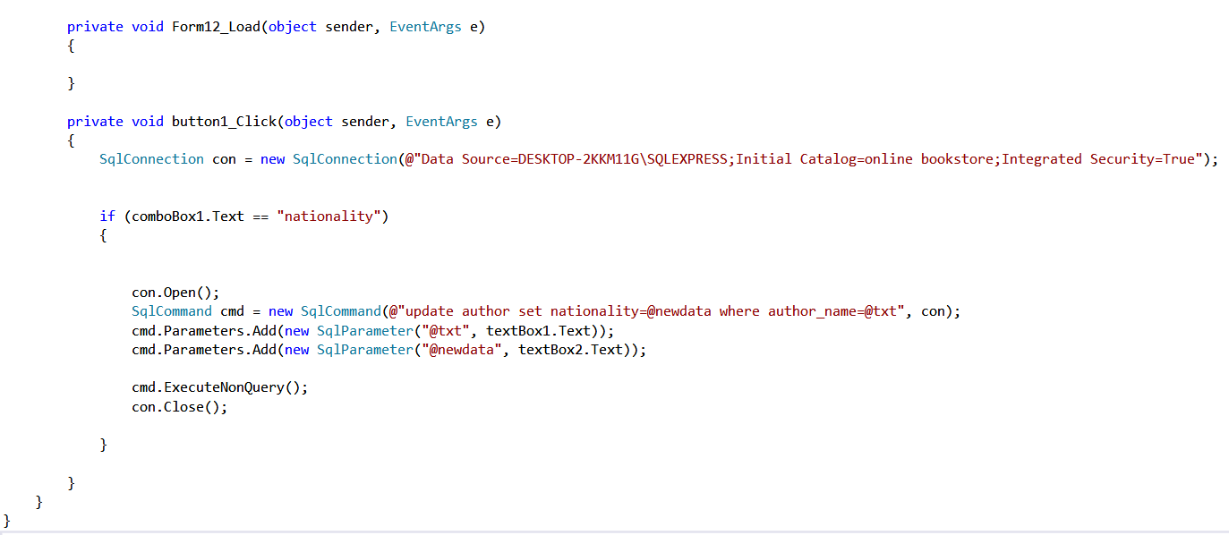

Form 12 delete for user

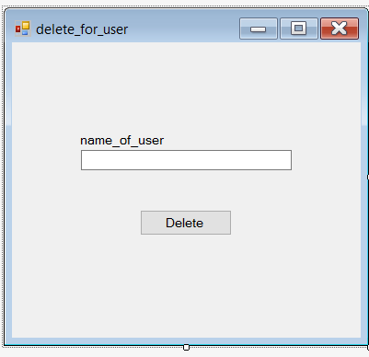

Delete button

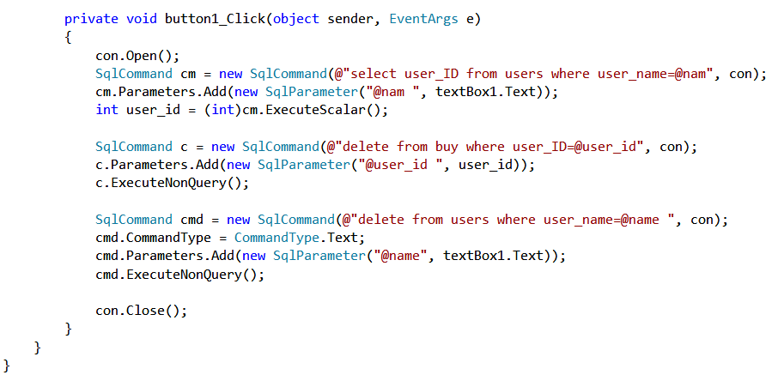

Form 13 delete for book

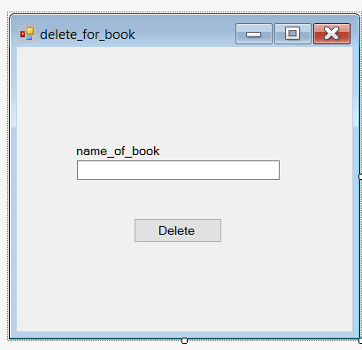

Delete button

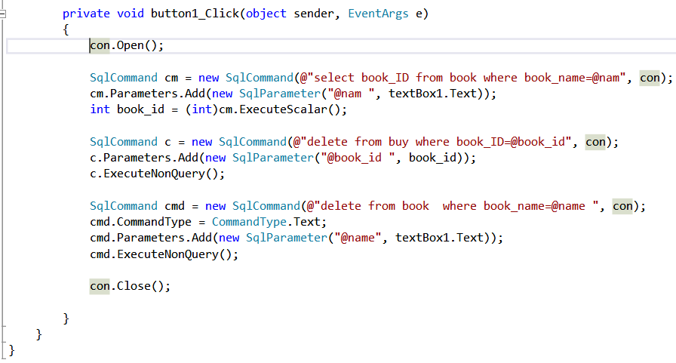

Form 14 delete for publisher

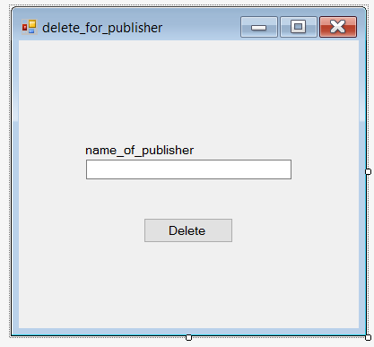

Delete button

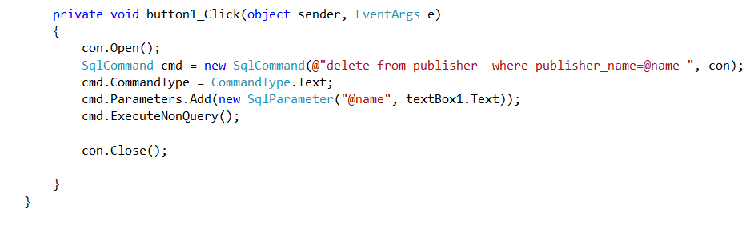

Form 15 delete for author

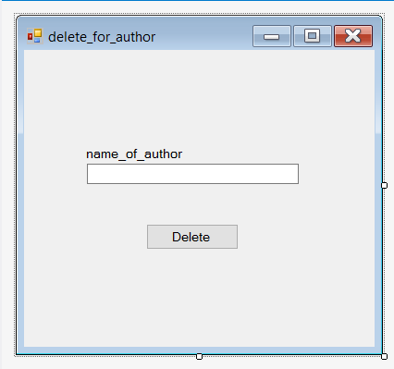

Delete button

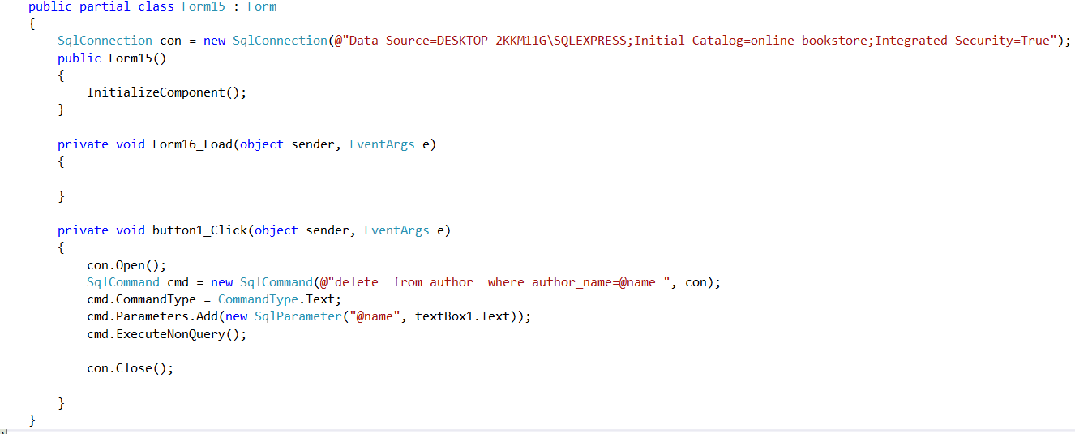

Form 16 edit for user

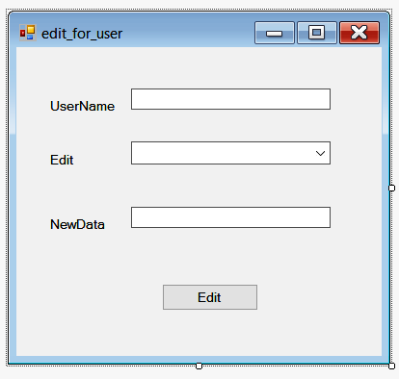

Edit button

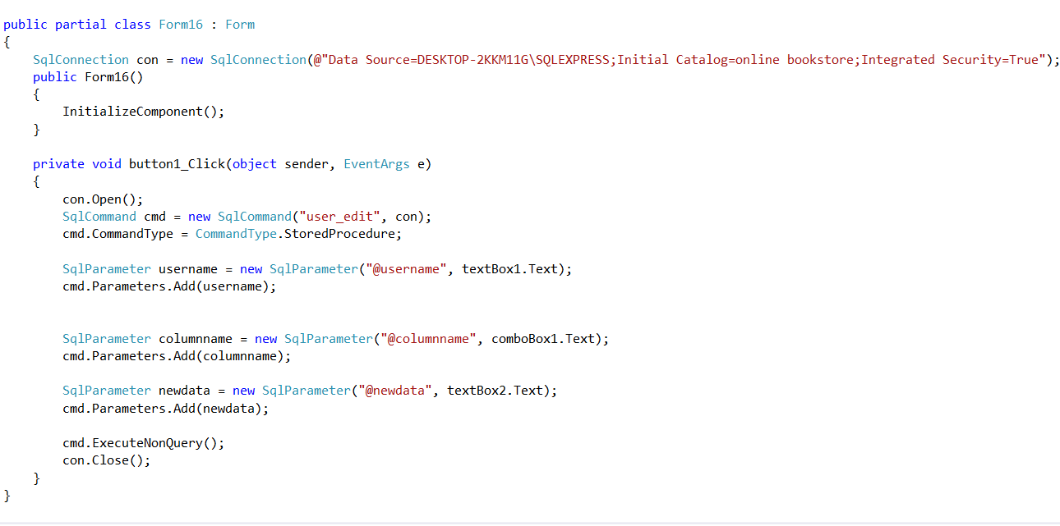

References

Lectures

Lectures Notes

IS laps

Instructor instructions