**Student Housing**

**Project Plan**

*Date: 20/04/2022*

*Erfan Alizada – 4592964*

*Aya Shikh Suliman – 4668839*

*Ryan Bakeroot – 4252519*

**Table of Contents**

**1 Project definition** 3

**1.1** **Project background** 3

**1.2** **Problem definition** 3

**1.3** **Project goal** 3

**1.4** **Expected result** 3

**1.5** **Way of working** 4

**2** **Project structure organization** 5

**2.1** **Project members** 5

**2.2** **Tutors** 5

**3 Risk assessment** 6

**4 Deliverables** 7

**5 Planning** 8

# **1 Project definition**

We were contacted by the Student Housing BV to build a software solution to solve the problems they are facing.

## **Project background**

Student Housing BV owns different buildings where students (our clients) can stay during their study in the Netherlands. Their buildings are composed of rooms, which are rented by clients, but also shared facilities such as toilets, bathroom, kitchen, hallway, storage space, etc.

## **Problem definition**

For some time now the company is receiving complaints from their clients related to:

* Appointed persons not cleaning the shared facilities.
* Groceries are not done or paid for shared items such as toilet paper, dish soap, etc.
* Garbage disposal is not done on time. Unannounced parties, gatherings, etc.

## **Project goal**

We want to offer Student Housing BV a software solution to better arrange day-to-day situations and hopefully this will reduce the number of issues they are facing.

## **Expected result**

Our software solution will contain these features:

**Tenants account:**

* Task schedule: tenants can see when they are assigned to clean a specific area of the house, e.g., kitchen, toilet, hallways, storage space, etc.
* Grocery: tenants can enter the amount of money they paid to buy the needed groceries. Then the app will automatically divide the amount on the current tenants. Each tenant will get a notification that tells them that they must pay for one of the tenants.
* House rules: tenants can only display the house rules.
* Announcements: when tenants have parties, gatherings, etc. they can place an announcement so that everyone knows and take that into consideration.
* Complaints: if there is something wrong that the software cannot solve, and there is need for Admin’s help, then we have a complaint box in which you can add your complaint. This complaint is going to be sent to the admin and based on the situation the admin can reply on the complaint.

**Admin account:**

* Tenant accounts management: create/delete/view tenant accounts
* House rules: add/remove house rules that are visible to tenants
* Task schedule: admins are only able to view the task schedule
* Complaints: admins can view the list of complaints made by the tenants and are able to reply to them or delete them when resolved.
* Announcements: admins can view as well as make new announcements for the tenants to see.

## **Way of working**

We are going to try to work physically as much as possible, but when it is not possible, we can use Teams to meet. And when it comes to coding, we are going to work together on the bigger features, but we are going to split the small features between us.

# **Project structure organization**

## **Project members**

Erfan Alizada: developer

Aya Shikh Suliman: leader - developer - designer

Ryan Bakeroot: developer

## **Tutors**

[Jesús Ravelo Sánchez](https://git.fhict.nl/I875196)

[Marco Meulenbroeks](https://git.fhict.nl/I882775)

[Timo Hermans](https://git.fhict.nl/I873300)

[Mariëlle Fransen](https://git.fhict.nl/I872270)

[Hanane Ezzikouri](https://git.fhict.nl/I887178)

# **3 Risk assessment**

|  |  |  |  |
| --- | --- | --- | --- |
| **Risk** | **Probability** | **Impact on project** | **Mitigation** |
| getting sick (short time) | low | Little to no impact if mentioned in time | let the other members immediately know so that they can put that into consideration |
| getting sick (long time) | high | Moderate impact due to lack of face-to-face feedback | let the tutors know because this might affect the work during the project. |
| facing programming problems. | medium | Moderate to high impact if not communicated with other members | First, we ask our colleges for help. If they cannot solve it, we can ask the teachers for a way that can help us solve the problem. When our knowledge is limited, we can look it up online or try to implement the whole feature but simplify it. |
| miscommunication | high | Little too high if clarification is not made | meet up together to share our perspectives and ideas. And we must try to be open and patient. When we cannot communicate with each other anymore, we can discuss it with one of our tutors. |

# **4 Deliverables**

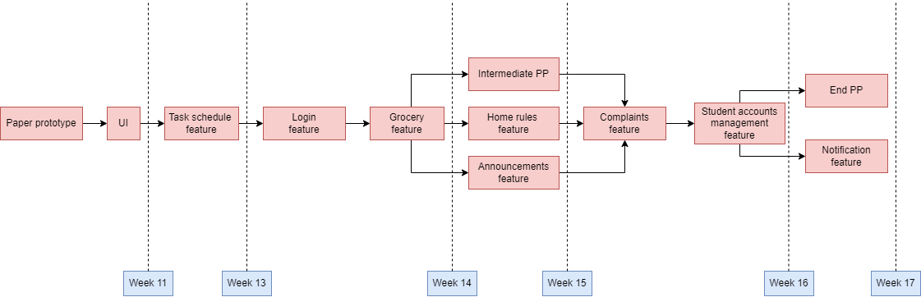

# **5 Planning**

