|  |
| --- |
| REPORT |
| Student Housing |

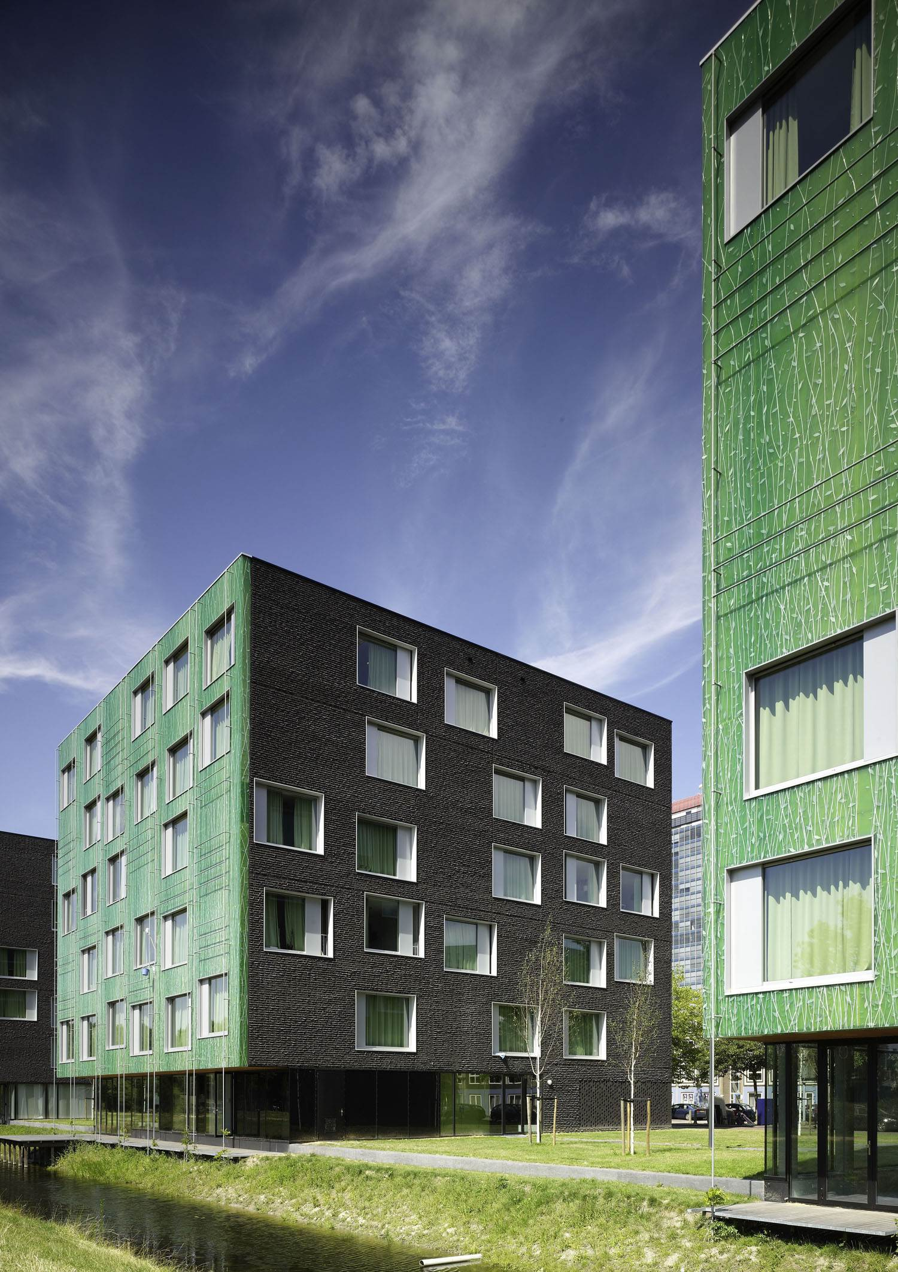

Erfan Alizada - 4592964

Ryan Bakeroot - 4252519

Aya Shikh Suliman - 4668839

Table of Contents:

Introduction: 3

Current situation: 4

Problem statement: 5

Process and results: 6

Conclusions and recommendations: 8

Reflection: 9

# Introduction:

In this document, we are going to look back at our journey while developing the Student Housing application and reflect on it. For example, what was the problem? How did we solve it? What can we recommend? Where are we now? What could we have done better? and so on.

# Current situation:

At this moment (June 19), we are done implementing all hard features. We have a nice UI, as others have given us as feedback. We still have some tiny features that we are going to implement today before the deadline, so that we have a fully functional application without any bugs. In addition, we are also going to update our UML since we changed some things in the classes. This way we make sure that we have done everything that was asked from us.

Besides, we think that having a fully functional application is not enough. On Wednesday, June 22 is the final presentation of the project. We are planning to practice the presentation together before presenting for the whole class. This way we complete our project.

# Problem statement:

We were contacted by the Student Housing BV to build a software solution, so that we solve the problems they are facing.

Student Housing BV owns different buildings where students (our clients) can stay during their study in the Netherlands. Their buildings are composed of rooms, which are rented by clients, but also shared facilities such as toilets, bathroom, kitchen, hallway, storage space, etc.

For some time now the company is receiving complaints from their clients related to:

* Appointed persons not cleaning the shared facilities.
* Groceries are not done or paid for shared items such as toilet paper, dish soap, etc.
* Garbage disposal is not done on time.
* Unannounced parties, gatherings, etc.

We want to offer Student Housing BV a software solution to better arrange day-to-day situations and hopefully this will reduce the number of issues they are facing.

# Process and results:

After receiving the problem, we immediately started working on the project plan. This way we make sure that we are going to have everything done before the deadline.

After that, we created a paper prototype to have an idea of the UI. We implemented that in the visual studio and started implementing the features from the hardest to the easiest, following the planner with some changes. Then, we implemented the login feature and then the task schedule feature. Then the groceries. We implemented that, and it was time for the intermediate presentation. We made a presentation and presented it to other groups and got some feedback that helped us to improve the project. We also got many compliments about our project in general.

After the presentation, we started fixing some errors and implemented the announcements, and we stored data in a CSV file. We stopped working on the project for about a week because we received an individual assignment that we had to deliver on Thursday, June 16. But we caught up again on Friday to finalize everything and submit the project on time.

So, as we expected and planned for our software solution contains these features. Some features like house rules and complaints are not fully done yet, but they are easy to implement after implementing other features. And we are trying our best to implement them before the deadline.

Tenants account:

* Task schedule: tenants can see when they are assigned to clean a specific area of the house, e.g., kitchen, toilet, hallways, storage space, etc.
* Grocery: tenants can enter the amount of money they paid to buy the needed groceries. Then the app will automatically divide the amount on the current tenants. Each tenant will get a notification that tells them that they must pay for one of the tenants.
* House rules: tenants can only display the house rules.
* Announcements: when tenants have parties, gatherings, etc. they can place an announcement so that everyone knows and take that into consideration.
* Complaints: if there is something wrong that the software cannot solve, and there is need for Admin’s help, then we have a complaint box in which you can add your complaint. This complaint is going to be sent to the admin and based on the situation the admin can reply on the complaint.

Admin account:

* Tenant accounts management: create/delete/view tenant accounts
* House rules: add/remove house rules that are visible to tenants
* Task schedule: admins are only able to view the task schedule
* Complaints: admins can view the list of complaints made by the tenants and are able to reply to them or delete them when resolved.
* Announcements: admins can view as well as make new announcements for the tenants to see.

# Conclusions and recommendations:

In general, we think that our project was a successful journey. We were able to communicate good, to split the work on time, discuss features, etc. But as always, some things could have been done better. We were able to communicate good, but sometimes it was too late. It was not only between us, as group members, but also between our group and the teachers. So, we recommend ourselves first and other groups to pay attention for timing when you for example, have a doctor appointment, and you cannot attend the meeting . That was the most important lesson that we have learned during our project.

# Reflection:

Each one of us reflected on his/herself and on the other. And we also reflected on our group in general.

This was the result:

|  |  |  |  |  |
| --- | --- | --- | --- | --- |
| Name/team name: Aya Shikh Suliman | | | | |
|  | Group 1 | If you are doing something that is not working for you. **Stop** doing it. | If you are doing something that is working for you. **Keep** doing it. | If there is something, you think might work for you if you did it.  **Start** doing it and see what happens. |
| …. | **Me** (estimate on own performance) | I must stop thinking of extra features | Aya: having trust in my team members | Aya: implementing complaints |
|  | **Team** (feedback on team performance) | Overthinking | Keep working the same way we are working right now in terms of communicating, taking the responsibility of your work etc. | Setting more realistic deadlines for the upcoming submission |
| **You** | (Name of team member receiving personal feedback) | Ryan: stop being moody.  Erfan: getting worried when it is not needed. Stop coming late without a warning. Stop being overdramatic. | Ryan: keep putting the effort you r putting on the project. Keep being friendly.  Erfan: taking the work seriously. Keep giving your opinion of the project | Ryan: start smiling. Give more accurate opinion. Let people help you when needed.  Erfan: thinking more positively. |

|  |  |  |  |  |
| --- | --- | --- | --- | --- |
| Name/team name: Ryan Bakeroot | | | | |
|  | Group 1 | If you are doing something that is not working for you. **Stop** doing it. | If you are doing something that is working for you. **Keep** doing it. | If there is something, you think might work for you if you did it.  **Start** doing it and see what happens. |
| …. | **Me** (estimate on own performance) | I cannot think of anything | Ryan: working with my team and asking for feedback from them | Ryan: Trying to have better communication with my team |
|  | **Team** (feedback on team performance) | Overthinking | Keep working the same way we are working right now in terms of communicating, taking the responsibility of your work etc. | Setting more realistic deadlines for the upcoming submission |
| **You** | (Name of team member receiving personal feedback) | Aya: trying to have everything perfect.  Stop focusing on the additional feedback instead of the main feature  Erfan: getting worried when it is not needed. Stop coming late without a warning. Stop being overdramatic. | Aya: keep giving feedback on each piece of work. Keep discussing everything with us  Erfan: taking the work seriously. Keep giving your opinion of the project | Aya: be more positive about yourself because that also effects the other team members.  Erfan: thinking more positively. |

|  |  |  |  |  |
| --- | --- | --- | --- | --- |
| Name/team name: Erfan Alizada | | | | |
|  | Group 1 | If you are doing something that is not working for you. **Stop** doing it. | If you are doing something that is working for you. **Keep** doing it. | If there is something, you think might work for you if you did it.  **Start** doing it and see what happens. |
| …. | **Me** (estimate on own performance) | I must stop overthinking | Working as aways with the same tempo | Setting real deadlines and be clearer about what I exactly want. |
|  | **Team** (feedback on team performance) | Overthinking | Keep working the same way we are working right now in terms of communicating, taking the responsibility of your work etc. | Setting more realistic deadlines for the upcoming submission |
| **You** | (Name of team member receiving personal feedback) | Aya: trying to have everything perfect.  Stop focusing on the additional feedback instead of the main feature  Ryan: stop being moody. | Aya: keep giving feedback on each piece of work. Keep discussing everything with us  Ryan: keep putting the effort you r putting on the project. Keep being friendly. | Aya: be more positive about yourself because that also effects the other team members.  Ryan: start smiling. Give more accurate opinion. Let people help you when needed. |