

Memory

OS project



**Name :Aya Alaa Mohammed**

**B.N: 33746**

**Name :Aya Kamal Shawqii**

**B.N: N33747**

**Section :1**

**Steps**

1. Enter number of processes[any number ] , processes size ,processes name "taking the process as a list of processes"
2. Press Add Process.
3. 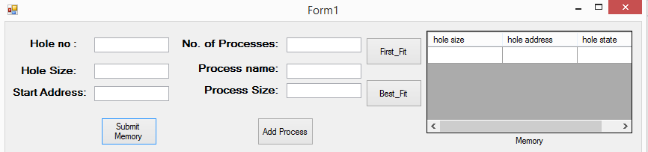Enter number of Holes [any number ] ,holes size ,holes starting address "will appear at the data
4. choose if you want best fit or first fit and this will be for your hole process if you want to change the type click Reset button
5. your output will be at here ..**"waiting process"**means there's not any hole that fits

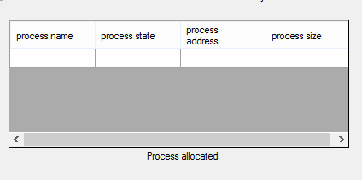

**6.** If you want to deallocate a process ..type it's name and press deallocate

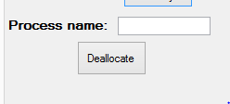

**7.** If you want to allocate a process type it's name and size..

**"It's type will be the same as what you chose first for the processes List "**

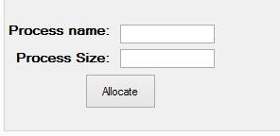

**8.** Reset button will make you start from all over again

**9. example 1**

|  |  |
| --- | --- |
| Process name | Process  size |
| **P1** | **60** |
| **P2** | **5** |
| **P3** | **100** |
| **P4** | **100** |
| **P5** | **300** |
| **P6** | **100** |

|  |  |
| --- | --- |
| **Holes size** | **Holes**  **address** |
| **50** | **10** |
| **100** | **60** |
| **10** | **200** |
| **5** | **210** |
| **200** | **250** |
| **70** | **500** |
| **150** | **570** |
| **30** | **650** |
| **20** | **700** |
| **30** | **750** |

**\*first fit**

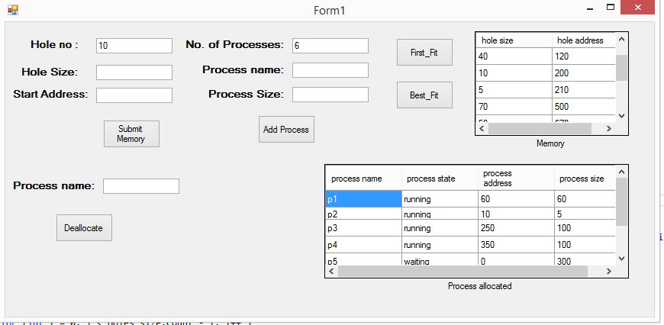

*deallocate p5

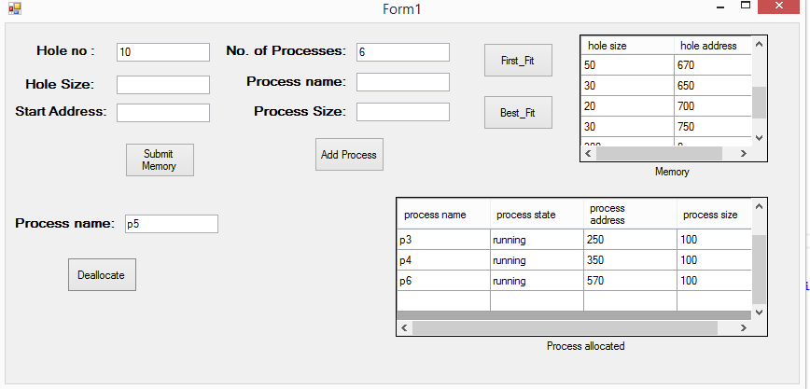

*Best fit and deallocate p4

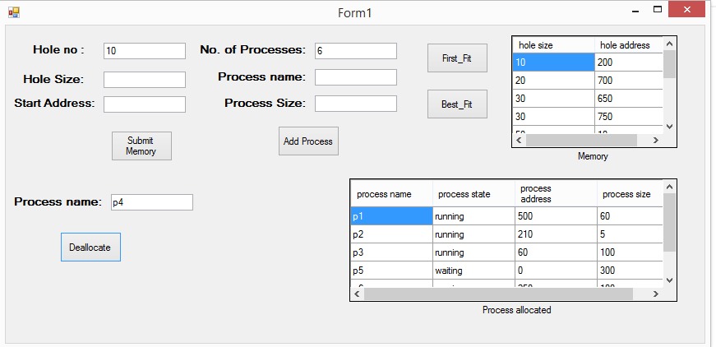

10. Example 2:

|  |  |
| --- | --- |
| Process name | Process  size |
| **P1** | **10** |
| **P2** | **3** |

|  |  |
| --- | --- |
| Holes  size | Holes  address |
| **5** | **0** |
| **10** | **5** |

First fit

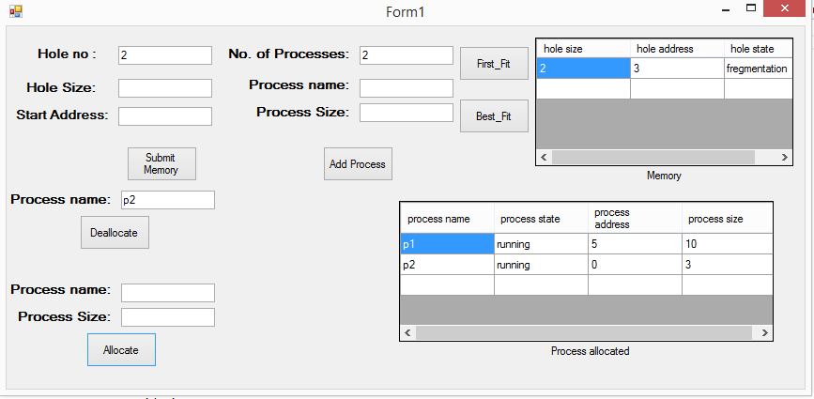

deallocate p2

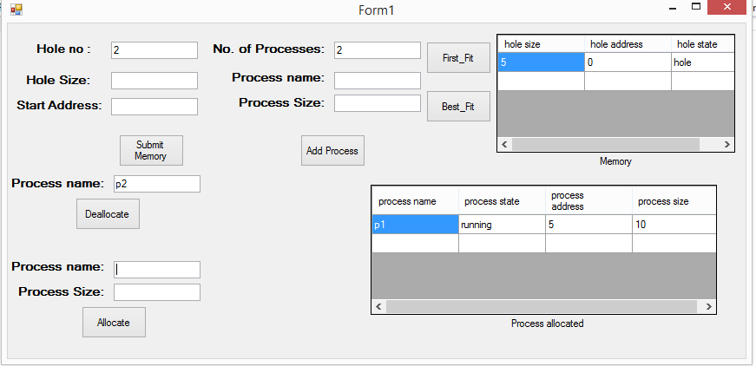

Allocate p3 with size 2

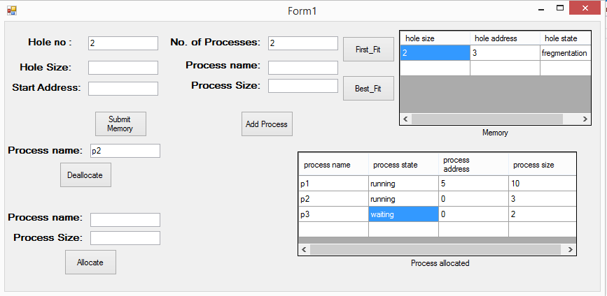

deallocate p2

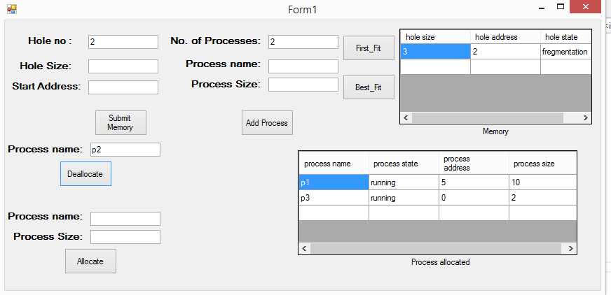

Allocate p2 after deallocate p3 with size 5

