**Variable Distributions:**

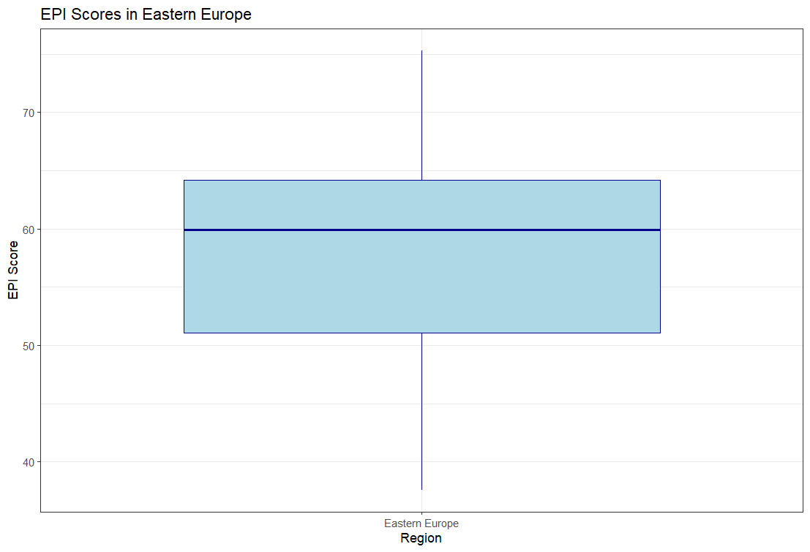

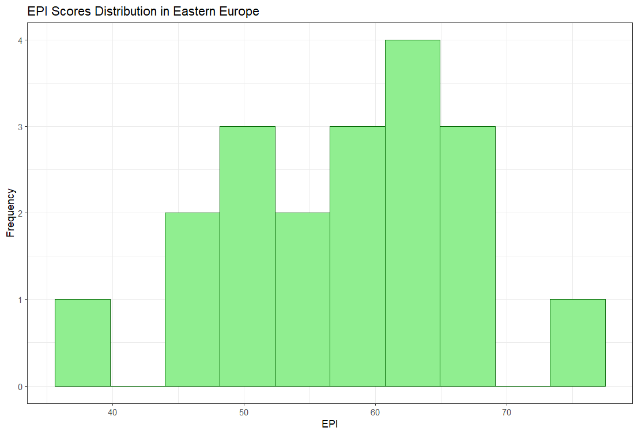

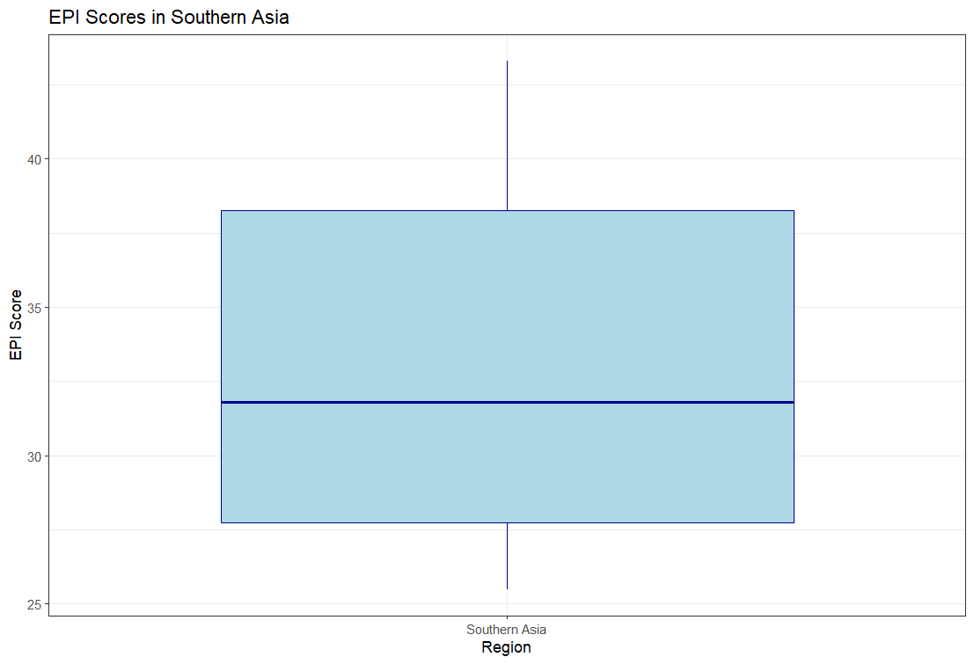

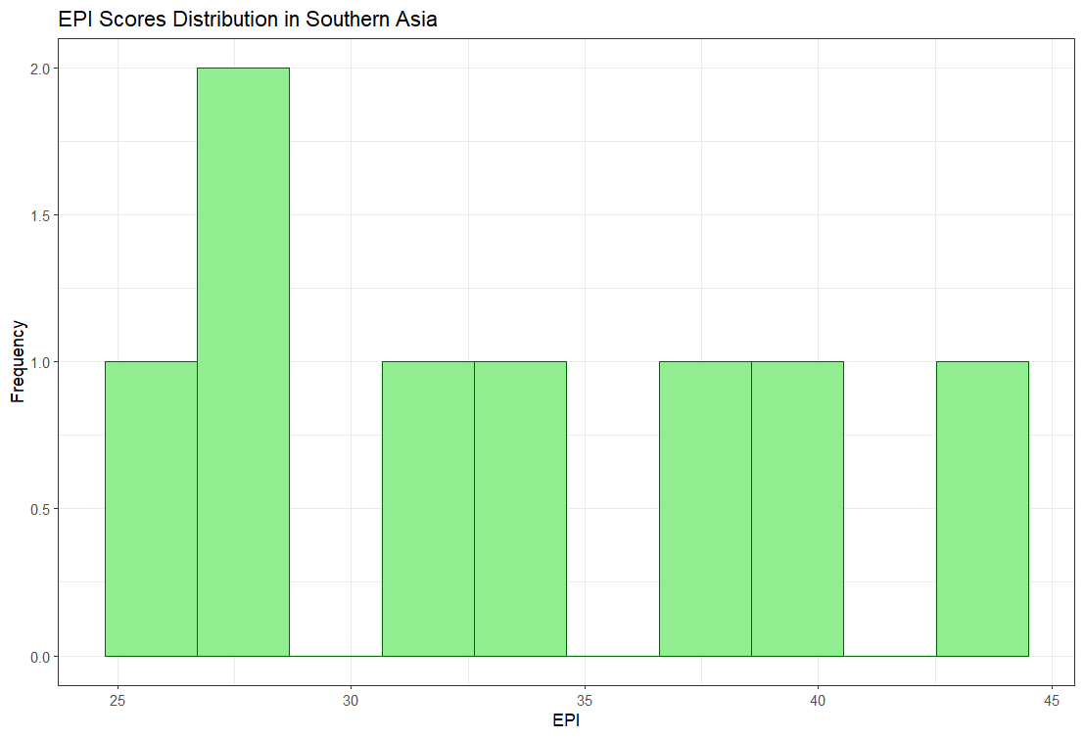

**Linear Models:** EPI.new is used as the variable  
Model 1: No Log

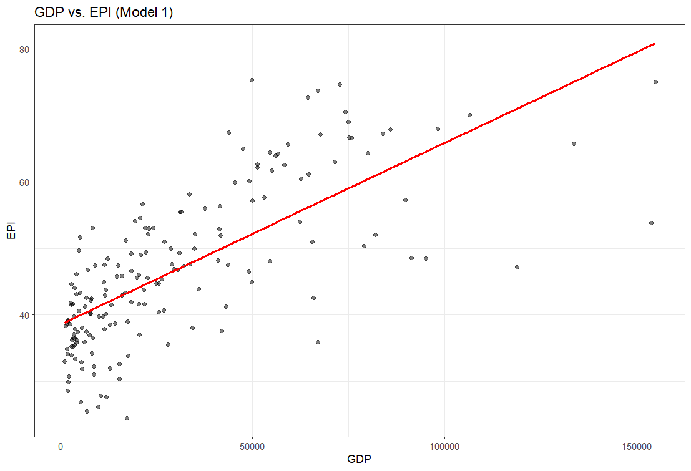

Using GDP because it is a stronger predictor as shown by the summary stats above.

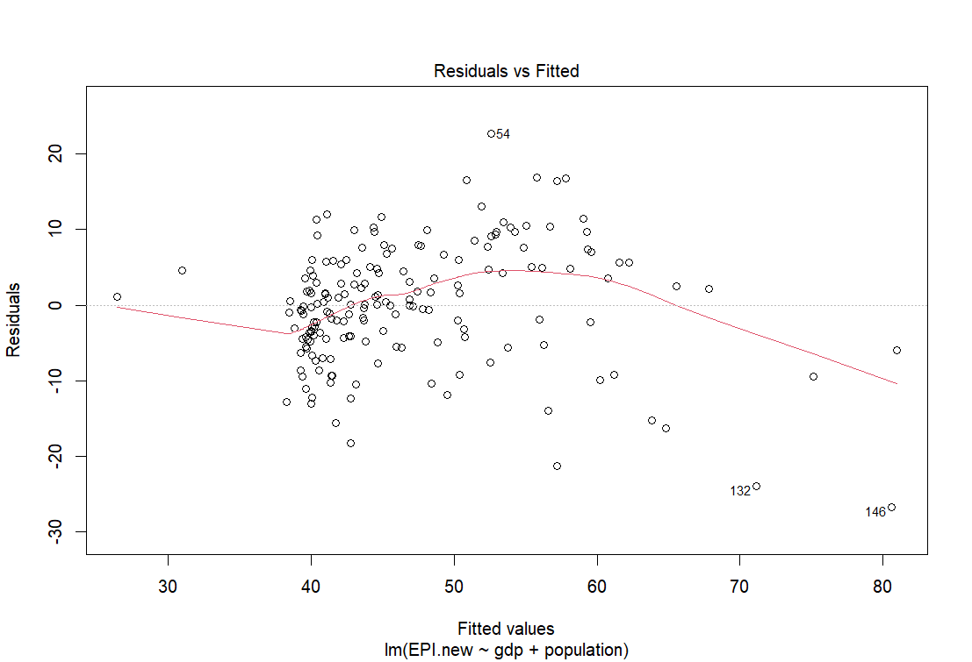

Model 2: With Log

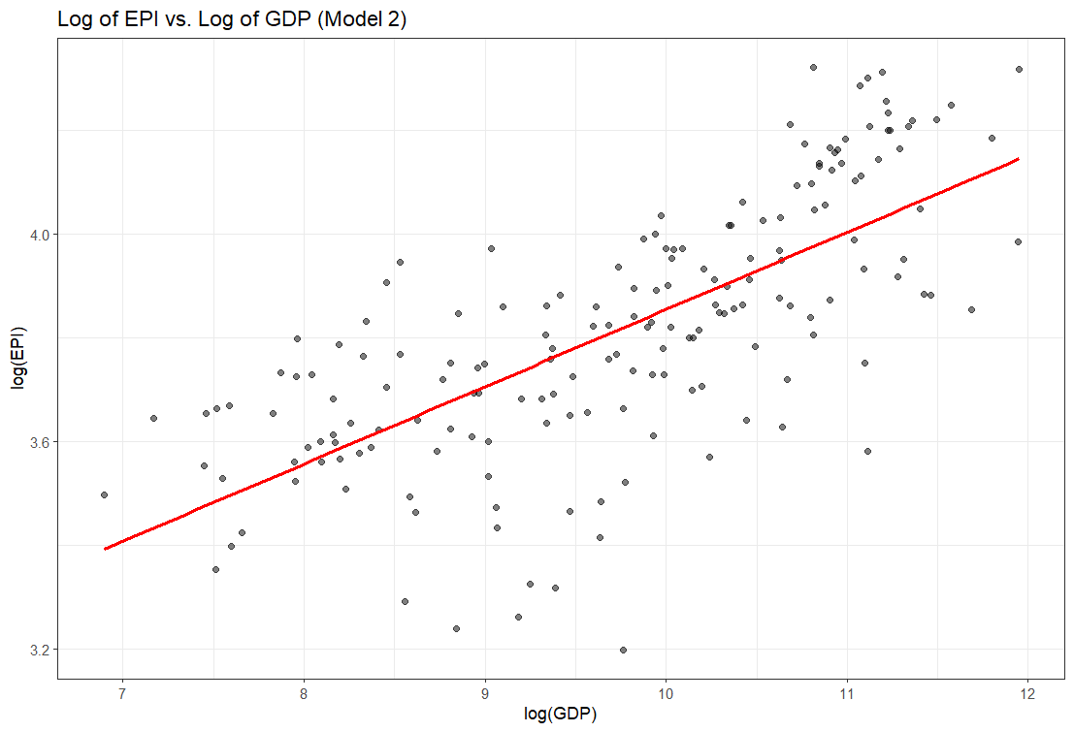

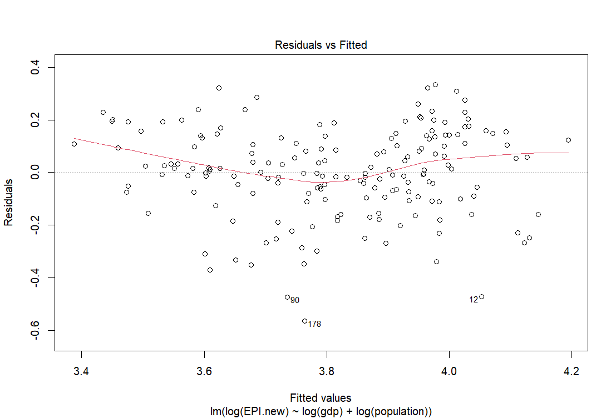

2.2: Southern Asia Region

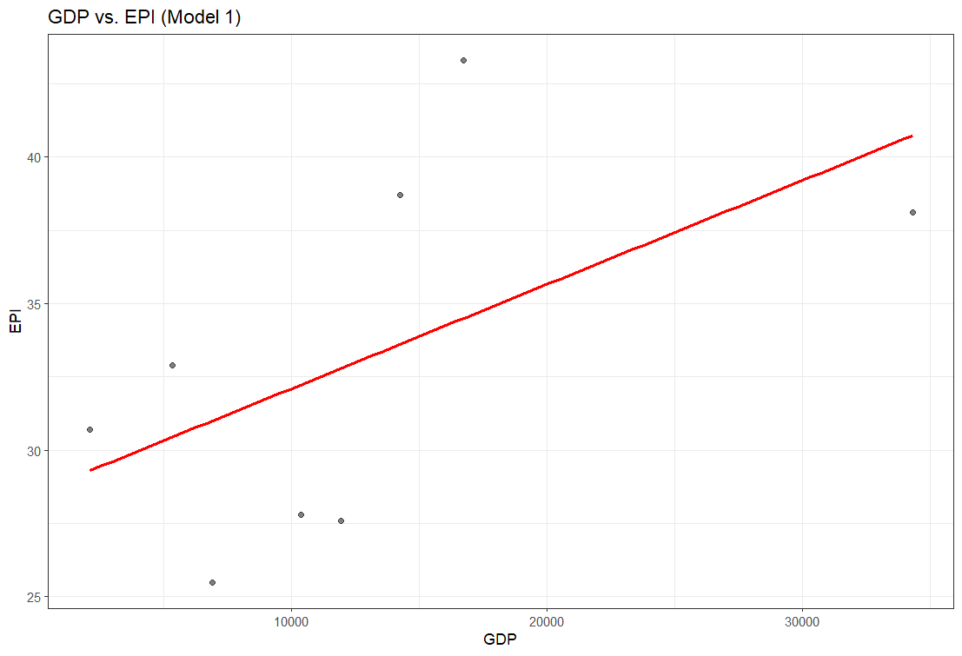

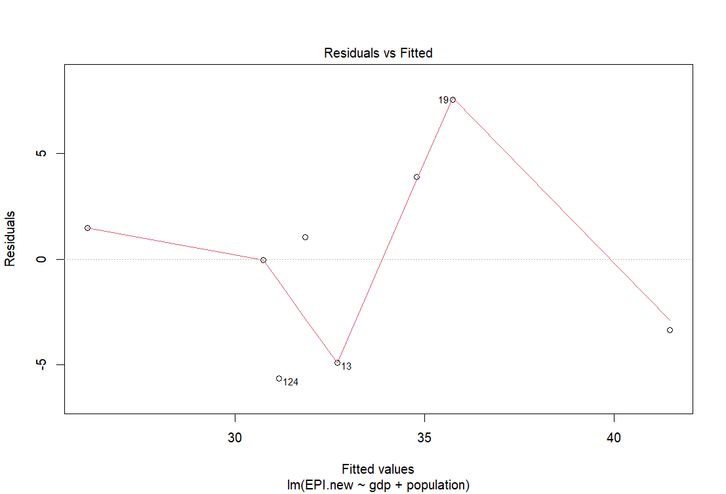

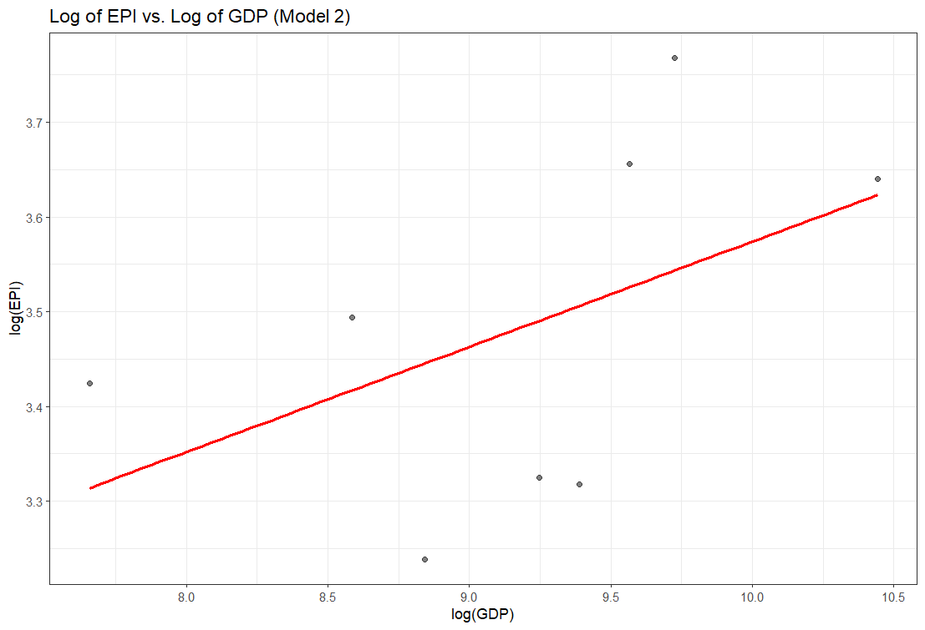

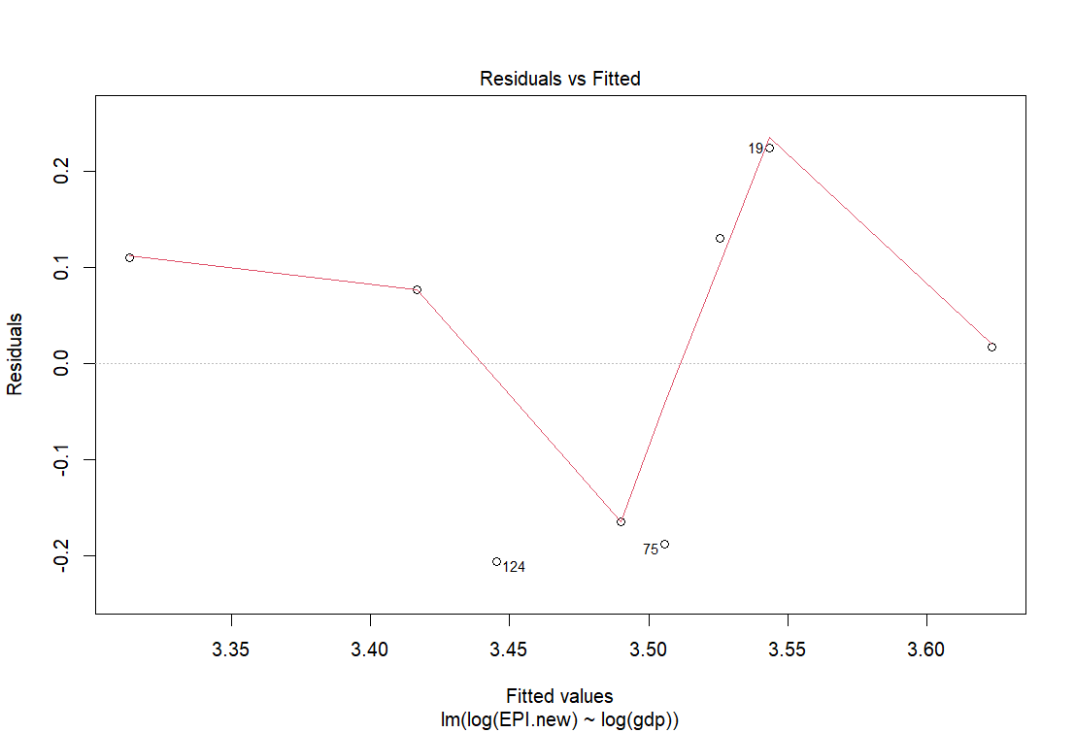

I would say that both models are terrible. Not only is the r^2 value low, the residuals show that the line is all over the place, indicating that a linear model is not a good fit for this data.

Classification (kNN)

Model 1: EPI, ECO, BDH



Model 2: PAR, PHL, APO



Model 1 has a much better accuracy compared to model 2, so I would classify it as being the better one.