Model 1: Price, PropertySqFt

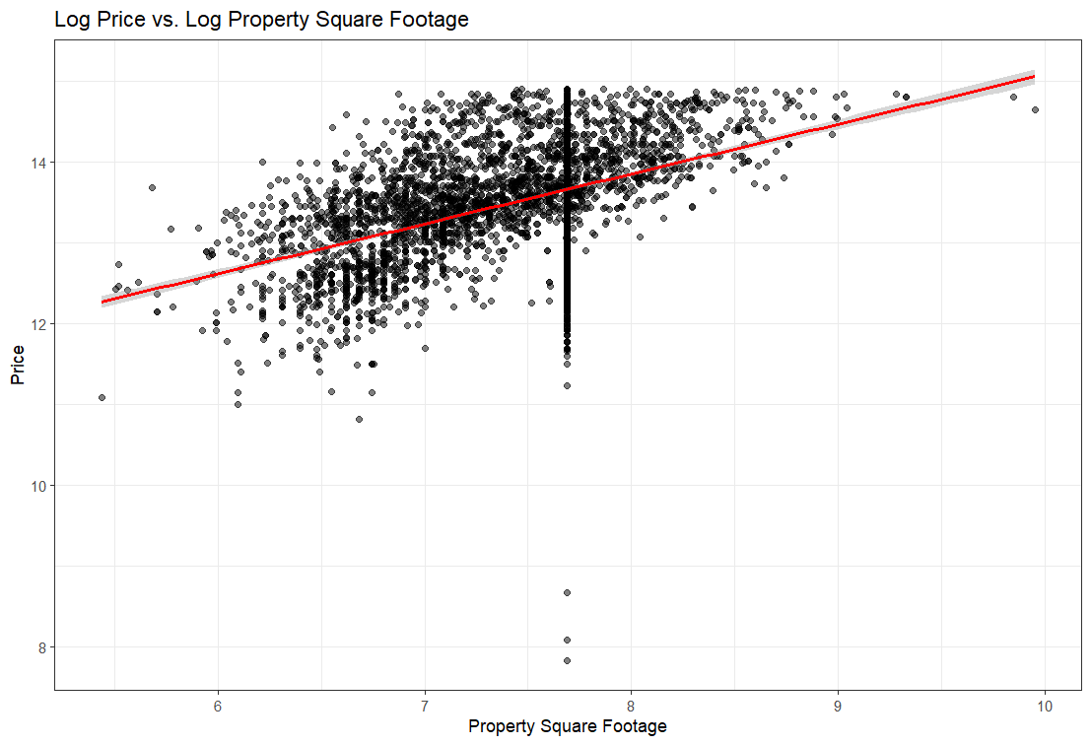

I log transformed Price, PropertySqFt, Beds, and Bath because the data was very heteroscedastic, meaning the points were grouped together and varied.

I think the size of the property is the best predictor for price. Looking at the other two graphs, the prices vary still regardless of number of bedrooms and bathrooms.

Model 2: Price, PropertySqFt + Beds

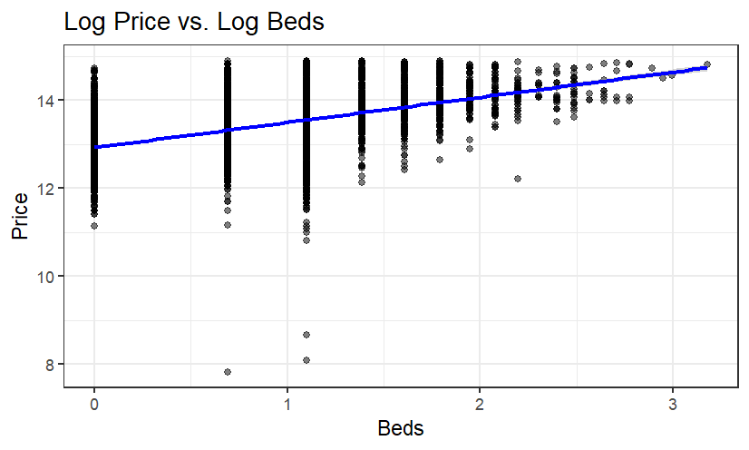

Model 3: Price, PropertySqFt + Beds + bath

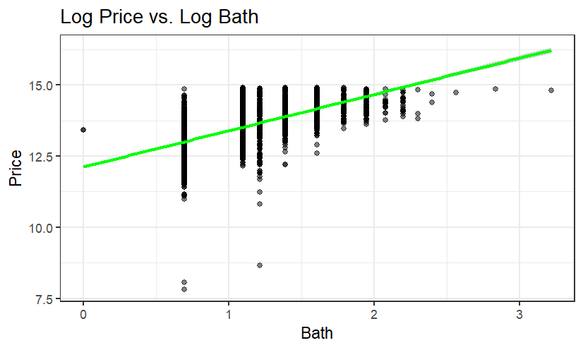

Because Bath was added as a predictor to lm, the p value for bedrooms went down. This means that the model has enough information to predict the price, without the additional need for the number of bedrooms. This makes sense because as the number of bedrooms goes up, so does the number of bathrooms.