1. Exploratory Data Analysis (3%) Explore the statistical aspects of the dataset. Analyze the distributions and provide summaries of the relevant statistics. Perform any cleaning, transformations, interpolations, smoothing, outlier detection/ removal, etc. required on the data. Include figures and descriptions of this exploration and a short description of what you concluded (e.g. nature of distribution, indication of suitable model approaches you would try, etc.) Min.1 page text + graphics (required).
Answer: I saw that most of the data was categorical and the columns were not named, so after giving each columns its names, I created another data frame which switched out the categorical numbers to their factorized counterparts. This made the data easier to analyze.
The bar plot shown in Figure 1 shows a heavily left-skewed distribution, meaning most students received higher grades. The most frequent grades are DD (the highest count), followed by DC and CC. The count of the best grades, AA, is also relatively high, similar to BB. The count of Fail grades is the lowest, which is good for that school.
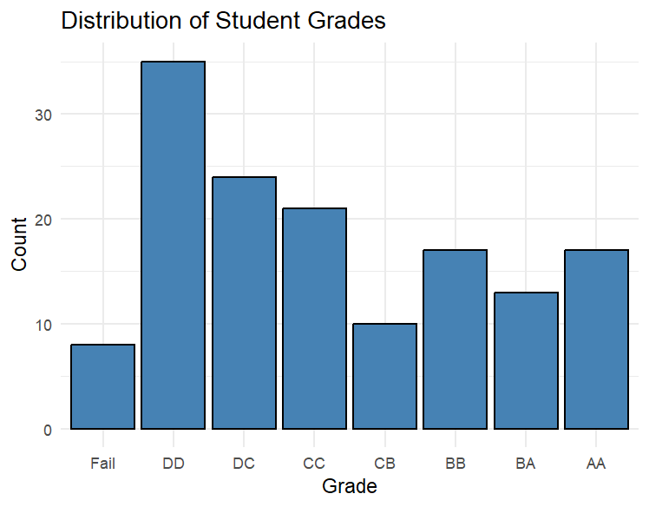
Figure 1.
Figure 2. shows the grades separated by sex. It looks like generally, the dataset contains more males than females, and the males might get higher grades as well.
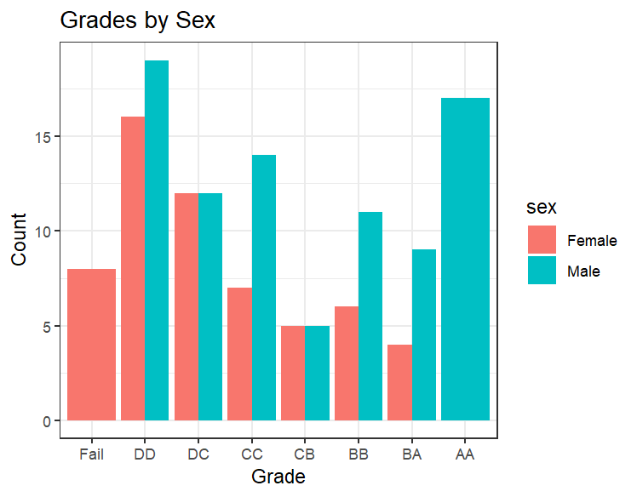
Figure 2.

2. Model Development, Validation and Optimization (10% 4000-level / 7% 6000-level) Develop and evaluate three models. If possible, these models should cover more than one objective, i.e. regression, classification, clustering. Consider the effect of dimension reduction of the dataset on model performance. Different models means different combinations of an algorithm and a formula (input and output features). The choice of independent and response variables is up to you. Explain why you chose them. Construct the models, test/ validate them. Briefly explain the validation approach. You can use any method(s) covered in the course. Include your code in your submission. Compare model results if applicable. Report the results of the model (fits, coefficients, sample trees, other measures of fit/ importance, etc., predictors and summary statistics). Min. 2 pages of text + graphics (required).
Answer: I wanted to see what factors affected gpa the most, so I create dan analysis of variance (ANOVA) model on many of the variables. My results were as follows:
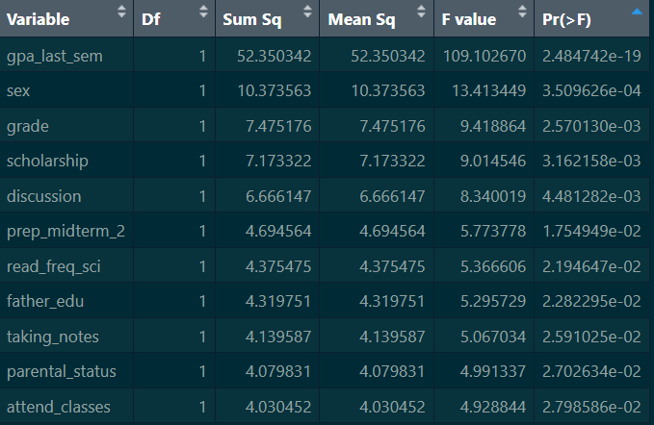
Figure 3.
As shown in figure 3, the variables that affected expected gpa the most were gpa_last_sem, sex, etc. I feel like since there are more males than females in the dataset, the results for sex might be misleading.
For another model, I ran the Kruskal-Wallis to check if expected gpa determine total salary. As shown in figure 4., the p-value was greater tha 0.05, meaning gpa and salary do not have a correlation which is interesting.
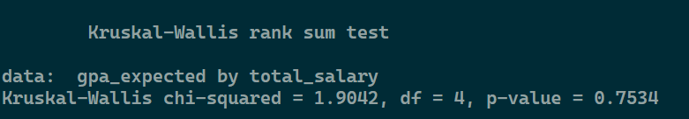
Figure 4.
The reason I did a Kruskal-Wallis and not an ANOVA was, as shown in the box plot below, the data for salary and gpa does not look normal.
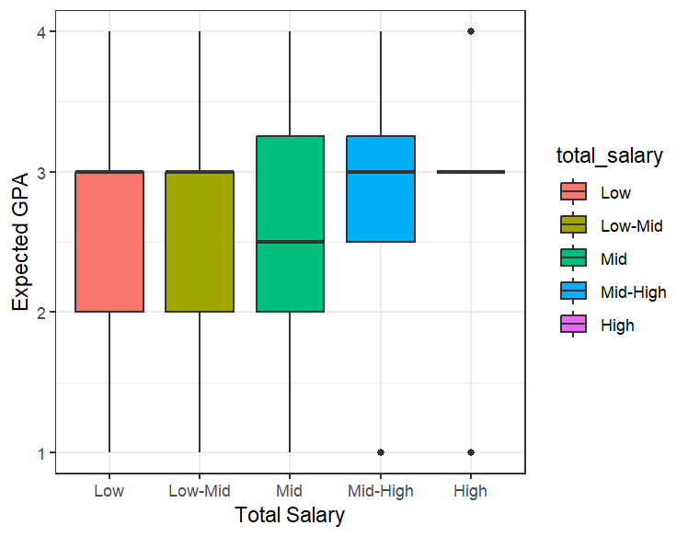
Figure 5.

Finally, I ran a random forest to see how accurately the model could predict a student’s grade based on the factors that were seen as most significant according to the ANOVA. However, the results were not as good as I expected.
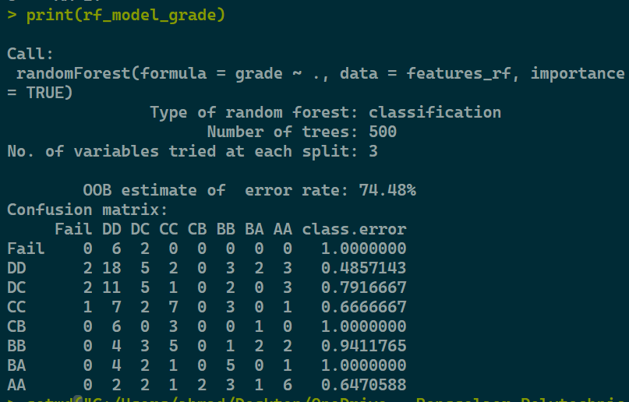
Figure 6.
As shown in the figure above, the model had a high error rate of ~ 75%. I want to attribute this high error rate to simply how much data is in the dataset because there are only 145 rows, there is not much for the model to go on.
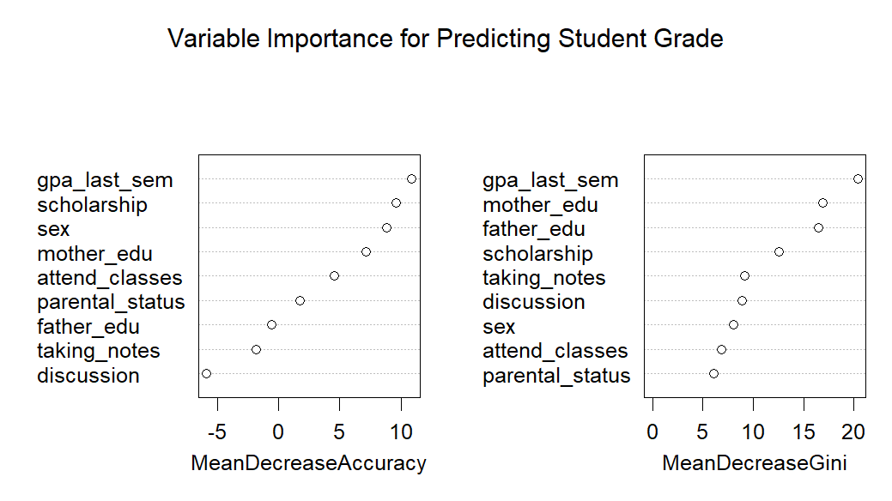
Figure 7.

3. Decisions (2% 4000-level / 5% 6000-level) Describe your conclusions from the model fits, predictions and how well (or not) it could be used for decisions and why. Min. 1/2 page of text + graphics.
Answer: I believe this dataset is not to fit to be used to train supervised or unsupervised machine learning models. However, for statistical models like an ANOVA, the dataset is useful for seeing which features have the most affect on the labels. There simply are not enough data points for ML models to be trained. For instance, according to the count I did below of the grades (Figure 8.), we can see that there only 8 instances of “Fail” grades. This dataset could be used to help in making decisions, however, one must be cautious.
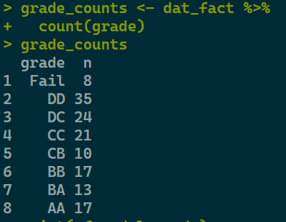
Figure 8.

