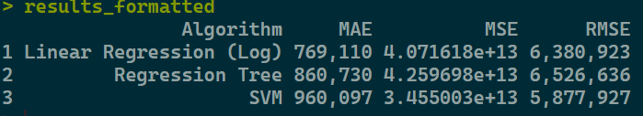
There are so many outliers in the data, so our errors are also huge. I just believe that is because of the price of huge mansions in NYC. It is simply just how the data is.

