- Create Derived Dataset
  - I would explore trends like what neighborhoods contain the most Class 1 tax class (1–3 family residential homes Single-family homes, duplexes, triplexes). Is a neighborhood a more construction neighborhood based on how many Class 4 tax classes are in it?
  - I created a boxplot on the sale price to see how many outliers exist in the data. As shown below, we can see there are many outliers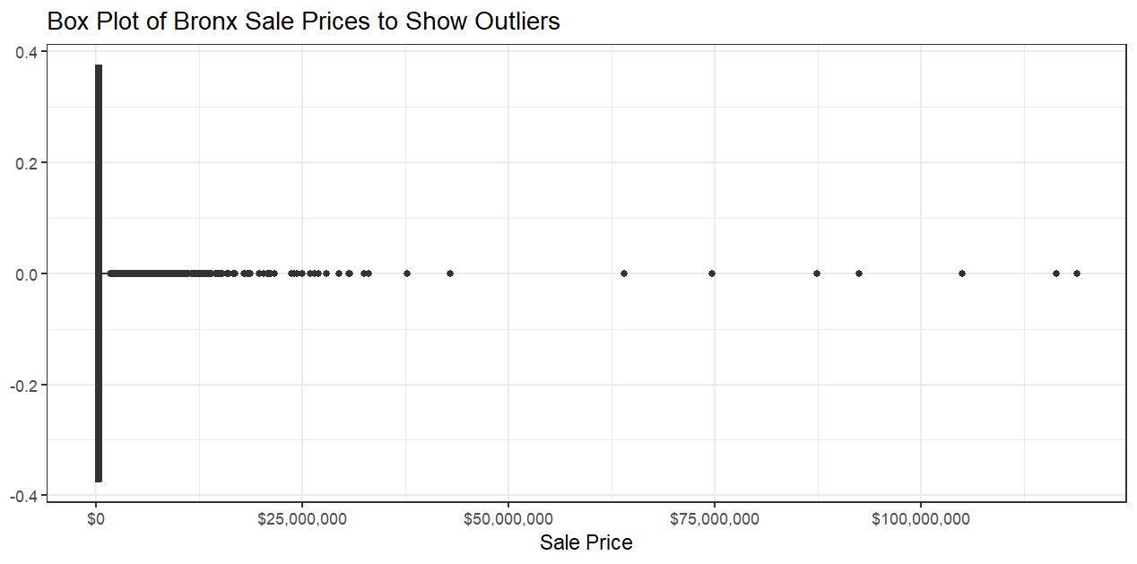I also created another dataset showing the average of each neighborhood’s house price. According to the graph (shown below), apparently Mott Haven has the highest average price, however this feels incorrect because research shows that Mott Haven actually has a ton of crime. 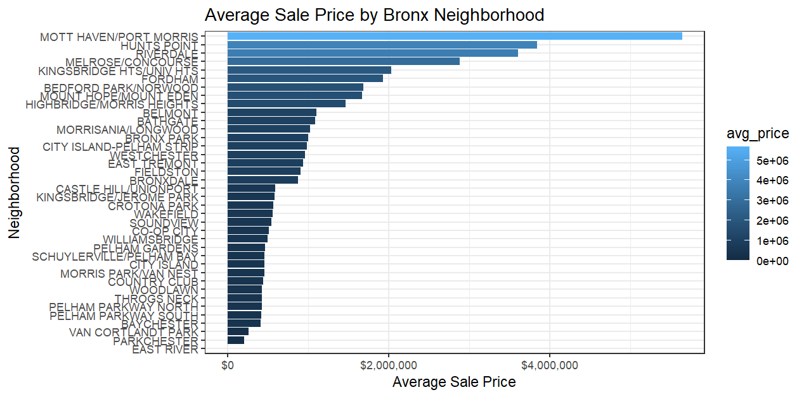
  - I had to clean the sale price data because of the outliers, so in my cleaned up dataset I used the log function on it. I also got rid of any NA values in the square feet columns by converting them to numerics and using na.omit().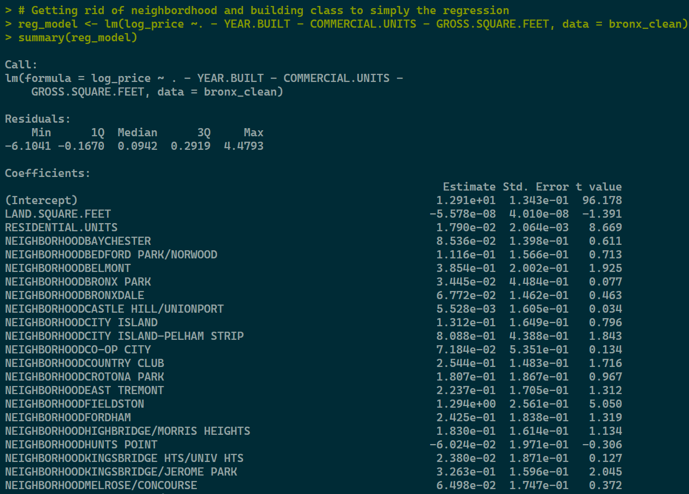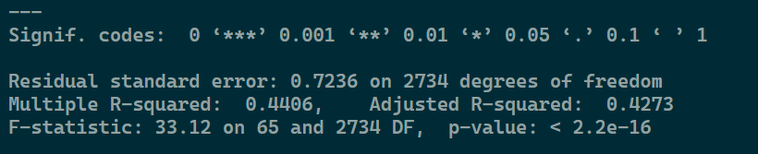The data is significant, however I did remove some labels which had a p value of > 0.05. The Adjusted r^2 came out to be ~0.43.
  - I used the same clean dataset as last time. I just had to make sure the neighborhoods column was a factor. 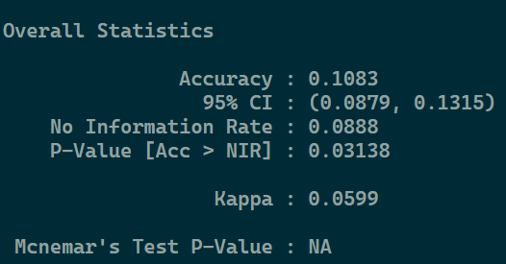 kNN Stats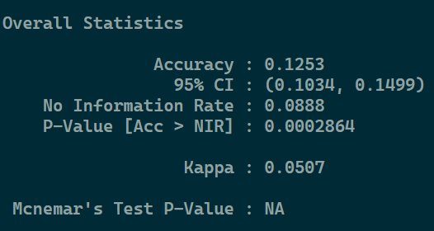Decision Tree Stats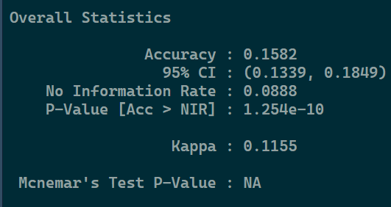Random Forest Stats
- Different Borough
  - The models generalize well. Interestingly after using the best model from 1c for the Brooklyn dataset, the r^2 value went up compared to the bast model. 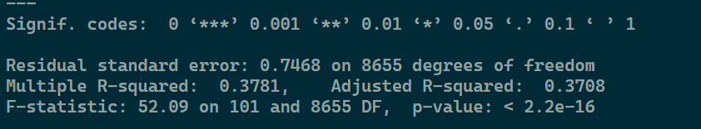 Base Model 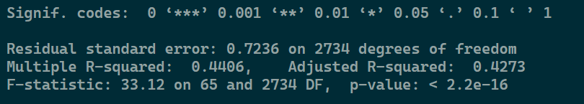 Best Model From 1c
  - The models seem to be about the same in accuracy. I believe its because the data distribution is relatively the same across the datasets. Below are the kNN, and Decision Tree, and Random Forests results respectively.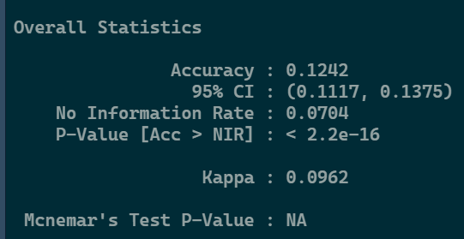 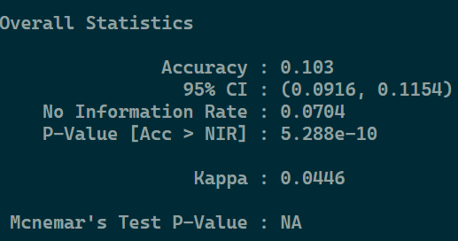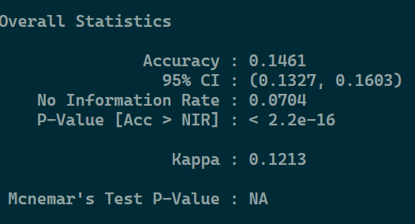
  - I am not sure if I messed something up but the accuracy seems pretty low, so I might seem that price and area don’t seem to be good predictors for neighborhoods. Perhaps, I can do more to clean the data.

