DATABASE_SCHEMA

1. CREATE DATABASE CareerHub;
2. Use CareerHub;
3. CREATE TABLE Companies (

CompanyID INT PRIMARY KEY,

CompanyName VARCHAR(255) NOT NULL,

Location VARCHAR(255) NOT NULL

);

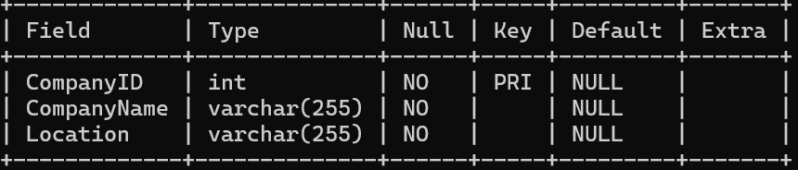

CREATE TABLE Jobs (

JobID INT PRIMARY KEY,

CompanyID INT NOT NULL,

JobTitle VARCHAR(255) NOT NULL,

JobDescription TEXT NOT NULL,

JobLocation VARCHAR(255) NOT NULL,

Salary DECIMAL(10, 2) NOT NULL,

JobType VARCHAR(50) NOT NULL,

PostedDate DATETIME NOT NULL,

FOREIGN KEY (CompanyID) REFERENCES Companies(CompanyID),

ON DELETE CASCADE,

ON UPDATE CASCADE

);

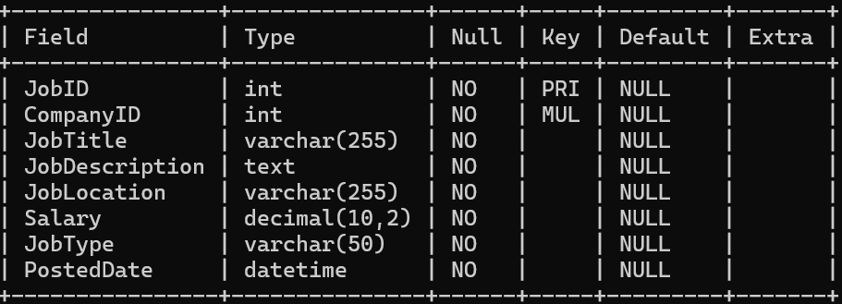

CREATE TABLE Applicants (

ApplicantID INT PRIMARY KEY,

FirstName VARCHAR(100) NOT NULL,

LastName VARCHAR(100) NOT NULL,

Email VARCHAR(255) UNIQUE NOT NULL,

Phone VARCHAR(20) NOT NULL,

Resume TEXT,

Experience INT,

City Varchar(255) ,

State Varchar(255)

);

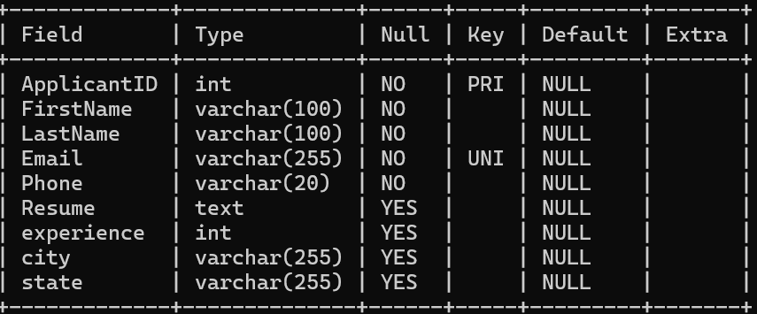

CREATE TABLE Applications (

ApplicationID INT PRIMARY KEY,

JobID INT NOT NULL,

ApplicantID INT NOT NULL,

ApplicationDate DATETIME NOT NULL,

CoverLetter TEXT,

FOREIGN KEY (JobID) REFERENCES Jobs(JobID),

FOREIGN KEY (ApplicantID) REFERENCES Applicants(ApplicantID),

ON DELETE CASCADE,

ON UPDATE CASCADE

);

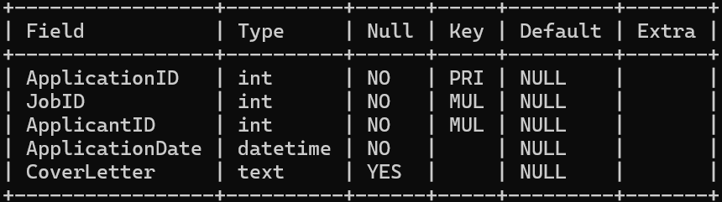

RECORD_INSERTION

INSERT INTO Companies (CompanyID, CompanyName, Location)

VALUES

(1, 'Tata Consultancy Services', 'Mumbai'),

(2, 'Infosys Limited', 'Bengaluru'),

(3, 'Wipro Technologies', 'Hyderabad'),

(4, 'HCL Technologies', 'Noida'),

(5, 'Tech Mahindra', 'Pune');

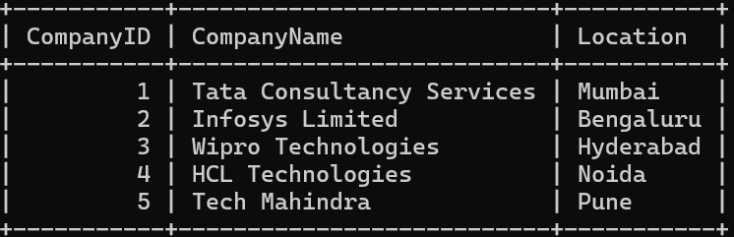

INSERT INTO Jobs (JobID, CompanyID, JobTitle, JobDescription, JobLocation, Salary, JobType, PostedDate)

VALUES

(1, 1, 'Software Engineer', 'Develop software applications', 'Mumbai', 600000.00, 'Full-time', '2024-01-01'),

(2, 2, 'Data Scientist', 'Analyze data and build models', 'Bengaluru', 800000.00, 'Full-time', '2024-01-15'),

(3, 3, 'IT Project Manager', 'Manage IT projects', 'Hyderabad', 1000000.00, 'Full-time', '2024-02-01'),

(4, 4, 'Quality Assurance Engineer', 'Test software applications', 'Noida', 500000.00, 'Full-time', '2024-03-01'),

(5, 5, 'Business Analyst', 'Analyze business requirements', 'Pune', 700000.00, 'Full-time', '2024-04-01');

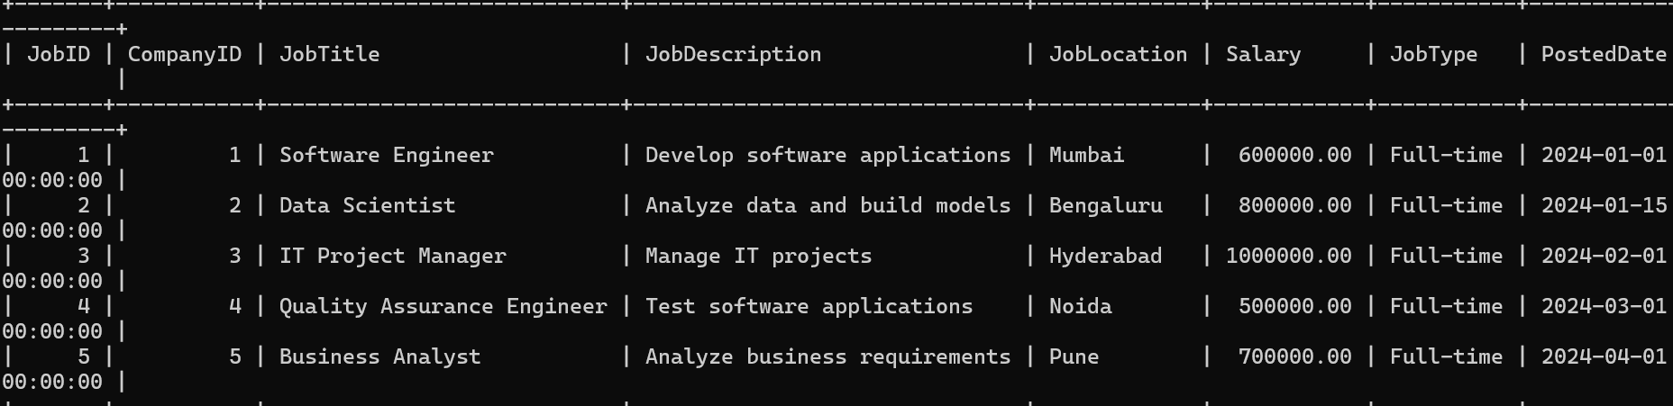

INSERT INTO Applicants (ApplicantID, FirstName, LastName, Email, Phone, Resume)

VALUES

(1, 'Rohit', 'Sharma', 'rohit.sharma@gmail.com', '9876543210', 'rohit_sharma_resume.pdf',4.’Raipur’,’Chattisgarh’),

(2, 'Priya', 'Jain', 'priya.jain@yahoo.com', '5432109876', 'priya_jain_resume.docx',3,’Gwalior’,’MP’),

(3, 'Karan', 'Singh', 'karan.singh@hotmail.com', '7654321098', 'karan_singh_resume.pdf',5,’Raipur’,’Chattisgarh’),

(4, 'Neha', 'Gupta', 'neha.gupta@gmail.com', '6543210987', 'neha_gupta_resume.docx',3,’Gwalior’,’MP’),

(5, 'Siddharth', 'Mishra', 'siddharth.mishra@yahoo.com', '3210987654', 'siddharth_mishra_resume.pdf',4,’Morena’,’MP’);

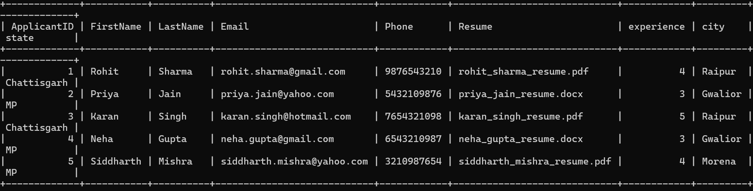

INSERT INTO Applications (ApplicationID, JobID, ApplicantID, ApplicationDate, CoverLetter)

VALUES

(1, 1, 1, '2024-01-05', 'rohit_sharma_cover_letter.pdf'),

(2, 2, 2, '2024-01-20', 'priya_jain_cover_letter.docx'),

(3, 3, 3, '2024-02-05', 'karan_singh_cover_letter.pdf'),

(4, 4, 4, '2024-03-05', 'neha_gupta_cover_letter.docx'),

(5, 5, 5, '2024-04-05', 'siddharth_mishra_cover_letter.pdf');

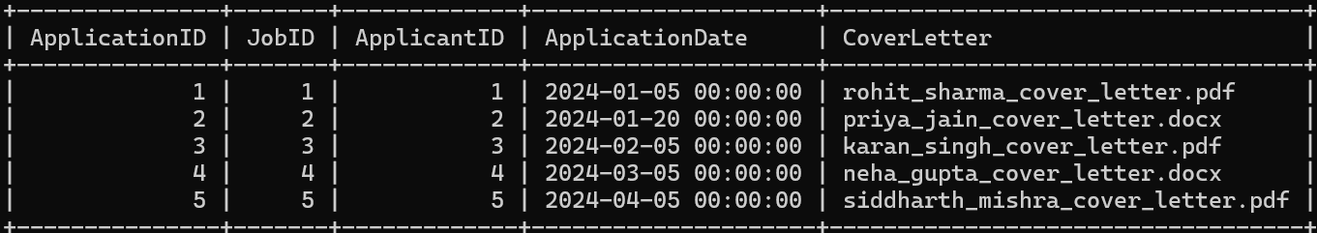

QUERIES

5. SELECT j.JobTitle, COUNT(a.ApplicationID) AS ApplicationCount

FROM Jobs j

LEFT JOIN Applications a ON j.JobID = a.JobID

GROUP BY j.JobTitle;

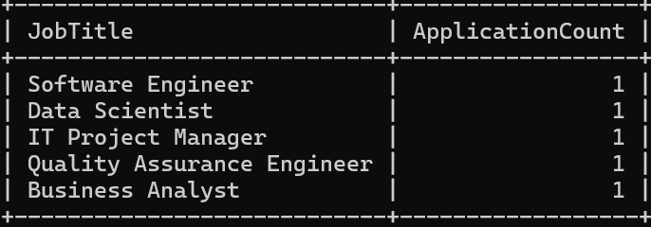

6. SELECT j.JobTitle, c.CompanyName, j.JobLocation, j.Salary

FROM Jobs j

JOIN Companies c ON j.CompanyID = c.CompanyID

WHERE j.Salary BETWEEN 500000 AND 800000;

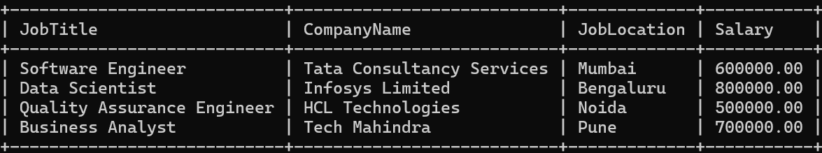

7. SELECT j.JobTitle, c.CompanyName, a.ApplicationDate

FROM Applications a

JOIN Jobs j ON a.JobID = j.JobID

JOIN Companies c ON j.CompanyID = c.CompanyID

WHERE a.ApplicantID = 1;

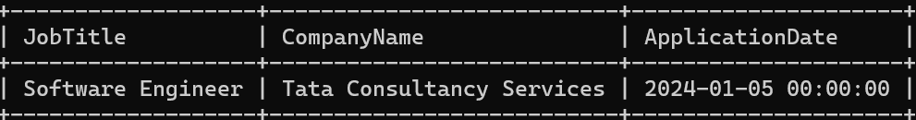

8. SELECT c.companyname, AVG(j.salary)

FROM companies c join jobs j on c.companyid=j.companyid

WHERE j.salary>0 GROUP BY c.companyname;

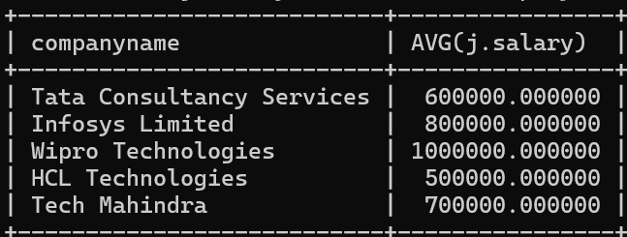

9. SELECT c.CompanyName, COUNT(j.JobID) AS JobCount

FROM Jobs j

JOIN Companies c ON j.CompanyID = c.CompanyID

GROUP BY c.CompanyName

ORDER BY JobCount DESC LIMIT 1;

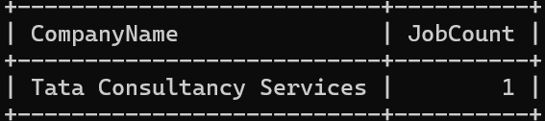

10. SELECT * FROM applicants WHERE applicantid IN

(SELECT applicantid FROM applications WHERE jobid IN

(SELECT jobid FROM jobs WHERE companyid IN

(SELECT companyid FROM companies WHERE location = 'CityX'))) AND experience >=3;



11. SELECT distinct jobtitle FROM jobs WHERE salary between '60000' AND '80000';

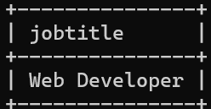

12. SELECT j.jobid , j.jobtitle , j.joblocation, j.salary FROM jobs WHERE jobid NOT IN (SELECT jobid FROM applications);

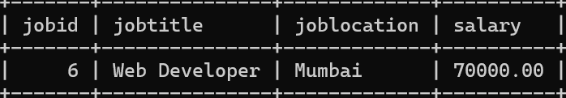

13. SELECT a.FirstName, a.LastName, c.CompanyName, j.JobTitle

FROM Applications ap

JOIN Applicants a ON ap.ApplicantID = a.ApplicantID

JOIN Jobs j ON ap.JobID = j.JobID

JOIN Companies c ON j.CompanyID = c.CompanyID;

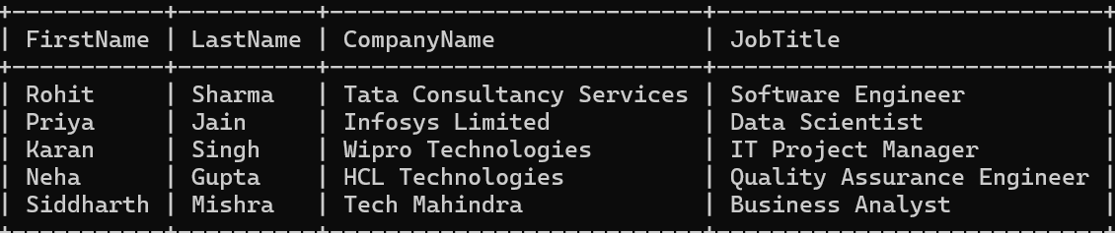

14. SELECT c.CompanyName, COUNT(j.JobID) AS JobCount

FROM Jobs j

JOIN Companies c ON j.CompanyID = c.CompanyID

GROUP BY c.CompanyName;

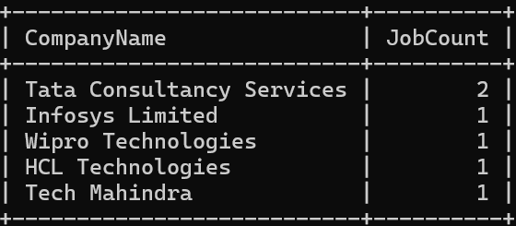

15. SELECT a.FirstName, a.LastName, c.CompanyName, j.JobTitle

FROM Applicants a

LEFT JOIN Applications ap ON a.ApplicantID = ap.ApplicantID

LEFT JOIN Jobs j ON ap.JobID = j.JobID

LEFT JOIN Companies c ON j.CompanyID = c.CompanyID;

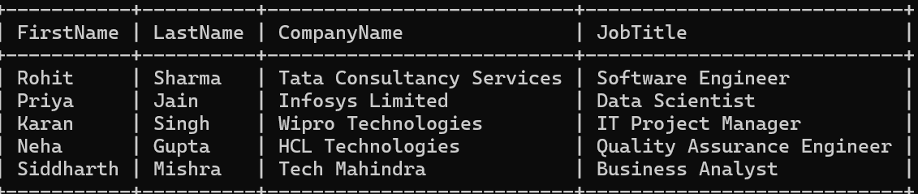

16. SELECT c.companyid,c.companyname,c.location FROM companies c join jobs j ON j.companyid = c.companyid and j.salary > (SELECT AVG(salary) FROM jobs);

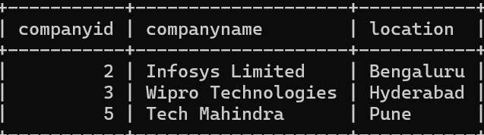

17. SELECT CONCAT(a.FirstName, ' ', a.LastName) AS ApplicantName, CONCAT(a.City, ', ', a.State) AS Location FROM Applicants a;

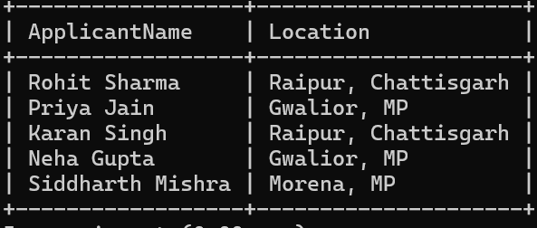

18. SELECT j.JobTitle FROM Jobs j WHERE j.JobTitle LIKE '%Developer%' OR j.JobTitle LIKE '%Engineer%';

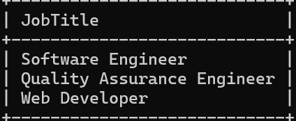

19. SELECT

a.FirstName, a.LastName, c.CompanyName, j.JobTitle

FROM Applicants a

LEFT JOIN Applications ap ON ap.ApplicantID = a.ApplicantID

LEFT JOIN Jobs j ON ap.JobID = j.JobID

LEFT JOIN Companies c ON c.CompanyID = j.CompanyID;;

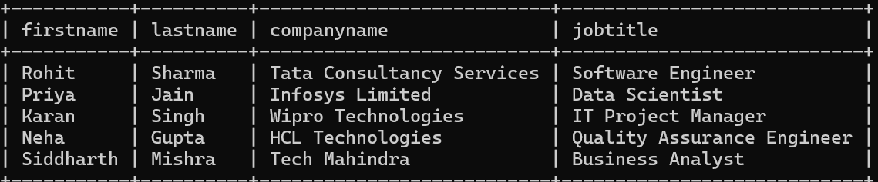

20. SELECT a.FirstName, a.LastName, c.CompanyName

FROM Applicants a

JOIN Applications ap ON a.ApplicantID = ap.ApplicantID

JOIN Jobs j ON ap.JobID = j.JobID

JOIN Companies c ON j.CompanyID = c.CompanyID

WHERE a.Experience >= 2 AND c.Location = 'Mumbai';

