Task : 01

CREATE DATABASE HMbank;

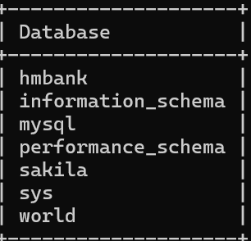

CREATE TABLE Customers (

customer_id INT PRIMARY KEY,

first_name VARCHAR(50) NOT NULL,

last_name VARCHAR(50) NOT NULL,

DOB DATE NOT NULL,

email VARCHAR(100) UNIQUE NOT NULL,

phone_number VARCHAR(20) NOT NULL

);

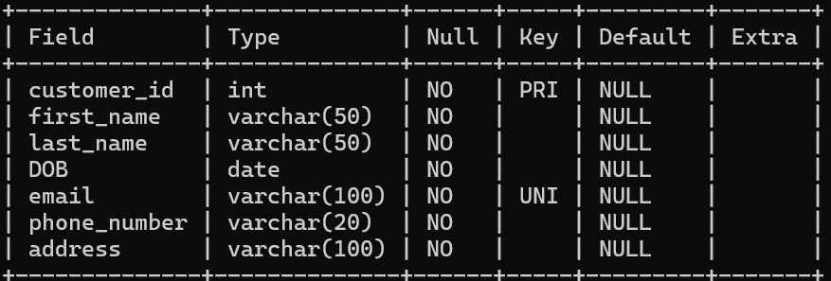

CREATE TABLE Accounts (

account_id INT PRIMARY KEY,

customer_id INT NOT NULL,

account_type ENUM('savings', 'current', 'zero_balance') NOT NULL,

balance DECIMAL(10, 2) NOT NULL DEFAULT 0.00,

CONSTRAINT fk_customer_id FOREIGN KEY (customer_id) REFERENCES Customers(customer_id)

);

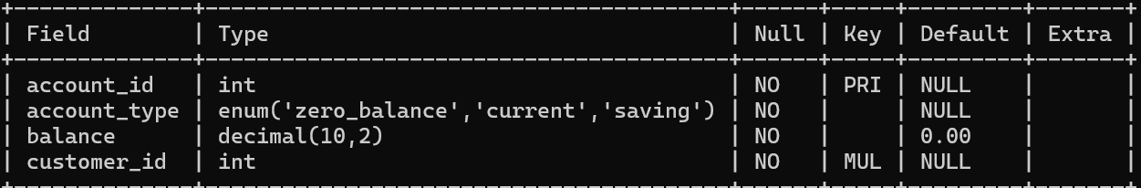

CREATE TABLE Transactions (

transaction_id INT PRIMARY KEY AUTO_INCREMENT,

account_id INT NOT NULL,

transaction_type ENUM('deposit', 'withdrawal', 'transfer') NOT NULL,

amount DECIMAL(10, 2) NOT NULL,

transaction_date TIMESTAMP NOT NULL DEFAULT CURRENT_TIMESTAMP,

CONSTRAINT fk_account_id FOREIGN KEY (account_id)

REFERENCES Accounts(account_id)

ON DELETE CASCADE

ON UPDATE CASCADE

);

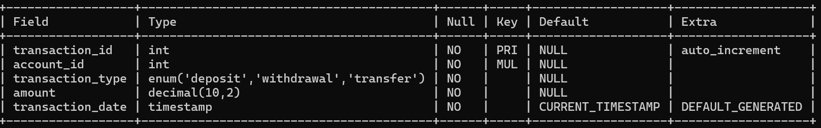

ER Diagram

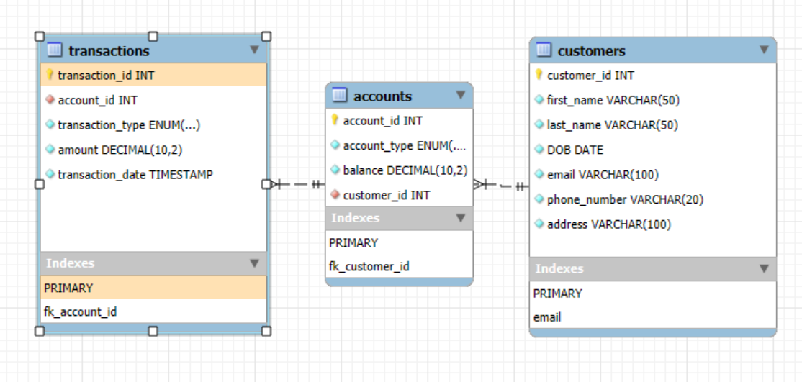

Task : 02

INSERT INTO Transactions (transaction_id, account_id, transaction_type, amount, transaction_date)

VALUES

(1, 1, 'deposit', 1000.00, '2022-01-01 10:00:00'),

(2, 2, 'withdrawal', 500.00, '2022-01-05 12:00:00'),

(3, 3, 'deposit', 2000.00, '2022-01-10 14:00:00'),

(4, 4, 'transfer', 1500.00, '2022-01-15 16:00:00'),

(5, 5, 'deposit', 3000.00, '2022-01-20 10:00:00'),

(6, 6, 'withdrawal', 2000.00, '2022-01-25 12:00:00'),

(7, 7, 'deposit', 2500.00, '2022-01-30 14:00:00'),

(8, 8, 'transfer', 1000.00, '2022-02-01 16:00:00'),

(9, 9, 'deposit', 4000.00, '2022-02-05 10:00:00'),

(10, 10, 'withdrawal', 3000.00, '2022-02-10 12:00:00'),

(11, 11, 'deposit', 5000.00, '2022-02-15 14:00:00');

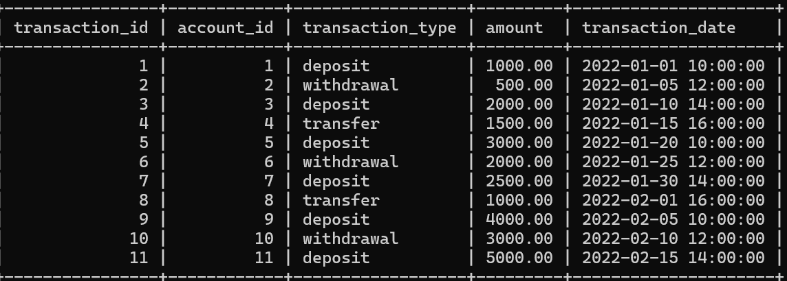

INSERT INTO Accounts (account_id, account_type, balance, customer_id)

VALUES

(1, 'savings', 1000.00, 2),

(2, 'current', 5000.00, 3),

(3, 'zero_balance', 0.00, 4),

(4, 'savings', 2000.00, 5),

(5, 'current', 3000.00, 9012001),

(6, 'savings', 1500.00, 9012002),

(7, 'zero_balance', 0.00, 9012003),

(8, 'current', 4000.00, 9012004),

(9, 'savings', 2500.00, 9012005),

(10, 'current', 6000.00, 9012006),

(11, 'zero_balance', 0.00, 9012001);

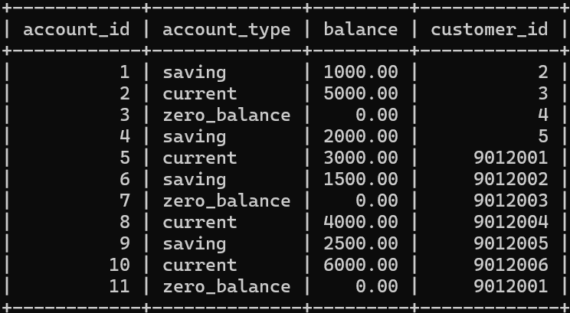

INSERT INTO Customers (customer_id, first_name, last_name, DOB, email, phone_number, address)

VALUES

(‘9012001’ , ‘Sameer’ , ’ Shukla’ ,’2001-01-01’ ,‘sameershukla@gmail.com’ , ‘6260575863’ , ‘ Candla Gujarat’),

(‘9012002’ , ‘Adesh’ , ‘Tomar’ , ‘2001-03-14’ , ‘tomaradesh@gmail.com’ , ‘ 6268679445’ , ‘Andheri Mumbai’),

( ‘9012003’ , ‘Roohi’ , ‘Sharma’ , ‘2002-02-28’ , ‘sharmaroohi@gmail.com’ , ‘6266578912’ , ‘jaipur’),

(‘9012004’ , ‘Arohi’ , ‘Tomar’ , ‘2002-02-14’ , ‘TomarArohi@gmail.com’ , ‘6261565419’ , ‘Gwalior’),

(‘9012005’ , ‘zoya’ , ‘Trivedi’ , ‘2001-09-14’ , ‘ZoyaTrivedi@gmail.com’ , ‘7566347812’ , ‘DELHI’),

(’9012006’ , ‘Arvi’ , ‘Sharma’ , ‘2001-09-03’ , ‘ArviSharma@gmail.com’ , ‘7564677812’ , ‘DELHI’),

(2, 'Emily', 'Chen', '1995-08-12', 'emily.chen@example.com', '+1-987-654-3210', '123 Main St, New York, NY 10001'),

(3, 'David', 'Lee', '1980-02-28', 'david.lee@example.com', '+1-555-123-4567', '456 Elm St, Los Angeles, CA 90001'),

(4, 'Sophia', 'Patel', '1992-01-15', 'sophia.patel@example.com', '+1-111-222-3333', '789 Oak St, Chicago, IL 60601'),

(5, 'Jackson', 'Brown', '1985-10-20', 'jackson.brown@example.com', '+1-444-555-6666', '321 Maple St, Houston, TX 77001');

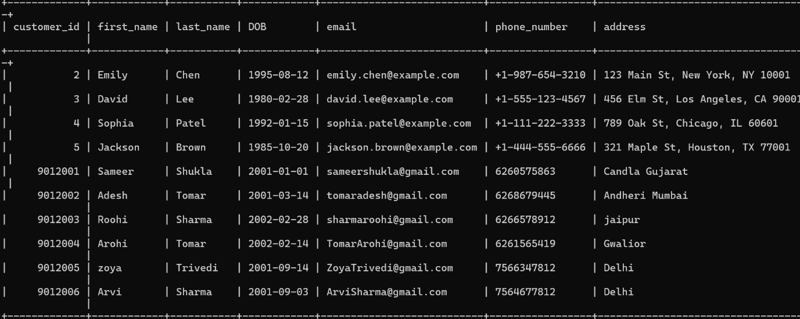

SELECTfirst_name,last_name,email,account_type FROM customers,accounts WHERE customers.customer_id = accounts.customer_id;

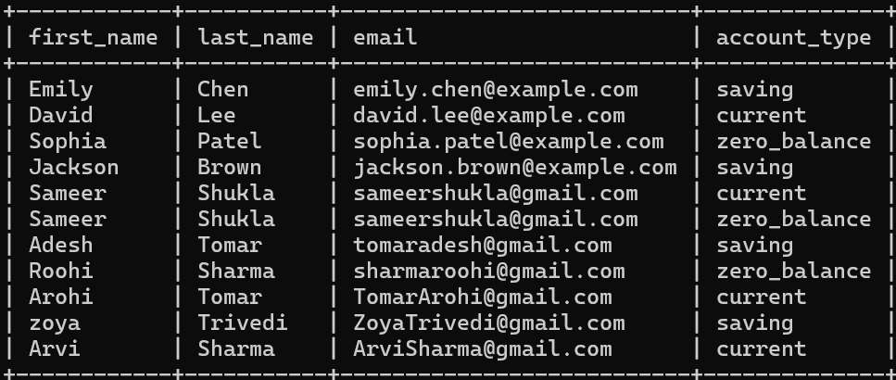

SELECT* FROM transactions WHERE account_id = '2';

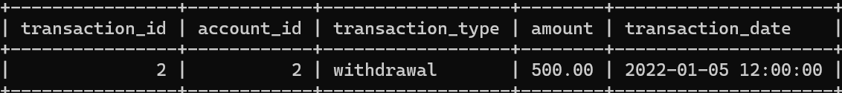

UPDATE accounts SET balance = balance + '1000' ;

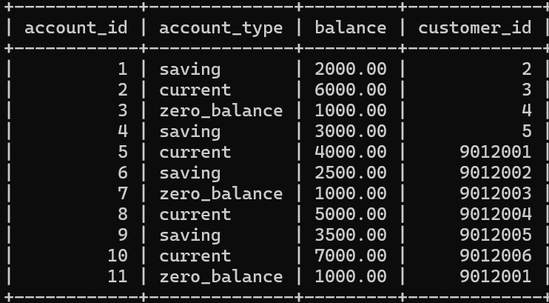

SELECT CONCAT(first_name,' ',last_name) AS full_name FROM customers;

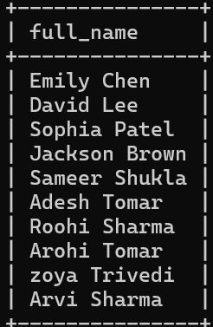

DELETE FROM accounts WHERE balance = '0' and account_type = 'saving';

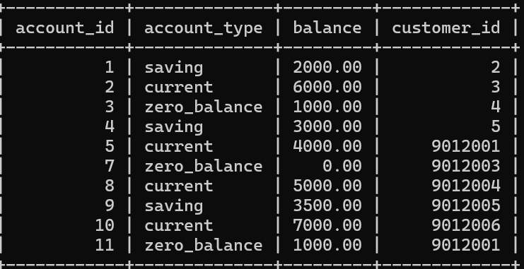

SELECT* FROM customers WHERE address ='DELHI';

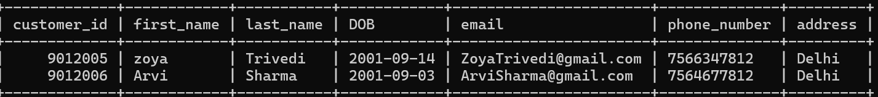

SELECT balance FROM accounts WHERE account_id = '10';

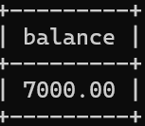

SELECT * FROM accounts WHERE account_type = 'current' and balance > '1000';

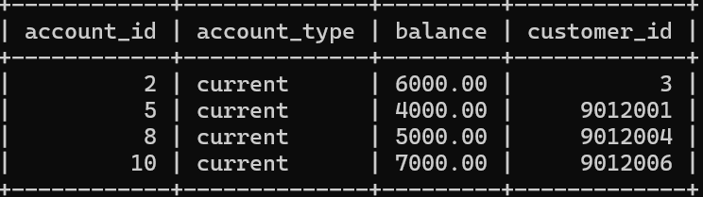

SELECT transaction_id,transaction_type,amount,transaction_date FROM transactions WHERE account_id ='5';

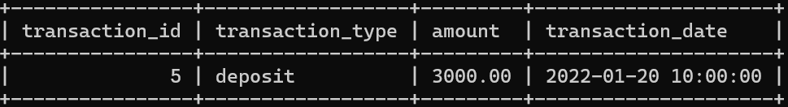

SELECT account_id,account_type,balance,interest_rate,(balance * interest_rate / 100 / 12) AS monthly_interest FROM accounts WHERE account_type = 'saving';

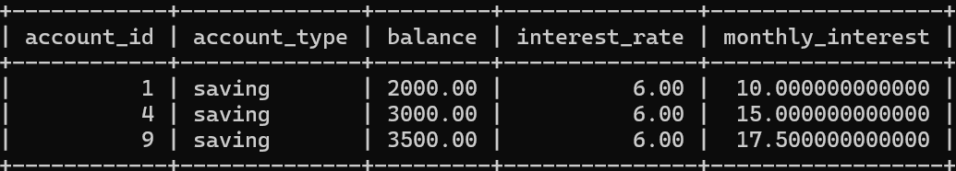

SELECT account_id, account_type,balance,customer_id FROM accounts WHERE balance < ‘2300’;

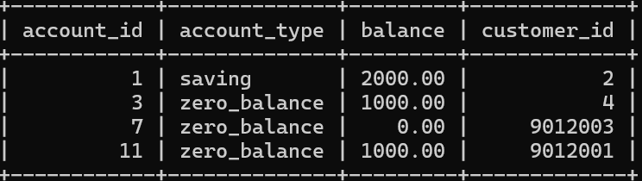

SELECT * FROM customers WHERE address != 'DELHI';

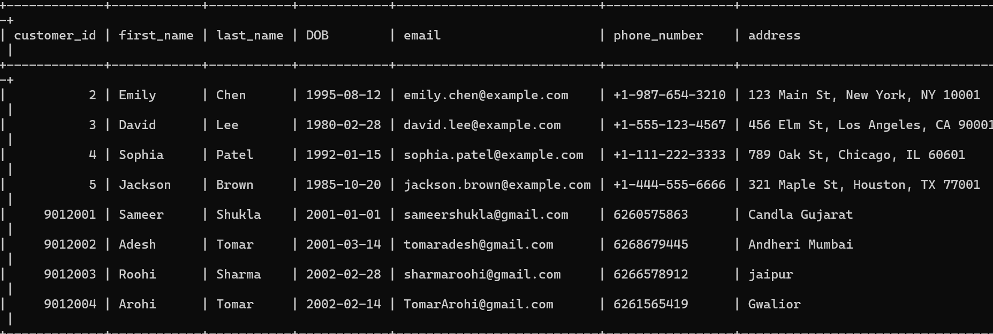

Task : 03

SELECT AVG(balance) Average_Account_balance FROM accounts;

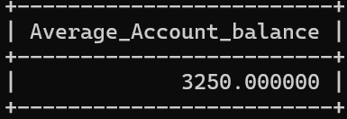

SELECT balance FROM accounts ORDER BY accounts DESC limit 10;

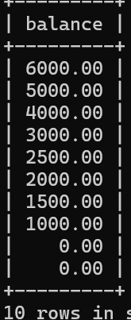

SELECT SUM(amount),transaction_date FROM transactions WHERE transaction_type = 'deposit' GROUP BY transaction_date;

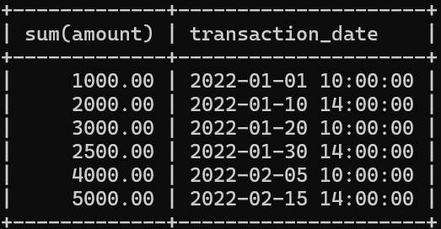

SELECT MIN(DOB) AS oldest_customer,MAX(DOB) AS newest_customer FROM customers;

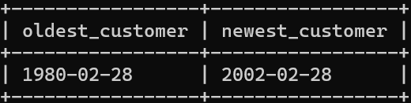

SELECT transaction_id,transaction_type,amount,transaction_type,account_type FROM transactions t, accounts a WHERE t.account_id = a.account_id;

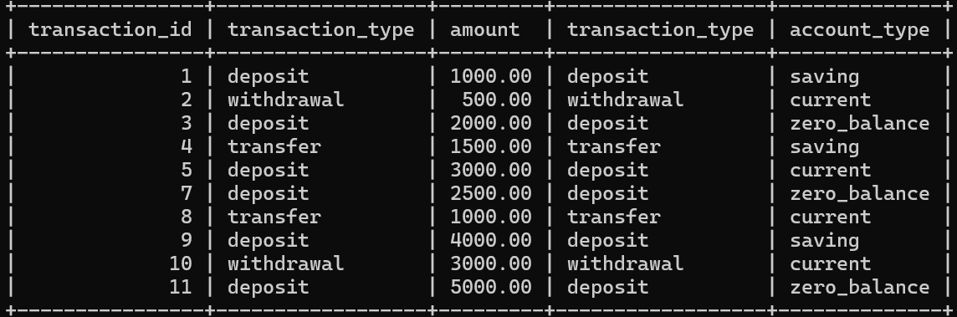

SELECTfirst_name ,DOB,phone_number,account_id,account_type,balance,interest_rate FROM customers c, accounts a WHERE c.customer_id = a.customer_id;

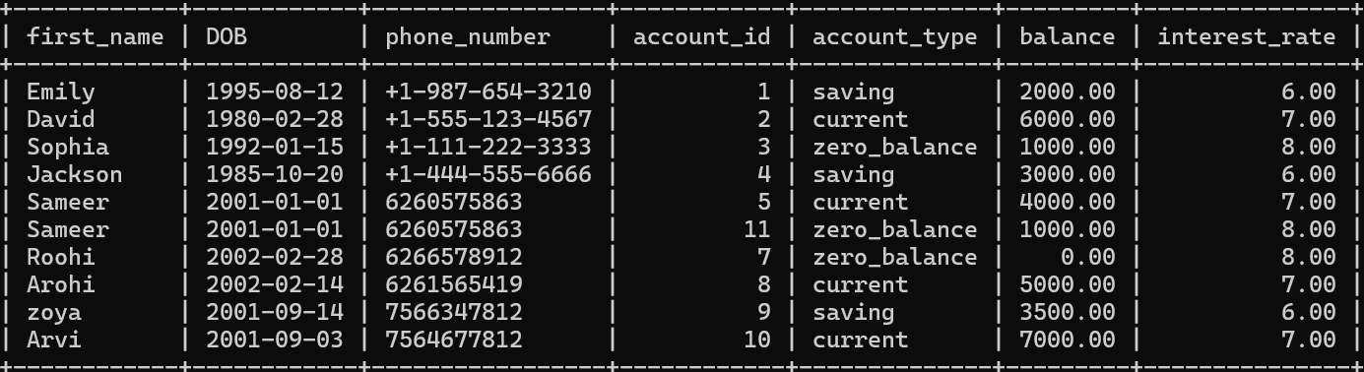

SELECTt.transaction_id,t.transaction_date,t.transaction_type,t.amount,a.account_id,a.account_type,c.customer_id,c.first_name,c.last_name FROM transactions t INNER JOIN accounts a ON t.account_id = a.account_id INNER JOIN customers c ON a.customer_id = c.customer_id WHERE a.account_id = '7';

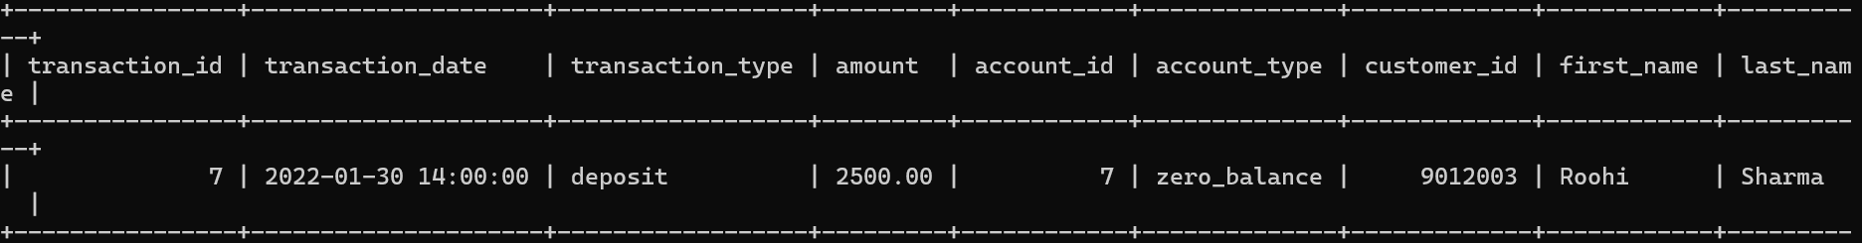

SELECTc.first_name, c.last_name

FROM customers c

WHERE c.customer_id IN (

SELECTa.customer_id FROM accounts a GROUP BY a.customer_id HAVING COUNT(a.account_id) >1

);

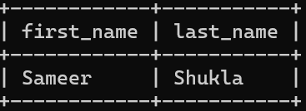

SELECT((SELECTSUM(amount) FROM transactions WHERE transaction_type ='deposit') - (SELECTSUM(amount) FROM transactions WHERE transaction_type='withdrawal')) as Difference;

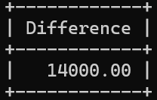

SELECTa.account_id,AVG(d.daily_balance) AS average_daily_balance FROM accounts a JOIN (SELECTt.account_id,t.transaction_date,SUM(t.amount) OVER (PARTITION BY t.account_id ORDER BY t.transaction_date) AS daily_balance FROM transactions t WHERE t.transaction_date BETWEEN '2022-01-01' AND '2022-12-31') d ON a.account_id = d.account_id GROUP BY a.account_id;

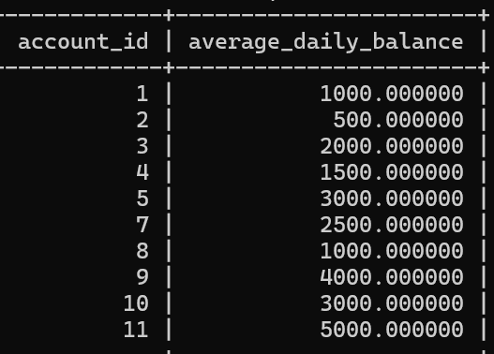

SELECTSUM(balance) , account_type FROM accounts GROUP BY account_type ;

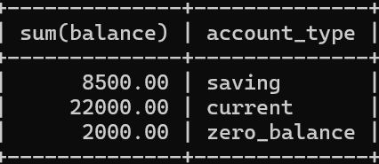

SELECTaccount_id as Top_transactions_account_id ,count(transaction_id) as No_of_Transactions FROM transactions GROUP BY account_id ORDER BY No_of_Transactions DESC;

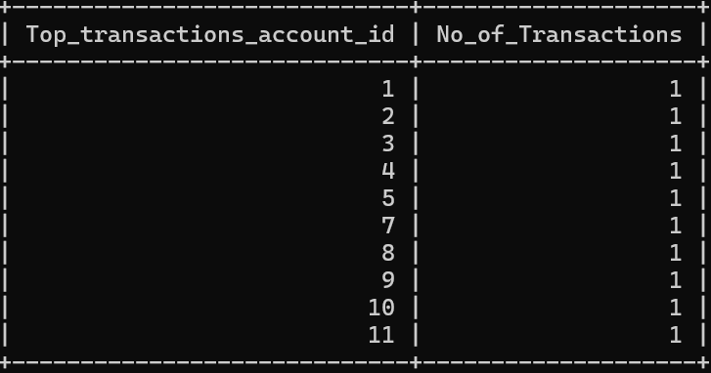

SELECTbalance, account_type FROM accounts ORDER BY balance DESC;

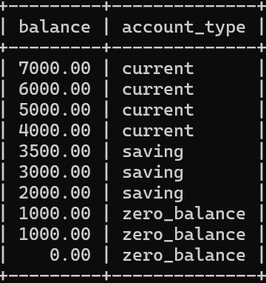

**SELECT**account_id,transaction_date,amount , **count**(*) **as** Duplicate_transactions **FROM** transactions **GROUP BY** account_id,transaction_date,amount **HAVING** Duplicate_transactions >1;

Task : 04

SELECTc.first_name,c.last_name,c.customer_id,a.account_id,a.balance FROM accounts a ,customers c WHERE a.customer_id = c.customer_id AND balance = (SELECTMAX(balance) FROM accounts);

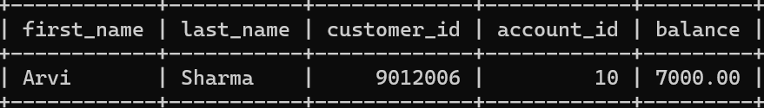

SELECTAVG(balance) , customer_id FROM accounts GROUP BY (customer_id) HAVING COUNT(account_id) > 1;

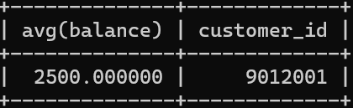

SELECTaccount_id FROM transactions WHERE amount > (SELECTAVG(amount) FROM transactions);

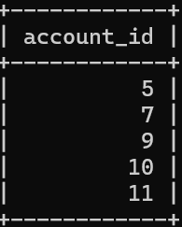

SELECTc.first_name ,c.last_name,c.customer_id FROM customers c WHERE c.customer_id NOT IN (SELECTa.customer_id FROM accounts a , transactions t WHERE a.account_id = t.account_id);

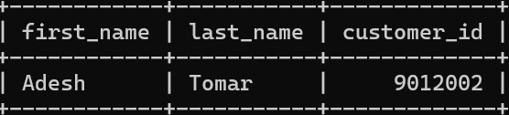

SELECTSUM(balance) AS Total_balance FROM accounts WHERE account_id NOT IN (SELECTaccount_id FROM transactions);

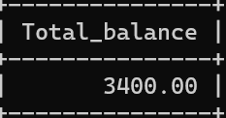

SELECTt.transaction_id,t.account_id ,t.transaction_type,t.amount,t.transaction_type , a.balance FROM transactions t, accounts a WHERE t.account_id = a.account_id AND balance = (SELECTMIN(balance) FROM accounts);

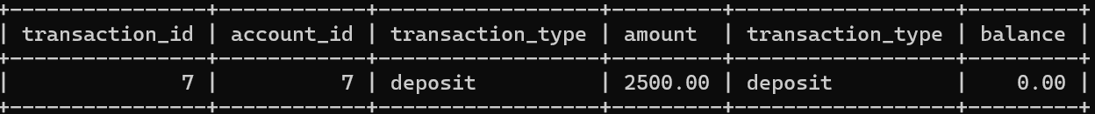

SELECT* FROM customers WHERE customer_id IN (SELECTcustomer_id FROM accounts GROUP BY customer_id HAVING COUNT(customer_id)>1);



SELECTaccount_type , ROUND((COUNT(*)/(SELECTCOUNT(*) FROM accounts))*100,2) as precentage FROM accounts GROUP BY account_type;

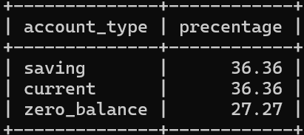

SELECT* FROM transactions WHERE account_id = (SELECTaccount_id FROM accounts WHERE customer_id = '5');

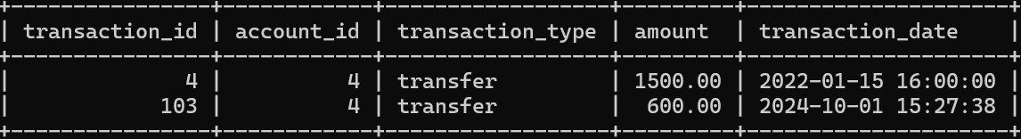

SELECTaccount_type ,(SELECTSUM(balance) FROM accounts a WHERE a.account_type = accounts.account_type) AS total_balance FROM accounts GROUP BY account_type;

OR

SELECTaccount_type, SUM(balance) FROM accounts GROUP BY account_type;

