**NEWS PORTAL**

# Project report in partial fulfillment of the requirement for the award of the degree of

**Bachelor of Technology**

**In**

**Computer Science and Engineering**

**Submitted By**

|  |  |
| --- | --- |
| Ayaan Al Bari | Enrollment No. 12021002001274 |
| Kaustav Karak | Enrollment No. 12021002001266 |
| Prerona Kundu | Enrollment No. 12021002001256 |
| Debadyuty Gayen | Enrollment No. 12021002001309 |
| Sanket Kumar Verma | Enrollment No. 12021002001169 |
| Pritam Kumar Roy | Enrollment No. 12021002001074 |
| Dona Paul | Enrollment No. 12021002001213 |
| Sayantan Maity | Enrollment No. 12021002001083 |
| Sagnik Basak | Enrollment No. 12021002001072 |
| Avijit Mondal | Enrollment No. 12021002001211 |

**Under the guidance of**

Prof. (Dr.) Sukalyan Goswami

&

Prof. Bipasha Mukhopadhyay

Department of Computer Science and Engineering



UNIVERSITY OF ENGINEERING & MANAGEMENT, KOLKATA

University Area, Plot No. III – B/5, New Town, Action Area – III, Kolkata – 700160.

# CERTIFICATE

This is to certify that the project titled **NEWS PORTAL** submitted by **Ayaan Al Bari (University Roll**

**No. 12021002001274), Kaustav Karak (University Roll No. 12021002001266), Prerona Kundu**

**(University Roll No. 12021002001256), Debadyuty Gayen (University Roll No. 12021002001309),**

**Sanket Kumar Verma (University Roll No. 12021002001169), Pritam Kumar Roy (University Roll**

**No. 12021002001074), Dona Paul (University Roll No. 12021002001213), Sayantan Maity**

**(University Roll No. 12021002001083), Sagnik Basak (University Roll No. 12021002001072) and**

**Avijit Mondal (University Roll No. 12021002001211)** students of UNIVERSITY OF ENGINEERING

& MANAGEMENT, KOLKATA, in partial fulfillment of requirement for the degree of Bachelor of Computer Science XXXXX, is a Bonafede work carried out by them under the supervision and guidance of **Prof. (Dr.) Sukalyan Goswami** & **Prof. Bipasha Mukhopadhyay** during 4TH Semester of academic session of 2022 - 2023. The content of this report has not been submitted to any other university or institute. I am glad to inform that the work is entirely original and its performance is found to be quite satisfactory.

Signature

of

Guide

Signature

of

Head of

the

Department

Signature of Guide

# 

# ACKNOWLEDGEMENT

We would like to take this opportunity to thank everyone whose cooperation and encouragement throughout the ongoing course of this project remains invaluable to us.

We are sincerely grateful to our guide Prof. (Dr.) Sukalyan Goswami and Prof. Bipasha Mukhopadhyay of the Department of COMPUTER SCIENCE AND ENGINEERING, UEM, Kolkata, for his wisdom, guidance and inspiration that helped us to go through with this project and take it to where it stands now.

Last but not the least, we would like to extend our warm regards to our families and peers who have kept supporting us and always had faith in our work.

Ayaan Al Bari

Kaustav Karak

Prerona Kundu

Debadyuty Gayen

Sanket Kumar Verma

Pritam Kumar Roy

Dona Paul

Sayantan Maity

Sagnik Basak

Avijit Mondal

**TABLE OF CONTENTS**

**CHAPTER – 1: INTRODUCTION .......................................... PAGE NO: 5**

**CHAPTER – 2: LITERATURE SURVEY .............................. PAGE NO: 6**

**CHAPTER – 3: PROBLEM STATEMENT ............................. PAGE NO: 7**

**CHAPTER – 4: PROPOSED SOLUTION ............................... PAGE NO: 8**

**CHAPTER–5: EXPERIMENTAL SETUP**

**AND RESULT ANALYSIS …………………...PAGE NO: 9**

**CHAPTER -6:RESULTS OF OUR WEBSITE……………..PAGE NO:10**

**CHAPTER – 7: CONCLUSION & FUTURE SCOPE ............ PAGE NO: 11**

**CHAPTER -8:BIBLIOGRAPHY................................................ PAGE NO: 12**

# INTRODUCTION

In this fast-moving world where people find little to no time to spend with their own family, it is arduous to find time to read newspaper and stay updated with the current affairs and state of the world.

Reading newspaper might often be time consuming considering the size of the article.

Often people bypass the article due to lethargy if it is monotonous and lengthy.

Information gained via listening and visuals is easily apprehended as compared to reading which requires a lot more engagement.

To make things easier, we have created an application and website where users can find both articles and videos as per their preference.

The app and website allow users to browse through news headlines for different categories.

The app and website lets users glance through the daily news(like political,sports,international,business,education,health,economy,technology,entertainment,lifestyle news etc) and weather conditions.

The app fetches data from third-party API’s(Application Programming Interface), and then populates the data to the front end of the app.

**LITERATURE SURVEY**

Content Report

* The main focus of this application and website is to unite different news articles from around the globe and deliver it to the user without delay whilst maintaining the visual aspect.
* We are also trying to give a good experience to read, listen and watch news for the users in a very convenient way by pushing news update in brief, so that users can save their precious time.
* The portal provides news on various topics such as Politics, Economy and Finance, Entertainment, Infra and Tech ,Sports ,etc.

Technical Report

* This project has been developed on HTML, Bootstarp,CSS, JavaScript for the website and for the app we have used Android studio in which we have used Java as the main language along with XML to give different properties of the app.
* We have used different free API’s to fetch news from different news outlets.
* We have used GitHub pages to host our website and also bought a public DNS/Domain name from namescheap.com so that we can access the website from anywhere in the world.
* The website is dynamic in nature as the API’s used are constantly updating news every day.

*Scope of the project Today and Tomorrow News Portal :*

It may help collecting perfect management in details. In a very short time, the collection will be obvious, simple and sensible. It will help a person to know the management of passed year perfectly and vividly. It also helps in current all works relative to News Website. It will be also reduced the cost of collecting the management & collection procedure will go on smoothly.

Our project aims to give information to the peoples all over the world. Our website will give instant & latest news all over the world.

# PROBLEM STATEMENT

1. Users face different problem while reading news articles as they are very long in nature and people usually don’t have any time to read such long articles.
2. The number of audio, video news articles available online are very less as compared to reading materials.
3. There is very less variety of editors in the news portals that we have in the internet.
4. No news archive or portal is there that gives news articles from different sources and company in a brief format.
5. There are very few Websites that provide videos and audio news clips from different sources and merge them together in a single place.
6. Today the news medias are usually funded by different Governments and journalists sometimes has to take sides of the govt.

# PROPOSED SOLUTION

1. We are providing brief news clippings so that users can save their precious time.
2. We are also providing news in audio and video format in a detailed manner.
3. We are providing news whose editors are from different media houses
4. Our portal enables users to get news updates from different news portals at same place.
5. We provide news from different editors so that users could identify and select the news that they feel like are not fake and unbiased.
6. Our website optimisation is centered around providing an exceptional user experience.
7. Frequent site audits help businesses optimize web content on a continual basis.
8. The user must be able to navigate through the website easily.

**EXPERIMENTAL SETUP AND RESULT ANALYSIS**

Code Base (GitHub - https://github.com/AyaanBari/TodayAndTomorrow_News.git)

Some Code Snippets are shown

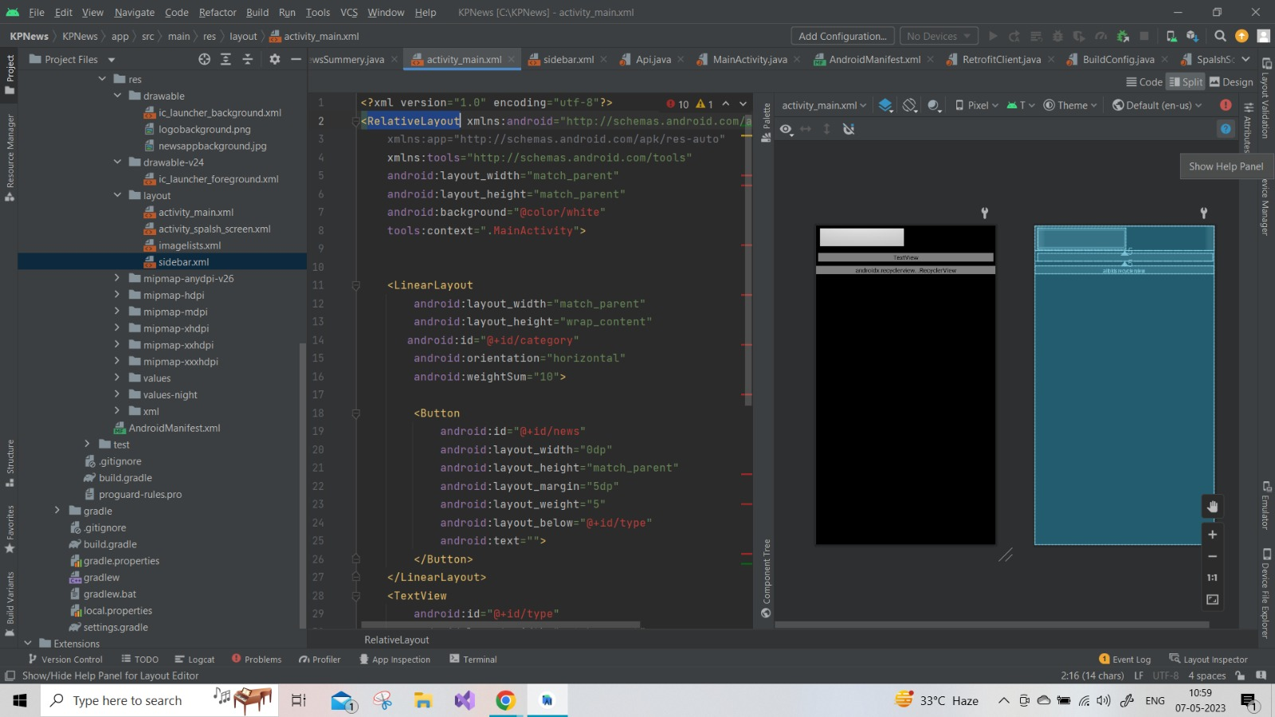

**Results of our Website**

Website Link – todayntommorow.news

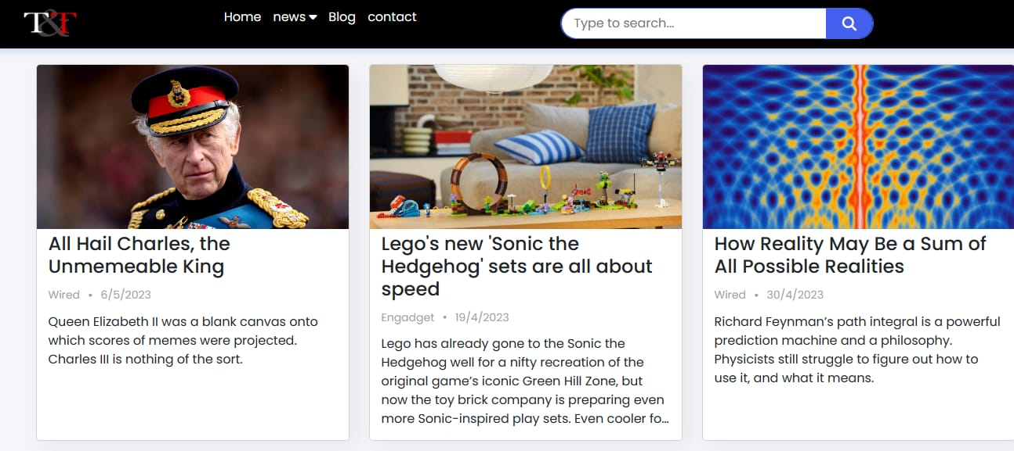

**Result of our App**

# CONCLUSION & FUTURE SCOPE

We use AI and ML to analyse a user’s reading habits and the topics that they like so that we can fetch news according to that.

The days where people would spend a valuable amount of time reading newspapers is far gone, but with advancement comes advance solutions to these problems.



News app or news website is a great medium which makes gaining information via newspapers much more interesting, user friendly and effortless.



This easily usable UI makes the application very user friendly and above all saves time.



We have created a website and an app that saves people time with the help of different technologies by incorporating brief news articles ,audio and videos.

*The future scope of the project circles around maintaining information regarding:*

1. We will be using AI and ML to analyse a user’s reading habits and the topics that they like so that we can fetch news according to that.

**BIBLIOGRAPHY**

1. <https://www.studocu.com/in/document/university-of-mysore/environmental-geology/pdfcoffee-good/30639480>
2. Different CSE_4th_Sem_10News Media and Outlets