***Sum of Premature Death Count by Entity***

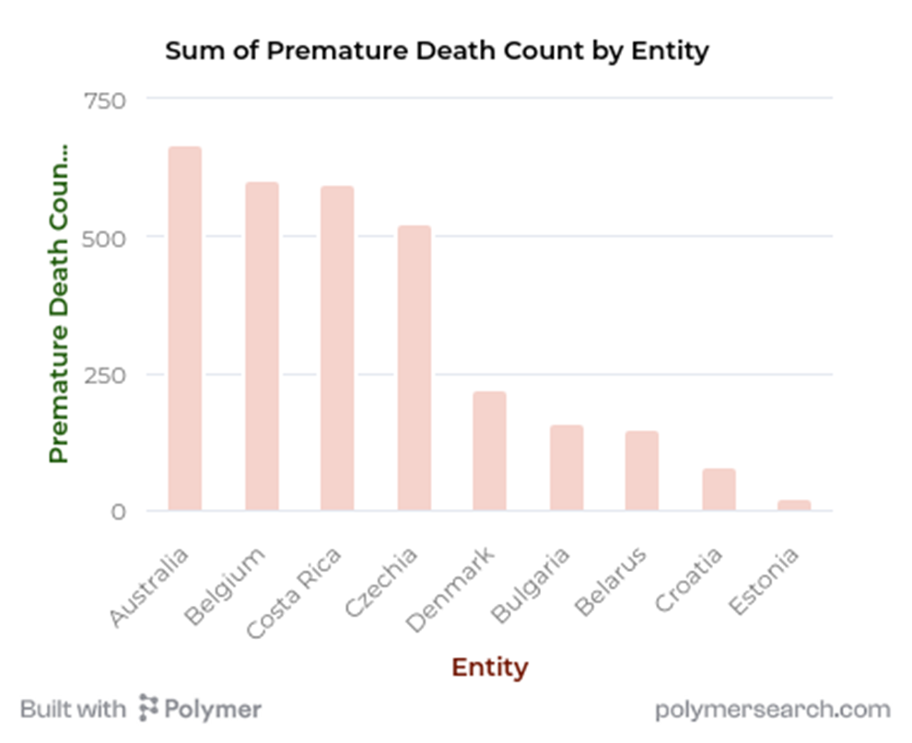

The image shows a bar chart of the sum of premature death counts by entity.

Key findings :

1. Australia has the highest premature death count, suggesting it faces significant health challenges and risk factors leading to early mortality. Australia should prioritize investigating and addressing the root causes, such as lifestyle factors, healthcare access, and environmental issues.

2. Belgium has the second highest count at roughly 600, also indicating room for improvement in preventing premature deaths. Belgium should similarly examine and tackle the underlying factors contributing to early mortality.

3. Costa Rica, Czechia, Denmark, Bulgaria and Belarus have lower premature death counts between about 600 to 150. While lower than Australia and Belgium, these counts still represent significant losses of life. These countries should also work to identify and mitigate the causes of premature deaths.

All entities should strive to minimize premature deaths by investing in healthcare, public health programs, and addressing social determinants of health. Regularly monitoring and analysing premature death data can help identify problem areas and guide targeted interventions. Collaboration and knowledge-sharing between entities can also drive progress in reducing preventable early deaths.

***The Sum of Total discharge to inland waters (millions m3 by entity)***

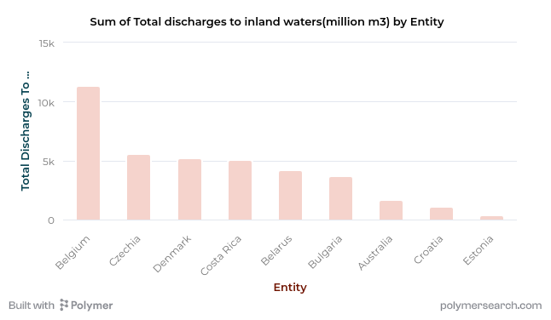

The chart shows the sum of total discharges to inland waters over time by different entities. Belgium has the highest total discharge at around 12,000 million cubic meters, significantly more than the other entities shown.

Some key observations:

- There is wide variation in total discharges across the entities, ranging from under 1,000 to over 12,000 million m3

- Croatia and Estonia have very low discharge totals compared to Belgium

- The data suggests certain entities are contributing disproportionately to inland water pollution

To reduce inland water contamination from these discharge sources, potential improvement measures could include:

- Investigating and addressing the reasons for Belgium's extremely high discharge rate, e.g. through tighter regulations, improved treatment, identifying biggest polluters, etc.

- Studying what is enabling the low discharge levels in places like Croatia and Estonia and seeing if those practices can be replicated elsewhere

- Setting discharge caps and reduction targets for the highest polluting entities

Solving this issue will require a concerted effort across public and private stakeholders to implement a range of technological, policy and behavioural solutions aimed at minimizing discharge at the source and capturing and treating waste flows before they contaminate inland waterways. With focus and collaboration, meaningful reductions in pollution levels are achievable over time.

***Sum of Agricultural Wastewater Discharges by Entity***

This shows a bar chart displaying the sum of agricultural wastewater (including forestry and fisheries) discharged directly by Entity.

Key findings:

1. Denmark has the highest agricultural wastewater discharge at around 1480 million m3, significantly higher than other entities shown. This suggests Denmark likely has the most intensive agricultural industry and/or the least effective wastewater treatment and discharge practices. Denmark should prioritize improving wastewater management in its agricultural sector.

2. Australia's discharge volume is second highest at about 1460 million m3, also quite high compared to most others. Australia should also focus on reducing agricultural wastewater through better practices and treatment.

3. The remaining entities (Belarus through Croatia) have much lower discharge volumes, all under 1300 million m3. This could indicate they have smaller agricultural sectors and/or better wastewater handling. However, there may still be room for improvement.

In summary, the data highlights the need for improved agricultural wastewater management, especially in high-discharge countries like Denmark and Australia. Implementing best practices, regulations and treatment infrastructure can help reduce discharge volumes and mitigate negative environmental impacts.