***Carbon neutrality of wastewater treatment - A systematic concept beyond the plant boundary***

The document discusses the carbon neutrality of wastewater treatment systems and their impacts on carbon intensity and social well-being. It emphasizes that achieving carbon neutrality in wastewater treatment extends beyond the treatment plant boundary and requires a systematic approach. As stated in the document, "carbon neutrality of the wastewater system is far beyond the plant boundary" (Section 2).

***Figure 1***

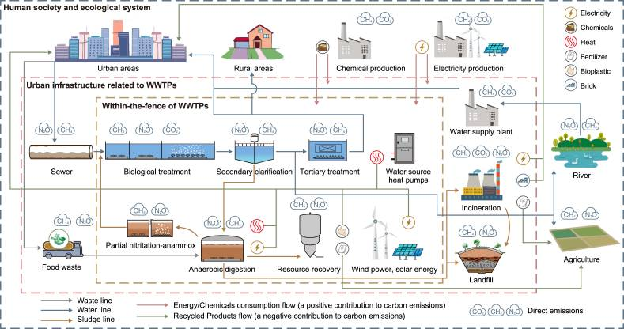

Figure 1 in the document provides a sketch of multiple boundaries for carbon accounting of wastewater treatment. It illustrates three boundaries: within-the-fence of WWTPs (yellow dashed line), urban infrastructure related to WWTPs (pink dashed line), and human society and ecological system (blue dashed line). The figure shows that the scope of carbon accounting can be gradually expanded from wastewater treatment processes to the entire human society and ecological system. It also depicts direct carbon emissions with specific symbols and indirect carbon emissions implied in the flows of energy/chemicals consumption and recycled products.

***Key points and recommendations:***

1. "Wastewater treatment can contribute approximately 1–2% of the total greenhouse gas (GHG) emissions in the world" (Section 1). To achieve carbon neutrality, a comprehensive accounting of direct and indirect carbon emissions within and beyond wastewater treatment plants (WWTPs) is necessary.

2. Direct emissions include CH4 and N2O from wastewater treatment processes and sludge treatment/disposal. The document recommends "including fossil CO2 in GHG accounting is necessary for setting accurate guidelines" (Section 3).

3. Indirect emissions stem from energy and resource consumption. Energy-saving measures, such as "upgrading obsolete equipment and apply real-time controllers" (Section 4), can reduce indirect emissions.

4. Energy recovery through biogas production from anaerobic digestion and water source heat pumps can offset energy demand. However, the document notes that "energy neutrality and carbon neutrality are two different terms" and "successful wastewater treatment cases in energy self-sufficiency may not achieve carbon neutrality" (Section 4).

5. Resource recovery, specially producing carbon-based materials like bioplastics and biochar, is encouraged. The document states that "the production of carbon-based materials from wastewater treatment can promote CO2 sequestration and decrease GHG emissions" (Section 4).

6. Decentralized wastewater treatment systems are highlighted as a potential solution for reducing energy consumption, enhancing resource recovery, and closing the water loop. The document mentions that "decentralized system outcompetes the centralized system in less energy input and more efficient resource recovery" (Section 5).

***Conclusion:***

In summary, achieving carbon neutrality in wastewater treatment requires a holistic approach that considers direct and indirect emissions, energy and resource recovery, decentralized systems, and the overall urban infrastructure layout. Figure 1 illustrates the multiple boundaries for carbon accounting, emphasizing the need to extend beyond the treatment plant boundary. Addressing these challenges is essential for reducing the carbon intensity of the wastewater sector and promoting social well-being through improved sanitation and public health.

***Reference:***

<https://www.ncbi.nlm.nih.gov/pmc/articles/PMC9488052/>

[1] Lu, L., Guest, J.S., Peters, C.A., Zhu, X., Rau, G.H., Ren, Z.J., 2018. Wastewater treatment for carbon capture and utilization. Nat. Sustain. 1(12), 750–758.

[2] Li, L., Wang, X., Miao, J., Abulimiti, A., Jing, X., Ren, N., 2022. Carbon neutrality of wastewater treatment - A systematic concept beyond the plant boundary. Environ. Sci. Ecotechnol. (In Press)

[3] IPCC, 2013. Climate Change 2013: the Physical Science Basis. Contribution of Working Group I to the Fifth Assessment Report of the Intergovernmental Panel on Climate Change. Cambridge University Press, USA.

[4] McCarty, P.L., Bae, J., Kim, J., 2011. Domestic wastewater treatment as a net energy producer--can this be achieved? Environ. Sci. Technol. 45(17), 7100–7106.

[5] Hao, X., Liu, R., Huang, X., 2015. Evaluation of the potential for operating carbon neutral WWTPs in China. Water Res. 87, 424–431.

***Key words/acronyms:***

Carbon neutrality - having a balance between emitting carbon and absorbing carbon from the atmosphere in carbon sinks.

Plant boundary – a plant that grows along the boundaries.

Carbon intensity - Carbon intensity is a measure of how clean our electricity is.

WWTPS – Wastewater treatment plants

Ecological system – Ecosystem where that environments organism interacts,