RESUME
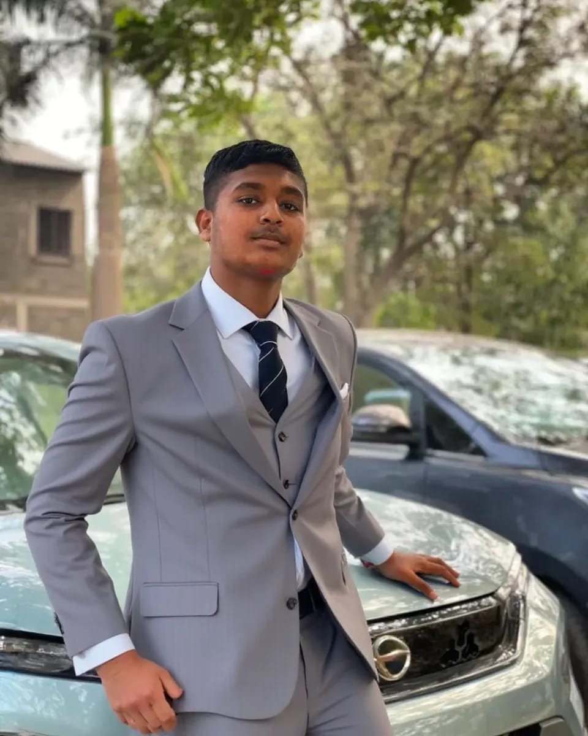

Name :- AYAAN ALLARAKHUBHAI KHALIFA
Father Name :- ALLARAKHU FAKIRBHAI KHALIFA
Date of Birth :- 27/ 06/2006
Address :- At & Post : 5222 BAZAR STREET KHATRIVAD,
CHIKHLI
Ta : CHIKHLI Dist: NAVSARI STATE : GUJARAT
COUNTRY: INDIA
Pin code : 396521
Mobile no :- 8799097673
E-mail Id :- ayaankhalifa4432@gmail.com
Cast :- MUSALMAN KHALIFA
Gender :- Male
Marital status :- un-married
Language known :- ENGLISH ,Gujarati , Hindi, URDU
SKIL :- CODING, COMMUNICATION, EDITING
Nationality :- Indian
Education Qualification :-
Sr. no | Name of exam | Name of bord / univ. | Passing year | Percentage
1. | 10th | G.S.H.E.B.GANDHINAGAR | MAY-2021 | 71.33.%
2. | 12th | G.S.H.E.B.GANDHINAGAR | MAR-2023 | 65.84 %
3. | BCA | V.N.S.G.U | AUG - 2026 | CONTINUE

Signature
( A. A. KHALIFA )

