Q1:

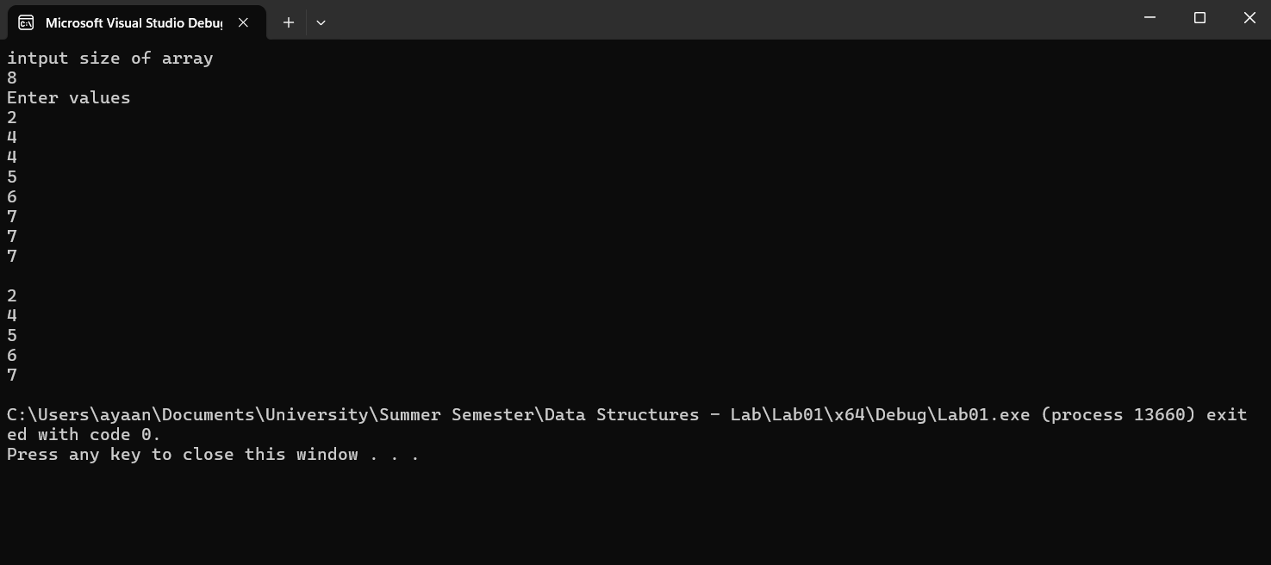

#include<iostream>

using namespace std;

void removeDuplicates(int\* arr, int& size)

{

int\* arr2 = new int[size];

int count = 0;

int count2 = 0;

for (int i = 0; i < size - 1; i++)

{

int count3 = 2;

int count4 = 1;

if (\*(arr + i) != \*(arr + i + 1))

{

\*(arr2 + count++) = \*(arr + i);

count2++;

//i++;

}

else

{

\*(arr2 + count++) = \*(arr + i);

while (\*(arr + i) == \*(arr + i + count3++))

{

count4++;

}

i += count4;

count2++;

//size--;

}

}

size = count2;

for (int i = 0; i < count2; i++)

{

\*(arr + i) = \*(arr2 + i);

//cout << \*(arr + i) << endl;

}

//cout << endl;

}

int main()

{

int size;

cout << "intput size of array\n";

cin >> size;

int\* arr = new int[size];

cout << "Enter values\n";

for (int i = 0; i < size; i++)

{

cin >> \*(arr + i);

}

cout << endl;

removeDuplicates(arr, size);

int count = 0;

while ((count) < size)//(arr + count) != NULL)

{

cout << \*(arr + count) << endl;

count++;

}

return 0;

}

Q2:

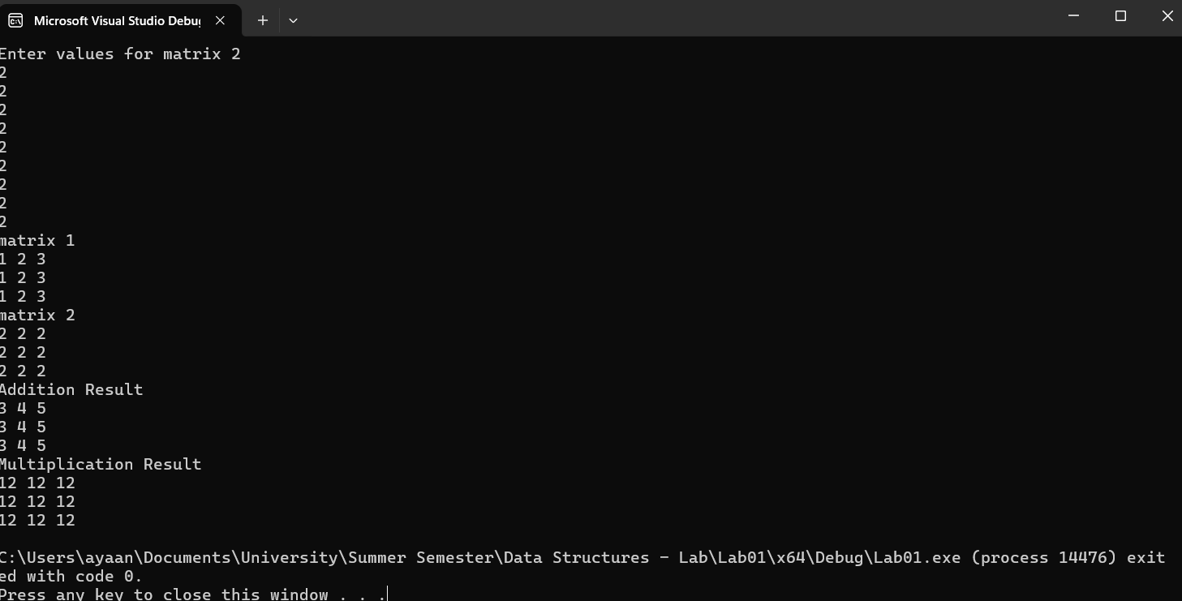

#include<iostream>

using namespace std;

int\* multiplication(int\* matrix1, int\* matrix2, int rows, int cols)

{

int\* final = new int[rows \* cols] {0};

for (int i = 0; i < rows; i++)

{

for (int j = 0; j < cols; j++)

{

for (int k = 0; k < cols; ++k)

{

\*(final + j + (i \* cols)) += \*(matrix1 + k + (i \* cols)) \* \*(matrix2 + j + (k \* cols));

}

}

}

return final;

}

int\* addition(int\* matrix1, int\* matrix2, int rows, int cols)

{

int\* final = new int[rows \* cols];

for (int i = 0; i < rows; ++i)

{

for (int j = 0; j < cols; ++j)

{

\*(final + j + (i \* cols)) = \*(matrix1 + j + (i \* cols)) + \*(matrix2 + j + (i \* cols));

}

}

return final;

}

int main()

{

int rows = 3;

int cols = 3;

int\* matrix1 = new int[rows \* cols];

int\* matrix2 = new int[rows \* cols];

cout << "Enter values for matrix 1" << endl;

for (int i = 0; i < rows; i++)

{

for (int j = 0; j < cols; j++)

{

cin >> \*(matrix1 + j + (i \* cols));

}

}

cout << "Enter values for matrix 2" << endl;

for (int i = 0; i < rows; i++)

{

for (int j = 0; j < cols; j++)

{

cin >> \*(matrix2 + j + (i \* cols));

}

}

cout << "matrix 1" << endl;

for (int i = 0; i < rows; i++)

{

for (int j = 0; j < cols; j++)

{

cout << \*(matrix1 + j + (i \* cols)) << " ";

}

cout << endl;

}

cout << "matrix 2" << endl;

for (int i = 0; i < rows; i++)

{

for (int j = 0; j < cols; j++)

{

cout << \*(matrix2 + j + (i \* cols)) << " ";

}

cout << endl;

}

int\* additionMatrix = addition(matrix1, matrix2, rows, cols);

cout << "Addition Result\n";

for (int i = 0; i < rows; i++)

{

for (int j = 0; j < cols; j++)

{

cout << \*(additionMatrix + j + (i \* cols))<<" ";

}

cout << endl;

}

int\* multMatrix = multiplication(matrix1, matrix2, rows, cols);

cout << "Multiplication Result\n";

for (int i = 0; i < rows; i++)

{

for (int j = 0; j < cols; j++)

{

cout<< \*(multMatrix + j + (i \* cols))<<" ";

}

cout << endl;

}

return 0;

}

Q3:

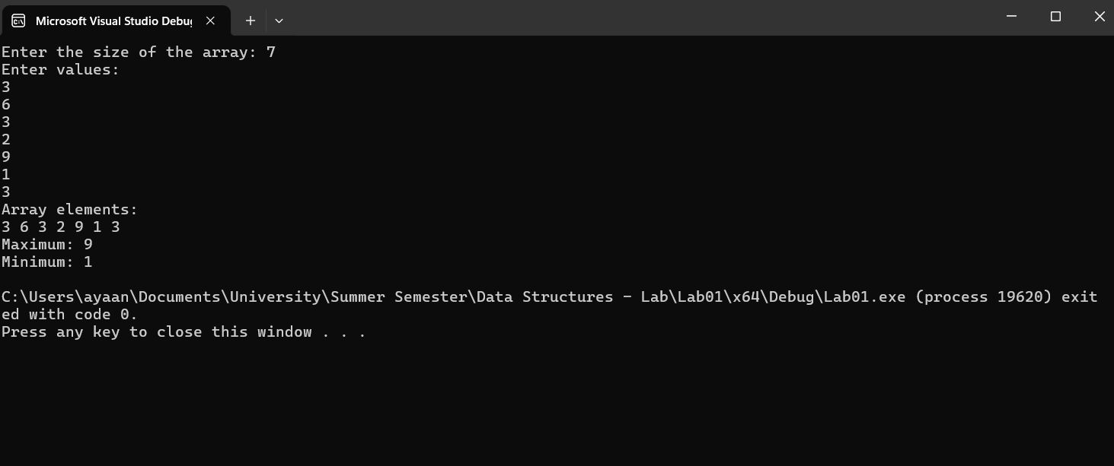

#include <iostream>

using namespace std;

void findMinMax(int\* arr, int size, int& max, int& min) {

max = \*arr;

min = \*arr;

for (int i = 1; i < size; ++i) {

if (\*(arr + i) > max)

{

max = \*(arr + i);

}

if (\*(arr + i) < min)

{

min = \*(arr + i);

}

}

}

int main() {

int size;

cout << "Enter the size of the array: ";

cin >> size;

int\* arr = new int[size];

cout << "Enter values:" << endl;

for (int i = 0; i < size; ++i) {

cin >> \*(arr + i);

}

cout << "Array elements:" << endl;

for (int i = 0; i < size; ++i) {

cout << \*(arr + i) << " ";

}

cout << endl;

int max, min;

findMinMax(arr, size, max, min);

cout << "Maximum: " << max << endl;

cout << "Minimum: " << min << endl;

delete[] arr;

return 0;

}