**Project Report: Design and Implementation of a Hotel Management Network Using Cisco Technologies**

**1. Title Page**

**Title:** Design and Implementation of a Hotel Management Network Using Cisco Technologies  
**Prepared by:** Ayaan Khan  
**Course:** Computer Networks  
**Institution:** FAST NUCES Islamabad  
**Section:** CS-K

**Roll Number:** 22i-0832

**2. Objective**

The project aims to design and implement a robust network architecture for a hotel management system that ensures efficient communication, resource sharing, and internet connectivity across various departments and floors. The network integrates advanced features such as VLANs, DHCP, NAT, dynamic and static routing, VLSM, server-based services like HTTP, FTP, Email, and SYSLOG, and Access Control Lists (ACLs) to secure and regulate traffic flow.

**3. Technologies Used**

* **Cisco Packet Tracer:** For network design and simulation.
* **Cisco Routers and Switches:** Configured for VLANs, routing protocols, and NAT.
* **Routing Protocols:** Static routing, RIP, OSPF, EIGRP.
* **Server Services:** HTTP, FTP, SMTP (Email), DNS, and SYSLOG.
* **Access Control Lists (ACLs):** Applied to enhance network security.
* **DHCP:** For dynamic IP address assignment.
* **NAT (Network Address Translation):** To enable internet access.
* **VLSM (Variable Length Subnet Mask):** For efficient IP addressing.

**4. Implementation Details**

**4.1 Design and Approach**

The network design is as follows:

1. **Topology:**
   * Four routers: R1, R2, R3, and an ISP router.
   * VLANs for each department and floor to segregate traffic:
     + R1 VLANs: 70, 80, 90
     + R2 VLANs: 30, 40, 50
     + R3 VLANs: 10, 20
2. **Routing:**
   * RIP between R2 and R3.
   * OSPF between R1 and R2.
   * EIGRP between R3 and R1.
   * Static routing for direct routes between the routers and the ISP.
3. **DHCP:**
   * A centralized DHCP server located in R3 assigns IPs dynamically to all devices across VLANs.
4. **NAT:**
   * Configured on R3 to translate internal private IPs to a public IP for internet access via the ISP router.
5. **Server Services:**
   * HTTP for web hosting
   * FTP for file sharing
   * SMTP for email communication.
   * SYSLOG for centralized logging of router events.
6. **VLSM:**
   * Applied across the network to optimize IP address utilization.
7. **ACLs:**

* Applied to secure traffic between VLANs and regulate access to the ISP.

**4.3 Email Integration**

* Configured SMTP services on the server located in R3.
* Devices across VLANs access the mail server for internal and external communication.

**5. Results and Testing**

**Functionality Achieved:**

* VLAN communication within routers and inter-VLAN communication via routing protocols.
* DHCP successfully assigns IPs across all VLANs.
* NAT ensures internet access for all VLANs via the ISP router.
* SMTP email services allow sending and receiving emails across the network.
* Test cases demonstrate seamless communication and connectivity between devices.
* Devices within authorized VLANs could access ISP services and other VLANs seamlessly.

**Testing Evidence:**

* **Ping Test:** Devices across VLANs successfully ping each other.
* **Email Test:** Internal email communication verified using the mail server.
* **NAT Test:** Internal devices access the internet (ISP router).
* Screenshots of packet tracing, DHCP bindings, and NAT translations are attached at the end of the document.

**6. Challenges and Learnings**

**Challenges:**

* Initial issues with VLAN communication due to incorrect trunk configurations.
* Routing loops encountered during dynamic protocol configurations.
* DHCP failure in early tests due to misconfigured relay agent settings.
* NAT translation issues with public IP allocation.

**Learnings:**

* Proper planning of IP addressing schemes, including VLSM, is crucial for efficient resource utilization.
* Understanding the nuances of routing protocols ensures seamless integration.
* Effective debugging techniques are essential when working on large-scale network simulations.

**7. Conclusion**

This project successfully demonstrates the design and implementation of a hotel management network. The integration of VLANs, dynamic routing protocols, DHCP, NAT, and email services ensures efficient communication and resource sharing across the network. Future enhancements could include implementing advanced security measures such as ACLs, firewalls, and VPNs to secure sensitive data.

**8. Testing Screenshots**

**Topology:**

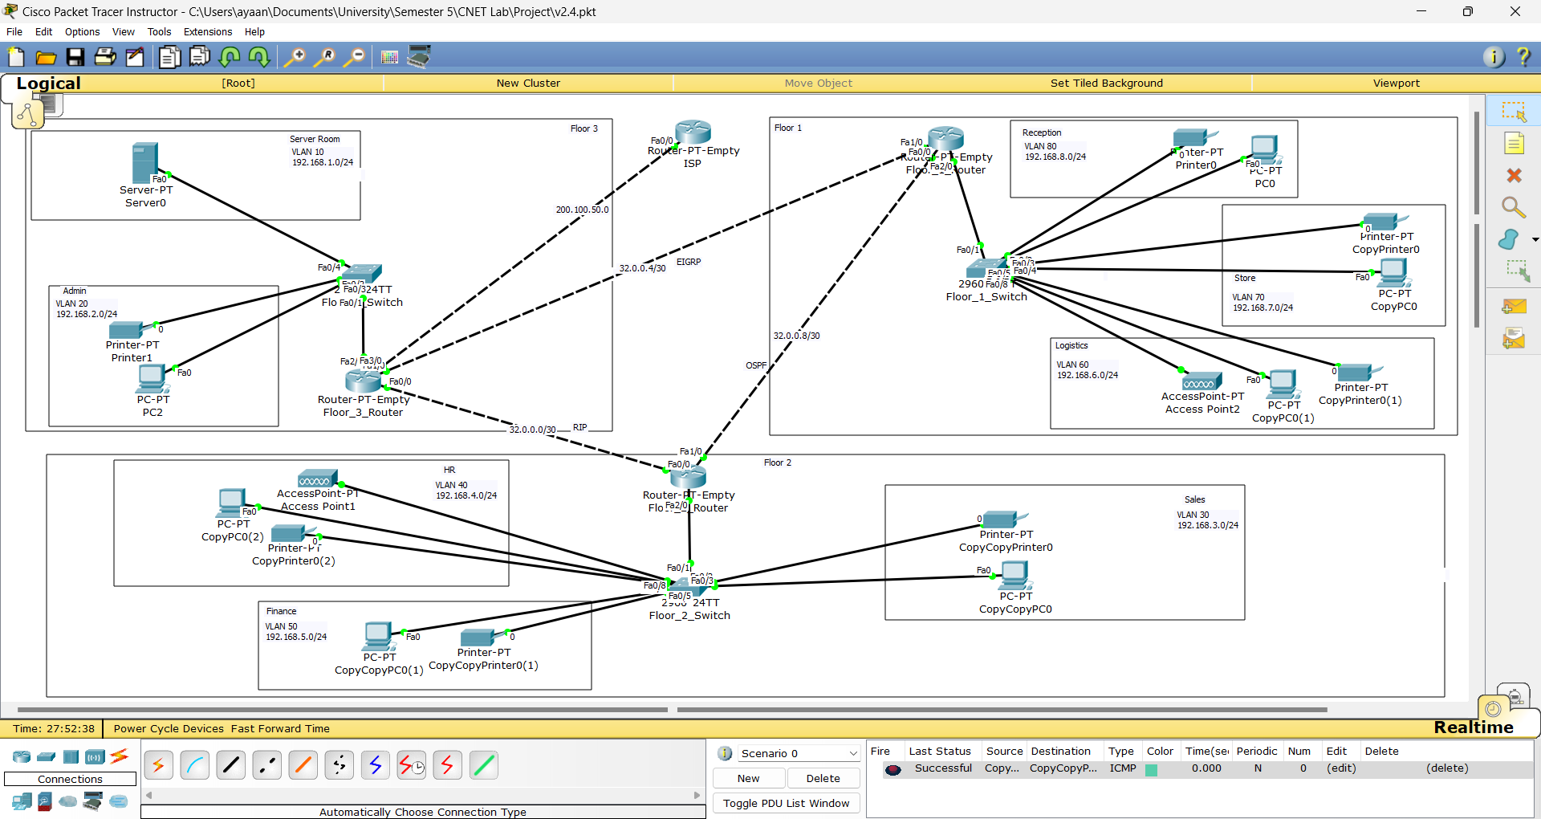

**Inter-VLAN Routing:**

All VLANs in Switches

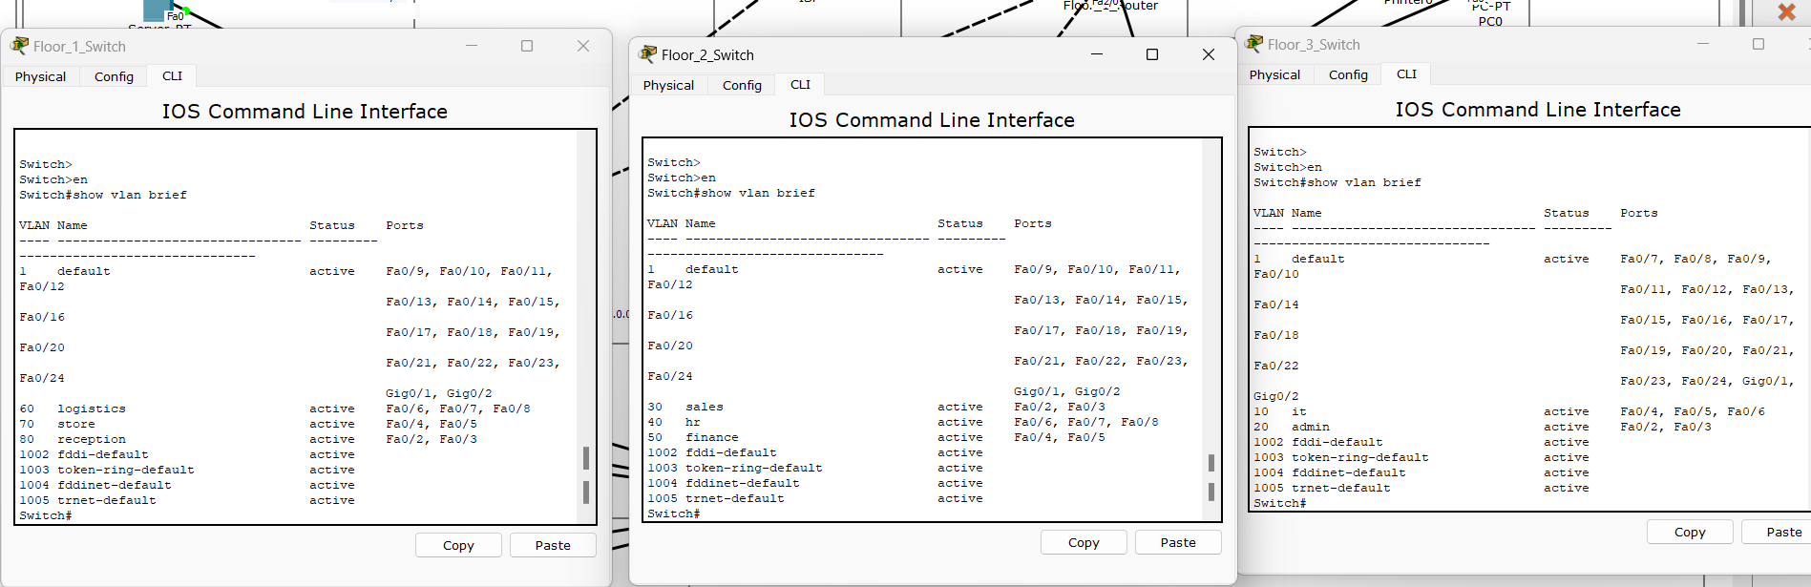

Packet Test (VLAN 40 to VLAN 50 in R2):

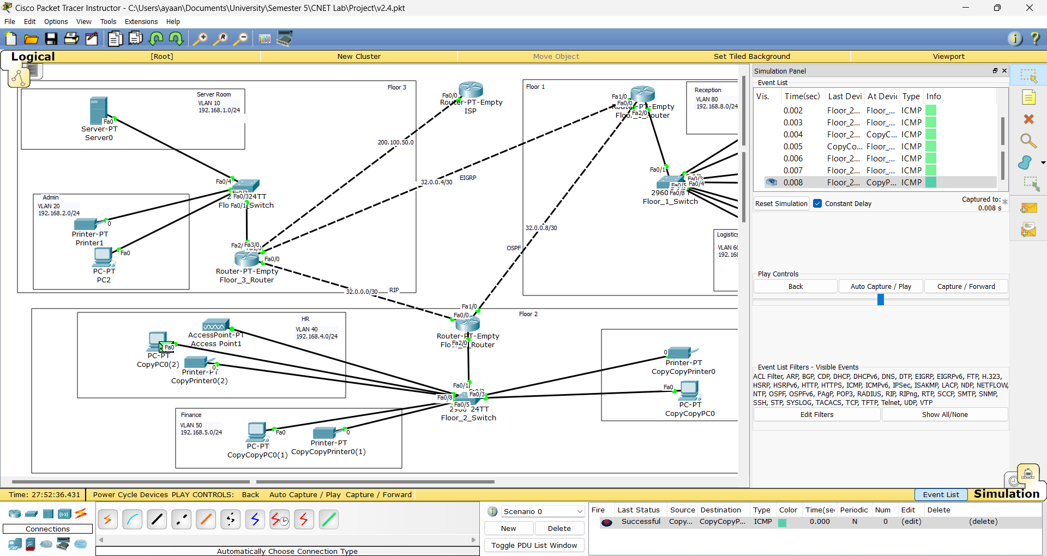

**Dynamic Routing:**

Routing Tables:

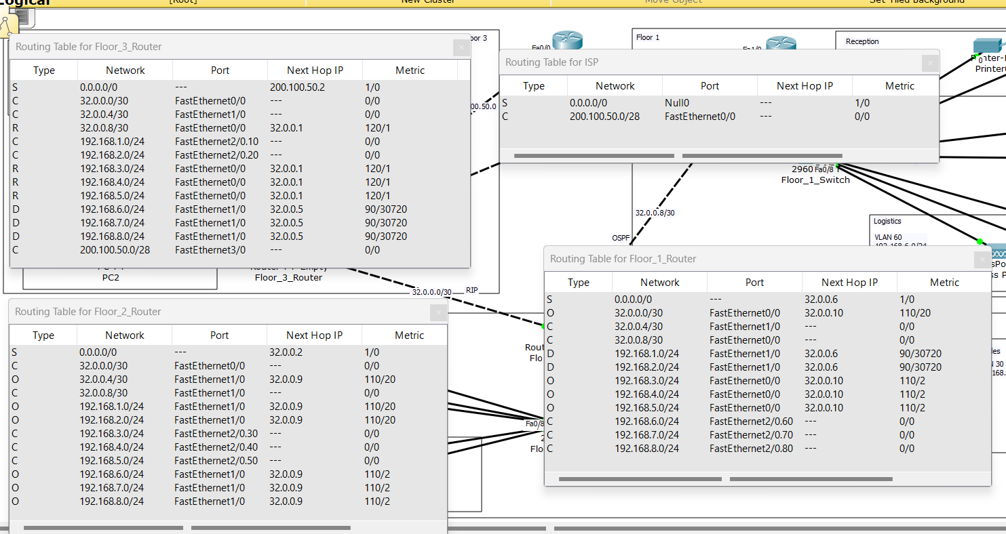

OSPF (VLAN 30 to VLAN 60):

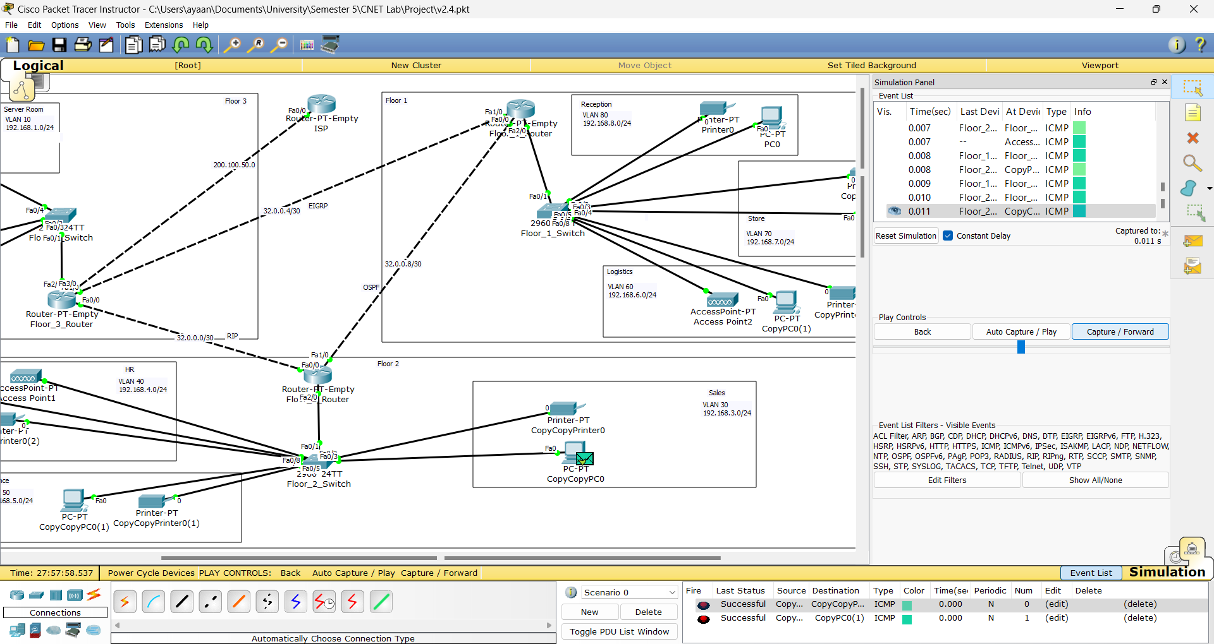

RIP (VLAN 40 to VLAN 20):

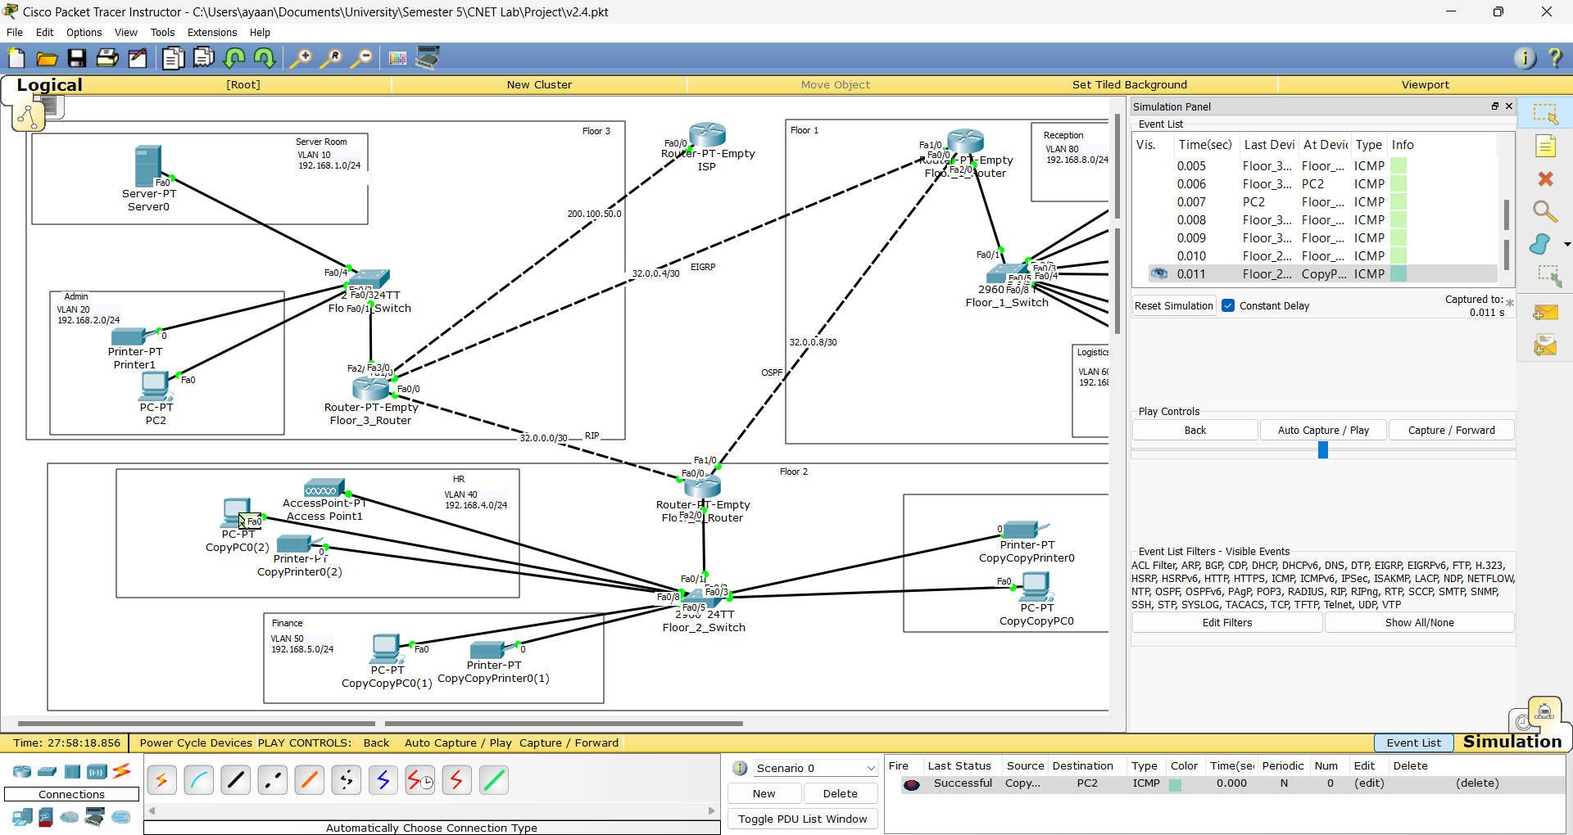

EIGRP (VLAN 20 to VLAN 60):

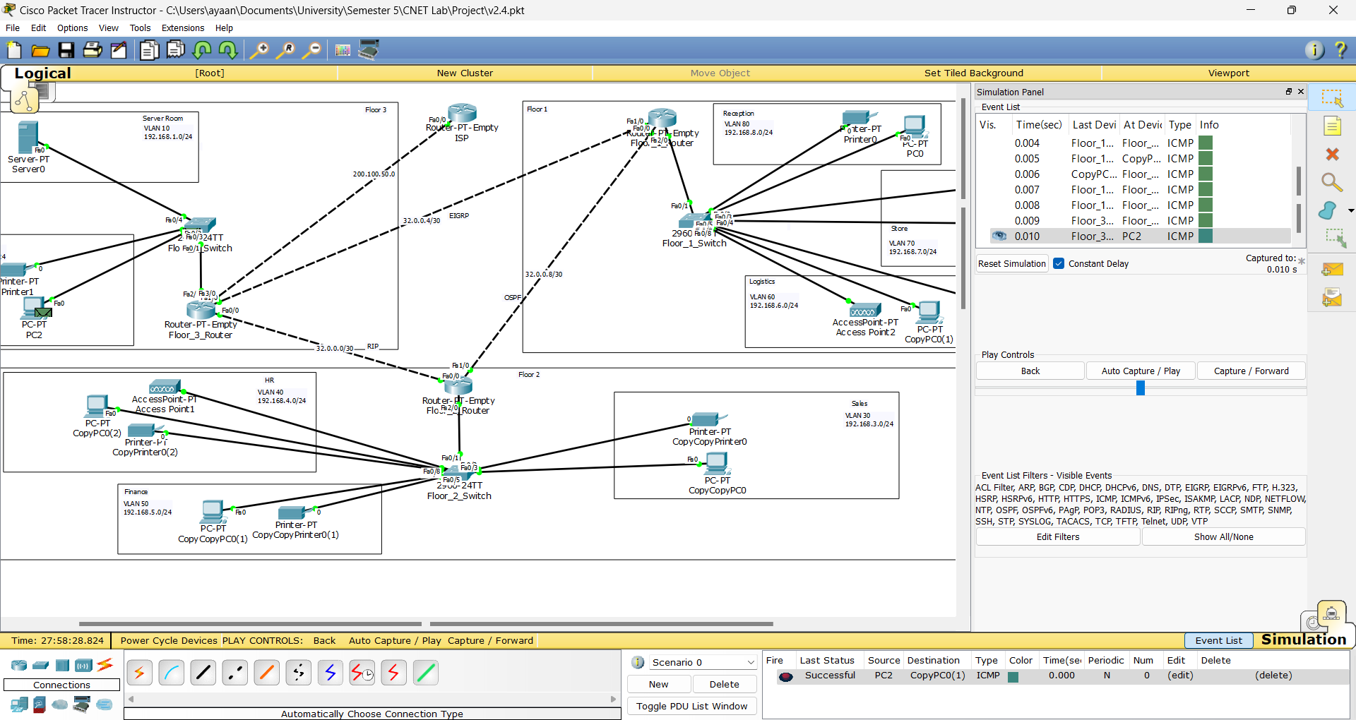

**DHCP:**

DHCP Table in Server:

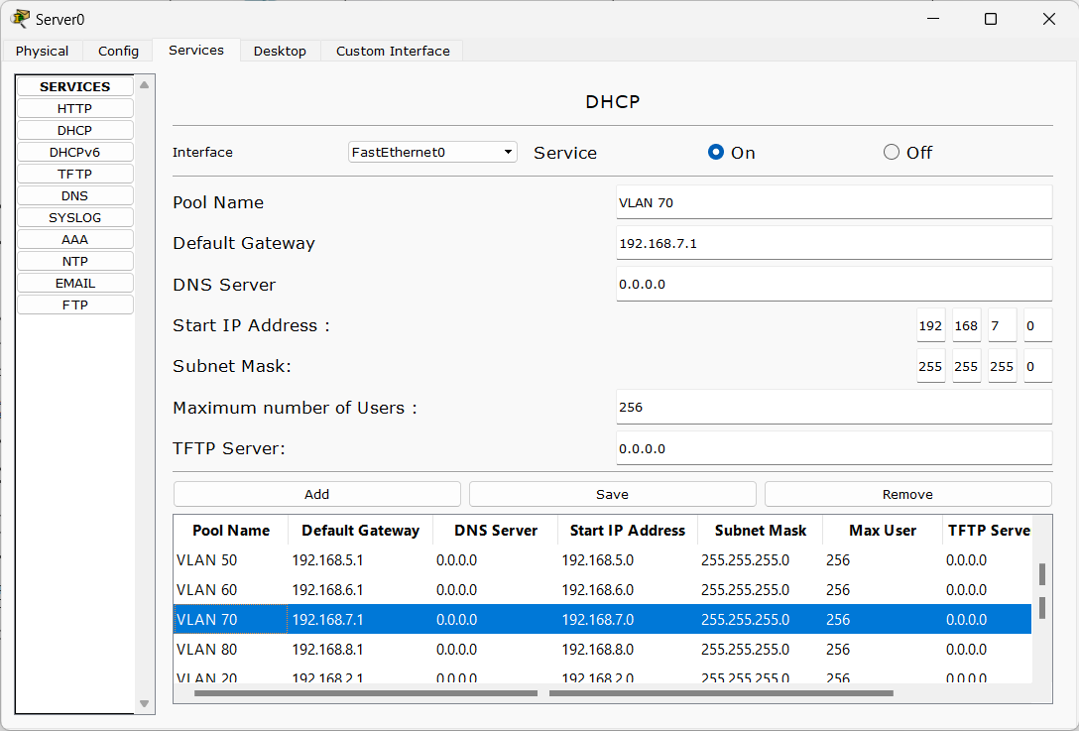

PC in VLAN 40:

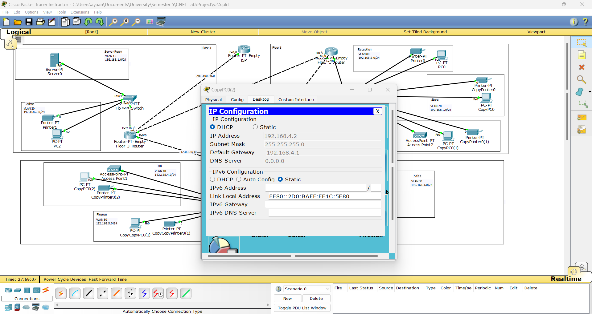

**NAT:**

Ping Test (PC in VLAN 50 to ISP Router):

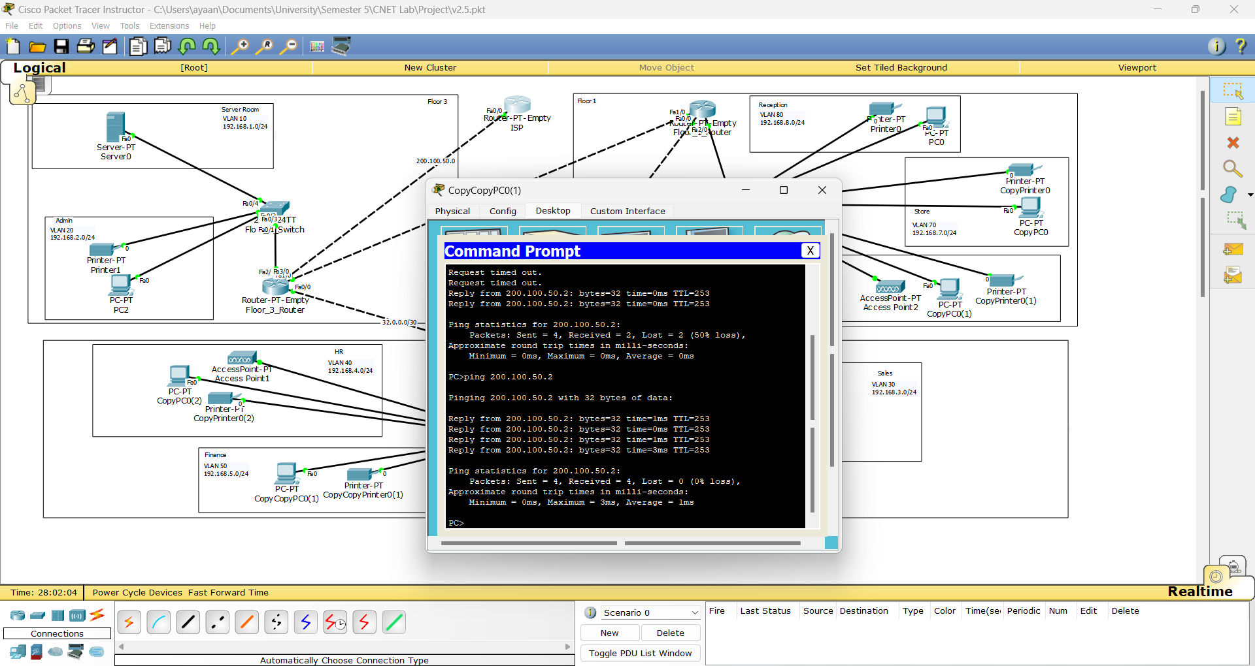

NAT Translations (Router 3):

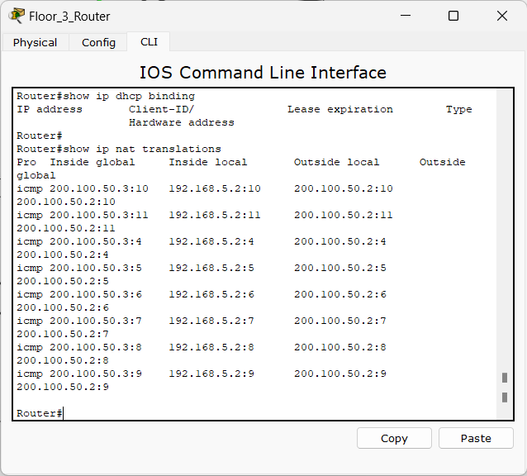

**ACL:**

Allowed IPs to ISP Router:

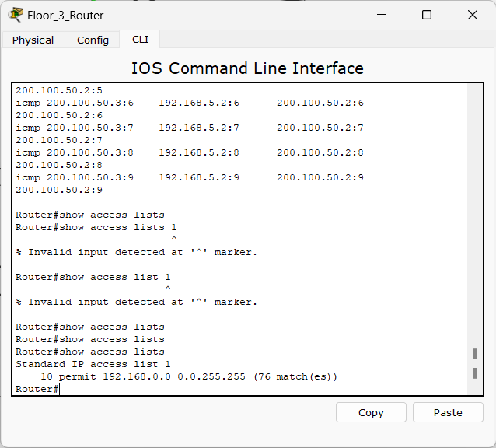

Ping Test from Allowed IP (VLAN 30 i.e 192.168.3.0):

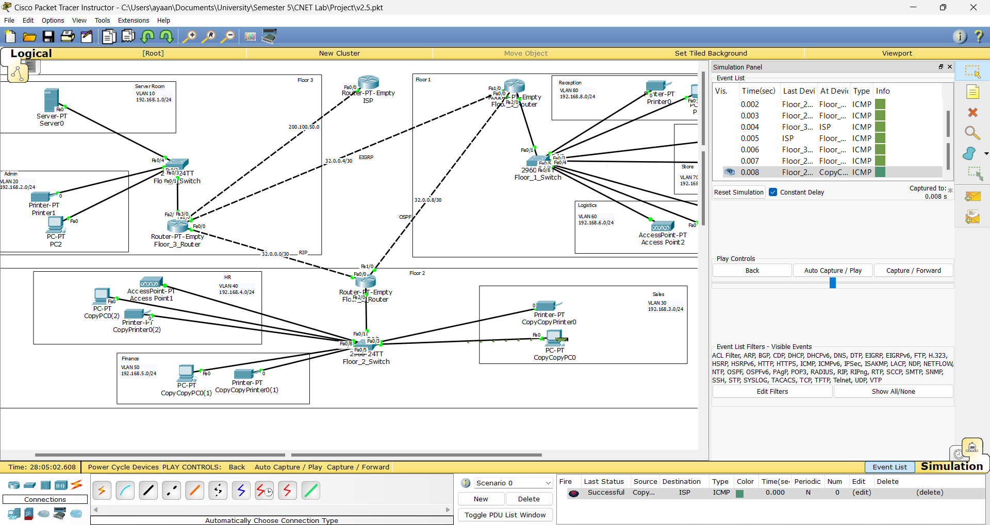

Ping Test from Disallowed IP (Router 1 i.e 32.0.0.0):

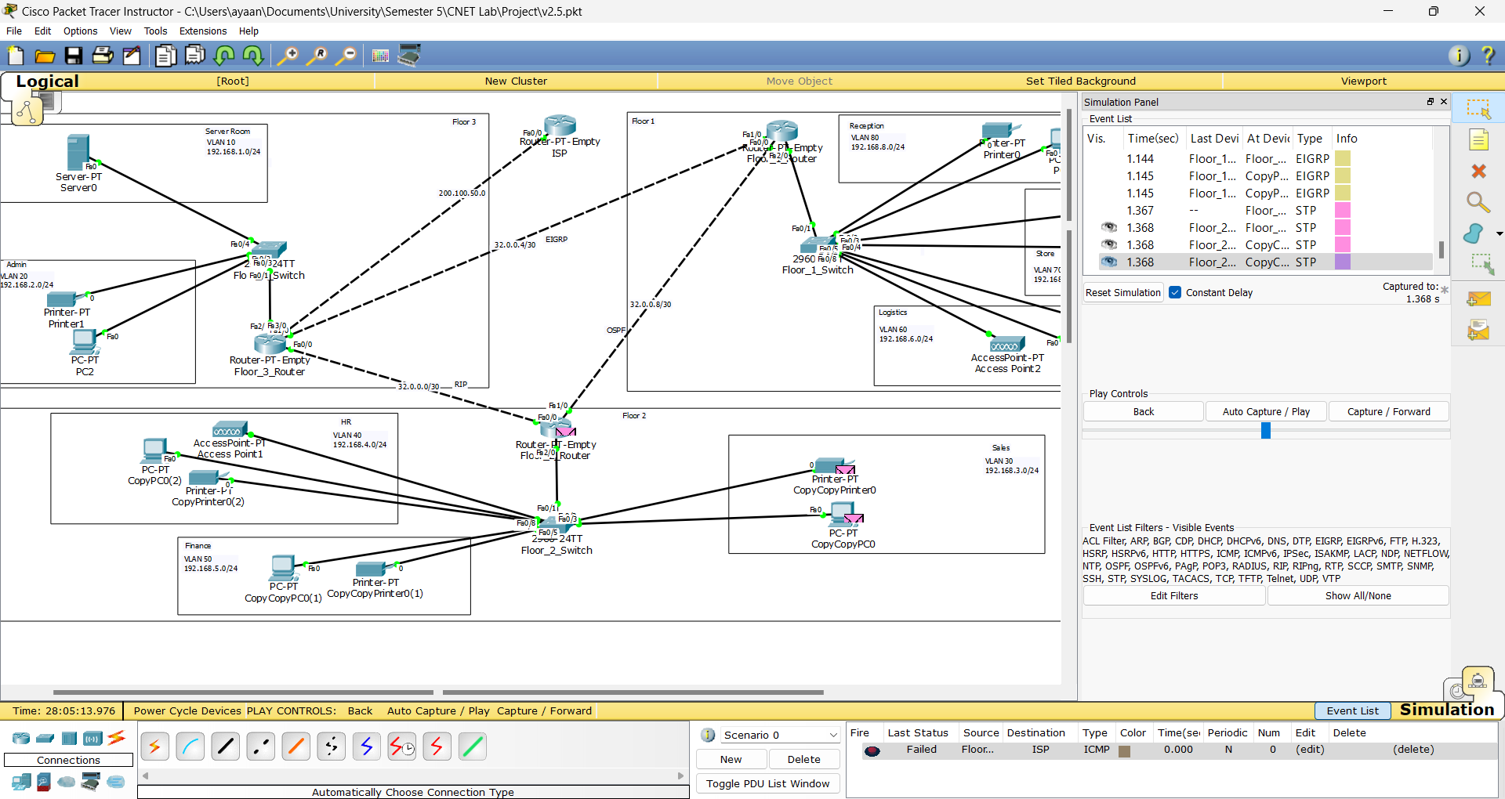

**Server Services:**

HTTP:

Index File in Server

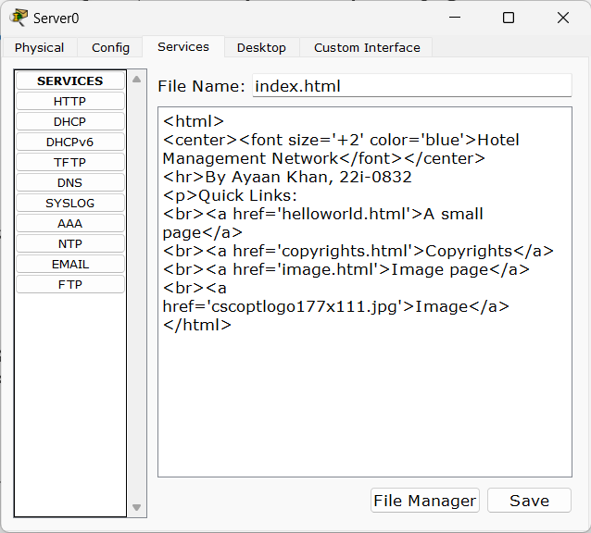

Webpage Accessed from VLAN 60:

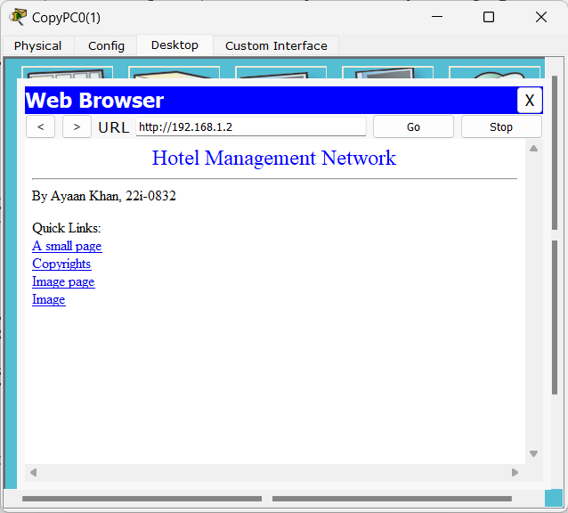

Email:

Sending from VLAN 20 to VLAN 40:

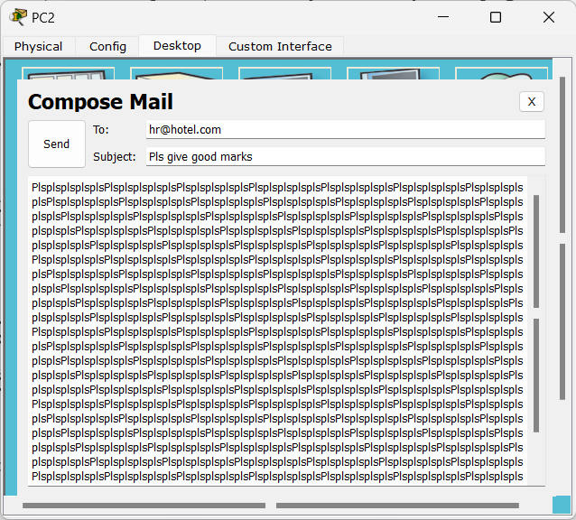

Email Sent Acknowledged:

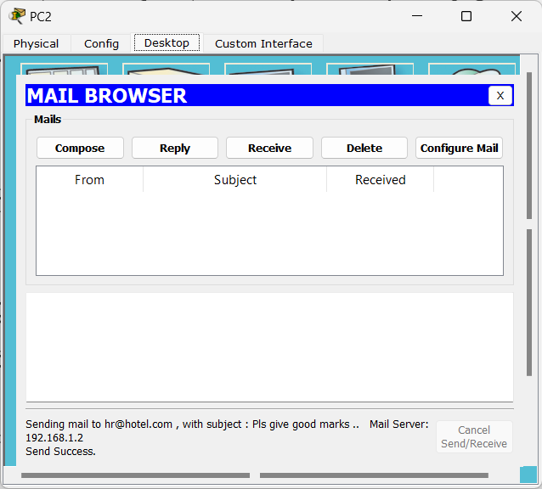

Email Received:

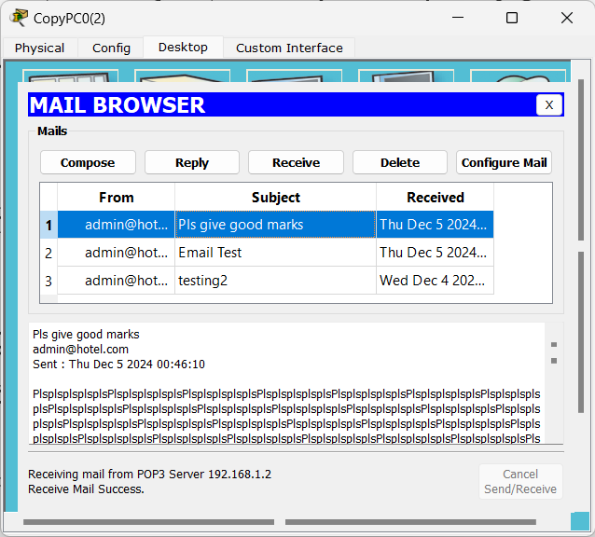

FTP:

FTP in Server Configured:

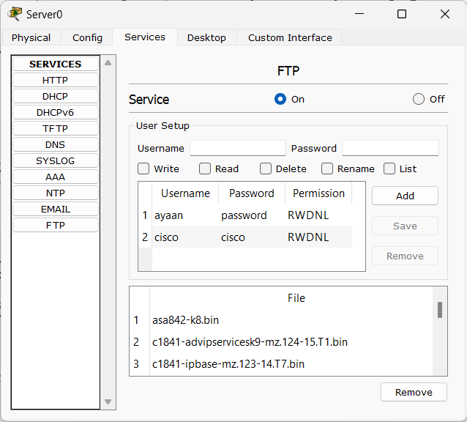

Command Prompt of PC in VLAN 80 showing FTP:

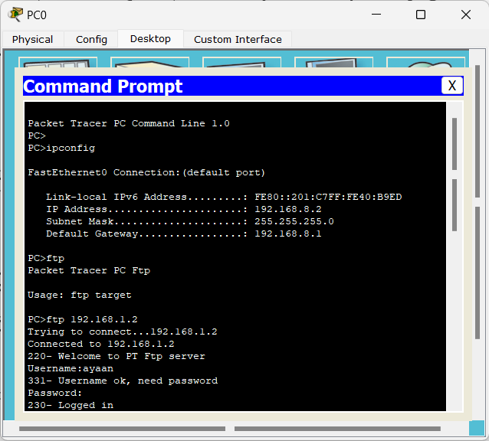

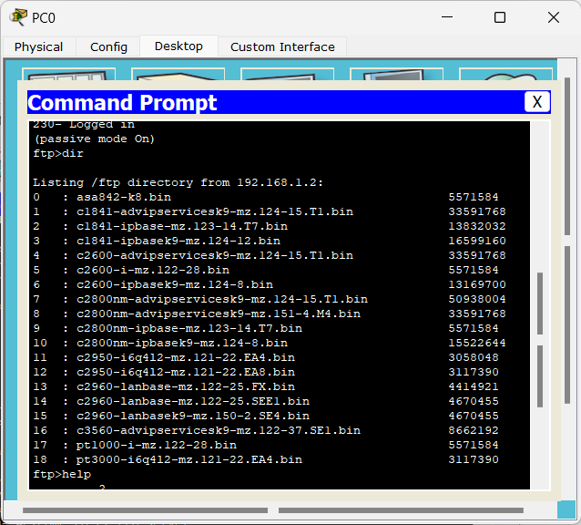

SYSLOG:

