Game Design Document

Fill up the Following document

1. Write the title of your project.

Iron-Man And The Pillar War.

1. What is the goal of the game?
2. Write a brief story of your game?

Tony Stark means Iron Man once saved World From Thanos Who

Came From Planet Wall-E And destroyed The Planet with Thanos.

After , That the Pillar War Started.

1. Which are the playing characters of this game?

* Playing characters are the ones which respond to the user based on the input from the user
* Cars, monkeys, dinos, wizards etc, are the playing characters in the game.

|  |  |  |
| --- | --- | --- |
| Number | Character Name | What can this character do? |
| 1 | Iron Man | He can Fly and Dodge the Pillars |
| 2 |  |  |
| 3 |  |  |
| 4 |  |  |
| 5 |  |  |
| 6 |  |  |
| 7 |  |  |
| 8 |  |  |

1. Which are the Non Playing Characters of this game?

* Non Playing characters are the ones which don't have an action or a behaviour when the user interacts with the game.
* Hurdles, stones, bananas, coins, etc are non playing characters in the game.

|  |  |  |
| --- | --- | --- |
| Number | Character Name | What can this character do? |
| 1 |  |  |
| 2 |  |  |
| 3 |  |  |
| 4 |  |  |
| 5 |  |  |
| 6 |  |  |
| 7 |  |  |
| 8 |  |  |

Draw your imagination of this game. What does this game look like?

* Draw the game either on your computer or on paper,
* Add images of scenes of the game to show each of the playing and non-playing characters at least once.

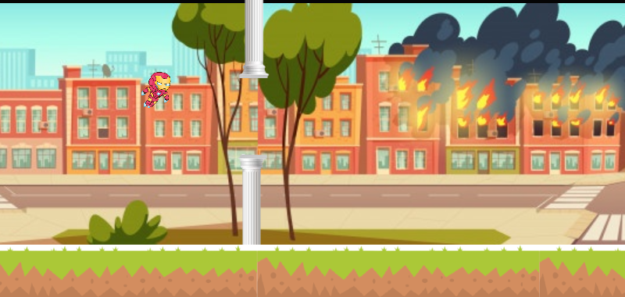

How do you plan to make your game engaging?