A-Rent

**Concept :**

# It is a website on the Internet for renting household items with the main goal of helping people and its name is A-Rent .

**Technology:**

Html5 , Css3 , JavaScript , Bootstrap , Laravel , MySQL

## **Project Information:**

The Project has an **admin dashboard** the dashboard should have secure login with username and password, the dashboard should do all these functionalities:

Manage Admin (**Create Read Update Delete**).

Manage Category : **admin can Create Read Update Delete**. all categories will appear in the public site with the image provided for each Category.

Manage Products: **admin can Create Read Update Delete products**, and each product will be linked to a specific category.

Manage Users: **Create Read Update Delete customers** that are registered from the public site.

The Project has a public website, the public site should have all of these : **HomePage, Profile, Cart, checkout page and Store page.**

**Home page**:Contain navbar with login, register, and **cart buttons**.

Main slider .

The main categories in the website must be clickable.

When the customer click on a single category will go to grid view will show all the products assigned to this category

When the customer clicks on a product will go to a single page of products to see all product information and **add to the cart.**

The cart page will see all the items inside the cart.

In **checkout page** will check if the customer logged in or not he can log in or register, after this he can continue checkout

Each customer can view his **profile** and can edit it.

Customers can search for products.

**Database Diagram:**

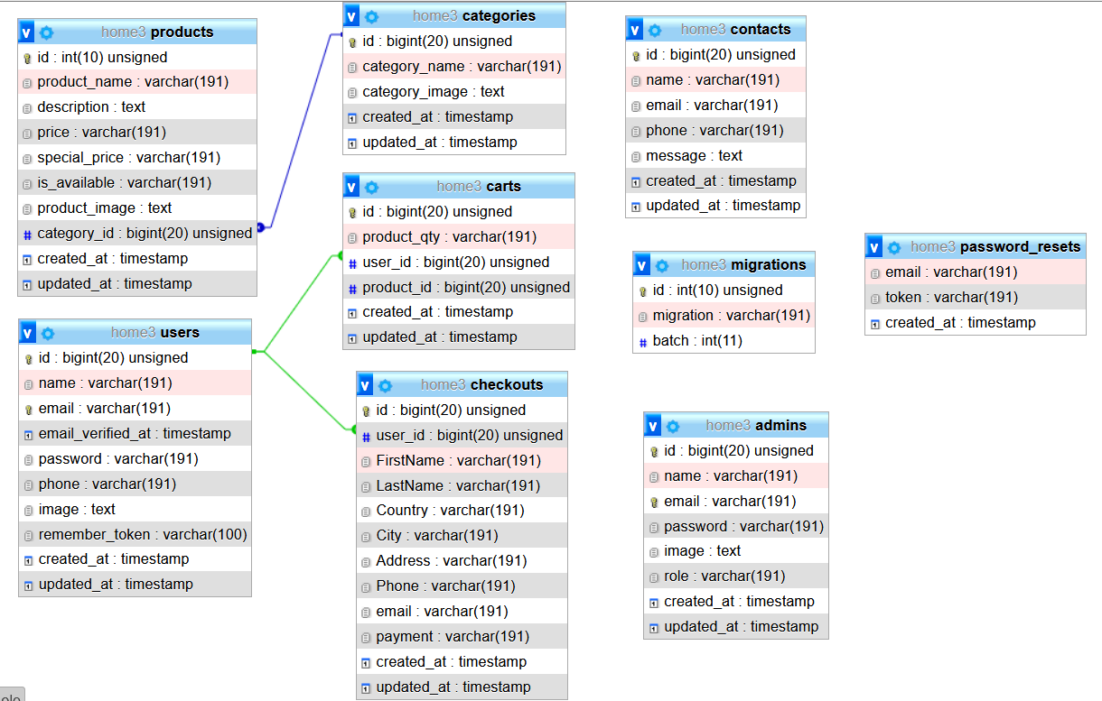

WireFrame:

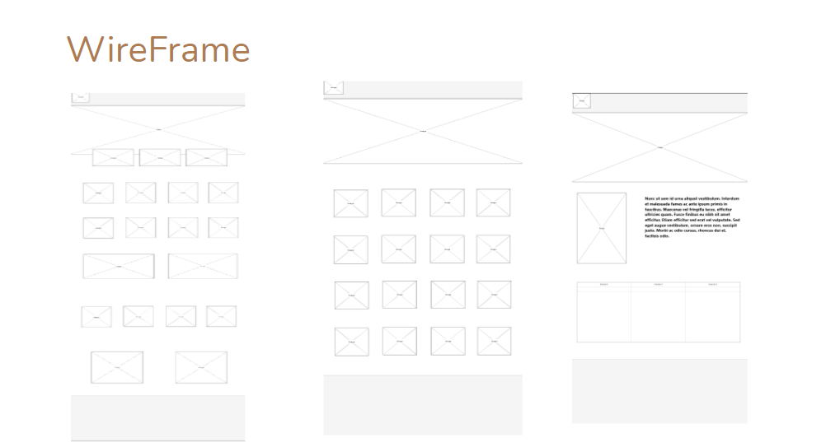

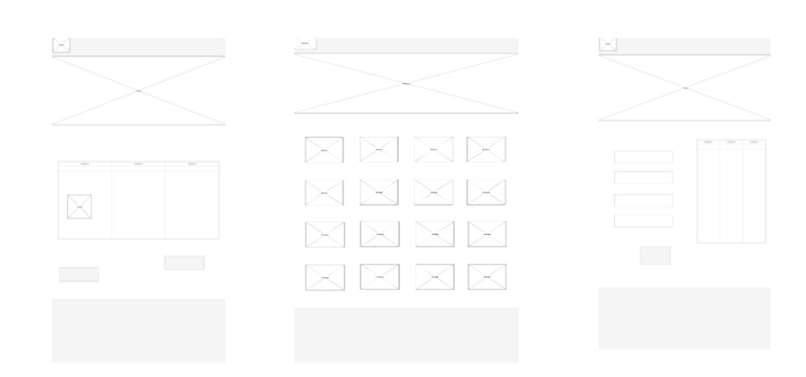

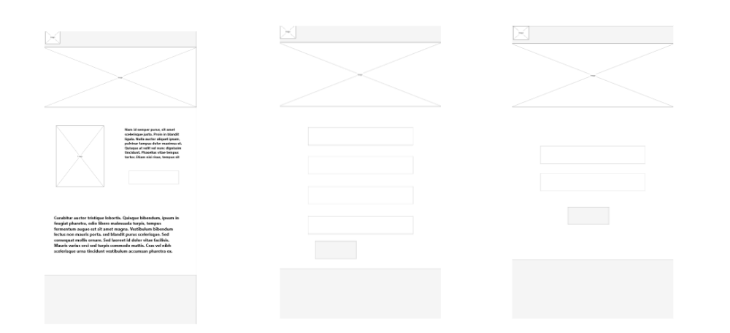

Mockup:

