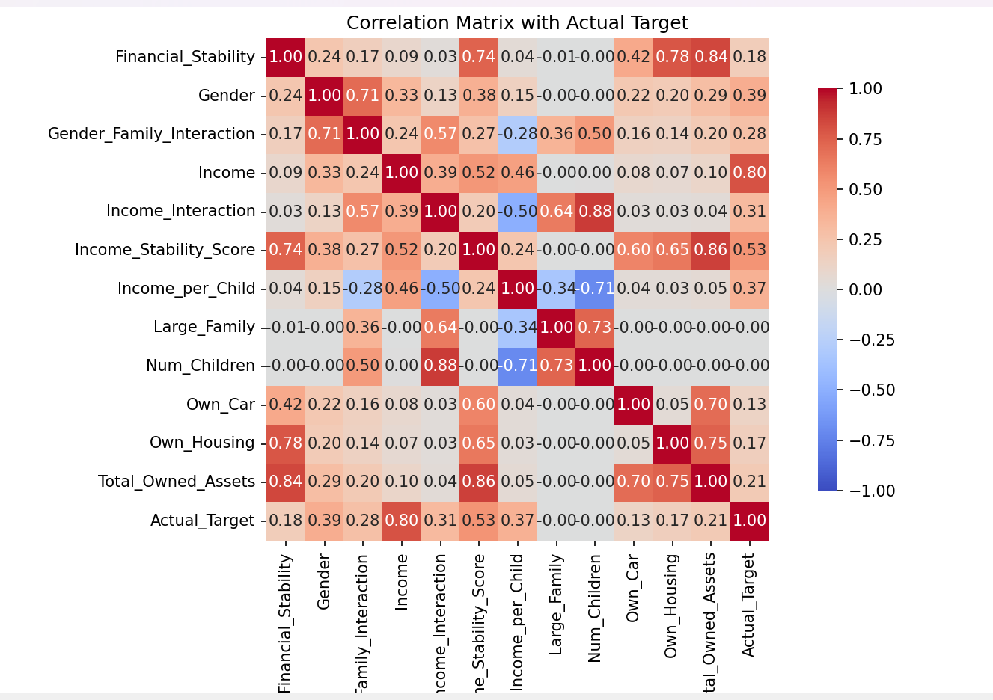

**Evaluation Results:**

**performance: {'accuracy': 0.97082, 'precision': 0.9745798766219953, 'recall': 0.9491894131662092, 'f1_score': 0.961717089554197}**

**Variance of Numerical Features:**

**Num_Children: 1.9882564969649696**

**Income: 528038693.06598526**

**Fairness Metrics:**

**Attribute: Gender**

**Statistical Parity: {'Female': 0.1857514508705223, 'Male': 0.566180291824905}**

**Equal Opportunity (TPR): {'Female': 0.8959679901508156, 'Male': 0.9671597325665985}**

**Equalized Odds (TPR): {'Female': 0.8959679901508156, 'Male': 0.9671597325665985}**

**Equalized Odds (FPR): {'Female': 0.013648907341570744, 'Male': 0.019231677928460048}**

**Attribute: Own_Car**

**Statistical Parity: {'No': 0.2748579070544968, 'Yes': 0.4192752175774005}**

**Equal Opportunity (TPR): {'No': 0.9131331652532662, 'Yes': 0.9597162740899358}**

**Equalized Odds (TPR): {'No': 0.9131331652532662, 'Yes': 0.9597162740899358}**

**Equalized Odds (FPR): {'No': 0.01194297583081571, 'Yes': 0.01748669220436794}**

**Attribute: Own_Housing**

**Statistical Parity: {'No': 0.31124397106109325, 'Yes': 0.4721753375694996}**

**Equal Opportunity (TPR): {'No': 0.9423794753167551, 'Yes': 0.9558005410095443}**

**Equalized Odds (TPR): {'No': 0.9423794753167551, 'Yes': 0.9558005410095443}**

**Equalized Odds (FPR): {'No': 0.01621980290481925, 'Yes': 0.014302971732302489}**

**Attribute: Income_Category**

**Statistical Parity: {'High': 0.7149538040378692, 'Medium': 0.0}**

**Equal Opportunity (TPR): {'High': 0.9554993612972184, 'Medium': 0.0}**

**Equalized Odds (TPR): {'High': 0.9554993612972184, 'Medium': 0.0}**

**Equalized Odds (FPR): {'High': 0.0671206908656884, 'Medium': 0.0}**

**Subgroup Accuracy by Sensitive Attribute:**

**Attribute: Gender**

**Male: 0.9729162502498501**

**Female: 0.9687212327396438**

**Attribute: Own_Car**

**Yes: 0.972792124411471**

**No: 0.9661985957873621**

**Attribute: Own_Housing**

**Yes: 0.9711576648133439**

**No: 0.9705921757770632**

**Attribute: Income_Category**

**High: 0.9493745484962549**

**Medium: 0.9946200261614414**